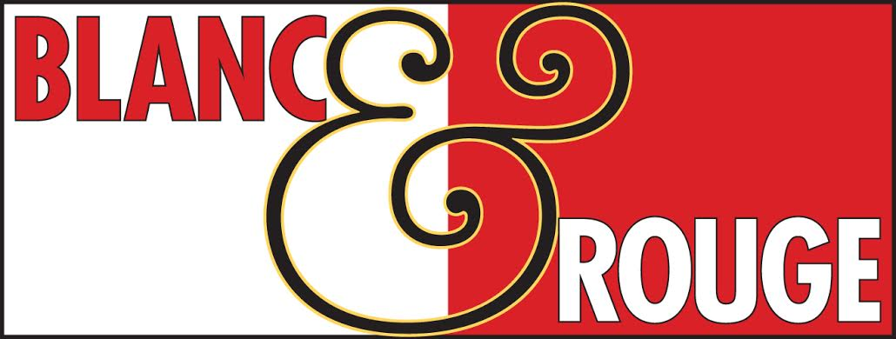
Nov. 2019
WINE CLUB
TASTING NOTES
Tier I
Tier II
Tier IV
Tier I
Red
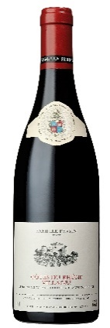
Perrin Cotes du Rhone Village $15
Originating from different terroirs in France’s Côtes du Rhône Villages, this wine is one of the most faithful illustrations of the Southern Rhône Valley. Inviting black-cherry and plum flavors are nuanced by layers of bramble, garrigue and forest floor in this impeccably balanced wine. Black-fruit characteristics are ripe and pristine, finishing on fine-grained tannins and a peppering of sweet anise. It's a fantastic value to enjoy now through 2021. 91 Wine Enthusuast & Best Buy, 90 Wine Spectator

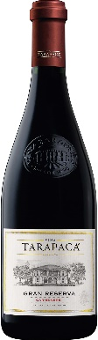
Tarapaca Gran Reserva Carmenere $15
This Chilean wine has an expressive, complex, fresh aroma characterized by spicy notes such as clove and pepper, as well as subtle vegetal notes including red pepper. These aromas are accentuated due to the vineyards being situated very close to the river, with its cool waters, and also due to the summer afternoons, when fresh breezes travel up through the valley from the Pacific Ocean to the Andes mountain range. This wine stands out for its unique red ruby color and black fruit aromas; in mouth it is well rounded and rich in flavors, where the figs, plum, cherry and wild fruits create a lip-smacking flavor. Round, smooth, full-bodied, and ripe tannins. Black fruit aromas, such as blackcurrant, blackberry and plum. Flavorsome and polished, balanced and with good persistence. 92 Janes Suckling, 91 Decanter, 90 Wine Spectator
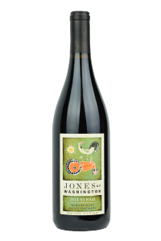
Jones of Washington Syrah $16
In the glass an inky deep purple core fades to a violet color at the rim. The explosive aromatics mix ipe and lush blackberry and Bing cherry, raspberry Kool-Aid damp violet, crushed river rock, dried rosemary and allspice. These sensations carry over to the palate with additions of dark plum and fresh turned soil. The magic of this full bodied wine is how voluptuous and supple the tannins are with a sweet fruit character balanced by a rich, earthy quality. Gold Seattle Wine Awards

Chateau Pesquié Terrasses $15
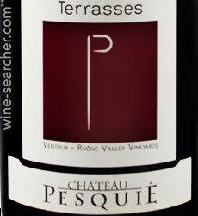
A stunner for the up-and-coming Ventoux region of Southern France. Grenache and Syrah come together to make this certified organic wine from brothers Alex and Fred Chaudiere. Remarkably consistent in even the most challenging vintages, Les Terrasses Rouge benefits from being sourced from vineyards scattered around the foothills of Mont Ventoux. These protected microclimates are warm during the day and cool at night. Due to their elevation, these sites are protected from stray summer storms that can devastate other parts of the Rhône valley. The limestone-rich soils, where Syrah does particularly well, makes for a bright, lively wine with enticing red fruit flavors and aromas of garrigue – thyme and rosemary.

No. 1 Rouge $18
This Pinot Noir Gamay blend comes from France’s Loire Valley. It showcases red fruits with lovely and fruity aromas. This is a friendly wine begging to be served with charcutier meats, quiches, chicken and pork dishes.

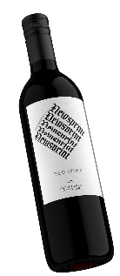
Newsprint Red $18
Sourced primarily from Washington’s Red Mountain, this red blend is comprised of 65% Cabernet and 35% Syrah. This rich, dense and full wine won't disappoint. This vintage features notes of raspberry, black cherry, vanilla and dark, juicy, red fruit.

White

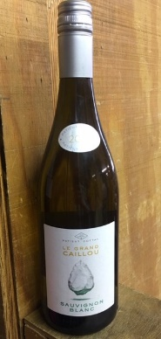
Cottat le Grand Caillou Sauvignon Blanc $15
Patient Cottat was a famous Master Goldsmith in mid-19th century France. Born in Paris, he loved the Berry region of central France. His legacy is perpetuated through a selected Le Grand Caillou varietal range grown in the French Valley of the Kings.
This selection has subtle aromas of lime and cantaloupe with a whiff of minerality. Flavors of green plum, kiwi, and citrus with a vibrant acidity and minerality.

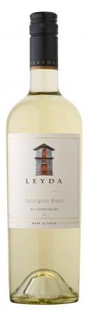
Leyda Classic Sauvignon Blanc $15
This 100% Sauvignon Blanc comes from one of our vineyards located in the Leyda Valley, a mere 12 kilometers from the Pacific Ocean in Chile. This proximity to the sea creates a truly unique winegrowing location. Ocean breezes and cool climate conditions throughout spring and summer make this an extraordinary area for cultivating white varieties such as Sauvignon Blanc, Chardonnay and Riesling.
This Sauvignon Blanc has a pronounced aromatic intensity with a wide array of aromas such as herbal notes, citric notes such as grapefruit and mandarin, and tropical notes such as guava and passion fruit. In mouth, this wine has a sharp, crisp acidity bringing a refreshing, citric and juicy pleasure.

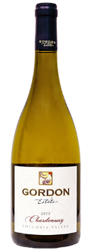
Gordon Estate Chardonnay $15
The buttered popcorn and woodspice aromas in this wine are vibrant. The palate is all about texture and feel, with the spice and stone fruit flavors as an accent. The finish lingers. For those looking for a bold, buttery style, look no further.
This classic expression of Washington Chardonnay is simultaneously complex but approachable. Aromas consist of honey, candied pineapple, citrus, and jasmine laced with a hint of caramel. Citrus flavors are echoed on the palate, complemented by subtle hints of anise. The slight richness is balanced by gentle citrus and minerality. This Chardonnay is versatile, pairing seamlessly with Northwest seafood, as well as lighter vegetarian fare and white meat options. Serve with a rich filet of halibut, poultry with cream sauce, scallops in chive butter, or simple crab cakes. All estate fruit.
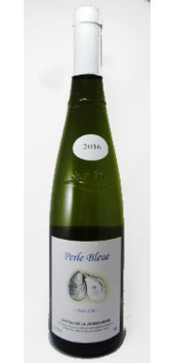
Jousseliniere Perle Bleu $15
A Melon de Bougogne (Muscadet) from the Nantes region of France’s Loire Valley. The Chon brothers make their wine from their own grapes. They practice organic viticulture. Originally Burgundian winegrowers, Mathurin Chon left for the Loire in 1719. Nantes, being on the coast of Brittany, where the Loire meets the Atlantic Ocean, this wine has a bracing sea tang that pairs perfectly with shellfish – especially oysters. Fresh flavors of apple and citrus with underlying mineral notes.
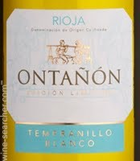
Ontañón Tempranillo Blanco $15
Ontañón Tempranillo Blanco is made from the Tempranillo white grape. In 1988 a wine grower in the Rioja Baja region discovered, in the midst of his Tempranillo red grapes, one of his vines had produced yellow green clusters of grapes. After several years of investigation, the Consejo Regulador of Rioja accepted that this was a natural mutation of the usually red grape.
Currently Tempranillo blanco is found only in the Rioja wine region of Spain. In 2007, the Spanish Institute for Foreign Trade working with the Consejo Regulador of the Rioja region came to an agreement that would allow the planting and use of Tempranillo blanco in white Rioja wines produced under the DOC labels.

Only a handful of wine growers in Rioja have Tempranillo Blanco vines. Bodegas Ontañón saw the potential of this grape and planted in 2010. 2016 was the first vintage of Tempranillo Blanco that they released. The wine produced from these mutated grapes have intense tropical fruit aromas, with hints of pineapple, white flower and citrus. The palate has texture and balance with ripe stone fruit characters, crisp acidity and a lengthy finish.

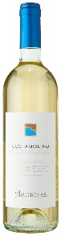
Quirico Vermentino $15
Made from 100% Vernaccia grapes organically grown in hillside vineyards surrounding the Tuscan town of San Gimignano. This wine offers the unmistakable spicy notes that are common to Vernaccia. Very aromatic on the nose, crisp, dry and refreshing on the palate, with nice acidity and a pleasing light touch of bitteness on the finish.

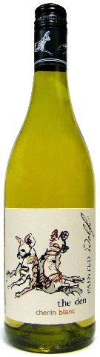
Painted Wolf Chenin Blanc $15
The Den is rare, charismatic, energetic, persistent, social and distinctly cool. It was developed to honor Southern Africa’s most endangered large mammal, the wild dog, with wines that capture their character.
This wine has a bright aroma and flavor of tropical fruits - honeydew melon, guava and pineapple with an under lying savory minerality and a lick of wood. The wine has a great texture and a long-layered finish with bright acidity keeping it fresh and vibrant.
It somehow smells rich and generous, but not in a fruity way, with the fruit playing only a supporting role here to the richer waxy and oily sensations. The palate is light-plus in weight, but surprisingly nervy and brisk, with searing acidity and green fruit tones that are tart and sharp. A perfect everyday drinker.

Tier II
Red
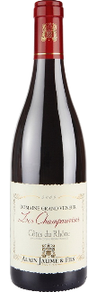
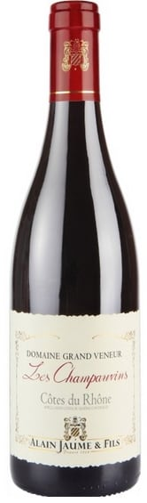
Grand Veneur Cotes du Rhone “Les Champauvins” $22
Capable of rivaling many wines from neighboring Châteauneuf du Pape, this wine is a big, brash mouthful of fruit with nuance. Full-bodied and dense, it tastes more like a “baby Châteauneuf” than a Côtes du Rhône. Hints of licorice, cracked pepper and garrigue, along with a bit of warmth on the long, mouthwatering finish. Supple tannins make it approachable now, but it should easily drink well for 6 years, if not more. A complete wine, rich and elegant at a terrific value. 92 Wine Spectator

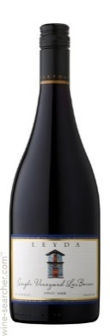
Leyda Las Brisas Pinot Noir $25
This 100% Pinot Noir comes from an estate vineyard in Chile’s Leyda Valley, just 12 kilometers from the Pacific Ocean. Las Brisas is perfumed with floral and seductive fresh red fruit aromas intermingling with herbal and spiced notes such as white pepper. The oak is smooth, almost unnoticeable, allowing the fruit to stand out. The palate is fresh and fruity with a vibrant, juicy texture.
Bright, with a strong Pinot character, this wine displays spicy, subtle wild herb and earthy notes, a good minerality, and a sour red fruit profile of raspberries, cherries and blueberries. It is delicate, refined, and juicy on the palate, offering a lasting finish with lively acidity. Pair with lasagna, pork roast, or eggplant tapenade. Drink now. 92 James Suckling, 91 Wine Spectator

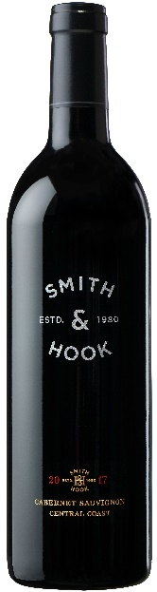
Smith & Hook Cabernet Sauvignon $21
The fruit for this wine comes from four prestigious appellations of the Central Coast: Arroyo Seco for structure and backbone; San Antonio Valley for rich plum and currant flavors; Hames Valley for dark skin color and intense blackberry and spice aromas; and Paso Robles for black cherry notes and seductively round and supple tannins. The result is a spirited, layered and luscious Cabernet Sauvignon.
Fragrant aromas of plum and black cherry with hints of vanilla, cola, cloves and cocoa dust. Right on the heels of all that aromatic intensity are interwoven layers of blackberry, boysenberry, black currant, dark plums and mocha. This wine is full bodied with supple tannins and firm texture with a long, generous and robust finish. Well balanced. Great with roasted duck breast, beef tenderloin, grilled pork or short ribs. 91 Wilfred Wong, 90 Wine Enthusiast

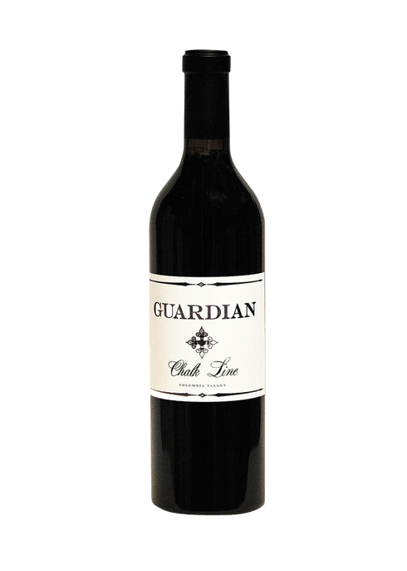
Guardian Chalk Line $25
This Washington selection is a blend of 42% Cabernet Sauvignon, 28% Syrah, 28% Merlot and 2% Petit Verdot. The aromas pop, with notes of raspberry, huckleberry, green pepper, plum and herb. The fruit flavors are supple, showing a pleasing sense of texture and balance. 90 points Wine Enthusiast

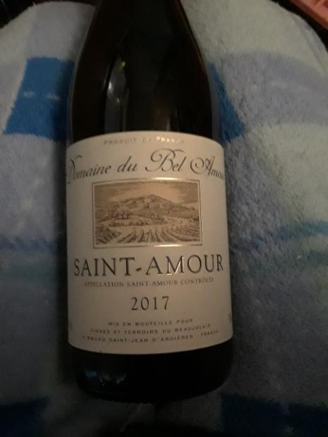
Bel Avenir Saint-Amour La Gagere $22
100% Gamay from the Beaujolais region of france, this wine comes from very old vines, 60 years old on average. Showing a magnificent cherry flavor with fine herbs. Medium weight with tremendous charm and softness.

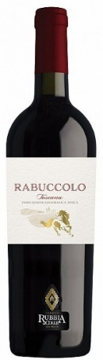
Rubbia al Colle Rabuccolo $24
As the crow flies, it’s barely more than 7 miles from the deep blue waters of the Mediterranean Ocean to the fertile flatland vineyards of Tenuta Rubbia al Colle. This is the western range of romantic Tuscany, where Medieval mountain villages overlook New World wine making techniques. In homage to the rich heritage of the region, the wine takes its name from the term Romans used to designate their most important grape varietal, “Rabucculo.” In this region, the Bordeaux varietals are dominant – Rabuccolo is a testament to that fact. This is a ruby-colored, persistent, ready to drink wine that delivers ripe, fresh fruit, spice and mouthwatering acidity. Green pepper but also red fruits together with nuances of balsamic aromas. Direct, fresh and pleasing. This red blend is right at home with everything from omelets to roasted vegetables, cheeses and pizzas. It’s best suited for hearty soups made from barley, spelt, legumes, lentils or beans.

White
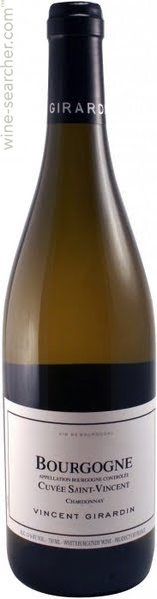
Vincent Girardin Bourgogne Blanc Cuvee $30
A fresh and elegant translation of a typical Chardonnay from Burgundy. A floral and fruity wine (citrus, peach) combines with mineral notes and a beautiful length. A good pairing for this wine would be seafood, grilled fish, white meat and cheese.

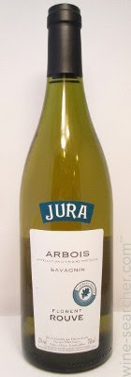
Florent Rouve Arbois Savagnin $30
Emerging superstar Florent Rouve was partners with famed Burgundian negociant Jean Rijkaert until 2013 when he took the reins alone. Producing in two of France’s hottest winemaking regions, the Maçonnais and Jura, Rouve’s oenological approach emphasizes freshness, integrity, balance and terroir and offers superb alliance of tradition and a modern, minimalist style. 100% Savagnin, also known as Traminer, the signature grape of the Jura region. Made with native yeasts, 100% hand harvested. Dry white with good acidity. Typical citrus and floral character with a hint
of tropical flavors.
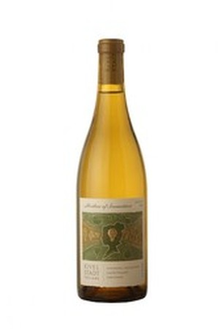
Kivelstadt Cellars Mother of Invention Rhone Blend $25
The Mother of Invention is a white blend influenced by the Southern Rhone. Produced from the most interesting and expressive grapes on the planet (Marsanne and Roussanne). It is fermented and aged entirely in barrel to bring out the beauty and weight of the grapes. This wine retains its freshness while having the intense aroma and flavor that we love from Rhone whites. Creamy and luxurious texture. Light-bodied. Butter and almond aromas with marzipan and vanilla flavors. Rich mouthfeel with just enough crispness to give it good balance. Varieties: Marsanne (50%) Roussanne (50%). Production: 330 Cases
91 Wine Enthusiast
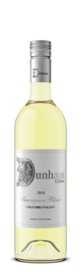
Dunham Sauvignon Blanc $21
This is Dunham’s inaugural vintage of Sauvignon Blanc. This food-friendly Sauvignon Blanc leads with aromatics of fresh cut pineapple, Asian pear and green apple. Refreshing flavors of zesty key lime, toasted coconut and fresh baked pie crust are highlighted by a bright acidity adding crispness to the long, clean finish.

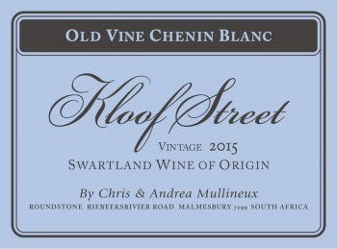
Kloof Street Chenin Blanc $21
This South African selection is pale straw in color with scents of sun ripened pears and wet granite. The palate has a vibrant acidity balanced by a soft, round texture and some pithy character. Pear and apple fruit flavors. The wine has a savory, dry finish. Grapes come from two old vineyards in Paardeberg. Fermented with natural yeasts and very lightly wooded. 90 Tim Atkin

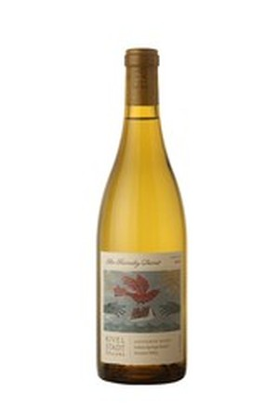
Kivelstadt Family Secret Sauvignon Blanc $20
This wine, from Sonoma California, is a composite of two styles of Sauvignon Blanc. The 50% in barrels bring texture and depth. This is balanced by a racy zing from the stainless tank fermented juice. Then the blend is aged in barrel for six months. It shows a moderate midpalate of structure of supportive oak. In taste, it's a tart tangy expression of green apple, lemon and grapefruit pith, the acidity up front and persistently fresh and forgiving. 90 Wine Enthusiast

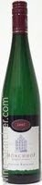
Monchhof 2016 Urzig Wϋrzgarten Spätlese Riesling $30
Mint tinged kiwi and honeydew melon on the nose anticipate the juicy, cooling, invigoratingly seedy impression on a polished, buoyant palate. This finishes with infectious juiciness and admirable clarity, its invigoration reinforced by noticeable dissolved CO2 giving it a light spritz. High residual sugar which is nicely checked by strong and efficaciously bright acidity.
Dusty mineral, salt and spice accent white peach and grapefruit in this light-footed spätlese. Honeyed yet spine tingling with acidity, it finishes on a refreshingly green melon-rind note. Delicious now but should improve through 2026 and likely further.
92 Wine Enthusiast, 2019 Top 100 Wines Wine Spectator

Tier IV
Red
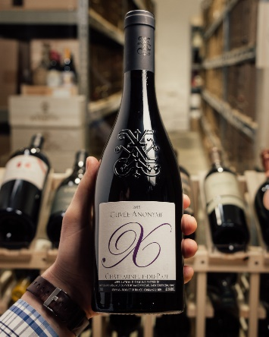
Xavier Chateauneuf-du-Pape $40
Classic Rhone flavors of black pepper, spice, dark cherry, juicy kirsch, mint and herbs are right out in front. Plushly textured, this is a really nice wine that's fun to drink on the young side. It needs to blossom with time in the glass to get the best out of the cassis, leafy herbs, graphite, black olive and earthy notes to flow into a ripe, full-bodied and balanced wine. The wine was made from a blend of 55% Grenache, 35% Mourvedre and 10% Syrah. Aged in old barrels.
93 Jeb Dunnuck, 91 Robert Parker's Wine Advocate

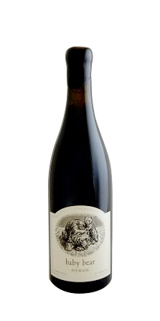
Pursued by Bear Baby Bear $45
Kyle MacLachlan produce this Washington Syrah stunner. Full-bodied richness, sweet tannins and a grand finish. Sensuous aromas of blackberry, licorice and smoky cedar. Soft and lush with well-balanced tannins that give way to flavors f ripe, red raspberry, blueberry and a hint of vanilla.
96 points Jeb Dunnuck, 92 Wine Spectator, 90 Wine Enthusiast

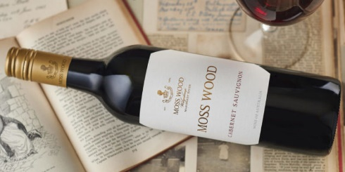
Moss Wood $35
From Margaret River on Australia’s West coast. This Cabernet Sauvignon expresses with classic blueberry and red currant scents with add perfumes of violets and pomegranate. Dig deep to reveal layers of leather, cedar and tar. In the mouth you discover rich fruit with depth and length. The structure is supple. Acidity gives the flavors vibrancy. Tannins are concentrated but rounded for smoothness and length. The finish is soft oak, leather and tar.

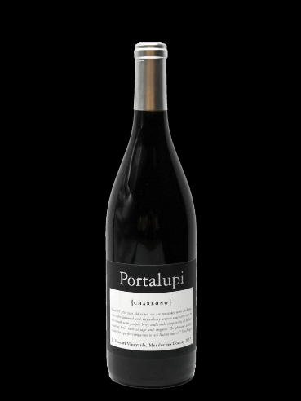
Portalupi Charbono $30
Balanced with distinctive rhubarb flavors. Firm tannins but with enough acid to offset unwelcome harshness. This lesser known varietal is less over-the-top than Zinfandel with a distinct old world style. Charbono is a red wine grape that originated in the Savoie region of Italy under the name Douce Noir, and in California it’s been described as a Cult variety due to its scarcity and devotion of its connoisseurs. The grape is revered for producing powerfully rich, inky-like flavors, voluptuous texture and colossal structure.

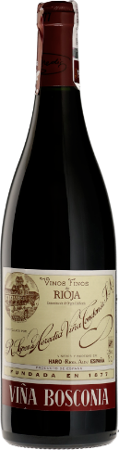
Lopez Vina Bosconia $35
Viña Bosconia wines come from a single El Bosque vineyard. Viña Bosconia wines are elegant but full-bodied; have a deep color and good structure and are wines with great complexity and expression. Production varies yearly from 20,000 to 48,000 bottles. The difference between the Reserva and the Gran Reserva is that the former are made every year and are "coupage" wines and not vintage wines. They age for 5 years in American oak barrels, and are hand racked around 10 times before they are released to the market.
The Gran Reserva wines are only made in very exceptional vintages, in small quantities and from selected grapes. The number of bottles made varies from 5,000 to 15,000. They age in barrel for a minimum of 8 years to a maximum of 10. They are both bottled and corked by hand, and finally waxed so that the cork is protected when they lie in underground cellars for another 10 years before being released to the market.
This Spanish selection is full if red and black currant, dried cherries, crushed stones and vintage leather with a back beat of mushroom stock, red flowers, plum, coconut husk, sandalwood and the scents of an archive section of a library. Subtle complexities unfold with time. The palate is elegant, ultra-classic and delivers a medium-plus body. Immensely savory and structured. Due to five years of aging in porous American oak, it can be enjoyed over the course of days.
80% Tempranillo, 15% Garnacha, 5% Mazuelo & Graciano

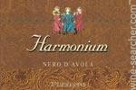
Firriato Harmonium Nero d’Avola $35
From Sicily this Nero d'Avola opens with ripe black-skinned berry, carob and cedar aromas. The chewy savory palate offers dried black cherry, raspberry jam and cocoa alongside fine-grained tannins. Enjoy through 2022. 90 points Wine Enthusiast

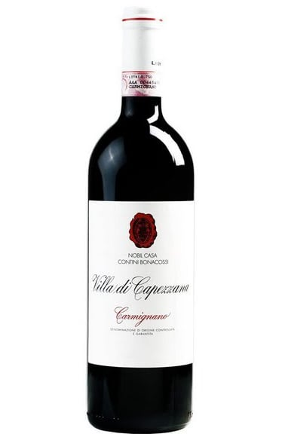
Villa di Capezzana Carmignano $30
From the Tuscany region of Italy. Deep ruby red color. Elegant with notes of red and dark fruit with spicy aromas. Well structured, with rich, concentrated flavors of currant and wild berries set against a backdrop of silky tannins. Outstanding served with roasted or grilled red meat, lamb, polenta, mushroom risotto and semi-hard cheeses. 91 James Suckling

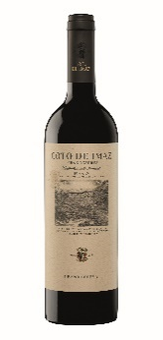
Coto de Imaz Gran Reserva $35
Brilliant ruby color, with russet tones. Mature and elegant, its aromatic richness is changing and subtle, becoming more apparent as the wine breaths. Notes of toast and coconut followed by tertiary aromas (leather, wet earth), and red fruit and dried fruit. Round, silky tannins, persistent and complex aftertaste.93 points Wine Spectator. 93 points Wine Enthusiast

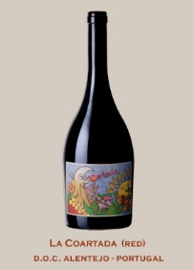
Eladio Pineiro 2009 La Courtade grand reserve $32
From Portugal this blend of 80% Aragonez (Tempranillo), 15% Alicante Bouschet (cross of Garnacha and Petit Bouschet), and 5% Cabernet Sauvignon grapes are grown organically and Biodynamically. On the nose there is a rush of dried red fruits, blood oranges, potting soil and leather. In the mouth this wine is ample and gentle revealing a complexity with hints of roast and minerals. Complex, round, edgeless despite the tannic strength. Long aftertaste with a hint of sweetness. Best with duck, pork, fatty tuna and goat cheese. 91 Wine Spectator, 90 Wine & Spirits Magazine

White
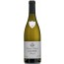
Delaport Sancerre AC $33
Ultra lean acidity invokes stone fruit, which develops a creaminess by mid-palate. Finishes fresh with key lime notes. From the Sancerre region of France’s Loire Valley. 93 Tasting Panel

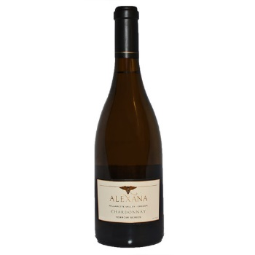
Alexana Chardonnay $36
Vibrant bouquet of lemon zest, toast and vanilla. Rich and rounded with notes of toasted brioche, pineapple and barrel spice. Shows apple pie, cream, vanilla and caramel. Full body, creamy texture. Finishes with a citrusy note. Enjoy this year. 2,338 cases made. 90 Wine Spectator. 90 James Suckling

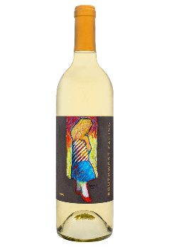
Upchurch Southwest Facing Sauvignon Blanc $36
This is the inaugural vintage of Upchurch’s first white wine 100% Sauvignon Blanc from a single plot in Boushey Vineyard. Only 200 cases produced. Aromas of pear, lime chutney, honey save and passion fruit. This riper Sauvignon Blanc exhibits great purity and complexity with an elegant yet plush mouthfeel. The flavors show white peaches, honeyed stone minerality and bosh pear plus mouthwatering and juicy lime acidity. The finish is
compact, long and very promising.

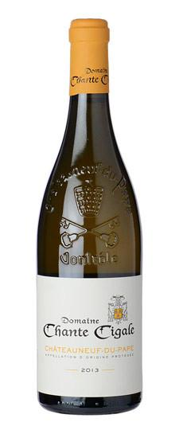
Chante Cigale Chateauneuf-du-Pape Blanc $40
From the Rhone Valley of France. Full-bodied, plump and round, with lashings of pineapple, tangerine and lime-like aromas and flavors. Vibrant citrus zest. Suave honeysuckle nuance that gains strength with air. Dry and focused in the mouth. Finishes long, crisp and mouthwatering. Enjoy now through 2020. 1,650 cases made.
Chante Cigale means singing cicada. The property has been in the family since the 19th century and is currently run by Alexandre Favier, who assumed the reins at the ripe old age of 20! The domaine is planted to 40 ha of red and 5 ha of white on 45 different parcels throughout the appellation. The Blanc is a blend of equal parts Grenache Blanc, Roussanne, Bourbelenc and Clairette. The grapes are destemmed and fermented with native yeasts. Only a small amount of this wine is made, and it is always one of the great values for white from the region. 25% Grenache Blanc, 25% Roussanne, 25% Clairette and 25% Bourboulenc. On average, 1,750 cases are produced each vintage. 92 Parker's Wine Advocate, 91 Vinous, 91 Wine Spectator

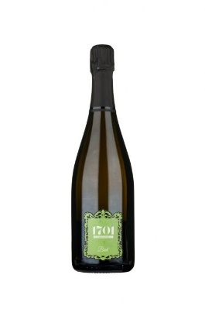
1701 Franciacorta Brut $35
This Italian sparkler comes from the Lombardy region near Milan. The Chardonnay (85%) and Pinot Noir (15%) grapes used are organic and biodynamic and the wine is unfined and unfiltered. Full palate balanced by marked acidity. Mineral hints softened by fresh fruits and lingering flavor of red apple.

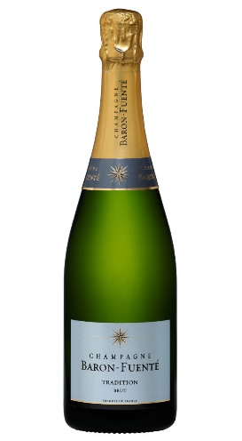
Baron Fuente Tradition $30
This Champagne is 70% Pinot Meunier and 30% Chardonnay from the Marne Valley. Light yellow color with a very fine mousse. The scents are elegant with a note of brioche and candied fruits with a light honey hint. In the mouth this wine is supple and well balanced. Unctuous with a good length in the mouth. An ideal partner to salmon on toast.

