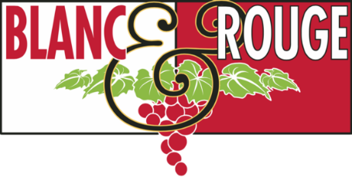
Wine Club Tasting Notes
Fall Club Release
November 6th, 2020

Wines of Alpine France – Savoie and Jura

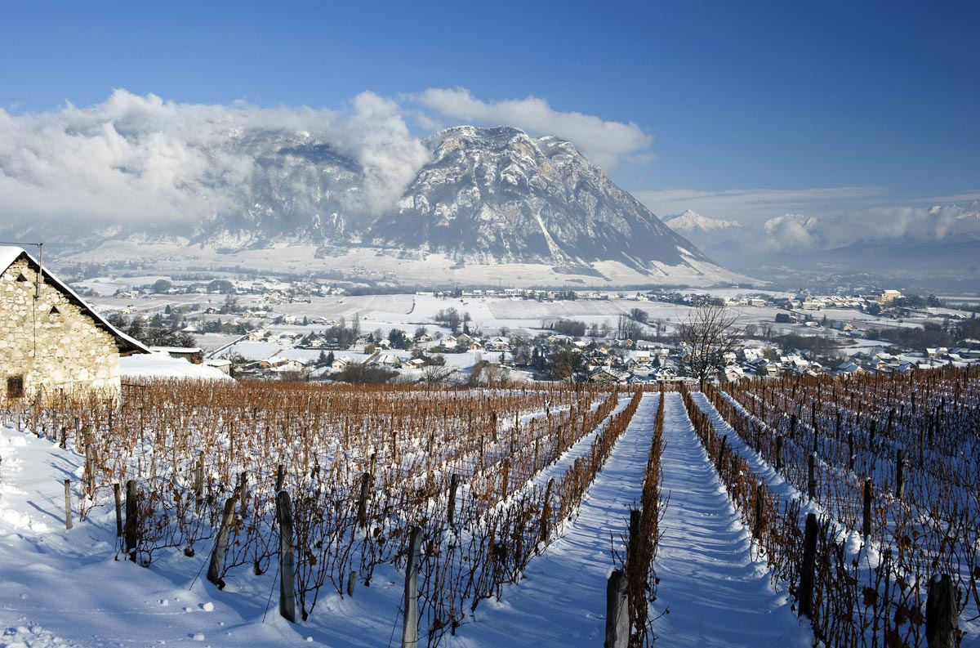
Photo credit: Vin de Savoie

Burgundy, Bordeaux, Beaujolais… There are a handful of destinations that come to mind when we talk about French wine. Rarely, if ever, do you hear people mention the regions of Savoie and Jura. At the base of Europe’s most prestigious mountain resorts, generations of farmers have produced the world’s most compelling alpine wines. These crisp, mineral whites and silky, bright-berry reds are built to pair with fondue after a long day on the slopes. Quickly, these wines have become sommelier-favorites due to their freshness and versatility with food pairings, and we were grateful to get our hands on a small collection of these bottles, given that they rarely leave Western Europe. For this fall club release, we have included some familiar French classics like Syrah and Cabernet, but we hope you’ll discover new favorites such as Mondeuse from Savoie or sparkling Trousseau from Jura. Bundle up and allow these compelling wines to transport you to a lodge in Chamonix!

Quick links: Tier I Tier II Tier III

The tasting notes below represent the core wine selections for this November club release. We may have included a special selection in your club bag, so please contact wineclub@blancandrougewine.com if you would like any additional information about your club wines. Cheers!

Tier I

Red

Domaine Jean-Charles Girard-Madoux Vin de Savoie Gamay (Savoie, France)

Savoie Wine!

Made from 60-year-old vines, this Gamay is a beautiful example of this cultivar. Gamay, while not native to the Savoie, is rising in popularity among the domaines of this region. Girard-Madoux’s experience in both Beaujolais and Burgundy lends to the crafting of this beautiful wine. Pair this wine with a simple toasted Gruyere sandwich and a warm bowl of butternut squash soup.

The Jack Syrah (Columbia Valley, Washington State, USA)

85% Syrah, 10% Grenache, 5% Mourvedre

Produced by Walla Walla’s Saviah Cellars.

This wine has appealing aromas of red and black fruit, violets, olives, anise and savory notes. The Jack is a food-friendly wine, offering a mouthful of juicy fruit flavors that are complemented by polished tannins. Pair with hard cheeses, lamb, and grilled vegetables.

Domaine Piquemal Cote du Roussillon Tradition (Languedoc-Roussillon, France)

50% Syrah, 30% Grenache, 20% Carignan

This fourth-generation, 48-hectare estate in the foothills of the Corbieres massif in the French Pyrenees was founded a century ago by the Piquemal family. Quality-driven and sustainably-farmed to allow the natural expression of the terroir, winemaker Marie-Pierre Piquemal was selected by France’s famed Le Guide Hachette as Winemaker of the Year for 2018. This wine is supple with smooth tannins and notes of blackberry, spice, and liquorice. Pair with lasagna, soft cheeses, or as an easy pairing with an appetizer course.

Ad Lucem “Elaina” Red (Columbia Valley, Washington State, USA)

52% Mourvedre, 26% Syrah, 22% Grenache

Produced by Oregon’s Lady Hill Winery using fruit from Washington State.

Elaina Red has classic aromas of blackberry, with hints of white pepper, orange rind and barrel spice. On the palate, this wine is juicy with layers of berry and floral notes with a soft velvety tannin structure. Pair with braises, stews, and shepherd’s pie.

Lagrézette “Purple” Malbec (Cahors, France)

While Malbec may be best known as a South American wine or a grape blended in our favorite Bordeaux wines, the Malbec grape originated from the small southwestern French region of Cahors, where the winemaking estates specialize in varietal bottlings of this inky varietal as well as truffles and foie gras. A deep purple color. In a modern, smooth style with plush, black fruit and rich tannins. If you are feeling traditional, pair this dish with truffle-based dishes, or this will pair beautifully with any umami-rich fall foods such as roasted mushrooms with polenta.

White

Philippe Viallet Savoie Blanc (Savoie, France)

Savoie Wine!

The Viallet family have been working the vineyards of Savoie since 1966. This white wine is a blend of Chasselas, Chardonnay, Altesse and a majority of Jacquere. This blend of local white grape varieties is full of mountain crispness and freshness. Zesty and tangy, its fruitiness is balanced by a touch of minerality and refreshing acidity. Serve with fish, shellfish and with traditional local dishes (cheese fondue, tartiflette.) Serve chilled.

City Limits Roussanne (Columbia Valley, Washington State, USA)

Produced by Maltby’s Covington Cellars.

It is exceedingly rare to see a bottle of this Rhone variety from Washington State at this price. Intriguing aromas of pear, apricot, citrus and seashell are followed by full-bodied, textured flavors. Great with lobster bisque, roasted squash, or sandwiches made with leftover Thanksgiving turkey.

Luciano Ercolino Vinosia Falanghina (Columbia Valley, Washington State, USA)

100% Falanghina, an indigenous grape from Campania.

Vinosia by Luciano Ercolino tells the family history that goes back over a hundred years ago in an ancient land: the Irpinia within the heart of Campania. Here since 1887, a simple farming family has pursued its utopia: a winery that produces unsurpassed traditional wines from the region with minimal impact on the environment. Exotic fruits, citrus, and flower aromas; fragrant and fresh character with apple and pear flavors on a background of spicy mineral notes. To be enjoyed as an aperitif or with light starter dishes or deep-fried food.

Weingut Max Ferdinand Richter ‘Zeppelin’ Riesling (Mosel, Germany)

The estate of Max Ferdinand Richter has been passed down from father to son for the past 300 years. There are notes of grapefruit, lemon, herbs and green apple on the palate. This wine is fermented to an off-dry style, so expect a balanced sweetness like holding a sugar cube on the tip of your tongue for 15 seconds. Ripping acid balances this sweetness, making this wine the perfect accompaniment to spicy dishes.

Esporao Assobio Branco (Duoro, Portugal)
A blend of indigenous grape varietals: Verdelho, Gouveio, Viosinho, Rabigato, Códega do Larinho
At the edge of Quinta dos Murças’ boundaries, a valley is formed by steep slopes. Assobio comes from these vineyards, from plots boasting unique characteristics and planted at higher altitudes. Five grapes go into this blend giving an attractively smooth-textured wine. There is a fine intensity to the wine's acidity, brightening the citrus fruitiness and the crisp aftertaste. Pair with light veggie or seafood dishes or as an aperitif.

Blacksmith Chardonnay (Columbia Valley, WA, USA)
A second label for Walla Walla’s Forgeron Cellars. This is this last vintage this wine was produced under the careful hand of winemaker Marie Eve Gilla. A touch of new French oak lends a creamy plush texture to this wine, while notes of grilled corn on the cob, white peach, pepper and hay dance on the palate. Pair this wine with grilled shrimp, avocado tuna tapas, or creamy mustard tarragon chicken.

Tier II

Red

Domaine Ravier Mondeuse St Jean de la Porte (Savoie, France)

Savoie Wine!

Intense color, garnet-colored hue, fawn and dark purple reflections. The first nose is bloody. The, it reveals the concentrates fruit, spicy and rustic hints: onion, carnation, blueberry and damson, berry, paprika and tobacco. The mouth matches rustic and powerful expression, with gourmet and spiced aromatic, density of the minerality, and the solidity of the structure. This is an ideal wine for flavorful meats such as skirt steak with onions, roast poultry, herbed chicken, curried pork, or even a tasty leg of lamb.

Fattioria Di Magliano Altizi (Maremma Toscana DOC, Italy)

100% Cabernet Franc

In 1997, Agostino Lenci turned his passion into a business investing in a 97-hectare property in the small town of Magliano in the DOC appellation of Maremma Toscana. Although the region has long since produced wine, it was not internationally recognized for quality until recently. Lenci’s vision to bring glory to this little-known area was realized. In recent years, the Maremma Toscana emerged as a preeminent wine producing region. It was subsequently granted DOC status by the Italian government. Fattoria di Magliano was at the forefront of this endeavor, receiving rave reviews from top critics and consumers alike. Planting began in 1998 with Sangiovese and Vermentino, the region’s signature varietals. At present, 52 hectares are under vine with smaller parcels of Cabernet Sauvignon, Cabernet Franc, Syrah, Merlot, and Petit Verdot interspersed throughout. On the nose, the wine is vegetal with hints of red fruit, spice, and light smoky notes. On the palate, the wine is very aromatic, round and fresh. Altizi is a full-bodied wine with velvety tannins and beautiful notes of blueberries, currants, raspberries that finishes with a subtle note of licorice. Great as an aperitivo, or with seasoned cheeses, cured meats, game meat, and risotto.

Bodegas Penafiel Mironia Crianza (Ribera del Duero, Spain)

Produced from fruit the heart of Ribera del Duero. Spending 14 months in French oak to refine the balance and mellow this wine with body and soul of Ribera. Red cherry color and claret rim. Red wild berries aromas with balsamic and some spicy notes from the French oak, that provides delicacy and elegance. It tastes fleshy and powerful in the mouth, yet balanced, refined and silky. Pair this wine with tapas, simple pasta dishes, or anything with a touch of Cajun spice.

Cesari Boscarel (Valpolicella, Italy)

70% Merlot, 30% Cabernet Sauvignon
The Cesari portfolio is comprised of unique, elegant, and balanced appellation wines renowned for authenticity, respected for regional character, and distinguished for superior quality. Located near the Cesari cellar in Cavaion Veronese in the province of Verona, the Boscarel vineyard is comprised of morainic, alluvial soil. A highly aromatic young, fresh, single vineyard Super Veneto, Boscarel shows notes of wild berries upfront, quickly followed by hints of violets. It is full in body with soft tannins and a lingering finish. Each varietal is vinified separately after which they are blended together to undergo malolactic fermentation and left to rest for 6 months. Pair this wine with mushroom risotto or braised beef.

Richard Rottiers Beaujolais Cru Moulin à Vent (Beaujolais, France)

There are ten Crus within the Beaujolais region, and Moulin-a-Vent is the highest-rated overall. Richard Rottiers has winemaking in his blood. He is from Chablis, not from the Beaujolais, but he specifically searched out prime vines in Moulin-a-Vent because he knows the potential there. Yields in Moulin-a-Vent are always naturally low, making this the most powerful, concentrated and long-lived of the Beaujolais Cru. In fact, an older Moulin can easily be mistaken for a Pinot Noir from the Cotes de Nuits. Here we have pure Gamay fruits, black and mineral, with the distinctive Moulin-a-Vent lingering violets. Six months in 'foudre' (large oak barrels) give the wine structure, finesse and fullness. This wine is extremely food-friendly. Pair with mashroom ragu, Camembert cheese, Osso Buco, Carne Asada, or Thai chicken wings.

Beau Joubert “The Ambassador” Red (Stellenbosch, South Africa)

Nestled within the Polkadraai Hills of the world-renowned Stellenbosch wine region, Beau Joubert’s viticultural history dates back to 1695 when the governor of the Cape, Simon van der Stel, allocated this remarkable land, titled as Veelverjaagt, to Coenraed Visser. A century later in 1795, this unique terroir would inspire a French family to continue the winemaking tradition in South Africa. The classic blend of Merlot, Cabernet Franc and Cabernet Sauvignon, all matured for 24 months in new small French oak barrels, is Beau Joubert’s flagship selection. Black currant and red cherries infuse elegantly with plum, mint and fruitcake flavors. Lingering on the back palate are subtle mint, leather and smoky pencil shaving flavors. The stern oak maturation lends firm, yet smooth, tannins and excellent structure to this wine. The intense fruit, grippy tannins and balanced acid make this extremely complex wine wonderfully accessible now but also allows for 10 years of cellaring. This premium wine will complement most meat dishes but will also prove glorious on its own and dark chocolate with a high cocoa content.

White

Domaine Ravier Methode Traditionnelle Bul Vin Des Allobroges Brut (Savoie, France)

Savoie Wine!

Cremant from Savoie was the starting point for the theme of this club release. Mina, Bruce, and Ally were blown away by the complexity of this stunning Cremant. This wine is 100% Jacquere, a regional grape that has captured the attention of sommeliers and restraunteurs for it’s food-friendliness and versatility. Silky in texture, with notes of green apple, chalky seashells, and fresh baked croissants, this wine was built to pair with the classic fondue of this region. It would also pair well butternut squash soup, pan-fried halibut, or anything warm you’re enjoying after a long day on the slopes.

Sagemoor Carving Blocks Dry Riesling (Columbia Valley, WA, USA)
Sagemoor has long been one of the most renowned growers of premium wine grapes in Washington State. This new venture between Sagemoor and Ali Mayfield (formerly of the acclaimed The Walls winery) presents a stunning example of Washington’s iconic white wine grape. Contrary to popular belief, Riesling is often produced in a dry style, and it’s an incredibly food-friendly varietal. The ambrosial aromatics are alive and well in this wine. The medium-bodied palate is rich with pear, white peach, and limestone minerals. Bright and balanced acidity makes for a very clean finish.

Groom Sauvignon Blanc (Adelaide Hills, Australia)
Marshcall Groom Cellars is a very small family winery situated in the famous Barossa Valley region of South Australia. The winery produces three varietals, Sauvignon Blanc, Shiraz & Zinfandel - under the label GROOM. What emerges from this clean, uncomplicated winemaking approach is a wine with brilliant acidity and flavors that balance citrus with floral. Brighter than California Sauvignon Blanc, and a little less pungent than New Zealand, this wine exemplifies the Adelaide Hills appellation as a world class Sauvignon Blanc producing region. Pair this wine with garlic-lemon chicken, sardines on toast, and Greek food.

Tier III

Red

Caves Jean Bourdy Cotes de Jura Rouge (Jura, France)

Jura Wine!

Caves Jean Bourdy is one of the oldest domaines in the Jura. Created in the late 1400’s, the Domaine is now run by brothers Jean-Phillipe and Jean-François, the 15th generation of winemakers at this estate. The Bourdys grow their vines on 10 hectares of land, including a half hectare in Chateau Chalon AOC. Caves Jean Bourdy makes wine the old-fashioned way, using old barrels—some as much as 80 years old—for fermentation and aging of the wines. The Domaine is known for its extensive library of old wines, with reds dating back to 1926 and whites dating back to 1911 (1865 for Chateau Chalon). The Domaine was certified biodynamic in 2006, and the combination of some of the best terroir in the Jura and careful and patient winemaking results in wines that thoroughly express the land on which it is grown. The Bourdy Jura Rouge is a blend of pinot noir, trousseau and poulsard. Also from high elevation alpine vineyards with various exposures. Little red flowers, sweet herbs, perfume, tiny alpine strawberries, soil and stone with weightless extract and a refreshing airy quality. Delicious. Open 2-3 hours before serving or decant. Pair this wine with game like roasted duck or with herbed pork dishes.

Domaine de l'Espigouette Vacqueyras (Rhone Valley, France)

Domaine de l’Espigouette is an organically grown vineyard that has been family run for four generations, and is located in the Rhone Valley of France. The estate is currently run by Bernard Latour, his wife, and his two sons Julian and Emilien; who carefully work the vineyard according to the climatic characteristics of vintage and different terroirs. Vacqueyras is a local appellation wines of southern Côtes du Rhône in the Vaucluse. Silky and supple without feeling dense or heavy, this rippling blend of Grenache, Syrah and Mourvèdre drenches the palate with blackberry and plum-preserve flavors. It's succulent and fruity but freshly balanced in acidity and framed by fine, firm tannins. The long finish is marked by earthen shades of black pepper and bramble. Pair this wine with leg of lamb and crunch vegetables or a nice piece of beef. This wine can stand up to hearty spices.

Lopez de Heredia Vina Boscania 2007 (Rioja, Spain)

Lopez de Heredia - one of the most venerable producers in Spain– produces traditional, age-worthy Rioja. Their wines are legendary and still made the way they were when the winery was founded over 130 years ago. Following a tradition that has been passed down through generations, their wines are released at least 5-10 years after harvest, which provides added complexity and elegance to their Crianzas and Gran Reservas. The Bosconia vineyard, which has always been vinified separately at the winery, has more clay in the soil and tends to produce richer, plumper wines that are priced below Tondonia. This cuvée of Tempranillo with 10% Garnacha and 5% each of Graciano and Mazuelo has caressing sweetness, supple tannins and notes of dill and tobacco. Pair this wine with grilled flank steak or chile rellenos.

Damsel Cellars “The Fates” GSM (Columbia Valley, WA, USA)

40% Grenache, 40% Syrah, 20% Mourvedre

Boushey Vineyard - Yakima Valley AVA

Winemaker and owner, Mari Womack began her love affair with wine while working in Seattle restaurants. She caught the wine bug early when food and wine pairings captured her heart and her imagination. In 2010, she began working in nearby Woodinville tasting rooms, including Obelisco Estate and volunteering at Baer Winery during harvest. Becoming a part of the Woodinville wine community fostered her enthusiasm for winemaking and encouraged her to dream big. Co-fermented Grenache and Mourvedre integrates flavors giving this wine a full, round mouthfeel and firm tannins. The aromas are fascinating, with notes of fresh savory herbs, capers, sea salt, white pepper, bacon fat and mixed fruit. The flavors are plump and appealing, mixing fruity and savory tones that lead to a pepper and olive finish. Pair with cassoulet, Korean short ribs, or a hearty stew.

Obsidian Ridge Cabernet Sauvignon (Red Hills Lake County, CA, USA)

Obsidian Ridge Vineyard is planted at 2,640′ atop the Mayacamas range north of the Napa Valley. This is one of the newest American Viticultural Areas, named Red Hills Lake County for the distinctive volcanic soils that define this remarkable mountain appellation. The vineyard′s red soils are shot through with obsidian rock- this steep, sloping terroir of obsidian gravel is all that a winemaker could hope for. This ageworthy Cabernet is extremely deep and concentrated, but holding everything rather tightly at this young age. Aromas of tamarind and tobacco lead to dense flavors of blueberry, black cherry and dark chocolate that expand on the palate beautifully. It was aged in Hungarian barrels, 45% new. Best from 2025–2035. Pair this wine with roasted mushrooms, juicy burgers with blue cheese, or filet mignon.

Fattioria Di Magliano Altizi (Maremma Toscana DOC, Italy)

100% Cabernet Franc

In 1997, Agostino Lenci turned his passion into a business investing in a 97-hectare property in the small town of Magliano in the DOC appellation of Maremma Toscana. Although the region has long since produced wine, it was not internationally recognized for quality until recently. Lenci’s vision to bring glory to this little-known area was realized. In recent years, the Maremma Toscana emerged as a preeminent wine producing region. It was subsequently granted DOC status by the Italian government. Fattoria di Magliano was at the forefront of this endeavor, receiving rave reviews from top critics and consumers alike. Planting began in 1998 with Sangiovese and Vermentino, the region’s signature varietals. At present, 52 hectares are under vine with smaller parcels of Cabernet Sauvignon, Cabernet Franc, Syrah, Merlot, and Petit Verdot interspersed throughout. On the nose, the wine is vegetal with hints of red fruit, spice, and light smoky notes. On the palate, the wine is very aromatic, round and fresh. Altizi is a full-bodied wine with velvety tannins and beautiful notes of blueberries, currants, raspberries that finishes with a subtle note of licorice. Great as an aperitivo, or with seasoned cheeses, cured meats, game meat, and risotto.

White

Caves Jean Bourdy Cremant de Jura Rosé (Jura, France)

Caves Jean Bourdy is one of the oldest domaines in the Jura. Created in the late 1400’s, the Domaine is now run by brothers Jean-Phillipe and Jean-François, the 15th generation of winemakers at this estate. The Bourdys grow their vines on 10 hectares of land, including a half hectare in Chateau Chalon AOC. Caves Jean Bourdy makes wine the old-fashioned way, using old barrels—some as much as 80 years old—for fermentation and aging of the wines. Rosé cremant is rare in Jura. Bourdy's is made exclusively from the native Trousseau, a grape known for its acidity. As such, this rosé is zingy and bright, with sweet strawberry notes. Bourdy has been Demeter-certified biodynamic since 2006.

Henri Bourgeois Sancerre Blanc “Les Baronnes” (Sancerre, Loire Valley, France)

For ten generations now the Bourgeois family has devoted its passion and values to Sauvignon Blanc and Pinot Noir, becoming Sancerre’s most well-known producer. The company is now led by the current generation of the family – Jean-Marie and Remi Bourgeois. The winery and family base is the village of Chavignol, and Domaine holdings can be found on a mosaic of plots throughout Sancerre and Pouilly-Fumé. ubtle yet powerful, its persistence and harmony find their origin in the exposition and quality of the terroir. Crispy, and fruity this wine has some lime, apple and gun-flint aromas balanced by ripe tropical and yellow orchard fruits. Pair with roasted turkey, salmon, marinated tofu, or arugula salad.

Infiné 1939 Pinot Grigio (Trentino, Italy)
In 1939, David S. Taub, the “father of Pinot Grigio,” was born. Beyond introducing Pinot Grigio to America, his quest was to showcase Italy’s finest wines. He dedicated 36 years to pursuing his dream with world-renowned winemakers; that effort culminated in this pure expression of Pinot Grigio from the most unique Trentino vineyards. At 1300 ft. elevation, these Trentino vineyard sites are at the highest elevation that Pinot Grigio can be grown. Intense, pale, straw yellow color. Robust fruity aromas on the nose reminiscent of green apple and pear enhanced with mineral and citrus notes. On the palate, a wine of substantial structure and complexity with a particularly high acidity for the varietal. This is a full-bodied Pinot Grigio.

