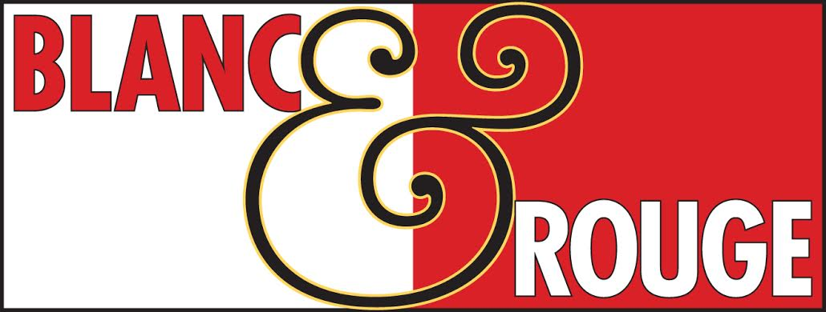
Wine Club Tasting Notes
August 3, 2018
Tier I
Red
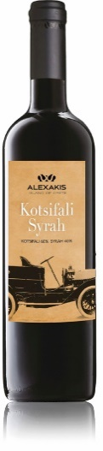
Alexakis Kotsifali Syrah $15
A one-of-a-kind blend of Syrah with the indigenous red variety of Crete, the mighty Kotsifali Intense dark red, with a complex bouquet, reminiscent of forest fruits and hints of green pepper. Well-structured with a velvety mouthfeel. Very well balanced acidity and a long finish. A perfect fit with roasted and grilled meats with spicy red sauces.

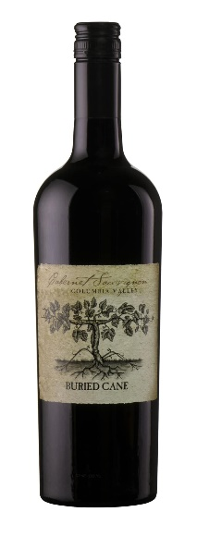

Buried Cane Cabernet Sauvignon $15
The king of red varietals, Cabernet Sauvignon, is also king of Washington State. Washington’s primary vineyard areas are at the same latitude as Bordeaux, France, the historic home of Cabernet Sauvignon. It shouldn’t really be any surprise that great Cabernet wine is made in both places. Washington State Cabernet Sauvignon makes deep, purple colored wines, with definitive dark-fruit and herbal varietal character. While they are appealing for that dark fruit in their youth, they have the structure to age remarkably in the bottle. Aromas of black cherry, red raspberry, and fresh-roasted coffee, with hints of spice. Soft, rich, and round in the mouth. Well-balanced with a lingering cherry and spice finish.

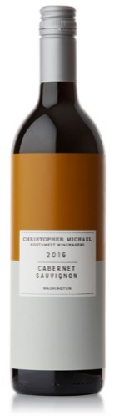
Christopher Michael Cabernet Sauvignon $14
This selection comes from across Washington, widely respected as a place that can compete with the big reds anywhere. This wine is bursting with blue and black fruits and framed by sweet vanilla and coco from the oak on which it was aged. It’s ready to drink now and shows layers of cherry, raspberry, tobacco and baking spice. 78% Cabernet Sauvignon, 10% Merlot, 9% Cabernet Franc, 3% Grenache.

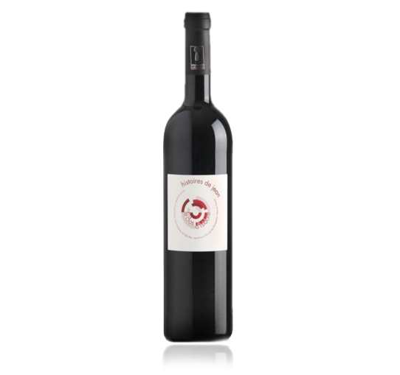
Histores de Jean $15
From France’s southern Languedoc region the vineyards are facing the sea, and they benefit from the sea sprays during summer which allow the grapes to ripen smoothly and fully. Since 2010 the wines have been classified as organic. A nice ruby red in color, the nose is very aromatic with aromas of blackcurrant and licorice. Fresh and well-balanced with red fruit flavors. Elegant and crisp. Pair with cheeses and charcuterie, spicy foods like curry. A bland of Sarah, Mourvedre and Carignan.

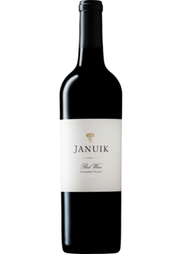
Januik Red Table $20
This wine is made from a short list of vineyards considered to be among the best in the state. The fruit for the Columbia Valley blend is sourced from Ciel du Cheval, Champoux, Lady Hawk, Shaw, Alder Ridge and Weinbau vineyards. The nose is filled with expressive black cherry, raspberry and mocha notes. On the palate, the wine is brimming with fresh berry and spice flavors. A concentrated and balanced mid-palate follows into a nice supple finish. 33% Cabernet Sauvignon, 32% Merlot, 7% Syrah, 5% Grenache, 19% Malbec, 4% Cabernet Franc.

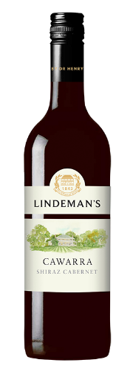
Lindemans Cawarra $10
A classic Australian blend (Syrah/Shiraz with Cabernet Sauvignon) with lots of flavor. Blackberry with hints of spicy oak. Aromas of blackcurrents with sweet vanilla. On the palate this wine displays dark berry fruit with a hint of mint. Medium bodied. Soft, approachable tannin structure. This is a seamless blend with soft, ripe tannins. The Lindeman’s Cawarra Range is a tribute to the vision of Dr Henry Lindeman, who in 1843, purchased a property in the Hunter Valley named 'Cawarra' (an Aboriginal word meaning 'beside running water') and planted his first vines. The Lindeman’s Cawarra wines are made with the idea of creating wines that offer fresh, easily enjoyable flavors at a price that offers incredible value for money.

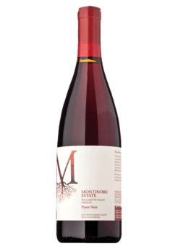
Montinore Pinot Noir $15
From Oregon’s Willamette Valley this is an aromatic wine with notes of resperry, cherry and cranberry. On the palate it is fresh and ripe with more cherry, raspberry, loganberry and baking spice with subtle notes of earth and mocha that unfolds in layers in the mouth. AAll sure markers of the distinctive Willamette Valley. Lingering finish with strawberry and spice. This is a carefully constructed blend of wines produced from different areas and soils within the Willamette Valley.

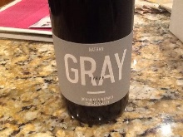
Nathan Gray Syrah $17
Single Vineyard fruit comes from the Den Hoed brothers’ famed vineyard at this price is unheard of. This 100% Syrah was crafted by Winemaker Morgan Lee. Rich purple in color. A nose that is full of freshness and purity. Lovely, great fruit. Polished texture and fantastic structure with balanced acidity and supple finishing tannins. A lovely wine that is terroir-expressive offering a Syrah with an accessible price tag.

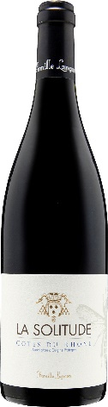
Solitude Cote d Rhone $15
Fresh, clean fruit with elegant tannins. This wine from France’s Rhone Valley is ideal as a dinner party companion. A real crowd pleaser. Pairs well with charcuterie, cheeses and classic meat stew. 60% Grenache, 30% Syrah, 10% Mourvedre.

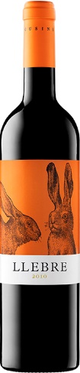
Tomas Cusine Llebre $15
Clean and vivid, LLEBRE (Catalan for hare) is a unique Spanish blend of Ull de Llebre (Tempranillo - Ull means “eye”), Merlot, Cabernet, Grenache, Syrah & Samsó (Carignan). The wine is bright with red fruit highlights, complimented with spice and vanilla tones from the six months spent in French oak . A versatile companion to an array of cuisines. Dark red cherry color with garnet edge. Clean vivid nose with red fruit compote tones, vanilla, white pepper, clove and oak. Well integrated. Velvety, fresh and elegant in the mouth with nice and gentle tannins and licorice. Red fruit and spiced tones on the finish.

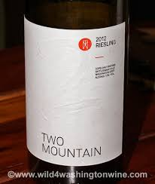
Two Mountain Lemberger $15
Inviting flavors of pepper, fig and boysenberry mesmerize your nose while your palate is entertained with pepper, white pepper and raspberry with the slightest hints of vanilla that frame this delightful wine. Lemberger is also known as Blauer Limberger and Blaufränkisch, a red Germanic grape that is used to add structure to blends. Delicious with lamb.

White
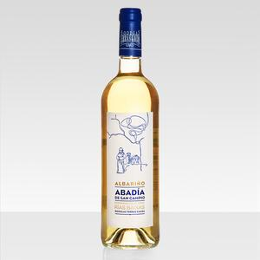
Abadia de San Campio Albarino $15
A white wine, this selection is 100% Albariño from Rias Baixas, Galicia, Spain. Made from grapes grown in the highest-altitude vineyards where it is less humid, cooler and with a greater difference daytime-nighttime temperature. This makes for slower ripening, giving a fresher Albariño of great aromatic intensity, a greater degree of acidity and smoothness on the palate. Tropical fruit aromas, mainly pineapple, along with delicate, fresh aromas of ripe white fruit such as Golden apple and pear, accompanied by subtle notes of lime over an anise background. These aromas are enhanced thanks to cold maceration. Abadia de San Campio wine is both fresh and powerful on the palate. Amiable and velvety. The acidity is restrained yet vibrant, along with an appreciable unctuous quality, providing a balanced, lively, appetizing wine. Ample tropical and white fruit aromas with a very long, powerful finish. Serve chilled on a hot summer day. Pairs well with shellfish, oysters, clams and crab. Enjoy with spicy Asian cuisine.

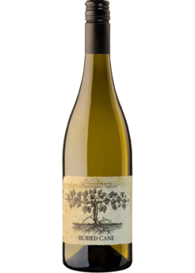
Buried Cane Chardonnay $15
From the Columbia Valley, this solidly made and easy to enjoy. Buried Cane is named for a time-honored Washington State grape-growing practice used to protect grape vines from frigid winter temperatures. Low-growing vine canes are buried under the soil for protection form the cold and are then unearthed after the threats of winter freeze are past. This selection is a bright, crisp, dry with gentle hints of cream and vanilla coming from just a touch of oak-aging. This dry white wine has wonderful ripe aromas loaded with apple and pear, vanilla custard, créme brulee and buttered toast. Floral notes compliment. Viscous and honeyed in the mouth, much of the aromatic character comes through on the palate with pear, apple and papaya followed by a creamy texture. offering layers of green apple and aromatic citrus, light spice and hazelnut, and a subtly creamy note. Medium-bodied, clean, with a refreshing finish. Ready to drink now.

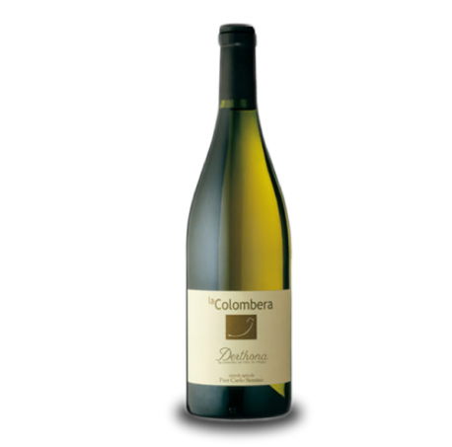
La Colombera Bricco $15
Timorasso is one of Italy’s most interesting white wine grape varieties, one of the few noble varieties that age well (the variety reminds me of Chenin Blanc, one of my favorite age-worthy white varieties); Elisa Semino of La Colombera is a brilliant and enthusiastic proponent of the variety, and of this region, the Colli Tortonesi; and her and her brother and father grow and vinify one of the best examples of it, as well as some other very good wines. Timorasso is crisp, high acid and very minerally. It may remind you of a very dry Riesling, with less sweet fruit when it is about five years of age or more. Before that, it has aromas and flavors of white flowers, unripe stone fruit, and bright citrus.
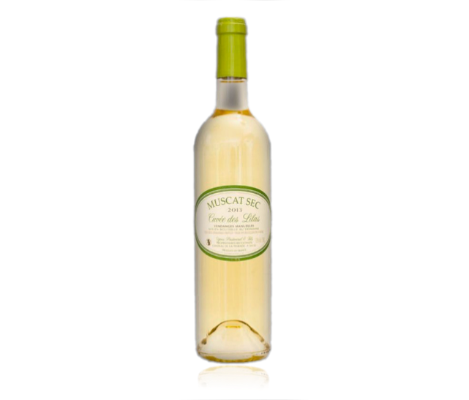
Les Lilas Muscat $15
This is a fresh and dry Muscat. Clear, pale in color with green highlights. Lively in the mouth with aromas of lime and verbena. Nice finish. Perfect as a aperitif or with fish, seafood, spicy food, goat cheese or fruit salad. The wine comes from east of Paris.

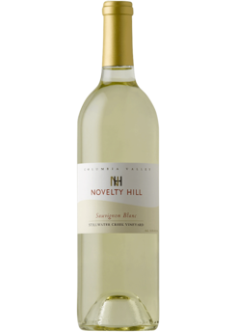
Novelty Hill Sauvignon Blanc $15

A fresh, vibrant wine with expressive juicy pear, ripe melon and bright citrus aromas and flavors that linger across a long, flavorful finish. Vibrant, fresh. Whiffs of tropical fruit and cut grass, herbs and lime zest. Tart and zingy with mouthwatering citrus flavors and a light, creamy feel on the finish.
90 points Wine Enthusiast

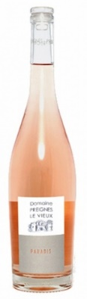
Paradis Rose $15
A perfect blend of Grenache and Syrah gives this wine a smooth texture and the right amount of acidity. Flavors of red currant and Bartlett pear giving a fruity flavor.
90 points Wine Enthusiast

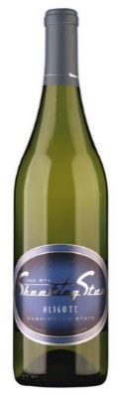
Shooting Star Aligote $15
Aligoté is a variety, which is little known but widely planted. It is popular in Eastern Europe with plantings in the Ukraine and Moldavia. In France, it is the other white grape in Burgundy, but has always played second fiddle to the noble chardonnay grape. Generally, aligoté is planted in either hilltop or cooler valley locations because it is more cold-tolerant. It has never been planted in any commercial quantity in California, but in Washington State, where cool winters are a fact of life, aligoté has found a happy home. The Newhouse family has farmed the land south of Sunnyside Washington for generations. They were some of the first wine grape growers and were always experimenting with growing different varieties including two acres of aligoté, planted in the 1970's.These grapes were made into varietal wine by one Washington winery for many years, for a time even outselling its chardonnay. When the boom for chardonnay took hold in the late 1980's, the sales of aligoté declined and eventually the grapes were blended into the chardonnay. Given his penchant for working with lesser-known varietals, when Jed had the opportunity to contract for the fruit he jumped at the chance. Aromas of corn on the cob and spice lead to lightly sweet-seeming and ripe quality. Medium-bodied fruit flavors that bring a sense of balance. This is the other part of the classic French cocktail kir, vin blanc cassis made by adding cassis to Aligoté.

Tier II
Red
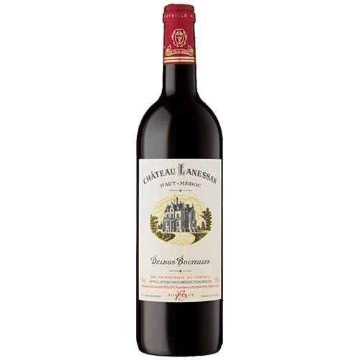
Lanessan Haut-Medoc $26
This classic left bank Bordeaux is made from a blend of 50% Cabernet Sauvignon, 35% Merlot, 10% Petit Verdot and 5% Cabernet Franc. Considered a medium/full-bodied wine, it is full of luscious fruits with silky tannins, juicy cassis, plums and tobacco. The wine has richness, length and sweet fruits. Chateau Lanessan needs some time before it can be enjoyed. Young vintages can be decanted for an average of 90 minutes to 2 hours. This allows the wine to soften and open its perfume. Older vintages might need very little decanting, just enough to remove the sediment. Chateau Lanessan is usually better with at least 7-8 years of bottle age. Of course, that can vary slightly depending on the vintage character. Chateau Lanessan offers its best drinking between 7-20 years of age after the vintage. The wine of Chateau Lanessan is best served with all types of classic meat dishes, veal, pork, beef, lamb, duck, game, roast chicken, roasted, braised and grilled dishes.

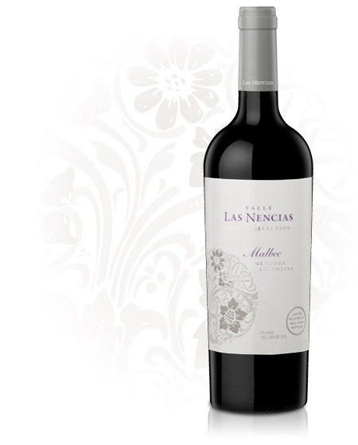
Las Nencias Malbec Family Selection $25
Deep purple in color and a high intensity of blackberries, blueberries, plums and milk chocolate. Unique to the La Consulta terroir is the aroma and color of violets. This wine is a family affair, five generations in the making. Angel Morchio, the winery’s current patriarch, visited Blanc & Rouge last year to introduce us to his selections and tell us the history and show us photos of the winery and vineyards. The estate vineyard is in a valley 3,000 meters above sea level in Mendoza, with a back-drop view of the Marmolejo glacier in the Andes. This valley is accessible only by foot or horseback. A few times a year the family gathers in this place to enjoy the wild growth of nencias, a variety of plant that produces a stunning bluish-purple flower.

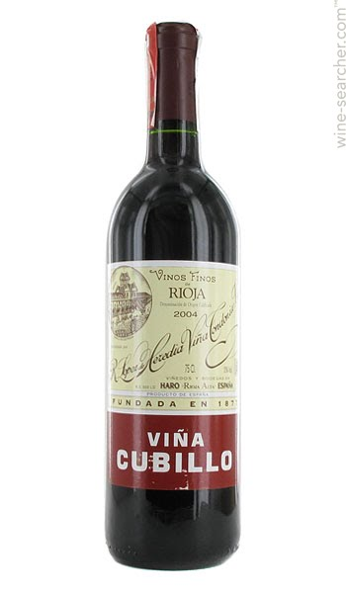
Lopez Heredia Vina Cubillo $25
For 141 years, four generations of the López de Heredia family have devoted themselves to producing exceptional and unique wines. Masterpieces which have achieved what the founder of the company, Rafael López de Heredia y Landeta, defined in the late nineteenth century as the "Supreme Rioja". Viña Cubillo wines come from the vineyard called Viña Cubillas, some 4 km away from the bodega (winery), which as with all of the other vineyards, was bought by Sr. López. Historically these wines were called "Special Harvest". Vina Cubillas has an altitude of 410 m, and the vines have an average age of 50 years. This wine is clear, bright and ruby color. On the note you will detect a slight aroma of licorice. It is fresh and persistent on the palate. 65% Tempranillo, 25% Garnacha/Grenache, 10% Mazuelo and Graciano. Pair with meat dishes, tapas, or charcuterie. This is so easy to drink it can be dangerous. Elegant and powerful.
92 points Robert Parker

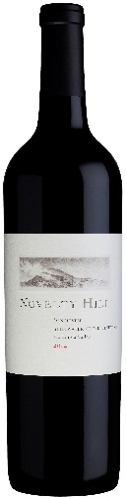
Novelty Hill Sangiovese $25
A bright, ruby-red wine with inviting ripe cherry, fresh strawberry and spicy currant aromas and flavors. Medium-bodied, with polished tannins and a lively finish that lasts. Fruit for this Italian-inspired selection comes from Novelty Hill’s family-owned estate vineyard, Stillwater Creek. It’s home is a steep, south-facing site on the Royal Slope of the Frenchman Hills in Washington State’s Columbia Valley. The vineyard is developing a growing reputation for high quality wines through innovative clonal selection, such as Sangiovese clones 19 and 23, two Tuscan favorites yielding superior results. 94% Sangiovese, 6% Cabernet Sauvignon

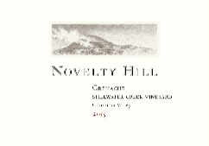
Novelty Hill Grenache $25
Fresh and expressive, this delicious medium-bodied wine offers sun-ripened raspberry, wild strawberry and sweet cherry aromas and flavors on a polished frame laced with silky, refined tannins that echo on a long, satisfying finish. Fruit for this selection come from Novelty Hill’s family-owned estate vineyard, Stillwater Creek. This site is a steep, south-facing site on the Royal Slope of the Frenchman Hills in Washington State’s Columbia Valley. With the goal of growing world-class wine grapes through clonal selection and careful vineyard management, the site is known for its top-quality grapes. Washington wine critic Paul Gregutt named Stillwater Creek one of the Top 20 vineyards in the state.

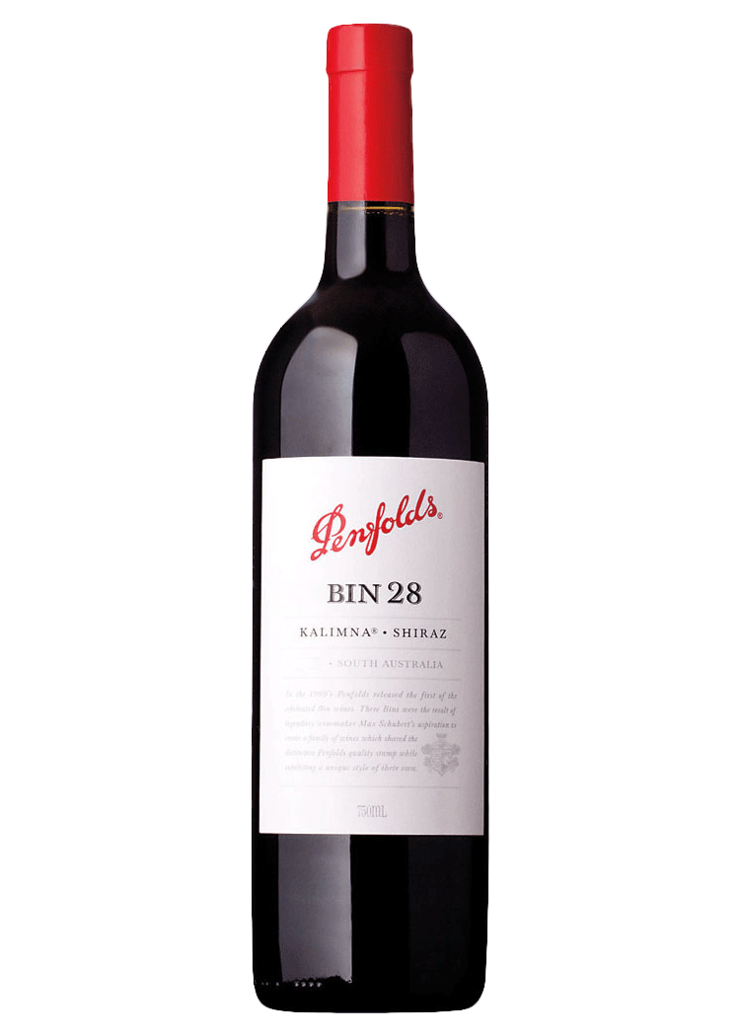
Penfolds Shiraz Kalimna Bin 28 $30
From Australia’s famed Penfolds, this Shiraz/Syrah has scents of crushed black currants and blueberries with subtle notes of licorice, tar, roses and tapenade. Medium to full-bodied, opulent and densely packed with black fruits and savory layers featuring succulent dark black-cherry fruit flavors. It has a solid frame of rounded tannins and wonderful freshness, finishing long. Vibrant, fresh and lively. Long, elongated tannins – sleek, slick and slender! Neither alcohol nor oak intrude. Unobtrusive acidity will ensure cellarability.
93 points Wine Advocate

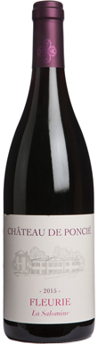
Poncié Fleurie $25
A serious Cru Beaujolais has arrived! Deep, brooding blackberry and bramble fruit on the nose mirrors the palate with the added delight of dusty granite and graphite lift. Full-bodied, smooth and velvety with a lovely purity of fruit and a long, mineral and liquorice driven finish. Very polished. This Gamay is stepping up to the plate with all the depth and complexity of Gamay.This Enjoy through 2021.
90 points Decanter Tasting Panel

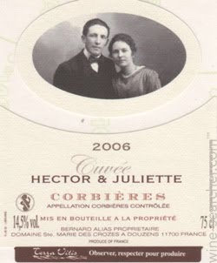
St Marie des Crozes Corbieres $20
Hector and Juliette are the winemaker’s great grandparents, and founders of the estate. This is a replica of the first cuvée created on the estate. It looks like the wine he loves. It has character and it is not forgotten when the glass is empty. The label picture was taken on the day of their wedding, a day to remember. Beautiful cherry color, very sustained with purple hues. The nose is very intense and complex with notes of jammy fruit, which are mixed with flavors of cocoa. In the palate the wine is powerful and warm, with lots of fat and volume at the same time. The tannins are very present. As soon as the attack there is an overwhelming fineness suggesting a very good evolution of bottle aging. Organic.
90% Syrah, 10% Grenache

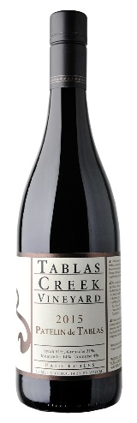
Tablas Creek Patelin $25
Syrah-driven (51%). This selection has a savory and dark side. Blackberries, crushed rock, menthol and saddle leather on the nose, it also exudes a little sweet lift like honey graham crackers. The mouth shows black cherry, loam and pepper spice, with chalky tannins and flavors of cranberry and freshly turned earth that come out on the finish. Delicious now, but with the substance and balance to age for up to a decade. 31% Grenache, 14% Mourvedre, 4% Counoise.
91 points Vinous
91 points Wine Enthusiast
90 points Wine Enthusiast

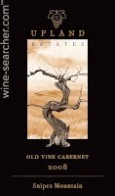
Upland Old Vine Cabernet Sauvignon $30
Planted in 1973 on the south slopes of Snipes Mountain by Alfred Newhouse, it was the first ed variety he planted after adding wine grapes to his farming portfolio. This block is one of the oldest plantings of Cabernet in the State of Washington. It showcases berry fruits, herbal spice and chocolate caramel. Its refined tannins are backed by well-integrated oak flavors that build around its depth, concentration and full-bodied finish. Aged in new 75% American oak for 23 months. This is the last you will see of this selection. Upland has exited the winery business, instead refocusing on it’s vineyards and growing grapes for other wineries.
White
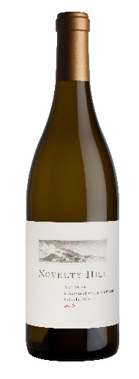
Novelty Hill Viognier $24
Faint white flower, orange peel, spice and citrus aromas are followed by broad fruit flavors in this wine. Bright and fresh, with perfumed floral aromas and juicy Bartlett pear, white peach and shaved lime woven across the palate. A lively wine with great richness and just the right amount of acidity to frame a long, clean finish.

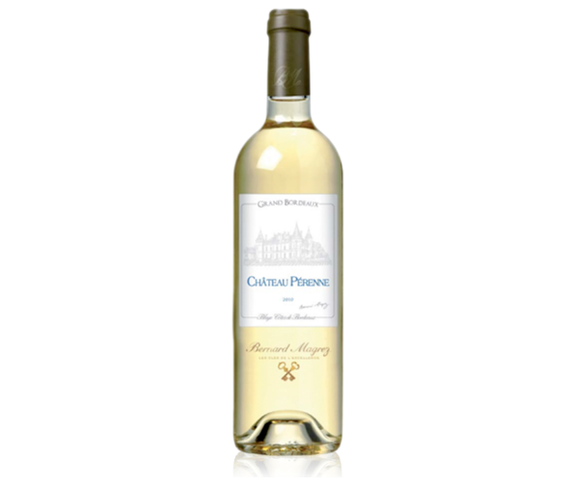
Perenne Blanc Blaye-Cotes Bordeaux $26
This fruity and fresh wine is simple, modern and well made. From France’s Bordeaux region. Pale color, intense nose with smoked notes. In the mouth it is dense with attractive substance. Elegant and well-balanced. Pair with grilled oily fish, mussels, clams, white meats and soft rind cheeses. Sauvignon Blanc, Sémillon Gris, Sémillon.

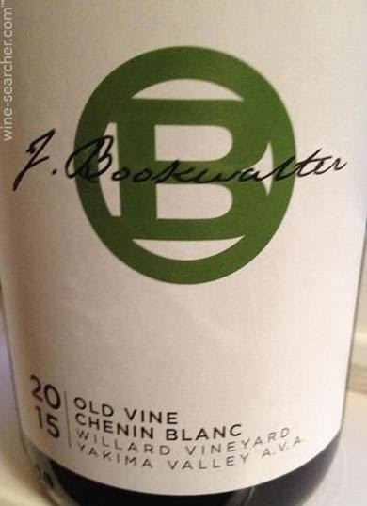
Bookwalter Chenin Blanc $23
Fermented and aged in concrete eggs, for rounder flavors and bigger texture, this wine brings unusual aromas of grape skins and grape nuts that lead to dry and leesy fruit flavors. A unique interpretation of the variety. From Yakima Valley. This wine stands out with amazing richness. Vibrant and fresh, layering fruit, floral and mineral tones in perfect harmony. Succulent pear and apple, lemon, chamomile, beeswax and wet stones punctuate this selection. Good weight and acidity. Clean finish with a refreshing quality. This wine is from old vines. John Bookwalter was looking for an alternative for Chardonnay that was not Semillon/Sauvignon Blanc. John went back to his dad’s farm to Yakima’s Willard Vineyard and the vines, planted in 1980, were still there.
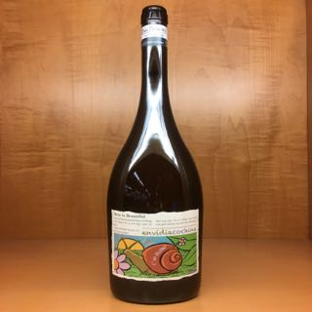
Envidia Cochina Albariño $22
Lemon yellow color with greenish, thick and satiny tones. It presents a wide range of long intensity aromas which highlights salinity, white fruit and yellow bone, a touch of marine, memories of white flowers, citrus freshness. On the palate it is very elegant, with feelings of fruit in syrup and balsamic from aging on lees. Salty flavor with a bouquet of lime, sweet grapefruit, a touch of ocean breeze, lemongrass and orange peel. Hints of aniseed, fennel, with excellent acidity. Fresh, tasty, persistent. A long finish with mineral tones and some excellent bitterness.

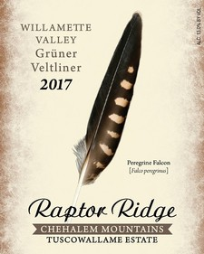
Raptor Ridge Grϋner Veltliner $18
This Austria, Slovakia, Czech transplant is finding success in Oregon. Aromas of Asian pear, exotic starfruit, melon and white musk waft from the glass on a wave of floral talc. Bright, green apple, lime zest plus almonds, then finishing on a peppery note. The classic Gruner flavor profile. The palate is tense and energetic thanks to integrated acidity that lifts and lengthens the memorable finish. Superb with any spicy Thai dish, oysters or delicate fish.

Sparkling
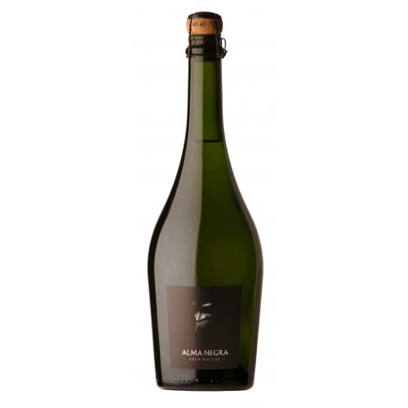
Alma Negra Brut $20
The sparkling rose Alma Negra Brut Nature is made from Malbec and Pinot Noir. Great surprise of a wine. The effervescence is a produce of the methode champenoise, and the wine, from a relatively cool climate, displays crisp, elegant acids intermixed with strawberry, cranberry and fruit cocktail-like notes. Medium-bodied and simply delicious.
90 points Robert Parker

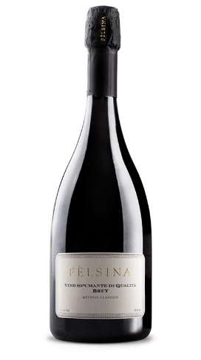
Felsina Spumante $26
The wine appears with a luminous straw and tending towards a green, and releases a long lingering with a bead of very fine bubbles. The bouquet is crisp and delicate, with floral and fruit notes, along with impressions. The palate is dry, full-flavored, and very well balanced. A fresh acidity drives the lengthy finish hinting of aromatic tropical fruit.

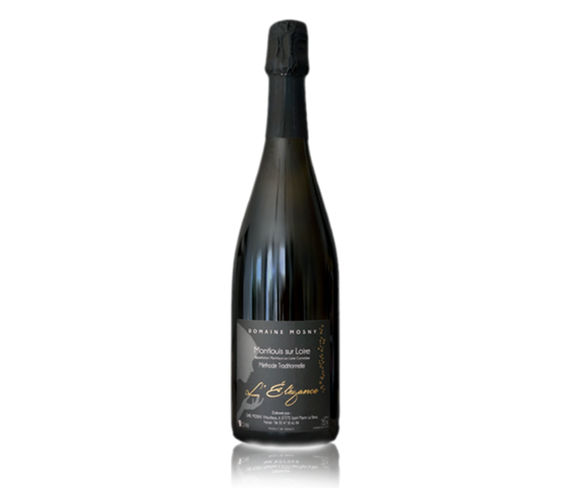
L’Élégance Montlouis sur Loire $28
This cuvee has very fine bubbles and fine aromas thanks to a very light dosage. It is intense and lively with a nice freshness. Serve as an aperitif and with desserts of all kinds. 100% Chenin Blanc

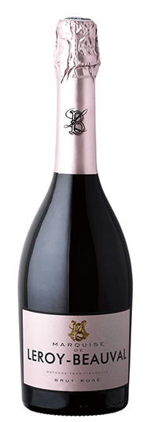
Leroy-Beauval Rose $21
Rose in color, deep and crystal clear. This wine is blessed with an expressive and gourmand bouquet. Its notes of strawberry and red currant combine, on the palate, to compose an extraordinary complexity together with floral notes and a bonbon sweetness. The explosive aromas on the palate, the delicate bubbles and a beautiful balance between ripeness of fruit and acidity weave into a tapestry of sensual experience.

Tier IV
Red
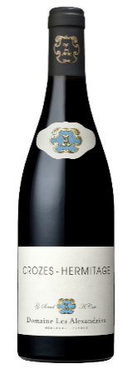
Alexandrins Crozes-Hermitage $37
This Syrah is from France’s Rhone Valley. In the glass note the beautiful garnet red color. Enjoy the scents wafting from your glass and recall red fruits, floral and baking spices. Very balanced. Silky tannins. Made to enjoy now, but you can cellar it for a few years for more animal and roasted notes on the nose.

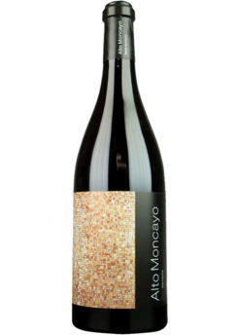
Alto Moncayo Campo de Borja $40
This Spanish selection is a showcase of what Grenache is all about. Lovely aromas of
raspberry and cherry. This robust red shows tremendous concentration on the palate with a nice lengthy finish. Another great Jorge Ordonez selection.

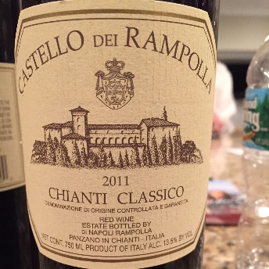
Castello Rampolla Chianti Classico $36
A genuine expression of Sangiovese with all the tang and spice the grape can present. Bright ruby color. The bouquet is intense with rich charry and red berry aromas and leafy undertones. On the palate it is silky, balanced with medium body. Hints of chestnuts. Subtle nuances of moist earth. Refined tannins with a long flavorful finish of blackberry, leather and chocolate. Pair with red grilled meat like Bistecca Florentina. 91 points James Suckling
90 points Robert Parker’s Wine Advocate
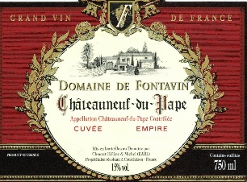
Fontavin Chateauneuf-du-Pape $40
Domaine de Fontavin Chateauneuf du Pape is produced from a blend of 85% Grenache and 15% Syrah. The vines are on average 40 years of age. The wine is aged for up to 18 months in a combination used, French oak barrels and demi-muids. The production is 2,500 cases per vintage.
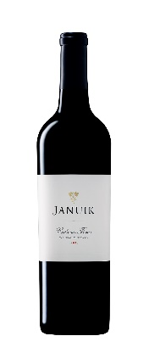
Januik Cabernet Franc $35
93% Cabernet Franc; 7% Cabernet Sauvignon from the Weinbau Vineyard near Mattawa on the Wahluke Slope. The vineyard is one of the oldest in the area and is known for its particularly fine silty loam soils. This talcum powder-like soil provides good drainage and heat retention. Thanks in part to its location at the eastern portion of the Wahluke Slope, the vineyard experiences more moderate temperatures that help create longer hangtime and ideal ripening conditions. This dark, rich Cabernet Franc is packed with elegant plum, blueberry, and licorice on the nose. Vibrant and focused on the palate, the wine displays a clear sense of balance. The long, polished finish was developed in part from aging in new French oak barrels

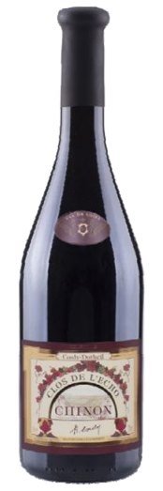
L’Echo Chinon $34
Since 1921 Couly-Dutheil has been known for the quality of its wines served at the most prestigious tables in France. Chinon is located in the Loire Valley in Touraine, producing Cabernet Franc. Today, Couly-Dutheil remains a family house owned by the 3rd and 4th generation. This selection is nice and dark, intense and shiny with purple and ruby. It is intensely flavored and complex bouquet showcases ripe grapes and spicy notes. Voluptuous and generous in the mouth. Concentrated with elegant tannins.This Chinon will accompany a poultry casserole, lamb, a fricassee of mushrooms, beef chuck steak or a rack of lamb.

Upland Old Vine Cabernet Sauvignon $30
Planted in 1973 on the south slopes of Snipes Mountain by Alfred Newhouse, it was the first ed variety he planted after adding wine grapes to his farming portfolio. This block is one of the oldest plantings of Cabernet in the State of Washington. It showcases berry fruits, herbal spice and chocolate caramel. Its refined tannins are backed by well-integrated oak flavors that build around its depth, concentration and full-bodied finish. Aged in new 75% American oak for 23 months. This is the last you will see of this selection. Upland has exited the winery business, instead refocusing on it’s vineyards and growing grapes for other wineries.

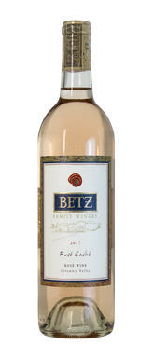
White
Betz Rose $24
For centuries Grenache has been the foundation of so many satisfying rosés globally. This ancient variety found welcoming soils across the Western Mediterranean, from the Southern Rhone, Spain, Sardinia and then on to New World vineyards. Loving sunshine, hot summer days and parched land, easily blended with other lower tannin red varieties, Grenache’s rosé offerings please a range of preferences. America’s love affair with well-made rosé is now in full bloom and Washington Grenache is an eager suitor. Pale, pure, penetrating, these wines deliver just enough fruit and structure to be a favorite go-to summer choice. The hot summers we experience in the Columbia Valley yield exciting Grenache, dating back to the 1950s (those earliest Grenache wines were all rosés). Long time Betz Family fans know that my earliest rosés were anything but pale (this is Bob writing!). I always darkened them up with Syrah, adding weight, structure and color, making them more “chillable reds”. But now in the hands of Louis Skinner, Betz Family’s winemaker, this is the real McCoy, a graceful wine that’s still compelling enough for mealtime. Louis has long championed the spirit of rosés made in the Southern Rhone, bone dry yet with attractive fruit sweetness, refreshing but with ample concentration. The 2017 Rosé Caché reflects his dedication to the style: Grenache-dominant (65%), with the balance made from other southern Rhone varieties in our stable, Counoise and Mourvedre. Fresh raspberry/strawberry fruit leads the aromatics, with touches of dried brush, cream, earth and lemon curd. The palate is racy yet ample, with abundant berry flavor, and crystalline freshness.

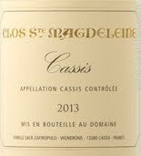
Clos Sainte Magdeleine Cassis Blanc $34
From Provence (France). Some connoisseurs appreciate this white wine because it is well balanced. It's aniseed-flavored freshness and salted touches, offers a vigorous and material taste over flavors that become honeyed.
This straw-colored wine evolves softly to tastes of acacia and peach syrup.
Delicately balanced when in mouth, this wine is at home on your table from day to-day. This organic white will perfectly pair with fish, seafood, bouillabaisse and goat's cheese. And you'll be surprised how it gets along with spicy food and sushi.

Envidia Cochina Albariño $22
Lemon yellow color with greenish, thick and satiny tones. It presents a wide range of long intensity aromas which highlights salinity, white fruit and yellow bone, a touch of marine, memories of white flowers, citrus freshness. On the palate it is very elegant, with feelings of fruit in syrup and balsamic from aging on lees. Salty flavor with a bouquet of lime, sweet grapefruit, a touch of ocean breeze, lemongrass and orange peel. Hints of aniseed, fennel, with excellent acidity. Fresh, tasty, persistent. A long finish with mineral tones and some excellent bitterness.

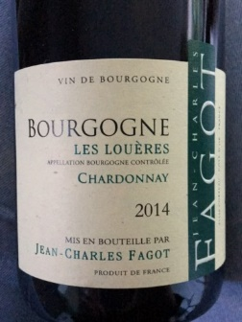
Fagot Bourgogne Chardonnay $27
The Fagot family has been located in the small village of Corpeau since 1860. Just outside Chassagne-Montrachet in Burgundy France. It is located near some of the most prestigious vineyards in the Cote de Beaune, so it would be fair to say that wine is in the family’s blood. Jean-Charles is part of the 5th generation of Fagots in the area and the third generation to own vineyard acreage in Chassagne-Montrachet. On his estate vineyards, Jean-Charles employs lutte raisonée, a method of growing in which chemical intervention is employed only when necessary. The wines are vinified traditionally and naturally. The nose on this selection shows hints of white flesh fruits, including peach and pear. A refreshing and smooth Chardonnay. Balanced acidity and full mouthfeel. Only 3,000 bottles produced

Perenne Blanc Blaye-Cotes Bordeaux $26
This fruity and fresh wine is simple, modern and well made. From France’s Bordeaux region. Pale color, intense nose with smoked notes. In the mouth it is dense with attractive substance. Elegant and well-balanced. Pair with grilled oily fish, mussels, clams, white meats and soft rind cheeses. Sauvignon Blanc, Sémillon Gris, Sémillon.

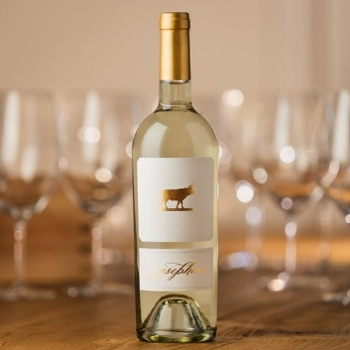
Turnbull Sauvignon Blanc $23
From Oakville in Napa Valley this selection has aromatics of grapefruit, guava and melon. It exhibits lively citrus notes with zest of Meyer Lemon with bright, focused fruit flavors balanced with minerality. Crisp and lively, with medium body and focused finish.

