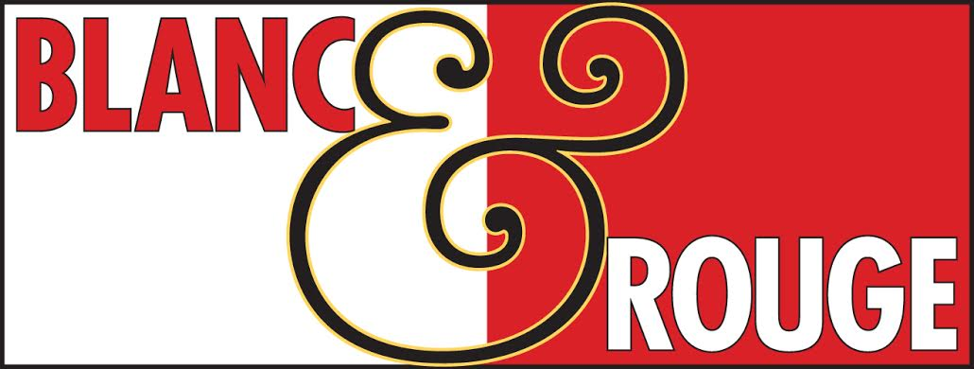
Nov. 2, 2018
WINE CLUB
TASTING NOTES
visiting winemakers Kelly & Tim Hightower of Hightower Cellars, Red Mountain.
"About 210 miles from Seattle is the Red Mountain area...Don't leave the region without sipping the hard-to-find wines of Hightower Cellars..."
-Alice Feiring, Time Magazine
"Tim and Kelly Hightower make small amounts of high-quality, handcrafted Cabernet Sauvignon. They focus on grapes from such fine vineyards as Boushey, Artz, Pepper Bridge, and Alder Ridge as they produce the wines from vine to the bottle. Best Bets: Cabernet Sauvignon. Hightower's first wine is a Cab with small amounts of Merlot blended in. The result is a red wine of distinction with wonderful depth, power and grace."
-Andy Perdue, Northwest Wine Guide, A Buyer's Handbook
"Service only a smaller winery can provide ... A perfect example is Hightower Cellars, located in Eastern Washington's Red Mountain growing region. Tim and Kelly Hightower literally run the entire winemaking process from start to finish. They're also wonderful hosts and you'll be hard pressed to find a nicer pair of people in the wine business."
-Dan Radil, Bellingham Herald

TIER I
Red
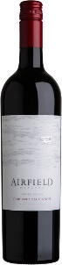
Airfield Cabernet Sauvignon $17
From Yakima Valley, this classically styled Cabernet Sauvignon showcases pronounced aromas of cherry and blackcurrant with undertones of toasted oak. A smooth, well-balanced palate framed with lingering tannins on the finish. 100% estate grown. Pairs perfectly with grilled steak, beef short ribs or a good white cheddar or Roquefort. Gold award, Seattle Wine Awards
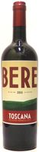
Bere Viticcio Red Blend $17
This Super Tuscan from Italy is a blend of 50% Sangiovese, 25% Cabernet Sauvignon and 25% Merlot. It bursts onto the palate with generous, vinous red fruit. The wine reveals lovely density and inner perfume in a soft, accessible style that is sure to find many admirers. It is a great choice for casual drinking over the next few years. A real crowd pleaser.

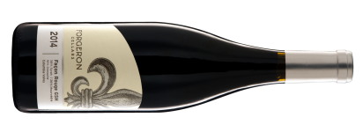
Forgeron Red Blend $17
Façon Rouge is a Grenache-based blend with Syrah and Mouvedre. Made with Columbia Valley fruit in the Southern Rhône River Valley tradition. This offering was procured at an exceptional price that Blanc & Rouge has passed along to only our Wine Club Members. Regular price is $37.
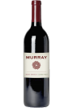
Hightower Murray Red Blend $19
Soft and polished, with a strong mint and rosemary character weaving through the cherry and spice flavors, lingering easily. Drink now through 2020. 89 points Wine Spectator.
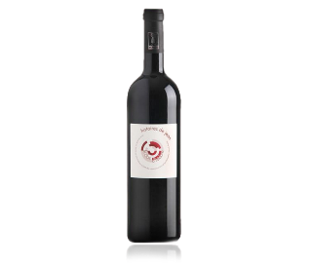
Histoires de Jean $16
From France’s Languedoc region this wine is a bland of Syrah, Mourvedre and Carignan. Facing the sea, the vineyards benefit from sea sprays during summer which allow the grapes to ripen smoothly and fully. Since 2010, the wines are classified as organic. This wine presents a nice ruby red in color. The nose is very aromatic with aromas of blackcurrant and licorice. In the mouth, it is fresh and well-balanced with red fruit flavors. This is a crisp red. Pair with a charcuterie platter, spicy dishes including curry.

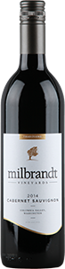
Milbrandt Cabernet Sauvignon $20
Blackberries, plums and savory dried herbs greet the nose. On the palate this is a dense, broad wine full of chewy tannin that evolve into a luscious symphony of dark fruit. It has a touch of vanilla and toast. Pioneer of the Columbia Valley wine region, Butch Milbrandt saw potential in Eastern Washington. In 1997, this fourth-generation farmer took a risk in planting grapes and soon became recognized for helping establish two of the top AVAs in Washington State: Ancient Lakes and Wahluke Slope.

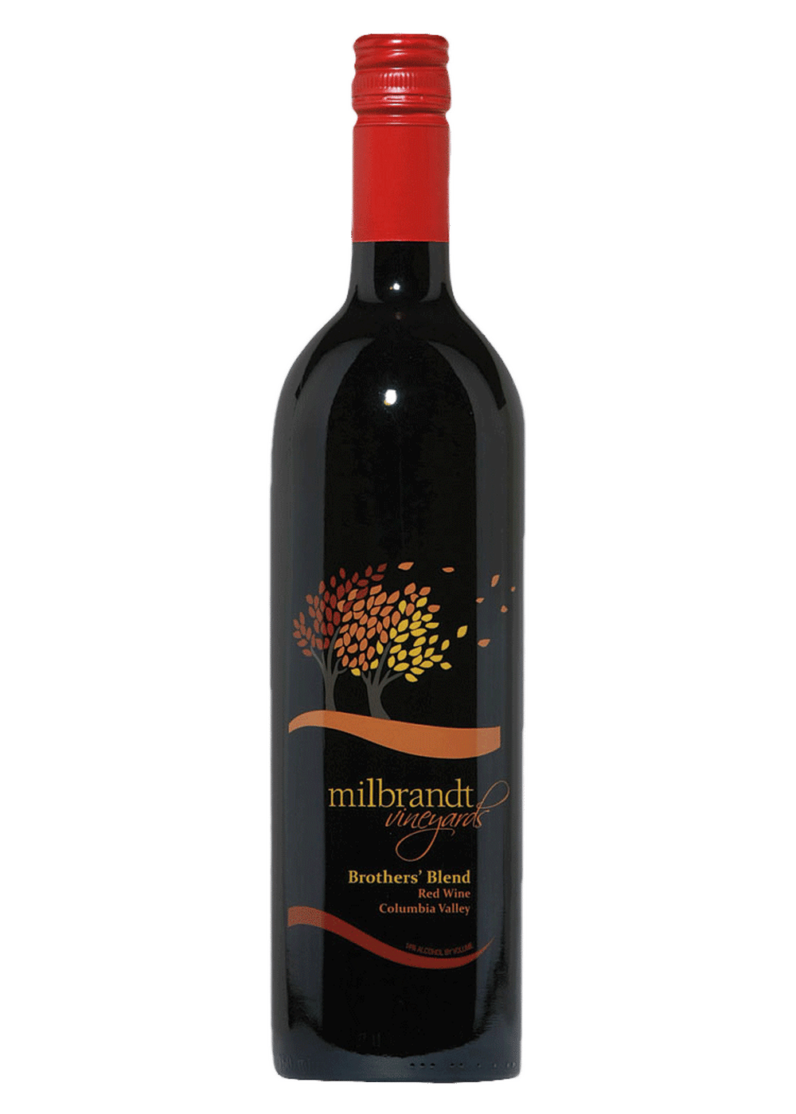
Milbrandt Brothers Blend $17
From Washington’s Columbia Valley this wine shows mocha, vanilla and black cherries on the nose. The fist sip parachutes you into a spectrum of rich, dark fruit followed by a pleasing long finish. 87 points Wine Enthusiast

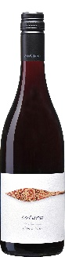
Totara Pinot Noir $17
From New Zealand’s Marlborough region this wine presents vivid ruby red color in the glass. Bright and lively on the nose showing cherry, cranberry and savory spice aromas. The palate is silky, with a mixture of berry fruits up front along with underlying notes of sweet herbs, spice and earth. A pure finish, with excellent length, nicely frames each component. An overall profile that combines the best of Burgundy and Willamette Valley. Drink now and over the next 5 years, paired with salmon, chicken, game birds, and anything with truffles.

Tried and True TATT $15
From Washington’s Columbia Valley this non-vintage red blend incorporates Syrah, Cabernet Sauvignon and Merlot into a selection with tons of personality. Medium bodied. Full of dark berry and black plum. This wine offers fresh and dried black fruit accented by cocoa and vanilla. It's plush in feel with red and black fruit flavors that bring plenty of appeal. Every vintage year the blend shifts and every year a different tattoo artist creates the label.

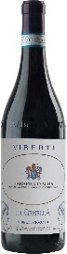
Viberti Barbera $15
From the Alba area of Italy’s Piedmont region. “La Gemella” (twin in Italian) was created to honor the winemaker’s mother, Maria, who is a twin herself and a lover of Barbera. Expressive floral tones of wild rose, fresh berries and crushed mineral. Full-bodied layers of blueberry, licorice, and earth are perfectly balanced. A vibrancy of acid, silky tannins, and lengthy finish contribute to the outstanding quality. Aged for 1 year in bottle. Will offer ideal drinking over the next 2-3 years.

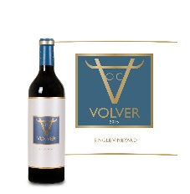
Volver Tempranillo $16
From the La Mancha region of Spain this wine is dense and has flavors of red currant, licorice, espresso and minerals. Well-integrated tannins and fresh acidity. Lovely fruit balanced by an appealing savory edge. 100% Tempranillo. 90 points Wine Spectator

White
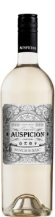
Auspicion Sauvignon Blanc $12
There is a lot going on with this one. Bright and lively with citrus and tropical fruit flavors and a hint of banana. Crisp and refreshing with green apple and gooseberry, it exudes the true spirit of California Sauvignon Blanc. Enjoy on its own or with salads, shellfish and chicken dishes.

Cedargreen Chenin Blanc $18
Floating on air and water, our dry Chenin Blanc balances minerality with aromas of D'Anjou pear and Jamaican ginger. Piercingly fresh yet succulent, this wine pairs well with Dungeness Crab and grilled fish. Hand harvested, hand sorted, stored and stirred on the lees to promote mouth feel and creaminess.

Grassie Sauvignon Blanc/Semillon $18
Aromas of citrus fruits leading to this crisp and refreshing wine. Medium body. Flavors of green apple and lemon.

Grassie Rosé $15
Woodinville winemaker Bill Grassie crafted this dry rosé with Cabernet Sauvignon (60%) and Merlot (40%) from such vineyards as Ambassador, Boushey, Stillwater Creek, Quintessence, Upland and Weinbau. The nose is rather fascinating and very fruit-forward with whiffs of red cherry, strawberry, blood orange and apricot. There’s a similar theme to the palate that opens with a touch of creaminess before readily giving way to flavors of Red Haven peach and blood orange, backed by pomegranate acidity and peach skin with a hint of cherry cordial in the finish. His wines are available his tasting rooms in Woodinville and Fall City. 200 cases made.
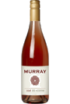
Hightower Rosé $17
This is summer sunshine in a bottle with a beautiful coral color and aromas of red currant and strawberry mingled with that signature flinty Red Mountain mineral component to the nose. The smooth, long finish garners plushness from short-term aging in neutral oak barrels.
As much as possible, we take a non-interventionist approach to winemaking. We place great emphasis on vineyard selection, picking, pressing, and blending so that Hightower wines are naturally beautiful and free from pretense. We let the powerful and concentrated fruit from Red Mountain speak for itself. The result is a collection of well-balanced, nuanced wines that reveal something new and interesting each time you open a bottle. We like to think they’re wines with character through and through — in how they were made, how they taste, and in the connections they inspire. – Kelly & Tim Hightower

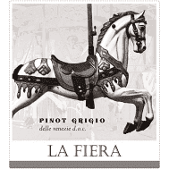
La Fiera Pinot Grigio $12
From the Veneto area of Italy, this wine has a straw color and a fruity bouquet. The palate is dry, soft, and well balanced. It is a fresh and crisp wine, both floral and fruity; it expresses ripe peach and apple flavors with a subtle mineral finish.
Excellent with all types of grilled fish dishes and courses based on mushrooms. It is also a perfect match with pasta in cream or olive oil, perhaps with shrimp, though pairs well with a wide range of foods from salads to poultry to lighter, soft cheeses.
The origins of the carousel featured on the label originate from medieval riding fairs in the north of Italy. These elaborate equestrian ballets took place in royal courts and featured lavishly decorated horses and highly skilled riders performing synchronized formations. Popularity led builders to replicate them by designing rotating platforms with mounted wooden horses for children to ride. The carousel has been the centerpiece of La Fiera, The Fair, for centuries.
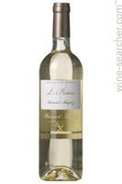
Le Bordeaux de Bernard Magrez $15
A blend of three classic white-wine grapes of Bordeaux: Semillon, Sauvignon Blanc & Muscadelle. Trademark grassy aromas with citrus and hay, a touch of complexity with a waxy, honeyed note and grapey aromas. This is not sweet, like its cousin Sauternes.

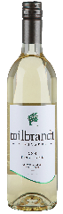
Milbrandt Pinot Gris $15
This Washington selection starts with a big whiff of cantaloupe followed by a lingering waft of wet grass and lemon zest. Bright & focused acidity refreshes the tongue. The finish is full of glazed tropical fruit.

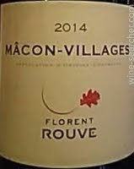
Rouve Maçon Village $18
A terroir-driven Burgundy from Florent Rouve. This soft, siply fruity Chardonnay is ready to drink. Attractive acidity as well as crisp apple fruitiness. Bright with citrus and zest. 86 points Wine Enthusiast.

Sparkling
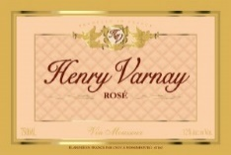
Henry Varnay Rosé $15
Intense, bright pink hue with red fruit aromas and flavors highlighting red currant. Fresh and fruity, lively on the palate, with a delicate mousse and appealing finish. A delicious Loire Valley sparkling rose made in the Champagne method. The blend is Gamay, Cabernet Franc and Pineau d’Aunis grapes.
Tier II
Red
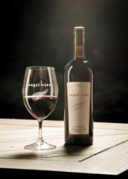
Angel Vine Stonetree Zinfandel $23
A Columbia Valley classic. Vibrant aromas of cranberry, raspberry and red currant are followed by full-bodied jammy red-fruit flavors. It drinks quite sweet but overall holds the sugar well and the acid provides a counterbalance. Single Vineyard fruit. 90 points Wine Enthusiast.

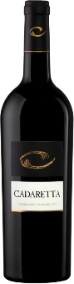
Cadaretta Cabernet Sauvignon $25
From Columbia Valley This wine exhibits intense aromas of pomegranate, Bing cherry, and black currants. Its primary fruit qualities are accented by hints of fresh rosemary. Light herb, sweet spice, orange peel, maple and red and black fruit aromas are followed by dark fruit flavors in this wine. There’s a wonderful richness in the mouth, filled with black cherry fruit. Silky, round tannins linger on the palate, ever so gently. Finally, there’s a light hint of licorice, right on the finish. The preponderance of fruit for this wine came from Southwind and nearby vineyard in the Walla Walla Valley AVA (50%), and from the Red Mountain AVA (43%). It's a bit wound up now, so give it some time in the cellar or a long decant. 89 points Wine Enthusiast.

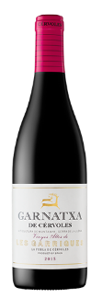
Cervoles Granache $20
This Spanish selection is a young wine with flavors of strawberries, red cherry, blackcurrant and blackberry. Hints of citrus jellybeans. 100% Grenache.

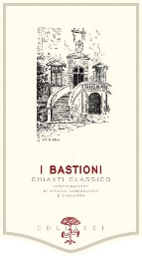
Collazzi Bastioni Chianti Classico $23
Magnificent ruby red color with dark hues. On the nose, notes of cherries, dark spices, combined with aromas of small red fruits and spices. Tasty, mineral, and complex on the palate, with a gentle, captivating tannic structure. The long finish and velvety tannins make this wine ideal to enjoy with food. 92 points James Suckling. 92 points Vinous

CVNE Medianias Red Blend $28
From Spain’s Canary Islands off the southwestern coast of Morocco this wine shows what a far removed, off the beaten path can be like and with entirely volcanic soil! This wine has a unique minerality, due to that black soil of ash. Sometimes smoky, flinty, salty it can be like drinking liquid stones. This is the selection will reward you for your exploration.
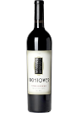
Hightower Cabernet Sauvignon $28
Another high toned effort is this Cabernet Sauvignon. Made from 80% Cabernet and 10% each of Malbec and Merlot, it gives up lots of candied violets, vanilla bean, incense and sweet black fruits in a charming, supple, layered and incredibly drinkable style.

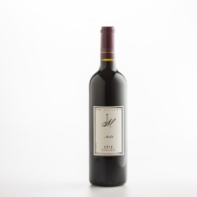
JM Merlot $48
This Merlot features fruit sourced from three vineyards of distinction – Stillwater Creek, Klipsun and Ciel du Cheval. Rich and smooth, this wine reveals the potential for producing exceptional Merlot from select Washington State vineyards.
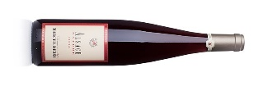
Marcel Deiss Pinot Noir $29
From France’s Alsace. This wine comes from the estate vineyards of Domaine Marcel Deiss. It is made mainly from ripe Pinot Noir, with the utmost respect and without intervention. These grapes express the soil and climate of Alsace - it is a wine that speaks of our region: deep crimson color, complex and aromatic bouquet (hints of Burgundy's Cote de Nuits), silky mouthfeel, and thirst-quenching finish.

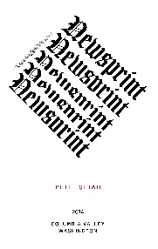
Newsprint Petit Sirah $20
Brooding aromas of purple fruit, apple and spice are followed by brawny dark fruit flavors. The tannins bring a firm squeeze.

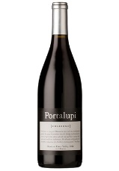
Portalupi Charbono $30
Made in California with Italian parts. Charbono is a rare find. From 90 year old vines in Mendocino County bursts flavors of rich red and black currants with meat and mushroom undertones. Strong and tart blackberry. Very firm and tannic texture with low alcohol. Hints of earth and new leather lend complexity. The pleasant acidity makes this the perfect companion for Northern Italian cuisine. Charbona grapes are sometimes called Douce noir in France or Bonarda in Argentina. They have a complicated history originating in the alpine vineyards of Savoie. If you can, this selection will be best after 2022.

Pallus Chinon $19
From France’s Loire Valley, Chinon is Cabernet Franc. This wine is only made in exceptional years and in tine quantities. A special offering, at a reduced price. Juicy, ripe and compact. A solid core f cassis, plum and blackberry fruit. Good grip. Smoldering tobacco on the finish. Best from 2018 through 2025. 92 points Wine Spectator, 91 points Robert Parker.

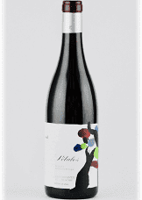
Palacios Petalos $25
Spain’s Petalos del Bierzo is assembled from old hillside and hilltop vines across from Bierzo's western edge. The wine is vinified for immediate appeal, but it retains the estate's signature finesse and restraint. From vines ranging between 40 and 90 years old. Dark berry, stone and limestone. Medium body. Focused and refined. Linear and very long finish.

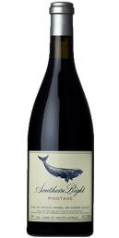
Southern Right Pinotage $29
Southern Right is re-defining Pinotage with this intense classically styled, clay-grown wine, packed with complex berry fruit, beautiful tannins and subtle wood spice. Full ripeness and the longer hang-time afforded by cooler sites, combined with the complex, more classic fruit aromas and structure resulting from clay-rich soil, make this wine a highly individual expression of South Africa's unique grape variety. 90 points Robert Parker.

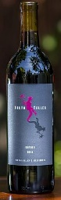
Truth Teller Satire Red Blend $25
This Yakima Valley red blend is made up of Merlot 41%, Cabernet Franc 27%, Cabernet Sauvignon 14%, Malbec 13% and Petit Verdot 5%. Aromas of baking spice and blue fruit followed by cocoa powder and blue fruit flavors. Quite dry. 88 points Wine Enthusiast.

II Vintners Grenache $25
This new offering from the winery combines fruit from Olsen and Boushey vineyards. Light in color, it offers restrained but nuanced plum, fresh herb, orange peel, smoked meat, white pepper and raspberry aromas. There's a pleasing sense of purity to the juicy fruit flavors, making it a very pretty interpretation of the variety. Give it plenty of time to open up. 91 points Wine Enthusiast.

Upland Tempranillo $28
From Washington’s Snipes Mountain AVA outside Yakima. Planted in 2007 high on the steep, rocky slopes, this is one of seven varieties that comprise the 14 acre “Iberian” block. The early ripening Spanish variety is strategically planted on the southeast slope of a ravine that takes full advantage of the gently morning sun and cool night air. The conditions are the same that result in Tempranillo being known as Spain’s “noble grape.” Aged 20 months in 20% new French barrels.

White
Adrice Leadfoot Louie $22
Fashioned after the best French White Bordeaux wines, this second vintage of Leadfood Louie is a blend of 79% Semillon and 30% Sauvignon Blanc. Soft and round with flavors of honeysuckle, almond and hints of floral with a fruit blend of apricot, pear and fig. Named after the winemaker’s mom who had a propensity to travel a tad fast in her convertible.

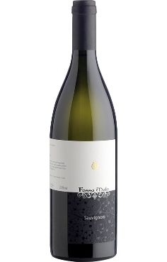
Fossa Mala Sauvignon $20
A forward-looking family operated estate in the Italy’s Grave del Friuli DOC of Friuli-Venezia Giulia. Grave eludes to the gravely soils (like those of Bordeaux) which make the area perfect for Bordeaux varieties such as Sauvignon Blanc. Serious sauvignon nose with elderflower, white peach and attractive floral notes. The palate follows nicely lean citrus fruit and a clean minerally finish.

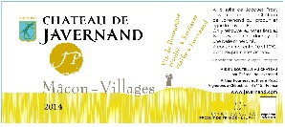
Javernand Macon Village $20
From a small, east-facing, three hectare block of estate-grown, sustainable, 30 year-old Chardonnay vines planted on limestone soil in the village of Serrieres. The grapes are direct-pressed and the juice is cold fermented in stainless steel where it remains for eight months on its fine lees before bottling. Lovely aromas of white flowers and ripe pears with a medium texture and a fine mineral finish. Only 250 cases produced.

Jourdies White Bordeaux $20

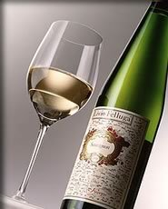
Livio Felluga Collio Sauvignon $22
A variety originally from France, Sauvignon was introduced into Friuli under the Hapsburgs and became widely planted in the early 20th century. The wine is refreshing and captivating, with a generously wide, distinctive range of aromas, with notes of exotic fruit, yellow pepper, tomato leaf, mint and box hedge notes. It's a traditional wine from Italy’s Friuli region.
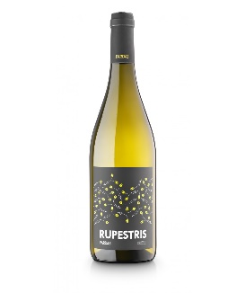
Pardas Rupestris $17
Made from local grapes grown in the Alt Penedes region of Spain. Intense nose with notes of citrus to begin, followed by pear and ripe melon. Beyond the fruit are notes of minerality and flint. The palate is fresh and fruity with pear, apricots and peach that overlay a marked acidic background. The label design is a tip of the hat to the local wild boar that visit the vineyard, leaving only their hoof prints.

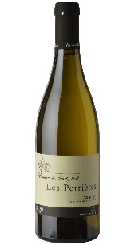
St. Just Les Perrieres Saumur $20
This racy Loire Valley white is an incredible example of the precision and focus that Chenin Blanc can achieve in the right hands. Planted in 1996, the certified organic vineyards of Domaine de Saint-Just are planted on clay soils on top of a limestone bedrock. The Les Perrières 2015 is lively and bright with taut citrus notes of lemon zest, green apple, lemongrass and big-time minerality. The brisk acidity adds clarity and leads to a long, very refreshing finish.
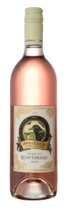
Sweet Cheeks Rosé $19
A semi-sweet rosé, Rosy Cheeks has fragrant floral notes filling the nose with a honeyed bouquet of lilies and gardenias. With a dense and delightful mouthfeel, notes of strawberry sorbet and berry cobbler fill the palate and swirl over the taste buds. Smooth and gratifying.

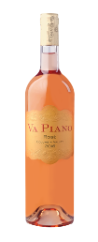
Va Piano Rosé $25
Made with Cabernet Franc to be refreshing, this crisp old world style rose' is bone dry & reminiscent of rhubarb and young baby strawberries, with a long lingering clean finish.

Sparkling
Barron-Fuente Tradition Brut $30
Montinore Vivace $19
Sterling 2012 Carneros Brut $25

Tier IV
Red
Adrice La Montagna Nebbiolo $35
Amuse Bouche Rosé $30
Carpineto Vino Nobile di Montalcino Riserva $30
Haut Bergey White Bordeaux $35
Hightower Estate Red $45
Lopez Rioja Red Blend $35
Tempranillo Grenache
Bosco
Pataille Marsannay Pinot Noir $33

White
Changarnier Chardonnay $35
JM Cellars Chardonnay Clone 15 $39
Turnbull Sauvignon Blanc $25

