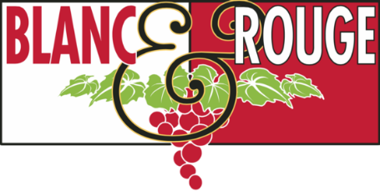
Wine Club Tasting Notes
Feb. 1, 2019
Tier I
Tier II
Tier IV
TIER I RED
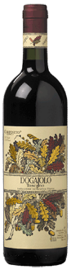
Carpineto Dogajolo ($15)
From Italy’s Tuscany region this selection has a core of Sangiovese (up to 70%) blended with Cabernet and other varieties. Very fruity and intense, with hints of cherry, coffee, vanilla and spice. Full, soft on the palate, complex, well developed. Given its fruitiness, Dogajolo can be paired with first courses and white meats. But shows at its best with full-flavored dishes such as roasts, grilled meats and cold cuts. The two grape varieties are vinified separately, since they ripen at different times. Toward the end of fermentation, they are blended and placed in small wooden casks where they slowly complete alcoholic and malolactic fermentation.

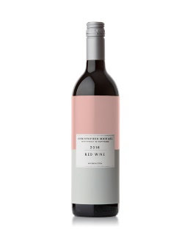
Christopher Michael Washington Blend ($15)
The base of this blend is Merlot which lends fresh red and blue fruit to the aromatics and brings a lushness to the palate. The Cabernet Sauvignon adds layers of cassis and currant to the nose and adds length to the palate while the Syrah ties it all together. There’s a touch of Tannat that gives the wine a structural framework. It was aged on 25% new French oak which plays a nice supporting role in the background of this wine from the nose through the palate.
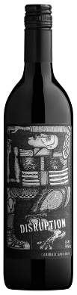
Disruption Cabernet Sauvignon ($18)
A Cabernet to impress any discerning drinker, this wine is powerful yet elegant with fine structure and a style all its own. Disruption Cabernet Sauvignon is a blend of three unique Washington vineyard sources. First, the Wahluke Vineyard provides concentration and density with its 35 year-old vines. The Northridge Vineyard, located 5 miles from Wahluke, has rich soils that bring bright acidity, amazing color, and focus. Finally, the Denhoed Vineyard’s cool climate contributes flavors of bright rhubarb, cedar and currant. The wine sees enough new French oak (20%) to add depth and richness to this focused Cabernet. The palate opens with aromas of dark fruit and cedar. The wine only improves with aeration, which makes the texture velvety and wonderfully integrated. The finish continues on the palate for a good while with distinct flavors of blackberry fruit, pipe tobacco and earth.
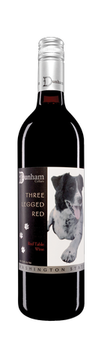
Dunham 3 Legged Red ($20)
It was a sunny day in the summer of 1994 when I met Port. Outside I heard the distinct sound of an animal in distress. It took only moments to realize what was happening across the field from my house – a young puppy had fallen into harm’s way and was being attacked by another dog. I ran to the scene, broke up the fight and found that the puppy was very badly injured. Instinctively, I wrapped him up and took him to the veterinarian, and although the puppy had lost a leg, he had found a home. With only three legs, and two on the port side, I named him Port, and he was my best friend. – Eric Dunham, Founding Winemaker
Each year, Dunham Cellars blends a portion of its wines into this red table wine. Featuring fruit from Dunham’s estate vineyard, this wine sees the same barrels in which the winery’s finest Cabernet, Merlot and Syrahs do. This means the same consistent, high quality presented by Dunham’s top wines, while creating a great everyday wine that is price-friendly. 90 points Wine Spectator Smart Buy
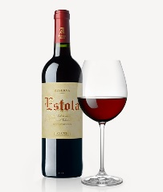
Estola Reserva ($10)
A warm aroma of spices and mature fruits, the result of its excellent ageing in wood. Full-bodied and well-rounded on the palate. An internationally award-winning wine. Prepared from a selection of the best Tempranillo and Cabernet Sauvignon grapes. After fermentation, it is aged in American oak barrels, to achieve the plenitude of its extraordinary character. Of a cherry-red color with brick-red tones. Warm, intense aroma with fruity tones over an excellent base of ageing in wood. This Spanish selection is excellent with roasts, red meats in general, game and semi-mature cheeses.
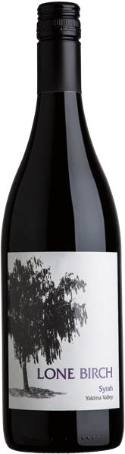
Lone Birch Syrah ($15)
This wine is handcrafted in a balanced, approachable style that showcases the quality of fruit from Washington State. All of the Lone Birch Wines are sourced from fruit from our 830 acre estate vineyard located in the Yakima Valley. This Syrah imparts a bouquet of dark berries and toasted oak leading to a smooth finish with soft lingering tannins.

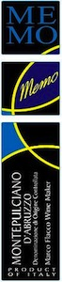
Memo Montepulciano ($15)
Another terrific release from Marco Flacco. Ruby red, this is an intensely, persistent and fruity southern red. Hints of vanilla adds enticing notes to the Marasco cherry, and plum fruit flavors. Full bodied, tannic and well balanced with a classic Italian richness and robust personality. Delicious with salami, rich main courses, meat and cheese, also enjoyable on its own. From the Abruzzo region of Italy, east of Rome, along the Adriatic coastline.

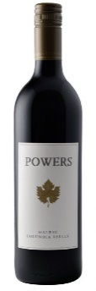
Powers Malbec ($15)
Lushly layered this Washington selection is fragrant with aromatics of blackberry, plum, black currant, violet with a touch of anise, this Malbec jumps out on the palate with nice depth and complexity. The wine shows layered flavors of rich cherry, plum, pomegranate, alongside a slight touch of herbs, black tea, and orange zest. Flavors linger with a nice rich and balanced mouthfeel and a firm and focused finish. 93% Malbec, 7% Mourvedre
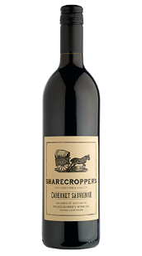
Sharecropper Cabernet Sauvignon ($15)
During the economic recession of 2001, and Owen Roe’s first couple vintages as a winery, Northwest growers were facing hardship in selling their fruit, come harvest time. At Owen Roe, they wanted to help our farming friends and prevent missing out on such well-tended, beautiful fruit. When presented with the difficult and costly purchasing of grapes to process, cellar and bottle, waiting several months to recover costs on the finished wine, the folks at Owen Roe decided to bring back the historical business practice of sharecropping. They aptly named wine, “Sharecropper’s.” This partnership meant that Owen Roe would take the fruit, make the wine and once it was sold, share the profits with the growers. This remains an important part of our history and due to the success of this wine; we are now able to pay our growers upfront.
This selection has become a favorite go-to weeknight Cab. Bright aromas of blackberry, candied fruit, vanilla and brown sugar leads to a more savory palate of pomegranate, green pepper and oil cured olives. This Cabernet finishes with bright acidity and lingering tannins. Open this wine now and enjoying it at a young age, however, it will age well for 4-6 years when properly cellared.
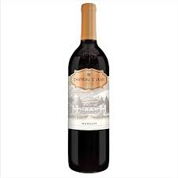
Chateau St. Jean Merlot ($15)
Crafted in an approachable California style from coastal vineyards. Beautifully balanced full of ripe fruit aromas of fresh berry, red plum and cherry leading to a palate filled with flavors of fresh berry pie, milk chocolate and notes of black tea. Smooth tannins and a juicy mouthfeel.
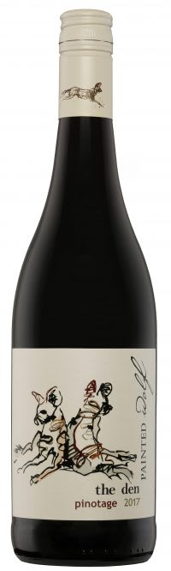
The Den Pinotage ($15)
The South African producer named The Den wines after the heart of the wild dog community – the den. They encourage drinkers to share the flavor packed, juicy, everyday drinking wines with your pack. Pinotage, a cross between Pinot noir and Cinsaut created at Stellenbosch University, is South Africa’s signature variety. It is medium to full bodied with a smorgasbord of bright red and black summer berries, savory spice and toasty wood flavors, leading to a nicely poised finish. Pinotage is best with Mexican dishes, especially ones featuring Mole. It is also very good with pulled port or smoky Texas-style BBQ. It also works with Moroccan flavors and Malaysian dishes.
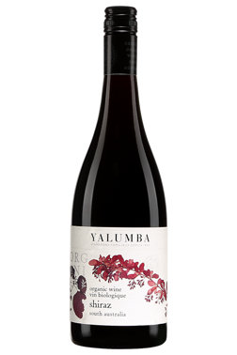
Yalumba Shiraz ($16)
Yalumba has been pushing the organic envelope in recent years in Australia, and this Shiraz is a winner. It's full bodied and supple nearly to the point of creaminess, but delivers mixed berry, vanilla and baking-spice flavors, all with a certain amount of elegance. Drink now–2022. 90 points Wine Enthusiast.
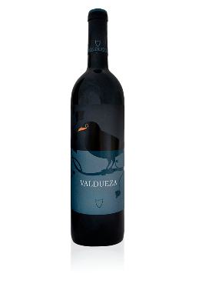
Valdueza el Canto de los Pajaros ($15)
An easy red wine from Spain that can be enjoyed at release and for the following two years. Merlot and Syrah bring fruit and softness to this wine. Cabernet Sauvignon brings freshness and vivaciousness. About half of the wine is aged for 12 months in stainless steel, which preserves the fruit and energy. The rest is aged for 12 months in French oak barrels (new, one, and two-year old barrels) to achieve a velvety mouthfeel. This is an ideal wine for everyday meals.

WHITE
Dunham 4 Legged White ($16)
Four Legged White is a 100% Riesling opening with tropical aromas of orange blossom and jasmine. The fresh palate offers notes of dried mango, apricot and pear on a beautiful backdrop of bright acidity. This food-friendly wine finishes with a touch of sweetness and crisp minerality that begs for another sip. All the fruit comes from Washington’s famed Lewis Estate Vineyard and is fermented in only stainless steel.

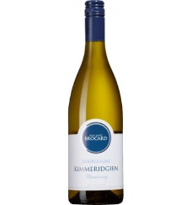
Jean-Marc Brocard Bourgogne Kimmeridgen Blanc ($15)
Pure soil of Chablis, Kimmeridgian is alternate layers of very compact limestone, and softer clayey marls containing marine fossilized bodies (exogyra virgula). Jean-Marc Brocard created a Geologic Chardonnay Collection to allow every soil to reveal its personality and its authenticity through Chardonnay. This crackling value white from the Kimmeridgien soils of Auxerrois, just west of Chablis, is perfectly ripe and utterly delicious with no oak. Clean, fresh, aromas of citrus peel, green apple, flint and seashell really pull you in for a sip. You'll find it vibrant, but nicely rich in mouthful with flavors of yellow apple, peach, lemon and lime zest fruit enlivened by juicy acids and salty stone minerality.

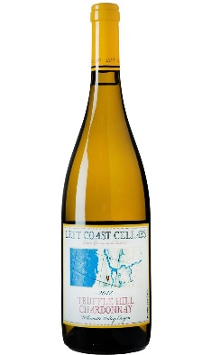
Left Coast Estate Truffle Hill Chardonnay ($17)
Truffle Hill is one of the most unique places on the Oregon estate of Left Coast Cellars. It is home to 4 acres of European Black Truffle-inoculated hazelnut trees, shrub roses and holly oaks. The producer’s Pinot Noir comes from the highest vineyard on Truffle Hill, planted with 5 acres of the Swiss clone Wädenswil Pinot Noir. The Chardonnay comes from an additional 5 acres of planted in an ancient sea bed near the top of the hill. It is fermented in 100% French Oak for 10 months. Only 2,200 cases are produced. This easy drinking Chardonnay delivers golden flower aromas of honeysuckle and elderbury accented with brown sugar. A burst of acidity on the palate is complimented with ripe pear fruit, rounded out by vanilla, coconut, caramel and butterscotch on the finish.

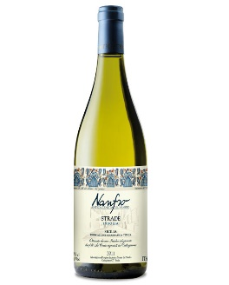
Nanfro Strade Insolia ($15)
Many of the indigenous Sicilian white grapes are used to make fortified wines, but increasingly varieties such as Insolia (or Inzolia) are being recognized for their aromatic freshness and great-value drinkability. Insolia as been described as containing the rays of the Sicilian sun. Picked in the cool of an early September morning, this Strade Insolia is a straw-yellow color with intense aromas of white peaches and honeysuckle. Soft, dry and gentle with herbal, floral tones, this wine is best served lightly chilled to make it perfect with chicken, fish, shellfish, white meat and cheese.
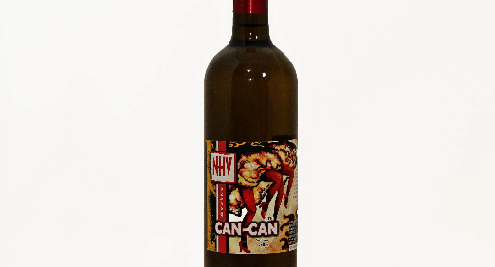
Naches Heights Vineyard Can-Can ($15)
Can-Can is sure to please those of us who enjoy a flavorful dance on the tongue and in the mouth. This unique blend of Riesling, Grenache Blanc, Viognier, Marsanne, and Gewurztraminer were co-fermented to create the flavors of rich ripe pear, green apple, apricot and peach. Can-Can is slightly spicy in the mid-palate finishing with cantaloupe melon and Mandarin orange. Off dry. Serve chilled. 800 Cases produced

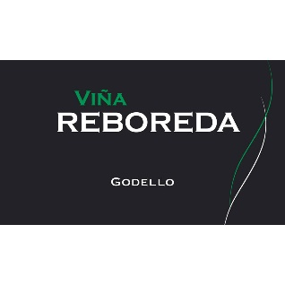
Reboreda Godello ($15)
100% Godello from 40-year-old vines planted in chalky-clay soils on steep slopes overlooking the Mino River in Spain. This is a medium-bodied, fresh, complex and minerally wine that displays a savory character. Aromas of ripe white fruit, touches of citrus and minerals, plus some details of flowers. This is round and wide, but with a column of firm acidity that keeps it balanced.

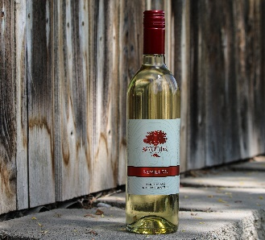
Scarlet Oak Semillon ($15)
This dry, golden Semillon has all the classic French Bordeaux characteristics one expects. Light honeydew fragrances with great acid, and a subtle citrus lemon/lime finish. Perfect pairing with cheeses, game birds and fresh trout. Only 72 cases produced from this Oregon producer that works with Washington fruit.

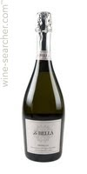
La Bella Prosecco ($18)
From Italy’s Veneto region. A sparkling prosecco that is aromatic, fresh and lively with a distinctive taste and fine, persistent perlage. A crisp, fruity sparkling wine with aromas and flavors of apple and peach. A perfect pair for a cheese plate, poultry and shellfish.

Wine Club
Feb. 1, 2019

TIER II
RED

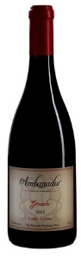
Ambassador Attache Grenache ($22)
A subtle mix of raspberry, vanilla, dried spices, cocoa, cherry, coconut, and an intriguing hint of fruit punch. This wine pulls you in with the exciting and exotic notes rounded out by a cool mint sweetness. Rich and full with a long slightly puckering finish. Rich and high octane. Not for the faint of heart. 90 points Wine Enthusiast

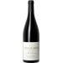
Chave Mon Coeur Cotes du Rhone ($25)
A cut above most Côtes-du-Rhônes in structure and complexity. Lurid ruby in color. Ripe cherries and red berry liquor on the deeply perfumed spice tinged nose. This French offering shows notes of sweet and spicy berries, rich black raspberry, bitter cherry, violets, and a touch of licorice. Smooth, gently tannic finish delivers a solid punch. Impressive power and breadth. Pairs well with beef stew or macaroni and cheese. Organic grapes. 91 points Vineous. 91 points Wine Spectator. 91 points James Suckling

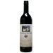
Cote Bonneville Train Station Cabernet Sauvignon ($30)
In 1992 High and Kathy Shiels planted DuBrul Vineyard outside Yakima. In 2001 they founded Côte Bonneville to produce classically styled wines to best express their spectacular site. In 2005 they converted a historic train station in Sunnyside into a tasting room. In tribute to the building they make Train Station Cabernet Sauvignon that is bursting with Bing cherry, cassis, raspberry and sassafras. Bold and fruit driven yet easy to drink.

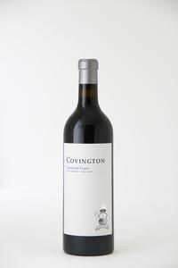
Covington Cabernet Franc ($25)
Like so many of Washington’s top small producers, Covington Cellars sources its wines from the State’s very best vineyards and makes a very wide variety of wines. But the two that always sell out are the two that established their reputation: Sangiovese and especially Cabernet Franc. Only 250 cases of this very rich, dark and full but dead-on Cabernet Franc were made. Most sold to top restaurants around the Country – and it sold out at the winery for $37. 100% Cabernet Franc, sourced from different vineyards allowing for some blending magic to spotlight the herbaceous, earthy notes Cabernet Franc is known for. Full of rich, dark fruit flavors of Washington State.

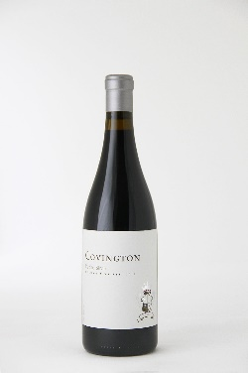
Covingon Petit Syrah ($25)
In 2007 Cindy, one of the three winemakers, decided that she really liked Petite Sirah and wanted to make some. Because it’s not widely planted in Washington state, she asked Leif Olsen of Olsen Vineyard to plant an acre. Having a full-time job and a business to run, Cindy is a busy lady. As she tells the story she “honestly forgot to mention it to David (her husband and fellow winemaker) or Morgan (the winemaker the completes the triangle)” - For three years. Subsequently, about halfway through the 2010 harvest Morgan got a phone call from Leif asking when he wanted to pick his Petite Sirah. "What Petite Sirah?" was Morgan's response.
Now, with a few vintages under their belts (and a great response to the wine!) they can look back and chuckle about the beginnings of Covington’s Petite Sirah. BTW…Cindy is still not allowed to order fruit.
Not a shy wine, this is a big, assertive, palate coater, with dark fruit flavors intermixed with an amazing earthiness. This wine shows aromas of smoke, incense, ground gravel and purple fruit. The palate is full bodied, with firm yet still well-refined tannins. It's a beautiful example of the variety. 91 points Wine Enthusiast.

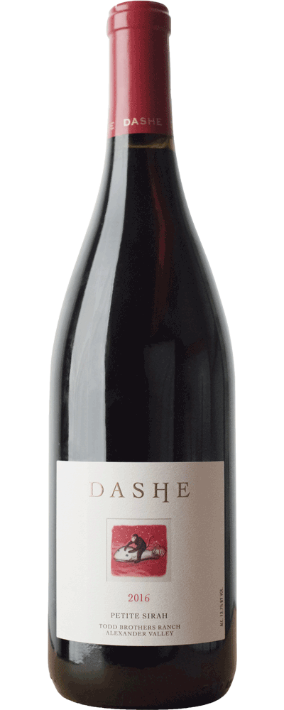
Dashe Petite Sirah ($25)
Dashe Cellars is a family-owned artisan winery located in the heart of the Urban Wine Country in a warehouse at Jack London Square in Oakland, CA. Fournded by the husband and wife winemaking team of Anne and Michael Dashe, the inaugural vintage in 1996 was Dry Creek Zinfandel. Since then, the Dashe’s have focused on producing exceptional, single-vineyard wines using traditional, non-industrial methods of winemaking.
Without question, this is one of the most voluptuous and sensuous Petite Sirahs that has come out of this vineyard. The Todd Brothers Ranch, located outside of the town of Geyserville in the Alexander Valley, is an ideal site to grow intense, substantial Petite Sirah. The bright red rocky soil and the steep slopes of the vineyard make the vines struggle to survive, and the resulting grapes are jet-black and tiny. The resulting Petite Sirah is astonishingly intense, luscious, and complex. Fermentation using native yeast further enhanced the flavor, color and complexity to deliver a wine that is very intense, dark, and complex, tasting very much like a wine from the Southern Rhone Valley of France. It should easily improve over 10 or more years and last for over 25 years of bottle age. A great wine for the cellar.

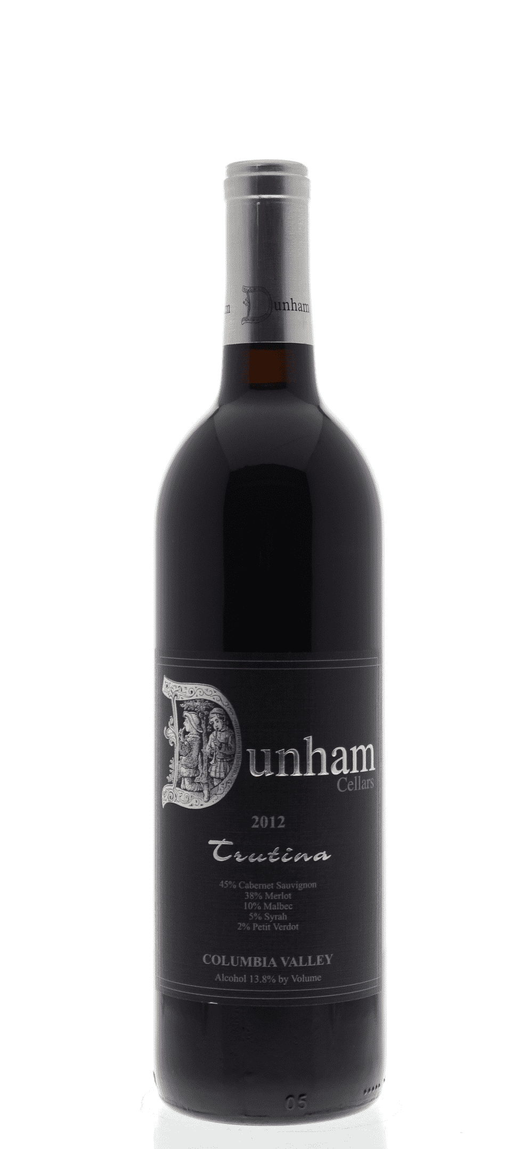
Dunham Trutina ($30)
This wine is a blend of 54% Cabernet Sauvignon, 34% Merlot, 10% Malbec and 2% Cabernet Franc. Aromas of blueberry, herb, vanilla and toasty spices lead to very lightly styled cherry and vanilla flavors. The flavors seem a bit washed out, with the oak way out front. Trutina is a beautiful reflection of the classic Bordeaux varieties. This blend opens with aromas of dark fruit, black cherry, black currant and black raspberry. Subtle flavors of coffee and chocolate and layered with hints of cedar and baking spice, while elegant tannins roll through the seamless finish. Enjoy now or cellar for 5 – 7 years.

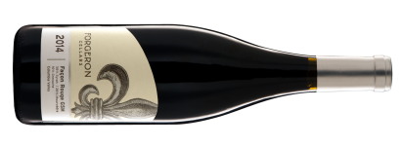Forgeron Façon Rouge Grenache-Syrah-Mourvedre ($28)
Façon [FAH-son] is French for the style or way of doing something. Façon Rouge wine speaks to Forgeron’s style inspired by its French roots and old-world philosophy, and dedicated to showcasing Washington terroir. Façon Rouge pays tribute to the fragrant and dynamic fruit of Grenache-based wines of the Southern Rhône River Valley in France.

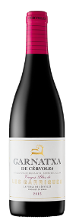
Garnatxa de Cérvoles ($20)
100% Grenache from Spain. An amazing experience of fresh fruit and candies. This young wine represents the producers new style bet on purity - no makeup, no masks - just fruit in its utmost expression. Strawberries, blackcurrant and blackberry followed by citrus jellybeans cover the whole spectrum of this wine which spotlights this indigenous grape variety.

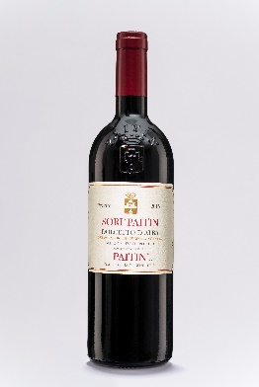
Paitin Dolcetto d’Alba ($17)
Dolcetto translates to “little sweet one” referring to the individual grapes and their classic lilt of sweetness that is balanced with good acidity. This 100% Dolcetto from Paitin, is sourced from high-elevation vineyards with south-west exposure, on the famed hill Serra Boella. The fermentation and ageing is in a combination of large, neutral casks and stainless steel tanks, as to preserve the inherent fruitiness of the varietal. Filled with aromas and flavors of baking spices and dark berries, black cherry, raspberry and blueberries. Notes of licorice and grilled almonds. Balanced, medium-bodied with soft tannins and good acidity. High-toned and fresh, perfect with a variety of dishes, including grilled meat and mild cheeses.

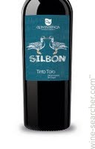
Quinta Esencia Silbon Tinto Toro ($22)
This wine is made from Tinta de Toro grapes coming from different vineyards aged 28 to 45. Soils have been selected in order to nurture its Toro character in keeping with fruits and alcohol content. Chalky, loamy-sandy soils, exploring exposure and orientation. From Venialbo to Toro, through Morales and La Boveda. Intense red with blue-violet highlights. Spicy red fruit aroma and notes of fresh grapes. Full-bodied and very fruity also on the palate; resulting in a fresh and tasty wine with a long finish. Because of its tannic levels and artisanal production, over time this wine can develop lees.

Sinskey Aries Pinot Noir ($25)
Berry, cherry, earth, tea and spice aromas beckon from the bottle. A delicate but brilliant ruby color allows the eye through; as an honest Pinot Noir should. The wine’s sensual texture shows off rich strawberry and cherry fruit, backed by forest floor, tea, and pie spice. Most importantly, the wine has a bright mouth watering finish and a texture. Organic & Biodynamic 100% Pinot Noir

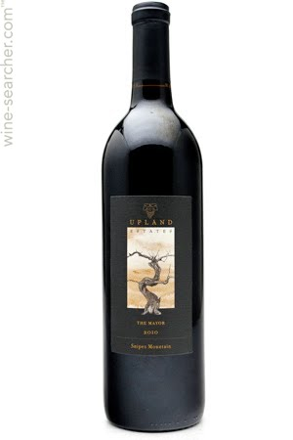
Upland Red Blend The Mayor ($20)
The Mayor is the winery's most unusual blend, a mix of Bordeaux and Rhône grapes that's aged for 21 months in French, eastern European and American oak barrels. It's a mélange of flavors, but the barrel notes take over in the form of pretty baking spices. Best to drink soon. Upland wines are no longer in production. The family instead wants to focus their efforts on growing grapes in arguably Washington’s oldest vineyard on Snipes Mountain.

WHITE
Adrice White Blend Leadfoot Louie ($23)
This Washington White Wine Blend of 70% Semillon and 30% Sauvignon Blanc honors the winemaker’s mom Helen Louise (aka – Leadfoot Louie). Fashioned after the best French White Bordeaux wines “Leadie” appeals to red and white wine lovers alike with a soft, round nose of honeysuckle, almond and hints of floral. She lasts long on the palate with a pleasing summer fruit blend of apricot, pear and fig. This will become your go-to in warmer weather.
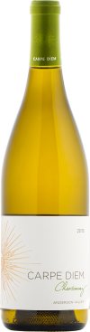
Carpe Diem Chardonnay ($21)
Carpe Diem is a second label of Roederer. A nice pedigree to have. This Chardonnay is produced in Northern California‘s Anderson Valley. Over the years, this region has gained the reputation of an ideal terroir to grow Chardonnay for still wines. Grapes for the Carpe Diem Chardonnay are selected exclusively from the best vineyards in Northern California‘s cool Anderson Valley. This fog-shrouded region not far from Mendocino Coast and the Pacific Ocean provides ideal growing conditions for these delicate grapes.
Vinified under the meticulous supervision of Domaine Anderson‘s Winemaker Darrin Low, Carpe Diem‘s philosophy is to offer the best of two worlds: the richness of California fruit and the elegance of a French wine. This mission brings this appealing and medium-bodied wine to us with a light earthy, buttery aroma and plenty of butter, lemon and vanilla flavors underpinned by good, lively acidity that keeps it fresh through the finish. 93 points Decanter, 90 points Wine Enthusiast

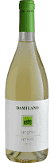
Damilano Arneis ($23)
This stunner from the Piedmont region of Italy is pale straw yellow in color. On the nose it presents fine and fruity. It is dry, vivid and fresh with delicate, elegant flavors of sliced lemons and grapefruit, as well as hints of crushed stones and a slight aftertaste of almonds on the crisp finish. Medium body. A fresh wine, suitable for appetizers, fish courses and white meats. 91 points James Suckling.

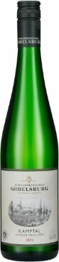
Gobelsburg Grϋner Veltliner Kamptal ($18)
This Austrian stunner opens with scents of fresh lime and ivy, followed by a leesy hint and some pear on the nose. The palate comes in with salty savoriness that suggests yeasty miso, chervil and lovage, with lots of white pepper accented by a little spritz. Brightened by fresh lemon notes, this makes for a spicy, elegant and slender wine with a light touch and real depth. So excited to bring this to our Wine Club Members because it was tapped as #75 Wine Spectator Top 100 of 2018! AND 92 points Wine Enthusiast

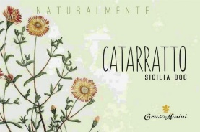
Minini Catarratto White Blend ($23)
From Sicily’s western-most coast. Fresh and clean, the wine is elegant, balanced, and fragrant. Honeysuckle, Spanish broom and tropical-fruit aromas leap out of the glass. On the tangy palate, fresh acidity lifts peach, green apple and citrus. Its lemon notes are complimented by a distinct minerality, typical of wines grown in the large “cuti,” or stony soil of the region. Pair with a light pasta, white meat, or simply drink as an aperitivo.
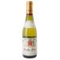
Pabiot Pouilly-Fume ($29)
Pale gold with brilliant highlights. Intense nose with notes of citrus and white fruits. Complex rich and saline palate with good balance showing aromas of ripe fruits (pineapple, citrus fruits, peach). An intense and aromatic Pouilly Fumé (aka sauvignon blanc) from the Loire River Valley of France. Delicious by itself or as an aperitif. It is excellent served with most hors d’oeuvres and appetizers, seafood, fish and certain cheeses like goat cheese. 90 points Wine Enthusiast

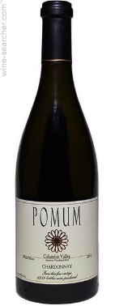
Pomum Chardonnay ($25)
With the fruit coming from the esteemed French Creek Vineyard, the aromas are bright in notes of baked apple, pear, citrus, stone fruit and lees which bring scents of vanilla and cream plus almond. The palate brings lighter flavor intensity, with a sleek profile and a citrusy finish. Though fermented and aged in French oak (30% new), the oak influence seems quite dialed back yet a fleshy texture and roundness shows well. Ready to enjoy now through 2020.

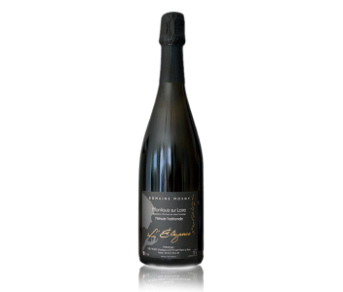
BUBBLES
Montlouis L’Elegance ($27)
A sparkling Chenin blanc from France’s Loire Valley. This cuvee has very fine bubbles and fine aromas thanks to a very light dosage (added sugar). Intense and lively with nice freshness. Lovely as an aperitif or with desserts.
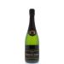
Roederer Estate ($25)
Roederer Estate Brut is the first California sparkling wine produced by Champagne’s Louis Roederer and builds upon that 200-year tradition. Roederer’s style is based on ownership of its own vineyards and the addition of oak-aged reserve wines to each year’s blend or cuvee. All the grapes for the Anderson Valley wines are grown on the Estate. This wine debuted in 1988 and is considered one of California’s premier sparklers. Seamless and silky, showing an almost effortless sense of complexity with notes of lemon and pear paired with toasty brioche, fresh ginger and hazelnut. So happy to bring this to our Wine Club because of its distinction of #27 Wine Spectator Top 100 of 2018! AND 93 points Wine Spectator. 92 points Wine Enthusiast. 92 points Wine.com. 92 points Wine & Spirits. 91 points Connoisseurs’ Guide. 90 points Decanter

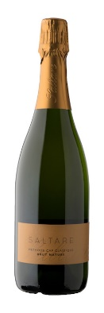
Saltare Brut Nature ($29)
Brut Nature is a fresh wine perfect on its own anytime during the day and amazing with oysters and other seafood. A blend of Chardonnay and Pinot Noir from the Somerset West region of South Africa. It spends 18 to 24 months on the lees. No dosage (sugar) or sulphur is added when it is disgorged. The dates of bottling and disgorgement are printed on each label to give you the exact time the bottle has spent on the lees. Crisp, fresh rose and lavender with a hint of clove; green apple, strawberry, a clean finish and exceptional length.

Wine Club
Feb. 1, 2019

TIER IV
RED

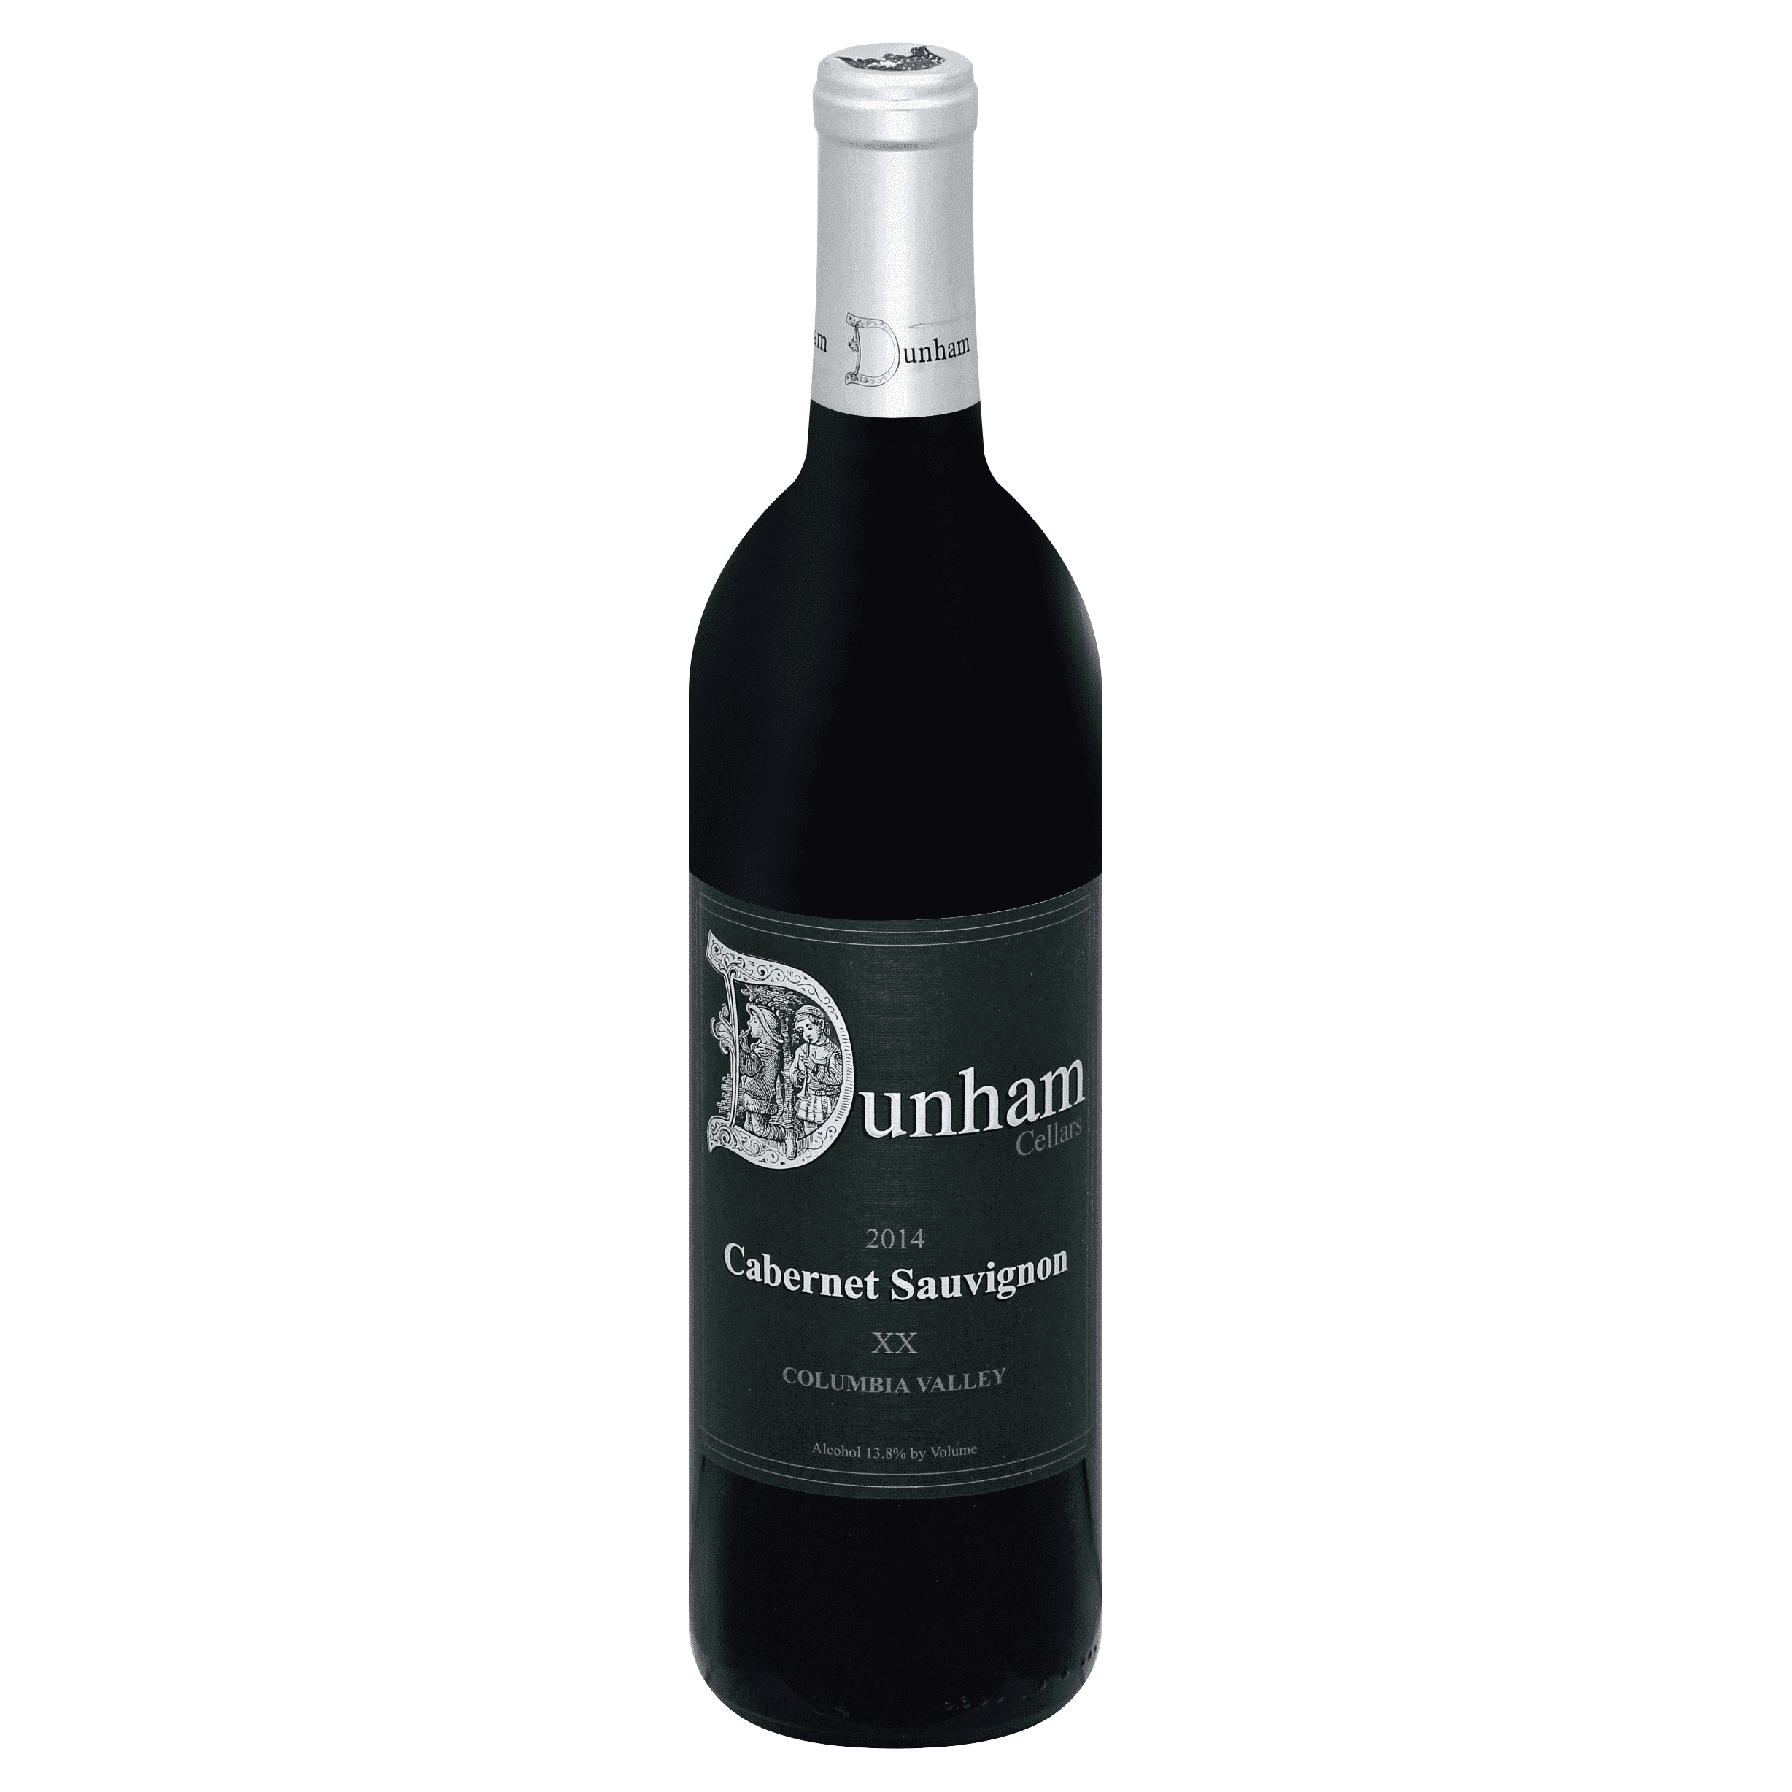
Dunham Cabernet Sauvignon ($40)
This vintage marks the 20th year that Dunham has made this wine. The 2014 'XX' Cabernet Sauvignon by Dunham is amongst the best recent releases from this historic Walla Walla winery. This inky colored Cabernet stains the glass and was aged in 70 new French oak and 30% new America oak for 22 months prior to bottling. Largely sourced from the Kenny Hill and Lewis Vineyards, the Cabernet opens with a bouquet of sagebrush, black tea, crushed mint and crème de cassis. The silky mouthfeel coats the mid-palate as the wine reveals deep flavors of black cherry cordial, dark chocolate torte, blackberry pie and suggestions of baking spices that complete this gorgeous wine. Enjoy this Cabernet Sauvignon now through 2030.

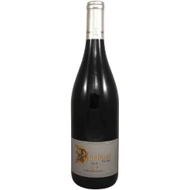
Dunham Syrah (37)
Dunham has developed a sterling reputation for their Syrah wine and this new release is absolutely no exception. Rich, earthy and meaty, this great Syrah opens with ripe aromatics of sagebrush, milk chocolate, black cherry compote and blackberry jam. Subdued aromas of vanilla, cocoa and smoke are followed by silky-feeling fruit and barrel flavors. It brings a sense of elegance, with the fruit and oak playing equal parts in the show. Aromatics of rich marionberry are layered with hints of lavender and spicy pink peppercorn in this 100% Syrah. This leads to intense flavors of blackberry cobbler, milk chocolate and crème de cassis with sage accents. There is notable weight to this Syrah, which possesses a lovely texture and a rich mouthfeel and lingering, smooth and well-structured finish. Overall this is a serious value out of Washington. Best now through 2028

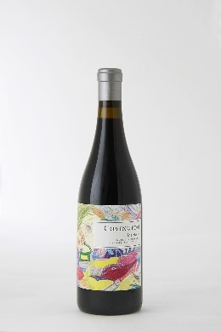
Covington Ma Belle Grenache ($35)
Covington’s co-founder Cindy calls this her wine. A devout lover of Southern Rhone blends, Cindy wanted to make a wine like this since inception. It wasn’t until 2007 that Covington Cellars had access to the Cinsault varietal. Sitting at the blending table with her partner winemakers, Morgan and David, Cindy named the wine “Ma Belle”, meaning my beautiful in French, and it’s been on the production schedule ever since. A single vineyard bottling, this Grenache dominate blend has a dedicated following among our wine club members. 75% Grenache, rounded out by 15% Mourvedre, and 5% each of Syrah and Cinsault. This wine offers up a palate coating mixture of ripe red fruits and floral notes. 92 points Wine Enthusiast. 91 points Wine Advocate.
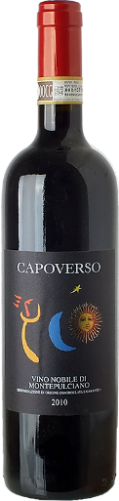
Copoverso Vino Nobile ($30)
From the Tuncan area of Italy between Cortona and Montelpulciano, this selection is mainly Sangiovese with a small percentage of Merlot. Ruby red in color. Rich and refined bouquet. While it can be intense on the nose, it opens up with elegance unveiling notes of sour cherry, roasted almonds and coffee. Round bodied, harmonious, firm and enveloping. Long persistence with velvety and well balanced tanninic hints.

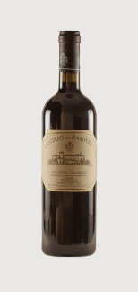
Castello Rampolla Chianti Classico ($36)
This Tuscan delight is 90% Sangiovese, 5% Cabernet Sauvignon, 5% Merlot. The bouquet on the nose is intense, with rich cherry and red berry aromas and leafy undertones. On the palate it is silky and balanced with a medium body and refined tannin. A long flavorful finish punctuate blackberry and chocolate. A perfect partner for red grilled meat (Bistecca Fiorentina) and semi to well-age cheeses.

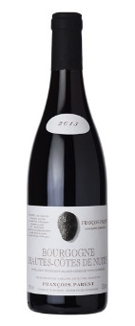
Parent Hautes Cotes de Nuits ($42)
Francois Parent's father was one of the first vignerons in Burgundy to begin bottling as a domaine, rather than simply selling off his wine in bulk to the local negotiants. His mother helped in marketing the wines, traveling throughout Europe as one of the first grower/producers, pioneering a boutique trend that has become much more normalized today. Francois has continued in his parents' (no pun intended) footsteps, making traditional and terroir-driven wines from Pommard, as well as Beaune, Corton, and Vosne Romanee. This selection is dense red in color and scents of white pepper, roses and a pleasant minerality. The taste is elegant and juicy with shades of cherry, dark chocolate and raspberry jelly. A nice glass of wine for the discerning wine connoisseur who loves good Burgundy. The Hautes Côtes de Nuits are located west of the Côtes de Nuits on a ridge that includes several valleys and hills.

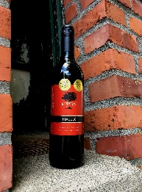
Scarlet Oak Malbec ($30)
Dusty malt and cedar aromatics followed up with flavors of dried fruits, dark cherry and subtle hints of tobacco and black pepper. Excellent companion with grilled Rib Eye Steaks, Sirloin Burgers with Smokey Bacon & Blue Cheese crumbles, and Seasoned Portabella Mushrooms.

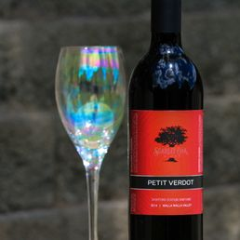
Scarlet Oak Petit Verdot ($30)
This Washington selection is 93% Petit Verdot, 7% Sangiovese. Hint of leather and boysenberry truffle on the nose. A distinct piquancy of Huckleberry and other dark berries, ripe plums rich on the palate making this wine an ideal companion to Spicy Thai Foods, Lamb, and Bold Sausages.

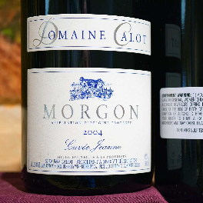
Calot 2004 Morgon (35)
100% Gamay from France’s Beaujolais region. Aromas of raspberries, black cherries, red plums, licorice, pepper. Full-bodied, suave, refined. A splendid partner for grilled lamb and pork sausages. ‘Jeanne’ is a tribute to winemaker Vincent Calot’s grandmother

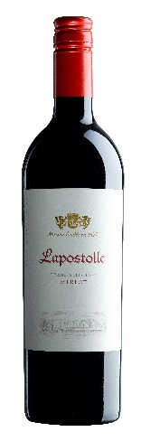
Lapostolle Grand Select Merlot (32)
This Chilian Merlot is a big surprise in a little bottle. Clean burgundy color with cherry hues. Expressive nose of red and black fruit such as blackberry along with fresh aromas such as thyme and black pepper. You can almost smell the fresh air in the shadows of the Andies. Medium body with a good fruit expression. Good balance among components. The ideal companion for pastas with red sauces, or paprika stuffed with quinoa and tomatoes, or a pizza with mushrooms and pepperoni. 91 points James Suckling.

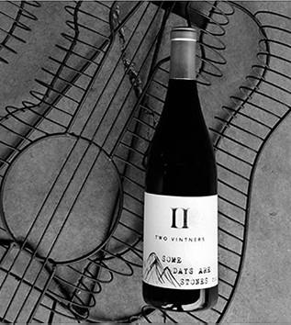
Two Vintners Some Days are Stones ($40)
There is funky wine, and then there is the Washington’s Rocks District funky wine. Lucky for us we’ve been able to get our hands on some amazing rocks fruit. This Syrah is sourced entirely from Stoney Vine vineyard which is in the “The Rocks District of Milton-Freewater”AVA of the Walla Walla Valley. Planted over the old riverbed of the Walla Walla river the Stoney Vine Vineyard is vineyard produces some of the most unique and distinguishable Syrahs. Imagine a plethora of earthy and meaty flavors all wrapped together with a single dark berry smashed in and you’ll start to understand. Rich and powerful without being over the top. This vintage was the fifth from this vineyard. This wine was fermented 50% whole cluster with native yeasts. Aged in combination of 500lt puncheons and neutral French oak barrels. 93 points - Jeb Dunnuck. 92 points - Wine Enthusiast. 250 Cases Produced…and yes, we have more!

WHITE
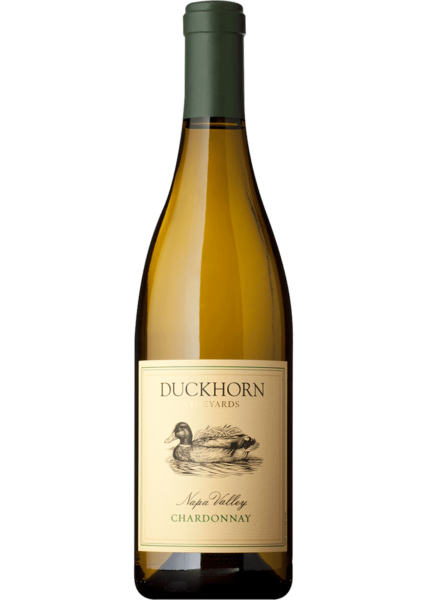
Duckhorn Chardonnay ($35)
Inviting aromas of pear, lemongrass, ripe peach, jasmine and graham cracker rise from the glass revealing a wine that is layered and complex. On the palate, a silky texture creates weight and volume with elegant acidity framing the stone fruit and citrus flavors. The finish is long and fresh, with tantalizing hints of lemon zest, vanilla and clove. 91 points Wine Enthusiast. 90 points Robert Parker.

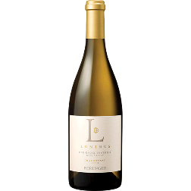
Beringer Luminus Chardonnay ($30)
Rich and plush. Attractively fresh. Scents of melon and hazelnut nougat. Plenty of buttery notes plus ripe apple, pear and dried ginger flowers and a bonus of citrus and grilled peaches. Very layered and textural. Creamy finish. Drink now through 2020. 92 points James Suckling. 91 points Wine Spectator.

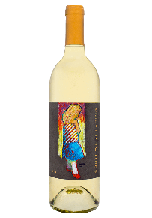
Upchurch Sauvignon Blanc Southwest Facing (35)
This is the inaugural bottling of Sauvignon Blanc from Chris Upchurch’s solo project (apart from his work at Delille Cellars). Fruit from the famed Boushey Vineyard. Aged 18 months on the lees in Cement eggs. Only 200 cases produced. This selection is crafted with old world techniques. Aromas of pear, lime chutney, honey sage and passion fruit.A riper presentation it exhibits purity and complexity with an elegant, plush mouthfeel. The flavors show white peaches, honeyed stone minerality, bosch pears. Mouthwatering and juicy lime acidity.
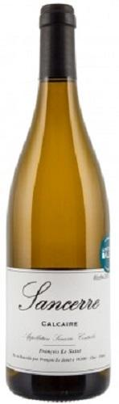
La Saint Sancerre Calcaire ($30)
This is the organic label form Domaine Fouassier in Sancerre, France. 100% Sauvignon Blanc grown in Calcaire soils. Free-run juice is transferred by gravity to stainless steel tanks for an indigenous yeast fermentation. Aged on fine lees to add complexity. Medium-body and fresh acidity, scant phenolics. Deliciousand supple flavors of ripe citrus and tree fruit with the fine mineral character you expect from Sancerre. Multi textures and dimensions.
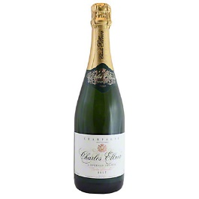
Charles Ellner Carte Blanche Brut Champagne($33)
Elegant and subtle, fresh and fruity with floral hints. Austere in structure at first, with rapier acidity. Flavors of black currant, slivered almond, white peach and candied lemon peel are intense and tightly knit, expanding on the palate and lingering on the vibrant, spiced finish. A beautiful Champagne from Epernay and an extraordinary price. 91 points Wine Spectator.

