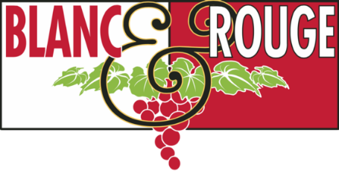
Wine Club Tasting Notes
Feb. 14, 2020
Tier II
Tier III
Tier IV & V

TIER I
Red

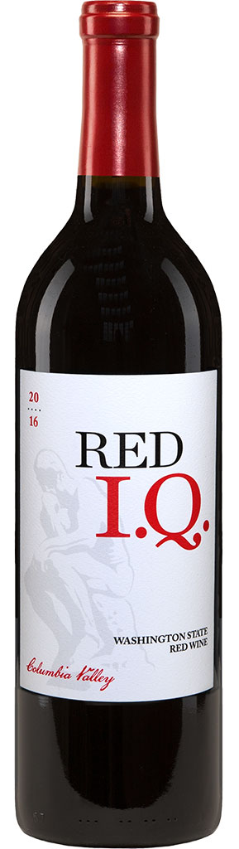
Pamplin Family Winery IQ Red Blend ($17)

IQ Red Blend is the collaborative brainchild of Art North and Robert Henry, the duo behind the highly-acclaimed Pamplin Family Winery. Their goal is to craft a wine that over-delivers on quality at a consumer-friendly value. This intriguing Bordeaux-style blend of Merlot, Cabernet Sauvignon, Petit Verdot and Malbec offers high-toned aromas, with notes of toasty spice and herb in front of raspberry and cherry. Supple and well-balanced, the fruit flavors show poise and length. Grapes for this wine are sourced from top vineyards in the Walla Walla Valley, Red Mountain, Horse Heaven Hills and Rattlesnake Hills.

Gabbiano Chianti Classico ($15)

Castello Di Gabbiano, a historic castle dating back to the 12th century, is set among 100 hectacres of olive trees and vineyards, about 20 miles outside of Florence. The winery, a working farm as well as an inn and restaurant, has built a reputation as one of the oldest and premier producers in Chianti. Made with 90% Sangiovese, 5% Merlot and 5% Colorino, this juicy wine opens with aromas of blue flower, black-skinned berry and a whiff of tobacco. The savory palate doles out Marasca cherry, licorice and black pepper alongside velvety tannins. Enjoy over the next few years.

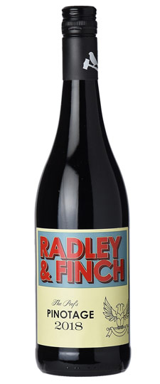
Radley & Finch ‘The Prof’s” Pinotage ($15)

Radley & Finch is a range of varietal wines made by Thinus Kruger and Pascal Schildt at their local coop in the Western Cape, South Africa. Their motto: “Optimism, beats the pants off pessimism. We want these wines to be an honest path for wine drinkers to delve into the special world of premium South African wines over time.” The majority of the grapes are sourced from the Voor-Paardeberg Mountain (1 hr north of Cape Town) and a small portion from Stellenbosch.

A fresh, approachable style of Pinotage. This wine is fermented and aged in stainless steel. Aromas of blackberry, leather, coffee, and dates are followed by gentle spice, and notes of cola, dark chocolate, and red fruit.

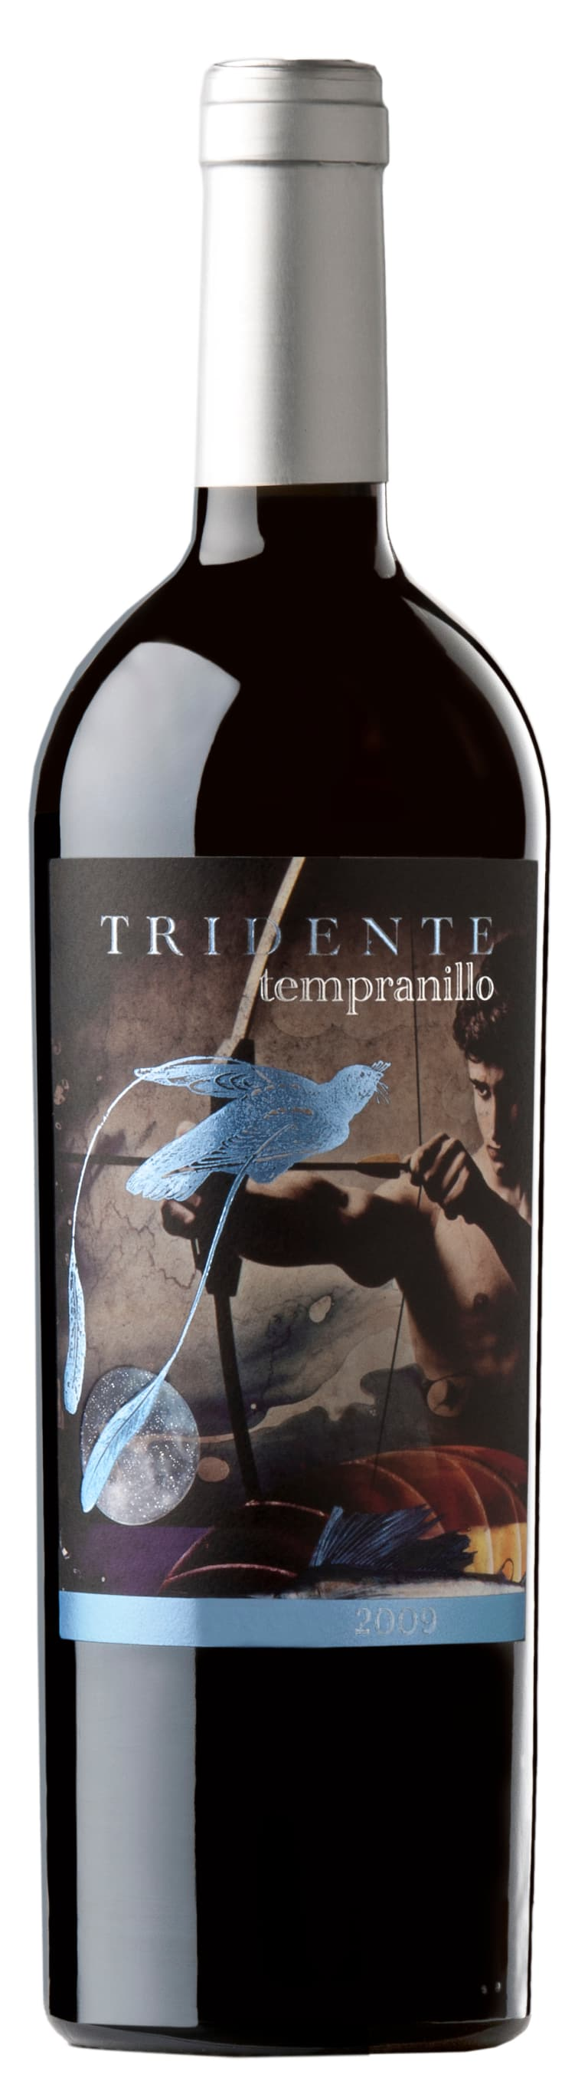
Bodegas Tridente Tinta de Toro ($12)

The facilities of Bodegas Tridente are located in Villanueva de Campean, 30km south of Zamora, Spain. The winery was designed for small productivity of red grapes, especially those of the indigenous Tinta de Toro (Tempranillo) varietal. This deep purple wine has notes of toasty oak, graphite and balsamic. The flavors are densely fruit with crème de cassis persisting through the lingering finish.

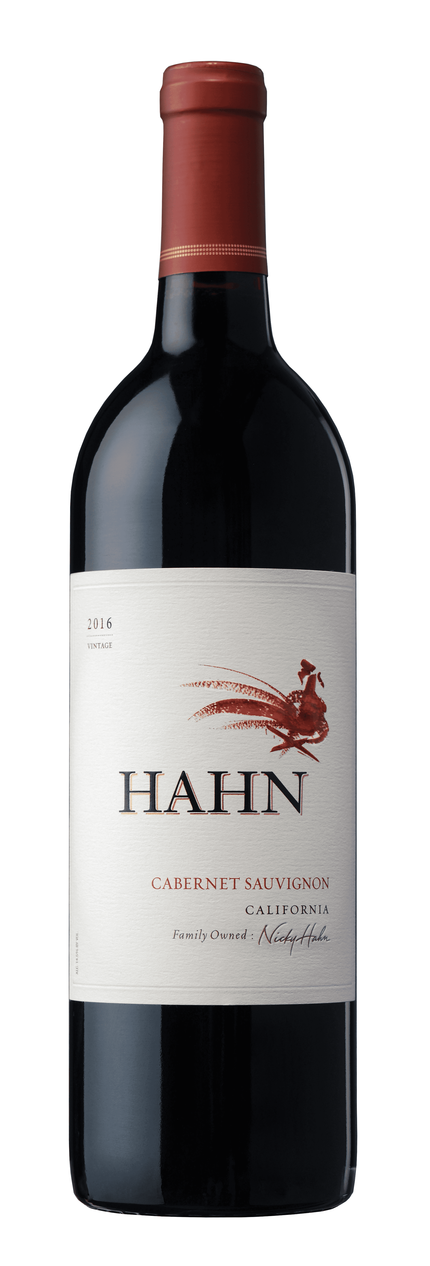
Hahn Cabernet Sauvignon ($15)

The grapes for this Cabernet Sauvignon grow in outstanding vineyards planted throughout Monterey County, CA. Inviting red cherry and currant jam aromas complement notes of vanilla and caramel. Chewy tannins frame bright cherry and berry flavors that carry through the long, smooth finish.

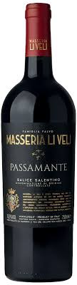
Masseria Li Veli Salice Salentino Passamante ($15)

Masseria Li Veli is located on an ancient Messapian site dominating the fertile and sunny Salento plain. A pine forest known as “Passamante” or “The Forest of Lovers” surrounds the vineyards of Negroamaro that produce fruit for this wine. This grove was historically a romantic place where loved ones would meet in secrecy-- “Pass” (to pass) and “Amante” (lover). Dense ruby red with a purplish rim, it is immediately intense on the nose with marked aromas of ripe and fleshy red fruits, notably cherries followed by spicy notes of cinnamon and nutmeg; in the mouth it is full, powerful, smooth and very long, with a well defined acid streak which makes it fresh and pleasing.

White

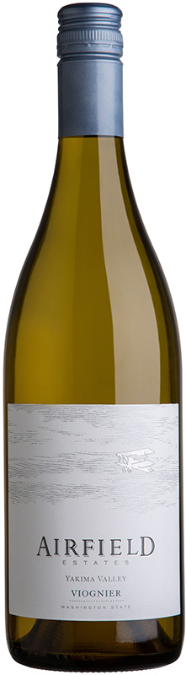
Airfield Estates Viognier ($15)
Airfield Estates has a deeply rooted history that traces back to 1907 when founder H. Lloyd Miller, pioneered to the northwest settling in Sunnyside, Washington. Originally leased as a base for the Army Air Corps pilots in WWII, the family’s property, Airport Ranch, is now home to 1180 acres of grapevines. Vivid aromatics of ripe pear, banana peel, and honeysuckle carry through to the palate. Secondary flavors of marzipan intertwine with the fruit adding a layer of complexity. Richly textured and exceptionally balanced, this wine leaves a smooth, creamy mark on the finish.

Clos de la Chapelle Muscadet ($15)

Bone-dry, super-aromatic and breathtakingly elegant, this Muscadet possesses a sophistication not often seen in the varietal. Lilac flowers and lemon zest aromas mingle in the citrus mouthfeel while a minerally streak of acidity dances throughout. Muscadet is ideally paired with anything sourced from the sea.

Lagar de Condesa Albariño ($17)

This classic bottle of Albariño was produced in the Val do Salnès in Northwest Spain, where the grape is the predominant varietal in the region. Yellow and greenish glints of color with a golden iridescence. Aromas of pineapple, passion fruit, lychee and pear. The wine has a full mouthfeel of ripe fruit, very nice acidity and a long, persistent finish.

Hahn Chardonnay ($15)

The Chardonnay grape favors cooler climates. Most of the fruit for this wine grows in the Arroyo Seco appellation of Monterey County where cool winds from Monterey Bay bathe the vineyards. This climatic condition causes fruit to ripen slowly, resulting in balanced, vibrant flavors, while the region’s rocky-loam soils help juxtapose ripeness with acidity. Aromas of tangerine, white peach, honey and smoky lees. Sappy and round in the mouth, offering ripe orchard and pit fruit flavors that become livelier and spicier as the wine opens up. The spicy note carries through a persistent finish.

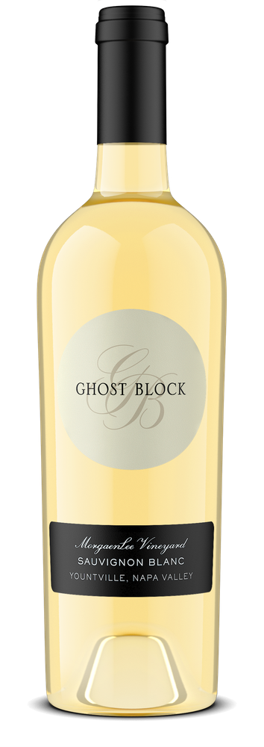
Ghost Block Sauvignon Blanc ($15)

Ghost Block Single Vineyard wines are created from the highest quality fruit from the owners’ four finest organically-farmed vineyards—the MorgaenLee and Ghost Block Vineyards in the Yountville AVA and the Pelissa and Rock Cairn Vineyards in the Oakville AVA. This bright and silky sur lie aged Sauvignon Blanc boasts with aromatics of peach, pear, and guava. This wine has lively acidity of white grapefruit and a beautiful citrus backbone.

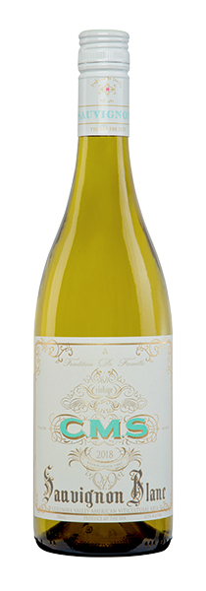
Hedges Family Estate CMS Sauvignon Blanc ($15)
Tending to the riches of Red Mountain with a visionary blend of biodynamic farming and time-honored winemaking techniques, Hedges Family Estate lends an ear to the earth and a voice to the vines. Light straw color. Lively aromas of lemon peel, lemongrass, fresh warm pineapple and shortbread, with just a touch of sweet almond pastry. Refreshing acidity dances on the tongue with a hint of green apple flavor, which leads you into a pleasantly creamy lemon custard finish. This wine combines the more interesting aromatics and acidity of Sauvignon Blanc and cooler climate unoaked Chardonnay with the more inviting mouthfeel of a fuller bodied, warmer site Chardonnay. Blend: 76% Sauvignon Blanc, 23% Chardonnay, 1% Marsanne

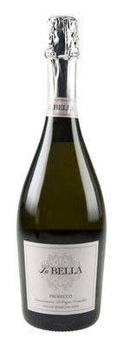
La Bella Prosecco ($15)

Prosecco is a sparkling white wine from north-eastern Italy, specifically the Veneto and Friuli-Venezia Giulia wine regions. It is also the informal name for the grape variety used to make these wines, which is now known officially as Glera. This is a crisp, fruity sparkling wine with aromas and flavors of apple and peach.

TIER II
Red
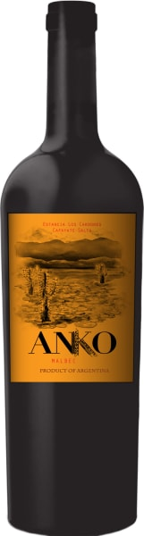
Anko Malbec ($20)

Anko means “high water” in the native language of Salta, located in the northwest corner of Argentina. In this rugged, mountainous desert, an “Anko,” or high altitude oasis, was treasured as a precious sanctuary, protection from the harsh elements of nature. The winery’s estate vineyards in Estancia Los Cardones, named for the area's majestic cacti, which can grow as tall as 30 feet, are indeed an oasis amid the surrounding jagged landscape.
The very intense sunshine at 5,700' elevation produces concentrated dark fruit flavors. The cold Andean nights lend floral and sweet spice aromatics. This shows lots of dark plums, morello cherries, blackberry compote, a touch of some hot stones and bark. Full body, a lovely serving of fresh acidity, juicy tannins and a medium chewy finish.

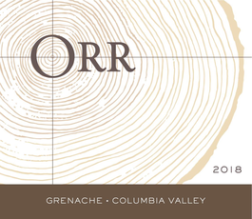
Orr Wines Grenache ($25)

Erica Orr, a skilled biochemist and winemaker, moved to Washington State in 2005 to found an independent winemaking consulting and enology business. Since then she has been a valuable member of the Woodinville wine community—consulting wineries such as Mark Ryan, Guardian, Sparkman, and Baer (where she is currently head winemaker). In 2013, Erica created her namesake label to produce two wines—old-vine Chenin Blanc and Grenache.
Blended with a touch of Mourvedre and Syrah, this wine shows lighter cinnamon and toasty oak aromas that connect with bright red fruits. Red cherry puree, cran-pomegrnaate and sage flavors all nicely combine in the glass. This is an excellent effort that will cellar well over the next 8+ years.

La Spinetta Il Colorino Di Casanova ($25)

La Spinetta’s Tuscan Estate lies in the village of Terricciola, between Pisa and Volterra. The Rivetti family produce wines from three indigenous varieties: Sangiovese, Colorino, and Vermentino.

Much like Petit Verdot in Bordeaux, Colorino is primarily a blending grape used to provide Chianti its deep ruby color. This bottling of 100% Colorino displays intense aromas of spicy currant, plum, prune and pepper. The full-bodied palate has intense fruit and chocolate flavors with fine tannins and a fresh finish.

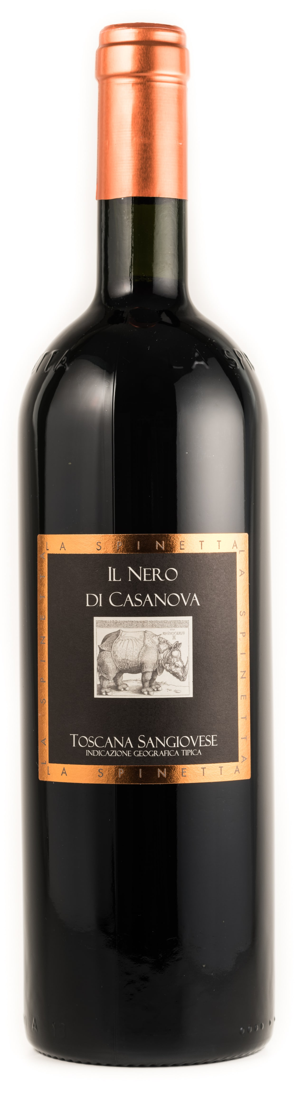
La Spinetta Il Nero Di Casanova ($25)

La Spinetta’s Tuscan Estate lies in the village of Terricciola, between Pisa and Volterra. The Rivetti family produce wines from three indigenous varieties: Sangiovese, Colorino, and Vermentino.

This bottling of 100% Sangiovese displays aromas of ripe cherry and mint. The dense, rich mouthfeel and grippy structure of the Sangiovese make this wine an ideal pairing with anything grilled or a hearty bowl of pasta.

Kontozisis ‘By Soft Nails’ Syrah ($27)

Andreas Kontozisis is an organic grower in Karditsa, a rural town in the region of Thessaly. Karditsa is known as the bicycle capital of Greece, and the homeland of the impressive Limniona red grape. The winery and vineyards are on the foothills of mount Agrafa, in two distinctive terroirs between Kanalia and Dafnospilia. “By Soft Nails” is a glugable and approachable fresh Syrah, of natural and unoaked vinification, expressing the optimal topography of Thessaly for this varietal. A rich nose of layered blueberry, vanilla, and cracked black pepper. The palate is similarly peak-Violet Beauregarde, with a dense body, creamy tannins, and rich plum compote. Cheeky, rich and fun, making it ideal for transition from Sunday roast to dessert.

Acustic Celler Tinto, Monsant ($25)
Tucked away in a mountainous corner of northeastern Spain, Montsant has long been in the shadow of its big brother, the neighbouring Priorat wine region which is known for its powerful red wines. Thanks to local winemakers like Albert Jané, the region is finally getting the recognition it deserves for its supple, intensely-flavoured red wines which offer tremendous value. Acustic Tinto Montsant is a traditional blend of the indigenous grape varieties Carinena and Garnacha which he carefully hand harvests from 35 to 65 year old vines. The result of his efforts is a deliciously smooth red wine bursting with enchanting red berry, cherry and plum aromas. On the palate the velvety tannins, well-rounded texture and generous fruit flavours are nicely balanced by a refreshing acidity. This easy-going red is equally at home being sipped on its own or paired with a plate of roast lamb seasoned with fragrant Mediterranean herbs.

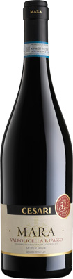
Cesari Mara Valpolicella Superiore Ripasso ($25)

Cesari was founded in 1936 by Gerardo Cesari who set out to produce an Amarone capable of competing with the great red wines of the world. Their estate holdings include more than 100 hectares of hillside vineyards located in premier sites in the Valpolicella appellation, including 3 single vineyards, primarily in the historic Classico area. In recent years, Cesari has adopted environmentally sustainable growing practices. Focused on quality, Cesari extensively ages their wines beyond the DOCG regulations.

Named after the Cesari family matriarch, Mara is vinified using the Valpolicella’s exclusive Ripasso technique. Fresh wine was refermented on the Amarone pomace to create a smooth, elegant wine with an aromatic bouquet of ripe cherries. Mara Valpolicella Superiore Ripasso boasts a persistent, warm finish with round tannins.
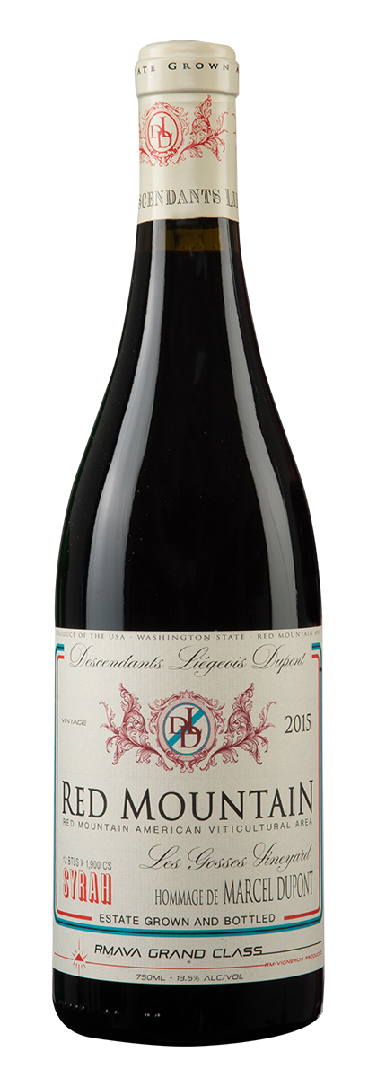
Hedges Family Estate ‘DLD’ Syrah ($28)
Tending to the riches of Red Mountain with a visionary blend of biodynamic farming and time-honored winemaking techniques, Hedges Family Estate lends an ear to the earth and a voice to the vines. Dark purple, almost black color. Dried fig and blueberry compote. Chocolate cherry, black licorice and cinnamon spice. Just a hint smoke, leather and cocoa make for an interesting nose that you could smell for hours. The palate is rich and lush with flavors of earthy cocoa, blueberry pie and a pinch of cinnamon. The finish is long and very well structured.

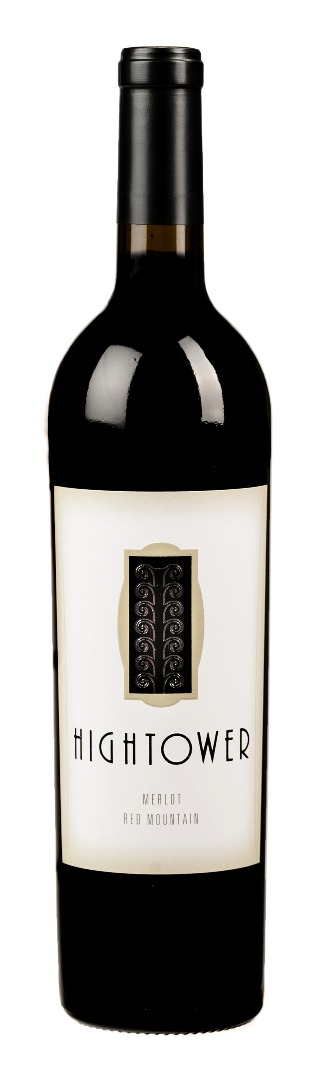
Hightower Red Mountain Merlot ($30)
There are two main styles of Merlot made around the world. The first, the “International Style,” waits to harvest the grapes till they are fully ripe and produces inky, full-bodied wines with velvety tannins and intense fruit flavors. The second, the traditional “Bordeaux style,” harvests the grapes earlier. Using fruit from Washington’s acclaimed Red Mountain AVA, winemakers Tim and Kelly Hightower tend towards the international style, but not so much that they lose structure and balance. Deep and dark red fruit notes dominate the palate with subtle undertones of raspberry, earth and spice. An extended finish that seamlessly blends the lush tannins into the mix.

Le Bec Fin Cabernet Sauvignon ($26)
Winemaker Jean Claude Beck, a long-time friend of Mina and Bruce, was born in the Alsace region of France to a winemaking family. As a child, he took his first steps among the Pinot Gris, Riesling, and Muscat vines of his family’s estate. Opportunities in Napa and the Yakima Valley led him to the American wine community. His expertise in both modern and traditional winemaking practices allow him to produce balanced, expressive wines under his Washington label—Le Bec Fin.

It opens with tobacco, cedar, minerality, earth, fennel, and spice. Full-bodied, this wine awards you with a juicy, rich mouthful of fresh, ripe Cabernet Sauvignon blended with a touch of Merlot. The long finish ends with a blast of fruit and spice, showing complexity with opulent layers of diversity.

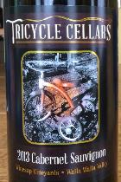
Tricycle Cellars Cabernet Sauvignon ($25)
Chuck Hundley, Class of ’13 in Walla Walla Community College’s viticulture and enology program, pulled from Winesap Vineyards in The Rocks District of Milton-Freewater for this expressive Cabernet Sauvignon as the debut release for his young brand. The nose offers hints of brambly Marionberry and blueberry with red currant, Western red cedar, moist earth and savory black olive. Its flavor profile features bright purple fruit akin to blackberry, boysenberry and Montmorency cherry. Well-managed tannins allow for a long finish of pomegranate acidity with Nutella and vanilla.

EFESTE ‘Taylor Mag’ Red Mountain Cabernet Sauvignon ($28)
EFESTĒ, pronounced F-S-T, is an acronym for the winery’s founders, Daniel & Helen Ferrelli – Patrick Smith – and Kevin & Angela Taylor. Their estate vineyard in the Red Mountain AVA, Taylor Mag Vineyard, utilizes a system of high-density planting and single cordon trellising, which work to create fruit with a higher flavor concentration including Cabernet Sauvignon, Merlot, and Petit Verdot. This wine starts off with ripe aromas of red cherry and red bell pepper with chocolate. The palate is plush with rich blackberry cobbler, milk chocolate and crushed mint flavors.

White
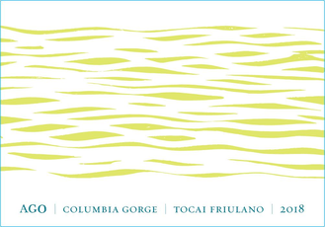
COR Cellars AGO Tocai Friulano ($28)

Tocai Friulano, known simply as “Friulano” in Friuli, Italy is often mistaken for Sauvignon Blanc due to its peachy, herbal flavor profile. This wine is a rare American bottling of the grape by COR Cellars, grown and produced in the beautiful Lyle, WA. This lean, dry white is one of few wines that can stand up to challenging pairings like green beans, artichokes, cabbage, and Brussels sprouts.

Le Bec Fin Blanc ($20)

Winemaker Jean Claude Beck, a long-time friend of Mina and Bruce, was born in the Alsace region of France to a winemaking family. As a child, he took his first steps among the Pinot Gris, Riesling, and Muscat vines of his family’s estate. Opportunities in Napa and the Yakima Valley led him to the American wine community. His expertise in both modern and traditional winemaking practices allow him to produce balanced, expressive wines under his Washington label—Le Bec Fin.

This bright, aromatic blend combines the fullness of Pinot Gris, the finesse and elegance of Riesling, and the delicate, floral notes of Muscat ottonel.

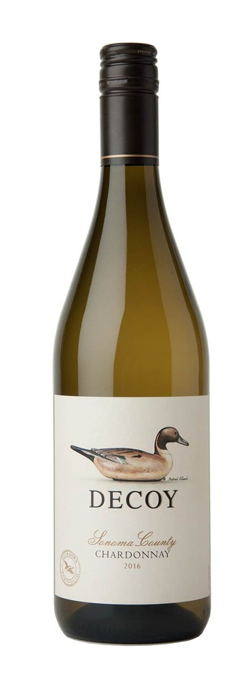
Decoy Chardonnay ($24)

Fruit for the Decoy program comes from a mix of Estate vineyards and top grower vineyards in Sonoma County, CA. Since their inaugural vintage almost 25 years ago, Decoy has taken an important place in Duckhorn Wine Company. Their labels feature a decoy Pintail duck carved by Richard “Fresh-Air Dick” Janson during the 1930s. Janson was a premier carver whose decoys are the most recognizable of all Pacific Coast carvings. This enticing Chardonnay offers vibrant layers of green apple, white peach and honeysuckle, as well as hints of cinnamon. On the palate, a supple texture from sur lie aging is balanced by bright natural acidity, which adds poise and length to the lush, pure fruit flavors.

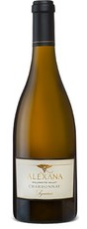
Alexana Chardonnay ($25)

Alexana Winery was born of Dr. Madaiah Revana’s love of the great wines of Burgundy. In the spring of 2005, Dr. Revana began a search for both the ideal region with the goal of producing Pinot Noirs that could rival those from Burgundy. His search ended in the Dundee Hills AVA of Oregon’s Willamette Valley. Alexana is named after Dr. Revana’s daughter, Alexandra.

This wine opens with freshly sliced green apple and green pear notes accompanied by crushed rock, crème frâiche, and faint white blossoms aromas. Medium-bodied with a streak of acidity and a mineral-driven finish, this ripe, full expression of Oregon Chardonnay would pair beautifully with smoked salmon or risotto with spring vegetables.

Callan Cellars Picpoul ($25)

Lisa Callan, a graduate of the Washington State University enology program, produces wines under her boutique, namesake label in Woodinville. She sources Picpoul de Pinet grapes from esteemed grower, Dick Boushey, in the Yakima Valley. A bright lemon-zest aroma leads the expressive nose of this white wine. Tart citrus flavors contribute to the puckering mouthfeel on the palate, brightened even further by a blast of acidity. It screams out for oysters.

Lyrarakis Winery Dafní ($22)

The Dafní grape variety was saved from extinction by the Lyrarakis family, when it was planted in the “Psarades” family vineyard at 480 meters altitude in central Crete in the early '90s. Its name derives from the laurel (bay leaf) plant, which is called “Dáfni” in Greek, as the wine produced resembles these aromas. A wine with a distinctive herbal character, refreshing mouthfeel and intense aromatic aﬅertaste, in a citrus fruit background.

Acustic Celler Monsant Blanc ($25)
These exciting wines, from very old vines in the DO of Montsant (a 'doughnut-like' ring of land that encircles Priorat on all sides) is the project of Albert Jané Ubeda. Unlike Priorat's famous slate soils Monsant has a mixture of terroirs with more clay, sand and slate vineyards. Planted with Garnatxa (Garnacha) and Samso (Cariñena). 60% Garnacha Blanca, 25% Macabeu, 10% Garnacha Roja (pink Grenache), and 5% Pansal (Xarel-lo). Stony with soft lemon on the finish. This mineral-driven, citrusy blend of indigenous grape varietals pairs beautifully with tapas as well as a roasted chicken a-la Ina Garten.

Le Devoy Martine Lirac Via Secreta Blanc ($25)

Aromas of pineapple, lemon and citrus blossom greet the nose. This wine from the Rhone Valley is generous, racy, clean and focused through the long finish. A refreshing, elegant white made of a blend of white Rhone varietals including Grenache blanc, Clairette blanc, Bourboulenc and Roussanne.

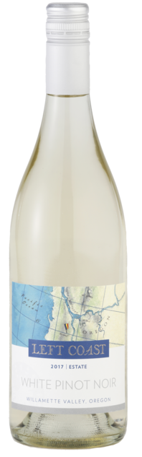
Left Coast Cellars White Pinot Noir ($24)

Famed for its diversity to complement nearly any food pairing, Left Coast Cellars’ White Pinot Noir is a people’s favorite. Limited skin contact gives the White Pinot Noir its pristine clarity. The wine itself is enticingly fruit forward with distinct aromas of white cherry, nectarine, peach, citrus, and beeswax. Its rich mid-palate is beautifully framed and focused with flavors of spiced pear, ripe honeydew, wet stone, and a mineral finish.

Cicada’s Song Rosé ($25)
This wine's name celebrates the chirrup of the cicada, a familiar Provençal sound. It is a smooth, creamy-textured wine with the ripe red fruits up front. It has tangy acidity as well as a crisp texture in the back, but enjoy this delicious wine mainly for its fruit. 50% Grenache, 50% Mourvedre.

Le Bec Fin Vin Rosé ($21)
Pale orange, mineral tinged aromas of raspberry and tangerine are complemented by a subtle floral top note. Shows good intensity and cut on the palate, offering tangy red berry and bitter cherry flavors, with a touch of zesty orange pith. Finishes on a nervy note, delivering solid punch, good tenacity and a lingering citrus note. Syrah and Viognier.

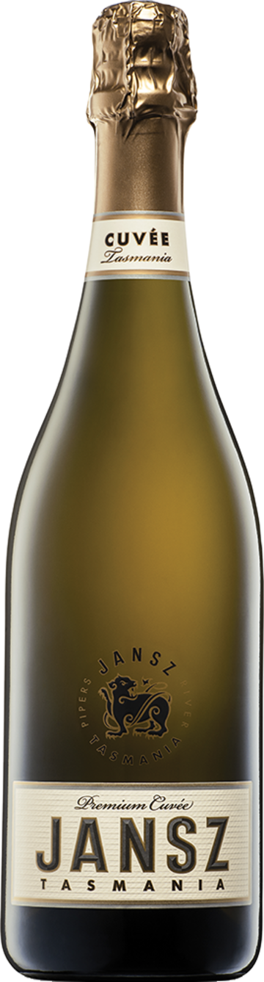
JANSZ TASMANIA PREMIUM CUVÉE ($25)
This sparkler is crafted by an all-female team of wine professionals in Tasmania using what they have termed their “Methode Tasmanoie”. The wild and “unforgivingly cold” Tasmania climate rivals the famed French region of Champagne. These cool-climate vineyard sites are all specifically-designated for the production of sparkling wine. A fresh nose with apples, fresh citrus and preserved lemons. Medium-bodied with some nice green and citrus fruit, steely acidity and a bright finish.

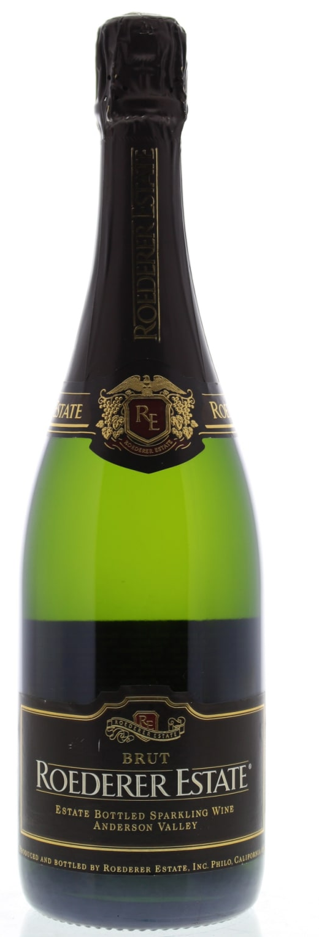
Roederer Estate Brut ($25)
Roederer Estate Brut, the first California sparkling wine produced by Champagne Louis Roederer, builds upon a 200-year tradition of fine winemaking that has made Roederer champagne among the most sought-after in the world. Medium straw color, refined beads; excellent aroma of ripe apples and light creaminess, maybe even a hint of hazelnut; medium bodied, delicately layered on the palate, excellent structure; dry, fine acidity, well balanced; complex flavors of ripe apples and cream; medium to long finish, fine nuances in the aftertaste.

Saint-Just Cremant de Loire Brut ($25)
Former banker, Yves Lambert, took over the Domaine in 1996; he is now joined by his son Arnaud who had completed his wine studies in 2005. Together they manage the 99-acre estate where they make a variety of wines just 5 miles south of Saumur village. An area famous for heavyweight Chenin Blanc and Cabernet Franc, the vineyards around Saumur also produce some great Chardonnay for blending into its sparklers. Domaine de Saint-Just delivers lots of bang-for-buck in this 60/40 blend of Chenin Blanc and Chardonnay. Medium-bodied, dry. A fruity nose followed by almond, quince, and pear on the palate. This finish has an elegant creamy texture with long flavors. Pair with cheese, fish, spicy food, or as an aperitif.

Domaine Riefle Cremant d’Alsace Brut ($25)
At Domaine RIEFLÉ, the winemakers have chosen to use Pinot Blanc and Pinot Auxerrois to make their Brut Blanc de Blancs. AOC Crémant d’Alsace is one of the many sparkling wine appellations in France. The Crémant d’Alsace is a fresh and elegant wine made using the ''traditional'' sparkling method which involves a second fermentation in the bottle to give it its effervescence. Toasted aroma with subtle white flowers on the nose. Rich and soft on the palate with a fine mousse, and balanced and dry on the whole.

TIER III
Red
II Vintners ‘Legit’ Cabernet Sauvignon ($34)

Two Vintners was founded in 2007 with a partnership between an acclaimed young winemaker, Morgan Lee, and the owners of Covington Cellars, David and Cindy Lawson. Staying true to the Two Vintners style this is not just a fruit-driven wine. Legit exemplifies that powerful red need not be a fruit bomb, but can be a focused blend of fruit and savory flavors. 83% Cabernet Sauvignon, 7% Petit Verdot, 5% Cabernet Franc, & 5% Merlot.

The bulk of this wine is sourced from Discovery, StoneTree, Pepper Bridge and Dineen vineyards. High-toned aromas of bruised apple, cherry, anise and dried herb are followed by sweet cherry flavors.

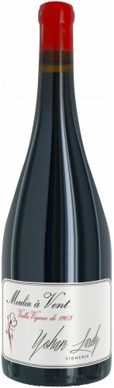
Yohan Lardy Moulin-à-Vent ‘Vignes de 1903’ ($34)

Yohan Lardy produces wines of elegance in Moulin-à-Vent in the northern Beaujolais region. All of his grapes are handpicked, and they’re vinified using only native yeast, without added sulfites. This wine is produced from fruit grown in a single vineyard that was planted in 1903 by the previous landowner. He selected “Riparia Gloire” rootstocks that were adapted to the iron-rich pink granite soil. This wine is firm and concentrated, with wood aging lending a minty character as well as a dry core. Low-yielding vines bring richness and a solid texture, which allow this wine to pair beautifully with roasted duck or game.

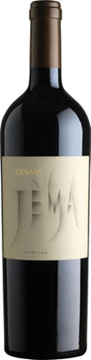
Cesari ‘Jèma’ ($40)

Cesari was founded in 1936 by Gerardo Cesari who set out to produce an Amarone capable of competing with the great red wines of the world. Their estate holdings include more than 100 hectares of hillside vineyards located in premier sites in the Valpolicella appellation, including 3 single vineyards, primarily in the historic Classico area. In recent years, Cesari has adopted environmentally sustainable growing practices. Focused on quality, Cesari extensively ages their wines beyond the DOCG regulations.

Derived from the Italian word gemma, which has a dual meaning of “vine bud” and “precious gem,” Jèma is a pure expression of Corvina – the region’s signature varietal. Produced from a 3-hectare single vineyard located in the heart of Valpolicella Classico, Cesari’s “gem” is full, supple, and well-balanced with rounded tannins. Cherries pervade the nose backed by toasted mocha notes lent from 18 months of aging in French oak barrels. The grapes were dried in crates for 20 days prior to vinification. This wine is produced in limited quantities in only the finest vintages.

Beckham Estate Pinot Noir ($33)

Andrew & Annedria Beckham founded Beckham Estate Vineyard in 2005 as a family project. Andrew is a ceramics instructor at Beaverton High School and actively produces pottery at his studio on the property. He was able to integrate his love of ceramics with wine after trying a bottle of tinaja-aged wine by the Italian winemaker, Elisabetta Foradori. This prompted him to build a set of experimental clay amphorae to find the correct firing temperature and porosity. Andrew’s amphorae are now being used in the vinification and aging of wine. Organically farming their estate vineyard at Parrett Mountain, and adding nothing but minimal sulfites at bottling - we love the bright crunchy red fruit and balanced mouthfeel here in this 400 case production bottling. A blend of all four clonal varieties planted, this vintage utilized 25% whole clusters and 15% new oak. This is fresh and energetic, without any of the bitter edge.

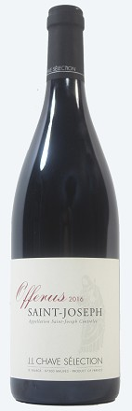
Domaine Jean-Louis Chave, Offerus Saint-Joseph ($44)

Wine growers in the northern Rhône since 1481, the Chave family (currently helmed by Gérard and son Jean-Louis) represents 16 generations of unbroken lineage committed to the production of some of the finest Syrah, Marsanne, and Roussanne on the planet.
The Chave family's methods for their winemaking include traditional farming, super low yields, full ripeness, and minimal manipulation. Their unmatched meticulousness continues through five centuries to render venerable expressions of the purest of northern Rhône terroir. Brilliant magenta. Expansive scents of fresh blackberry and boysenberry are complicated by suggestions of cracked pepper, olive and pungent flowers. Sappy, appealingly sweet dark berry preserve and cherry flavors show sharp delineation and spice and mineral qualities that build with air. Finishes with strong, energetic cut, well-knit tannins and lingering sweetness.

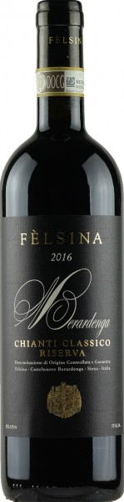
Felisna Chianti Classico Riserva ($43)

Fèlsina is located on the southeast edge of the Chianti Classico appellation, between the last spurs of the Chianti hills and the beginning of the Ombrone valley. The entire Fèlsina estate covers 600 hectares, of which 95 is planted with vines. From a geological viewpoint, Fèlsina is a “frontier land” nestled between the Chianti Classico and Crete Senesi areas, in the direction of Montalcino. The estates of Fèlsina, developed over more than a thousand years, still represent the basic drive of the winery team’s work culture, despite the post-WWII exodus from the countryside by sharecropping families. Flavors of black cherry, plum, earth, chestnut, leather and bark are matched to a dense, brooding profile. Needs time to find balance, while cherry notes lurk beneath as this plays out on the firm, dry finish.
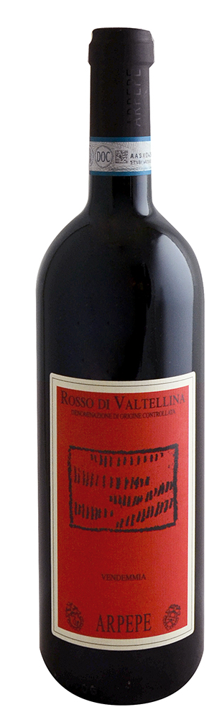
Ar.Pe.Pe Rosso di Valtellina Nebbiolo ($39)

In 1984, Arturo Pelizzatti Perego decided to resurrect his family's winery under the moniker Ar. Pe. Pe. His father and grandfather had both run their family winery in Valtellina but sold it in the 1970s. Today, Arturo's three children, Isabella, Emanuele and Guido continue their father’s work as the family's fifth generation of growers.
The mountain region of Valtellina sits near the Swiss border and is one of the most picturesque of Italy. From steep, south-facing, and terraced mountain vineyards the Pelizzattis produce beautifully restrained styles of Nebbiolo, or Chivanesca as it is called in Valtellina. Delicate scents of wild berry, star anise and alpine herb float out of the glass. On the polished palate, supple tannins lightly support juicy Marasca cherry, strawberry preserve and clove. A mineral note wraps up the finish.

White

Brick House ‘Ribbon Ridge’ Chardonnay ($29)

Brick House Vineyards produces estate grown wines from the three great varietals of Burgundy: Pinot Noir, Chardonnay, and Gamay Noir. Their vineyards have been Certified Organic since 1990 and Demeter Biodynamic since 2005. In what was once the farm's horse barn, they produce about 3,800 cases in accordance with both standards - native yeast fermentations and minimal handling to produce wines that are both elegant and profound in their simplicity. All the Brick House wines are produced and bottled by hand on their 40-acre farm. A deep straw-yellow moving to a clear-tipped rim. Its wonderfully rich nose is accented by a persisting brightness as it erupts with ripe yellow and green apples, lemon meringue, hazelnut, pineapple core, white pear, and candied lime peel that are all intertwined with vanilla, crushed rocks, acacia, and honeysuckle. The energetic palate is nearing medium-plus bodied and delivers ripe, mouthwatering orchard fruits that linger until the next sip. This is firmly structured Chardonnay with brilliant crispness and tension—like those you’d find in Chassagne-Montrachet and its surrounding villages.

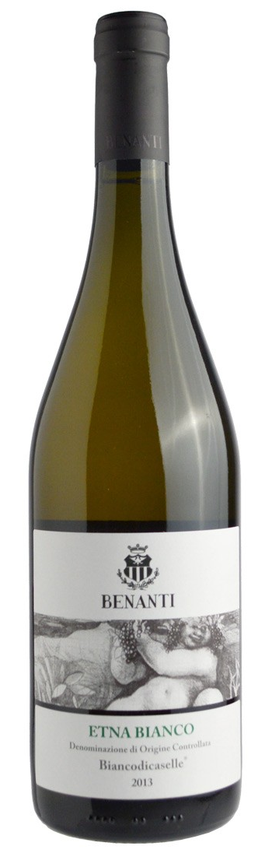
Benanti Etna Bianco ($28)
At the end of the 1800’s, Giuseppe Benanti, grandfather of Dr. Giuseppe Benanti, began the production of wines on one of his father’s old farms on the slopes of Mount Etna, at Viagrande (Catania). In 1988, Giuseppe Benanti revived the family’s old passion, with an extensive and selective study of the Etnean soils highly devoted to viticulture. Blessed with a long growing season at high altitudes on the eastern slopes of the Etna Volcano, the 100% Carricante fruit in this bottling displays profound mineral depth and floral aromatics reminiscent of both Chablis and the Savoie. It’s hard to believe that a white from this far south can feel so much like a wine of the cool, mountainous north, but such is Etna—implausible and amazing, with wines to match. In the glass, it’s a reflective straw-gold with hints of green at the rim, with aromas of green apple, white grapefruit, lime zest, white flowers, and a note of smoke/flint reminiscent of Pouilly-Fumé.

Chateau d’Épiré Savennières Cuvee Speciale ($32)

One of the oldest and most celebrated domaines in Savennières, Chateau d’Épiré is rich in history, not only for its fabulous architectural rendition of the Petit Trianon of Versailles, but most especially for its exquisite wines. Savennières is situated just southwest of Angers, on the north bank of the Loire River. Vines have been cultivated there since the time of the Romans. The bouquet jumps from the glass in a very classy melange of orange, pear, powdered stone, citrus blossoms and a faint hint of honeycomb. On the palate the wine is deep, full and vibrant, with a fine core of fruit, impeccable focus and balance. A wine that combines the richness of the vintage with the extreme flinty texture of young, dry Chenin Blanc. Packed with ripe acidity, it is pure, very crisp, yet for aging.

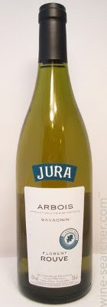
Florent Rouve Arbois Savagnin ($30)

Emerging superstar Florent Rouve was partners with famed Burgundian negociant Jean Rijkaert until 2013 when he took the reins alone. Producing in two of France’s hottest winemaking regions, the Maçonnais and Jura, Rouve’s oenological approach emphasizes freshness, integrity, balance and terroir and offers superb alliance of tradition and a modern, minimalist style. 100% Savagnin, also known as Traminer, the signature grape of the Jura region. Made with native yeasts, 100% hand harvested. Dry white with good acidity. Typical citrus and floral character with a hint of tropical flavors.

Upchurch Southwest Facing Sauvignon Blanc ($35)

This is the inaugural vintage of Upchurch’s first white wine 100% Sauvignon Blanc from a single plot in Boushey Vineyard. Only 200 cases produced. Aromas of pear, lime chutney, honey save and passion fruit. This riper Sauvignon Blanc exhibits great purity and complexity with an elegant yet plush mouthfeel. The flavors show white peaches, honeyed stone minerality and bosh pear plus mouthwatering and juicy lime acidity. The finish is compact, long and very promising.

Domaine de la Garreliere Touraine Le Chenin de La Colline ($35)

Located near the small town of Richelieu, in the most Southern part of the AOC Touraine in the Loire Valley, lies Domaine de la Garrelière. After phylloxera wiped out production in the late 19th century, the Plouzeau family acquired the estate in 1973 and replanted vines. Pascale and Francois took over in 1985 and fully converted the now 50 acres to biodynamic farming. The terroir is mostly clay and limestone mixed with sandy soils and rocks. The unique labels produced by local artists that reflect the naming of the wine.A dry and crisp organic white wine with a golden pale yellow colour with green hues. The pronounced aromas of green, such as gooseberry and crushed herbs follow through into the flavour profile with a medium body and refreshing finish.

TIER IV
NV Champagne Lelarge-Pugeot Tradition Premier Cru Brut ($53)

This ripe and creamy wine offers a good depth of flavor. It has plenty of fresh apple flavors, although the dominant fruits are riper, richer and tangy with orange zest and apricots. To balance all this fruit, the texture is tight with a good streak of minerality to give a crisp aftertaste. 65% Pinot Meunier, 20% Pinot Noir and 15% Chardonnay.

Champagne Colin Champagne Brut Blanc de Blancs ($55)

Growers based in Vertus, at the southern end of the Chardonnay-dominated Côte des Blancs, the Colin brothers have made a deliciously balanced wine that is rich, with some age, along with good concentration, weighty green fruits, and a touch of almonds. 100% Chardonnay.

Marie Copinet NV Caractère Rosé Brut ($51)

This is a structured style of rosé with a tannic edge as well as red-currant flavors. It is fruity, dry and with fine refreshing acidity to finish this fragrant wine. 50% Chardonnay, 30% Rosé de Saignée Pinot Meunier, and 20% Pinot Noir.

Lanson ‘White Label’ Dry Sec ($50)

38% Chardonnay, 37% Pinot Noir and 25% Pinot Meunier. Pale gold. Spicy pear, melon and white peach scents and flavors are lifted by a note of tangerine. Emphatically fruity, showing good depth and energy for its sweetness. Closes smooth and long, with a touch of ginger adding bite.

Louis Armand Premier Cru Brut ($36)

Pale straw color with subtle pink hues. On the nose gentle aromas of fresh croissants, poached plum and vanilla. Refreshing, mouthwatering palate with notes of apple. Soft acidity. Grippy, long finish.

Hugues Godme Blanc de Noirs Champagne Grand Cru ($70)

A 100% Pinot Noir Cuvee disgorged in January 2016 with 6 years on lees. Pours with a very fine lacy mousse that possesses excellent staying power. Pale straw colour with pale gold edges and an exceptionally fine bead that shows good persistence. Beautiful fresh aromatics of yeast lees and baked bread rise to the top over hints of strawberry, light toast and cashew. Very refined yet rich the palate has well meshed flavours of yeast lees, toast and citrus within a light airy mouthfeel.

TIER V

JB Neufeld ‘Old Goat’ Reserve Cabernet Sauvignon ($63)

As head winemaker for Gilbert Cellars in the Yakima Valley, winemaker Justin Neufeld is well acquainted with some of the best vineyards in Washington State. Together with his wife Brooke, he created his namesake label to exclusively craft world-class Cabernet Sauvignon.
Only 60 cases were produced of this reserve Cabernet Sauvignon which features fruit from Artz, DuBrul, and Two Blondes vineyards. “Old Goat” displays intense aromas of plum and mint. Full-bodied with deep flavors of black cherry, lovely acidity and velvety tannins, this wine will drink beautifully for years to come.

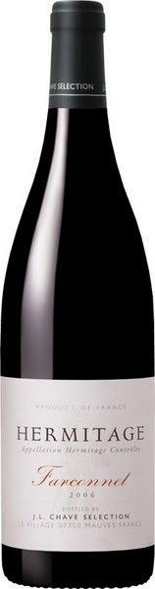
Domaine J.L. Chave Farconnet Hermitage ($92)

Wine growers in the northern Rhône since 1481, the Chave family (currently helmed by Gérard and son Jean-Louis) represents 16 generations of unbroken lineage committed to the production of some of the finest Syrah, Marsanne, and Roussanne on the planet.
The Chave family's methods for their winemaking include traditional farming, super low yields, full ripeness, and minimal manipulation. Their unmatched meticulousness continues through five centuries to render venerable expressions of the purest of northern Rhône terroir.
Ripe and fleshy in feel, with an open-knit personality to the mix of steeped blackberry and black cherry compote flavors, backed by warm anise, smoldering black tea and loam notes. Offers well-integrated grip through the finish, making this approachable while giving it staying power. Drink now through 2032.

Ar. Pe. Pe. Valtellina Superiore Inferno Fiamme Antiche Reserva ($82)

In 1984, Arturo Pelizzatti Perego decided to resurrect his family's winery under the moniker Ar. Pe. Pe. His father and grandfather had both run their family winery in Valtellina but sold it in the 1970s. Today, Arturo's three children, Isabella, Emanuele and Guido continue their father’s work as the family's fifth generation of growers.
The mountain region of Valtellina sits near the Swiss border and is one of the most picturesque of Italy. From steep, south-facing, and terraced mountain vineyards the Pelizzattis produce beautifully restrained styles of Nebbiolo, or Chivanesca as it is called in Valtellina. They choose to stay loyal to the region's traditions and avoid the trappings of modern winemaking technology, instead opting for long macerations and old large-format chestnut and oak barrels.
Fiamme Antiche is 100% Nebbiolo (50 year old vines) sourced from Inferno, the "burning terraces". Aromas of flint, pressed rose petal, dark spice and a light balsamic note delicately lead the nose. The slim palate is vibrant and smooth, offering sour cherry, crushed herb and a smoky mineral note framed in bright acidity and taut, refined tannins.

