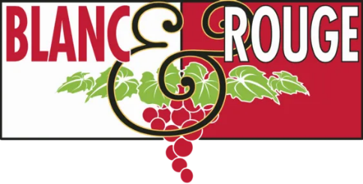
June 2022 Bubble Club

Sunshine. Pouring rain. Thunderstorms. Sunshine, again. Rain, again. We do our best to select wines to fit the season, but it’s difficult to embrace summery selections when the weather outside is screaming October! more so than the middle of June. This month, we turned to two favorites— Premier Cru Champagne and Cava— to carry us through whatever Mother Nature has in store for us for the Summer Solstice.

This June, your Bubble Club selections include:

Nicolas Maillart Premier Cru Champagne
During a recent Farmers Market Thursday, our distribution partner and friend of the shop, Steve Hoverson, sidled up to our wine bar with a sample bottle of this gorgeous grower-producer Champagne. It was pouring down rain, and Steve generously filled our glasses as we lamented over this Pacific Northwest June-uary. The wine brightened us up, and we knew we had to share it with all of our Bubble Enthusiasts. The Maillart Family has been farming grapes in the village of Montagne de Reims since at least 1753, though there is evidence that they may have been associated with these vineyards 200 years prior. Nicolas (9th generation) has been in charge since 2003. He is deeply committed to sustainable farming. Maillart is one of the first Champagne estates labeled both HVE (Haute Valeur Environnementale or High Environmental Value in English) and sustainable viticulture. His installation of photovoltaic panels resulted in energy production almost equaling their usage. The 8.5-hectare estate of only Premier and Grand Cru vineyards in Bouzy, Ecueil and Villers-Allerand are planted to 75% Pinot Noir and 25% Chardonnay. This Champagne is ripe and full of crisp green-apple flavors. Although described as Extra Brut and with a suitably low dosage, the wine has richness from the ripe fruits that balance with acidity and minerality.

Naveran Cava Brut Rosado
The “white” Naveran cava has been a longstanding favorite among our Spanish sparkling selections. Its rosado counterpart is just as dreamy. Naveran Brut Rosado is an estate-bottled vintage organic Cava made from Pinot Noir and the traditional Parellada grape. The Naveran family legacy began in 1901. Today the estate has 110 hectares (272 acres) of vines in the town of Torrelavit located in the Alt (high) Penedés sub-region, about 30 minutes outside of Barcelona. Cava is produced utilizing the same methods as in Champagne and has remained Spain's best-kept secret. Bodegas Naveran is a premium Cava producer that exclusively uses the organic grapes they farm on their own properties. Naveran Brut Rosado spends at least 12 months on its lees after fermentation in the bottle to achieve greater depth, complexity, and elegance. The Pinot Noir character in this wine is apparent throughout, with beautiful bright red fruit and a compelling vinous character and texture.

