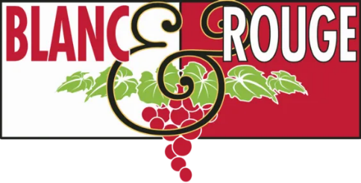
June 2022 Explorers Club: Italy’s Apulia (Puglia)

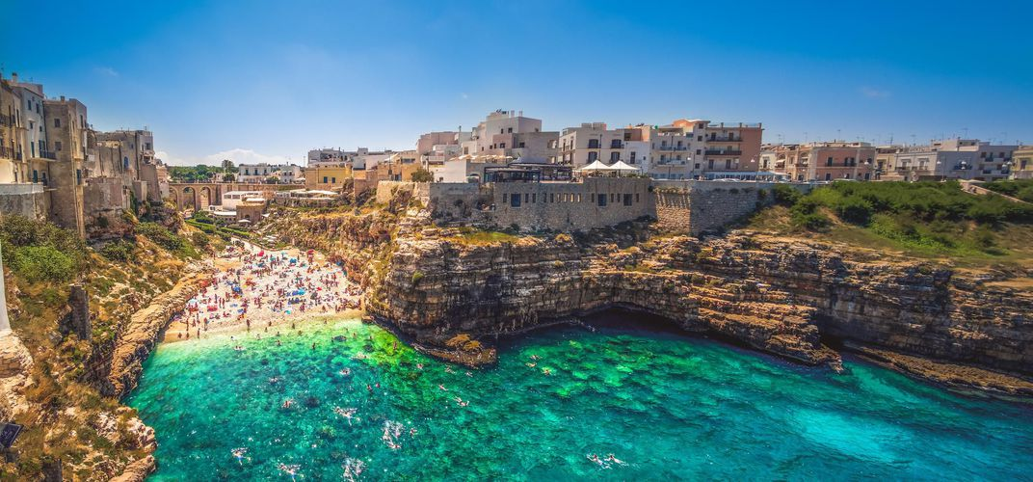

While we at Blanc & Rouge champion rosé year-round and feel Champagne pairs with countless occasions beyond New Years Eve, there are certain wines that cry out for a specific season. Such is the case for the two wines featured in your June Explorers Club!

As we finally get to experience sunny weather in the Pacific Northwest, the wines from “the heel of the boot,” Italy’s Apulia (Puglia) region, are some of our summer favorites. Apulia is surrounded on three sides by the Mediterranean, and while it may be known for its vibrant blue water and pristine beaches, vintners in the area are producing some of the greatest values in Italian wine. From powerful, peppery reds to citrusy, lean whites these are the wines we grab for backyard BBQs, because they are crowd-pleasers that pair with everything coming off the grill.

This month we are featuring two wines from Agricola Felline. Gregory Perrucci, the owner and operator of Felline, is much more than a winemaker. Most importantly, he has made a name for himself internationally through his research organization Accademia dei Racemi. They were the first to champion the Primitivo grape in the Puglia region, previously only used to produce cheap bulk wine, and the first to commit serious effort to studying the many facets of the area’s different soils. The project began as a collection of five vineyards participating in Puglia's original experiment in soil analysis. Led by Gregory, this innovative group of wineries and wines has shaped the culture of Southern Italian wine and is pushing the limits of varietally correct expressions of their diverse grape varieties. They focus only on older, native grapes, mostly unknown and underrated on the market: Negramaro, Ottavianello, Malvasia Nera, Sussumaniello, Primitivo. The most important results were achieved on the Malvasia Nera, and, recently, Verdeca and Vermentino.

Red Selection: Felline “Sum” Susumaniello 100% an indigenous red grape called Susumaniello, that is incredibly rare to find in the United States market. A ruby red tending towards the violet, this is a robust wine with intense fruity notes. Black cherry, berries, and baked blackberry are strong on the nose and complemented by spicy notes. It is full-bodied and smooth with velvety tannins and a rusty metal finish. The strong fruit and spice of this Susumaniello are best paired with red meats and traditional Puglian and Mediterranean dishes.
White Selection: Felline Fiano Fiano is another indigenous Italian grape, mainly found in Southern Italy and the isle of Sicily. It’s a lovely white wine with a salty aftertaste reminding you of the coastal influence. Golden color, medium peach, lemon, and other citrus fruits. Good acidity, pairs consistently with seafood or shellfish.

