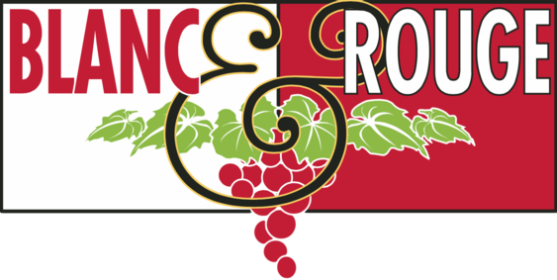

Bubble Club Members,

Your March Bubble Club selections are ready for pick-up!

This month we are exploring two examples of *Methode Champenoise*(also referred to as the "Traditional Method"). This is a winemaking process used by sparkling wine producers around the world, and most prominently in its place of origin-- the Champagne region of France.

For more information, this graphic from Wine Folly is a fantastic resource.

[Link to Wine Folly](https://winefolly.com/deep-dive/how-sparkling-wine-is-made/)

This month we are pairing a stunning, classic Champagne alongside a California sparkling wine, made by an iconic American producer, inspired by the wines of Champagne. Your selections include one bottle each:

**André Jacquart "Vertus Experience" Extra Brut Blanc de Blancs Champagne**

100% Chardonnay

The André Jacquart wines are “grower champagne” in the truest sense. For four generations, the parents and grandparents of André Jacquart only produced Champagne grapes and sold them to other wineries. In 1958 André Jacquart introduced a new spirit in the family, producing his own estate-bottled Champagne.

Brilliant pale gold, with a tight bead and persistent mousse. The Chardonnay provides green pear apple and toasted bread on the nose, with distinct wet stone minerality. Lush creamy mousse upon entry, rich full and crisp, with warm toasty elements. Explosive aged Chardonnay elements, intense minerality and great depth of flavor. Length and persistence of Burgundian-style Chardonnay in the finish. Regardless of whether a festive occasion, aperitif high class, or with dinner, this wine deserves to be enjoyed with delicate dishes such as a Sole “Meuniere,” steamed lobster, or halibut.

**Decoy by Duckhorn Brut Cuvée**

49% Pinot Noir, 47% Chardonnay, 4% Pinot Meunier

Established more than 30 years ago by legendary vintners Dan and Margaret Duckhorn, the Decoy brand has deep roots in California. From vine to bottle, the Duckhorn team crafts wines to the highest standards, using grapes from exceptional vineyards. This brand new Brut Cuvée is crafted in the méthode champenoise tradition to ensure that your special moments truly sparkle.

The cuvée is an enticing sparkling wine that offers alluring layers of baked apple, white peach and orange zest, as well as aromatic hints of honeysuckle and vanilla. On the palate, a delicate sweetness is perfectly balanced by bright acidity, which adds poise and energy to the lush, pure fruit flavors.

This month we have also included a special gift in your bag, which we hope will complement your home wine bar supplies.

Please feel free to reach out to me if you have any questions about these wines.

Cheers, and we look forward to seeing you soon!

Ally Ingalls

Wine Club Manager

Blanc & Rouge, Snohomish, WA