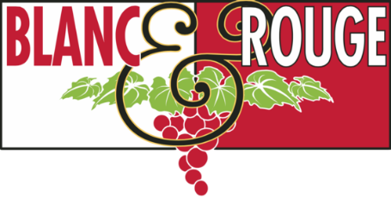
Wine Club Tasting Notes
May 1, 2020

Viva l’Italia!

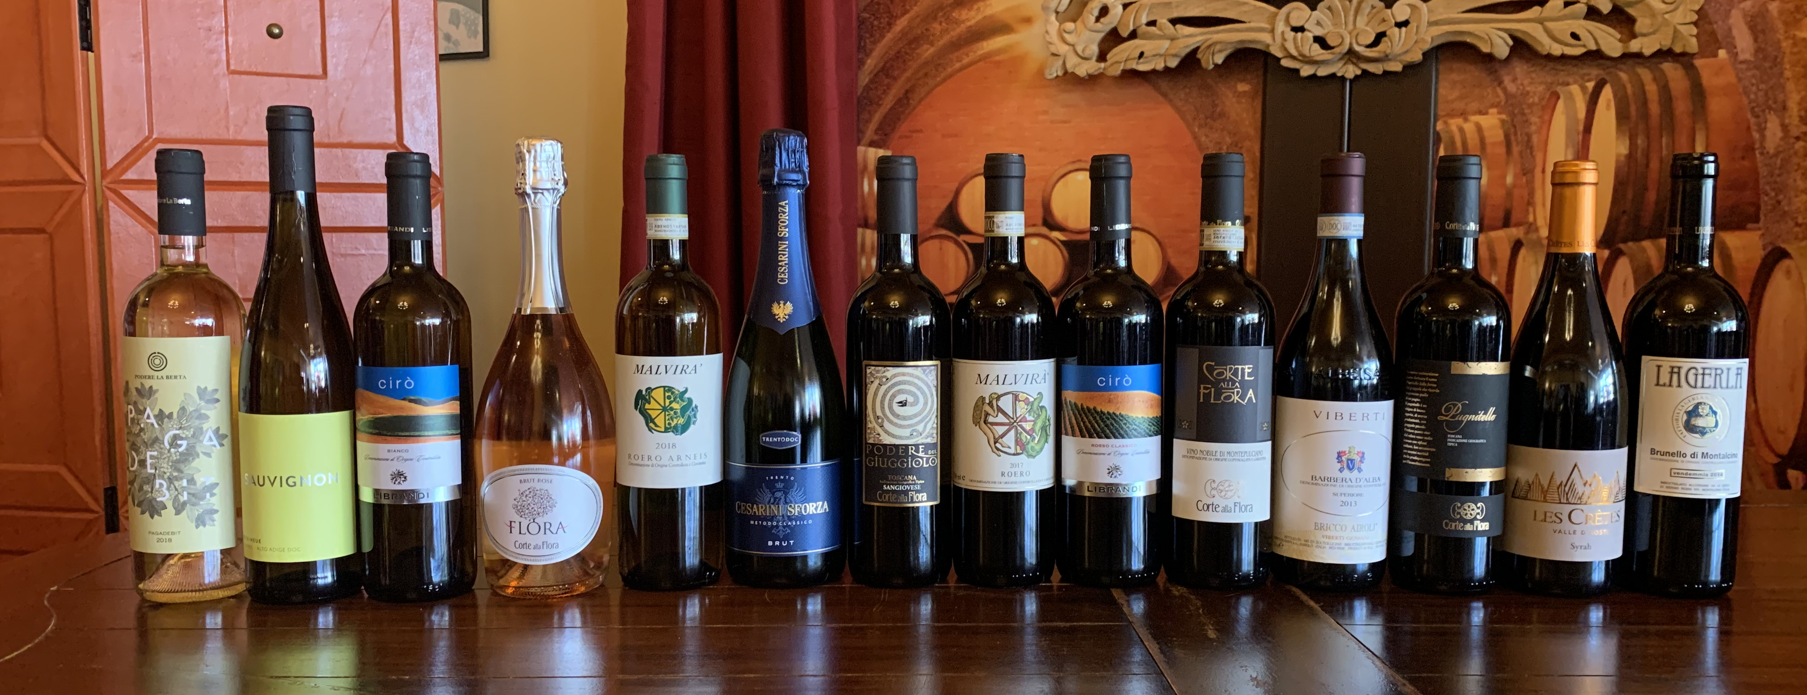
Quick links: TierI TierII TierIII TierIV TierV

This spring we celebrate Italian wine! Italy is home to many of our favorite wine regions from the mountainous Valle d’Aosta to the Mediterranean island of Sicily. We are excited to feature fourteen Italian wines (pictured above) in this release. Whether it’s Sauvignon Blanc from Alto Adige, Pugnitello from Tuscany, or sparkling Sangiovese spumante, we hope you enjoy the stunning diversity of Italian wine.

Four of these Italian selections were produced by our featured winery—Corte alla Flora. We had the pleasure of meeting Andrea Cragnotti, the executive director of Corte all Flora, just before he returned home to Tuscany to shelter-in-place during this COVID-19 global crisis. The winery was a gift from Andrea’s father to his mother, Flora, to celebrate 25 years of marriage. From their first vintage thirty years ago, the Cragnotti family has embraced modern winemaking techniques while rooting themselves in traditional farming practices. Corte alla Flora produces terroir-driven wines utilizing traditional Tuscan grapes such as Sangiovese, or Prugnolo Gentile as it’s known in Tuscany, while also experiementing with French varietals such as Syrah, Cabernet Sauvignon, Merlot, and Cabernet Franc. Look for their red wines in Tiers I, II, and III, as well as sparkling Sangiovese in Tier II.

The tasting notes below represent the core wine selections for this May club release. We may have included a special selection in your club bag, so please contact wineclub@blancandrougewine.com if you would like any additional information about your club wines. Salute!

TIER I

Red
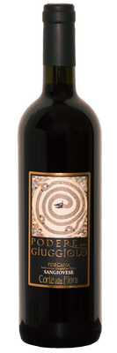

Corte alla Flora Podere del Giuggiolo Rosso Toscano ($15)

Featured winery!
This beautiful Tuscan wine is 100% Sangiovese. The wine emanates wonderful aromas of violets, purple fruits and crushed cherries. It’s a juicy and ripe wine with dark, earthy flavors, coffee notes, and a touch of cocoa at the finish. Pair this wine with young cheeses, salumi, and thin-crust pizza.

For more information about our featured winery, please see the first page of these tasting notes.

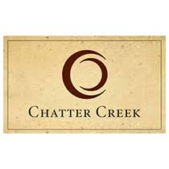

Chatter Creek Valley Terroir ($15)

Merlot 38%, Cabernet Sauvignon 36%, Malbec 26%
This Right Bank Bordeaux-inspired blend from Woodinville’s Chatter Creek Winery is a testament to winemaker Gordon Rawson’s 30+ year career producing premium wine in Washington State. This wine sparkles with a bright ruby color. The nose, ripe and forward, is an aromatic blend of violets, cassis, and black cherry. A complex palate features plummy cherry and blueberry. Gordy is retiring this year, and we raise a glass to his tremendous contributions to the Washington wine industry.

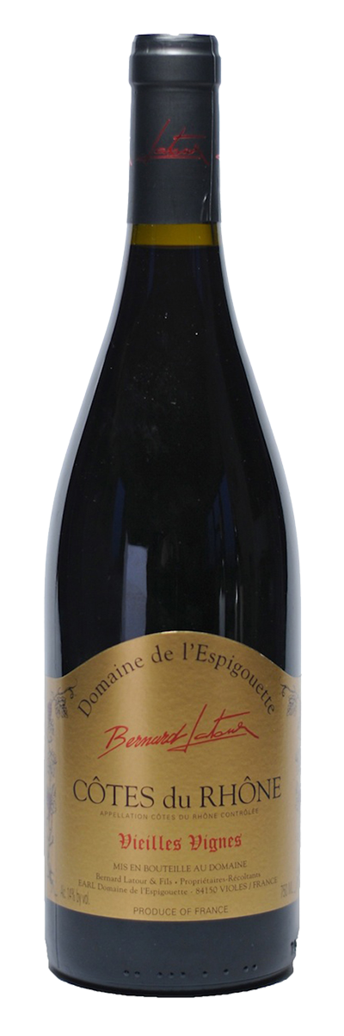

Domaine de l’Espigouette Cotes Du Rhone Vieilles Vignes ($17)

Grenache 70%, Syrah 10%, Mourvedre 10%, Carignan 5%, Cinsault 5%
Domaine de l’ Espigouette is an organically-grown vineyard that has been family run for four generations, and is located in the Rhone Valley of France. The estate is currently run by Bernard Latour, his wife, and his two sons Julian and Emilien. Dark, dense colored, this wine smells of black cherries, clove and spice. Medium to full-bodied. Balanced, long and classy. This wine would pair beautifully with dishes featuring Mediterranean spices.

Vina Herminia Reserva 2011 ($15)
Located in the Rioja Baja, at the southeastern end of the Rioja, Viña Herminia offers a full range of Rioja wines from vineyards on the slopes of Monte Yerga and Monte Argudo, up to an altitude of 700m, complemented with grapes from the best communes of the Rioja Alta and Rioja Alavesa. This wine is complex, with an excellent balance between black fruit and oak on the nose, with cream and tobacco tertiary notes. Rioja Reserva red wines must be aged for a minimum of three years—one year must be in oak barrels—before release. Thanks to one of our amazing distributors, we got our hands on the last few bottles of this vintage at an incredible value. Pair this wine with a pot roast or rich game stew.
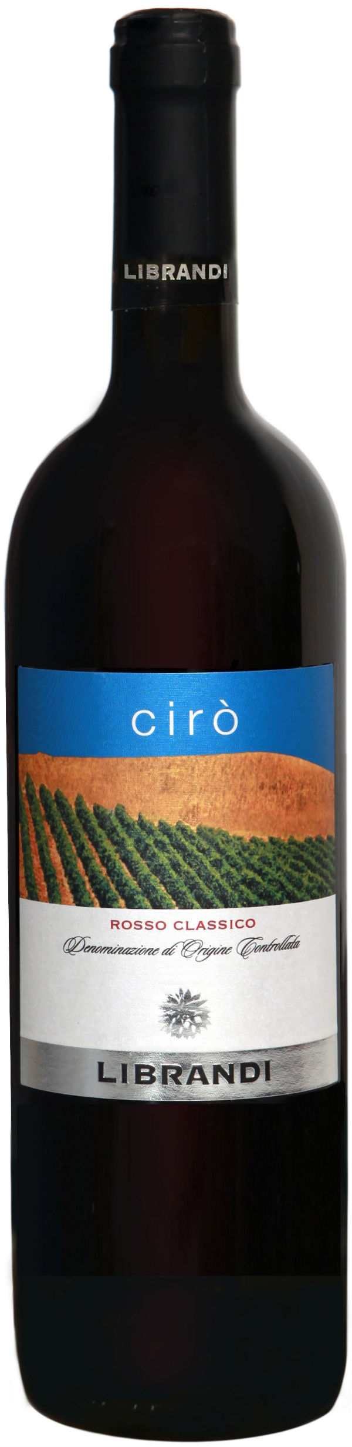
Librandi Cirò Rosso Classico ($15)
Calabria is a wine-producing region located at the southern tip of Italy’s boot-shaped peninsula. This wine is made entirely from Gaglioppo, the most important varietal from the heart of the Cirò appellation, Calabria’s oldest and most famous DOC. Ionian sea breezes and higher elevations cool these southern vineyards, effectively slowing the ripening process. Cirò Rosso is fermented and aged in stainless steel tanks to preserve the wine's fresh, youthful character. Don’t let the pale color fool you, this is a substantial wine. Aromas of red fruits and spice complement undertones of cranberries, wild berries, and plums. On the palate, ripe tannins and substantial body make for an incredibly rich, yet easygoing red wine. Pair this wine with sausage, spicy curry, or tandoori chicken.
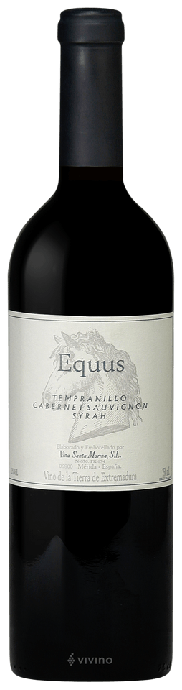

Vina Santa Marina Equus ($15)

Vina Santa Marina is a spectacular site at the foot of the Lamoneda Mountain range which, according to recent research, was where the family of Roman General Maximus produced wines that were fashionable in Rome. Twenty centuries later, this unique vineyard, and a combination of cutting edge technology and traditional methods, produces exceptional wines from a bodega tucked into the vineyards. Earthy berry aromas are potent. So is the palate, which is demanding and bouncy. Pinched, herbal plum and tomato flavors are rustic in style and reflect Extremedura's sunny, dry terroir. Pair this blend of Tempranillo, Cabernet Sauvignon, and Syrah with Cajun jumbelaya, chicken satay, or (of course) tapas.

White

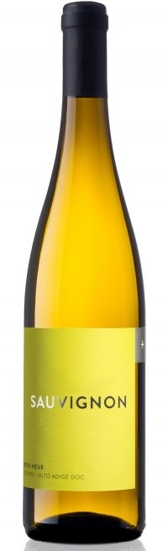
Erste + Neue Alto Adige Sauvignon ($15)
Alto Adige is a mountainous wine-producing region in the northeast of Italy, sharing borders with Switzerland and Austria to the north. Known for producing world-class white wines, Alto Adige is the hub of some of the best large cooperative wineries in Italy. Erste + Neue, meaning ‘First + New’, is the merger of the oldest and the newest co-ops in the small town of Caladro. With classic 'green' aromas such as elderflower and nettles and hints of apricot and white peach, this is one of the best examples of Italian Sauvignon Blanc. For Sauvignon Blanc fans, the style is somewhere between Loire and New Zealand examples. Luscious fruit is balanced by bright acidity. This works well with a broad variety of antipasti and seafood dishes (and asparagus, a local spring specialty).

Chateau St. Jean North Coast Chardonnay ($12)

Chardonnay is truly a “winemaker’s grape,” meaning that Chardonnay—which is naturally a light, neutral grape—can be crafted to reflect the winemaker’s taste prefences and style. Gone are the days of the overoaked, buttery California Chardonnay. Wineries up and down the West Coast are crafting dynamic expressions of the varietal, from lean and unoaked to creamy and lush. This offering from Chateau St. Jean features bright aromas of ripe apple, creamy lemon pie, warm vanilla and brown spice notes. The palate is rich and supple with juicy flavors of fresh nectarine, apple and a pineapple tropical note. Notes of toasted hazelnut and subtle brown baking spice add complexity. Pair this wine with almond-crusted halibut with beurre blanc.
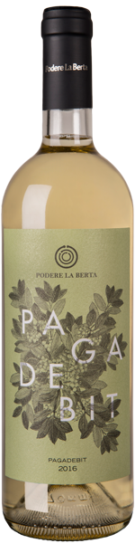

Podere La Berta Pagadebit ($18)

Bombino Bianco 100%

The rural region of Emilia-Romagna is a northern Italian region that extends from south of Milan out east to the Adriactic Sea. Pagadebit, meaning the “debt payer” is both a DOC in Romagna as well as an alternative name for the indigenous varietal Bombino Bianco. Farming families grew Bombino Bianco knowing they could count on its hardiness, and used the wine sales to pay off their debts in the worst of vintages. This offering from Podere La Berta features intense aromas of sweet almond, acacia blossom, elderflower, and wisteria. Pair this wine with sashimi, Dungeness crab, a lightly-cured ham, or spring vegetables.

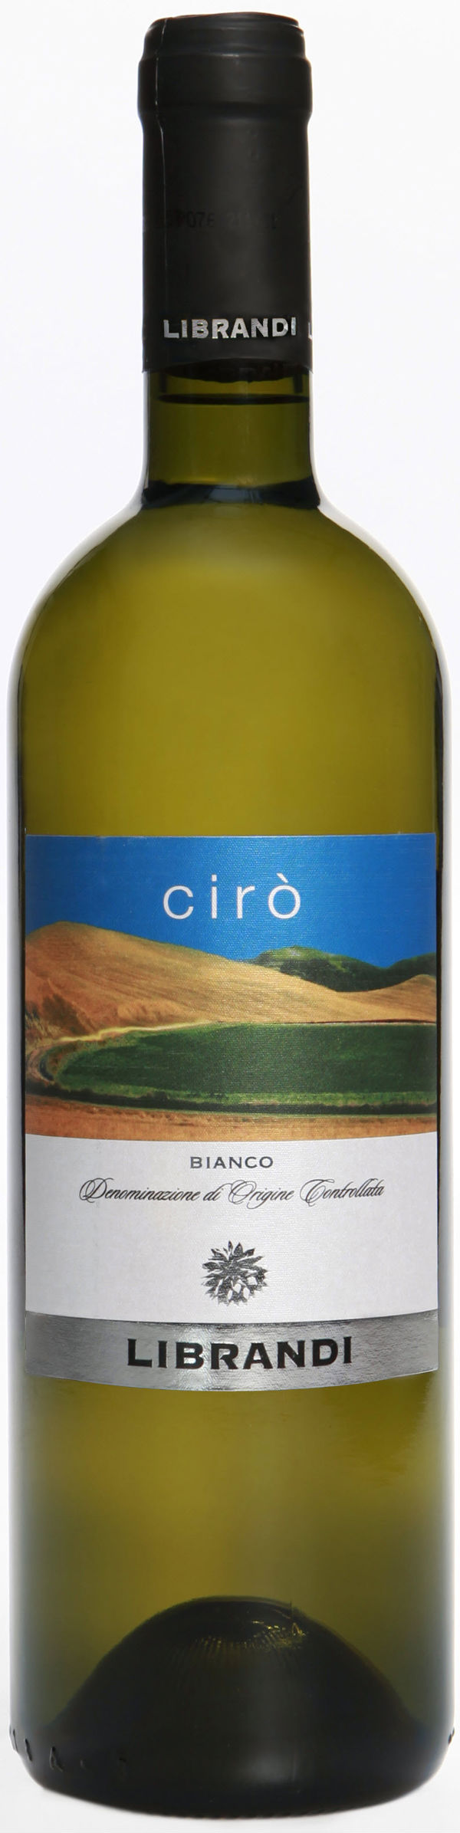
Librandi Ciro Bianco ($15)
Calabria is a wine-producing region located at the southern tip of Italy’s boot-shaped peninsula. This wine is made from 100% Greco Bianco, a white variety brought to Calabria by the ancient Greeks. After a soft pressing, the must is fermented in stainless steel tanks to preserve its freshness. This wine is brilliant lemon-green in color with aromas of peaches and citrus fruits to complement undertones of herbs and flowers. On the palate, there’s zesty acidity and a long finish to showcase this wine's subtle hints of toasted almonds and macadamia nuts. Pair this wine with ceviche, gremolata sauces, or grilled swordfish.

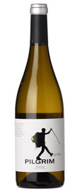
Bodegas Godelia “Pilgrim” Godello ($15)
Located in the Bierzo village of Cacabelos, which is on the route of the Camino de Santiago, Godelia is no stranger to pilgrims making this centuries old trek, so they decided to honor them with their introductory line of Bierzo wines. The white is primarily Godello, though there is also a good splash of Doña Blanca blended in as well. A clean, nicely dry white with well defined edges and lots of drinkability. Good Godellos such as this one are Spain's answer to a Macon Villages or other tasty, value-driven white Burgundy.

Bodega Rezebal Txakolina Rosé ($17)
This is one of our staple rosés at Blanc & Rouge, and thankfully it landed in Washington just in time for May club release. Hailing from the Basque region of Spain, this wine is 100% Hondarabbi Beltza, an indigenous red grape varietal. Aromatic, dry and slightly effervescent, it has delicate flavors of wild strawberries, bright acidity and great minerality. This is a serious food-friendly rosé that is refreshing on its own, but pairs beautifully with seared ahi over a mustard green salad that has been dressed with a touch of sweet rice vinaigrette.

TIER II

Red

Corte alla Flora Vino Nobile di Montepulciano ($25)

Featured winery! Club exclusive pricing—reg. $30

Sangiovese 80%, Merlot 10%, Cabernet Sauvignon 10%
This Super-Tuscan blend features aromas of underbrush, crushed blue flower and a whiff of saddle leather. These carry over to the palate along with spiced plum, mature black cherry, black pepper and game, with brooding tannins. Enjoy this wine with roasted mushrooms over polenta or aged cheeses.

For more information about our featured winery, please see the first page of these tasting notes.

Upland “The Mayor” Red Blend ($25)

Club exlcusive pricing—reg. $30
This Cabernet Sauvignon and Malbec -dominant blend pays homage to twice-elected mayor of Sunnyside, WA, William B. Bridgman. Aromas of red fruit, nutmeg, clove, and anise burst from the glass. Don’t miss out! This is Upland Estate’s final vintage, after they decided to move away from winemaking and sell their estate Snipes Mountain AVA fruit exclusively to partnering wineries. Pair this wine with skirt steak or Portobello mushroom burgers.

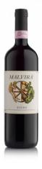
Malvira Roero Rosso ($25)

Club exclusive pricing—reg. $30
Nebbiolo 100%
Malvira is one of the elite producers in Piedmont’s Roero appellation, just across the Tanaro River from the hollowed hills of Barolo. If you haven’t had an opportunity to taste a Nebbiolo from Italy’s Piedmont region, we highly recommend this offering. Gorgeous ruby red in the glass, this wine offers notes of roses, strawberries, raspberries and black currants. Pair it with crispy pork belly or anything you are grilling this spring.

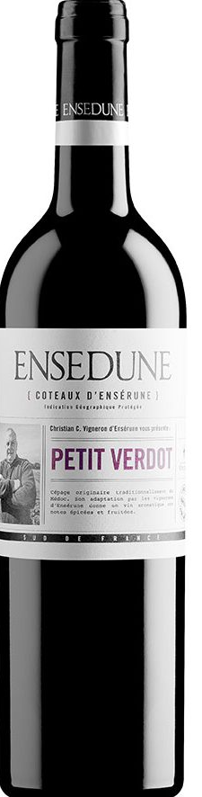

Les Vignobles Foncalieu Ensédune Petit Verdot ($22)
Petit Verdot translates in French to “little green one,” and this is most likely because this grape is a late-ripening, warm climate variety. In Bordeaux, it meant that the grapes were often not quite ready (e.g. a little green) when they had to be picked for harvest. Because of this, Petit Verdot was only used in blends in small amounts (usually only 1–2% of the Bordeaux Blend) to add tannin structure, color and herbaceous notes of violet and sage. This rare varietal bottling of Petit Verdot from the Languedoc region of France is bright ruby red with aromas of cherry, raspberry, licorice and peony. Pair it with a simple cheeseboard or smoked meats.

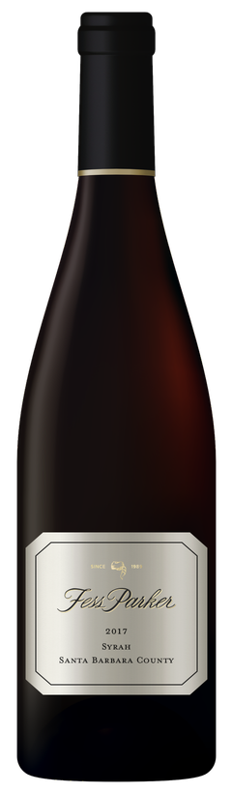
Fess Parker Syrah ($28)

Fess Parker may be best remembered for his portrayls of Davy Crockett and Daniel Boone, but post-Hollywood, Parker was a successful businessman, with notable investments including a 714-acre ranch in the heart of California’s Santa Ynez Valley wine country. Still family-owned and -operated, the winery has sharpened its focus toward production of small lot, vineyard-designated and clonal selection Rhone and Burgundian varietals. Deep ruby-purple and scented of white pepper, menthol and turned earth with cedar and ripe black fruits, the 2017 Syrah is full-bodied and fills the mouth with juicy black fruits, framed by firm, slightly chewy tannins and just enough freshness. Pair this wine with grilled lamb chops.

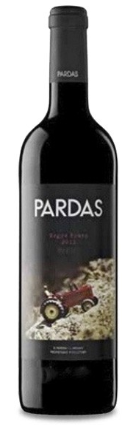
Celler Pardas Negre Franc ($28)

Cabernet Franc 53%, Cabernet Sauvignon 31%, Sumoll 16%

Celler Pardas is located in Penedes, the northeast region of Spain best known for the production of Spanish sparkling wine—cava. Punchy and pure on the bouquet, this has nicely presented blackberry and cassis aromas that are offset by a whiff of leather. It feels snappy, fresh and firm, with toasty, mildly-spicy plum, berry and toasted flavors. Lengthy, juicy and healthy on the finish. Pair with chicken adobo or aged Manchego and Iberico ham.

White

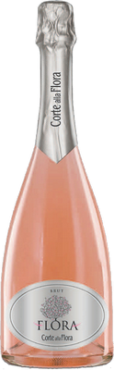
Corte alla Flora Spumante Rosé Brut ($28)

Featured winery!

This gorgeous bottle of salmon-colored bubbly is produced with 100% Sangiovese grapes, an ulta-rare bottling. Sangiovese grapes are harvested earlier than usual, by hand, then pressed directly, without being crushed or de-stemmed, in order to avoid unnecessary tearing and preserve the integrity of the skins. Dry and fresh with red currant and red berry notes, this wine is a wonderful apertif or summer sunset sipper.

For more information about our featured winery, please see the first page of these tasting notes.

Chatter Creek Chardonnay ($22)

Chardonnay is truly a “winemaker’s grape,” meaning that Chardonnay—which is naturally a light, neutral grape—can be crafted to reflect the winemaker’s taste prefences and style. Gone are the days of the overoaked, buttery California Chardonnay. Wineries up and down the West Coast are crafting dynamic expressions of the varietal, from lean and unoaked to creamy and lush. This offering from Woodinville’s Chatter Creek winery was fermented in the traditional Burgundian way using neutral, French oak barrels to maintain a fresh and elegant style. This Chardonnay has apple and white peach aromas. The palate is refined and creamy with flavors of white peach and pineapple, which linger in a clean, refreshing finish. Pair this wine with roasted chicken or weighty seafood dishes.

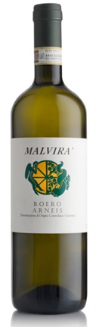
Malvira Roero Arneis ($22)

Located in the Piedmont region in Northern Italy, Malvira produces a classic bottling of Arneis, a crisp, citrusy white wine varietal. Aromas of tropical fruit and white peach carry over to the creamy palate along with ripe Granny Smith apple, candied lemon rind and a ginger note. Fresh acidity lifts the rather rich finish. Pair this wine with fish and shellfish crudite, seafood, chicken, light pastas, young fresh cheeses.

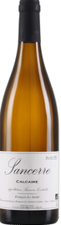
Francois Le Saint Sancerre ($31)
François Le Saint is a label used by the Fouassier family, owners of Domaine Fouassier. They are one of the oldest wine-growing families in Sancerre. For centuries they have dedicated themselves to preserving and capturing terroir and the noble Sauvignon grape varietal through an extensive range of appellation wines. Today, the estate is comprised of nearly 56 hectares, 80% of which are planted to Sauvignon Blanc and 20% to Pinot Noir, all of which is certified organic and biodynamic. Green straw color with good legs; dry, medium-bodied with fresh acidity and scant phenolics. Delicious supple ripe citrus and tree fruit Sancerre with a fine mineral character. Textured and dimensional with layers of flavor unusual in under $70.00 white wines. Pair this wine with crab cakes or baked salmon.

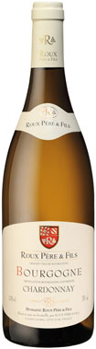
Domaine Roux Pere et Fils Bourgogne Blanc ($24)
Domaine Roux was founded in 1885 with a mere 4 hectares in the village of Saint-Aubin in the heart of Burgundy, France. Under the leadership of the 3rd and 4th generation, Marcel Roux and his son Christian, the family’s proprietary vineyard holdings have expanded to include more than 70 hectares located throughout the Côte d’Or, most extensively in the sub-region of Côte de Beaune. Roux Bourgogne Chardonnay brings out the best of the native white Burgundian varietal. Golden yellow in color with a bouquet comprised of notes of hazelnut, honey, and sugared chestnuts accented by faint spice nuances. Aged for 6-8 months in stainless steel, there is a subtle buttery quality to the palate. Pair with richer fish dishes, pork, chicken and anything in a cream sauce.

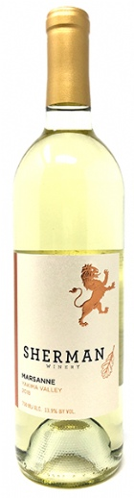
Sherman Marsanne ($27)
Sherman is Washington winemaker Michael Florentino’s second label to focus exclusively on French grape varietals. Marsanne is a primary blending grape in white Rhône blends that also include Roussanne, Grenache Blanc and sometimes Viognier. Rich and fruity Marsanne pairs excellently with rich shellfish (think shrimp) and the citrus notes make it a great counterpoint to south Asian cuisine.

TIER III

Red
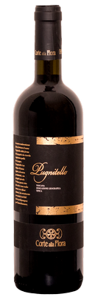
Corte alla Flora Pugnitello ($32)
Featured winery!
In the 1980’s research conducted at the University of Florence led to the identification of Pugnitello, a grape from the province of Grosetto. Since 2003, Pugnitello is in Italy’s national register of vine varieties by the Ministry of Agriculture. The little historical evidence on Pugnitello suggests that the name comes from the Italian word ‘pugno,’ meaning fist, because the shape of the grape clusters resembles a clenched fist. The wine is a deep violet color with aromas of ripe black and blue fruit mixed with cloves and tobacco. It is velvelty on the palate with bursts of wild berry and refined structure. This wine can be paired with robust dishes such as venison stew. For more information about our featured winery, please see the first page of these tasting notes.
Piggyback Cellars Syrah 2009 ($40)
Thanks to winemaker and chef Brian Scheehser, we got on our hands on the few remaining cases of this library vintage of Piggyback Cellars Syrah. Aromas of boysenberry jam, dried cranberry and herbs are light, with restrained oak. The flavors are tart and bright, showing depth and richness with sharp, bright acids keeping it all in focus. It stands up on its own but would pair beautifully with Asian spice-glazed barbecued chicken or roasted mushrooms.

2009 was a notable year for Washington Syrah and Merlot. A late frost in the fall allowed for long hangtime on the vines for optimal flavor development.

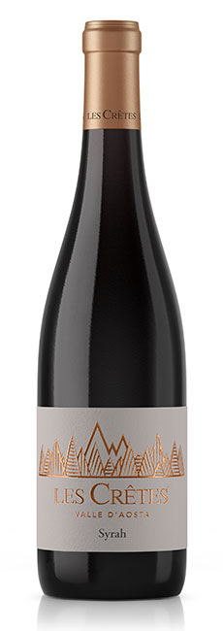
Les Cretes Valle d’Aosta Syrah ($38)
The Aosta Valley is an Alpine valley located in the far northwest of Italy, bordering France and Switzerland. In the shadows of some of Europe’s tallest peaks, Italy’s smallest wine region is known for producing high-altitude Pinot Noir, Chardonnay, and Nebbiolo. Les Crêtes, now Valle d’Aosta’s largest private winery at 16,000 cases, was created in the 1980s by Constantino Charrère, the founder of a Mont Blanc ski school and the son of a local farmer and winemaker. Classic black pepper and spice aromas dominate this silky, rich and extraordinarily well-balanced wine. Layers of complex berry fruits and Rhone-like earth linger on the finish. Pair this wine with fondue!

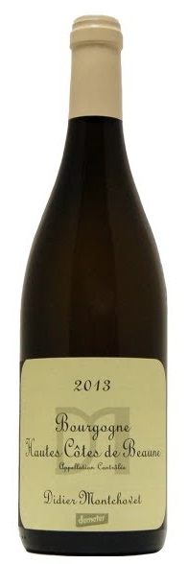
Didier Montchovet Bourgogne Rouge Cotes de Beaune ($36)

Pinot Noir 100%

Didier Montchovet created his biodynamic vineyard in 1984, leasing a modest half-hectare just outside Pommard. Five years later, he added an additional 2.5 more hectares that enabled him to begin making wine under his own name. In 1990 Didier sold his first bottling, and today Didier works 9.2-hectares of biodynamic vines near the village of Bouze-les-Beaune, which is approximately 4-kilometers northwest of Beaune. The cellar was conceived to make maximum use of gravity, as a result, no pumps are used during the bottling process. Didier also has a system that recuperates rainwater, helping him to conserve this natural resource during the spring and summer. Ruby in the glass with a deep purple rim. Red cherry and strawberry preserves dominate the nose. The palate is rich with red cherry and bright strawberry fruit. Moderate tannins, red berry spice and vibrant acidity dominate the elegant finish. Works well with grilled beef, veal chops, venison and lamb.

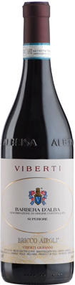
Viberti Bricco Airoli Barbera d’Alba Superiore ($30)

Club exclusive pricing—reg. $35
Viberti has been located just above the village of Barolo, in the commune of Vergne, since 1923. This stunning Barbera was vinified in the Barolo-style with fruit from 40+ year-old vines. Layered with notes of ripe cherries, juicy plums, and baking spices, this wine is a lush expression of the varietal and can be cellared for 10+ years. Pair it with rich dark meats, mushrooms, or herbaceous cheeses like blue cheese.

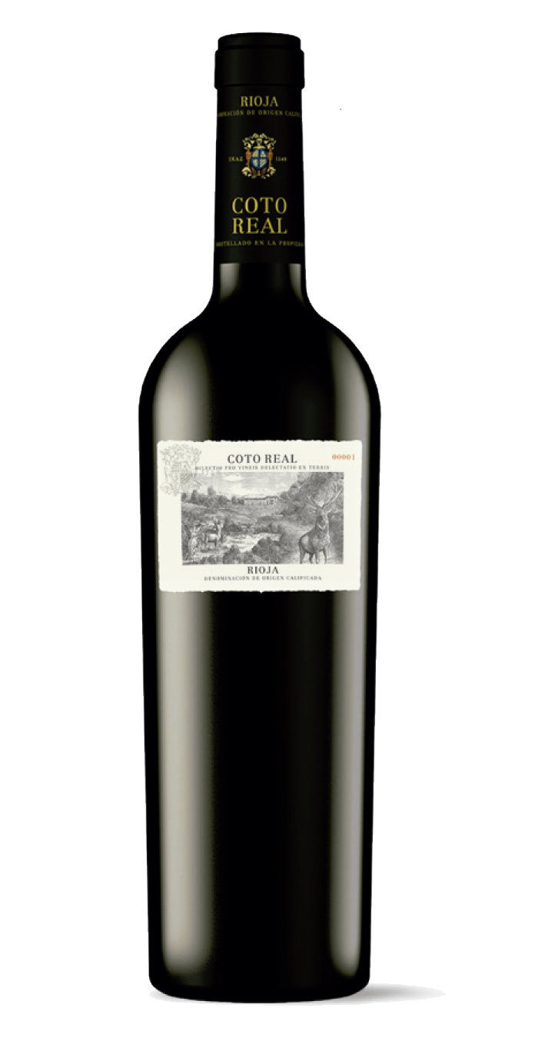
El Coto de Rioja Coto de Imaz Gran Reserva ($35)
Founded in 1970 and based in Oyón, El Coto came of age during the era when Rioja rose to international prominence. Today, with widely admired red, white, and rosé expressions, El Coto is a leader in Rioja, with 2,000 acres of estate vineyards located in three subzones (Rioja Alta, Rioja Baja and Rioja Alavesa). Classic Rioja aromas of graphite, cherry, plum and oak are lightly toasted and spicy. On the palate, this offers chewy depth and impeccable balance. Ripe, heady plum, cassis and berry flavors are also nuanced and elegant, while this gran reserva from a ripe vintage tastes of vanilla and mild oak on the finish. El Coto is no stranger to our Spanish selections at Blanc & Rouge, and this Tempranillo is the perfect pairing for all of your springtime grilling.

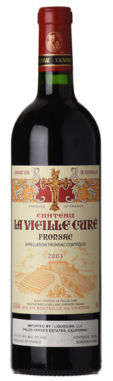
Château La Vieille Cure ($30)

The commune of Fronsac is a ten minute drive from the better-known Right Bank Bordeaux regions of St. Emilion and Pomerol. From one of the top terroirs in Fronsac and made with the help of talented Jean-Luc Thunevin, the 2016 Château La Vieille Cure is 80% Merlot and 10% each of Cabernet Sauvignon and Cabernet Franc. This deep purple-colored effort boasts a head-turning bouquet of cassis and black raspberry fruits intermixed with notes of dried flowers, vanilla bean, and leafy herbs. With remarkable purity, medium to full body, silky tannins, and a great finish, it’s a thrilling Fronsac that I suspect might be one of the best to date. Drink it over the coming 10-15 years. Pair this wine with roasted duck.

White

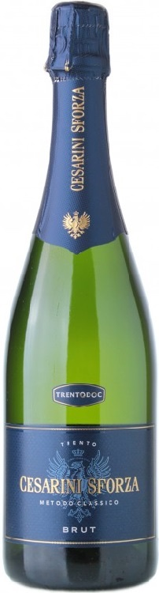

Cesarini Sforza Brut Metodo Classico Alto Adige ($30)

Alto Adige is a mountainous wine-producing region in the northeast of Italy, sharing borders with Switzerland and Austria to the north. The rugged terrain of German-speaking Alto Adige (also referred to as Südtirol) focuses on small-scale viticulture, with great value placed on local varieties—though international varieties have been widely planted since the 1800s. Sheltered by the Alps from harsh northerly winds, many of the best vineyards are at extreme altitude but on steep slopes to increase sunlight exposure. This elegant bottle of bubbly is produced with 100% Chardonnay grapes. Citrusy, with white floral aromatics and a touch of brioche on the palate, this is a stunning example of Alto Adige sparkling wine.

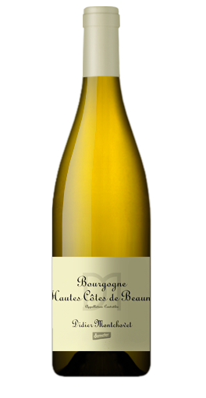
Didier Montchovet Bourgogne Blanc Cotes de Beaune ($36)

Chardonnay 100%

Didier Montchovet created his biodynamic vineyard in 1984, leasing a modest half-hectare just outside Pommard. Five years later, he added an additional 2.5 more hectares that enabled him to begin making wine under his own name. In 1990 Didier sold his first bottling, and today Didier works 9.2-hectares of biodynamic vines near the village of Bouze-les-Beaune, which is approximately 4-kilometers northwest of Beaune. The cellar was conceived to make maximum use of gravity, as a result, no pumps are used during the bottling process. Didier also has a system that recuperates rainwater, helping him to conserve this natural resource during the spring and summer. Light yellow in the glass with pale highlights. Pretty notes of lemon skin infused with freshly baked brioche and buttery wet stones. Silken white fruit unfurls on the palate and is backed by moderate acidity and a judicious note of cool oak. Pair this wine with smoked salmon, roast chicken, pork loin, rich cheeses, hearty garden salads and seafood in cream sauces.

Pardas Pur Xarel-lo ($33)
Celler Pardas is located in Penedes, the northeast region of Spain best known for the production of Spanish sparkling wine, cava. Owners Ramon and Jordi are in the forefront of the varietal revolution happening in Penedès. The story of native grapes in the region is not unlike many others in different areas: the local varieties, deemed hard to work with and less valuable than international ones, were slowly substituted by high-yielding types. Many of the new generation of growers in the area, however, decided to replant and work with native grapes. Pardas's plantings all come from cuttings of old vines found in the region. This unique bottling of 100% organically-grown, still (rather than sparkling) Xarel-lo is fresh with aromas of juicy peach abounding on the nose, accented by notes of orange peel. It is well-balanced with vibrant acidity and pronounced mineral qualities. Fruit, acid, and body come together seamlessly to showcase the wine’s elegance. Pair this wine with tapas, Thai-style Penn Cove mussels, or any light seafood dishes.

Santorini Assyrtiko ($30)
Santorini is a Greek island in the southern Aegean Sea, 70 miles north of Crete. Geologically, the island is all that remains of an ancient volcanic cone, whose eruption created the cliffs and lagoon around which the Santorini tourist trade thrives. Although it also produces red wines from Mandilaria and Mavrotragano, the island is best known for its crisp, dry whites and sweet vinsanto, both of which are based on the island's flagship grape variety, Assyrtiko. Ripe, juicy peach and apricot flavors hint at mango, even as the island’s stony character comes through. It ends firm and clean, leaving behind the scent of sea air. Assyrtiko is perfect for shellfish and, of course, Greece’s classic tomato-feta salad.

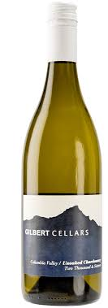
Gilbert Cellars Chardonnay ($30)
Chardonnay is truly a “winemaker’s grape,” meaning that Chardonnay—which is naturally a light, neutral grape—can be crafted to reflect the winemaker’s taste prefences and style. Gone are the days of the overoaked, buttery California Chardonnay. Wineries up and down the West Coast are crafting dynamic expressions of the varietal, from lean and unoaked to creamy and lush. The nose on this offering from Gilbert Cellars opens up with lemon meringue mixed with baking spices and herbs. The palate is light and crisp with good weight and viscosity. As the wine opens, melon and floral characters dominate the nose. Fruit-forward on the palate, the bright acidity is a perfect pairing for soft cheeses and seafood.

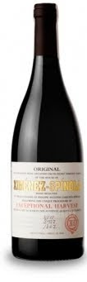
Bodegas Ximénez Spínola Exceptional Harvest ($30)
Bodegas Ximénez-Spínola is a very discreet bodega, to say the least. Although it was founded by Phelipe Antonio Zarzana Spínola in 1729 and has a long tradition, it is not well-known due to painfully low quantities (probably the lowest of the whole sherry region) and a philosophy that sets it apart from most other sherry bodegas. As a rule, the bodega doesn’t take part in any wine competitions and they don’t apply for VOS or VORS labels. They are only focusing on the quality and work with a very limited amount of distributors, making their wines very much an insider’s choice. Ximénez Spínola Exceptional Harvest is not officially sherry, but a kind of vendange tardive white wine, made with grapes that are picked overripe after 21 days on the vine. The nose is intense, with exceptional aromas typical of late picking: figs, raisins and plums, which are mixed with fermentative aromas and pastries, typical of the aging on lees. The acidity and the natural sweetness play with the ripe and fleshy fruit, giving way to a continued aftertaste in which the wood does not bother. Pair with a roasted turkey or spatchcocked chicken alongside a hearty serving of root vegetables.

TIER IV/V
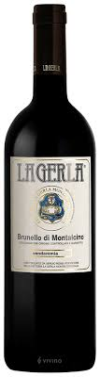
La Gerla Brunello di Montalcino 2014 ($58)
Fattoria La Gerla, named for the large, old-fashioned, conical baskets that grape-harvesters used to carry on their backs, was founded in 1976 by the late Sergio Rossi. Originally from Milan, Mr. Rossi purchased the property in 1975 from Tedina Biondi-Santi, the daughter of Tancredi Biondi-Santi, who had inherited the property after her father’s passing. Today, La Gerla consists of 11.5 hectares, and makes five wines, all made entirely from Sangiovese Grosso, the only grape planted on the property. Enticing scents of rose, woodland berry, exotic spice, smoke and a whiff of grilled herb take shape on this perfumed red. Reflecting the nose, the approachable palate offers sour cherry, pomegranate, star anise and hints of tobacco alongside supple tannins and bright acidity. Pair with roasted lamb chops.

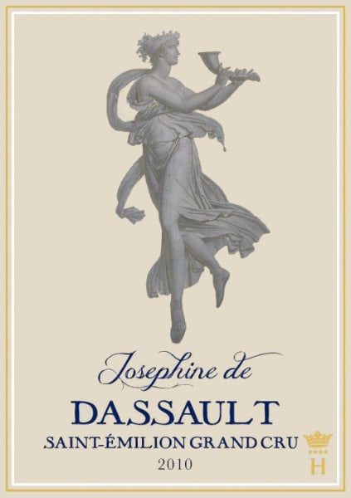
Josephine de Dassault St. Emilion Grand Cru ($48)
Merlot 70%, Cabernet Franc 30%
Saint Emilion is a charming medieval commune on the right bank of the Dordogne River in Bordeaux. Thought to be the oldest wine-producing appellation in Bordeaux, much of its history is inseparable from its grapevines. Evidence suggests that the Romans made wine here as early as 56 BC. The Catholic church carried the torch through the Middle Ages, with the Benedictine order solidifying the area’s wine production in the 11th century. Shortly thereafter, Saint-Émilion gave birth to the first wine society in France. By the 14th century Saint-Émilion was exporting its wine to England because it had an enthusiast in King Edward. Marcel Dassault, a pioneer of the aeronautic industry, purchased Chateau Couperie in 1955 and renamed the property after his family. After years of hard work, Chateau Dassault gained the well-deserved rank of Grand Cru Classe in 1969. Spicy, packed with dark fruit, rich chocolate and pepper, this is a powerful, sumptuous wine. Pair this wine with beef or venison.

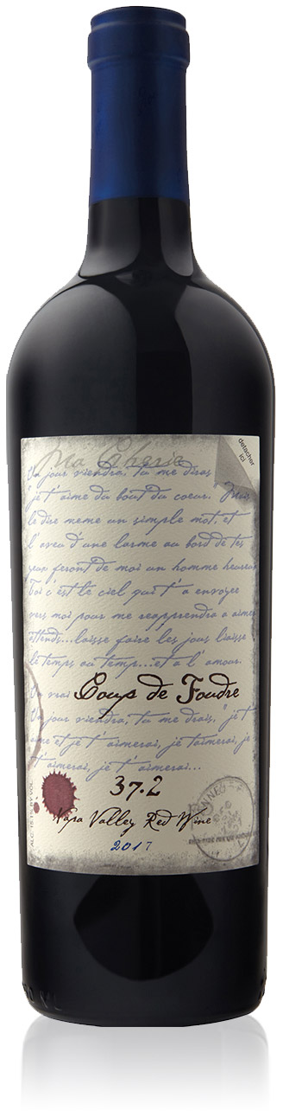
Coup de Foudre 37.2 Cuvee 2010 ($65)
Merlot 65%, Cabernet Franc 30%, 5% Petit Verdot
Coup de Foudre, translating to “stroke of lightning” or slang for “love at first sight,” is the boutique Napa venture of two wine industry titans—John Schwartz and winemaker Kent Jarman. This Right Bank Bordeaux-inspired blend is deep garnet-purple in color with a wonderfully spicy nose with baked cherries, plum preserves, dried herbs, florals & damp soil with waft of truffles. The palate is medium to full-bodied with firm, grainy tannins & great energy, finishing with a compelling lift.

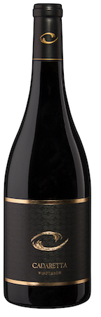
Cadaretta Windthrow ($50)
84% Syrah, Grenache 10%, Mourvedre 6%
The Middleton Family has been working the land in Washington State for five generations. With Cadaretta the family aims to craft wines that stand among Washington’s best. The winery is named for a lumber schooner used by the family company in the first part of the 20th Century. This wine expresses a perfumed nose of violets, boysenberry, vanilla, anise and tobacco leaf. Soft mouthfeel with more boysenberry, violet, anise, black cherry, and vanilla has an added venison note. Soft and delicate in nature. This wine can stand its own paired with game dishes as well as simple, herbed Sunday roast.
Tenor 2:2 2012 ($45)
Merlot 35%, Cabernet Franc 34%, Cabernet Sauvignon 27%, Malbec 4%
Tenor is the highly-acclaimed reserve label from Washington’s Matthews Winery. Smoked strawberries, caramel, and spice. Supremely rich, energetic, and intoxicating. Swirling releases rich blue and black fruit, complex spice, scorched earth, and berry potpourri. The palate is opulent and expansive with dark spices, black fruit, and fine silky tannins.

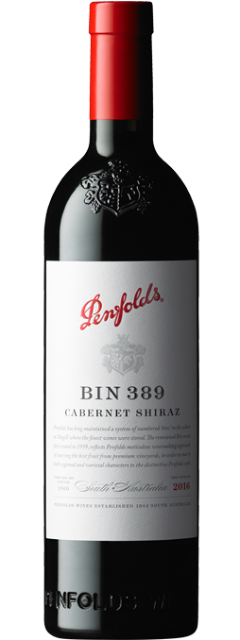
Penfolds Bin 389 Cabernet- Shiraz ($50)
Cabernet Sauvignon 51%, Shiraz 49%
Penfolds is an Australian wine producer that was founded in Adelaide in 1844 by Christopher Rawson Penfold, an English physician who emigrated to Australia, and his wife Mary Penfold. It is one of Australia's oldest wineries. Penfold’s founding winemaker, the legendary Max Schubert, developed the winery’s best-known wine, ‘Grange’, which was a revolutionary bottling of Shiraz (Syrah) blended with a touch of Cabernet Sauvignon. Bin 389 is often referred to as ‘Baby Grange’, in part because components of the wine are matured in the same barrels that held the previous vintage of ‘Grange’. First made in 1960, by Schubert, this was the wine that helped to forge Penfolds’s solid reputation with red wine drinkers combining the structure of Cabernet Sauvignon with the richness of Shiraz. Bin 389 also exemplifies the judicious balance of fruit and oak.

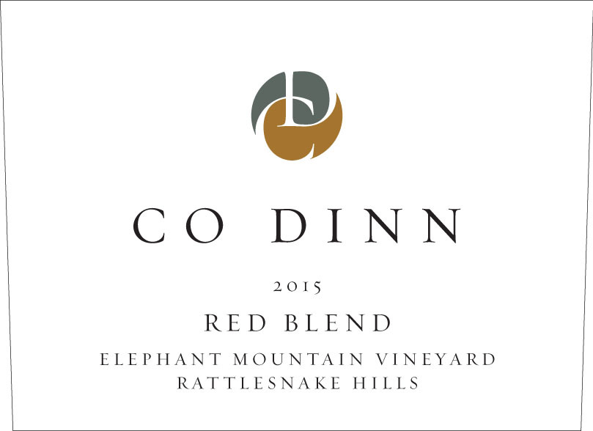
Co Dinn Elephant Mountain Vineyard 2015 ($65)
Cabernet Sauvignon 58%, Petit Verdot 16%, Merlot 15% and Malbec 11%
UC Davis alumnus Coman Dinn founded Co Dinn Cellars in 2013, focusing on single vineyard wines in the Yakima Valley. The winery is in the old city of Sunnyside water department. Remodeled into an industrial deco design with beautiful brick location, the building, built in 1930, still houses the city’s original wells, located beneath the floor, as well as the crane once used for daily operation. The nose here impresses with black olive tapenade, coffee ground, and creme de cassis. At an elevation of 1,466 feet, the south-facing slope of Elephant Mountain Vineyard is among the highest vineyards in the Yakima Valley. The palate shows good freshness and elegance with mocha, anise, creme de cassis and black olive tapenade flavors.

El Coto de Rioja “Coto Real” Reserva ($60)
Founded in 1970 and based in Oyón, El Coto came of age during the era when Rioja rose to international prominence. Today, with widely admired red, white, and rosé expressions, El Coto is a leader in Rioja, with 2,000 acres of estate vineyards located in three subzones (Rioja Alta, Rioja Baja and Rioja Alavesa). Rioja Reserva red wines must be aged for a minimum of three years—one year must be in oak barrels—before release. El Coto’s showstopper “Coto Real” Reserva is aged for at least two years in barrel and a minumum of 18 months in bottle before it is released. Lusty black-fruit aromas mesh with hints of tobacco and mocha on the bouquet. The palate feels lively and not overly heavy with flavors of cherry and plum fruit. This Tempranillo is the perfect pairing for all of your springtime grilling.

