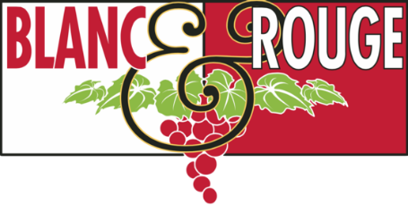
Wine Club Tasting Notes
May 3, 2019
TIER I
TIER II & III
TIER IV
TIER V
TIER VI
TIER I
RED
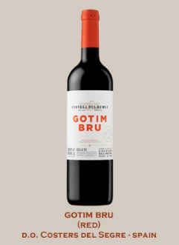
Castell del Remei ($17)
From Spain’s Catalan area this wine is overflowing with fruit flavors due to the particular blend of Garnacha/Grenache, Tempranillo, Syrah and Cabernet Sauvignon. Black cherry color of medium intensity with garnet highlights. Powerful, complex aromas; noted are red fruit preserves with lactic hints; toffee, sweet spices and toasted notes that evoke its time in cask. Aeration reveals mineral aromas, alongside biscuit notes, candied fruit cake and hints of aromatic herbs such as thyme. Sweet, voluptuous mouth feel. Well-structured tannins fill the palate. Good acidity is present throughout adding freshness. Very long, balanced finish with hints of dried fruit and wafers.
Castell del Remei is located in Penelles (D.O. Costers del Segre, Spain) and was built in 1780 and the first vines were planted at the same time. By the 19th century, they had 988 acres of local varietals of grapes, and were the first Catalan winery to sell “aged wine” on the market, using their own brand. They received their first award in 1887, the gold medal at the Brussels International Expo. In 1902, Castell del Remei established a guide for their workers on how to care and provide for the vineyards (Manaments pels Mitgers). It is a reflection of their admiration and respect for the vineyards and soils, and consistency of the vineyard work. Castell del Remei is the 4th oldest brand in Spain.
Gotim Bru has been around the shop, and in some lucky wine club members’ boxes in the past. This tasty treasure is worthy of your revisit.

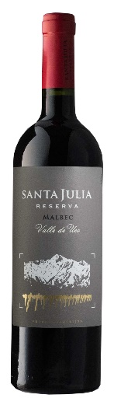
Santa Julia Mountain Blend Reserve ($16)
70% Malbec and 30% Cabernet Franc from Uco Valley, Mendoza, Argentina. The Santa Julia Reserva Mountain Blend spends 10 months in French oak barrels. Handcrafted from estate grown, handpicked fruit, the Santa Julia Reserve Mountain Blend is sourced from high elevation vineyards in the Uco Valley. The Malbec gives the wine typical aromas of red and black fruits: cherries, plums and jam while the Cabernet Franc adds dark fruit and tannins.
This selection comes from Argentina's largest family-owned winery. For over 40 years, the Zuccardi family has produced wines of exceptional quality and value from the soils of Maipu and Santa Rosa. Every wine at Santa Julia is from estate grown, hand-picked fruit and is produced in a state-of-the-art facility. Value Brand of the Year in 2012 from Wine & Spirits Magazine and a Top "Wineries for Value" from Wine Spectator, the wines from Zuccardi & Santa Julia are outstanding for the price.

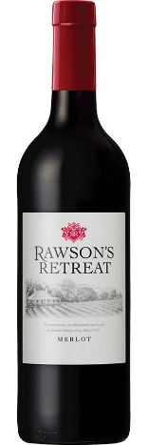
Rawson’s Merlot ($12)
From Australia’s famed Penfold’s winery Rawson’s Retreat Merlot has delicious red and black berry fruit characteristics with lifted herbal and floral notes, all supported by subtle cedary oak. This delightful wine is best matched to pasta with tomato-based sauces or other Mediterranean inspired dishes.
A juicy, youthful and lively palate. Soft, ripe tannins court appealing varietal flavors of dark plums, raspberry and rhubarb. The wine has a medium to full body with a fleeting suggestion of savory meats arousing further interest towards the finish

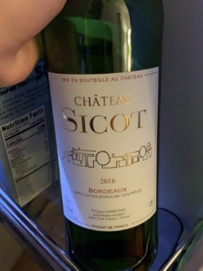
Sicot Bordeaux Superiour ($15)
This is the second label for France’s Chgateau Rioublanc which is located just north of the village of Libourne on the right bank. Dating back to the 18th century, the castle is actually a traditional stone-built villa with a cellar built into the structure. Owning all of their own vineyards, a total of 47 to be exact, the property is dedicated to farming organically for more than a decade. This selection is supple and direct with good acidity and chalky tannins to match the dark fruit. A blend of 70% Merlot, 20% cabernet Sauvignon, 6% Cabernet Franc and 4% Malbec.

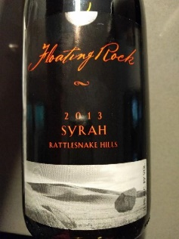
Floating Rock Syrah ($15)
Hyatt Vineyards offers this selection that was 15,000 years in the making! It started with the Missoula Flood during the last ice age when an ice dam broke in Western Montana and created cataclysmic floods that that flowed west into the eastern part of Washington and redeposited fertile soils as well as granite boulders and rocks. When we first started clearing our original vineyard many years ago, it was full of those boulders as well as massive amounts of rocks and was a huge undertaking. (But well worth it.) Thanks to those massive ice-age floods today our vineyards consist of rich, light loam soil (with a few of those pesky rocks scattered about) providing the perfect structure for quality grapes. The name Floating Rock is a nod to the unique and historic way the rocks got to the vineyard. Floating Rock wines are estate grown within the renowned Rattlesnake Hills appellation.
Full of energy, this delicious Syrah is loaded with black cherry and raspberry fruits that are bright, juicy and vibrant with a nice dose of black pepper on the finish.
Pairs well with lamb, sausages, grilled meats of all kinds, roast pork, BBQ, stews, game meats-particularly venison, black olives, dishes with lots of ground pepper, and dishes with pungent herbs. A versatile food wine from Washington State.

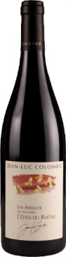
Jean-Luc Colombo Red Blend ($15)
Les Abelles de Colombo Red is a Côtes du Rhône blend of 33% Grenache, 34% Syrah and 33% Mourvèdre from France. This buoyant red wine is marked by aromas of ripe blackberries, blueberries and anise. It's full bodied and plump but balanced by crisp acidity and a firm, tannic finish. An easy-drinking but classic Côtes du Rhône, it has just a hint of mineral intensity. Enjoy now–2021.
90 Points Wine Enthusast

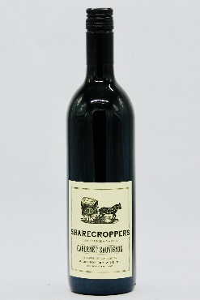
Sharecropper Cabernet ($15)
From Owen Roe outside of Yakima this wine has spicy aromas of jalapeño and cassis that lead to flavors of plum, blackberry, olive and brioche. The mouth-feel is balanced with bright acidity, tart berry fruit notes and firm tannins. We recommend opening this wine now and enjoying it at a young age, however, this will age well for 4-6 years when properly cellared.
During the economic recession of 2001, and Owen Roe’s first couple vintages as a winery, Washington growers were facing hardship in selling their fruit, come harvest time. At Owen Roe, they wanted to help their farming friends and prevent missing out on such well-tended, beautiful fruit. Owen Roe was presented with the difficult and costly purchasing of grapes to process, cellar and bottle, waiting several months to recover our costs on the finished wine.
To overcome this obstacle, they decided to bring back the historical business practice of sharecropping, resulting in the aptly named wine, “Sharecropper’s.” This partnership meant that Owen Roe would take the fruit, make the wine and once it was sold, share the profits with our growers. This remains an important part of our history and due to the success of this wine; we are now able to pay our growers upfront.
This Cabernet is a favorite go-to weeknight wine. Bright aromas of blackberry, candied fruit, vanilla and brown sugar leads to a more savory palate of pomegranate, green pepper and oil cured olives. This Cabernet finishes with bright acidity and lingering tannins. We recommend opening this wine now and enjoying it at a young age, however, this will age well for 4-6 years when properly cellared.

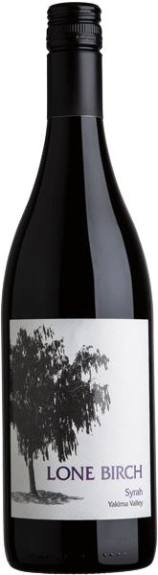
Lone Birch Syrah ($15)
Integrated bouquet of dark berry and toasted oak. Well-balanced, full-bodied, approachable and smooth. Aromas of dark plum, blue fruit and spice lead to full fruit flavors that show intensity, with vanilla flavors on the finish.
Drink now through 2024

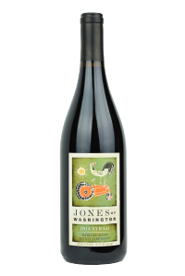
Jones of Washington Syrah ($15)
Explosive aromatics mix ripe and lush blackberry and Bing cherry, raspberry Kool-Aid, damp violet, crushed river rock, dried rosemary and allspice. These sensations carry over to the palate with the additions of dark plum and fresh turned soil.
In the glass the color has a core of inky deep purple. Voluptuous and supple tannins. Rich, earthy quality.
Double Gold 2018 Wine Press NW Platinum Competition.

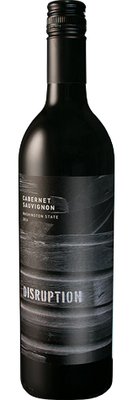
Disruption Cabernet Sauvignon ($17)
100% Cabernet Sauvignon is comprised of three vineyard sites in Columbia Valley, each bringing a new layer to this wine. Wahluke Slope Vineyard gives concentration and density with its 35-year-old vines. Northridge Vineyard is a mere 5 miles from Wahluke but a world apart in its soil, lending bright acid and spectacular color to give the wine serious focus. Art Denhoed's Vineyard in Yakima Valley has a long cool season that contributes rhubarb, cedar and currants. The wine sees just enough new oak (15%) to add a touch more depth and richness.

TIER I WHITE
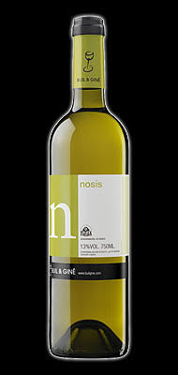
Buil & Gine Nosis Rueda ($15)
From Spain’s Rueda area this selection is dry, fresh and very fruity white wine. Complex, with notes of tropical fruits: pineapple, mango, passion-fruit. Very well-balanced in the mouth while having very intense aromas.It combines well with white and blue fish and seafood. A refreshing accompaniment for all types of appetizers. Perfect with rice dishes and baked and grilled fish, and surprising with smoked fish. Ideal for rice dishes with fish.
Buil & Giné returned to wine elaboration in 1996. The founder’s grandfather was originally a grower in Priorat and an active member of the wine making community. Their first vintage was released in 1998, the 1997 Gine Gine. Today Xavi and his wife Anna who run the winery together, own vineyards in Priorat, Montsant, Toro and Rueda. They are dedicated to producing wines with harmony and balance that are a true expression of each region. Their moto is “passion for fruit, appreciation of wood and respect for the soil.”

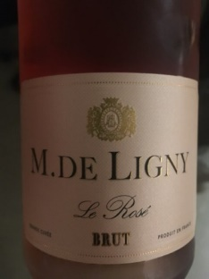
M. de Ligny Sparkling Rose ($15)
A delightful blend of Granache, Gamay and Pinot Noir. Persistent effervescence. The wine develops fruity aromas with notes of grenadines and raspberry liqueur. The best of Burgundy’s Chablis region, it is ideally served as an aperitif of with dessert.

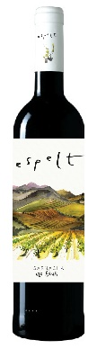
Espelt Grenach Blanc ($14)
Spain
The Garnatxa from Espelt comes from their highest elevation vineyard, Rabós, tucked in the Albera Nature Reserve Area. These are the oldest vines on the property with centenary Garnatxa Negra and Carinyena grow on sandy slate and granite soils. While there are plenty of inexpensive, fruit-forward Garnachas coming from Spain, few have the depth of minerality and complexity found in this old-vine cuvée.
Espelt Garnacha, made with 100% Garnacha, has black fruits on the nose. It is very rounded in the mouth and has a soft, smooth finish. This wine pairs well with meat and pasta, as well as cheddar and manchego cheeses.
This stunning custom cuvee from Eric Solomon was made with the help of Frenchman Jean-Marc Lafage. From granite soils around Spain’s Costa Brava, just two kilometers from the Mediterranean Sea, some of the grapes in this wine come from old vines dating back to 1900. The 2013 Garnacha Old Vines (100% Grenache aged four months in new and used French oak) boasts remarkable intensity as well as richness along with lots of strawberry, wild, briery mountain fruit and hints of spice, flowers, underbrush and Mediterranean herbs. The sweet tannin, medium to full-bodied mouthfeel and luscious personality have resulted in a gorgeous wine to enjoy over the next several years.
90 points Robnert Parker’s Wine Advocate

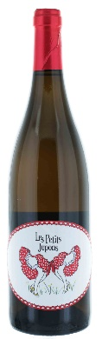
Les Petits Jupons Muscadet Sec ($15)
“Little Petticoats” is made by a mother-daughter team in France’s Loire Valley. This dry white wine has a lilt of sweetness (not cloying) that is foiled by grapefruit, citrus pith and a great flinty, mineral character. Nice texture on the palate, lots of chew and interest. This is a different grape, often referred to as Melon, than Muscat which presents as decidedly sweet. This wine is the most perfect pairing for seafood.

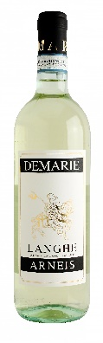
Demarie Langhe Arneis ($17)
Arneis is a white wine grape variety most associated with Piedmont in northwest Italy. The name Arneis translates to “little rascal” in the local dialect, a fitting moniker given the grape’s trickiness in the vineyard. Arneis is highly susceptible to powdery mildew, is very low-yielding and can struggle to retain acidity.
In the glass this Arneis is brilliant, sunny, bright with shades of straw yellow and green reflections. The aroma is full and well-established with hints of peach and apricot, wild broom and camomile. The flavors are well-balanced, fresh and persistent. A pleasant, dry wine. Careful not to over chill – serve between 46-50 degrees F. Excellent as an aperitif, it is perfect with hors d’oeuvres, light, vegetable first courses. Ideal also with fish or poultry. This wine lends elegance to simple herbed and roasted chicken

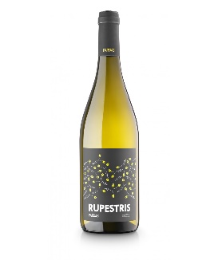
Pardas Rupestris $17
Made from local grapes grown in the Alt Penedes region of Spain. Intense nose with notes of citrus to begin, followed by pear and ripe melon. Beyond the fruit are notes of minerality and flint. The palate is fresh and fruity with pear, apricots and peach that overlay a marked acidic background. The label design is a tip of the hat to the local wild boar that visit the vineyard, leaving only their hoof prints.

SPARKLING
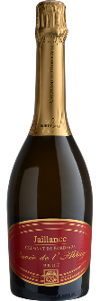
Jaillance Crémant de Bordeaux ($15)
A blend of Sémillon and Cabernet Franc, this is a smooth, soft wine. It has soft fruitiness, some fresh acidity, abundant effervescence and a light but clean aftertaste.

TIER II & III
RED
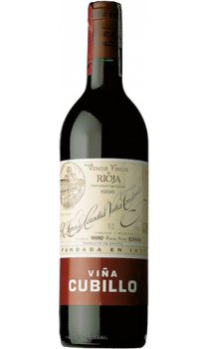
Lopez de Heredia Vina Cubillo ($26)
Coming from the Rioja region of Spain, this selection is a blend of Tempranillo (65%), Garnacho (25%), Mazuelo and Graciano, the rest, all from the winery’s estate vineyards. The wine enters your glass with a clear, bright ruby color. On the nose it is fresh and slight aroma to licorice with consistent texture and persistent aroma. A splendid smooth, fresh and persistent finish.
It all started in the middle of the nineteenth century when French negociants visited the Rioja region to find alternative sources of quality grapes to transform into wine, since the phylloxera epidemic had decimated their vineyards. Founder, Don Rafael López de Heredia y Landeta, a knowledgeable and enthusiastic student in the art of wine making, followed closely in their footsteps. Don Rafael fell in love with the region and especially the area around Haro, the mythical capital of the Rioja Alta region. He observed that there was a magical combination of soil and climate that would offer the perfect environment for producing wine that would eventually become world famous. Around 1877 he began the design and construction of the complex that is today known as the López de Heredia bodega (winery), the oldest in Haro and one of the first three houses in the Rioja region. Founded in 1877, Lopez de Heredia stands out as one of the few worldwide wineries that respects and adheres to core principles taught by their ancestors. Little about this winery has changed in the 135 years since it began, and the family adheres to a winemaking doctrine blueprinted in the 1880’s – to make a wine only from their own vineyards. Fermentation takes place in their 72 large oak vats, some of which are 139 years old. After fermentation, the wines are ready to be aged, in 14,000 hand-made American oak barrels. The wines remain in the underground cellars, stored at perfect temperature and tranquility, for a minimum of 3 years for crianzas and 10 years for Gran Reserva wines. Lopez de Heredia define themselves as “Vine Makers”. Their wine names are their vineyard names, 100% estate, and single vineyard wines. Lopez de Heredia wants to let you experience and enjoy their terroir and soul.

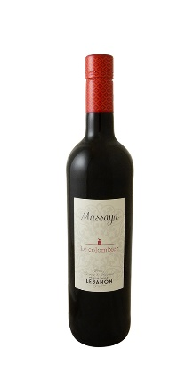
Massaya Rouge ($22)
Le Colombier comes from Lebanon. We tasted a number of wines from the Middle East this winter to find just the right one for our Wine Club.
The Massaya winery and vineyards are nestled between the mountains and the Mediterranean, producing a wide range of unique wines. This is an easy-drinking, unoaked blend of Cinsault, Grenache, and Syrah with fresh ripe raspberries on the nose and plush red fruits on the palate. In the glass a ruby color of good intensity. The nose is aromatic with strawberry notes and cherry with a touch of fine spices. On the palate the wine is generous and light, round and easy to drink. The palate is supple, and the finish is fresh and on the fruit.
Overall this selection is a fresh, thirst quenching wine for everyday drinking. It is a wine of all times. Drink now to fully enjoy its fruit.

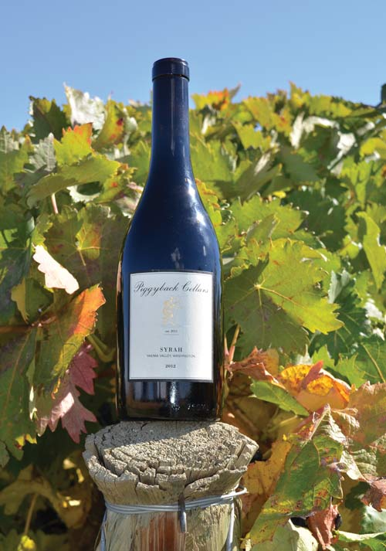
Piggyback Syrah ($26)
The aromas of boysenberry jam, dried cranberry and herbs are light, with the oak pulled back. The flavors are tart and bright, showing depth and richness with sharp, bright acids keeping it all in focus. It stands up on its own but will show best at the dinner table. This wine comes from Brian Scheehser, a long-time chef at the Sorrento’s Hunt Club and Heathman Hotel’s Trellis, now the Dean of Students at South Seattle College’s Culinary, Horticulture and Wine Academy programs and a personal friend of Mina & Bruce’s.
90 points Wine Enthusiast

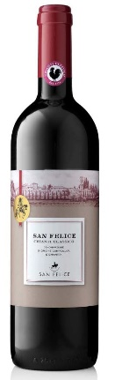
San Felice Chianti Classico ($21)
Il Grigo is produced entirely from native varieties, predominantly Sangiovese with addition of Colorino and Pugnitello. It is a medium-bodied Chianti Classico with a distinguished personality and notable for its elegance. Traditional fermentation practices are employed with average-length maceration, followed by 12 months maturation in large Slovenian oak casks.
This wine boasts enticing aromas of wild berry, black cherry, black currant, pipe tobacco and violet. On the smooth, juicy palate, polished tannins lend lithe support to black cherry, crushed raspberry, truffle and a hint of baking spice. Look for the touches of earth and iron that add complexity. Medium body, soft tannins, integrated fruit and acidity plus a clean and pure finish. Enjoy now through 2024.
94 Wine Spectator, 92 points Wine Enthusiast, 91 James Suckling, #19 Wine Spectator Top 100 of 2018

Upland Mayor ($25)
A delightful blend of Cabernet Sauvignon, Malbec, Merlot and Mourvedre from Snipes Mountain outside of Yakima. Earthy, rich, velvety with subtle power. You will never see this wine again as the winery has closed so that the third generation of the family could concentrate their efforts as fruit growers.
More than 100 years ago William Bridgman recognized the potential of a wine industry in Washington’s Yakima Valley. Bridgman was the two-time mayor of Sunnyside in the Yakima Valley and a lawyer with expertise in irrigation law. In 1914, he planted wine grapes on Harrison Hill in Sunnyside and, as Prohibition effectively closed the wine business, he planted more wine grapes in 1917 on nearby Snipes Mountain. When the country came to its senses and repealed Prohibition in 1933, Bridgman was ready and launched Upland Winery the next year. During that time, sweet wines ruled the Washington wine landscape, and Bridgman went along, even though he thought the future was in dry table wines. Then Bridgman met a scientist named Walter Clore, introduced him to wine grapes and gave him cuttings from his vines to propagate. Clore became the champion for the wine industry over the next half-century and influenced everything that is happening today.
Bridgman died in 1968, and Upland Winery closed in 1972, the same year Al Newhouse bought the Snipes Mountain vineyards from Bridgman’s family. When Bridgman died, the Washington wine industry was in chaos, and the focus had not yet fully turned toward using European wine grapes to make dry table wines. He must have been heartbroken.
Bridgman’s story would be nearly lost were it not for Ron Irvine, founder of Pike & Western Wine Shop in Seattle and now owner of Vashon Winery. In 1997, Irvine published “The Wine Project: Washington State’s Winemaking History,” the definitive history of Washington’s wine history, and he told Bridgman’s story in detail.
Today, Al Newhouse’s grandson Todd, who studied history at Whitman College in Walla Walla, runs the vineyards. He oversees some of the last remaining grapes Bridgman planted on Snipes Mountain. In 2006, Newhouse launched Upland Estates, with winemaker Robert Smasne. Todd has since decided to focus on farming and supplying the best grapes in Washington to outstanding winemakers, so Upland Estates has closed.
In 2009, the federal government recognized Snipes Mountain as an American Viticultural Area.
Today, Bridgman’s dreams for the Washington wine industry are fulfilled, and his legacy is honored. If his spirit still roams through those old vines he planted a century ago.

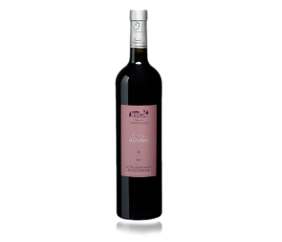
Domaine De L’anticaille ($22)
Mazurka Red from the Coted de Provence. The farmers from Trets village used to meet to celebrate the end of the harvest and dance “I’Anticaille” farandole in the crushing place which still exists today. This dance from Provance has given its name to the domain. To celebrate the history of the domain, each cuvee of the chateau is named after a dance. This wine has a purple color with garnet-colored hints. Aromas of red fruits and spices and a touch of iodine and dry grass. A powerful wine that pairs with white and red meats, spicy food and Mediterranean dishes or light cheeses. Grapes for this blend are Syrah and Grenache coming out of limestone soil.

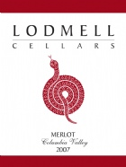
Lodmell Merlot ($30)
A stunning Washington selection. Aromas of boysenberry and barrel spice are followed by ripe pleasing purple-fruit flavors. The tannins deliver a light squeeze. It's hard to find the variety exactly, but it still brings appeal.
Highly complex with ripe plum, Cassis liqueur, canned black cherry and fresh picked yarrow leaves. This Bordeaux-style wine only just qualifies as a Merlot, as it is blended with a generous portion of Cabernet Sauvignon in the Pomerol tradition. Velvety soft tannins. A reserve-style wine, it is ready to be enjoyed now yet it can stand for a long life in the cellar. Perfect with lamb, quail and salmon.

Gorman Winery Red Blend ($28)
Devil You Don’t Know is a Rhone varietal blend of 80% Syrah, 15% Grenache and 5% Mourvèdre. Aromas of Band-Aid, licorice, flower, herb and cherry are followed by lighter-styled tangerine and dried cherry flavors. Compact but loaded with personality, offering blueberry, smoky bacon and cracked pepper flavors that build depth toward broad-shouldered tannins. It finishes quite warm.
92 points Wine Spectator Insider

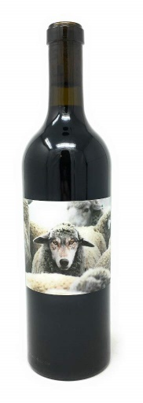
In Sheep’s Clothing Cabernet Sauvignon ($25)
Dark brooding blackberry balanced by bright bing cherry notes, this 100% Cabernet Sauvignon is sourced from both Wahluke Slope and Red Mountain in Washington state. The opulence of fruit is dominant, balanced by smooth tannins and a long finish. This is the first release of Washington Cabernet Sauvignon by renowned winemaker Andre Mack, famous for his Oregon projects.

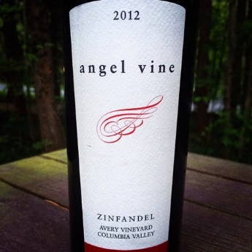
Angel Vine Zinfandel ($23)
Stonetree has bright aromas of raspberry, herb, cigar box and dried cranberry are followed by full-bodied cranberry and raspberry flavors. Search around and you will find hints of ripe dark plum, blackberry, black licorice, moist earth, crushed walnut and black pepper in this big redf. There’s a bold core of dark fruit with bold tannins with an undercurrent of boysenberry acidity.
When Ed Fus arrived in Oregon in 1997, he was intent on getting into the wine industry. His path ended up being a little different than most.
By 2001, the Penn State grad found a cherry orchard in Oregon’s Eola-Amity Hills. After clearing the blackberry bushes, he planted Pinot Noir. But his first love was Zinfandel, something you don’t find much of in Oregon. So Fus looked north when he decided to launch Angel Vine.
But Washington, while it has a warmer climate, doesn’t have a lot of Zinfandel — fewer than 100 acres. In 2006, he bought a little Zin from the Walla Walla Valley and began his quest to focus on the grape most often associated with California’s Dry Creek Valley.
Today, Fus crafts no fewer than five Zinfandels — and one Primitivo, which is a clone of Zin — making him the only winery in the Pacific Northwest to put such focus on the red grape.
Rare is the Oregon winery that seeks the majority of its grapes from north of Columbia River. But Fus, who makes his wine in the tiny Yamhill County town of Carlton, does just that. His lone Oregon wine uses grapes from his estate vineyard in the Eola-Amity Hills, but his other nine wines all come from Washington.

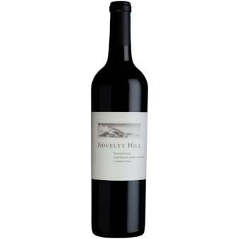
Novelty Hill Sangiovese ($25)
Using the fruit from the estate vineyard Stillwater Creek, this selection is bright and inviting. A brilliant ruby-red in the glass, aromas of toast, coffee and herb jump out of the glass. It is brimming with red fruit flavors followed by generous coffee and fresh cherry, wild strawberry and spicy currants. Medium-bodied on the palate, with focused tannins and a long, lively finish.

WHITE
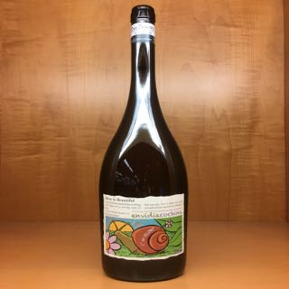
Eladio Pineiro Albarino ($25)
This is a shop favorite. Envidia Cochina comes from the Rias Baixas are of Spain. This Albarino displays a bouquet of lime, sweet grapefruit, gentle lees tones, salty minerality, a touch of ocean breeze, lemongrass, and a top-note of orange peel. The wine is crisp, complex and very nicely balanced, with a fine cut and grip and a long, focused, and classy finish.
Eladio Pineiro founded Bodegas Mar de Frades in 1983 after spending many years making Albarino wine, before the appellation Rias Baixas was granted. In January 2003, his wife fell ill and demanded his immediate attention. He sold the winery but kept the best of his vineyards with the intention of returning. After 5 years Eladio’s wife was well and to the vineyards he returned…this time he was determined to make the wines he wanted exactly as he wanted. He began making reds from his vineyards in Portugal and continued to make Albarino in Riax Baixas while maintaining absolute freedom to create and develop small amounts of wine, real wine, wine he says he makes for wine lovers seeking wines with meaning and that show their true terroir and history.

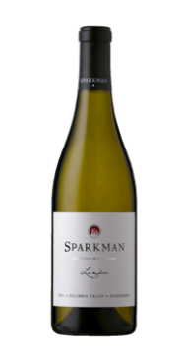
Sparkman Chardonnay ($25)
Lumiére is sourced from Stillwater Creek vineyard, a cooler site in the Frenchman Hills. It is crafted using wild yeast fermentations, weekly battonage and special cooperage. The nose is led by aromas of hazelnut, lemon curd, stone fruit and honeysuckle balanced against lively flavors of green apple, lemon oil, minerals, and just a smooch of sweet toasty French oak. An elegant, well-balanced chardonnay reminiscent of cool site White Burgundy, Lumière is delicious now, but designed to age for many years. Enjoy it as we do….with Dungeness crab with lemon butter dripping off the elbows.
90 points Wine Spectator, 90 points Wine Advocate

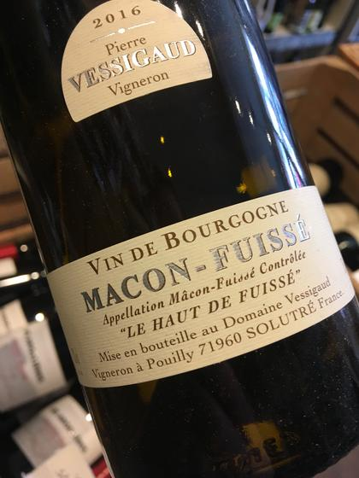
Pierre Vessigaud Macon Fuisse ($25)
This 5 generation vineyard is in the heart of Pouilly within the appellation of Pouilly-Fuisse in Burgundy, France. This Chardonnay is deep and bright golden yellow in color with a lot of tears on the glass. The nose reveals very ripe and expressive floral, mocca, tea, honey and mineral notes. On the palate, the wine is rich, concentrated and onctuous and is characterized with peach, pears and roasted almond notes. This wine has an astonishing long finish. Enjoy now or cellar for 6 years.

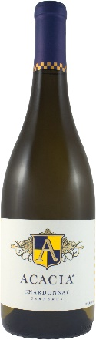
Acasia Chardonnay ($25)
This Chardonnay offers bright aromas of ripe stone fruit, lemon peel, mandarin spice and tones of warm honeycomb. The wine expands across the palate in rich, silky layers with flavors of crème caramel, green apple and lemon oil. The beautiful balance of rich, silky layers enables the wine achieves through the harmonious blend of acidity and creamy complexity leads to a natural, lingering finish graced by fresh lemony citrus and toasted almond notes.
The Acacia vineyard lies in the Carneros area of Napa and Sonoma by the shores of the San Pablo Bay. This terroir’s hallmark is balance and complexity.
92 points Wine & Spirits

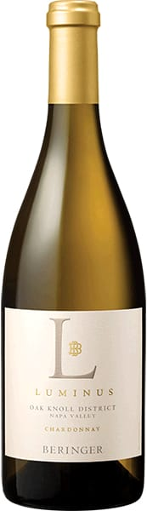
Berringer Chardonnay ($25)
One of Berringer’s upmarket selections, Luminus from the Oak Knoll District.
Heady oak aromas lead the nose of this silky, rich wine sourced from a cool site on the producer's own Big Ranch Vineyard at the southern end of the valley. Golden honey notes add to its luxurious nature, contrasting the linear infusion of tart lemon zest, orange peel and nutty spice flavors.
Pure, crisp and zesty, with a lively mix of green apple, pear, honeydew and citrus flavors. Light toasty oak joins in on the finish. Drink now through 2020.
93 points Wine Enthusiast, 91 points Wine Spectator

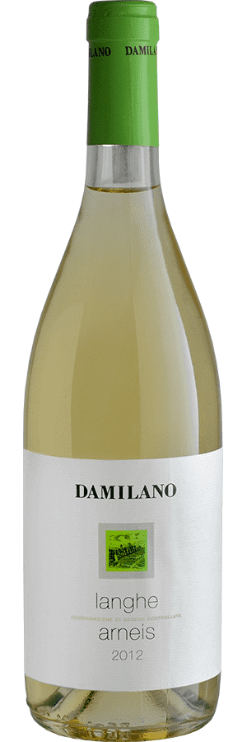
Damilano Arneis ($23)
Arneis is a white wine grape variety most associated with Piedmont in northwest Italy. The name Arneis translates to “little rascal” in the local dialect, a fitting moniker given the grape’s trickiness in the vineyard. Arneis is highly susceptible to powdery mildew, is very low-yielding and can struggle to retain acidity.
This selection is pale straw yellow in the glass showcasing the delicate nature of the wine. Dry, fresh wine with elegant flavors and moderate acidity. Rich and lush, boasting peach, apple and floral aromas and flavors, finishing with a touch of grapefruit peel. Suitable for appetizers, fish courses and white meats.

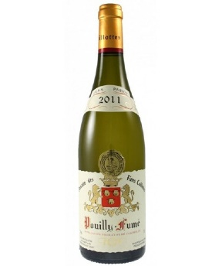
Pabiot Pouilly Fume ($29)
The Pabiot family has been making with since the late 19th century. Today it is in the hands of the 4th and 5th generations in Pouilly Fumé growing Sauvignon Blanc in France’s Loire Valley.
Almost tropical in its fruitiness, this wine, with one year in bottle, is generous, rich and open. Yes, it still shows a hint of minerality and herbal tanginess. But it is now a full wine packed with citrus and apricot flavors. Drink now.
94 points Wine Enthusiast

BUBBLES
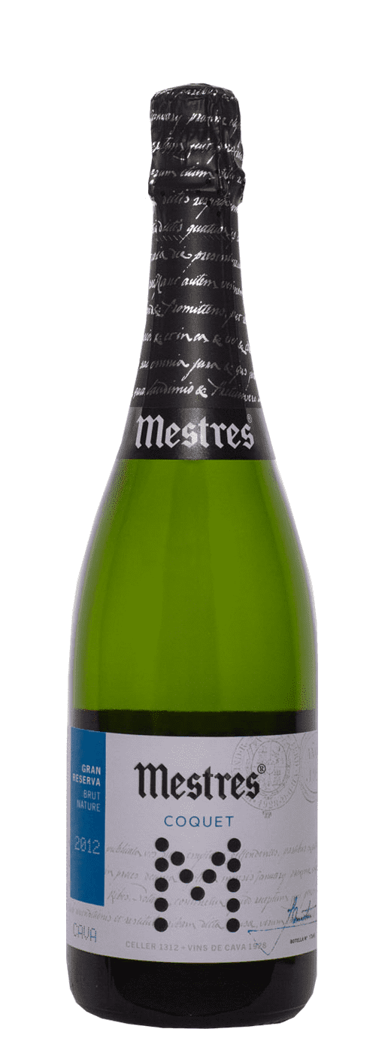
Mestres Coquet Gran Reserva Brut Nature Cava ($25)
Nothing has changed at Mestres since they produced their first Cava bottle, and you can taste the respect for their terroir and authenticity in their wines. The first records of the family as vine growers and négociants date back to 1312. In the 1600’s they began construction of the actual winery in San Sadurni d’Anoia, Penedes, Spain, which was closed in 1861. They bottled their first sparkling wine in 1925 and opened their first bottle to celebrate Christmas in 1928. They were the first producer to register the word cava in 1959, a word chosen to convey that this was a sparkling wine aged in a cellar.
They have always used the traditional grapes of their terroir: Xarel-lo, Parellada and Macabeu, all of them hand harvested on their 74 acres of vineyards, situated at 690 feet above sea level. These are some of the oldest vineyards in the area. To protect their patrimony, no insecticides or herbicides are used at the vineyard, and pruning is carried out to reduce their vigor, therefore producing grapes of greater ripeness and intensity.
Today, they still use traditional methods taught by their ancestors including, long aging in caves. The youngest of their wines is aged 2 years in the cellar, making all of their bottlings either Reserva or Gran Reserva. In order to achieve wines that are full and rich, aging is never rushed- the wines undergo a natural stabilization process during their long aging, so that the crystals which form can then be dégorged along with the yeasts. All of their production is aged under cork, and for all bottles riddling and dégorge is done by hand.

This selection is 30% Macabeu, 40% Xarel.lo, 30% Parellada. Straw yellow color with greenish reflections. Fine foam and good evolution in the glass. Very elegant cava with aromatic richness with notes of white peach, apple, pomelo, orange peel stand out. With a sip you will see how the freshness is emphasized and the notes of fruits combine with the careful construction resulting in a dry, but rich and lively fine bubbled selection.

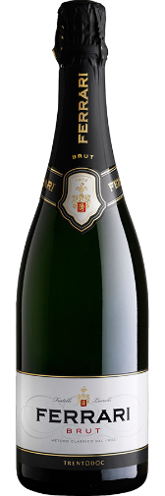
Ferrari Brut ($30)
The historic wine of Ferrari Trento is a Trentodoc that is the product of 100% Chardonnay grapes and of their incomparable synergy with the mountains of Trentino. Bright and lively and fresh with an intense bouquet. Broad fruity notes of ripe Golden Delicious apples, white flowers and a delicate scent of yeast coming from the more than 2 years of ageing. Harmonious flavors of ripe fruit and hints of crusty bread.

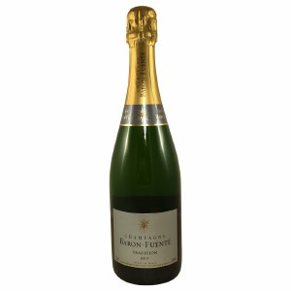
Baron Fuente ($30)
70% Pinot Meunier, 30% Chardonnay This blend is the perfect selection to showcase Meunier from the Marne Valley. Light yellow in color with a very fine mousse. The bouquet is discreet and elegant with notes of brichoe and candied fruits. A light honey aroma makes the whole package. The mouth is supple and well balanced. Unctuous with a good length n the mouth. Perfect for the aperitif, special occasions or as a cocktail. Ideal partner to salmon on toast…or a Tuesday!

TIER IV
RED
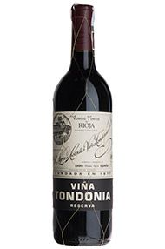
Lopez Bosconia Tondonia ($35)
This blend of Tempranillo (80%), Garnacho (15%), Mazuelo and Graciano, all from estate fruit in Rijoha, is blended to evolve perfectly. Starting with a deep ruby color with shades of orange. Its nose is persistent, full bodied and showing a lot of mature fruit, being dominated by the Tempranillo grape. Its taste is round, smooth, fresh, full of body and persistent.

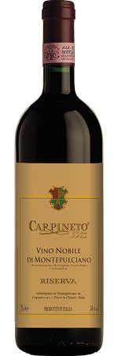
Carpineto Vino Noble Reserva ($40)
Brilliant ruby red color with a tendency to garnet. Aromas of ethereal, extraordinarily elegant with hints of violet and wood. Dry, harmonic, fruity and velvety, with an elegant texture and long finish. Pairs well with aged cheeses and game, especially wild boar.
The stunning bouquet of ripe black cherry, black currant, leather and woodsy spice notes is enticing, while the sweet fruit is a match for the dense structure. The lengthy finish lingers, with tobacco, eucalyptus and iron accents. Drink now through 2030.
#11 Wine Soectator Top 100 2018, 96 points Wine Spectator

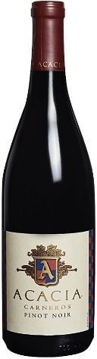
Acacia Pinot Noir ($30)
The 2016 Carneros Pinot Noir opens beautifully offering layers of red-fruit aromas; Bing cherry, cranberry, and sun-ripened raspberry. The aromas ring true on the silky textured palate where the juicy fruit core intermingles with baking spice, black tea, and wet stone minerality. The wine offers a fine balance with perfectly ripened Pinot Noir fruit and bright ‘Los Carneros’ acidity, underpinned by the carefully selected oak barrel regiment. This is a refined and elegant style of Pinot Noir offering a graceful and long-lasting finish.

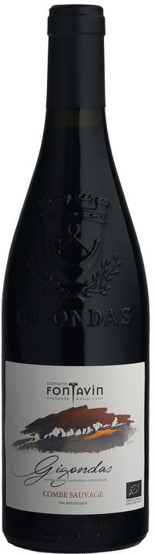
Fontavin Gigondas ($36)
This delightful blend of 75% Grenache noir, 10% Mourvédre, 5% Syrah, 3% Cinsault & 2% Rose Clairettes comes from the Rhone Valley in the same neighborhood as the famed Chateau Neuf de Pape at the heart of Dentelles de Montmirail, 400 meters above sea level in black marl and limestone scree soils. The vines are on average 60 years old and raised organically with native yeasts. The wine has aged one year in concrete tank.
This is a serious wine but enough geekie stuff….The garnet color of the wine has a violet hue. On the note the tell tale garrigue (sort of like sage brush) of the area gives its pedigree away. Other aromatic plants – rosemary, thyme – add mightily to the scent. On the palate you will experience a bright, peppery sensation backed up with spice and black berries. The tannins are tight and underpin the density of this selection. Par with tasty, meaty dishes like pepper steak, duck breast, lamb curry, paella, tajine.

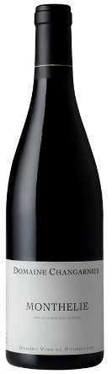
Changarnier Monthélie ($35)
This Pinot Noir is a soft and fruity example of what Burgundian winemakers can produce. From the Monthélie region, known for its pebbly limestone and red clay soils, this selection has aromas of red fruits – red currants and wild strawberries. On the palate you will experience a round and fruity finishing reminding you of a happy mix of citrus and apple adding a crisp texture. Then finishing up with a subtle hint of cinnamon and pepper and a touch of toast. This wine comes from younger vines. Drink now, or cellar for 3-7 years. Hand harvested. Light filtering. This cuvée comes from two plots with deep soils.

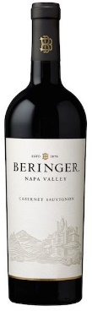
Berringer Cabernet Sauvignon
Beringer’s Napa Valley Cabernet Sauvignon is crafted to reflect the outstanding strength of the Napa Valley appellation, but with stylistic differences from the Private Reserve – differences that highlight the range of terroir found in Berringer’s Napa Valley vineyards. Possessing great structure and concentration, this wine is still immediately approachable and appealing but incredibly cellar worthy.
The Napa Valley Cabernet Sauvignon opens with vivid aromas of fresh boysenberry and ripe, dark fruits which are accented by hints of leather and dark chocolate notes. The wine is full-bodied with a dense concentration of flavors and plush tannins that underpin the solid structure.
Lots of ripe fruit to this cab with dried berries, cherries, currants and chocolate undertones. Full and powerful, yet there's a freshness and firmness to it all. Drink in 2021, but very approachable now in a fruit-forward way.
Blend: 88% Cabernet Sauvignon, 12% Merlot
92 points James Suckling

WHITE
Baron Fuente ($30)
70% Pinot Meunier, 30% Chardonnay This blend is the perfect selection to showcase Meunier from the Marne Valley. Light yellow in color with a very fine mousse. The bouquet is discreet and elegant with notes of brichoe and candied fruits. A light honey aroma makes the whole package. The mouth is supple and well balanced. Unctuous with a good length n the mouth. Perfect for the aperitif, special occasions or as a cocktail. Ideal partner to salmon on toast…or a Tuesday!
Pabiot Pouilly Fume ($29)
The Pabiot family has been making with since the late 19th century. Today it is in the hands of the 4th and 5th generations in Pouilly Fumé growing Sauvignon Blanc in France’s Loire Valley.
Almost tropical in its fruitiness, this wine, with one year in bottle, is generous, rich and open. Yes, it still shows a hint of minerality and herbal tanginess. But it is now a full wine packed with citrus and apricot flavors. Drink now.
94 points Wine Enthusiast
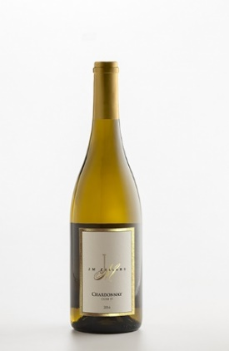
JM Cellars Chardonnay Clone 15 ($39)
Chardonnay has been an important wine for JM Cellars throughout the last ten years. The fruit we source comes from Conner Lee Vineyard and Stillwater Creek Vineyard. Both vineyards have clone 15 planted; the clone was originally from Dijon, France and is the major clone grown in the Meursault appellation. John ages this wine in very little new French oak to reveal the pure fruit flavors of this special chardonnay. Expect pear, apple and honey-butter. With nice acidity, this wine is refreshing and easy to drink.

TIER V
RED
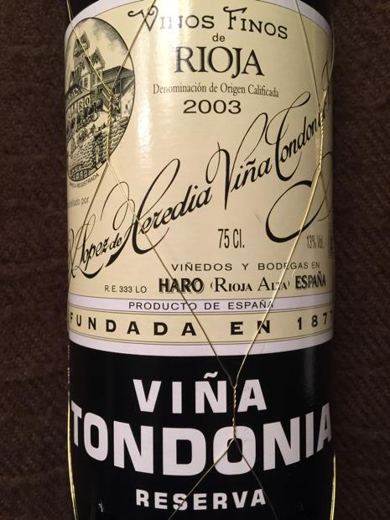
Lopez Tondonia Reserva Rioja ($47)
This Spanish selection is a blend of estate fruit. (75%), Garnacho (15%), Graciano and Mazuelo (10%). Vibrant red leading slightly towards amber. Light fresh texture with scents of vanilla and dried berry aromas. Rich flavors. Dry, smooth, developed. Firm tannins and good balance.

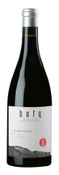
Buty Rockgarden ($52)
GSM blend
Nina Buty purchased 10 acres of apple orchard in Milton-Freewater in late 2006. In 2008, it was organically prepared and planted as Buty’s Estate, Rockgarden. The famous cobblestones section of the Walla Walla Valley appellation is located in the southeast part of the valley. In the 5% highest elevation of the cobblestones, this Grand Cru section has been the most prized farming section since the Walla Walla Valley was settled over one hundred years ago. Grand Cru is defined and set apart from its neighbors by location, history and consistently superior wines. She waited years to buy only here. Anywhere else further out in the cobblestones would have been a compromise. Like Rhône meets The Rocks District, this gorgeous wine combines complex layers of meat, minerality and black pepper with silky tannins and alluring layers of raspberry and strawberry.

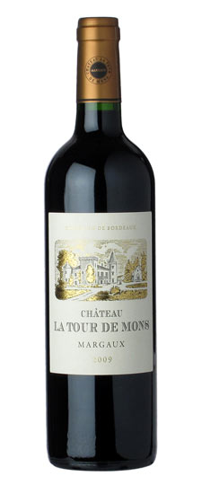
2009 La Tour de Mons Margaux ($50.00)
This assertive red delivers bold flavors, with crisp texture, offering bright black cherry and pomegranate notes over firm tannins. Orange zest acidity carries this through the juicy finish. Drink now through 2020. This is one of the better values in red wine in today's market. Quite rich with that forward 2009 Bordeaux fruitiness. Round tannins-great balance and more black fruit flavors. Long and lingering finish. 91 points Wine Spectator

WHITE
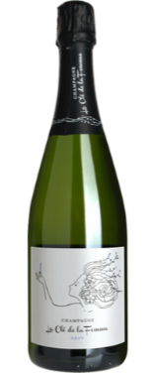
Magic Door La Cle Champagne ($40)
This Champagne is a blend of Chardonnay and Pinot Meunier--two of Champagne's primary grapes. The grapes are grown in top vineyards sites in the Marne Valley. These vineyard sites are made of sedimentary soils of calcium, silica, and limestone which impart layers of minerality into the wine. The wine goes through a cool fermentation in stainless steel and a complete malolactic fermentation. It is then left on the lees for a minimum of 20 months. A well-balanced and layered Champagne with expressive aromas of apple and white pear along with more subtle notes of almond, buttered toast and baking spices.

JM Cellars Chardonnay Clone 15 ($39)
Chardonnay has been an important wine for JM Cellars throughout the last ten years. The fruit we source comes from Conner Lee Vineyard and Stillwater Creek Vineyard. Both vineyards have clone 15 planted; the clone was originally from Dijon, France and is the major clone grown in the Meursault appellation. John ages this wine in very little new French oak to reveal the pure fruit flavors of this special chardonnay. Expect pear, apple and honey-butter. With nice acidity, this wine is refreshing and easy to drink.

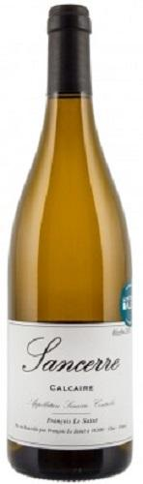
Sancere Calcaire Le Saint ($30)
Under the organic label from Domaine Fouassier (the largest landholder in Sancerre), this 100% Sauvignon Blanc grown in Calcaire soils. From the pneumatic press, the free-run juice is transferred by gravity to stainless steel tanks for an indiginous yeast fermentation. The Sancerre is briefly aged on fine lees to add complexity. Green straw color with good legs; dry, medium-bodied with fresh acidity and scant phenolics. Delicious supple ripe citrus and tree fruit Sancerre with a fine mineral character. Textured and dimensional with layers of flavor. Hints at tropical. A great wine from a great vintage.
From one of the oldest continuously operating estates in Sancerre, this is organically grown Sauvignon Blanc from soils laced with limestone and seashells - "Calcaire." It's 100% free run juice with just a bit of lees aging for richness, and it pumps out classic Sancerre aromas and flavors of white grapefruit and Granny Smith apple with just a hint of herb. Rounder and fleshier than some Sancerres, it has the generosity to savor solo but no lack of food-friendly energy on the crisp, lightly herbal and mineral, finish.

TIER VI
RED
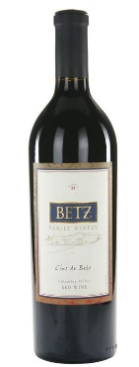
Clos de Betz ($66)
To tell the story of Clos de Betz, you must start at the beginning of Bob and Cathy Betz’ love affair with wine. The year is 1973, the place is Burgundy, France, the players are two young travelers in the beginning of a journey that has now spanned over 4 decades. Standing at the foot of the vineyard Chambertin-Clos de Beze; one of the most important vineyard parcels in not only all of France, but the world, and the young couple dreamed of one day trying their hand at winemaking, and naming the wine “Clos de Betz.” Fast forward two and a half decades, and this dream became a reality. At the time, Washington State already had a reputation for producing strong examples of Merlot, and the early drinking, generous character of a Merlot based wine was something the couple couldn’t resist. In 1998 the first Clos de Betz was born.
What makes Washington State Merlot unique is a combination of deep fruit flavors, weight, and ample structure (tannin, acid). Not unlike Père de Famille, grapes are sourced from throughout the Columbia Valley, but here the focus changes from Red Mountain, to the Yakima Valley. Red Willow, Elephant Mountain, DuBrul are the main sources, supplemented by Klipsun, Ciel du Cheval, and Seven Hills Vineyards. To add aromatic interest and weight, Cabernet Sauvignon and Petit Verdot play smaller roles.
2015 Clos de Betz offers the highest percentage of Merlot for this wine to date, at 75%. More often the final blend contains closer to 65% Merlot, and the higher than normal percentage reflects our success with the variety this vintage. The wine’s color shows the additional Merlot with shades of ruby red and plum.
he aromas of 2015 Clos de Betz lead with spices of cardomom and five-spice. Red fruit aromas of black cherry, pomegranate, and raspberry flavors are complimented by cedar and sassafras notes. A very long Malolactic fermentation, which lasted into April, endowed our Merlot lots with unusually silky textures. The integration of tannins has lent this notable finish.
75% Merlot 15% Cabernet Sauvignon 10% Petit Verdot
94 points Robert Parker Wine Advocate’s Jeb Dunnuck.
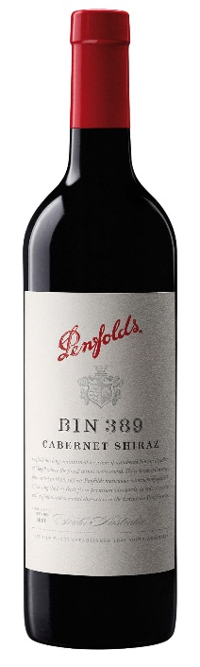
Penfolds Bin 389 ($65)
Bin 389 is often referred to as ‘Baby Grange’, in part because components of the wine are matured in the same barrels that held the previous vintage of Grange. First made in 1960, by the legendary Max Schubert, this was the wine that helped to forge Penfolds solid reputation with red wine drinkers combining the structure of Cabernet Sauvignon with the richness of Shiraz. Bin 389 also exemplifies the judicious balance of fruit and oak.
An immediate ascent of scent – no need to wait or to vigorously swirl this wine to tease out ‘what lies beneath’!
Dark berry fruits consistent to both varietal persuasions, (cabernet and shiraz), overtly courted by elements of ponzu, soy, sesame and dried shiitake mushroom.
Senses are easily conveyed to a forest after rain – wet bracken, liberated mulch, damp soils. Naturally (new and used) oak plays a (minor) role in this fanciful aromatic romp.
Flavors and textures akin to marbled Kobe beef and an earthy accompaniment of black liqorice root and anise. Structurally bold with little protruding – integrated, fine … and has comfortably already “settled into place”. ‘Appetising’ acidity – a non-intrusive and refreshing granita-like bite/attack. Tea maltiness and tannins merge with impressions of wet slate, pencil lead/graphite … no doubt somehow linked to earlier partial barrel fermentation and oak maturation.
Needs time, as per most Bin 389’s at release. Perhaps a little longer for this vintage.
51% Cabernet Sauvignon, 49% Shiraz. Peak drinking 2020 - 2046. Drinking well now but will improve with time. Peak drinking 2020 - 2046.
96 Points - Campbell Mattinson; 96 Points - Huon Hooke; 95 Points - Andrew Caillard MW; 95 Points - Tyson Stelzer; 94 Points - Anthony Rose, Decanter; 18.5+ - Matthew Jukes; 16.5+ - Jancis Robinson

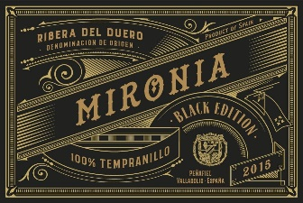
Bodegas Penafiel Mironia Black Edition ($79)
100% Tempranillo from the estate Rafael’s Vineyard in the Ribera del Duero region of Spain. Intense color with long legs, deep red cherry color with violet rim, forecasting its powerful and complex nose, full of black an red fruits, spaces (cloves, cinnamon) and light hints of coconut. Dark plum and licorice as well as a wealth of red fruit. This wine is swathed in tannins and has an effortless depth coming from the concentrated fruit.
93 points James Suckling
