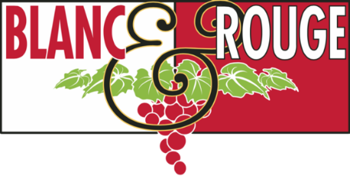
Wine Club Tasting Notes
Summer Club Release
July 31st, 2020

Old World vs. New World

The theme of our summer club release was sparked from a conversation on one of our favorite white grapes—Sauvignon Blanc. Sauv Blanc is a zesty, refreshing wine that pairs well with everything from spicy Thai curry to roasted chicken. That said, it takes on radically different flavor profiles depending on where it’s produced. We discussed the differences between tropical, herbal bottles from New Zealand and mineral-driven, peachy Italian Sauv Blanc from Friuli, and by the end, we knew we had our concept. This summer we will be comparing Old World and New World examples of some of our favorite grapes.

In your club allocation you will find at least one Old World vs. New World comparison of a grape varietal. These two bottles may have similar composition, but will demonstrate differences in soils, vineyard management, winemaking practices, and aging. We talk a lot about terroir at Blanc & Rouge—the concept that land and climate impart flavors that are unique to that specific place. This club release is an experiment in terroir, and we hope you’ll find it both fun and educational.

Our quarterly wine club was founded as an opportunity for exploration, a chance for us to feature lesser-known grape varietals, up-and-coming wine regions, rising winemakers, and challenging enology styles, with the hope that you’ll find some new favorite bottles. We thank you for continuing to explore the world of wine with us!

Quick links: Tier I Tier II Tiers III IV V

*If you have specified that you would like only New World or only Old World wines, you will not have this comparison in your club allocation. Please let us know if you would like to participate and we will adjust your selections.

The tasting notes below represent the core wine selections for this August club release. We may have included a special selection in your club bag, so please contact wineclub@blancandrougewine.com if you would like any additional information about your club wines. Cheers!

TIER I

Red

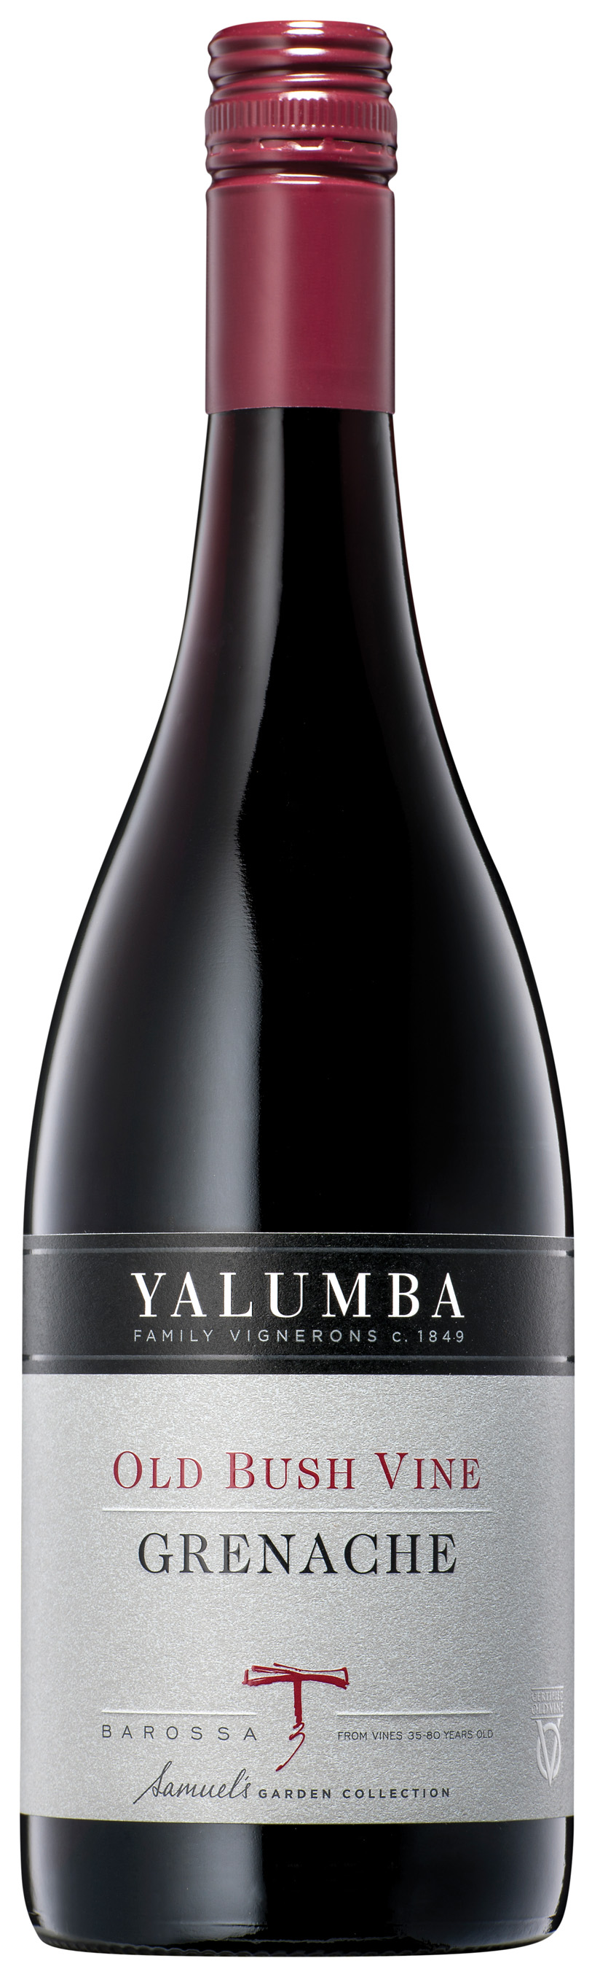
Yalumba Barossa Old Bushvine Grenache ($20)

New World Grenache

Established in 1849, Yalumba is Australia’s most historic family-owned wine company. It remains fiercely independent and extremely progressive through the generational ownership by the Hill-Smith family. Barossa is arguably the single most famous wine region in Australia. Barossa includes both Barossa Valley and Eden Valley, making it one of the only areas in Australia to have neighboring warm and cool climate growing conditions. Yalumba is privileged to have access to some of the oldest vineyards in the world in Barossa Valley, including 1889 bush vine Grenache and 1908 Shiraz. This wine is fragrant, fresh and full of red cherries, raspberries and crunchy pomegranates. Savory characters evolve into spices and dried herbs. A concise yet fleshy palate with rich red fruits weaving through a juicy, mouth-watering mid palate, with elegant tannins and fresh acidity to finish. Enjoy with charred mushroom and cashew pizza or a tea smoked duck with maple glaze.

Bodegas Anadas Care Garnacha Nativa ($16)

Old World Grenache (Garnacha)
Bodegas Añadas was founded in the very heart of Cariñena, Spain’s second-oldest officially designated wine region. Care is the ancient name used by the Romans to refer to the town of Cariñena, which then became Caraellana, “the dear plain”. In the English-speaking world, “Care” refers to the attention and respect the winery gives in their winemaking. The majority of Cariñena’s wines are made from Garnacha grapes, ranging in style from steely and aromatic (high-altitude vineyards) to ripe and robust (lower elevation vineyards). This bottle is elegant and powerful, with notes of cocoa and coffee bean that integrate well with weighty red and black fruits. The labels feature the original work of the artist Enrique Torrijos. Enjoy with Morroccon- spiced lentils or grilled chili-rubbed chicken.

Chateau de Miniere Rouge ($18)

100% Cabernet Franc

Château de Minière is a sprawling 18th century estate in the Loire Valley situated midway between Tours and Saumur, and lying within the Bourgueil appellation. The estate has numerous parcels of vineyards, comprising 18 hectares in all, and entirely planted in Cabernet Franc. The viticulture is entirely organic, certified as such by Ecocert and wines are fermented in stainless steel without the addition of commercial yeast or fining agents. This is a fresh, dry wine with bright red cherry and raspberry notes that intermingle with a touch of cocoa and bell pepper. Enjoy with ratatouille or crispy trout.

Babylon’s Peak Shiraz ($16)

Babylon's Peak winery, situated on the highest weathered granite slopes of the South Africa’s Paardeberg Mountain, is privately owned by the Basson family who has passed down the tradition, passion and art of winemaking over four generations. Predominantly low-yield dryland bush vines are selected to produce these excellent wines with distinctive character. This Shiraz offers nice purity of black fruit with a licorice note on the nose and flavors of blackberry, mocha, and a touch of dried fruit. It’s softly textured with good supporting acidity and has an attractive cracked pepper spice note. Enjoy with herbed lamb chops or grilled eggplant.

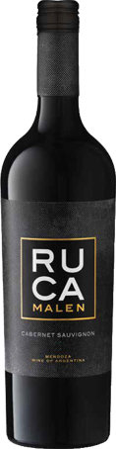
Ruca Malen Cabernet Sauvignon ($14)
Hailing from Argentina’s premier wine region and home to over half the country’s cultivated vines, Ruca Malen embodies the rich history, spirit, and pedigree of Mendoza winemaking. Ruca Malen, meaning “the house of the young girl,” takes its name from an indigenous legend of the Mapuche Indians. A young tribal woman looked up to the heavens and fell in love with a handsome god. He gifted her a house, overlooking the world’s splendors. The beauty of the Ruca Malen estate reminds of this location. Ruca Malen was the first winery in Argentina to adopt the “tasting menu” concept. Today, the internationally acclaimed winery restaurant is the most successful in the country, where the dishes are specifically prepared to further enhance the wines. This Cabernet Sauvignon hosts initial aromas of black fruit and baking spices with red pepper and currant progressively emerging. A vibrant wine, packed with sweet tannins that provide structure and body. Vinified in stainless steel, 20% of the wine is transferred into French oak to age for 6 months. Enjoy with Portobello mushroom burgers or classic Argentinian-inspired asado.

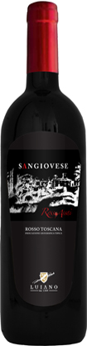
Luino Sangiovese ($16)
Luiano is an ancient fort, built in the late middle ages, that spans 40 hectares in the Chianti Classico appellation of Tuscany, Italy, just 10 miles south of Florence. Since it was erected, Luiano has belonged to several of the most important, noble families of Florence, renowned for its abilities to produce superb wine. Luiano Sangiovese is a young, fresh expression of Tuscany’s signature varietal with aromatics of cherries and strawberries that fill the nose and flood the palate. The acidity is balanced by rounded tannins creating a smooth mouthfeel. Vinified entirely in stainless steel to preserve the natural characteristics of the grapes, the wine rests for 10 months prior to bottling. Enjoy with spaghetti Bolognese or with dishes using local tomatoes at the peak of season.

White

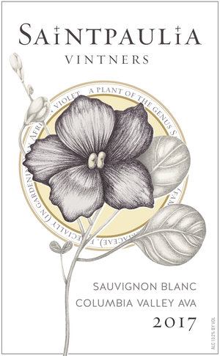
Saintpaulia Vintners Sauvignon Blanc ($15)

New World Sauvignon Blanc
Saintpaulia Vintners was founded in 1994 in Snohomish on Shinoda Floral’s commercial greenhouse property. Founding winemaker Paul Shinoda, was one of the largest commercial growers of African Violets (botanical name Saintpaulia) in the United States. In 2015, Paul’s granddaugter, Allyse Ingalls took over Saintpaulia’s winemaking program and she continues to produce small lots of hand-crafted wine in Snohomish. This Sauvignon Blanc is weighty with aromas of peach tea and melon. Juicy grapefruit, pineapple, and a touch of spice box burst on the palate. Enjoy with marinated grilled prawns or stuffed poblano peppers.

Domaine de la Foliette Sauvignon ($16)

Old World Sauvignon Blanc
Domaine de la Foliette has a 35 hectare vineyard set in the ancient grounds of the “Massif Armoricain”. Their wines reflect the diversity of the Loire Valley terroir. This fantastic Domaine, in the heart of the Muscadet region, has been in the Hervouet family for generations and today Jean Hervouet and his wife tend the vineyards and make the wines with patience and passion. The wines are produced following the traditional method specific to the Nantes area (Loire Valley) called “sur Lie” (the sediment remains in the wine during the fermentation process). Herbal and gooseberry flavors are part of this classic, light Sauvignon Blanc. Crisp acidity and lemon flavors lend a wine that is fresh to the finish. Enjoy with fresh-shucked oysters or difficult-to-pair green vegetables such as artichokes or zucchini.

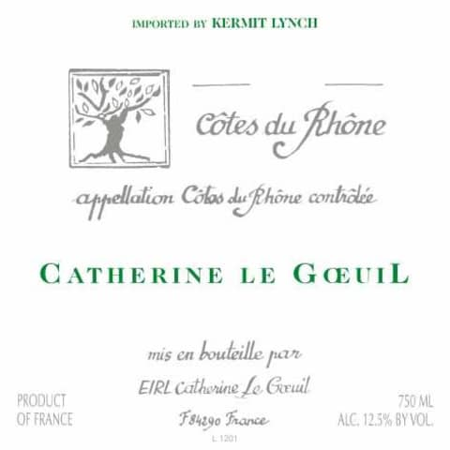
Catherine Le Goeuil Côtes du Rhône Blanc ($14)
Equal parts Roussane, Grenache Blanc, and Clairette
The hilltop village of Cairanne on the left bank of the southern Rhône between Orange and Vaison-la-Romaine is a picture of Provençal fantasy where fields of lavender paint the landscape purple and proud plain trees line the marketplace in the center of town. Cairanne belongs to the Côtes du Rhône Villages appellation and is widely regarded as the star among the seventeen villages that have the right to use this designation.
Catherine Le Goeuil’s taste for adventure has made her a leading pioneer in Cairanne. Having been born in the Congo to French parents, she had already lived in interesting places, but she longed to return to her roots. In 1993, with little experience and great determination, she and her family bought a six-hectare domaine. Soon after implementing one of their first chemical treatments on the vines, Catherine became very ill. The viticultural direction for the domaine became instantly clear. In her mind, farming as naturally as possible was the only way to go. Over time, she started the conversion to organic farming, and is now fully certified in this methodology. Notes of apricot and orange zest balance with Meyer lemon citrus on the palate. Rhone white blends are massively food-friendly, and refreshing any season of the year. Enjoy this wine with white fish with mango salsa or baked sweet potatoes.
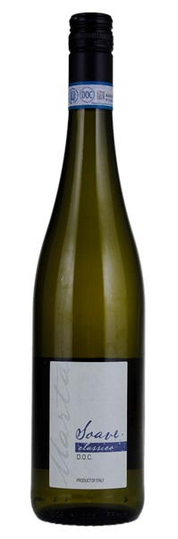
Monte Tondo ‘Marta’ Soave Classico ($14)
Monte Tondo is a family estate located in the beautiful hillside vineyards of Soave. Here the soils range from volcanic to chalky, which alongside the varying microclimates, gives the wines distinct flavour characteristics and individualistic style. Alongside his family, winemaker Gino Magnabosco is part of the third generation to run the estate. They believe that hard work, drive, and determination are key to obtaining the best results from their land. Maintaining, nourishing, and cherishing the land of their ancestors is of utmost importance. And although not certified, they farm using organic practices and an environmentally friendly approach to both viticulture and vinification. No chemicals are used in their production and they recycle everything excess coming from the vineyard (stems as fertilizers, skins for grappa, pruned branches for heating and fertilizer). Delicate and very floral, this lovely Soave Classico from Italy's Veneto region is made of 100% Garganega, the region's hallmark white variety. This wine is bristling and clean, flinty and fragrant, with terrific notes of granite, citrus, green apple. Enjoy with a simple roasted apple and fennel salad or Chicken Milanese.
Bodegas Shaya Verdejo ($16)
As the morning mist disperses across the countryside the Shaya deer emerge from the surrounding pine forest to forage. The gnarled vineyards, planted a long time ago in sandy riverstone soil, produce the finest Verdejo in Rueda, Spain. There is a distinct minerality in these wines which compliment the abundance of fruit flavors. Ripe, bright tropical notes of pineapple and mango on the nose with sweet/tart apple and pear flavors. A structurally balanced wine with nice minerality to complement the enduring finish. It displays a nose of toasty baking spices, nutmeg, spring flowers, marzipan, and pit fruits. A bit richer and more complex on the palate than the typical cuvee, this vibrant effort could evolve for 1-2 years but is drinking well now. Enjoy with Spanish-style steamed shellfish or Alice Waters’ s baked goat cheese salad.

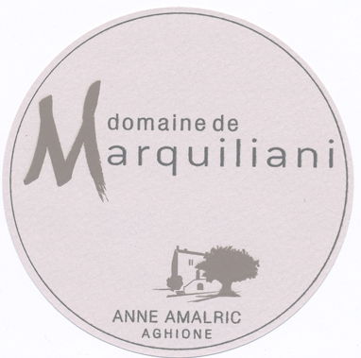
Domaine de Marquiliani Vin de Corse Rosé Gris ($20)
Domaine de Marquiliani is considered a pioneer of Corsican rosé, as they were the first to plant Niellucciu and Syrah on their side of the island. Fruit for their rosé comes from two hectares of 50-year-old vines, rooted in schist-gravel soils. Grapes are hand-harvested, direct pressed, and cold soaked for three days, creating a crisp and crunchy wine, oozing with notes of strawberry grapefruit, and salty sea air. Enjoy as an aperitif or a light salmon pasta dish.

TIER II

Red
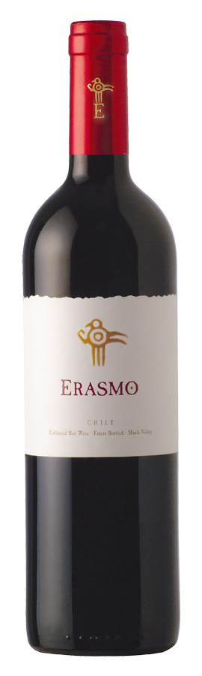
Erasmo Reserva ($26)

New World Cabernet Sauvignon-Dominant Blend

This wine is a dry-farmed Bordeaux-inspired blend of predominantly Cabernet Sauvignon, produced from a single vineyard on the ancient estate of la Reserva de Caliboro. It is named after the elderly person born on the estate who helped the current owners establish the vineyard utilizing local vineyard management practices. The blend acquires a unique character thanks to the aromas of boldos, peumos, wild roses and other native plants that thrive on the riverbanks surrounding the vineyard. Toasty oak and savory cherry and plum aromas are meaty and calm. On the palate, this is linear and compact, with a beam of acidity that keeps things healthy and plodding ahead. Spicy oak flavors blend nicely with tomato, herbal plum and red currant notes. Enjoy this wine with grilled lamb kabobs or spicy squash and poblano chili.
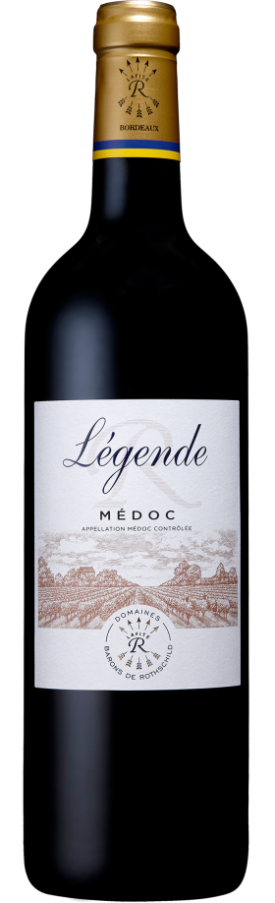

Domaines Baron de Rothschild Légende Médoc ($30)

Old World Cabernet Sauvignon-Dominant Blend

The prestigious Barons de Rothschild (Lafite) family has owned vineyards in Bordeaux for generations. In addition to the wines issued from their world-renowned vineyards, Domaines Barons de Rothschild (Lafite) has created a series of wines which are easy and pleasant to drink called “Légende”. Deep crimson-purple. Subtle and refined, mingling notes of polish with aromas of candied liquorices and Morello cherries. Elegant and well structured, with tight, dense tannins on the palate and a pleasant hint of liquorices on the finish, this wine already has a great deal of charm, and also has the structure to improve further with age. Enjoy with simple charcuterie or classic Shepherd's Pie.

Ferreri Cabernet Sauvignon ($25)

Old World Cabernet Sauvignon

This ultra-exclusive Cabernet Sauvignon hails from Italy’s southern isle of Sicily. Sicily, the largest island in the Mediterranean Sea, served as a crossroads for ancient civilizations. Today, it boasts one of Europe’s most dynamic wine industries. Though a part of Italy, Sicily’s breadth of landscapes approximates a small country itself. The Greeks, Phoenicians, Arabs and Italians have all held sway over Sicily. Though the Greeks brought their advanced viticulture techniques, Sicilians have been making wine since 4000 BC. Its dry, warm climate features regular sunshine and moderate rainfall that suits wine production. Arid conditions reduce the chance of rot and mildew, especially in areas kissed with coastal breezes. This makes Sicily a prime candidate for organic farming. Olives, citrus and grains drive the agricultural sector beyond wine. While this region is known mainly for the production of indigenous grapes, French grapes such as Cabernet Sauvignon and Syrah grow incredibly well in Sicily. Enjoy this wine with campfire-roasted sausages (veggie or meat) cooked with skewers of umami-rich mushrooms.

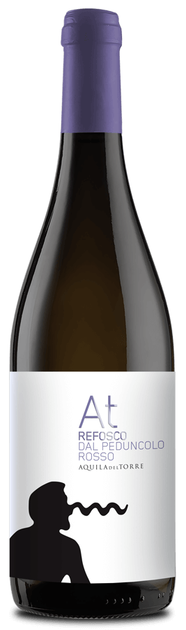
Aquila del Torre Refosco ($24)
Refosco is the ultimate summer red. Believed to be the main varietal of the old Roman wine, Puccinum, which was most often used for medicinal purposes, the Refosco varietal is one of the oldest in all of Italy. This grape is a staple in the northeast Italian region of Friuli-Venezia Giulia. This producer, Aquila del Torre produces stellar wines in the Colli Orientali del Friuli region using exclusively organic vineyard management practices. Rich in both tannin and acidity, the dark-skinned Refosco produces sturdy wines with red berry and currant flavors. Enjoy this wine anything you are grilling this summer. We would recommend Ina Garten's Tuscan Lemon Chicken.

Chatter Creek Cabernet Franc ($25)

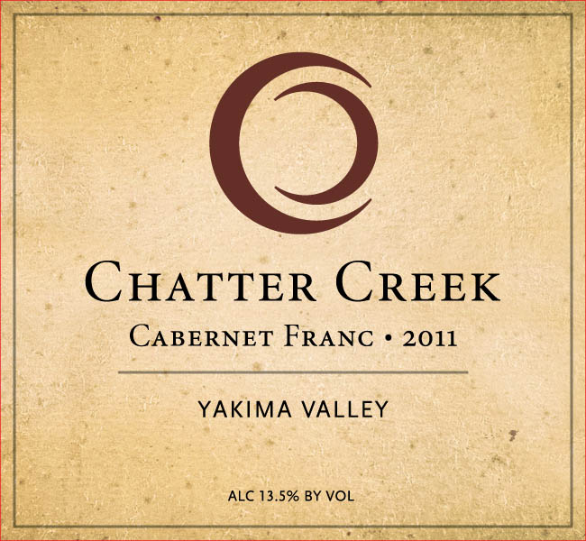
Cabernet Franc is best-known as one of the primary six Bordeaux varietals, but it has quickly become a favorite for Washington winemakers. Cab Franc is a late-ripening grape with notes of bell pepper and leafy herbs that lends savoriness to a blend and can be beautiful as a solo varietal bottling. On the nose, this wine gives aromas of blueberry, cranberry, cassis, and peppers. The mouthfeel is clean with ripe and youthful pie-cherry and red berry flavors that are unencumbered by oak. The tannins are well-integrated, and the lingering finish is fruity, and velvety. Gordon Rawson has been producing wine in Washington since the early years of the industry. His skilled approach to winemaking is inspired by the Old World and also demonstrates the best of local Washington terroir. Gordy is retiring this year, and we raise a glass to his tremendous contributions to the Washington wine industry. Enjoy this wine with bloomy cheeses or a hearty artisan pizza.

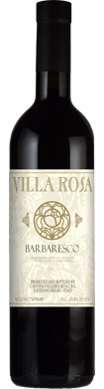
Villa Rosa Barbaresco ($25)

It’s not often you can find a delicious Barbaresco at this value. Villa Rosa was created by the Opici family as a tribute to the late Rose Opici, a founder of the Opici Wine Group. Rose was partial to Piedmont’s indigenous grapes, particularly the white varietals, regularly enjoying a glass of Gavi with her favorite Italian fare or celebrating life with sweet bubbles from Asti. From Asti to Barolo, Opici collaborated with some of Piedmont’s finest growers an d producers, each specialists in their respective appellations. The wines are high-quality examples of classic varietals at an ultra-approachable pricepoint. Mixed colors of ruby, plum, and brick converge in the glass. Black cherry, tar, tobacco and earth notes mingle across the complex bouquet. A lush, juicy style of Barbaresco, this fills the rich texture with cherry, strawberry, licorice and leather flavors. Supple yet firm, with terrific balance, ending with a long aftertaste of sweet fruit, mineral and vanilla. The tannins are well-integrated for a young Nebbiolo, leading to a long finish. Drink now, and over the next 10 years. Enjoy with truffles, mushrooms, wild game, or veggie lasagna.

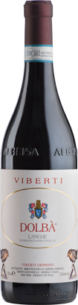
Viberti Dolbà Langhe ($25)

Viberti has been located just above the village of Barolo, in the commune of Vergne, since 1923. A blend of two of Piedmont’s native varietals, Dolcetto and Barbera, Viberti Dolbà shows fresh red berry aromas on the nose and palate. The vibrant acidity makes it an easy-drinking wine that is best consumed young. Aged for 6-8 months in stainless steel tanks and 2 months in bottle prior to release. Enjoy with mushroom and asparagus salad or chipotle-spiced pork tenderloin over sweet potato mash.

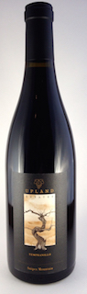
Upland Estates Tempranillo ($30)

Planted in 2007 high on the steep, rocky slopes of Snipes Mountain, this is one of seven varieties that comprise Upland Estates’s 14-acre “Iberian” block. This early-ripening Spanish variety is strategically planted on the southeast slope of a ravine to takes full advantage of the gentle morning sun and cool night air. These conditions allow Washington Tempranillo to echo the best of Spain’s “noble grape.” A beautiful light and bright ruby color, this Tempranillo opens with scents of cherry, leather and a touch of smoke. Flavors of cherry, black current and cured meat are followed with a bit of spice and minerality on the finish. Enjoy with smoked ribs with a hearty side of grits.

Kivelstadt Cellars Father’s Watch Red ($25)

Years ago, Kivelstadt Cellars was only an idea: the idea that people deserve to drink wines with soul. These wines would come from vineyards with heritage, farmed with the utmost respect for nature, and fermented with low intervention. A combination of these ideals has evolved into a lifestyle. A lifestyle which vintage after vintage results in delicious wines which pay homage to California’s terroir. This dramatic, medium-bodied wine does a great job of emulating its French Rhône forbearers as it offers fruity spicy earthy complexity on a big structure, complemented by a full mouthfeel and firm tannins. Enjoy with Tom Douglas's Tomato Soup or spicy crab hand rolls.

Portalupi Charbono ($30)

California’s wine industry is historically rooted in the great Italian immigrants who brought with them not only their spirit of living life to its fullest but also the first cuttings that would establish California’s Italian-influenced wine industry and love for Italian wines. At Portalupi, “Cal Ital” is a way of living, respecting the Old Traditions and merging them into contemporary lives of today. Charbono is a widely traveled red-wine grape variety with a complicated history. Originally from the alpine vineyards of Savoie in eastern France, it is now mostly planted in Napa Valley, where it is known as Charbono, and in Argentina, where it goes by the name Bonarda. It is thought that the varietal was brought to the USA by Italians under the guise of Barbera. In the 1940s, reseachers discovered that Charbono was its own distinct grape. Full body and massive tannins make this an imposing wine that needs a juicy, fatty accompaniment at the table, or a number of years in a cool cellar to mellow. It has a deep, dark color, bold aromas of cranberry and dark chocolate, and tight fruit flavors like tart blackberries. Enjoy with a juicy cheeseburger or a simple grilled Gruyere sandwich.

White
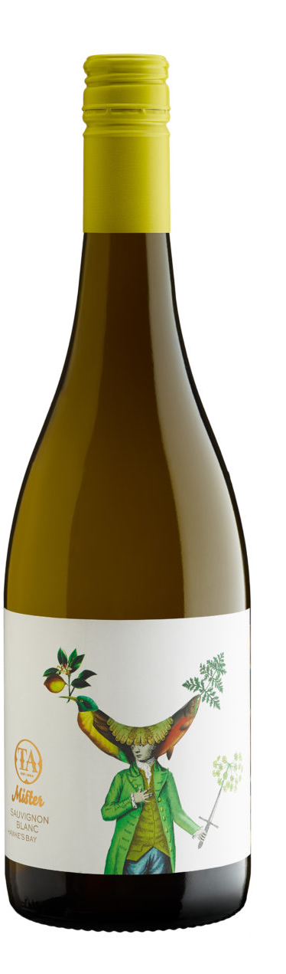

Te Awanga Estate ‘Mister’ Sauvignon Blanc ($25)

New World Sauvignon Blanc

Te Awanga Estate is the passion of winemaker Rod McDonald and a family owned wine business. Everything Rod and his team does are based on their love for making wine and reflects the love for the place they call home - Hawke’s Bay, New Zealand. Hawkes Bay is New Zealand’s oldest and second largest winegrowing region. Located on the North Island, its maritime climate is similar to Bordeaux. This highly enjoyable Sauvignon Blanc is filled with nectarine, grapefruit and rockmelon characters with an elegant lime zest lift. The palate is generous and flavoursome with excellent fruit intensity, beautifully structured by juicy acidity. It is long and attractive on the finish. Enjoy this wine with seared ahi or Spanish empanadas.

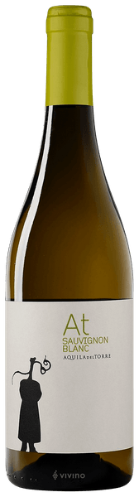
Aquila del Torre Sauvignon Blanc ($24)

Old World Sauvignon Blanc

Aquila del Torre is located in the Colli Orientali del Friuli region, an area of outstanding natural beauty that has always been superb wine country. Today, Aquila del Torre is a single estate with 18 hectares under vine, exclusively organically-farmed. The remaining 66 hectares are left as woodland, rich with oak, hornbeam and holly that influence the local terroir. This sauv blanc is flinty with notes of apricot, green apple, and lemon zest. This is a rare wine that can pair beautifully with vegetables such as asparagus, green beans, and artichokes. We would recommend that you enjoy this wine with grilled prawns or a Thai-style green papaya salad.

Pardas Sumoll Rosat ($24)

Championing the historical roots of Spain’s Penedès D.O., Pardas’s owner and winemaker, Ramon, has reintroduced the much-maligned indigenous Sumoll grape, transforming it into the only Rosé of its kind. The grapes of the south-facing, 40 year old vines, grown organically in clay-calcareous soils, are placed in 100-year-old concrete tanks where they undergo maceration for 28 hours to extract colour. The fresh and intense nose imparts notes of the Mediterranean sea, red apple peel, fresh, wild berries, pomegranate and ﬁgs. In the mouth, the fruit is enhanced by Sumoll’s background of anise and bright acidity. Enjoy this wine with grilled bratwurst and cranberry almond coleslaw.

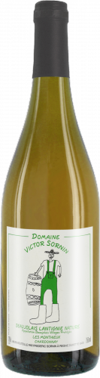
Domaine Victor Sornin Beaujolais Blanc ($24)
Hailing from the sandy granitic soils near the cru Beaujolais region of Morgon, the Victor Sornin wines are a second label of the organic winery run by Frédéric Sornin. Named after his son Victor, the aim of this label is to produce wines as naturally as possible, with native yeast, organic grapes, and no oak aging. This is a soft, nutty wine from light apple flavors and balanced acidity. Enjoy with roasted chicken or a light salad on a hot evening.

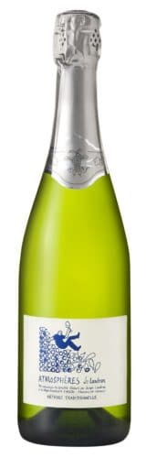

Domaine Landron Atmosphéres Brut ($28)
These Loire bubbles have enjoyed so much love amongst those who know the wine, and no wonder. It's a hand-harvested, estate-grown, biodynamic, naturally fermented, low-dosage fizz that shows up many conventional Champagnes for both quality and value. Jo Landron is not a fan of using Muscadet's Melon de Bourgogne for sparkling wine, preferring instead a hand-harvested blend of around 75% Folle Blanche (grown on sandy clay), and the balance Pinot Noir (gravelly soils). Expect waves of racy citrus and fresh peachy fruit and lots of rocky, flinty, earthy complexity, all wrapped up in a deliciously bready texture. The salty-fresh, smoky finish also makes it extremely food-friendly. Enjoy as an aperitif.

Murgo Brut Classico ($24)
This wine is made from Nerello Mascalese grapes grown in vineyards located 500 meters above the sea level, on the eastern slopes of Sicily’s Mount Etna., Europe’s largest active volcano. Citrus, Spanish broom and Mediterranean scrub aromas lift out of the glass along with a eucalyptus note. Dry, savory and elegant, the palate offers white grapefruit, white cherry, thyme and a saline mineral note. Vibrant acidity gives it a crisp, clean finish. Our wine club manager recently enjoyed this bottle with scallops cooked in foil over a camp grill.

TIER III/IV/V

Red

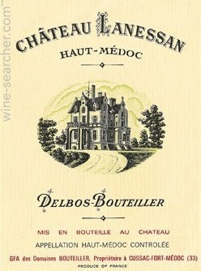
Chateau Lanessan Haut-Medoc 2002 ($30)

Old World Merlot Blend

Domaines Bouteiller lies in the commune de Cussac-Fort Médoc, in the heart of the Haut-Médoc, and consists of three internationally known estates, Chateau Lanessan, Chateau Lachesnaye and Chateau de Sainte Gemme. Domaines Bouteiller extends over 380 hectares on the outskirts of the village of Saint Julien and on the Appellation d’Origine Contrôlée Haut-Médoc 'terroir' and includes 80 hectares of vines, most of which are Cabernet Sauvignon and Merlot, though Chateau Lanessan has some Cabernet Franc and Petit-Verdot. The wines of Chateau Lanessan are characterized by their deep and intense ruby color. The nose is elegant with dominant fruit and floral aromas. The mouth is structured, complex and dense. Together it is harmonious with a beautifully long finish. Though this region is normally known for their classic Left Bank Bordeaux (Cab-Dominant) wines, this bottling is a blend of 60% Merlot, 37% Cabernet Sauvignon, and 3% Petit Verdot.

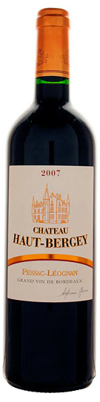
Chateau Haut-Bergey Pessac-Léognan 2007 ($35)

Old World Cabernet Sauvignon Blend
Pessac-Léognan is a wine growing area and Appellation d'Origine Contrôlée, in the northern part of the Graves region of Bordeaux. Unlike most Bordeaux appellations, Pessac-Léognan is equally famous for both red and (dry) white wines, although red wine is still predominant. A sleeper of the vintage, this constant over-achiever’s 2007 exhibits notes of plum sauce, soy, spice box, and unsmoked, high class cigar tobacco. This round, generous sleeper of the vintage shows good density, medium to full body, and a silky, smooth style. Full medium ruby. Wild if subdued aromas of black cherry, dark chocolate, licorice, game and leather. Juicy and intense but a bit youthfully bound-up, with fresh acidity perking up the concentrated, chewy mid-palate. A bit extractive but plenty rich for the year, and not green. Enjoy with roast lamb or even a honeyed ham over whipped sweet potatoes.

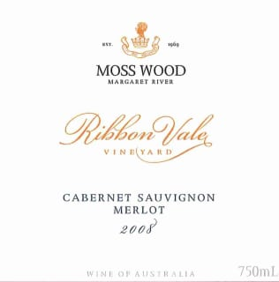

Moss Wood Cabernet Merlot Margaret River 2008 ($35)

New World Cabernet- Merlot Blend
Planted in 1969 Moss Wood is an important, founding estate of the Margaret River wine region, located in the northern sub–region of Wilyabrup, Western Australia. Clare & Keith Mugford, as winemakers, viticulturalists & proprietors, have been making wine & tending the vineyard at Moss Wood since 1984 & 1979, respectively. Their exacting viticulture ensures the production of grapes of excellent quality & they have created a stable of fine wines distinguished by their consistency over each vintage & their ability to age superbly. The Moss Wood & Mugford names are synonymous with uncompromising quality. Glass-staining ruby. Aromas of cherry, raspberry preserves, minerals, and pungent spices. Juicy intense flavors of bitter cherry, vanilla and clove, with a suave floral pastille accent. An attractively restrained and focused blend, finishing with sweet dusty tannins, and very good length.

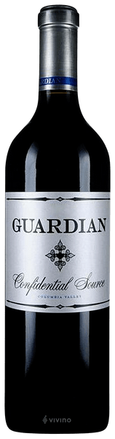
Guardian Cellars Confidential Source ($37)

New World Merlot
When Jerry met Jennifer he was known around the Woodinville wine scene as the chemist, turned cop, who was almost always around to help with wine work. Jerry had been volunteering 40-plus hours a week at several wineries, including Mark Ryan Winery and Matthews Cellars, assisting friends with harvest or in the tasting room. When Jerry and Jennifer opened the Guardian tasting room in November 2007, all 350 cases – a mix of Gun Metal, Syrah and Cabernet, were gone by the end of the day. When the 2005 vintage was released months later, it was gone within a few days. For harvest 2019, Jerry, Dane and the team produced 16 different wines between the two labels; a total of just over 9,000 cases. The newest vintage of Confidential Source is ripe and juicy, featuring notes of ripe red fruit, dark chocolate and hints of espresso. This wine is chewy and robust, bursting with full tannins – it will age beautifully over the next five to eight years. Confidential Source is “sourced” from StoneTree Vineyard, in the Wahluke Slope, and Quintessence Vineyard, on Red Mountain. This vintage was aged 20 months on 50% new French oak.

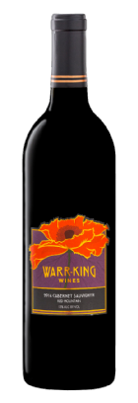
Warr-King Wines Red Mountain Cabernet Sauvignon ($38)

New World Cabernet Sauvignon
After spending 20 years in the high tech marketing world, Lisa was ready to move in a new direction. As a lifelong gourmet who developed a taste for Oregon’s earthy Pinots in her college days, she had a great interest in wine. With prodding from a friend, she took a few classes at Lake Washington Tech. One class led to another and more classes led to an internship at Patterson Cellars. One harvest and she was hooked. Lisa completed the Wine Technology Program at Lake Washington Technical College and then a two-year certification program in Enology from Washington State University. She spent two years with Patterson Cellars learning the business and making a bit of her own wine in collaboration with John Patterson. She spent a harvest at Chateau Ste. Michelle learning how to make white wines on a large scale. Yearning to get back to the fruit and the hands-on experience, she decided to make a go of it on her own and Warr-King Wines was launched. This Red Mountain Cabernet is big and bold in structure with loads of fruit. The color is deep plum with a nose of sweet creme de cassis, boysenberries, earth and a hint of tobacco. The palate provides layers of fruit; dark cherries, currants, plum, with a hint of chocolate. It’s rich and full-bodied, with magnificent texture and a memorable finish. This will only get better with time in bottle.

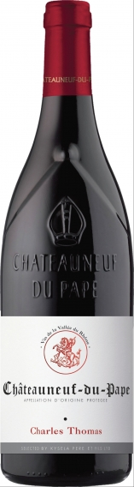
Charles Thomas Chateauneuf du Pape ($38)
60% Grenache, 20% Syrah, 10% Mourvedre, 10% Cinsault.
Châteauneuf-du-Pape is a French wine appellation known for its bold Grenache-based red blends. It sits towards the bottom of the Rhône Valley, close to the border of Provence. The name means “pope’s new castle,” and refers to a time when the seat of the Roman Catholic Church was in Avignon (between 1309–1377). Hints of bramble and earth offset the forward nature of ripe black cherry and blueberry in this wine. Yielding in both acidity and tannins, it's an open-knit, easy-drinking wine that's approachable now. Decant for an hour before enjoying. Pair with osso bucco or rich eggplant parmesan.

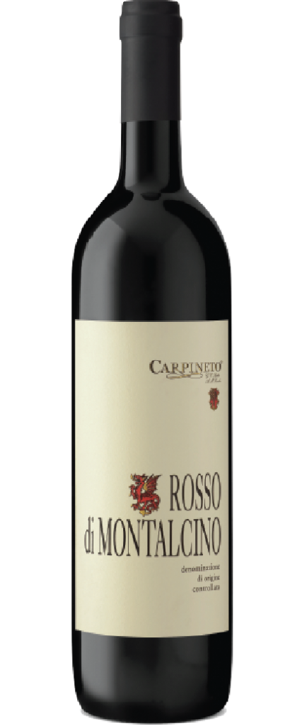
Carpineto Rosso di Montalcino ($35)
Carpineto was co-founded in 1967 by wine visionaries, Giovanni Carlo Sacchet and Antonio Mario Zaccheo. The pair set out to produce a world-class red wine from Chianti Classico — a region that had once reigned amongst Kings but had, at that time, fallen from favor amid wine aficionados. The duo quickly developed an international, award-winning reputation for consistently elegant wines by adopting modern viticulture and winemaking techniques to create wines that dramatically exceeded the quality standards of the time. Also known as the Baby Brunello, Carpineto Rosso di Montalcino is a complex red with aromas of dark cherry, cedar, spice, and licorice that developed following 6 months of oak aging and 6 months of bottle aging. The mouthfeel delivers a touch of bright acidity that is reminiscent of white cherry and cranberry, before yielding to a lengthy finish of mature red fruits and smooth tannins. Ageable for 10-12 years following the vintage, this pairs nicely with pork or poultry dishes.

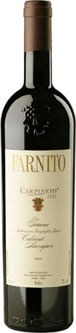
Carpineto Farnito Cabernet Sauvignon ($47)

Old World Cabernet Sauvignon
Carpineto was co-founded in 1967 by wine visionaries, Giovanni Carlo Sacchet and Antonio Mario Zaccheo. The pair set out to produce a world-class red wine from Chianti Classico — a region that had once reigned amongst Kings but had, at that time, fallen from favor amid wine aficionados. The duo quickly developed an international, award-winning reputation for consistently elegant wines by adopting modern viticulture and winemaking techniques to create wines that dramatically exceeded the quality standards of the time. The name Farnito is derived from a type of oak tree known as Farna found in the vicinity of the vineyards. Carpineto Farnito Cabernet Sauvignon is produced from estate-grown fruit. A full-bodied Super Tuscan, Carpineto Farnito is a rich expression of the Cabernet Sauvignon varietal boasting complex aromas of ripe red cherry with concentrated flavors of spice and licorice. Aged in French and American oak barrels for 12 months, the wine is structured with a vanilla note and big tannins marking the finish. Enjoy with a hearty steak dinner.

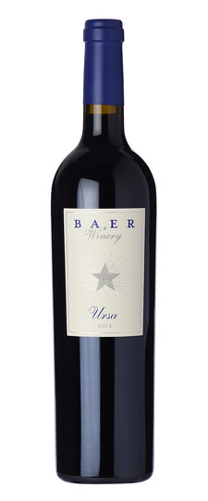
Baer Winery Ursa ($44)

New World Merlot Blend

Winemaker Lance Baer founded Baer Winery in 2000 with a single passion—to bring something unique to Woodinville. After years of working with some of the most prestigious wineries in the area, Lance wanted to take his winemaking skills in his own, creative, direction. Lance succeeded in handcrafting blends distinctly his own, and in April 2003 the winery’s signature blend, Ursa, was released. Ursa, a feminine expression of red wine, predominantly Merlot and Cabernet Franc, was soon followed by Arctos, a bolder Cabernet Sauvignon-based blend. This wine is equally split between Merlot and Cabernet Franc (38% each), with the balance Cabernet Sauvignon (22%) and Malbec. The aromas are brooding, with notes of barrel spice, coffee, blackberry, green pepper and dried herb. The flavors are bright and fresh, light on their feet, showing a fine sense of elegance and detail.

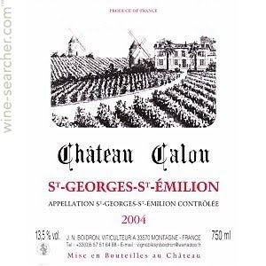
Chateau Calon St Georges-St Emilion ($50)

Old World Merlot Blend

Overperforming and mature Right Bank Bordeaux. Gorgeous bright red fruit on the nose typical of serious Merlot from limestone soils, a gentle tannic grip with something slightly herbal and yet in no way underripe, and fine length. This checks in at a delightfully refreshing 12.5% alcohol, not only did Calon not follow the trend in pulling up old vines for higher yields, they also kept true to the old school even through the heady days of 2009 when 15% Bordeaux started to become common. This is no fruit or alcohol bomb and is not one for those of you that like your claret at the fullest end of the spectrum, but does not lack ripeness, and could not possibly be in a better place maturity wise. Pair with anything you are grilling.

Chante Cigale Châteauneuf-du-Pape ($48)

65% Grenache, 20% Syrah, 10% Mourvèdre, 5% Cinsault.

As at many family domaines with deep roots in Châteauneuf-du-Pape, vigneron Alexandre Favier was by his own account “raised in the vineyards”: Alexandre’s grandfather, Noël Sabon, is from one of the best known winemaking families in the region. Alexandre himself began his viticultural studies in Orange at the age of fifteen and passed the exams four years later in 2001. A year later (at age twenty!) he took over winemaking duties at the domaine when his father experienced health problems.

White

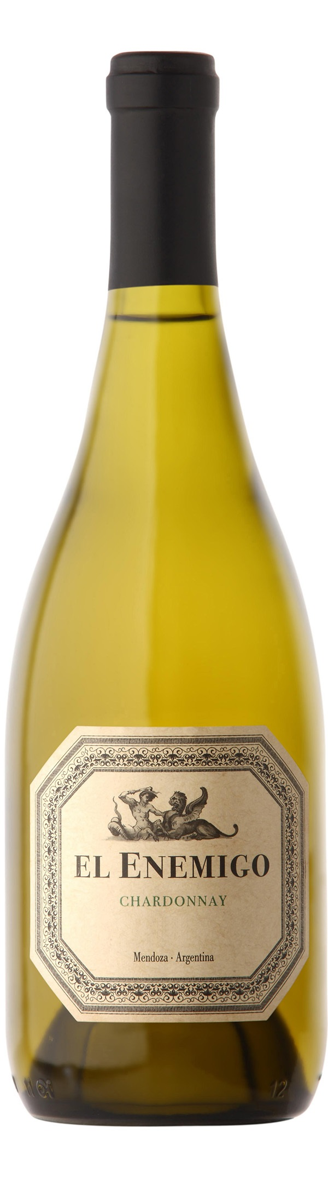
El Enemigo Chardonnay ($30)

New World Chardonnay
El Enemigo is produced at Piedemonte al Sur, located in southern foothills of Maipu, Mendoza. The facility is named for the unique aspect of Mendoza’s high-altitude winemaking region nestled in the foothills of the Andes Mountains. El Enemigo translates as the enemy. Nodding to the fact that at the end of any journey, most remember only one battle — the one fought within (the original enemy). This is the battle that defines us. The wines of El Enemigo are a tribute to those internal battles that make us who we are, brought to fruition by a winemaker, Alejandro Vigil, and a historian, Adrianna Catena who share a love of wine and reach back in time to capture the era when European immigrants first settled in Argentina. These settlers sought to make wines as fine, and finer, than those of their old homeland. A tight and beautiful white with a dense palate of beautiful, ripe lemons and apples. Layered and refined with phenolic tension. Jura was the influence and inspiration for this stunning Chardonnay, aged under flor. Leesy, racy, saline and yeasty, with a core of acidity, subtle oak and a long, tapering finish. A boundary-pushing white for Argentina.

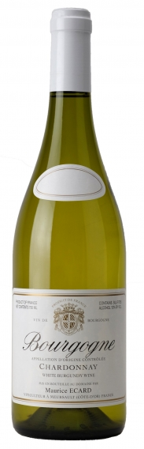
Domaine Maurice Ecard Bourgogne Blanc ($30)

Old World Chardonnay
This property has been producing some of the best Premier Crus in Savigny for more than 200 years. Founder Maurice Ecard, who is now retired, was considered by many experts to be the father of the appellation; the ‘Master of Savigny’. The new owner, François Martenot, has been carefully following Maurice’s footsteps in order to continue his legacy. Between the Hill of Corton and Beaune, the landscape opens up like a map unfolding. The hills of the Côte de Beaune recede a little on either side of the little river Rhoin. These vineyards are of ancient lineage. For much of their history, they belonged to the domaine of the Dukes of Burgundy, to neighboring religious houses, or to the Knights of Malta. An imposing 14th century castle testifies to the appellation's aristocratic qualifications. The AOC status dates from 1937. Intricate and characteristic bouquet of flower and fruit aromas (refreshing citrus fruit, soft pear, crisp apple). An elegantly rich, fruity wine with a hint of nuttiness. Lightly chilled, it will accompany all fish and shellfish dishes which are not too highly spiced. It will also enhance all white meat dishes as well as making an excellent before dinner aperitif.

Louis Armand Premier Cru Champagne ($40)

Chardonnay (20%) / Meunier (5%) / Pinot noir (75%)
"In the heart of the Montagne de Reims, Maison LOUIS ARMAND is a family own estate located in Mareuil-sur-Aÿ since 1996. Our vineyard is located among the most prestigious terroir of Champagne (Aÿ, Mareuil-sur-Aÿ, Mutigny, Avenay Val d'Or, Bisseuil, Hautvillers, Le Mesnil-sur-Oger, Tauxières, Verzy, ...). Our products are characterized by their great elegance, the brand of terroirs and our passion to magnify them. In our cellars located in Mareuil-sur-Aÿ, we elaborate in the pure Champagne tradition all the vinification of our production since the pressing until the shipment of our cuvées." --Champagne Louis Armand
Subtle white floral aromas, with balanced citrus, hazelnut and brioche on the palate.

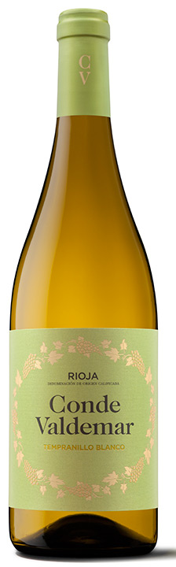

Bodegas Valdemar Tempranillo Blanco ($30)

Tempranillo blanco is a white Spanish wine grape variety that is grown in the Rioja Denominación de Origen (DOC). It is a mutation of the red Tempranillo grape variety. The white grape variety was discovered in a Tempranillo vineyard in the Rioja region by a wine grower in the late 20th century. In 2007, the Consejo Regulador of Rioja officially sanctioned the use of Tempranillo blanco in the DOC wines of Rioja. Straw yellow color with greenish tones. Clean and bright. Intense notes of stone fruit such as peach and tropical fruit, with the melon dominating. Floral notes of jasmine and almond blossom also stand out. Long and persistent aftertaste. Ideal for aperitifs. It is also perfect for scallops, cod, mussels, marinated anchovies, and grilled sardines.

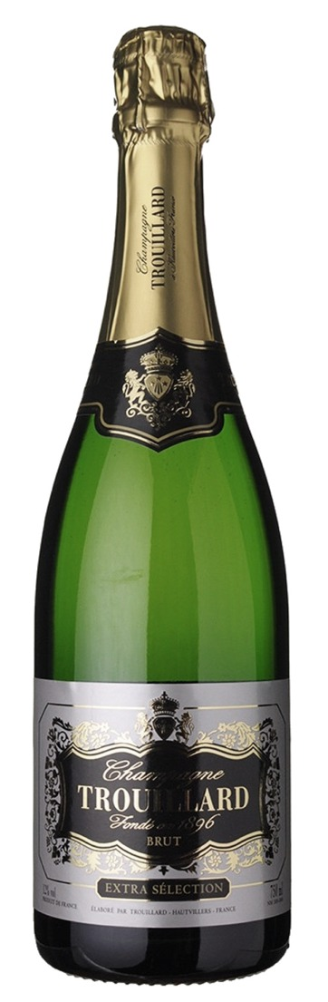
Champagne Trouillard Brut Extra Selection ($60)
35% Pinot Noir, 35% Pinot Meunier, 30% Chardonnay
The Trouillard family has been part of the Champagne business in Epernay since the 19th century with Lucien Trouillard, the founder, showing an interest in Champagne at an early age. He produced his first bottles in 1896, at the age of 17, and then went on to establish his own sales and distribution company (“Sparnacienne Niticole”). When he passed away in 1966, his two sons took over the operation, followed by his grandsons Luc and Bertrand. In 1979, the House of Trouillard became one of the most important houses in the champagne business. In 2006, Maison Trouillard joined forces with the Gobillard family, a 5th generation Champagne house who shared the history, passion and philosophy of the Trouillard family. They are located in Hauvillers – the heart of Champagne – 5 kilometers from Epernay, at the crossroads between the Marne Valley and the Montagne de Reims. Hautvillers is where Dom Perignon produced his first Champagne in 1668 – his grave is just 10 meters from the Gobillard property. With a light amber color and fine bubbles, full-bodied with a full mixture of white fruits. Dominating taste of hazelnuts and grilled almonds. This is a crisp, delicate, fresh, creamy and elegant champagne with just a touch of yeastiness.

