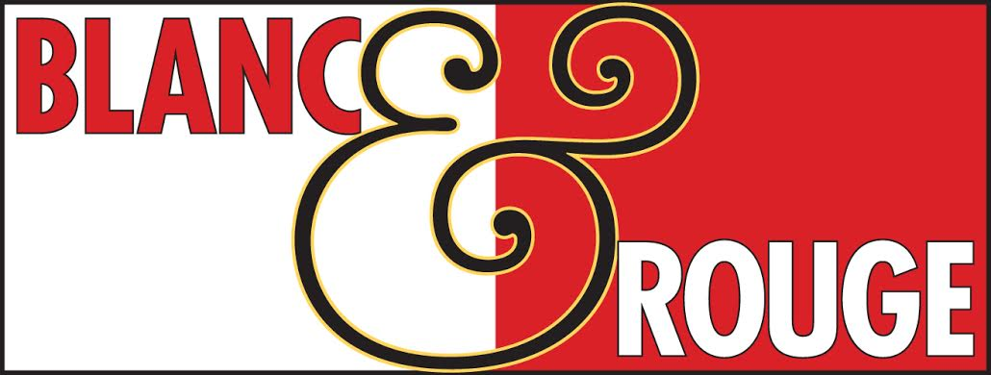Nov. 2, 2018

WINE CLUB

TASTING NOTES

**Tier II****Tier IV****Tier V****Tier VI**

**TIER I**  
**Red**

C:\Users\mbjwr\AppData\Local\Microsoft\Windows\INetCache\Content.MSO\8DA7C706.tmpBertani Valpolicella $15

An intense red colour with purplish highlights; intense hints of redcurrants, plums, raspberries, sour cherries balanced by spicy notes reminiscent of pepper and cinnamon. On the palate it is approachable, fresh and pleasant, thanks to good balance between acidity, savoury notes and richness of flavour.

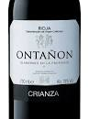Ontañón Crianza $15

The nose is well balanced with aromas of black cherry, spice and toasty oak. The palate has more bright, intense tangy black cherry and red cherry fruit, with fresh acidity, a silky mouthfeel, soft ripe tannins, with a lingering finish. 90% Tempranillo, 10% Garnacha. Produced from 40 year-old vines grown in Rioja Baja.

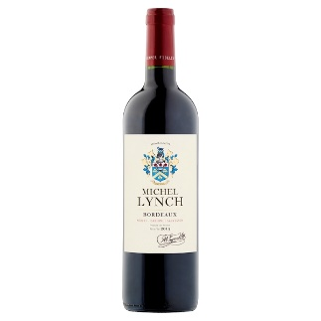Michael Lynch Bordeaux $15

This herbal, crisp wine is taut with mineral-driven acidity. It is still young, still tight and with lively aftertaste. Notes of black currant and fresh bread, with an overall impression of ripeness and power. Drink now. A classic Merlot/Cabernet blend. A good representative of the Bordeaux region, blending the richness of the left bank of the Garonne (Médoc and Graves), with the roundness of the wines from the right   
 bank (Fronsac, Côtes de Castillon).

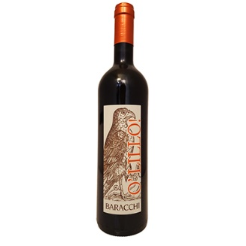Baracchi O’Lillo $15

A Tuscan blend that is round and elegant with a modern approach to focused fruitiness and soft, accessible tannins. 25% Merlot, 25% Sangiovese, 25% Cabernet Sauvignon, 25% Syrah from Tuscany.

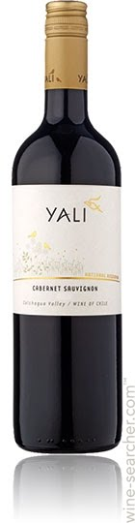

Yali Cabernet Sauvignon $15

Cassis, cherry and plum fruit gets a boost from the leathery, mouth coating tannins, while ancillary notes of vanilla, tomato and chocolate stir interest. Among basic Cabs, this is a good one.

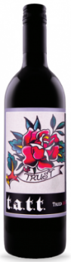Trust T.A.T.T. (Tried and True Table wine) $15

This red blend includes Syrah from Walla Walla, mostly from Les Collines (high elevation) vineyard along with some from Cali Vineyard on the Oregon side of the AVA. Cabernet is mixed in from several Columbia Valley vineyards. A delicious mid-week quaffer. Flavors of black currants, chocolate, earth and tobacco leaf. Medium to full-bodied.

**White**

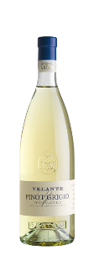Bertani Pinot Grigio $15

A golden yellow colour. An aroma of Golden Delicious apples, ripe pear and peach. It is a Pinot Grigio with good density and good balance between acidity and plushness. Elegant, mineral, racy. A carefree and light wine with taste.

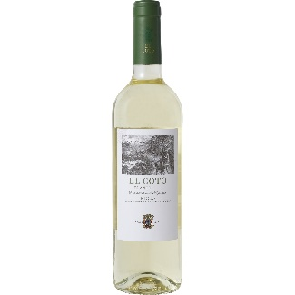El Coto Bianco $15

Pale gold-yellow with greenish hues, the wine is intensely aromatic, well balanced, with body and the fruit has a refreshing tart character. El Coto Blanco's pleasant acidity combines perfectly with an exquisite aftertaste of flowers, fruit and fine herbs.

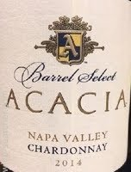Acacia Barrel Select Chardonnay Napa $20

Chardonnay flavors tend towards grapefruit, lemon zest, green apple, celery leaf and wet flint, while warmer locations coax out richer, more tropical flavors of melon, peach and pineapple. Oak can add notes of vanilla, coconut and spice, while malolactic fermentation imparts a soft and creamy texture. Since the 1990s, big, oaky, buttery Chardonnays from California have enjoyed explosive popularity. More recently, the pendulum has begun to swing in the opposite direction, towards a clean, crisp style that rarely utilizes new oak. In Burgundy, using older oak barrels produces a similar bright and acid-driven style. Anyone who doesn't like oaky Chardonnay would likely enjoy this

lighter style.

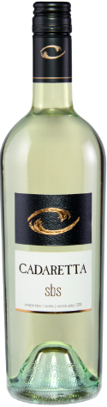Cadaretta Sauvignon Blanc $15

This release of SBS was bottled without oak contact. 66% Sauvignon Blanc and 34% Semillon. Light tropical fruit aromas with melon, grass, and citrus that are followed by tart zingy flavors. Crisp mouthfeel. Pair with seafood or salad.

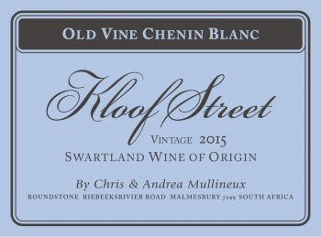Kloof Street Chenin Blanc $15

This South African selection comes from the Swartland area of the Coastal Region on the Western Cape. The Chenin Blanc comes from the three sustainably farmed vineyard parcels, one with 35-year-old Chenin vines. Pale straw in color. Sun ripened pears and wet granite on the nose. On the palate there is a vibrant acidity balanced by a soft, round texture and some pithy character. A fresh, mineral finish.

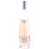Domaine de Blaïs Rose $16

From the Provence region of France. A blend of Cinsault, Grenache, Syrah and Rolle. Inviting aromas of red currants, raspberries, melon. Soft, Fully rounded texture caresses the palate. Pure fruit flavors from start to finish. Refreshing acidity in the finish adds to the lively, charm of this wine.

**Tier II**

**Red**

Bertani Valpolichela Ripasso $28

Coming from Verona in Italy’s Veneto region this selection is 85% Corvina, 10% Merlot and 5% Rondinella. Grapes are hand-harvested at the end of September, fermented in stainless steel tanks for 1 days then a second fermentation takes place. Called the Ripasso technique (meaning passing again) this is when the wine is passed over Recioto Amorone skins giving the wine more flavor, tannin and higher alcohol than a regular Valpolicella. Deep red in color with flavors of dark fruits (blackberry, black currant and cherry). In the mouth experience the full and complex round and lovely flavors of cherry , licorice and a lingering finish.

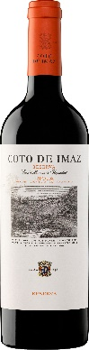El Coto de Imaz Reserva $21

Crafted from a selection of the best Tempranillo grapes in Rioja, this Reserva benefits from 18 months of aging in oak casks that provides great complexity with pronounced notes of ripe fruit, cocoa and well-balanced acidityLots of blueberry and blackberry aromas with hints f walnut-shell fllow through to a medium-bodied palate with firm tannins and a light finish. Some cho9colate and wood character. Ready to drink now. A great choice to pair with beef and other hearty meat dishes. 90 points James Suckling

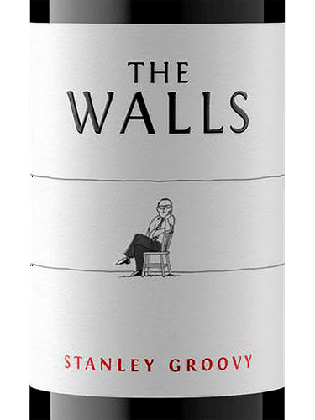The Walls Stanley Groovy $25

Stanley Groovy isn’t afraid to stray from the crowd — he's different and he knows it, just like the wine in this bottle. Cabernet Sauvignon lends depth and complexity while intense Portuguese varietals bring a whole lot of groovy. The result? A wine that celebrates the beauty of being “different” — something Stanley is proud to lend his name to. “In my opinion, it’s the best Groovy to date,” says Ali. After we put the blend together we aged half in concrete and half in oak so it’s got the freshness and the texture that both impart. “It’s one of those wines you have to taste to believe because it looks weighty but is not heavy on the palate,” adds Ali. “It goes well with everything from pizza to fresh fish or poultry cooked Portuguese-style; anything with tomatoes, garlic, capers and citrus.” From Red Mountain. 55% Touriga Nacional , 21% Cabernet Sauvignon, 13.5% Souzao, 9% Tinta Cao, 1.5% Tempranillo. 93 points James Suckling.

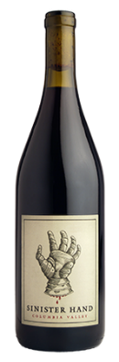Owen Roe Sinister Hand $25

Long ago, pre-dating the 11th century, the families that became modern day O’Neills and O’Reillys were feuding over the land that became their ancestral home. To settle the dispute, a competition was organized and several rowing teams agreed that the first to touch the land, after rowing across the lake, would become ruler of the land. O’Neill’s boat was falling behind so a member of the crew grabbed his own sword, cut off his hand and threw it ashore, and touching first, winning the title to rule the land.  The island fortress on this land can still be visited on Lough Oughter in County Cavan.

63% Grenache, 16% Syrah, 16% Mourvedre, 5% Cinsaut. A record-breaking hot vintage led to an early harvest in some of the vineyards in which we source our fruit for the Sinister Hand. Our estate Syrah from Outlook Vineyard came in as early as August 27th! We were excited about the heat and monitored the vineyards closely for optimal sugar levels and ripeness, finishing up harvest around the 3rd week of September. With these varying ripening dates, we found layers of complexity within each block. The heat rendered beautiful aromas of black pepper, clove and juniper with juicy hints of dried strawberry, pie cherries and fig. Flavors of chocolate, green peppercorn and boysenberry are delicious on the palate, resulting in a full-bodied, mouthcoating Rhone-styled blend.

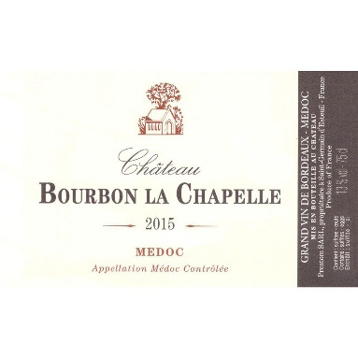Chateau Bourbon La Chapelle Medoc $25

Ruby clear color with dark purple reflections. Nose of small redberries, soft spices, with a fresh and aniseed note. The woodiness is fine and lightly marked with vanilla notes. In mouth, the supple attack evolves towards a delicately wooded fruit and ends with a tip of freshness which extends the aromatic persistency. 60% Cabernet Sauvignon, 40% Merlot. 90 points Wine Enthusiast

2015 Gran Reserva MalbecCorazon Del Sol Malbec $25

Scents of violets, red fruit, cassis and black currant. Flavors of blackberries, plums, dark chocolate. Firm tannins. From a high-altitude terroir in the Uco Valley of Mendoza Argentina.

**White**

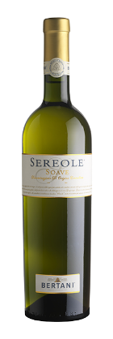Bertani Soave $20

Sereole is a modern interpretation of Boave. It is lively and unmistakeable made with native Garganega grapes, the most elegant white grape from the Verona area. A straw-yellow color with golden highlights; the floral bouquet has overtones of elderflower and pear, developing into sweeter aromas of yellow-fleshed fruits such as apricot, pineapple and melon. Plush on the palate, balanced with sapid notes that enhance the structure. Pairs well with starters, soups and white meats.

Left Coast Cellars White Pinot $21)

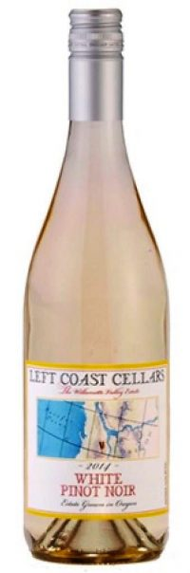What began in 2011 as a small experimental wine quickly blossomed into one of Left Coast’s most unique and popular wines. The fruit is crushed at extremely cold temperatures to ensure minimal coloration from the skins. The pure Pinot Noir juice is fermented in stainless steel and then aged on the lees. The result is a wine that bears the body and aromas of a classic Pinot Noir with the composition and brightness of white wine flavors.

Famed for its diversity to complement nearly any food pairing, this White Pinot Noir is a people’s favorite. Limited skin contact gives the White Pinot Noir its pristine clarity. The wine itself is enticingly fruit forward with distinct aromas of white cherry, nectarine, peach, citrus, and beeswax. Its rich mid-palate is beautifully framed and focused with flavors of spiced pear, ripe honeydew, wet stone, and a mineral finish. White Pinot pairs perfectly with grilled sockeye salmon, oysters, asparagus, and stone fruits. A simple snack of Rainier cherries and goat cheese is another ideal combination for this versatile wine.

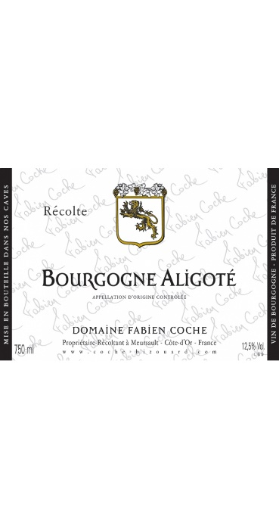Domaine Fabien Coche Aligoté ($23)

Fourth generation, Fabien Coche, took over his family domaine in 2005. He believes that Aligote is undervalued in terms of its ability t express the unique elements of Burgundy’s varying terroirs. Historically, Aligote was more prized than Chardonnay and as a guardian of Burgundy tradition, Fabien weaves this historical context into this bottling. The entirely estate-grown grapes are sourced from 60-year old vines in Les Penteaux vineyard in Meursault. And despite its humble appellation, the wine is crafted with the same care s his more esteemed entries in his line-up, featuring a relatively late harvest to emphasize maturity, with all winemakeing activities carried out by hand.

Classic pale straw-yellow core with slight green reflections. Wonderful notes of wet stone, raw hazelnut, pear blossoms, and white flowers appear first, then green apple skin, wet stones, lemon blossoms, candied lime peel, crushed chalk, and delicate accents of baking spices make an intoxicating appearance. Incredible balance with perfect acidity, rich textures, and complex layers come in waves from start to finish. Enjoy now or cellar 5-10 years. Allow for a 30-minute decanter and serve around 55 degrees and pair with this classic scallop and brown butter dish. Or enjoy with a drop of Cassis for the classic Burgundy cocktail.

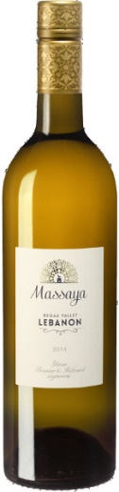Massaya Blanc ($21)

From Lebanon the ancient region with ancient trapes and modern wine. This wine is a well-balanced blanc with white flower scents. Made from a blend of French varieties and Obeidi (Obaideh), a grape indigenous to the Bekaa Valley: obeïdi 20%, rolle 20%, clairette 20%, sauvignon blanc 20%, chardonnay 20%. A supple, unoaked white with notes of spiced pear and white flowers. It combines depth, roundness, crispiness and an oriental twinkle thanks to the local obeïdi.

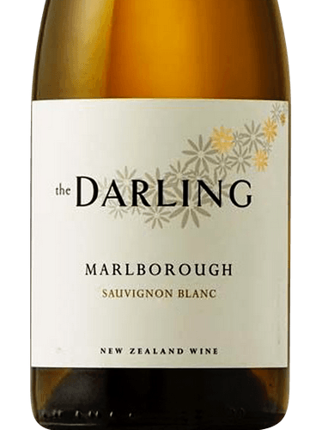Darling Sauvignon Blanc ($22)

New Zealand organic wines from Chris Darling and Bart Amst. The first thing you will notice is the intense aroma of this wine with notes of citrus and tropical fruits. These flavors follow through on the palate, while the wild fermentation in barrel adds great weight and texture to the wine that makes you want to go back for more. This wine will drink well anytime complementing white meats, salads and seafood.

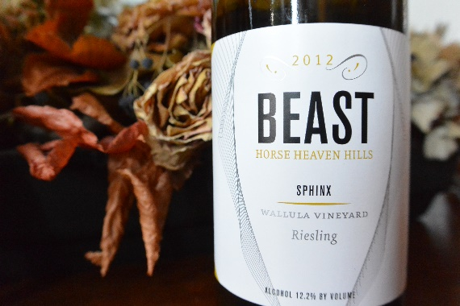Buty Winery Beast Sphinx ($25)

From the biodynamic block at Wallula Vineyard in the Horse Heaven Hills, this is truly a bone-dry style of Riesling, with intense concentration. It's fruity and complex, with grapefruit and lemon rind flavors that are backed with astonishing minerality. The acidity is high but natural and perfectly integrated. The dry extract gives texture to an amazingly long finish.

94 points Wine Enthusiast.

Tier IV

**Red**

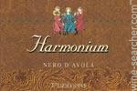Firriato Harmonium Nero d’Avola ($35)

This Nero d'Avola from Sicily opens with ripe black-skinned berry, carob and cedar aromas. The chewy savory palate offers dried black cherry, raspberry jam and cocoa alongside fine-grained tannins. Enjoy through 2022. 90 points Wine Enthusiast

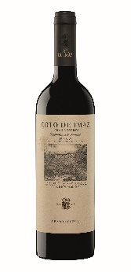El Coto de Imaz Grand Reserva ($35)

Brilliant ruby color, with russet tones. Mature and elegant, its aromatic richness is changing and subtle, becoming more apparent as the wine breaths. Notes of toast and coconut followed by tertiary aromas (leather, wet earth), and red fruit and dried fruit. Round, silky tannins, persistent and complex aftertaste.93 points Wine Spectator. 93 points Wine Enthusiast

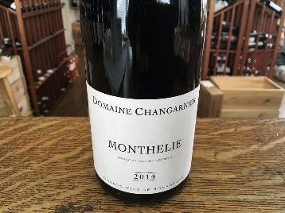 Changarnier Monthelie Rouge ($35)

From the Monthélie appellation in Burgundy, this wine has a firm and velvety texture with delicate tannins. The nose offers aromas of red fruits – red currants and wild strawberries – and the palate is round and fruity finishing with subtle hints of cinnamon and pepper. Classic Pinot Noir. Pair with roast lamb, rabbit or Brie cheese.

**White**

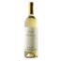 Massolino Chardonnay Langhe ($35)

From Norther Italy’s Langhe region of Piedmont, this wine has the most fanciful scents of ripe fruit and an excellent mineral quality emerge, together with optimal freshness. On the palate this wine is warm and expansive, it envelops the palate with gentleness and character, ending with a lingering aftertaste; undoubtedly blessed with the structure provided by the Langa soils.

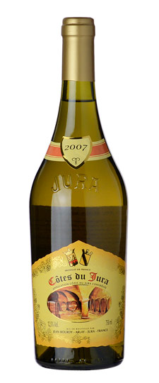 Jura Bourdy Blanc ($34)

Caves Bourdy is the oldest producer in the region, with a direct family line going back to the 16th century. This is a classic Jura white from 100% Chardonnay but forget about that and embrace the complexity of a wine close to ready to drink, yet with the potential to age many more years. Herbs, lemon curd and rocks are present in the flavors, making this a classic for roasted chicken. Open a bit before drinking and serve at a temperature of 60 degrees. Can be cellared for many years.

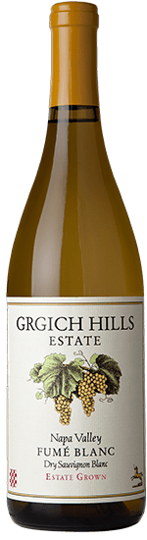 Grgich Hills Fume Blanc ($32)

Relying on naturally-occurring yeasts, 80% of the grapes were fermented in 900-gallon French oak casks, called foudres, with the remainder in previously-used small French oak barrels. The wine was then aged for six months on its lees (the spent yeast) in neutral barrels. On the nose this wine exhibits notes of lemon rind and dried orange, with savory, sweet hints of dulce de leche. The palate is fresh with citrus, lemon zest and balanced acidity with a mouthwatering, long finish. Pair with pork loin, chicken or all by itself.

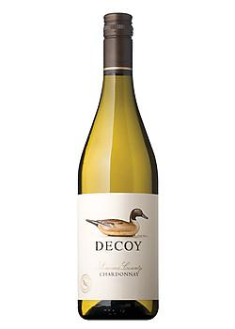 Duckhorn Chardonnay ($35)

This enticing Chardonnay offers vibrant layers of green apple, white peach and honeysuckle, as well as hints of cinnamon. On the palate, a supple texture from sur lie aging is balanced by bright natural acidity, which adds poise and length to the lush, pure fruit flavors.

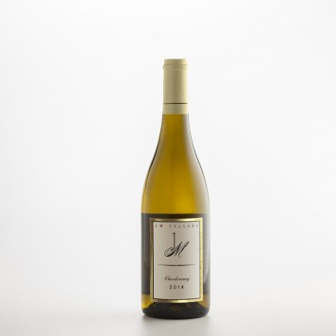JM Cellars Chardonnay clone 15 ($40)

This wine was created with fruit sourced from two longtime favorite vineyards that produce award-winning Chardonnay – Conner Lee and Stillwater Creek.  Blending Chardonnay sourced from these distinctive vineyards yields a refreshing yet smooth wine with layered flavors of citrus, spicy apple, vanilla and butter.  Aromas are fruit forward, suggesting cantaloupe, melon and pear.

Tier V

**Red**

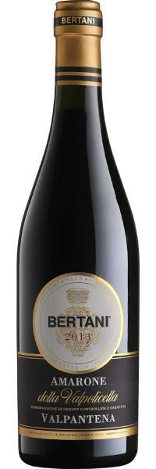Bertani Amarone Valpantena ($68)

On the nose, marked and intense aromas of very ripe cherries, sour cherries, spicy and nutty notes typical of the Valpantena. This opens with aromas of ripe dark berry, underbrush, incense and baking spice. The juicy palate delivers black cherry, chopped mint, tobacco and a hint of clove alongside polished. Good follow-through of red fruits on the palate, with supple and fine-grained tannins to give depth. 80% Corvina Veronese, 20% Rondinella. The harvest is done by hand and starts in the middle of September. The best grapes are selected so that only the healthiest and ripest bunches are sent to the drying rooms where they are laid out in single-layer crates. In mid-January, the grapes are destemmed and crushed, then fermentation starts, at first at 36-degrees, which reaches 50-degrees in the final stages. Pair this full-bodied wine with rich dishes, mature cheeses and strong-flavored meats. 92 points Wine Enthusiast

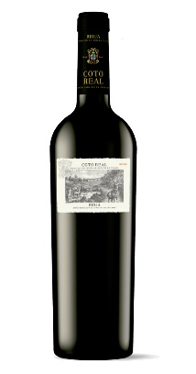El Coto Real ($50)

This Tempranillo comes from a single vineyard in the Rioja Alta region of Spain. Deep cherry red color. Notes of mocha and coffee embellish the aroma of red forest fruits. Silky and dense on the palate. Long aftertaste. Pair with game, duck breast and red meat.

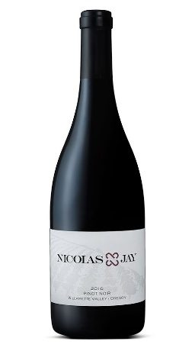

Domaine Nicolas Jay Williamate Valley Pinot Noir ($68)

In the glass, the 2016 Willamette Valley is a focused wine, revealing a darker nose than the previous vintage, with black cherry and plum accented by hints of violet, dried herb and bay laurel. The palate is supported by a backbone of racy acidity which lingers long into the finish, and offers bright red fruit along with savory herbs, olive, and a saline edge. The wine will benefit from decanting in the short-term and will mature in bottle for 10-15 years.

**White**

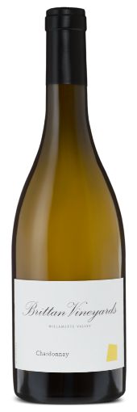Brittan Chardonnay ($48)

This Willemite Valley Chardonnay dances with notes of pear blossom and honeysuckle, spun sugar and biscuits with clover honey. The entry on the palate is lush and full, with blood orange and vibrant kumquat, while the finish linger with hints of exotic Ceylon tea. This is the first vinytage to contain a significant portion of fruit from the winery’s estate vineyard.

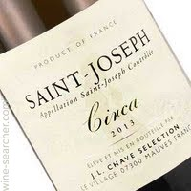St. Joseph J.L. Chav Selections Circa ($40)

This is the only white made by Jean Louis that comes from granite soil. The first vintage produced was 2009 after the purchase of a historic St. Joseph domaine that served as the toehold in old-vine Roussane planted in Mauves in the northern Rhone. Flavors of ripe pear, yellow apple and white peach layered and framed with alluring brioche and salted butter, all flowing through the finish in lockstep. Enjoy now through 2023. 92 Wine Spectator

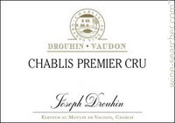Drouhin Vaudon Chablis Premier Cru ($50)

A dry and brisk wine, typical of Chablis. Brilliant yellow-green color. Aromas of lemon, citrus, asparagus. On the palate the first sip offers its clear-cut and fresh impression. Long on the aftertaste, with fruity as well as mineral flavors. This is a wine with great purity of taste and a pleasant floral style. Chablis is very mineral in character.

Tier VI

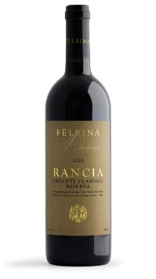Felsina Racha Chianti Classico ($63)

Ruby red appearance with rich, intense tones. Spicy nose with floral notes and hints of wild berry (red and black), accompanied by mineral impressions and light toasted notes. Spice re-appears on the palate, which displays firm but supple tannins, and the finale is vigorous and taut. Overall, the wine is compelling for its flavor-rich mid-palate and supporting acidity. 97 points Decanter. 96 points Wine Advocate. 96 points James Suckling.

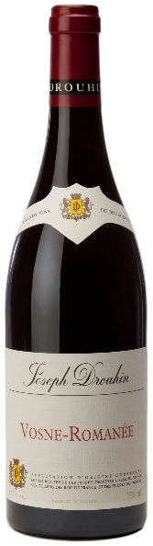Drouhin 2015 Vosne-Romanee ($75)

Supreme elegance! Beautiful color, with intense and bright reflections. The diversity of the aromas is striking - wild cherry, nutmeg, camphor wood, fine leather. Later, the wine takes on a subtle aroma of truffle, producing the most varied palette. With its perfect balance between tannin and acidity, the wine has a fleshy, sturdy body. Powerful and long aftertaste. A wealth of harmonious sensations characterizes this great Burgundy.

Pinot Noir is well-suited to pair with poultry, beef, fish, ham, lamb and pork. It will play well with creamy sauces, spicy seasonings and may just be one of the world's most versatile food wines.

93 points Wine Spectator

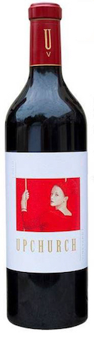Upchurch 2015 Cabernet Sauvignon ($75)

The aromas offer appealing notes of dried and fresh herbs along with cherry and dried orange rind and scorched earth. The palate is packed full of rich fruit flavors surrounded by firm, slightly dry tannins and tart acids. The flavors stretch out on the finish. It has enough structure to go the distance. 91 points Wine Enthusiast.