It is time for February Bubble Club, and this month we are featuring two lovely selections from Italy!

While we are big fans of high-quality prosecco at Blanc & Rouge, we are excited to feature two wines that push the boundaries of traditional Italian sparkling wine production. This month your bag will include one bottle each of:

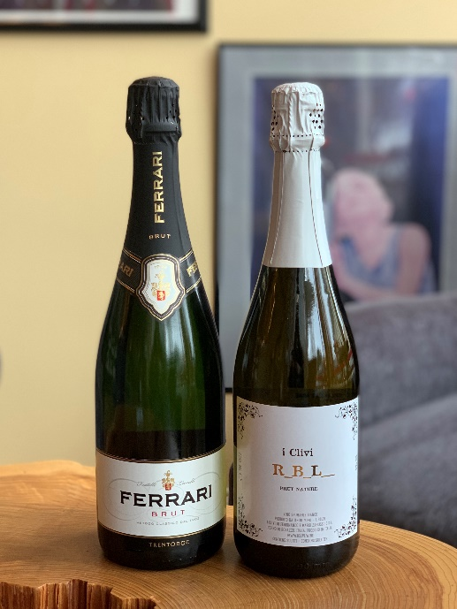

Ferrari Brut Trentodoc
Giulio Ferrari founded his namesake winery in 1902 in his home region of Trentino with the mission to produce sparkling wines that rival the wines of Champagne. He planted the first Chardonnay vines in Trentino, and today, Ferrari is hailed as the founder of Italy's premier destination for world-class sparkling wine. Located at the foot of the Dolomite mountains in Northeastern Italy, the Trento DOC (Denominazione di Origine Controllata, Denomination of Controlled Origin) is one of the most heavily-regulated and highly-regarded wine production regions that specializes in sparkling wine--second only to Champagne, of course.

Fresh aromatics with bold overtones of ripe golden apples, wild flowers and the subtle, delicate fragrance of almond. On the palate, the wine is clean and balanced, ripe citrus notes and a hint of brioche. A sparkling wine of pronounced finesse. Perfect served as an aperitif or with lighter dishes, especially seafood.

iClivi 'RBL' Brut Nature
The Friuli-Venezia Giulia region of Italy, south east of Trentino, iClivi is known for its indigenous grapes, such as Refosco, Friulano, Ribolla Gialla, and Malvasia. Ferdinando Zanusso, who founded iClivi, works to produce organic wines that are the purest representation of the region's terroir. This unique wine, produced with 100% Ribolla Gialla, stunned Mina and me.

The wine pulls you in with aromas of white peaches and kiwi, complemented by hints of tropical citrus, almond paste and smoke. It’s elegant and soft on the palate, with a gentle bead of bubbles which give way to hints of lime and wild flowers. It finishes with lovely minerality and nutty notes.

Unlike Champagne that is made from a finished wine that is fermented a second time in the bottle, RBL develops its sparkling quality from CO2 that is produced during its first fermentation. As a result, no refermentation is necessary and no yeasts or sugars are added.

We hope you enjoy these selections. Thank you for exploring the diverse world of sparkling wine with us!

