SPRING 2021 WINE CLUB RELEASE
Sunny Spain ft. Reds from Ribera del Duero
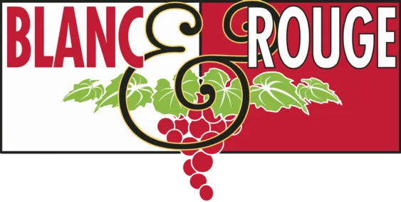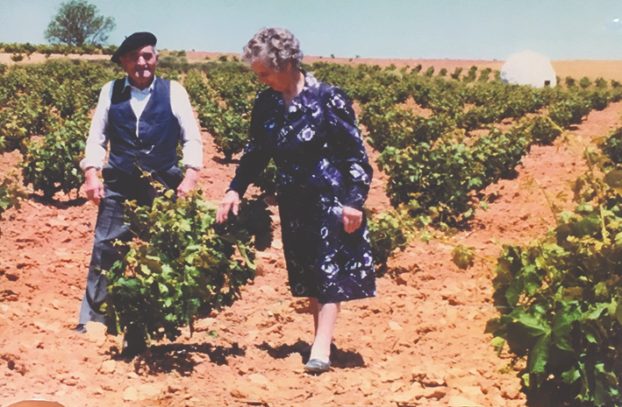
Photo courtesy of Viña Pedrosa

Quick Links: Tier 1, Tier II, Tier III, Tiers IV & V

As residents of the Pacific Northwest, we all reach that point each winter when we crave sunshine. Those first frosty, blue-sky days in early spring when the snow-capped Cascades and Olympics are in full view, send ripples of excitement down First Street. It’s our cue at Blanc & Rouge to dust off the quick-chiller, and make sure the first-of-the-year rosé rolls through the front door. The early wave of sunny weather we’ve experienced this spring has been such a gift. Entering into a new season of grilling, gardening, and al fresco dining (some days still bundled in our windbreakers), we also return to one of our favorite winegrowing nations--Spain.
While we’re regular advocates of the wines of Rioja, we were recently reintroduced to the reds from Ribera del Duero. Located about two hours north of Madrid, this tiny region in northwest Spain is renowned for its Tempranillo, known locally as “Tinto Fino” or “Tinto de Paîs”. The grape performs so well in Ribera del Duero that 95% of the vineyards are planted with Tempranillo, and the region is devoted almost exclusively to red wine production. In late February, one of our favorite distributors poured us wines from Viña Pedrosa, a family-owned and -operated winery in this region. Their wines are succulent and peppery with a restrained oak-aging program and refined tannin structure and acidity. They are stunning now if you are looking for a bottle to pair with the char of a hot grill, but time in the cellar will bring out their rustic elegance.
For our white wine lovers, we stacked our favorites from all over Spain. From lemony, textured Xarel-lo (one of the main grapes in sparkling Cava production) to plush Garnacha Blanc (Grenache Blanc), Spain offers some of the most dynamic and underrated white wines in the world. We need look no further than Spain for the perfect pairing with antipasti on the patio.

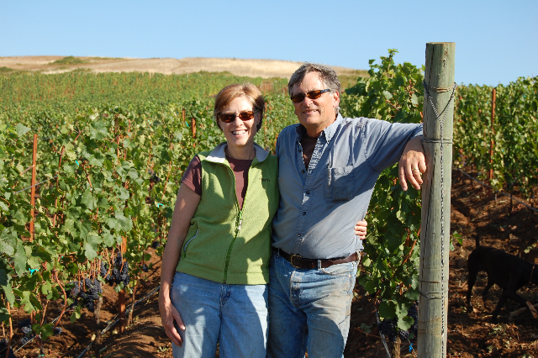
Photo courtesy of Brittan Vineyards

While Tempranillo is a year-round fave, we also must tip our hat this May to the wines of the Willamette Valley, in celebration of Oregon Wine Month. Mina had the opportunity to attend Oregon Pinot Camp in 2019. She dined and tasted with winemakers and sommeliers for a week-long immersive experience in the heartland of American Pinot Noir. Among the many producers she encountered that week, Brittan Vineyards distinguished themselves with elegant wines to rival the Burgundian bottles on our shelves. Robert Brittan made wine at Napa’s famed Stag’s Leap winery for sixteen years before he returned to his native Oregon. Brittan is well-equipped to produce terroir-driven wines that demonstrate the unique qualities of his 128-acre hillside property. We are excited to be able to offer Brittan wines at exclusive pricing throughout the month of May.

Every quarter, our wine club presents a carefully-curated selection of bottles that are high-quality, sustainably-produced, and food-friendly. We thank you for supporting Blanc & Rouge and exploring the world of wine with us! The tasting notes below represent the core wine selections for the May 2021 club release. We may have included a special selection in your bag, so please contact wineclub@blancandrougewine.com if you would like any additional information about your club wines. Salud!

TIER I
REDS
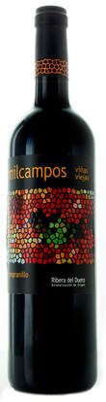
Bodegas La Milagrosa ‘Milcampos’ Tempranillo (Ribera del Duero, Spain)
Ribera del Duero
Bodegas La Milagrosa was founded by a small group of growers in 1962. The bodega owns many small vineyards that were planted in the early 1940’s. Milcampos means ‘a thousand fields’ because looking from the bodega at the rolling hills in the early morning fog, each hill looks like a different vineyard. Sourced from 50-year-old vines. it displays aromas of earthy black fruits, espresso, and blackberry, leading to a vibrant medium-bodied wine with excellent concentration and balance. Pair with takeout from your favorite Oaxacan restaurant.
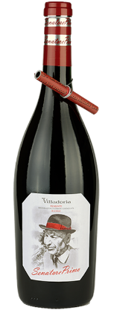
Villadoria Senatore Primo Rosso (Piedmont, Italy)
This wine is an ode to history, a ‘thank you’ to a man, a husband, an adventurer, a soldier, a farmer, a wine grower, a father who had the courage to keep on dreaming even at the most difficult times, who had a passion for his vines and for politics and was known by his friends as the ‘Senatùr’, Senator in Piedmontese. Daniele Lanzavecchia Senior farmed in Italy beginning during the interwar period and built the foundation for Villadoria as it is known today. A juicy blend of Dolcetto and Barbera. Purplish in colour, on the nose the wine has pronounced black fruit, plum and strawberry jam, violet and mild almond aromas. It is full-bodied on the palate thanks to Dolcetto, which balances out the residual sugars of the Barbera and its characteristic acidity. Pair with everything from starters to flavorful pasta and rice dishes.
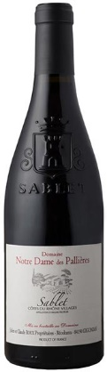
Notre Dame des Pallières Sablet Rouge ‘L’Olivet’ (Rhône Valley, France)
60% Grenache, 40% Syrah. Domaine Notre Dame des Pallières is a very old family estate, whose name comes from a place of pilgrimage visited by the Provençal people in the middle ages who believed that the fountain on the property would protect them from the plague. Claude Roux and his cousin Jean-Pierre have so many generations of Gigondas wine making experience in their family that they don’t know exactly how many of their relatives have been involved up to now – Antique writings suggest that this Domaine existed in the 900’s. Fortunately this tradition is continuing with Claude’s children, Isabelle and Julien, gradually taking over the day to day responsibilities of farming, production, and administration. Vineyard holdings total 74 acres in Gigondas, Sablet, and Cotes du Rhone. Very beautiful purple color, bright brilliant. Nose of fresh fruit, intense, on morello cherry, blackberry, red fruit coulis. The palate is fleshy, round, crisp, full of fruit, with matter, without hardness and silky tannins. Pair with coq au vin or anything barbecued.
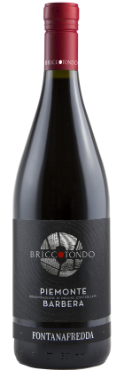
Fontanafredda Briccotondo Barbera Piemonte (Piedmont, Italy)
Since 1858, the Fontanafredda Estate & Winery has been instrumental to the growth and international awareness of Barolo, while championing sustainability and community engagement in the Langhe region of Piedmont. The nose is packed with black fruit, especially blackberries and plums, with slight spicy overtones hinting at black pepper and cinnamon. Sweet, soft tannins come together in a closely-woven texture that combines with great fruit character and crisp freshness on the palate. A perfect match for starters, cured meats and a variety of fresh and mature cheeses.
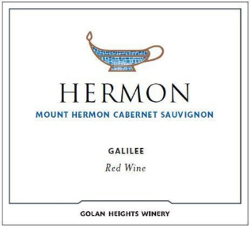
Golan Heights Winery Mount Hermon Cabernet Sauvignon (Galilee, Israel)
The Golan Heights Winery, founded in 1983, is the pioneering winery of Israel and inspired the country’s quality wine revolution. It is situated in the small town of Katzrin, high up on the Golan Heights. Their vineyards are situated on the Golan, a volcanic plateau that rises up to 3,600 feet above sea level. Their success put Israel on the international wine map and they became a main ambassador of Israeli wine in export markets. Their legendary winemaker, since 1992, is Victor Schoenfeld. The Mount Hermon Cabernet Sauvignon features classic Cabernet characters of berries and plum, complemented by complexing notes of herbs, earth and spice. With satisfying body and good concentration of flavor, the wine is wonderful for everyday drinking. Kosher.
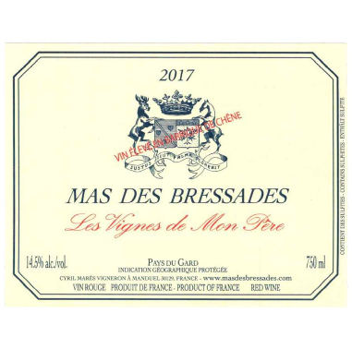
Mas de Bressades ‘Les Vignes de Mon Pêre’ (Costières de Nîmes, France)
Mas des Bressades consists of 40 hectares of vineyards in the AOC Costières de Nîmes, all of which are farmed sustainably. Just like his father, who left his mark on the domaine by replanting many of the vines in the 1970s, Cyril Marés began his tenure by replanting some of the old orchards with Syrah and Grenache. Since then, he has added to the family holdings by purchasing old-vine plots of Roussanne, Marsanne and Mourvèdre. Cyril also has parcels planted to 70-year-old Cabernet Sauvignon and Syrah vines, which he uses for “Les Vignes de Mon Père,” a tribute cuvee to his father, using the savoir-faire he acquired with Bordeaux varietals abroad. “Les Vignes de Mon Pêre” translates to “my father’s vines.” Pronounced notes of smoke and dried herb offset plump black cherry and plum flavors here. Plush and richly textured, it's a densely concentrated wine sourced from old-vine Cabernet Sauvignon and Syrah. A whisper of vanilla and soft, chalky tannins linger on the finish.

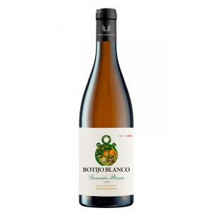
WHITES
Vino de la Tierra Valdejalón Botijo Blanco Garnacha Blanca (Valdejalon, Spain)
Vino de la Tierra Valdejalón is located in Aragon, west of the city of Zaragoza. The area has long been associated with quality wine, and it’s believed that viticulture here pre-dates Roman settlement. It shares the minerality of Calatayud with the fruitiness of Campo de Borja- both areas sharing borders with Valdejalón. Ninety-seven per cent of the region is planted to Garnacha, many of which are 50-90 year old wines. Garnacha Blanca can tend toward the heavy, oxidative side but with meticulous care in the vineyards (organic, dry farmed), harvesting early and a non-interventional approach in the winery, the Botijo Blanco coaxes out the vibrant citrus side of the varietal. The lemon-rind and pear-blossom aromas and flavors are delicious. Medium-bodied, crisp acidity and a flavorful finish. Pair with roasted pork loin and apples, high-quality ramen, or ceviche on a hot day.

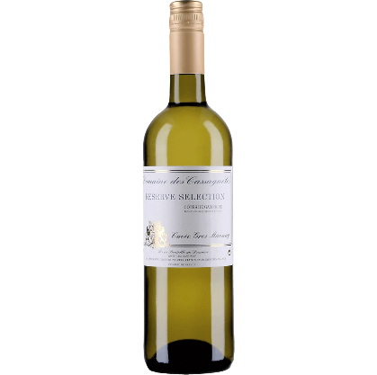
Domaine des Cassagnoles ‘Cuvée Gros Manseng’ (Cotes de Gascogne, France)
100% Gros Manseng, a grape primarily grown in Southwest France. This medium-bodied, rounded, impressively-textured white gives up attractive notes of spiced citrus, brioche and a salty, minerality-like character that develops with time in the glass. Pair with smoked salmon, goat cheese, or stir-fried wok vegetables.
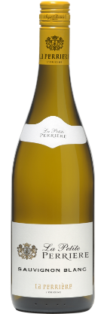
Saget ‘La Petite Perriére’ Sauvignon Blanc (Loire Valley, France)
A stunning value from a Northern Loire Valley producer. On the nose, a wide range of fragrances, from vegetal with ivy and acacia to fruity with peach and lychee. A fresh start, leading into persistent mineral and fruity notes and a lingering finish on the palate. Pair with steamed artichokes, simple salads, or seafood tapas on a sunny day.
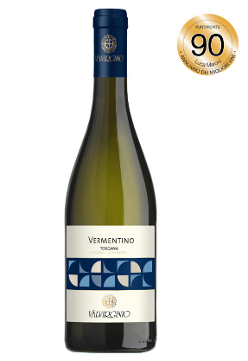
Valvirginio Vermentino di Toscana (Toscana, Italy)
Produced by an environmentally-conscious Tuscan cooperative, this dry, structured white displays notes of yellow fruits--crunchy peach and apple-- and finishes with a soft minerality. Pair with grilled fish or roasted vegetable pasta dishes. This is the prettiest Vermentino we’ve tasted in the last couple of years, and it’s one of the underrated Italian white wine varietals that we feel deserves a little more attention, especially as we enjoy sunny weather.
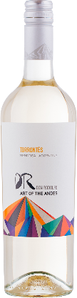
Don Rodolfo Art of the Andes Torrontes (Mendoza, Argentina)
Argentina is a country where people love to express themselves. Embracing art as a language, locals do this through the rich cuisine, vibrant music and eye-catching street art. A portion of every bottle of Don Rodolfo sold is donated to support a socio-economically diverse group of aspiring Argentinian artists. With this money they are able to cover costs of their art supplies, studio time, and continual education via special workshops, artist lectures and participation in open studios. Farmed sustainably in high-elevation vineyards, this handcrafted Torrontes reveals notes of citrus blossom and apricot with a dry, crisp finish. Torrontes is traditionally paired with chorizo empanadas, but also is a great match with any chile and spice-driven dish.

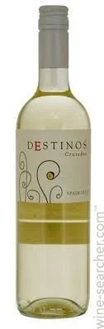
Destinos Cruzados Macabeo (La Mancha, Spain)
Macabeo (or Viura in Rioja) is a white wine grape used on either side of the Pyrenees, in the north and east of Spain and the southernmost reaches of France. A relatively versatile grape, it is used in still, sparkling, dry and sweet wines. Light-bodied and refreshing, with notes of tropical fruits and citrus. Intense crisp apple and peach notes on the palate make it a great wine to match with mild appetizers, seafood or simply to enjoy as an aperitif before your meal.

TIER II
REDS
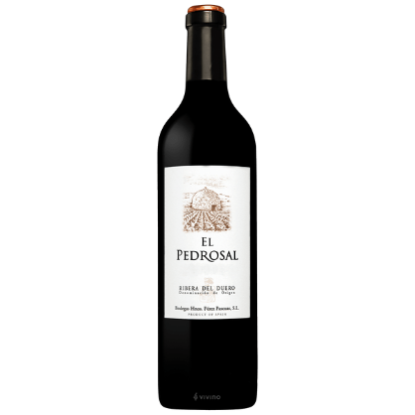
Bodegas Hermanos Perez Pascuas El Pedrosal Crianza (Ribera del Duero, Spain)
Ribera del Duero
On the palate this wine is powerful and fruity, with hearty tannins that give opulence. Notes of menthol, cocoa, toasted coffee, and minerals balance the fresh red fruit. The wine finishes with notes of cedar, and licorice, and an elegant touch of minerality. The textbook 2016 El Pedrosal was cropped from a cooler year that perfectly fit the house style and their preference for harvesting early to keep good acidity in their wines, which makes them fresh and long-lived. However, in 2016 the harvest started later, as the grapes ripened slowly and perfectly. This wine has the balance between ripeness and freshness, power and elegance, with a spicy touch from the oak that is not intrusive. Pait this wine with tomato-based dishes, lamb burgers, or roasted mushrooms.
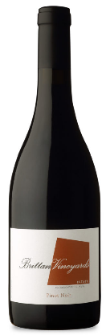
Brittan Estate Pinot Noir (Willamette Valley, Oregon, USA)
Featured Winery- Special Club Pricing for Oregon Wine Month!
The Brittan Estate Vineyard lies just 12 miles southwest of McMinnville, tucked into the foothills of the Coast Range. The original 18 acres were planted in 2001, but due to the challenging nature of this site and limited topsoil, only eight acres survived. Since 2004 when Robert and Ellen purchased the vineyard, it has been an ongoing rehabilitation project: replanting, retraining, and learning the unique landscape that has become Brittan Vineyard. A true expression of vintage and site, the 2018 Estate Pinot noir showcases notes of red currant, red plum, cherry and pomegranate which are accented with hints of five-spice, anise and tobacco. A lovely vein of salinity runs through the palate which finishes with the power and richness indicative of the 2018 vintage.
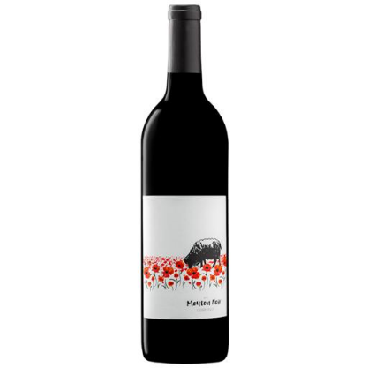
Warr-King Mouton Noir (Columbia Valley, Washington, USA)
Woodinville-based Warr-King Wines produces this unique “rebel blend” of 50% Petit Verdot and 50% Syrah. “Mouton Noir” or “Black Sheep” has robust tannin structure and notes of blackberry, baking spices, and dark violets. Give this wine plenty of time to open up or aerate. This is a wine to pair with animal fat--game, sausages, beef. It also could also pair well with heartier lentil-based dishes that have a good amount of umami and spice. Again, just make sure to give this wine plenty of time to open up. Like stew, it’s even better on the second day.

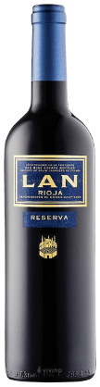
Bodegas LAN Reserva (Rioja, Spain)
LAN wines are estate-grown and bottled in Rioja, famous for their vino tinto (red wine) using Tempranillo grapes. La Rioja is in Northern Spain, about a five hour drive or train ride from Barcelona. Bodegas LAN has been making wine in this region since 1972, where grapes are harvested by hand and respectful care of the grapes and land are supported by sustainable viticulture practices. Bright, ripe cherry red. Intense and complex in aromas. Aromas of ripe red fruit, enveloped in white flowers, almond blossom and broom. Touches of cinnamon and resinous notes. Velvety on the attack, smooth and delicate. It is elegant, balanced and harmonious on the palate. A long finish, leaving a pleasant aftertaste that encourages you to take another sip. Pair with Iberico ham, aged Manchego, or barbecued chicken and vegetables.
We encourage you to taste the differences between this wine from Rioja and the Pedrosal wine from Ribera del Duero. Crianza bottlings have been aged at least two years before release, with a year or more in barrel. Reserva bottlings are aged at least three years, with at least one year in barrels and 6 months in bottles before release.
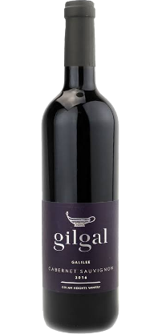
Golan Heights Winery Gilgal Cabernet Sauvignon (Galilee, Israel)
The Golan Heights Winery, founded in 1983, is the pioneering winery of Israel and inspired the country’s quality wine revolution. It is situated in the small town of Katzrin, high up on the Golan Heights. Their vineyards are situated on the Golan, a volcanic plateau that rises up to 3,600 feet above sea level. Their success put Israel on the international wine map and they became a main ambassador of Israeli wine in export markets. Their legendary winemaker, since 1992, is Victor Schoenfeld. Aromas of cherry, raspberry and coffee bean set the stage for flavors of black cherry, blackberry, apple peel, white chocolate and baking spice. Opulent tannins coat palate, making way for a juicy, blueberry pie flavored finish. Kosher.
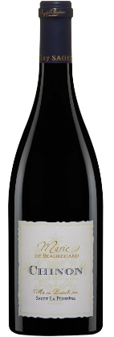
Marie de Beauregard Chinon (Loire Valley, France)
100% Cabernet Franc. The name “Marie de Beauregard” is a homage to the first owner’s wife of the water mill where the wines are aged. Stretching from one side of the country to the other, the river of kings has been the homeland of the Saget family for nine generations. On the eye, a garnet red wine with intense ruby tints. The nose is powerful, peonies mingle with slightly roasted notes. The palate is round and delicious, with vanilla and spices in the foreground followed by the powerful entrance of blackberries and blueberries. Pair with lamb gyros, pan-roasted trout, or a hearty arugula salad.
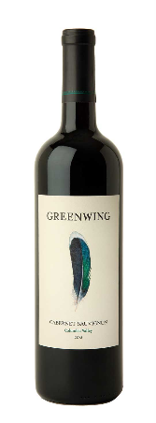
Greenwing Cabernet Sauvignon (Columbia Valley, Washington, USA)
Napa’s famed Duckhorn Winery has invested in the growing wine culture here in Washington State. Greenwing is their Cabernet Sauvignon dominant blend from various sites in the greater Columbia Valley AVA. Dark ruby in color, the 2018 Greenwing Cabernet Sauvignon from Columbia Valley presents generous and pure black and red fruit aromatics, framed in spicy and aromatic oak. Black plum and bing cherry lead the way, followed by notions of clove, brown sugar, and mocha. On the palate, the wine is broad, juicy, and plummy. Plush, with lots of body, the wine finishes with noble presence and fine-grain tannins.

WHITES
Brittan Estate Chardonnay (Willamette Valley, Oregon, USA)
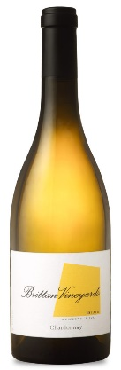
Featured Winery- Special Club Pricing for Oregon Wine Month!
The Brittan Vineyard lies just 12 miles southwest of McMinnville, tucked into the foothills of the Coastal Range. The original 18 acres were planted in 2001, but due to the challenging nature of this site and limited topsoil, only eight acres survived. Since 2004 when Robert and Ellen purchased the vineyard, it has been an ongoing rehabilitation project: replanting, retraining, and learning the unique landscape that has become Brittan Vineyard. The nose of the 2018 Chardonnay, the first vintage sourced exclusively from the estate, draws you in with a stylish flintiness and aromas of sweet Meyer lemon, pea tendrils, and a hint of honeysuckle. Scents of Asian pear carry through to the palate, mingling with lemon curd, yellow peach, and brioche. This sleek, taut, acid driven wine evolves in the glass and will continue to develop with cellaring. From white flakey fish dishes or butter-poached sea scallops to chicken pot pie or Indian curries, this is a workhorse, perfect food-pairing wine.
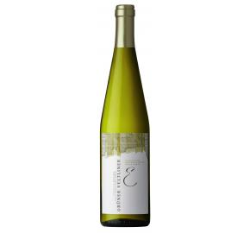
Cantina Valle Isarco Gruner Veltliner (Alto Adige, Italy)
Cantina Valle Isarco is located in the Isarco Valley, the northernmost wine producing area of Alto Adige. The winery incorporates 135 families as grower members and has an exceptional reputation for high quality white wines.In Alto Adige, the Austrian grape varietal Gruner Veltliner is grown almost exclusively in the Valle Isarco. Considering the total disappearance of the original Fruhroter Veltliner stock, today mostly the Veltliner Verde is cultivated. It is a rarity in the Alto Adige winemaking scene. This is a medium-bodied white backed with sleek acidity. Subtly creamy, with undertones of minerality and notes of grapefruit, crunchy peach, and the iconic hint of herbs on this finish. Pair with Thai food. We highly recommend Bhu Ping Thai in South Everett.

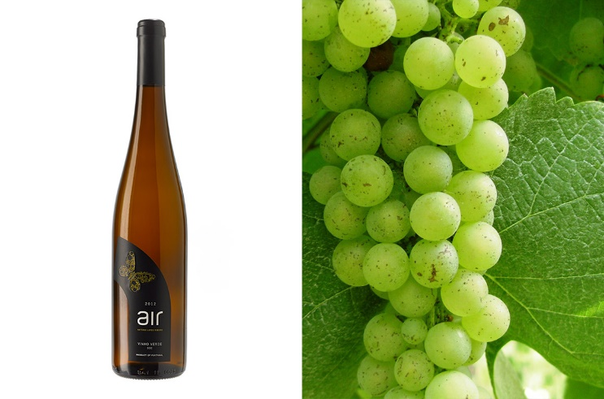
Casa de Mouraz “Air” Vinho Verde (Vinho Verde DOC, Portugal)
Husband and wife team, Sara Dionísio and António Lopes Ribeiro, are one of Portugal’s greatest proponents of organic (and more recently, biodynamic) wine production. With 98% of their wines exported and their wines listed in one of the world’s greatest restaurants, Copenhagen’s Norma, they are the essence of what Portugal’s tiny, traditionally focused, family run wineries are capable of achieving. There is common thread of freshness and purity in all Casa de Mouraz wines. They reflect the fact that they are unworked, non-interventionist and are very food-friendly, juicy wines (at a good value.) Slate undertones, honeyed, lime notes, and brilliant acidity makes this wine Riesling-like with a gorgeous persistence and vitality. Enjoy with tortilla soup, light seafood dishes, or a dozen fresh-shucked oysters.
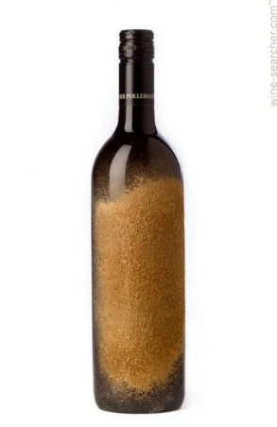
Der Pollerhof “Vom Löss” White Wine (Niederösterreich, Austria)
What you see on the painstakingly applied label is one of the wine world’s most treasured soil types, loess (a wind-blown silt), and what’s in the bottle is a mineral-infused, masterfully concocted, Sauvignon Blanc-dominated blend that is beyond addicting. This “Vom Löss” explodes with vividly lush aromas: Lime peel, green peach, apricot, orange blossoms, pink grapefruit, papaya, elderberry, honeysuckle, white flowers, sweet herbs, crushed stone, and a hint of pepper. Pair with pan-fried trout, halibut in beurre blanc, or a vegetarian red Thai curry.

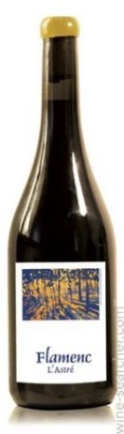
Domaine L’Astre Flamenc “Rosé” (Dordogne, France)
50% Semillon, 30% Cabernet Franc, 20% Cabernet Sauvignon
We have an ongoing conversation about the rise of “Natural Wine” at Blanc & Rouge. What differentiates a bottle with a striking, colorful label, farmed organically/biodynamically, fermented with native yeast and minimal sulfite additions…we could go on… from wines that have been produced by multigenerational estates with traditional practices, who have been making wine the same way since well before the Industrial Revolution? Are we simply attempting to add a coolness factor to centuries of sustainable agriculture? At the end of the day, Mina and Ally taste and vet every wine that reaches the shop shelves. This wine is one of the most esoteric and unique wines that have entered the shop, but this “natural wine” finishes clean and is immensely food-friendly, so we are excited to feature it in a few wine club bags. Located on a hillside 80 meters above the Dordogne valley with the forest protecting the vineyard, the vines are planted very densely at about 5000 vines per hectare with biodynamic treatments throughout the farm. Beautiful and very light salmon color gives way to bright red fruits: rainier cherries, ripe raspberry & field strawberries. Pair with ahi tuna steaks, carnitas street tacos, or a spring vegetarian dish such as watermelon radishes sliced thinly with a side of herbed creme fraiche.
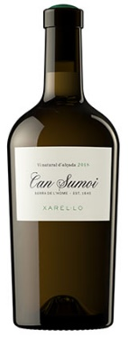
Can Sumoi Xarel-lo (Penedes, Spain)
Can Sumoi is the newest project from Pepe Raventós and Francesc Escala - a found treasure in the mountains of the Baix Penedès where they realize their vision and dreams in the remarkable landscape and passion for natural wines. Can Sumoi is an agricultural farm dating to 1645, located in Massís del Montmell, 600 meters above sea level. The estate has 400 hectares of land of which 30 are vineyards planted with Parellada, Xarel-lo and Sumoll; the rest is forest of oak, white pines, tall oaks and old stone walls that surround the winery and three farmhouses from the end of the 17th century, where wine used to be made. Clean, fresh and electric, the Can Sumoi Xarel-lo speaks to the wild landscape from which it is grown with aromas of herbs such as fennel and thyme. The fruit flavors teeter on underripe to just perfect apples with clean acidity and a hint of salinity. Pair with Vietnamese summer rolls, flaky white fish, or light pasta dishes.

TIER III
REDS

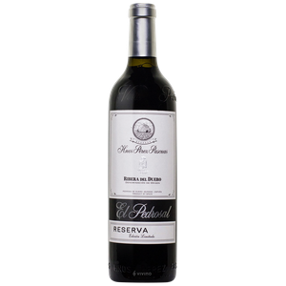
Pérez Pascuas El Pedrosal Reserva 2006 (Ribera del Duero, Spain)
Ribera del Duero
Cherry red with ruby hints. Intense and complex, on the nose, where we can still find red fruit aromas, balsamic notes, nuts, a slight toasted background, very clean, and intense. In the mouth it’s alive, well balanced, and fine. Elegant and complex, showing its optimum evolution in the bottle. It’s now in a great moment for consumption, but will develop positively for the next 8-10 years. A fresh, Atlantic wine, that still shows youth. Pair with grilled lamb chops or game. It would also be perfect with a big wedge of aged Manchego, enjoyed while sitting outside.
Brittan Estate Pinot Noir (Willamette Valley, Oregon, USA)
Featured Winery- Special Club Pricing for Oregon Wine Month!
The Brittan Estate Vineyard lies just 12 miles southwest of McMinnville, tucked into the foothills of the Coast Range. The original 18 acres were planted in 2001, but due to the challenging nature of this site and limited topsoil, only eight acres survived. Since 2004 when Robert and Ellen purchased the vineyard, it has been an ongoing rehabilitation project: replanting, retraining, and learning the unique landscape that has become Brittan Vineyard. A true expression of vintage and site, the 2018 Estate Pinot noir showcases notes of red currant, red plum, cherry and pomegranate which are accented with hints of five-spice, anise and tobacco. A lovely vein of salinity runs through the palate which finishes with the power and richness indicative of the 2018 vintage.
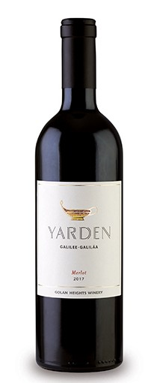
Golan Heights Winery Yarden Merlot (Galilee, Israel)
The Golan Heights Winery, founded in 1983, is the pioneering winery of Israel and inspired the country’s quality wine revolution. It is situated in the small town of Katzrin, high up on the Golan Heights. Their vineyards are situated on the Golan, a volcanic plateau that rises up to 3,600 feet above sea level. Their success put Israel on the international wine map and they became a main ambassador of Israeli wine in export markets. Their legendary winemaker, since 1992, is Victor Schoenfeld. The 2017 Yarden Merlot expresses notes of ripe red and black fruits, along with characters of orange peel, earth and fresh herbs. A wonderful example of the exceptional quality of Merlot grown in the Golan Heights, this classic Merlot is full-bodied, rich and flavorful. Although enjoyable to drink upon release, the 2017 Yarden Merlot will develop in the bottle over the next few years, and stay in good drinking condition for up to a decade from harvest. We love pairing this food-friendly wine with a rack of lamb with a Merlot glaze, braised beef short ribs, or roasted root vegetables.

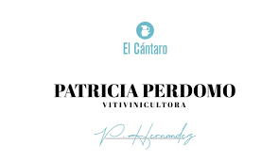
Patricia Perdomo La Palma "El Cantaro" Tinto
Patricia Perdomo is based in Garafia, in the northern part of La Palma in the Canary Islands, where she organically farms a single hectare vineyard in the region of Briesta that is composed of a number of indigenous grape varieties: Listan Prieto, Listan Negro, Negramoll, and others. This is a truly special place: surrounded by Canarian pines, planted on ancient terraces, the vines are 1200m above the sea and typically above the cloud line. El Cantaro, is the only wine she produces, a blend of all of the varieties from the plot co-fermented in the ancient method of the area. About 80% of the grapes are destemmed, ferment in open top vessels for about five days before resting in stainless steel for roughly a year. This shows savory notes of tea, smoke, stone and tiny red berries on the nose, while the palate is beautifully balanced, with delicate, grainy tannins around notes of macerated raspberries and cranberries and pomegranate layered on deep and dense volcanic minerality. Truly elegant. I recommend a quick decant to help this wake up and open fully.
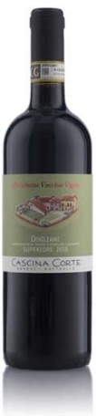
Cascina Corte Dogliani Superiore Pirochetta Vecchie Vigne
100% Dolcetto. Purple-red in colour with violet-ruby flashes. Deep and vertical on the nose with fruity aromas which intermingle to create a pervasive, balanced bouquet. Cherries, plums and redcurrants are subsequently replaced by notes of spice and liquorice. The palate is forthright and full of character with tannins well to the fore, though it maintains plenty of softness and roundness. The finish is long and lingering. Demonstrably capable of ageing well for years. By no means a light table wine. Its structure and personality make it ideal even with the tastiest meat dishes. Excellent also with soups, cured meats and cheese.

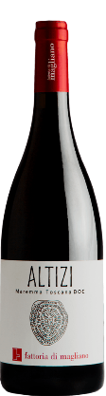
Fattoria Di Magliano Altizi (Maremma Toscana DOC, Italy)
100% Cabernet Franc
In 1997, Agostino Lenci turned his passion into a business investing in a 97-hectare property in the small town of Magliano in the DOC appellation of Maremma Toscana. Although the region has long since produced wine, it was not internationally recognized for quality until recently. Lenci’s vision to bring glory to this little-known area was realized. In recent years, the Maremma Toscana emerged as a preeminent wine producing region. It was subsequently granted DOC status by the Italian government. Fattoria di Magliano was at the forefront of this endeavor, receiving rave reviews from top critics and consumers alike. Planting began in 1998 with Sangiovese and Vermentino, the region’s signature varietals. At present, 52 hectares are under vine with smaller parcels of Cabernet Sauvignon, Cabernet Franc, Syrah, Merlot, and Petit Verdot interspersed throughout. On the nose, the wine is vegetal with hints of red fruit, spice, and light smoky notes. On the palate, the wine is very aromatic, round and fresh. Altizi is a full-bodied wine with velvety tannins and beautiful notes of blueberries, currants, raspberries that finishes with a subtle note of licorice. Great as an aperitivo, or with seasoned cheeses, cured meats, game meat, and risotto.
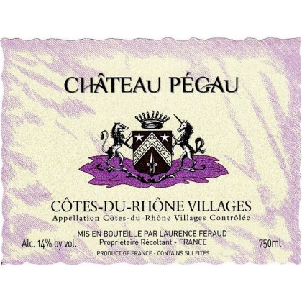
=
Château Pegau Cuvée Sétier (Côtes-du-Rhône, France)
Chåteay Pegau is located in an old Provencal farmhouse in Sorgues, on the banks of the Rhône between Châteauneuf du Pape and Avignon. This property is surrounded by 41 hectares of vineyards established on a magnificent terroir partially covered with rolled pebbles. Classified as Côtes du Rhône Village, the Cuvée Sétier, named after an old measure of wine averaging four litres or 8 pints, presents a classic, elegant example of Côtes du Rhône Village wines. Generous with pronounced tannins born from a blend of Grenache, Mouvèdre & Syrah planted on hillsides on rolled pebbles. A strong cedar note weighs in on the core of steeped cherry and raspberry fruit, before leaving a rather firm edge on the finish. Pepper and olive notes fill in as well. Frankly rustic. Pair with grilled or smoked meats, a hearty burger, turkey chili, or honey-roasted root vegetables.
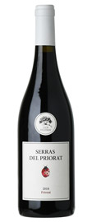
Clos Figueras “Serras del Priorat” (Priorat, Spain)
A blend of Garnacha, Samso (Carignan), Cabernet Sauvignon and Syrah it is fermented in tank and then aged in 500L used French oak barrels. This wine has always been considered the "entry level" offering for Clos Figueras, a brighter fresher interpretation of the region. This is an unadorned expression of Gratallops. This wine has everything you could want from Priorat; great aromatics mixed berries, wild meditereanan herbs, spice and that earthy mineral drive from the llicorella soils. The used oak speaks volumes for what it does to the wine and for what is does not impart. It is full, the tannins are supple, there is fresh acid and a very long finish. This is a perfect point of entry into this amazing wine region. Pair with lentil soup, duck confit, or cassoulet.

WHITES
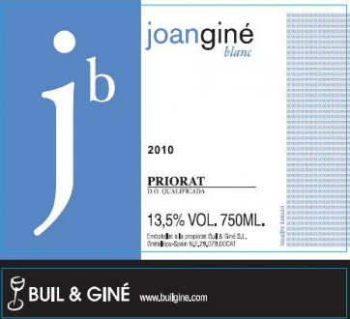
Buil & Gine Priorat Blanc (Priorat, Spain)
Joan Giné Blanc is showcasing the white grapes from Priorat and their power. Joan Giné was dedicated to the wine culture, education and development of wine in Priorat. This star white wine of their portfolio has weight and muscle, with firm acidity supporting the thick texture. Pear, tarragon and lanolin flavors are accented with more delicate notes of heather, spice and almond. Stays fresh and balanced. A blend of white Garnacha, Macabeo and Pedro Ximénez. Pairs well with roasted chicken and game birds, shellfish and rich fish dishes.

Brittan Estate Chardonnay (Willamette Valley, Oregon, USA)
Featured Winery- Special Club Pricing for Oregon Wine Month!
The Brittan Vineyard lies just 12 miles southwest of McMinnville, tucked into the foothills of the Coastal Range. The original 18 acres were planted in 2001, but due to the challenging nature of this site and limited topsoil, only eight acres survived. Since 2004 when Robert and Ellen purchased the vineyard, it has been an ongoing rehabilitation project: replanting, retraining, and learning the unique landscape that has become Brittan Vineyard. The nose of the 2018 Chardonnay, the first vintage sourced exclusively from the estate, draws you in with a stylish flintiness and aromas of sweet Meyer lemon, pea tendrils, and a hint of honeysuckle. Scents of Asian pear carry through to the palate, mingling with lemon curd, yellow peach, and brioche. This sleek, taut, acid driven wine evolves in the glass and will continue to develop with cellaring. From white flakey fish dishes or butter-poached sea scallops to chicken pot pie or Indian curries, this is a workhorse, perfect food-pairing wine.

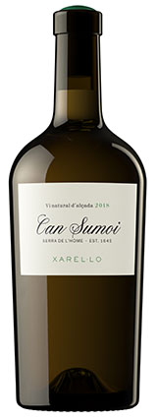
Can Sumoi Xarel-lo (Penedes, Spain)
Can Sumoi is the newest project from Pepe Raventós and Francesc Escala - a found treasure in the mountains of the Baix Penedès where they realize their vision and dreams in the remarkable landscape and passion for natural wines. Can Sumoi is an agricultural farm dating to 1645, located in Massís del Montmell, 600 meters above sea level. The estate has 400 hectares of land of which 30 are vineyards planted with Parellada, Xarel-lo and Sumoll; the rest is forest of oak, white pines, tall oaks and old stone walls that surround the winery and three farmhouses from the end of the 17th century, where wine used to be made. Clean, fresh and electric, the Can Sumoi Xarel-lo speaks to the wild landscape from which it is grown with aromas of herbs such as fennel and thyme. The fruit flavors teeter on underripe to just perfect apples with clean acidity and a hint of salinity. Pair with Vietnamese summer rolls, flaky white fish, or light pasta dishes.

TIERS IV & V
REDS
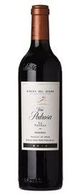
Pérez Pascuas Finca La Navilla Reserva (Ribera del Duero, Spain)
Ribera del Duero
Based in Pedrosa de Duero (Burgos), Perez Pascuas is perhaps the single most under-appreciated, top quality, traditional Ribera del Duero producer in the entire D.O. This La Navilla bottling, from the fantastic 2014 vintage, shows generosity and richness of fruit, but also plenty of freshness and minerality to balance out the spice and heft of the wine. A true beauty to be sure. One of the most elegant examples of Tempranillo that we have tasted from this region.

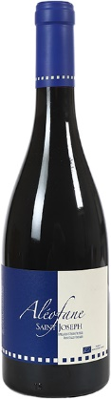
Domaine Aléofane Saint-Joseph
Natacha Chave knew she would make wine like her parents. Before setting up she decided to take her baccalaureate, then went on to obtain her masters in Philosophy of language. At the beginning of the year 2000, her brother Yann Chave took over their father’s domaine (Bernard Chave), a renowned vineyard created in 1970 on the Crozes-Hermitage and Hermitage appellations. Natacha was now ready to get into the family business. She enrolled at the Suze la Rousse wine university in 2003, then passed a Farming Professional Capacity (CPA), and then did her work experience with various winegrowers to complete her training. In 2004, she bought 1.5ha of vines in the Saint Joseph appellation at Tournon-sur-Rhône. The name of the domaine is Aléofane, in reference with the imaginary island from a book by author, John Macmillan Brown. According to Natacha Chave, “Our immediate will is the respect of nature, soils, grapes and is to be as little as interventionist as possible both in grape growing and in winemaking process.” Dark crimson color with purple a sheen. The nose detects flowery and spicy essences, including violets, blackcurrants, blackberries, Sichuan berry and mocha. The palate, full and balanced, combines the density of fine tannins and mineral freshness. 100% Syrah.

