**SUMMER 2022 WINE CLUB RELEASE**

***Featuring Tuscany’s Fattoria di Luiano***

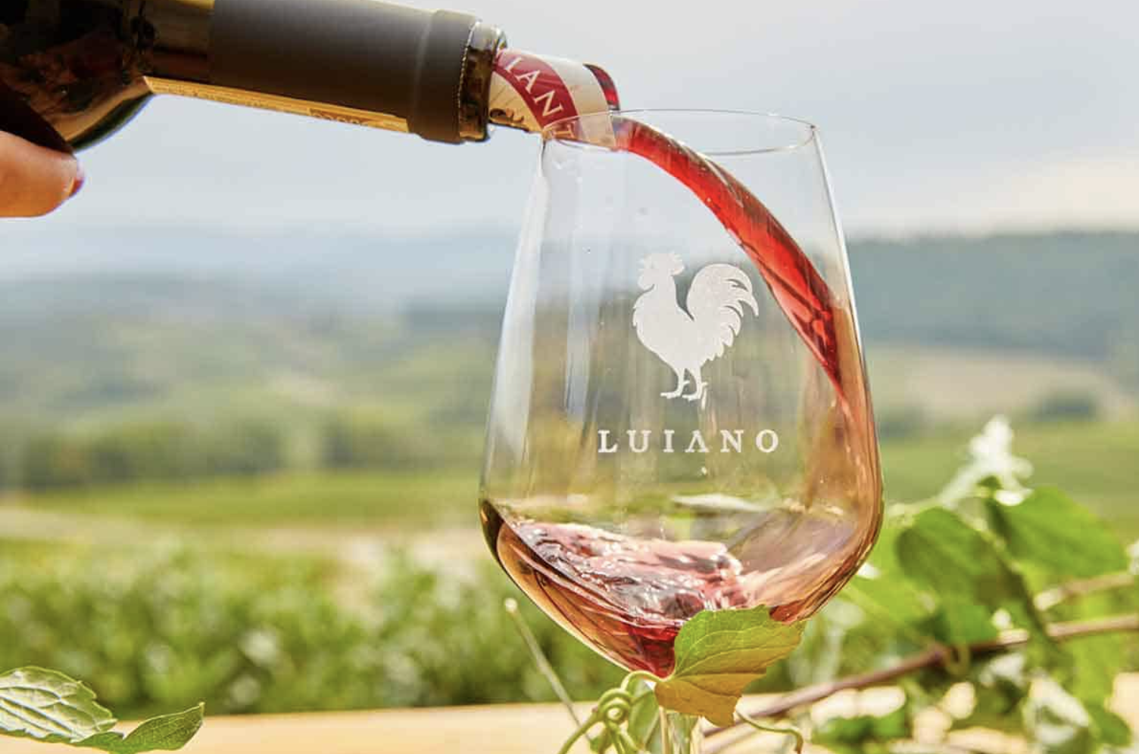

*Picture courtesy of Fattoria di Luiano*

Quick Links: [Tier 1](https://docs.google.com/document/d/1H7tI7Z3HM5J4CK-4t62d7rXehyw6C69vHbpzA7suoRg/edit#bookmark=id.y5y71wpz7qth), [Tier II](https://docs.google.com/document/d/1H7tI7Z3HM5J4CK-4t62d7rXehyw6C69vHbpzA7suoRg/edit#bookmark=id.55l6cagr3xgm), [Tier III](https://docs.google.com/document/d/1H7tI7Z3HM5J4CK-4t62d7rXehyw6C69vHbpzA7suoRg/edit#bookmark=id.5tefyebd82br), [Tiers IV & V](https://docs.google.com/document/d/1H7tI7Z3HM5J4CK-4t62d7rXehyw6C69vHbpzA7suoRg/edit#bookmark=id.g4etmkgms3ij)

It’s an ongoing joke at Blanc & Rouge that we love to drink seasonally “in-reverse” of much of the wine community. In the winter, we bundle up with a crisp, dry white wine next to the fireplace, while in the heat of summer, when we’ve fired up the grill, we reach for big, juicy reds, especially those from the Tuscan hills. Thus, this Summer Wine Club Release, we are celebrating Sangiovese by featuring five BBQ-ready reds from Fattoria di Luiano. We are one of the sole ambassadors of these wines in the State of Washington, as they have been special-ordered exclusively for our Wine Club from their East Coast importer.

From Luiano’s importer, Opici:

Luiano is an ancient fort, built in the late middle ages, that spans 40 hectares in the Chianti Classico appellation of Tuscany, Italy, just 10 miles south of Florence. Since it was erected, Luiano has belonged to several of the most important, noble families of Florence, renowned for its abilities to produce superb wine. In 1959 Alberto Palombo, a Neapolitan textile merchant, and his wife Licia, were so enchanted by Luiano and its history that they abandoned the city and purchased the property to carry on its long standing tradition of vine growing and winemaking.

In 1996, Antonio, Alberto’s son, followed suit, trading his career in banking for a life in the vineyards. He soon began to restore the vineyards and the cellar, establishing the property as a modern winery. In 2003, the third generation of the Palombo family joined the family business as well. Together with his children Alessandro and Felicia, Antonio has committed to preserving Luiano’s legacy while ushering in innovations.

Twenty hectares are planted to both native and international grape varietals, predominantly Sangiovese.  The vines are positioned at an average altitude of 300 meters above the sea level and benefit from the fertile, mineral-rich soil along the banks of the nearby Greve River.  Luiano’s 2nd-generation team of viticulturalists, born and raised in the Tuscan countryside as extended members of the Palombo family,  possess in-depth knowledge of these vineyard sites gained from working alongside their parents and care for the vineyards as though they were their own. The wines are produced in accordance with the traditions and regulations of the Chianti Classico DOCG.

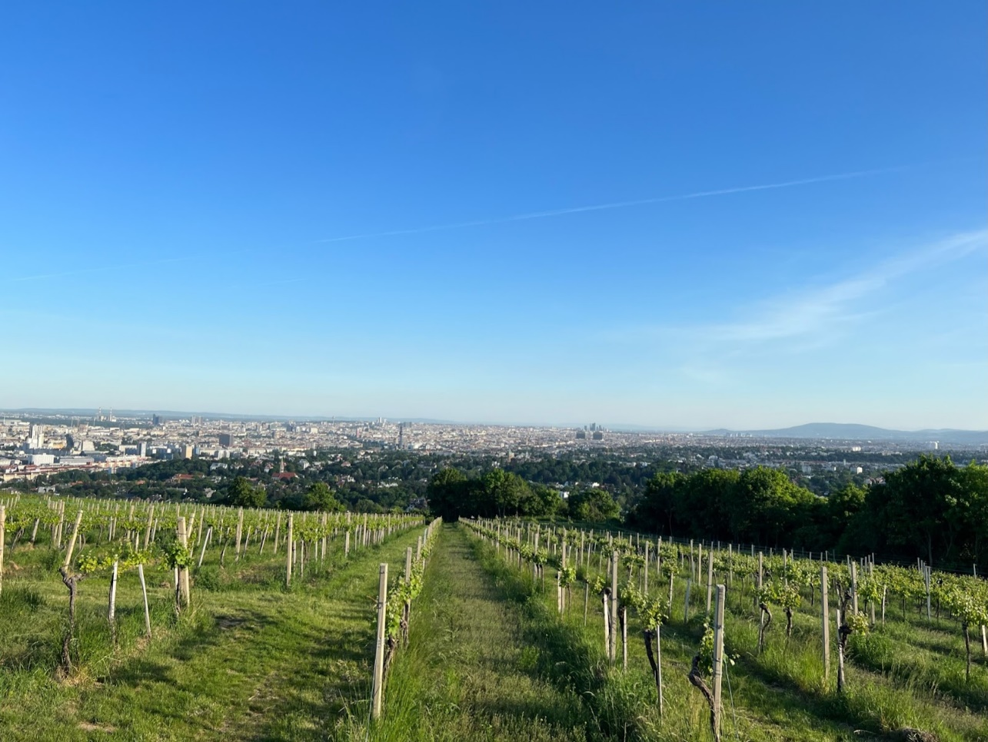

Mayer am Pfarrplatz’s vineyards surrounding Vienna. *Photo courtesy of Liz Porcelli, Raleigh Wine Shop.*

Many of you know that Ally had the opportunity to travel to Austria and Germany as a guest of the Austrian Wine Marketing Board and MS Walker Imports. Outside of being a wonderful educational opportunity, this trip opened up a discussion amongst our team about the diversity of white wine. As the cost of white Burgundy continues to skyrocket, we feel that well-made white wines, especially those from Austria and Germany, offer tremendous value, elegance, and food-friendliness. We are thrilled to partner with MS Walker Imports, and their Washington distributor, Unique Wine Company, to showcase some of Ally’s favorite wines from her travels.

Our Classic Wine Club presents a thoughtfully-curated collection of bottles that are unique, sustainably-produced, and food-friendly. We hope our selections offer you an opportunity to expand your palate, learn about wine grapes and regions, and discover new favorite bottles. The tasting notes below represent the core wine selections for the August 2022 club release. We may have included a special selection in your bag, so please contact wineclub@blancandrougewine.com if you would like any additional information about your club wines.

**TIER I**

**RED**

**Fattoria di Luiano Sangiovese (Tuscany, Italy)**

*Featured Producer*

Luiano Sangiovese is a young, fresh expression of Tuscany’s signature varietal with aromatics of cherries and strawberries that fill the nose and flood the palate.  The acidity is balanced by rounded tannins creating a smooth mouthfeel. Vinified entirely in stainless steel to preserve the natural characteristics of the grapes, the wine rests for 10 months prior to bottling. Best enjoyed in its youth. 100% Sangiovese.

**IBY Blaufränkisch Classic (Burgenland, Austria)**

*Featured Producer*

Ally met Anton and Eva Iby at VieVinum, the national Austrian Wine conference in Vienna. She was immediately taken by their positivity and passion for Austrian red wine. While Austria may be more commonly known for their white wines, one of their hallmark red grapes–Blaufrankisch– is the perfect summer grilling wine. The bright blackberry and cherry aromas of the grape are unmistakable, with its mineralic and earthy spice contributing delicacy and refinement.

The red wine estate IBY has been cultivating the vine in Burgenland for five generations, since the beginning of the 20th century—red wine varieties are planted exclusively on their 35 hectares of vineyard. This growing region is led by the Blaufränkisch grape—75% of the area under vines. The Blaufränker is known for most vividly reflecting the region’s Pannonian climate and its deep and heavy loam soils. Anton Iby V, with the strong support of his parents, has been leading the estate since 2000; his training includes practical experience in the vineyards of Priorat and California. His grandfather, Anton III, made the decision to mold the family estate into a red wine specialist, as well as to concentrate on Blaufränkisch. Other varieties planted are the indigenous Zweigelt and the international Merlot, both of which do well in the soils of Horitschon, enhanced by the estate’s regime of organic viticulture. Their traditional large casks of Austrian oak are instrumental in creating wine that is the purest expression of their fruit, without any cosmetic enhancement.

**Bodega Vistalba Tomero Cabernet Sauvignon (Mendoza, Argentina)**

The Tomero label pays homage to the noble trade of *the Tomero,* an old profession in Argentina’s agriculture industry. The Tomero guards the distribution of water from the melting of the Andes Mountains. The work of the Tomero, channeling the water through the ditches through the gates, is essential for each producer in Mendoza to have irrigation for their crops. The care and optimization of the use of water are closely linked to the values of the Tomero, who from an early age learns this trade from his parents and grandparents, it is a tradition that is proudly inherited. From a very young age, the children of the Tomeros watch their parents fulfill this exciting task with dedication. On the nose there are notes of red fruits reminiscent of cassis, amalgamated with the typical Cabernet Sauvignon notes of roasted pepper, sweet paprika and pink pepper. In the mouth it is juicy, with good structure, but with a long and silky finish.

**Colterenzio Schiava “St. Magdalener” (Alto Adige, Italy)**

Colterenzio is one of the newest wineries in South Tyrol, composed of over 300 families working together.  This is a new-generation cooperative that smashes any preconceptions, proving that a humble “co-op” can consistently deliver some of the most transparent, expressive wines in a well-respected region like Alto Adige. Member-winegrowers farm their grapes on a total of 300 hectares; the vineyards are located in one of the best wine growing sub-districts of Alto Adige, on altitudes ranging from 230 to 650 meters with 12 different varieties cultivated. Ecology is a driving principle here – farming is sustainable and the winery was built with permaculture in mind. Brilliant translucent ruby red in color with a fruity bouquet reminiscent of black cherry and violets expanding to a medium-bodied palate of red summer fruits; a succulent wine with mild acidity, medium length, and a soft and smooth finish.

**Mi Terruño Malbec “Expresión” (Mendoza, Argentina)**

Mi Terruño, Spanish for “my terroir,” is a collaboration between three Argentine siblings whose family has been making wine in Mendoza since 1960. Maria-Eugenia Baigorria runs the show as viticulturist and winemaker, combining modern technology with traditional techniques to capture the terroir of their prime holdings through a lens of old-vine plantings. Black cherry and blackberry aromas are ripe, with a touch of prune weighing in. In the mouth, punchy acidity sticks out. Wiry raspberry and plum flavors are surprisingly tart. Put a slight chill on this wine and enjoy it on a hot day.

**Domaine Bousquet Danaus Red Blend (Catalunya, Spain)**

Medium to deep cherry red color, vibrant and intense with purple hues. Aromatic with good balance between fruity and woody scents. Primary aromas of red berries mixed with floral notes, giving greater depth and complexity. Balsamic scents combined with toasty aromas. Smooth entry with a very pleasant flow across the palate. Medium bodied with mature tannins. The palate has a good structure with fruity flavors and toasty finish. 80% Tempranillo, 12% Garnacha, 8% Cabernet Sauvignon. Organic.

**WHITE/ROSÉ/SPARKLING**

**Agricola Felline Fiano (Puglia, Italy)**

Gregory Perrucci, the owner and operator of Felline, is much more than a winemaker. Most importantly, he has made a name for himself internationally through his research organization Accademia dei Racemi. They were the first to champion the Primitivo grape in the Puglia region, previously only used to produce cheap bulk wine, and the first to commit serious effort to studying the many facets of the area’s different soils. The project began as a collection of five vineyards participating in Puglia's original experiment in soil analysis. Led by Gregory, this innovative group of wineries and wines has shaped the culture of Southern Italian wine and is pushing the limits of varietally correct expressions of their diverse grape varieties. They focus only on older, native grapes, mostly unknown and underrated on the market: Negramaro, Ottavianello, Malvasia Nera, Sussumaniello, Primitivo. The most important results were achieved on the Malvasia Nera, and, recently, Verdeca and Vermentino. Fiano is an indigenous Italian grape, mainly found in Southern Italy and the isle of Sicily. It’s a lovely white wine with a salty aftertaste reminding you of the coastal influence. Golden color, medium peach, lemon, and other citrus fruits. Good acidity, pairs consistently with seafood or shellfish.

**Bodegas Callia Torrontes (San Juan, Argentina)**

Torrontes is one of those underrated grapes that far outperforms its price point. Bodegas Callia is situated in the Tulum Valley in Argentina’s province of San Juan, nestled between the Pie de Palo hills to the north and the Cerro Chico Del Zonsa to the south. At 630 meters above sea level, the area is blessed by temperate climate, low rainfall and rich sandy alluvial and clay loam soil; the result is intense and fruity wines that reflect the rich terroir of this region. On the nose, are delicate aromas of oranges and white flowers, followed by refreshing notes of citrus fruits, grapefruit, and lemon on the palate.

**Buil & Giné “Nosis” Verdejo (Rueda, Spain)**

The Buil and Giné family returned to their winemaking roots in the rapidly evolving Priorat region in 1996 and since then have expanded into neighboring Montsant, as well as Rueda and Toro. The defining thread linking their wines seems to be pure fruit expression, richness without heaviness and excellent price-quality ratio. Young Xavier Buil, the proprietor, shows an uncanny sensibility and instinct for proportion for one so new to the craft. Buil and Gine “Nosis” is a dry, fresh and very fruity white wine. Complex, with notes of tropical fruits: pineapple, mango, passion-fruit. Very well-balanced in the mouth while having very intense aromas.

**Colterenzio Pinot Grigio (Alto Adige, Italy)**

Colterenzio is one of the newest wineries in South Tyrol, composed of over 300 families working together.  This is a new-generation cooperative that smashes preconceptions, proving that a humble “co-op” can consistently deliver some of the most transparent, expressive wines of Alto Adige. Member-winegrowers farm their grapes on a total of 300 hectares; the vineyards are located in one of the best wine growing sub-districts of Alto Adige, on altitudes ranging from 230 to 650 meters with 12 different varieties cultivated.  Ecology is a driving principle here – Farming is sustainable and the winery was built with permaculture in mind. 100% Pinot Grigio. Mouth filling, mellow with finesse, discreet fruit aromas and impressive length. Pale straw yellow in color with an attractive aroma of citrus fruits, peach and honeydew melon; medium rich, fruity and direct on the palate with orchard fruit flavors and tangy acidity on the finish.

**Cantina di Sorbara Lambrusco “Omaggio a Gino Friedmann” (Emilia Romagna, Italy)**

We love lambrusco, on the full spectrum of sweet to bone dry. It's the ultimate charcuterie-pairing wine, and the Emilia Romagna region is renowned for its cured meats and cheeses. We are particularly fond of this dry style from Cantina di Sorbara. Cantina di Sorbara’s cooperative was founded in 2012 with the merger of two historic companies on the Modena wine scene: the Carpi Winery, which was founded in 1903 and a pioneering example of agricultural cooperation, and the Sorbara Winery, the name that quintessentially identifies Lambrusco DOC. They are a cooperative with over 1,200 grape growers. Light and dry, this wine offers a pleasant mix of tart red fruit notes, a little bit of citrus and white pepper, and a note of herbaceousness on the finish.

**TIER II**

**RED**

**Fattoria di Luiano Chianti Classico (Tuscany, Italy)**

*Featured Producer*

Sangiovese dominates this classic Tuscan blend rendering a bold wine that boasts aromas of ripe red berries and subtle nuances of spice.  Smaller percentages of Cabernet Sauvignon and Merlot add finesse with soft notes of violets and tea leaves.  Round, velvety tannins mark the finish. Following vinification in stainless steel, this Chianti Classico is aged in French and American oak barrels for 8 months. 90% Sangiovese, 5% Cabernet Sauvignon, 5% Merlot.

**Madrona Bay Winery Cabernet Sauvignon (Horse Heaven Hills, WA, USA)**

*Included at special pricing!*

We are ecstatic to be able to offer you the inaugural vintage of this Cabernet Sauvignon from our friends James and Pearce Stickney. They founded Madrona Bay with a focus on Rhone and Bordeaux red varieties, and the City of Lynnwood literally had to rewrite their city code to accommodate their first ever winery. Beyond Madrona Bay, Pearce is the manager of House of Smith’s tasting room in Seattle, and James wears many hats on both the sales and winemaking teams for Betz Family Winery. This Cabernet Sauvignon is one of the most unique and exciting expressions of Washington Cab that we have had the opportunity to taste in the past couple of years. A lighter, savory expression of Cab, this wine is bursting with raspberry, cherry, vanilla, mineral and chocolate.

**IBY Blaufränkisch Classic (Burgenland, Austria)**

*Featured Producer*

Ally met Anton and Eva Iby at VieVinum, the national Austrian Wine conference in Vienna. She was immediately taken by their positivity and passion for Austrian red wine. While Austria may be more commonly known for their white wines, one of their hallmark red grapes–Blaufrankisch– is the perfect summer grilling wine. The bright blackberry and cherry aromas of the grape are unmistakable, with its mineralic and earthy spice contributing delicacy and refinement.

The red wine estate IBY has been cultivating the vine in Burgenland for five generations, since the beginning of the 20th century—red wine varieties are planted exclusively on their 35 hectares of vineyard. Their palette of grape varieties is driven by the Blaufränkisch—75% of the area under vines. The Blaufränker is known for most vividly reflecting the region’s Pannonian climate and its deep and heavy loam soils. Anton Iby V, with the strong support of his parents, has been leading the estate since 2000; his training includes practical experience in the vineyards of Priorat and California. His grandfather, Anton III, made the decision to mold the family estate into a red wine specialist, as well as to concentrate on Blaufränkisch. Other varieties planted are the indigenous Zweigelt and the international Merlot, both of which do well in the soils of Horitschon, enhanced by the estate’s regime of organic viticulture. Their traditional large casks of Austrian oak are instrumental in creating wine that is direct, without any cosmetic enhancement. 100% Blaufränkisch.

**Domaine Pélaquié Lirac Rouge (Rhone Valley, France)**

The Pélaquié family has been cultivating vines on the same Southern Rhone parcel since the mid-1500’s. Each generation has protected this cultural legacy with love, keeping the familial footprint intact via some of the most elegant wines you’ll find in Lirac, Tavel, and Laudun. The estate is 95 hectares in total, and stylistically these are what you’d call “classic.” The medium to full-bodied Lirac starts with scents of black olive, but then those blend easily into red fruit flavors on the palate. Most impressive is the rich, velvety texture, which lingers elegantly through the long finish. 70% Grenache, 30% Mourvedre.

**Pecchenino San Luigi Dolcetto (Dogliani DOCG, Piedmont, Italy)**

The Dolcetto that goes into San Luigi is cultivated on 54 acres in the area with the same name. This sometimes problematic varietal reaches better maturity in the calcareous soils of the San Luigi, resulting in a final wine with sweet tannins and a rich color that is considered a signature of the appellation. San Luigi is an excellent introduction to Pecchenino’s line of elegant Dolcetto wines which showcase their unique profile. The color is ruby red with violet highlights. The bouquet is fruit-forward with notes of currants, raspberries, blackberries and prunes. The flavor is well-balanced with sweet tannins and good acidity. 100% Dolcetto.

**Sonder Grenache (Columbia Valley, WA, USA)**

Inspired by the “lo-fi” wine movement in Australia, Riley Miller established Sonder Wines to make beautiful, low-intervention, low alcohol Washington wines. Beginning his journey as an architecture student at WSU, Riley quickly realized he needed a more fresh-air approach to finding a job and changed his major to viticulture and enology. He sources sustainably-farmed fruit from the Yakima Valley for his small-batch wines. This light-bodied, juicy Grenache pops with bright Bing cherry and tart raspberry notes. This is a wine that can be served with a slight chill on a hot day.

**WHITE/ROSÉ/SPARKLING**

**Mayer am Pfarrplatz Gemischter Satz (Wien, Austria)**

*Featured Producer*

Many Austrian wine fans will know Mayer am Pfarrplatz for their secondary label, Landhaus Mayer, a.k.a. “the sheep label.” Ally visited their vineyards and heuriger (wine tavern) in Vienna in May in conjunction with VieVinum, the national Austrian Wine conference in Vienna. This traditional estate on the Pfarrplatz in Vienna’s 19th District has been in operation since 1683, vinifying wines that were instrumental in establishing Vienna’s reputation as the city whose very name stands for wine. In 1817, composer Ludwig van Beethoven moved into the first floor flat on the Pfarrplatz and began to compose his legendary Ninth Symphony.

In contrast with the German import Beethoven, Mayer’s vineyards are planted to traditional indigenous Austrian grape varieties, Grüner Veltliner and Riesling among them. Their top vineyards are nestled in prime sites on the mineral-laden hills surrounding the capital city. The estate is best known and most renowned for its classic ‘Wiener Gemischter Satz.’ This specialty is made by collectively harvesting Grüner Veltliner, Riesling, Rotgipfler and Zierfandler that have grown together in the same vineyard, subsequently pressing and fermenting them together as well. The wine marries the characteristics of several distinctive grape varieties, harmonious in its unique aromas and flavors.

Tender notes of ripe russet pear are subtle on the nose. The palate adds vivid bright zesty citrus as well as a yeasty texture. The dry finish reminds us of biting into a fresh green apple—wonderful and lip-smacking.

**Weingut Lagler Ried Burgberg Grüner Veltliner Federspiel (Wachau, Austria)**

*Featured Producer*

The Lagler family has lived on their beautiful estate in the Rote Tor Gasse since 1789, but it was only in the late 1970s that the Laglers stopped restricting their activities to grape-growing, and began working their fruit into wine instead of selling it off. Almost from the start, Karl Lagler began producing top class, fruit-driven wines from his vineyards, situated in the finest sites that the western Wachau town of Spitz has to offer: Steinborz,  Tausendeimerberg and Burgberg, where old vines are tended with natural farming  techniques and other measures focused upon quality and sustainability, yielding excellent results. All of Lagler’s work in the vineyard, including the harvest, is done by hand. Today the Laglers are known as one of the most charismatic families in the Wachau, and their wines command respect at the finest restaurants worldwide.

Lime peel, ripe pear and crushed arugula notes make for a most inviting, spicy, fresh nose. The body comes in with slender juiciness that adds notions of ripe Mirabelle plum to the mix. This is utterly user-friendly and refreshing, with a spicy, peppery, zesty glint on the finish. Federspiel, which literally translates to “feather game” is a white wine designation in the Wachau named after the elegant hunting falcons in the area. This designation requires that the wine be between 11.5% and 12.5% alcohol, making it the middle-weight of the three designations– Steinfeder, Federspiel, and Smaragd.

**Colterenzio Weissburgunder “Cora” (Alto Adige, Italy)**

Colterenzio is one of the newest wineries in South Tyrol, composed of over 300 families working together.  This is a new-generation cooperative that smashes preconceptions, proving that a humble “co-op” can consistently deliver some of the most transparent, expressive wines of Alto Adige. Member-winegrowers farm their grapes on a total of 300 hectares; the vineyards are located in one of the best wine growing sub-districts of Alto Adige, on altitudes ranging from 230 to 650 meters with 12 different varieties cultivated.  Ecology is a driving principle here – Farming is sustainable and the winery was built with permaculture in mind. ​​Straw yellow in color with green nuances, a fresh bouquet reminiscent of apple and pear; crisp and zesty on the palate, round, with masses of finesse. 100% Pinot Blanc (Weissburgunder).

**Illahe Grüner Veltliner (Willamette Valley, OR, USA)**

It’s incredibly rare to find Grüner Veltliner, the hallmark Austrian white wine, outside of its home country, and certainly to find it produced in the United States. Oregon’s Illahe has one of the largest domestic plantings  of this grape variety at just a scant acre and half. The winery received their vine cuttings of Grüner from a Hungarian fighter pilot who defected to the West and brought his love of Grüner with him. Aromas of green apple and Mexican-style cucumber (notes of chili and lime) with a palate of dandelion jam, wet stone, pear blossom, kiwi, and alfalfa. Acacia barrel fermentation lends to the textured mouthfeel of this wine that is accented by a classic Grüner white pepper finish. This wine is only available at the winery to their Wine Club, and we are thrilled to have access to a small amount of this wine exclusively for our Wine Club Members. 100% Grüner Veltliner.

**David Hill Vineyards Discovery Series Rosé (Willamette Valley, OR, USA)**

The Discovery Series Rosé has lush aromatics of peach tea, mango, and candied orange peel. These flavors follow onto the palate, but rather than a typical rosé experience, this wine plays with a bitterness that gives it a nuance seen in some cocktail bitters such as an Old Fashioned. A tea-like tannic structure leads to a gently lasting finish of tart strawberries and minerality. 100% Pinot Gris aged in egg-shaped vessels.

**Schiopetto Ribolla Gialla (Venezia Giulia, Friuli, Italy)**

A traditional Friuli wine which gives its best when cultivated in poor marl soil, always to be found growing from Collio Goriziano to Brda in Slovenia. In the zone of Capriva it originally took the name of Ribolla di Capriva. This is the last white grape to be harvested at the end of September, picked by hand and fermented at low temperatures to maintain the delicate aroma. Straw yellow with a golden background. Fresh and nutty, its bouquet is characterized by aromas of field blooming flowers. The palate is also lightly floral with a long and refreshing acidity. Ideal as an aperitif, is also a perfect match with all shellfish and raw fish in general.

**Naveran Cava Brut Rosado (Penedes, Spain)**

The “white” Naveran cava has been a longstanding favorite among our Spanish sparkling selections. Its rosado counterpart is just as dreamy. Naveran Brut Rosado is an estate-bottled vintage organic Cava made from Pinot Noir and the traditional Parellada grape. The Naveran family legacy began in 1901. Today the estate has 110 hectares (272 acres) of vines in the town of Torrelavit located in the Alt (high) Penedés sub-region, about 30 minutes outside of Barcelona. Cava is produced utilizing the same methods as in Champagne and has remained Spain's best-kept secret. Bodegas Naveran is a premium Cava producer that exclusively uses the organic grapes they farm on their own properties. Naveran Brut Rosado spends at least 12 months on its lees after fermentation in the bottle to achieve greater depth, complexity, and elegance. The Pinot Noir character in this wine is apparent throughout, with beautiful bright red fruit and a compelling vinous character and texture.

**Wimmer-Czerny Petillant Naturel “Sunbeam” (Wagram, Austria)**

*Featured Producer*

Hans Czerny and his family have been working the land from which Wimmer – Czerny Wines are produced for more than fifty years. A Demeter-certified biodynamic farm, Wimmer-Czerny demonstrates that if you want the land to continue working for you, you have to allow the land to work for itself. Situated on the northern waterside of the Danube, Wimmer-Czerny’s vines are planted in deep soils of löss left behind from the ice age, lending minerality to the deep roots of their vines which are 20-40 years in age. This brand new sparkling offering is 100% Gruner Veltliner. Don’t be deterred by the sediment–Get this wine super cold and enjoy it with smoked fish and tapas.

**TIER III**

**REDS**

**Fattoria di Luiano Chianti Classico Riserva (Tuscany, Italy)**

*Featured Producer*

A rich, structured wine with a complex bouquet layered with aromas of ripe red cherries and violets, followed by notes of leather and white pepper. Fermented in stainless steel, the wine rests for 10 months before being transferred into French and American oak barrels where it is aged for 12 months. 100% Sangiovese.

**Madrona Bay Winery Cabernet Sauvignon (Horse Heaven Hills, WA, USA)**

*Included at special pricing!*

We are ecstatic to be able to offer you the inaugural vintage of this Cabernet Sauvignon from our friends James and Pearce Stickney. They founded Madrona Bay with a focus on Rhone and Bordeaux red varieties, and the City of Lynnwood literally had to rewrite their city code to accommodate their first ever winery. Beyond Madrona Bay, Pearce is the manager of House of Smith’s tasting room in Seattle, and James wears many hats on both the sales and winemaking teams for Betz Family Winery. This Cabernet Sauvignon is one of the most unique expressions of Washington Cab that we have had the opportunity to taste in the past couple of years. A lighter, savory expression of Cab, this wine is bursting with raspberry, cherry, vanilla, mineral and chocolate.

**Marchetti Villa Bonomi Montepulciano Riserva (Conero DOCG, Marche, Italy)**

A doctor of agronomy, Maurizio Marchetti is part scientist in the cellar and part artist or, more accurately, part dreamer and part mathematician! His wines, crafted near the Adriatic Sea, come from the mind of a true renaissance-style thinker. One of the boldest expressions of the Montepulciano varietal we have ever tasted, this powerful, sleek, and muscular wine ages 14-18 months in the barrel and hails from Marchetti's oldest, single estate vines. With enticing layers of plum, exotic spice, cured meat, vanilla, and bitter, dark chocolate, this powerhouse should go on delivering for 20 years past its vintage!

**Domaine Baud “Génération 9” Trousseau Côtes du Jura (Jura, France)**

From Alpine France, this wine is produced in the foothills of Europe’s finest ski and winter sports resorts. The nose is characterized by red fruits, humus and mushrooms. The dominant aroma is gamy (leather). To the mouth, we like it round. The bouquet is franc without being aggressive and the tannins are discreet. It has flavors of Morello cherry and blackberry. It is well-balanced, silky,  and harmonious.

**Auclair Right Blend (Red Mountain, WA, USA)**

Charlie Auclair was first bitten by the wine bug when he took a trip to Napa in 1988. He moved to Washington State in 1992 and settled down in western Washington a few hours from one of the best grape-growing and winemaking regions of the world. He spent years traveling and tasting with stops in the Barossa and Yarra Valleys in Australia; Paarl, Franschhoek, Stellenbosch and Constantia in South Africa; Bordeaux and the Rhone Valley in France, Spain and of course closer to home–Oregon’s Willamette Valley and Washington’s many local stars. His first wine was a 2000 Merlot that was shared with a few friends who all praised the effort. After a few years and a few more trials and an apprenticeship under another WA winemaker,  Auclair winery was born in 2008. The Auclair “Right Blend” was made in the style of Right-Bank Bordeaux. 75% Merlot and 25% Cabernet Franc.

**WHITES**

**Lackner Tinnacher Gelber Muskateller (Südsteiermark, Austria)**

*Featured Producer*

The Lackner-Tinnacher estate is nestled between vineyards and orchards on a chain of hills in Steinbach near the municipality of Gamlitz. The vines have been cultivated here for centuries; in fact, four of the estate’s vineyards were described in detail in the Josephine land register of 1778. Today, Katharina Tinnacher and her family cultivate 27 hectares of vineyard, which thrive at the ideal elevation of 400–500 meters on the most promising steep slopes of Southern Styria. Hints of nutmeg and allspice enhance the nose of vineyard peach and rose petal. Clear, elegant and dry on the palate; ripe peach, pineapple and lemon zest. Elegant acidity and delicate mineral notes with a generous structure.

**Weingut Lagler Ried Steinborz Gruner Veltliner Smaragd (Wachau, Austria)**

*Featured Producer*

The Lagler family has lived on their beautiful estate in the Rote Tor Gasse since 1789, but it was only in the late 1970s that the Laglers stopped restricting their activities to grape-growing, and began working their fruit into wine instead of selling it off. Almost from the start, Karl Lagler began producing top class, fruit-driven wines from his vineyards, situated in the finest sites that the western Wachau town of Spitz has to offer: Steinborz,  Tausendeimerberg and Burgberg, where old vines are tended with natural farming  techniques and other measures focused upon quality and sustainability, yielding excellent results. All of Lagler’s work in the vineyard, including the harvest, is done by hand. Today the Laglers are known as one of the most charismatic families in the Wachau, and their wines command respect at the finest restaurants worldwide. Smaragd, translating to “emerald,” is an official designation of Wachau wines named after the small, green lizards that live locally in the Wachau’s terraces. The designation requires that the wine be at least 12.5% alcohol and have no more than 9 g/l residual sugar. Bright yellow-green, silver glints. Fine yellow tropical fruit, delicate mango, and blossom honey underlaid with meadow herbs and a hint of dried pear. Inviting bouquet. Complex, juicy, sweet fruit expression, lively acidity marked by a honey aftertaste. Good length, already very drinkable.

**Caleb’s Harvest Semillon (Walla Walla Valley, WA, USA)**

100% Semillon produced by Caleb Foster of Gunpowder Creek Winery. Foster apprenticed with Rick Small at Woodward Canyon for eight years. Then in 1999, he took on a new position at Chateau Ste. Michelle, making wines with Ernie Loosen. After many harvests in New Zealand and Washington State, he became the winemaker Bookwalter, where he continues to make wine today. Aromas of fig, toasted Grape-Nuts and fresh lemon are followed by lighter-styled fruit flavors. Pair with Arctic Char, Duck, or Butternut Squash soup.

**Santiago Ruiz Rias Baixas Blanco (Rias Baixas, Spain)**

Most talk of Albariño wine inevitably leads back to talk of Bodega Santiago Ruiz and its founder, Mr. Santiago Ruiz, a man hailed as the “inventor” of Albariño wine.  Located in the district of O Rosal, the bodega is one of the leading producers in Rias Baixas. Santiago Ruiz was a visionary, decades ahead of his time.  In 1978 at the age of 70, retired from his everyday work obligations, he decided to devote his newfound free time to his real passion by following the tradition of his ancestors (His maternal grandfather was one of the first winemakers and leabellers in Galicia, founding his own bodega in 1860). A stout defender of the quality of native grapes, Santiago Ruiz became an ambassador for Rias Baixas’ wines, traveling the length and breadth of Spain (mostly on foot), with the clear objective of heightening awareness of Rias Baixas among the most select restaurateurs and opinion leaders of the early 1980’s.  He was convinced that Albariño could give rise to some of the best white wines in the world, and his trailblazing work has clearly made a mark in the wine world, with Rias Baixas Albariño now considered a “must have” on any thorough wine list or cellar. Clear and bright yellow. Intense and complex nose showcasing aromas of fruit (apple, pear, apricot), herbs (lemon verbena, aniseed) and mineral notes. Full bodied, its fruity complexity returns combined with wet-stone minerality on the palate prior to a long and crisp finish. A blend of five native grapes from NE Spain– Albariño, Loureiro, Godello, Treixadura, Caiño Blanco.

**TIERS IV & V**

**Fattoria di Luiano “Lui” Super-Tuscan IGT Toscana (Tuscany, Italy)**

*Featured Producer*

Luiano’s “Grand Cru” is a blend of native and international grape varieties cultivated from a single vineyard produced in minimum quantities in only the best vintages. Defined by intense aromas of red berries and plums are accented by chocolate and tobacco notes. A full-bodied, complex Super Tuscan with rich fruit flavors and bold tannins, from 24 months of aging in French and American oak barrels following vinification in stainless steel. 34% Cabernet Sauvignon, 33% Colorino, 33% Merlot.

**Fattoria di Luiano Ottantuno Chianti Classico Gran Selezione (Tuscany, Italy)**

*Featured Producer*

The name Ottantuno, or 81, has much significance to the family, most importantly because it was the year the modern-day winery was founded. This limited production wine produced from 100% estate-grown fruit possesses remarkable aromatic notes of fruit and spices, such as cherry, strawberry, nutmeg, clove, curry, and white pepper, with hints of chamomile and vanilla rounding out the bouquet. It is full and round on the palate with balanced elegance. Pair this age-worthy wine with game and steaks. 85% Sangiovese, 15% Merlot.

**Baer Cabernet Franc (Royal Slope AVA, WA, USA)**

This is a special selection for many of our club members who attended our winemaker dinner with Erica Orr in the spring. A fun, lighter bodied counterpoint to the more complex and serious classic Baer blends. 31% new French oak. Bent toward freshness, the aromatics here are crunchy red fruited – red currant, pomegranate, and plum with green olive, cardamom, and clove. The mouth is focused and linear and approachable now.

**Stolpman Estate Syrah (Ballard Canyon, CA, USA)**

Estate Grown Syrah has long been the flagship of Stolpman Vineyards and the standard bearer of the entire Syrah-focused American Viticultural Area, Ballard Canyon. The Estate Grown Syrah cuvee includes the oldest “original” vines in Ballard Canyon planted throughout the 1990s as well as the mature high density and own-rooted vineyards planted in the 2000s.  Some of the newest, revolutionary pre-clonal massal selection Syrah also makes its way into this “main” Syrah bottling. In the glass, the 2020 Estate Grown Syrah possesses a deep black center with a bright red rim. On the nose, boysenberry fruit sits above black olives. Fine tannin melded into the smooth flesh carries into the finish already married with bright red acidity. Just a hint of Syrah wildness adds nuance to the beautiful opaque wall of fruit.

**Va Piano Cabernet Sauvignon (Walla Walla, WA, USA)**

One of the great wineries on the south side of the Walla Walla Valley, Va Piano, or ‘go slowly’ in Italian, was started by Walla Walla native Justin Wylie. Va Piano has the luxury of sourcing from some of the top vineyards in the state including the DuBrul, Stoney Vine, and Les Collines Vineyards. Justin’s first first commercial crush in the fall of 2003 and soon later Va Piano was born. He has seen the valley grow and his winery production has expanded considerably as well. Appealing green herbs, plum, green pepper, dark fruit, bittersweet chocolate and spice aromas lead to dark fruit flavors that show a sense of balance and restraint. It shows a touch of astringency but also polish, with barrel notes lingering on the finish.