Stephanie Mikulasek
EDLE 896 Theories of Change in International Contexts
Dr. David Farris, George Mason University
February 2021
Assignment #1: Organizational Profile

The United States Agency for International Development (USAID)

On behalf of the American people, we promote and demonstrate democratic values abroad, and advance a free, peaceful, and prosperous world. In support of America's foreign policy, the U.S. Agency for International Development leads the U.S. Government's international development and disaster assistance through partnerships and investments that save lives, reduce poverty, strengthen democratic governance, and help people emerge from humanitarian crises and progress beyond assistance.
www.usaid.gov

In November of 1961, after Congress passed the Foreign Assistance Act two months earlier, President Kennedy signed an Executive Order dictating the creation of the United States Agency for International Development (USAID), which unified the United States’ efforts to fulfill “our moral obligations as a wise leader and good neighbor in the interdependent community of free nations” (USAID, n.d.). As the decades unfolded, Agency staff moved from providing direct support to working almost exclusively through contractors or grantees to meet their prescribed mission. In addition, development sector focus shifted from health and education priorities to emphasize economic growth, civic reform, and regulatory reform. Today USAID works in over 100 countries across all development sectors and provides U.S. government humanitarian assistance overseas. The Agency reports to the Secretary of State and the National Security Council (NSC), and was recently named as a seated member of the NSC by the Biden Administration for the first time in its history.
Below is the public organizational chart for USAID, which reflects recent structural changes:

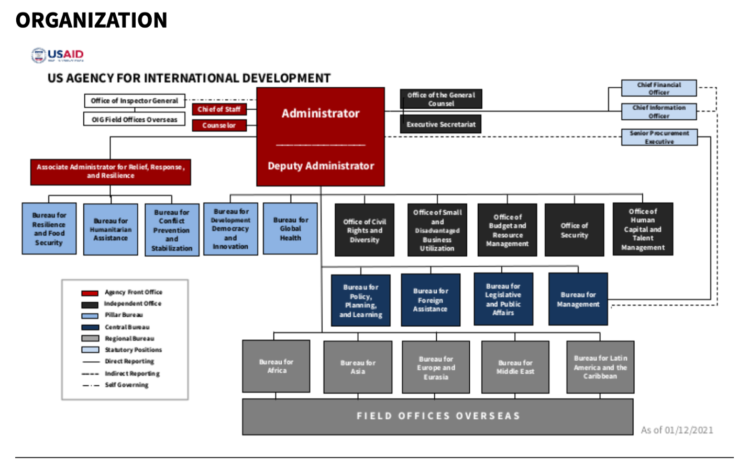

As an international organization with a broad and deep web of national and international stakeholders, sectors, nationalities, locations, cultures, vocabulary, and so on, USAID represents a cosmopolitan organization (Gready, 2013). While Gready (2013) explores an organization’s theory of change through a starting question of, “what change are we trying to achieve” (p. 1340), USAID often struggles with a challenge preceding this question, namely: “what is the problem that may need change.” Identifying the problem is a political, social, scientific, and pragmatic discussion; not surprisingly, therefore, USAID aligns its theory of change with dimensions of influence (Gready, 2013). Complex, multiple factors such as resource constraints, political actors, interagency and intra-agency relationships, prioritization, personalities, and others swirl in a mixed pot of environmental influences and influencers. As a complex, cosmopolitan organization, however, no single theory of change applies. For example, within USAID is the Office of Foreign Disaster Assistance (OFDA), recognized globally as a leader in responding to humanitarian crises. OFDA draws on its own theory of change in that it takes actions under a set of norms and laws rather than moving from evidence-based analysis to move “forward” with solutions to development and foreign assistance challenges, which is more reminiscent of how other parts of the Agency operate (Gready, 2013).
Janicijevic (2014) suggests the rational-empirical strategy and power-coercive strategy, that is, hierarchical cultures with great power distance, are common in government bureaucracies. While notably within the Agency a number of different strategies are evident, USAID’s culture among career staff tends to employ the normative-re-educative strategy. USAID staff are highly committed to their beliefs and values, which is reflected in their passion and commitment to the Agency’s mission. These values undergird and drive change, as Janicijevic (2013) points out, which is accomplished through relationships, mutual interactions, and leadership willing to gradually work within this value-driven, top-down/bottom-up culture (p. 6 - 7). This normative re-educative strategy is most closely held by seasoned staff, who are most familiar with not just the values and collective assumptions of the Agency but also most experienced and committed to the Agency’s mission.
However, the past Administration employed a highly acute power-coercive strategy. Power was reserved in the hands of very few actors, who generally were unavailable to the majority of staff, thereby signifying a high-power distance organization. This power was used as a tool and justification for decision-making, operations, assignments, and change mandates with staff expected to obey or resign. The clash of these two cultures, while mitigated by one or two exceptions, had a profound impact on morale and staff attrition. Further hampering the culture’s cohesiveness was the almost exclusive focus on “masculine” actions over more “feminine” being (Janicijevic, 2014)), whereas the working level culture was accustomed to incorporating both “being and doing” – interpreted as “why we do what do” and “results and metrics to show what we do.”
When looking at USAID as an “organization becoming,” the evolving historical shifts in practice and focus occurred in part because of changing political priorities, and in large part due the series of iterative conversations that effected new realities. This ability to reconfigure and adapt to environmental changes, new beliefs, and actions suggests the constancy of redefinition given the continual shifts in which humans are interacting (Tsoukas & Chia, 575). Maturana describes this process as the human process of continuous reflection on one’s self and behavior (Tsoukas & Chia, 574). USAID, despite the bulky nature of its bureaucratic self, continues to represent as an organization continuously changing with human action and reflection as its organization-self forms, patterns, emerges and shifts once again (Tsoukas & Chia, 577), which is how and why the Agency can adapt and cope with continually changing political leadership.
Using a different interpretative tool for organizational analysis, Itkin and Nagy (2014) point out that while metaphors can offer a simplified explanation of how an organization operates, learns, and is structured, the risk of this analogous tool is the possibility of shrouding the organizational reality (p. 38). Another risk is becoming too attached to a single metaphor and seeking to fit the organization to the metaphor rather than recognizing its limits in illuminating the inner workings of an organization. The Agency exemplifies these risks due to the varied metaphors that could arguably reflect the organization. For example, as a bureaucratic, federal government agency, USAID’s organization can be observed as a machine (Itkin & Nagy, 2014). Particularly at leadership levels, a strict hierarchy orders responsibility, tasks, and roles. Building efficiency in operations is under constant review, and these operations are captured in the machine-like virtual manual called the Automated Directive Systems (ADS), which articulates every policy, position, and structure in the Agency. Further, the Foreign Affairs Manual (FAM), clarifies the function of foreign service officers, including reporting structures, procedures at overseas posts, and the functioning of foreign affairs in the U.S. government. A structured clearance process ensures this hierarchy is consistently followed.
The machine analogy, however, while prevalent throughout the Agency, is incomplete. USAID is also a living organism (Itkin & Nagy, 2014), particularly in overseas Missions, due to the necessary adaptation necessary to changing environments. Problematically, balancing internal needs and environmental adaptability is frequently out of alignment (p. 41); overseas field offices, called “Missions” and situated as part of the Embassy community, are constrained in their adaptiveness by funding, political policy priorities, removed oversight (Washington), and host country priorities and concerns. As a result, incongruency between the management approach (hierarchical); decision making authority (mixed between the Mission’s leadership and Washington); strategic development (consistently at odds between the “on the ground” observed needs and the priorities dictated by Congress); and the working environment and desire of staff to “do what’s right” proliferate throughout the organization. This bucket of incongruencies is more acute in Washington among working level staff and middle management, who tend to observe a disconnect between political orders and the environment’s needs. As a result, most staff prefer to work in remote Missions in order to mitigate the felt incongruency.
Further complicating the Agency is the appropriate application of the brain metaphor in certain units of USAID (Itkin & Nagy, 2014). For example, within the Policy, Performance and Learning (PPL) Bureau is the “MEL” office, or Monitoring, Evaluation, and Learning, which is tasked to intentionally observe, ask questions, evaluate, learn and apply that learning to future tasks and initiatives. Transparency is encouraged, and offices are shown how to self-regulate and evolve as they learn from their own previous work and that of others. USAID therefore engages in single or double loop learning, that is, exploring how to improve performance and results within the existing metaphorical box, or to look at interventions outside of the box (Gready, 2013). Triple loop reflection – replacing the entire box – rarely, if ever, occurs given the bureaucratic restraints of this federal entity.
Finally, understanding the organization as a culture also applies to USAID, which is largely observed in political leadership (Itkin & Nagy, 2014). Multiple layers of culture exist within the Agency, which are shaped by the employees – their area of focus, their background, their time at the Agency, their political leanings, their level of focus on development, and a myriad of other personal and professional factors. At times the culture allows for the hierarchical nature to flatten, especially at the working or middle management level, which has the effect of emphasizing and conveying the collegiality, shared respect, and mission-focused personnel powering the culture. Most staff would describe the tenor of the Agency, that is, its core make-up or DNA, as one of “do-gooders” – a sense of ascribing to a higher purpose articulated through contributing to the world being a better place. At the same time, as part of the executive branch, USAID is led by a Presidential appointee with distinct biases. As those priorities are infused into the organization and executed, the culture of the organization is required at least nominally to align with political leadership and their reality constructed. For example, during the previous Administration, the culture shifted significantly to a top-down, centralized system with decreased trust and increased skepticism on the Agency’s purpose, practices, and policies. The organization’s public face sought to align with this new culture, but at a private cost of low morale, attrition, and decreased productivity.
When political influences on the culture of the organization are more limited, the call for change tends to be driven by career staff, who recognize when the alignment of “purpose and action” is not appropriately responding, is misaligned, with the internal and external environment (Gready, 2013). The resulting change tends to flow more deeply into the practice and culture of the organization. On the other hand, when political influences on the culture are high, political appointed staff and Administration leadership will decide when misalignment exists, articulate it as a problem, and then find solutions to address the problem. Such action does not tend to permeate the culture or practice of the organization. Said another way, the culture of USAID maintains both intrinsic and instrumental frameworks (Gready, 2013); when reform is instituted from outside the organization on problems identified for political means, the values, morals, and effectiveness of those reforms will not generally endure.
Improving or revamping USAID’s organizational structure has historically been under the purview of each new Administration. As a political entity, the structure of USAID pivots to reflect the priorities of that Administration while at the same time preserving its purpose as an international development and foreign assistance agency on behalf of the U.S. government. This at times dual purpose is accomplished by political leaders and working level political staff who are embedded throughout the organization to ensure continuity and adherence to the Administration’s values; these “politicals” work alongside or supervise career civil and foreign service employees. The only controlling lever to accept or defer structural changes by political leadership lies with Congress, which did occur in the last Administration when Congress refused to approve a couple of key structural changes proposed under President Trump. Career staff are not empowered to affect structural change, but they can guide and influence the narrative and conversations around the changes demanded. These conversations are interrelated with staff relationships and engagement, which are typically guided and influenced by individual personalities.
Therefore, the domain in which a theory of change can be affected is how those conversations are managed, facilitated, encouraged, and communicated. For example, in the previous Administration, a desire to centralize control of decision-making with regards to the Agency’s engagement with multilateral institutions led to a complex clearance process overseen by a single individual (a political appointee) and a series of lower level political appointees, largely unfamiliar with USAID or previous partnerships with multilaterals; career staff recommendations were largely dismissed. In order to preserve morale, the narrative developed among career staff focused on deflecting attention on the clearance process and more on the work accomplished with bilateral partners, a less controversial and controlled relationship. Private outlets to allow staff to express frustration also allowed some of the “steam” to be released to avoid further issues with attrition or requests for re-assignment.
My role currently sits in the Africa Bureau (AFR), which is one of five regional Bureaus in the Agency. As the Division Chief of Education and Youth for the sub-Saharan African continent, I oversee the largest portfolio in this sector for the Agency. One of my teams is responsible for a former Presidential Initiative called the Young African Leaders Initiative (YALI), which equips young people in Africa with leadership skills in the areas of public management, civic engagement, and business and entrepreneurial skills. In the past couple of years, some stakeholders engaged in YALI have raised concerns about the future sustainability of the initiative. Environmental factors – drops in funding, a mandate to be self-sufficient, time availability of key staff members, for example – were suggesting the current operational schema was no longer adequate.
However, the analysis and interpretations of the organizational structure of YALI have varied; depending on the stakeholder or staff member, multiple perspectives have developed, each of which was trying to “fit” their perspective into the accepted schema and corresponding definition for success. Leaning on definitions proposed by Gnyawali and Stewart (2003), this perception of equivocality has been compounded by changing Presidential Administrations, priority shifts, funding changes, Congressional interest, private sector engagement, and a host of other factors that weigh heavily on how this initiative might be understood as an organization (p. 68). As part of a government agency that emphasizes consensus and dialogue, the approach I’ve taken has been interactive, that is, continuous and lengthy dialogue and interaction among staff (Gnyawali & Stewart, 2003). This mode of learning began several months ago with a focus on identifying the challenges facing the organization, an effort which proved to be particularly difficult. Naming the problems meant reimagining the structure of the organization – a rewriting of the reality of YALI – which directly challenged long held beliefs about the ultimate goal of the initiative. As a result, the informational mode has been deployed as a way to objectify (i.e. depersonalize) the schema and structure and offer alternative processes and possibilities (Gnyawali & Stewart, 2003).
In future analysis, I will be examining the theory of change used in YALI and how this change both challenges the norms of USAID as well as allows for YALI to find its way forward.

References

Gnyawali, D. & Steward, A. (2003). A contingency perspective on organizational learning: Integrating environmental context, organizational learning processes, and types of learning. Management Learning. Sage Publications. 34 (1). 63-89. ISSN: 1350-5076.

Gready, P. (2013). Organizational theories of change in the era of organizational cosmopolitanism: lessons from ActionAid’s human rights-based approach. Third World Quarterly. 34 (8). 1339-1360. DOI: 10.1080/01436597.2013.831535

Itkin, H. & Nagy, M. (2014). Theoretical and practical use of metaphors in organizational development and beyond. Pannon Management Review. 3 (4). 37-71.

Janicijevic, N. (2014). The role of national culture in choosing a change strategy in organizations. Economic Horizons. 16 (1). 3-15. DOI: 10.5937/ekonhor1401003J

Tsoukas, H. & Chia, R. (2002). On organizational becoming: Rethinking organizational change. Organization Science. 13 (5). 567-582. ISSN: 1526-5455.

USAID (n.d). Accessed www.usaid.gov on February 12, 2021.

