Season’s Greetings to my fellow Nebraska Women of Today members-Wishing you peace, love and laughter this holiday season,

It was great to see fourteen members from across Nebraska (members from five of six chapters) attend the Fall Conference held on November 2, 2024 in Nebraska City. The Nebraska City Chapter members, Joyce, Christine and Laura did a great job hosting the conference this year.

At the conference Maxine Turner of Fremont Area was recognized for First Trimester Outstanding Newsletter and Joyce Harpster of Nebraska City was recognized as Outstanding Chapter Contact for First Trimester. Congratulations!! Heartland, Nebraska City, Fremont Area, Kearney and Lincoln Chapters all received incentives for answering the challenge to send in their newsletters. Linda Lenser and Joyce Harpster were also recognized for submitting Secretary Fast Starts for first Trimester. Please continue to send me your meeting minutes and Chapter newsletters. This contact helps keep me informed about the activities of individual chapters. I have included on the website helpful pointers to assist in producing effective meeting minutes and successful newsletters. These were provided by Mary Hansen, USWT Secretary.

Please send me any press releases (including Facebook, other social media or Website posts) that your Chapter does to promote your local Chapter’s activities. An “active” chapter portrays a positive image of NWT members being involved in the community. This can be valuable in stimulating interest and an effective recruitment tool in growing your membership.

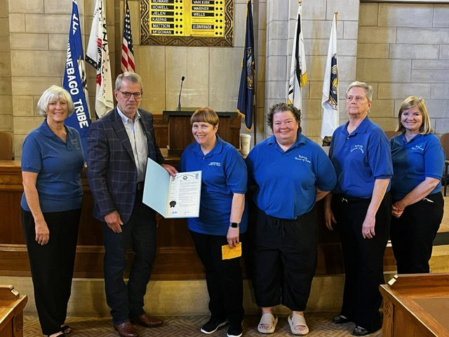

The official ceremony for the Governor’s Proclamation of Women of Today Week was held at the State Capitol on September 25. Cindy, Hillari, Maxine and Terri attended. After reading the Women of Today Week Proclamation, Governor Jim Pillen was very gracious shaking our hands and posing for a photograph with our group. There were eighteen other groups recognized that day for performing amazing work in our state.

Make A Difference Day was on the fourth Saturday of October. If your chapter participated in an activity to recognize this day, please submit photos with a description of what your chapter did to celebrate. (There will additional recognition for Chapter efforts at Annual.)

National Volunteer Week in 2025 will be from April 20-April 26, 2025. The theme for NVW is to celebrate service and highlight the volunteers. NVW is a time to recognize the impact of volunteers and their ability to address society's challenges, build stronger communities, and transform the world. Volunteers contribute their time, skills, and empathy to create real change in the lives of others. I encourage each Chapter to celebrate National Volunteer Week by recognizing and thanking volunteers who lend their time, talent and voice to making a difference in their communities. If your chapter participated, please submit photos with a description of how your chapter celebrated Volunteer Week.

For the third trimester USWT Shout out with Pubic Relations recognizes chapter public relation activity during Volunteer Week. Chapters are encouraged to complete the form online or email a downloaded form to USWT Public Relations Director, no later than May 5 for the third trimester. **CHALLENGE**-Submit the form by April 1 deadline for recognition at ANNUAL.

A Fast Start for Secretaries for the third trimester will be posted under Secretary on the NWT website. Please complete the Fast Start for third trimester and submit to me via email by April 1 for recognition at Annual.

Thank you for the opportunity to serve,

Nicolette Amundson, State Secretary

*Please send all correspondence and submissions to*

[nicolette.amundson@gmail.com](mailto:nicolette.amundson@gmail.com)