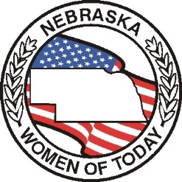

# THE GAVEL

**Newsletter of**

**The Nebraska Women of Today**

November 2024

[www.newomenoftoday.org](http://www.newomenoftoday.org) [www.uswomenoftoday.org](http://www.uswomenoftoday.org)

Fellow Members (Extended Family)

Our Emphasis for the month of November is Family Week and Aid to Foster Children.

These two programs go together here in Nebraska.

I thought about the definition of the word family, as I sat down to write my article for this issue. So, I did a search on my computer and the following definition came up: “a group of one or more parents and their children living together as a unit: "the family lived in a large house with a lot of land" · "the family home"

While I was doing some research, I came across a totally different direction of the meaning, “family doesn’t always have to be biological, or by marriage. Many people consider their close friends as family members, because they care for them as they care about their own family. Others may consider coworkers, community members, or other group members they are affiliated with to be an extension of their family. Family can be whomever you choose to call family, whether you are related or not”.

**There’s No Such Thing As “Normal”**

Now more than ever before, it is important for people to understand that when it comes to what is a family, there is no such thing as normal. Every person, every child, every parent, every couple has a unique situation, and to try and define everyone in one black and white term would make no sense.

Family is not defined by biology, or marriage, or even a home. Family is the people you love and who love you back, the people you feel safe around, and the people you can count on to be there when you need them.

As I stated when I started this article that Family Week and Aid to Foster Children do go together. I know many of our members have extended their family with their fellow members. We also have included the children from the “Foster Care Closet” and “Nebraska Families Children Camp Catch-Up” as part of our family our chapters educate and donate money each year to help these children.

Some of our chapters plan activities each day of Family Week which will be celebrated November 24 through November 30th this year. We also have a chapter that celebrates Friendsgiving with their chapter members.

So, at this time I would like to send a “Happy Thanksgiving” to my extended family.

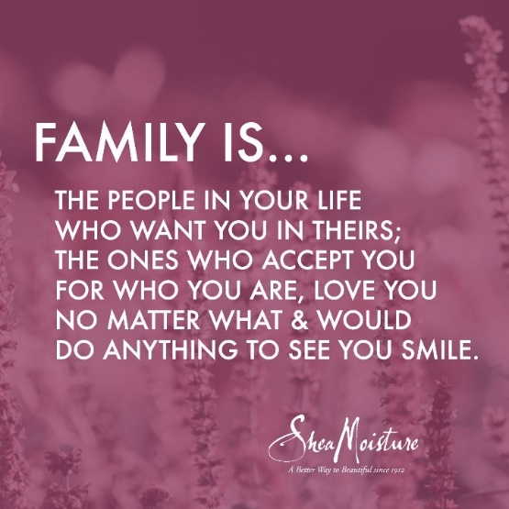

*Cherish Our Dreams*

Maxine Turner, President

‘Cherish Our Dreams’

[Maxine.turner.3@outlook.com](mailto:Maxine.turner.3@outlook.com)

***Chaplain’s Thought***

***“A goal is a dream with a deadline.”***

------ Napoleon Hill

Chairman of the Board

I will be working on the 2025-26 board in the coming six months. So, please think about a position you might be interested in, and ask me any questions you may have. From filing, to duties, etc. Filing deadline for Executive positions is February 15th. The following are Executive positions: President, Membership VP. Programming VP, Secretary and Treasurer. The filing deadline for Appointed positions is March 1st. The only two positions for this area are: Parliamentarian and Personal Development/Chaplain.

The filing form can be found here: chrome-extension://efaidnbmnnnibpcajpcglclefindmkaj/https://img1.wsimg.com/blobby/go/43396ad3-c359-47dd-8485-5f4a159571c1/downloads/NWOT%20Elections%20%26%20Credentials%20Filing%20Form%20(3).pdf?ver=1729733800378

If you have any questions, please feel free to contact me anytime.

We are Better Together!

# Shellie Haun, Chairman of the Board

# *‘Better together’* [COB@NEwomenoftoday.org](mailto:COB@NEwomenoftoday.org)

Membership

Hello Nebraska Women of Today!

I hope you all got to celebrate Women of Today Week in September. We are a great group that needs to be celebrated! ☺

Every month has different topics of Emphasis. For November we have Parliamentarian (National), Family Week and Aid to Foster Children (Nebraska). Looking ahead to December we have Membership, Community Connections (National) and Chaplain (Nebraska). Please make sure to put these on your meeting agendas to discuss and plan.

Membership is critical for our group. In the last 10 years we have lost a lot of members. Does everyone have flyers or business cards that they can hand out to promote our group? If you meet in a public place can you put up a banner?

In business, exit interviews are do

ne to see why people leave a company. Are we doing this with members who leave? I think it’s easy for us (myself included) to get in a rut and do the same things over and over, year after year. Do we need to change to attract more people? Maybe asking why people leave will give us some insight. In fact, maybe we need to do a survey with our current members to see what they like and don’t like so we can make changes if needed. Just a thought………

Enjoy this beautiful fall we are having. Have a wonderful Thanksgiving, I am thankful for all of you and what you do to help your communities!

Also, don’t forget 2nd Trimester dues! December 1st is the deadline to have your check in to Terri and the dues billing sheet email to me. However, the early bird deadline is November 15th. You will receive a treat if you get them in by the 15th.

Kim Hermann, Membership Vice President

‘Join Us in Making A Difference!’

[mvpstep@newomenoftoday.org](mailto:mvpstep@newomenoftoday.org)

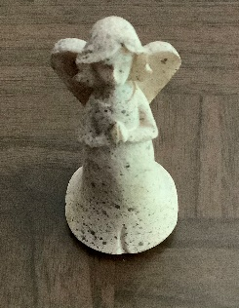Prayer Corner

***Please keep Cindy Urlacher and her family in your prayers.***

Chaplain/Personal Enrichment

Nebraska Women of Today:

Family Week is November 24-30, 2024. The Family Week certification form is on my page of the website. If your chapter participates in Family Week be sure and fill that out and send it to me. The form says that the deadlines is April 1st but fill it out and send it to me as soon as you have the form completed so you don’t forget.

Be sure and check to see if you are able to complete the Wellness/PD form. If you need the form, be sure and let me know. It is also on the website and you will be able to fill out the form on the US Women of Today web page.

I am offering a 2nd Trimester Fast Start and this will be due on December 1st. It is available on my web page.

The Nebraska Women of Today prayer chain is available. If you have a prayer chain request – please let me know. I will also have a “prayer corner” in each issue of the Gavel if you would like me to add a prayer request.

There will be a Leadership ZOOM on November 7th at 7:00 p.m. and on December 12th at 7:00 p.m. there will be a ZOOM training on Stress.

Til next time, keep chosing joy!

Joyce Harpster, Chaplain / Personal Development

*‘Choosing Joy!’*

chaplain@NEwomenoftoday.org

Parliamentarian

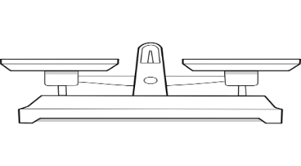As Nebraska Women of Today members, we use motions to govern our meetings; change our constitution, bylaws, and standing rules; or just conduct business. It is important to know how to make a motion, and how that process works.

* Any member in good standing can make and discuss a motion. Non-official members or guest are not able to make a formal motion. Refer to the United States Women of Today by-laws for clear definition of what a member in good standing is.
* A motion begins with the words “I move”.
* All motions should be kept in the positive. Motions should be made for items that will result in a positive action being taken.
* Only one subject should be discussed at a time. The topic of the motion should be what members are voting on. If the motion needs to be amended, you will need a new motion to amend the original motion. The amendment will need to be voted on before the original motion.
* The person presiding over the meeting will read the motion back to the members stating, “We have a motion and a second on the floor that reads….” After reading the motion, the chair will ask if there is any discussion.
* Motions should be discussed. When a second is made it does not mean that you agree with the motion being made, just that there is a request for discussion.
* Only one person may speak at a time. Members should take turns speaking for or against the motion being discussed. The member making the motions is the first to speak once the person presiding over the meeting calls for discussion.
* After the discussion seems to be done, the person presiding over the meeting will ask one time “Is there any more discussion?”
* When a call to vote, in favor, “vote yes”, if opposed “vote no”. is made by the person presiding over the meeting, the majority will determine if the motion will be approved of denied.

When we utilize and make motions effectively, our organization gets stronger. Knowing how to make a motion makes the organization move smoothly and ensures that everyone’s voice can be heard.

Hillari Zweibohmer, Programming Vice President

[PARLI@NEwomenoftoday.org](mailto:PARLI@NEwomenoftoday.org)

Programming

Hello Members,

I cannot believe that we are getting into the holidays, and I know all chapters will be active in your communities. Please fill out your community connections report and send to me and I will forward to my National counterpart Lisa Haun.

I know there are many members traveling this year to other chapters and to the conventions. Remember we have the Road Runner Miles form to be filled out and at year end we give an award to the highest road runner for chapter member and for a state member. Who will it be.

Also do not forget about OW award, which is due to me on March 1st. The information is on the website under the State Programming Vice President, if needing assistance please reach out to me.

Today’s youth can be in any chapter if you have a child that is helping with your chapters or assisting in the community, please let me know so that your youths can be recognized.

Emphasis month for December is Community Connections. everyone who fills out their community connections report during emphasis month will receive a special incentive.

I would like to visit chapters, please invite me and I would be happy to do a program or whatever you need in the programming area.

If you are needing anything please reach out to me by phone, text or email I would love to hear from you.

Cindy Urlacher, Programming Vice President

[PVP@NEwomenoftoday.org](mailto:PVP@NEwomenoftoday.org)

‘Making a Difference in Programming’

CHANGE IN REGISTRAR FOR ANNUAL

Registration for Annual Convention should be sent to Maxine Turner instead of Terri Sherman. Terri will be out of the state when these will be coming in so Maxine has agreed to receive them.

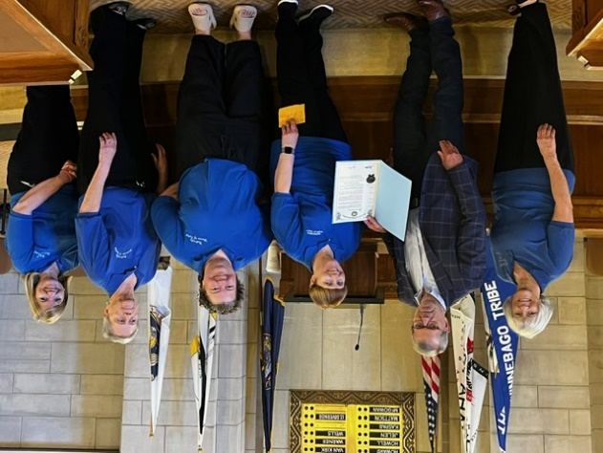Treasurer / Domestic Violence

[](javascript:%20void(0))October Emphasis Month has Domestic Violence program listed. Please have it on your agenda for Septebmer and make a plans for a speaker or maybe hold a fundraiser for a shelter in your community. If nothing else you may use the document that I have on my web page and copy and hand out at your meeting.

**Domestic violence** is a pattern of abusive behavior in any relationship that is used by one partner to

gain or maintain control over another intimate partner. It is the willful intimidation, physical assault,

battery, sexual assault, and/or other abusive behavior as part of a systematic pattern of power and

control perpetrated by one intimate partner against another. Domestic violence is when one person

behaves in a way that controls or dominates another person and causes fear for their safety and

wellbeing. It can occur between partners, relatives, and even divorcees and ex-partners. Domestic

violence can take many forms, including emotional, sexual and physical abuse and threats of abuse.

Domestic violence symptoms can include

• Feeling scared, anxious, isolated, or low self-confidence

• Having trouble sleeping or concentrating

* Being called names, insulted, or put down by your partner

• Being prevented or discouraged from working, studying, or seeing friends or family

• Being controlled or monitored by your partner in terms of money, activities, medicine, or clothing

• Being threatened, hit, or forced to have sex by your partner

• Seeing signs of jealousy, possessiveness, unpredictability, or bad temper in your partner

Terri Sherman, Treasurer

‘As Good as Gold’

[Treasurer@NEwomenoftoday.org](mailto:Treasurer@NEwomenoftoday.org)

Secretary

Greetings Nebraska Women of Today:

I am encouraging all Chapter secretaries to complete the second trimester Fast Start which has been posted on the website. Fast Start is due via e-mail by December 1, 2024 (the start of third trimester).

The official ceremony for the Governor’s Proclamation of Women of Today Week was held at the State Capitol on September 25. Cindy, Hillari, Maxine and Terri attended. After reading the Women of Today Week Proclamation, Governor Jim Pillen was very gracious shaking our hands and posing for a photograph with our group. There were eighteen other groups recognized that day for performing amazing work in our state.

I hope to see you all at the Fall Conference on November 2, 2024 in Nebraska City. I will email a Press release for the Fall Conference to Chapter Presidents after the conference. Please complete the press release and submit to your local media for publication

**Make A Difference Day** will be on the fourth Saturday of October, which is October 26 this year. If your chapter participates, please submit photos with a description of how your chapter celebrated Make a Difference Day! Your Chapter can also receive national recognition for your effort on Make a Difference Day by completing and submitting the Shout Out With Public Relations form that is found on the USWT website.

My appreciation goes to the newsletter editors for sending me their Chapter newsletters.

This contact helps keep me informed about the activities of individual chapters.

# Thank you for the opportunity to serve.

# Nicolette Amundson, Secretary

# *‘Communication’*

[secretary@NEwomenoftoday.org](mailto:secretary@NEwomenoftoday.org)

State Program –

Sex Trafficking Awareness

My fellow members,

Please look for my Fast Start and letter on the website for the next trimester.

I want to highlight what I have done so far this year: first trimester your chapter president received flyers that you can use to take to hotels when talking to managers; second trimester mailing, your chapter president received a brochure that you also can hand out when visiting the hotels in your community. Currently, I am working on brochures in Spanish to help with the hotel training.

In 2010 President Barack Obama designated**January** as National Human Trafficking Prevention Month. It was established with the intention of re-dedicating us to preventing and ending human trafficking.

National Human Trafficking Awareness Day is recognized each year on January 11th. In recognition of this important day, Blue Campaign hosts a social media campaign called #WearBlueDay. To raise awareness of human trafficking, they ask people to take photos of themselves, friends, family, and colleagues wearing blue clothing and share them on social media, along with our #WearBlueDay hashtag.

So, I hope each chapter will take their chapter photo wearing blue and post it on their Facebook page as well as hash tag.

Mariah Swanson, Program Manager

# *‘Enough is Enough’*

CHAPTER CHATTER

**Lincoln**

Kim Herman, President

**Fremont**

These past two months, our chapter has been quite busy. In the month of September celebrated Women of Today Week, with an item on the agenda for each day of the week. We ended the week by serving lunch to eighteen volunteers with Habitat for Humanity. In the month of October, we hosted U S Mid-year Meeting with Lincoln Women of Today. It was great to see two chapters work together as a team; our members should be proud of themselves. We had members in the front and members in the back working together as one. Fremont Area ended the month with two projects, we delivered cookies to Fremont Fire Department for Make-A-Difference Day. We also delivered personal hgiene items to “The Bridge” for Domestic Violence Awareness month.

**Heartland**

The Heartland Chapter began celebrating Women of Today Week by going through our closets collecting clothing to donate to Women Center for Advancement on Monday. On Tuesday several chapter members had great fun socializing as they met for dinner at Beacon Hill restaurant. Friday we got together for an M Night at Lansky’s for pizza and fun playing games. For Make a Difference Day this year we will be taking treats to the volunteers at the Habitat for Humanity Restore.

Nicolette Amundson

For Julie Fogelman

**On the road to a new journey**

Heartland Chapter President

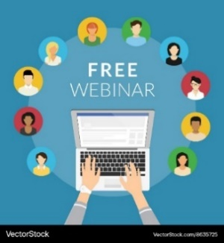

Maxine would like to invite you to the next webinar to be held on November 7th @ 7 pm, our topic is **LEADERSHIP**.

Beginning next week you will be able to find the US Women of Today newsletter on our website. We will publish it there a few days after it comes out.