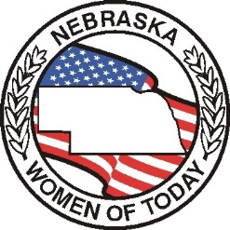

# THE GAVEL

**Newsletter of**

**The Nebraska Women of Today**

July 2024

[www.newomenoftoday.org](http://www.newomenoftoday.org) [www.uswomenoftoday.org](http://www.uswomenoftoday.org)

In my last Gavel article, I had asked Chapter Presidents, Chapters to complete a Plan of Action for 2024-2025 year. I have received the State Board Members Plan of Actions. I am looking forward to receiving the Chapter Presidents and Chapters Plan of Action.

The reason I had asked each chapter president to send me their plan of action and their chapter plan of action. As, I would like your state officers to help your chapter president and chapters to achieve their goals.

So, if I have not received these, please send them to me as soon as possible. I plan on sharing these with your state officers.

Your chapter presidents have received two-**chapter newsletters** from me so far this year. I hope they are sharing these with you.

Our webmaster was trying to set up email addresses for our state officers back in May through Google. At this time our website crashed. So, at our Board Retreat it was decided to go with Go Daddy for our website. Please give the webmaster time to rebuild the website.

If your chapter has a Facebook or chapter website, please send the **link** to our Webmaster. They will be able to set it up so that a visitor can link to a chapter from our state website.

Don’t forget the date **August 1st**! Be sure to have all certifications into the appropriate state officers by this date. If you need any forms off the website, please contact me and I will send it out to you.

**US Women of Today Mid-year** is going to be held in Omaha, Nebraska October 11-12, 2024. Your chapter presidents have received the registration forms in their chapter newsletter. If you have never been to a Mid-year meeting or convention, it is time for you to go since it is in your backyard. Thank you to Fremont Area and Lincoln chapters for hosting this meeting.

Don’t forget to mark November 2nd on your calendar for the **Fall Conference** in Nebraska City. This registration form was also included in your chapter president’s newsletter.

Maxine Turner, President

*Cherish Our Dreams*

‘Cherish Our Dreams’

[Maxine.turner.3@outlook.com](mailto:Maxine.turner.3@outlook.com)

Membership

Hello Nebraska Women of Today!

I hope your 1st Trimester is going well. I have exciting news to share……….the Kearney chapter signed a new member in May! Please welcome Melissa McCartney-Cline to our group! Thank you to Eileen Rainey who recruited Melissa! Don’t forget to have Melissa start working on S.T.E.P. 1 so she gets involved right away. ☺

Speaking of recruiting…….how many of you have had a guest/membership event? Obviously you can always invite guests to a regular meeting but having something special planned is always fun. The USWT website has lots of ideas for Membership. Click on the Awards & Resources tab on the home page, then scroll down to Membership Resources, then Membership Events and Membership Games & Ideas.

The deadline for Membership dues is coming soon, don’t forget! Please send the completed dues worksheet to me via email and the check for renewals gets sent to Terri Sherman. The deadline is August 1st but if you have everything to Terri and myself by **July 15th** you will get a “reward” at fall conference. If you have any questions about dues, please give me a call or send me an email. My contact info is: 402.499.2279 or [kahermann61@gmail.com](mailto:kahermann61@gmail.com)

Founders Day is July 1st, I hope you are all celebrating our special day!

Thanks for all you do!

Kim Hermann, Membership Vice President

‘Join Us in Making A Difference!’

[mvpstep@newomenoftoday.org](mailto:mvpstep@newomenoftoday.org)

***Chaplain’s Thought***

Happiness is not in our circumstances but in ourselves.

It is not something we see, like a rainbow, or feel, like the heat of a fire.

Happiness is something we are.

------ John D. Sheerin

Chaplain/Personal Enrichment

Nebraska Women of Today:

The first trimester is flying by. I hope that all of have had the opportunity to check out my Fast Start. If you are a chapter chaplain or Personal Development Program manager please let me know if I need to send it to you. It is due to me August 1st.

Effective Speaking/Writing:

The topic for Fall Conference is “What brings me joy”. Your submission along with $5 needs to be postmarked to me by October 1st.

Prayer Chain:

If you have a prayer chain request – please let me know. I will also have a “prayer corner” in each issue of the Gavel if you would like me to add a prayer request.

Wellness/PD form:

The new form is out but is not yet on the website. I have attached it to this issue of the Gavel.



I am so excited to be serving in this position this year and the best part is that along with Cindy Urlacher as Nebraska’s Programming VP – our own Shellie Haun is serving as our National Wellness and Personal Development Program Manager!!

Keep chosing joy!

Joyce Harpster, Chaplain / Personal Development

*‘Choosing Joy!’*

chaplain@NEwomenoftoday.org

Treasurer / Domestic Violence

I am getting this GAVEL issue out in time for all the chapters to send in their affilitation fees. They are due July 1st.

**Chapter Affiliation fee of $15** is due by July 1st.

Happy Founders Day – I hope each chapter takes some time to remember why we starting this great organization. Have some fun with it. Maybe a girls night out.

I am planning to hold a fall fundraiser. So be sure to watch for details regarding this.

A reminder if you haven’t filed your 990’s you should get them filed.

I hope you are making plans to hold a Domestic Violence program in your chapter. Maybe a speaker or hold a fundraiser for a shelter in your community.

Terri Sherman, Treasurer

‘As Good as Gold’

[Treasurer@NEwomenoftoday.org](mailto:Treasurer@NEwomenoftoday.org)

Parliamentarian

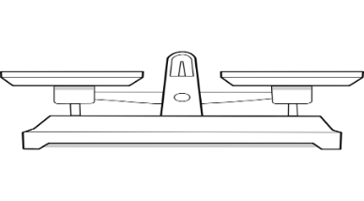Dear Members,

I have extended the Parliamentarian trimester challenge since the Website was down. The due date for the challenge will be December 1st. Go ahead and email it to me whenever you get the chance.

The discussion for this article is about a “Point of Order”. Does anyone know what a “Point of Order” is? It is defined as:

* ***A Point of Order is a powerful demand from a single member that can highlight violations of an organization’s rules.***
* ***It calls upon the chair for a ruling and enforcement of regular rules.***

Under *Robert’s Rules*, a Point of Order can be raised by a single member and is sometimes referred to as “raising a question of order.” A member raises a Point of Order when he/she believes a rule (including provisions in the Bylaws) is being broken. It has the following characteristics (RONR, 11th ed., pages 247-251):

1. A Point of Order can be made by a single member–no second is required.
2. A Point of Order can be made while most motions are pending. However, it yields to “privileged” motions like taking a recess or adjourning a meeting.
3. A Point of Order can interrupt a speaker while someone else has the floor.
4. Generally, no vote is taken on a Point of Order. Rather, the Chair makes a ruling
5. A Point of Order is generally not debatable. However, the Chair can allow members to weigh in before making a ruling.
6. A Point of Order must be raised promptly when the breach occurs.

**How to Make a Point of Order**

Raising a Point of Order is very easy! After getting the Chair’s attention, you simply state which rule you think is being broken, and then you wait for a ruling from the Chair. If you disagree with the Chair’s ruling, you can appeal it; thus, allowing the assembly to decide on the matter.

**Step 1: Getting the Chair’s Attention**

To make a Point of Order, a member can either seek recognition from the Chair, or yell out one of the following:

* “Point of Order!”
* “I’d like to raise a point of order.”
* “Mr. Chairman, I have a point of order.”
* “I raise a question of order.”

**Step 2: State the Rule that is being Broken**

Next, the Chair should pause the current proceedings and ask the member which rule he/she thinks is being broken.

* “This motion violates our Bylaws. According to Article X, Section 1 we are supposed to vote on the budget at the May meeting, not the April meeting.”
* “We shouldn’t be debating this motion. It did not receive a second.”

**Step 3: The Chair Rules on the Point of Order**

Finally, the Chair rules on whether the Point of Order is well taken or not well taken and announces any corrective action. The Chair is permitted to allow members to weigh in if it would be helpful in deciding. This is also a good time for the Chair to consult a [Parliamentarian](https://lastminutemeetings.net/services/meeting-parliamentarian/) if one is present. If a member disagrees with the Chair’s ruling, he/she can appeal it to the assembly for a vote.

* Chair: “The point is well taken. The assembly cannot consider the annual budget at this meeting. The motion will be withdrawn at this time.”
* Chair: “The point is not well taken. Under *Robert’s Rules of Order*, points of order must be timely. We have already had substantial debate on this motion, so it is too late to raise an objection that the motion did not receive a second.”

Please take a few minutes to read through proposed changes to the by-laws and standing rules at our November conference. I wanted to make sure to meet 45-day deadline for those items that need to be presented according to By-Law 12. I decided to provide all of them, so people have adequate time to familiarize themselves with the upcoming pending changes.

Regards,

Hillari Zweibohmer, Programming Vice President

[PARLI@NEwomenoftoday.org](mailto:PARLI@NEwomenoftoday.org)

‘Balancing Procedures of Life’

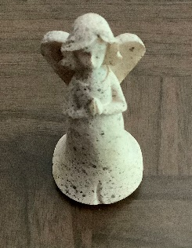Prayer Corner

***Continued prayers for the Fogleman family.***

***Please keep Spencer Iowa in your prayers. Iowa WT has a chapter there.***

Programming

Hello Chapter members,

I am so excited on being your State Programming Vice President this year. My theme is Making a Difference in Programming. The logo is two hands holding a heart. The reason I picked my theme is I would like all chapters to participate in the programming area and I will be certifying in all areas of the programming. I am keeping myself accountable and I always have that saying lead by example.

Maxine has asked us to be creative this year. I will be having zoom meetings each trimester with each of the chapters Programming vice Presidents and would like to Brainstorm on ideas. I need your help on what we can do to be effective in your chapters.

I will share my goals with you so that you can keep me accountable. My number one goal this year is communication. I am going to communicate to all the chapters and get your input on what we need to do with the programming area in your chapters.

I will be promoting emphasis month and will be doing zoom calls on those areas so that everyone can attend and certify.

All chapter Presidents were sent the Governmental Affairs, Community Connections Reports, and the Road Runner Forms, so please share with your members. If any members needing help with the forms, please reach out to me and I would be happy to assist.

Do not forget to fill out my fast start for first trimester. You will be recognized at Fall Conference.

Also Please watch for upcoming zoom meetings looking forward working with all of you and meeting new members. The first will be on August 21st. Watch for details.

I can be reached by phone, texts, and emails. You can call me in the evening after 7pm



Cindy Urlacher, Programming Vice President

[PVP@NEwomenoftoday.org](mailto:PVP@NEwomenoftoday.org)

‘Making a Difference in Programming’

Chairman of the Board

Well the summer is in full swing, and hot as ever! For me, June has always been my favorite summer month, because it was always cooler, the greenery was getting lush, and my family began sinking in to the feel and schedule of summer. Lows in the 60’s and highs in the 80’s. Perfect! Unfortunately, this year, we’re already in the 90’s.

In June, we had 10 Nebraska members attend the USWT Annual Convention in Des Moines. This was my first time attending Annual, and was eye opening for me. I had no idea there were so many committees, and who all sits on these, and what they involve. I sat in all ALL committee meetings that were open for me to attend and learned a lot, to say the least! During this convention, a new Wellness & Personal Development Certification form was presented and approved. If you normally certify in WPD, or are finding it’s difficult to every year, you’ll be happy to know that new areas were added, making it much easier to certify annually. I believe Joyce is attaching the new form to the Gavel this month.

July and August emphasis months are Membership, Project Recognition and Domestic Violence Awareness. Summer is a great time to have a membership night. There’s lots of things you can do, and places to meet that are outdoors and active. Kim Hermann would be happy to help with any ideas on membership nights. Project Recognition involves turning in a project folder for a project your chapter worked on. Cindy Urlacher is really wanting to receive these, and hold a competition at Fall Conference. Let’s start bragging about ourselves! Your successful projects can be replicated throughout our state, which helps every chapter be successful, and likely bring something new to their area. Check Terri Sherman’s article for a Domestic Violence Awareness challenge, and stay involved!

Be on the lookout for Inter-Chapter events coming up. Invitations will likely be emailed to chapter Presidents, as well as posted on Facebook. Come join the fun!

If you have any questions, please feel free to contact me anytime. Thank you for all you do!

We are Better Together!

# Shellie Haun, Chairman of the Board

# *‘Better together’* [COB@NEwomenoftoday.org](mailto:COB@NEwomenoftoday.org)

Secretary

Greetings Nebraska Women of Today:

I hope every Chapter secretary participates in the first trimester Fast Start. This was included in the Chapter Packet that was emailed to your Chapter President. Please submit the Fast Start via email to me by August 1, 2024 (the start of second trimester).

Minutes from the State Annual Convention in April 2024 will be posted on the website once the website issues have been resolved. If you would need minutes prior to posting I will email pdf of minutes on request.

Public Relations promotes communication and good will between Nebraska Women of Today and the public and serves to build a bridge to potential new members. We have two upcoming significant public relations events for Women of Today, which are Founder’s Day celebrated on July 1 and Friendship Day celebrated on Sunday August 4, 2024. I encourage Chapters to organize events for these special days recognized by our group and submit “Shout Out with Public Relations Form” to USWT by September 1, 2024 for acknowledgement by USWT mid year convention. Founder’s Day Certification and Friendship Day certification can be submitted online and can be found on USWT website under membership resources. I would appreciate if you copy me on these submissions.

I have submitted a request to the office of Nebraska Governor, Jim Pillen, to recognize the many activities of the dedicated Women of Today in Nebraska by proclaiming the week of September 22-28, 2024 as Women of Today Week. The signing ceremony would be at 9:00 AM on September 10, 2024 (this could change). We can invite as many as 15 to attend the ceremony. It would be great if each Nebraska chapter could send a representative. I would appreciate it if Chapters would let me know by no later than July 25 if a representative will attend and their name and contact info. Also please let me know if you would like to invite any state senators or elected officials or dignitaries, as I also would need to include them as well.

I look forward to being informed about the activities of individual chapters and reviewing your Chapter public relations efforts. I would appreciate if Chapters would send your Newsletters to me as well as links to your Facebook page and website. Each trimester I will recognize the best effort in each category.

Wishing you all a wonderful summer!

“Rise above the storm and you will find sunshine”

Mario Fernandez

# Nicolette Amundson, Secretary

# *‘Communication’*

[secretary@NEwomenoftoday.org](mailto:secretary@NEwomenoftoday.org)

State Program –

Sex Trafficking Awareness

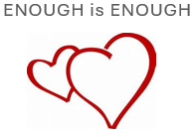Among the states in the Midwest, **Nebraska** has one of the highest rates of sex trafficking. The sex trafficking enterprise operates underground, which makes it difficult to quantify the number of victims with accuracy. However, it is estimated that every month there are around 984 individuals in Nebraska who are sold for sex.

The first paragraph tells how important that this program is for us to cut down Sex Trafficking in our state. A year ago, our organization was told to Educate, Educate, Educate about this program.

I hope every chapter uses the signage that I had put in the first trimester chapter packet. Remember, this is a very easy project to do. Just make a copy of the sign and take it to the hotels in your community. You just need to tell the front desk to give it to their manager. I would suggest doing this every trimester or at least every six months.

Looking ahead, January is Sex Trafficking Awareness Emphasis Month. If you have any idea what we could do as a state, please feel free to contact me through email. During this month I would like our organization to make an impact in our communities.

Mariah Swanson, Program Manager

# *‘Enough is Enough’*

Hall of Fame

The Nebraska Women of Today Hall of Fame’s main purpose is to recognize and honor members who have served Nebraska Women of Today in an outstanding manner. It’s the highest honor given to Nebraska Women of Today members.

All honorees are life members of the Nebraska Women of Today Hall of Fame.

Elected officers are President and Secretary/Treasurer. There is also a screening committee that goes over all nominated candidates.

Funds are raised with dues as well as Lucky Number drawings at each state meeting. This is where we sell numbers for $1 each (or more if there is more than one member wanting one or more particular numbers. ☺) With that money some of the things Hall of Fame support are; Awards for the competitors in STEP, help with the travel expenses for the State President or her representative to the National Annual Convention, the registration for the National President when she visits our state, plus $100 for her travel and other requests from the Nebraska Women of Today are considered.

Nebraska Women of Today Hall of Fame will always support the future success of Nebraska Women of Today.

Angela Moody, Hall of Fame President

CHAPTER CHATTER

**Lincoln**

The Lincoln chapter held their year end banquet and installation of new officers in April. In May we did our annual Mother’s Day project which was putting together bags full of goodies for the ladies at the City Mission. In June we played Bingo with the residents at Ambassador Health facility. Also, at our June meeting Shellie handed out awards from national convention and Terri had us do an Impromptu Speaking exercise. We are looking forward to celebrating Founder’s Day in July! Have a great holiday!

Kim Herman, President

**Fremont**

In the month of June, we sent Dunklau Garden ninety ( 90) “Thinking of You” cards for the residents to let them know that they are not forgotten.

Our chapter is busy purchasing merchandise for John C Fremont Days concession stand in July.

**Nebraska City**

The Nebraska City chapter recently provided cookies for our local Volunteer firefighters for their monthly meeting in observance of a belated Volunteer Week activity.  They had enough for the meeting as well as a couple activities during the rest of the week!

**Heartland**

The Heartland Chapter will be celebrating **M Night** at Blondo Bingo located at 8061 Blondo Street on Wednesday, July 17, 2024. (Doors open 5:00 PM-Games start 6:30 PM-$15 for Beginner Packet) All Nebraska Chapter members are invited. Please **BRING A GUEST** if you know anyone who is interested in finding more about Women of Today. Refreshments will be available for purchase or you may bring your own. But NO ALCOHOL, please. RSVP by email (nicolette.amundson@gmail.com) if you will be coming and number in your party by July 10.

Heartland was well represented at the US Women of Today National Year End Convention in Des Moines with Julie Fogleman, Cindy Urlacher, Madeline McCrae, and Nicolette Amundson attending. Cindy Urlacher received a President Volunteer Service Award for Lifetime Achievement. And Julie Fogleman was recognized as an Ambassador of US Women of Today.

Heartland will be joining Lincoln at the “Founder’s Day” event held at Mahoney Park.

Hillari Zweibohmer chaired the Water Drive in June for Open Door Mission.

Hope everyone is enjoying his or her summer and staying COOL!

Nicolette Amundson

For Julie Fogelman

**On the road to a new journey**

Heartland Chapter President

**BYLAW Changes**

These will be voted on at the next convention

From Future Directions

Future Directions recommends Article V Dissolution Section 2 to delete Nebraska Friends of foster Children and insert Foster Care Closet of Nebraska and Nebraska Children and Families Camp Cateh-up divide equally.

Future Directions recommends Article 11 Section 2C be deleted

Future Directions recommends Bylaw #4, Section 3 to delete February 15th and insert March 1st and to delete March 1st and insert March 15th.

Future Directions recommends Bylaw #6, Section 4A to deleteat a branch Great Western Bank, add in Nebraska Women of Today Bank Account

Future Directions recommends Standing Rule 4 to delete Membership Vice President, insert Treasurer

Future Directions recommends Standing Rule 9A to delete February 15th and insert March 1st

Future Directions recommends Standing Rule 9D to delete March 1st and insert once Chairman of the Board approves

Future Directions recommends Standing Rule 9E to delete March 1st and insert once Chairman of the Board approves

Future Directions recommends deleting Standing Rule 16D and renumber

Future Directions recommends Standing Rule 23 to delete Aid to Foster Children

Future Directions recommends deleting Standing Rule 3 and renumber.

**NATIONAL CONVENTION PHOTOS**

Nebrska delegates attending national convention were:

Front Row (L to R) – Kelley R., Shellie Haun – Lincoln; Madeline M. – Heartland; Terri S. – Lincoln

Back Row (L to R) – Nicolette A. – Heartland; Deb V. – Kearney; Cindy U. – Heartland; Maxine T. – Fremont Area; Julie F. – Heartland; Joyce H. – Nebraska City

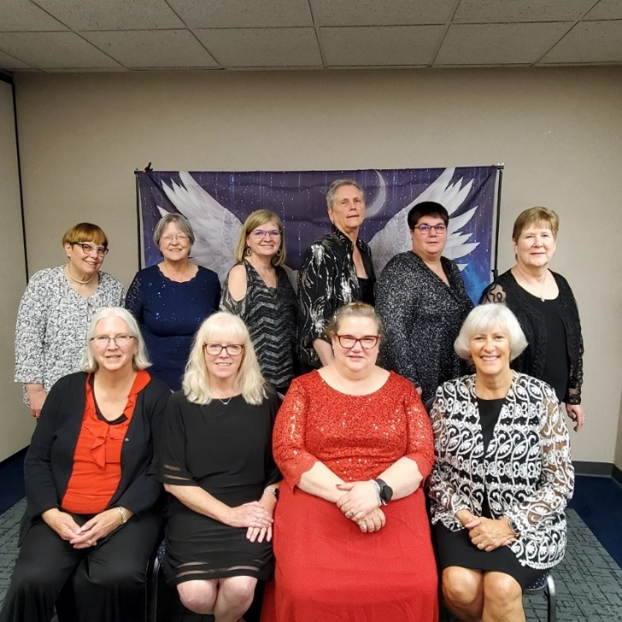



Shellie Haun winner of Speaking competition

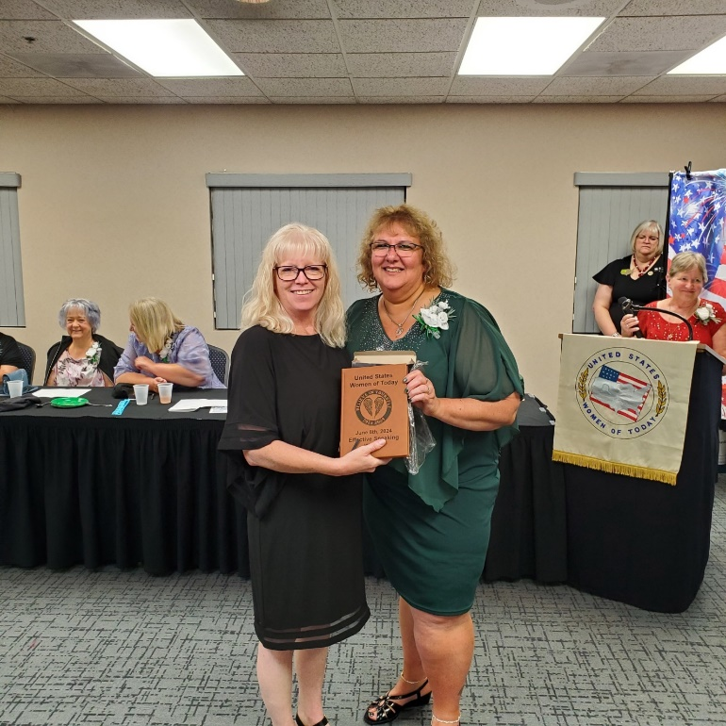



US Women of Today

National Awards

**Awards List 2nd trimester**

**Secretary**

**Newsletters/Minutes submitted** – *boxed pad & pen*

Nebraska

Terri Sherman

Angela Moody, Heartland

Kim Troudt, Kearney

**2nd Trimester Challenge –** *Micro puzzle, small pad & pen*

Nicolette Amundson, NE

**Outstanding Contacts –** *President Glass*

Secretary – Nicolette Amundson, NE

**Parli/2nd Trimester Challenge:**

To Submit Copy of Bylaws & Policies --

Nicolette Amundson, Heartland WT, NE

**Wellness and Personal Development**

Certificates

**Nebraska**

**Heartland**

Hillari Zweibohmer

**Domestic Violence Awareness**

Transmittals

Terri Sherman – Lincoln, NE

**Programming**

Total hours $176,916.85 Total hours recorded 1034.50

2nd trimester community connections recognition. (Small certificate)

Nebraska $1705.92 176.50 hours

Heartland

Lincoln

**Public Relations**

Shout Out with Public Relations form: certificates

Heartland, Ne

**Membership**

**100% Retention Chapter** **(certificate)**

**Nebraska**

Fremont

Heartland

Kearney

Lincoln

Nebraska City

**STEP 4**

Hillari Zweibohmer, Heartland NE

**Growth for 2nd trimester (certificate)**

**Growth +1**

**Nebraska -** Heartland

**Growth +3**

**States with Growth** (Small Certificate)

Nebraska + 2

**These awards were handed out at Tracey’s Presidential state visits:**

**Award of Excellence**

Shellie Haun, NE State President

**Awards List-3rd Trimester**

**Secretary**

Newsletters/Minutes submitted -- certificate

Nebraska

Terri Sherman, State

Angela Moody, Heartland

3rd Trimester Challenge **–** certificate

Nicolette Amundson, NE

**Parlimentarian**

Nicolette Amundson, Heartland WT, NE

**Wellness & Personal Development**

**(Small Certificate)**

Nebraska: 11)

Fremont Area (1)

Heartland (3)

Lincoln (5)

Effective speaking contestant: Shellie Haun

**DVA-Julie Hutchinson**

**State DVA Contacts**

Maxine Tuner – Nebraska

**DVA Transmittals**

Lincoln

Lincoln

Lincoln

Lincoln

Fremont

**DVA Challenge – Teen Dating Violence Awareness (wear orange)**

**Certificate and orange ribbon lapel pin**

Nicolette Amundson – Heartland, NE

Linda Lenser – Heartland, NE

**PVP Laura Bentley**

3rd trimester community connections

Nebraska $14,494.91 457 hours

Fremont

Lincoln

Nebraska City

$140,153.14 monies donated reported

28,551 hours reported

**PR**

Shout Out with Public Relations form

Heartland, NE – 3rd submission – Large Certificate

Buckets of Sunshine:

Heartland NE for Heartland Hope Mission

**Membership**

100% Retention 3rd trimester **(certificate**)

Nebraska:

Fremont Area

Heartland

Growth

Growth +2

Nebraska: Heartland

States with 3rd trimester Growth

Nebraska +2

Success Through Enthusiastic Participation (STEP)

Nebraska:

STEP 4 -1

Outstanding contacts for the 3rd trimester.

Kim Hermann from Nebraska

**Angel Awards:**

**Fremont Area, NE**

Embroidery Connections

Comfort Inn/Miranda Lewis

Arnie Urlacher

RVR Bank

Michael Connelly

Mark Johannsen

Fremont Area Art Association

Crown Trophy/Robert IV

Daves Drive In

Lindi Janulewicz

Atwood Chevrolet GMC

Niess Impressions

**Pins:**

The following pins were handed out on President Tracey state visits:

Julie Fogelman Heartland, NE

Nicolette Amundson Heartland, NE

Kim Hermann Lincoln, NE

Angela Moody Heartland, NE

Kim Troudt Kearney, NE

Madeline McCrae, NE

**Banquet Awards List year end 2024**

**MVP:**

State Growth for the year

Nebraska + 3

**Outstanding Local Officer:**

Julie Fogleman Heartland NE President

Joyce Harpster Nebraska City secretary

Christine Rice Nebraska City treasurer

**Outstanding State Officers:**

Kin Herman MVP

Nicolette Amundson Secretary

Terri Sherman Treasurer

**President:**

Outstanding State President:

Shellie Haun, NE

**The new Wellness and Personal Development form that was approved at national convention is ready to go. I just checked and it is not yet up on the USWT website. I have attached it to the email.**

Fireworks Safety Tips

**Leave Fireworks to the Professionals**

* The best way to protect your family is to not use any fireworks at home. Instead, attend public fireworks displays and leave the lighting to the professionals.
* If you plan to use fireworks, make sure they are legal in your area.

**Be Extra Careful With Sparklers**

* Little arms are too short to hold sparklers, which can heat up to 1,200 degrees. How about this? Let your young children use glow sticks instead. They can be just as fun but they don’t burn at a temperature hot enough to melt glass.
* Closely supervise children around fireworks at all times.

**Take Necessary Precautions**

* Do not wear loose clothing while using fireworks.
* Never light fireworks indoors or near dry grass.
* Point fireworks away from homes, and keep away from brush, leaves and flammable substances

**Be Prepared for an Accident or Injury**

* Stand several feet away from lit fireworks. If a device does not go off, do not stand over it to investigate it. Put it out with water and dispose of it.
* Always have a bucket of water and/or a fire extinguisher nearby. Know how to operate the fire extinguisher properly.
* If a child is injured by fireworks, immediately go to a doctor or hospital. If an eye injury occurs, don't allow your child to touch or rub it, as this may cause even more damage.