Jesus came to earth to love people and to teach them about God’s love. He performed miracles and did many wonderful things, and many people followed and believed he was the Son of God. Jesus never sinned, everything he did was pleasing to God, yet some people hated him. The chief priest and the elders hated him so much, they wanted Jesus to be killed. They did not believe he was the Son of God, and it made them very jealous that other people followed and worshipped him.
Peter Denies Jesus
With the help of Judas, one of Jesus’s disciples, they came up with a plan and arrested Jesus while he was in the Garden of Gethsemane praying with the other disciples. The soldiers carried Jesus away and the disciples scattered in fear. Jesus wasn’t afraid, He knew this was part of God’s plan. He knew bad things were about to happen. He had tried to warn the disciples about it many times, but they didn’t understand what he was telling them.
After Jesus was arrested, the soldiers and high priest led Jesus to the house of Annas. Annas was like a judge. He could give them permission to punish Jesus if he thought Jesus needed to be punished. Peter and John secretly followed them because they wanted to know what was happening to Jesus. When they came to the home of Annas, John entered the gate because he knew Annas. Peter waited just outside. When John realized Peter hadn’t followed him in, he went back to the girl who was guarding the gate and spoke to her. Then he went to Peter and told him it was ok for him to enter. As Peter was going in, the girl at the door recognized him and asked him if he was one of the disciples. Peter was afraid so he acted like he didn’t know what she was talking about. and just kept walking. Peter didn’t go too far from the door. He stopped by the fire to warm himself and tried to blend in with the servants who were also standing there. John walked farther so he could see and hear what was happening to Jesus.
Annas asked Jesus lots of questions. He asked him about his disciples and about what he was teaching. Jesus answered Annas by telling him that he wasn’t teaching anything in secret, it was for all people. Many people could tell him what he had been teaching. Annas and the soldiers didn’t like the way Jesus answered that question. One soldier smacked Jesus because they thought he was being rude to Annas. Jesus responded, “I’ve told the truth, why did you hit me?” Annas didn’t want to deal with Jesus anymore, so he sent him to Caiaphas. Caiaphas was the highest of the high priest. He already hated Jesus. In fact, he was the first person to have the idea to kill Jesus.
Caiaphas was married to Annas’s daughter, and he lived very close to Annas’s house. Peter was still standing by the fire with servants, but from the fire, he could see both houses. While he was standing there one of the servants said, “This man was with Jesus of Nazareth.” Peter was scared, he started to panic and said, “I swear I don’t know him.” This was the second time Peter acted like he didn’t even know Jesus. By this time some of the guards were also standing around the fire. One of them was Malchus. Malchus had been in the garden when Jesus was arrested. Peter had tried to fight him and cut off his ear with a sword. Jesus healed Malchus’ ear by just touching it. Malchus knew for sure that Peter was the man who had cut off his ear. He said to Peter, “Didn’t I see you with Jesus tonight in the garden?” For the third time Peter acted like he didn’t know Jesus. Just then the rooster crowed. Jeus looked at Peter from where he was standing. Peter knew exactly what he just had done. Just as Jesus said he would do; Peter had denied Jesus three times. Peter then ran away weeping. He was sad and embarrassed at what he had done.
Meanwhile, Caiaphas was questioning Jesus. The members of the Sanhedrin brought in other people to tell Caiaphas all the things Jesus had done wrong. People told lies about Jesus and twisting his words trying to get him into trouble. Caiaphas knew the people were lying and he needed proof before he could punish Jesus. Caiaphas turned to Jesus and said, “Are you the Son of God?” Jesus didn’t answer by saying “Yes.” Instead, he told Caiaphas that he would know the truth when he died and saw him sitting right beside God. This made Caiaphas so mad that he ripped his clothes. He accused Jesus of blasphemy which means pretending to be God. That is a very bad thing, and the law said people who pretended to be God should be put to death. They didn’t know Jesus wasn’t pretending to be God. He really was the son of God. Caiaphas and the priest wanted Jesus to die but he didn’t have enough power to make that decision. Jesus was then sent to stand before the Roman governor.

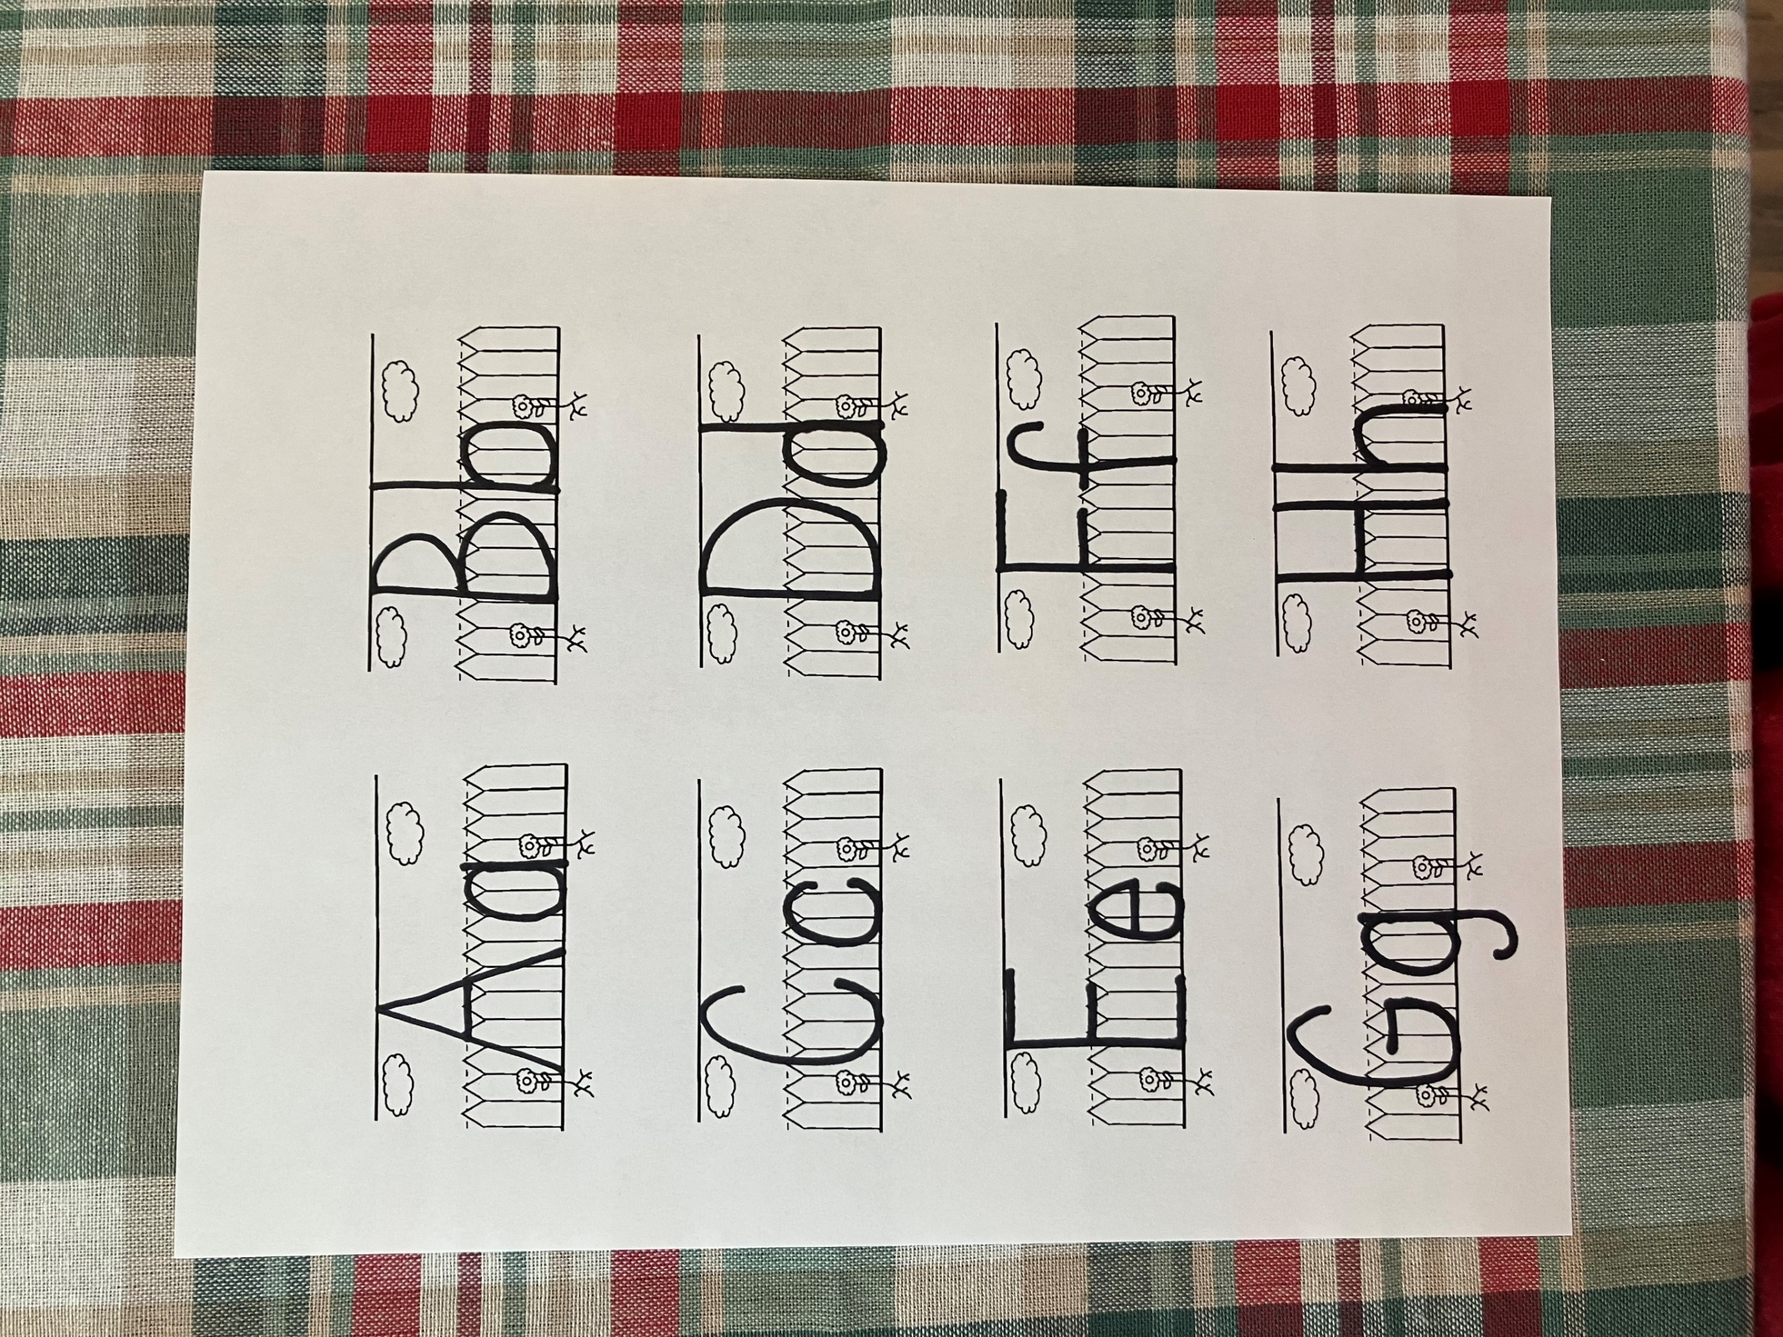
.
C

c

Caiaphas

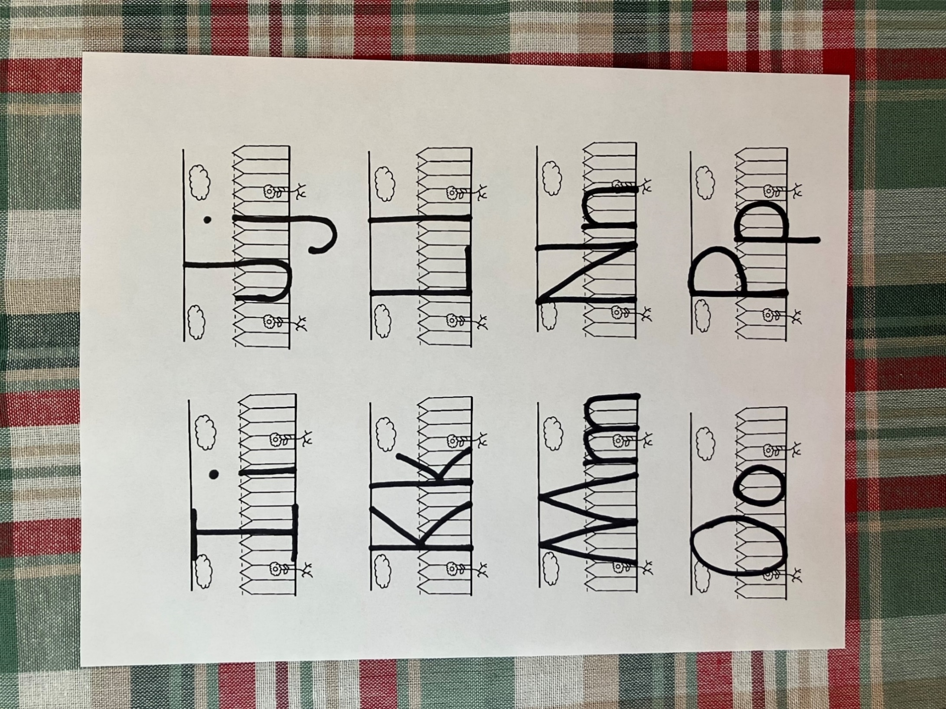
P

p
Peter

- Who was the first person the guards took Jesus to see.
- Which two disciples followed Jesus?
- Which disciple waited by the gate and which disciple went into the house?
- Where did Peter stand when he entered the gate?
- Who was the first person to recognize Peter?
- Who was the third person to recognize Peter?
- What happened after Peter denied Jesus the third time?
- What happened to Jesus when the guards didn’t like his answers to Annas?
- Who did Annas send Jesus to speak to?
- When Jesus told Caiaphas that he would one day see him sitting beside God, what did Caiaphas do?
- Who did Caiaphas send Jesus to talk to?

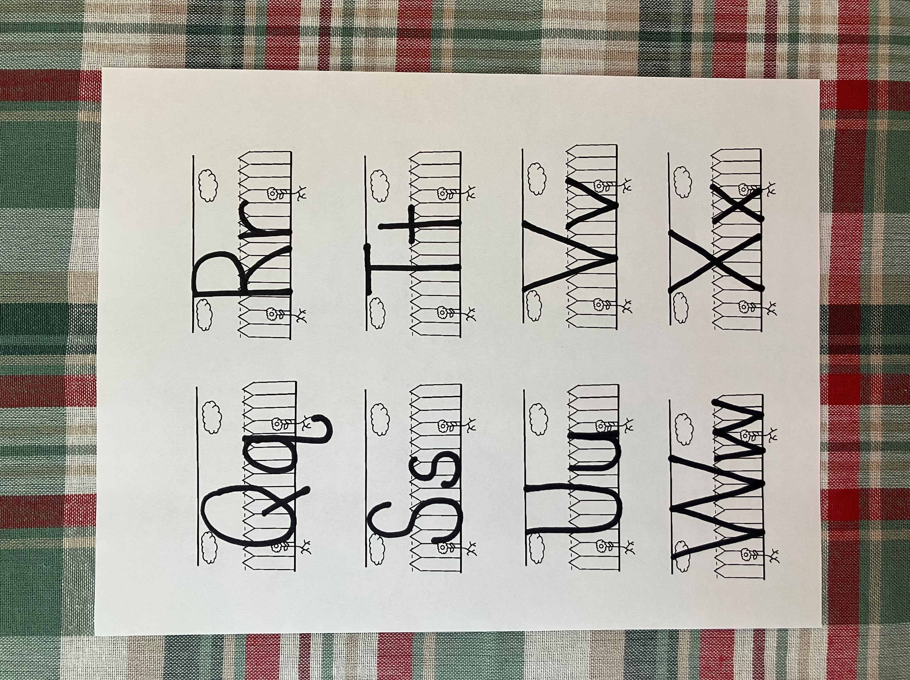
R

r

rooster

Peter denied Jesus 3 times before the rooster crowed just as Jesus said he would do. Look at the picture below and match the animal with the sound it makes.
.
.










Ribbit Tweet Meow Maa Hee-Haw Ruff Moo Baa
Peter couldn’t believe that he would ever deny Jesus but then he did it 3 times when he thought his life might be in danger. Trace the number 3 below and then circle the items that are in groups of 3.

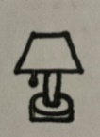

3
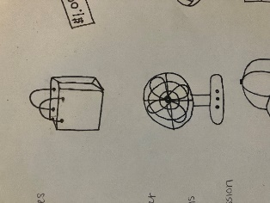
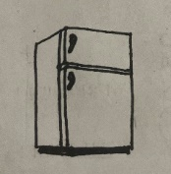
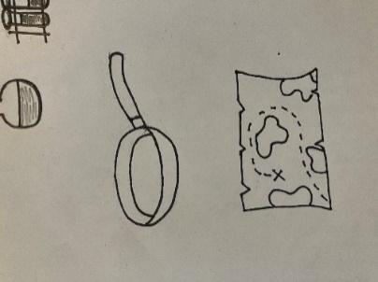

Peter then denied again: and immediately the cock crew. John 18:27
Rr

After Peter denied Jesus 3 times, he heard the rooster crow. In the space below, draw a rooster.
deny
- refuse to admit the truth

- I was one of Jesus’ twelve disciples.
- I followed Jesus when the guards took him to Annas house.
- The girl at the gate allowed me to enter.
- I went back outside to get Peter.

Who am I?
_____ _____ _____ _____

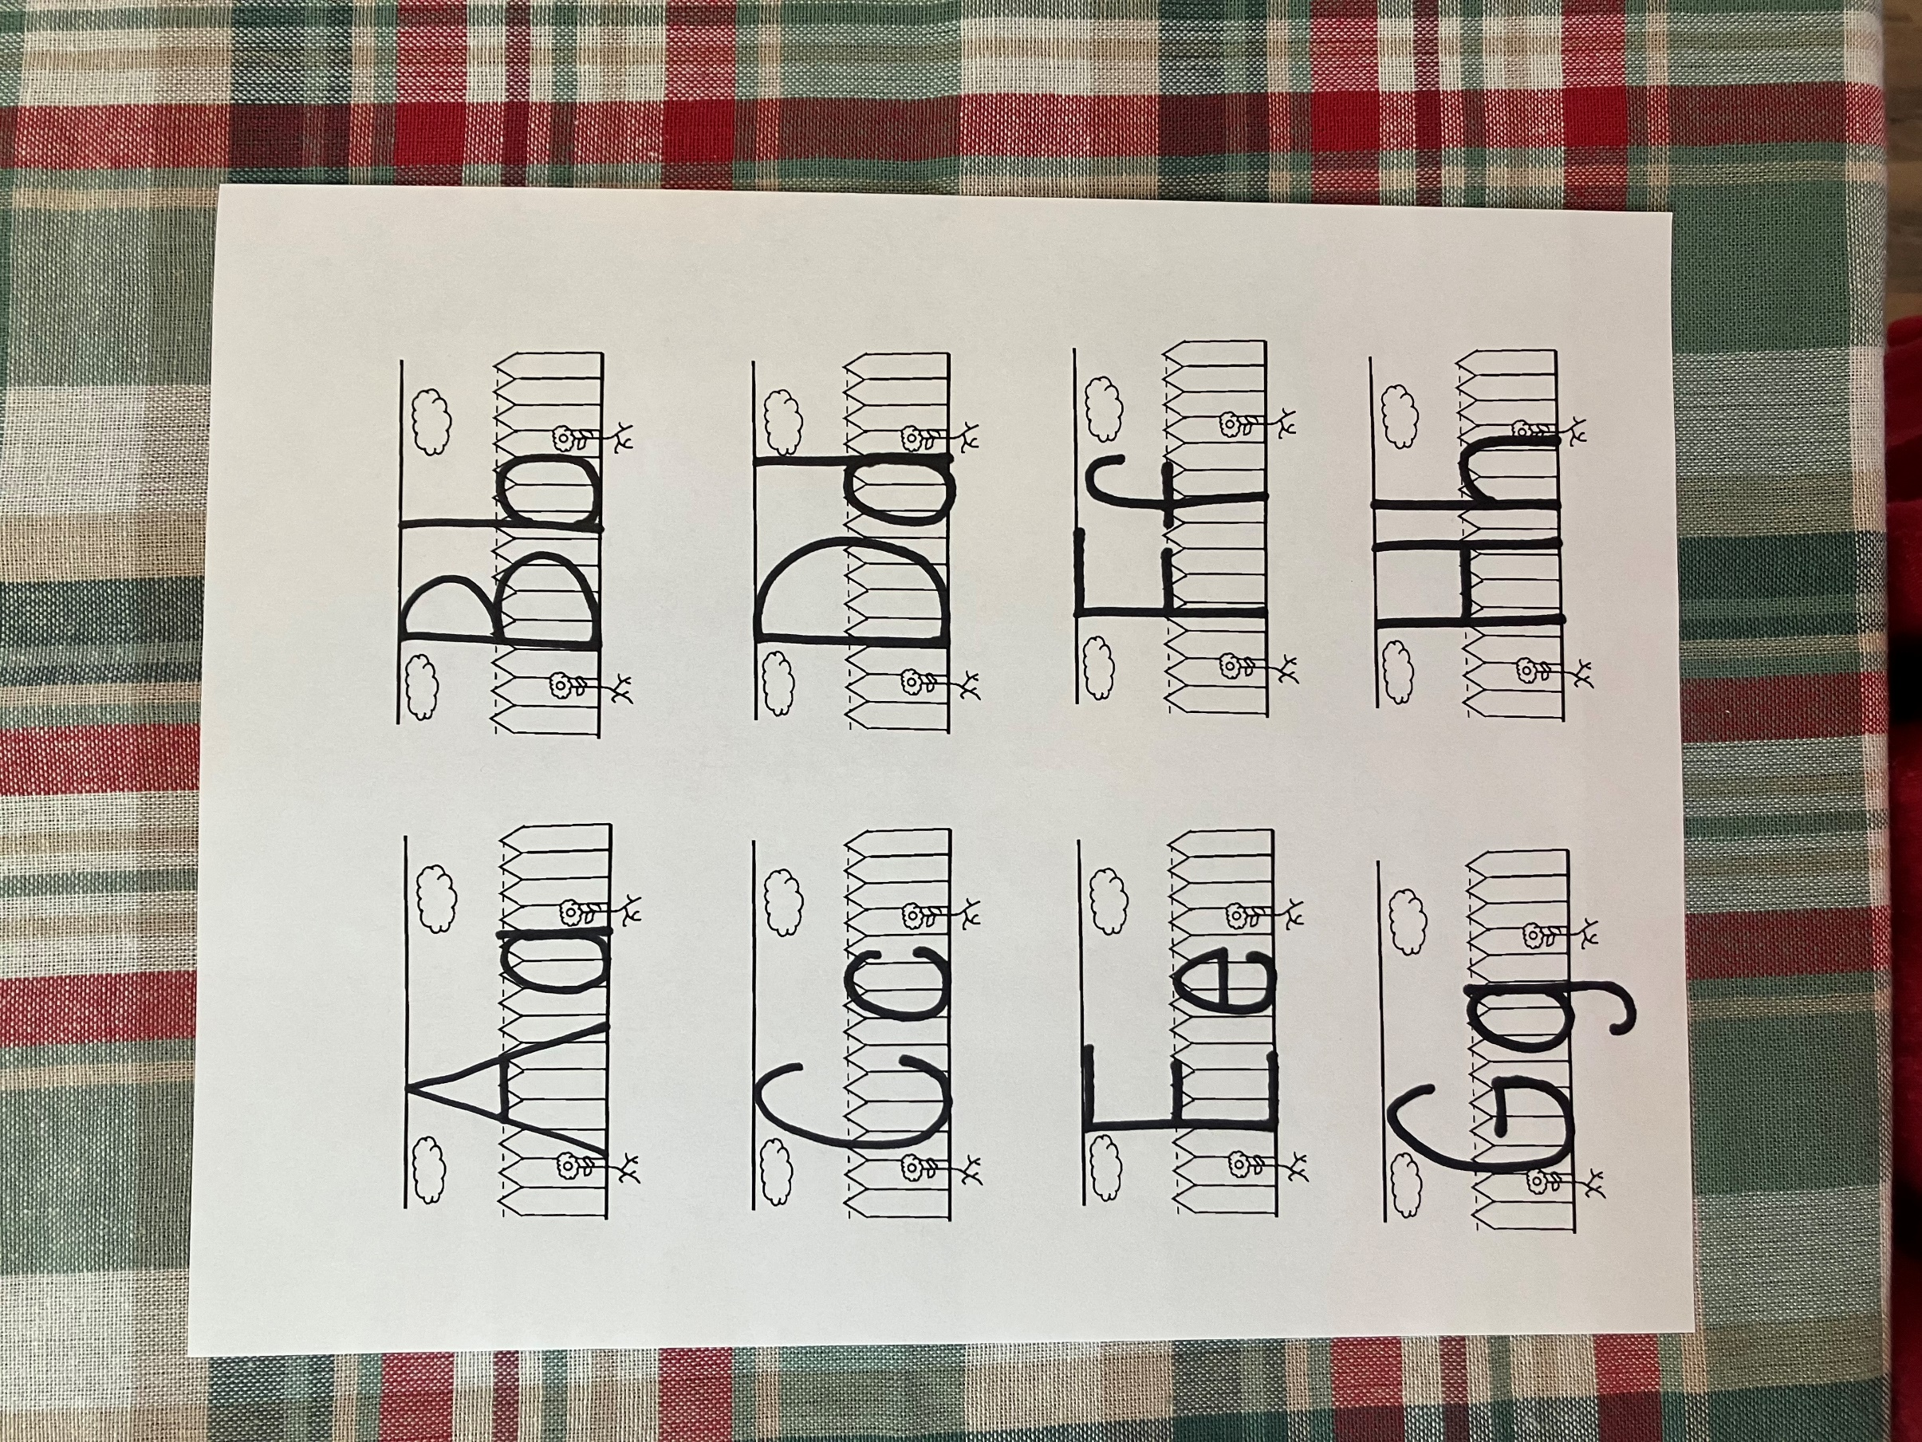

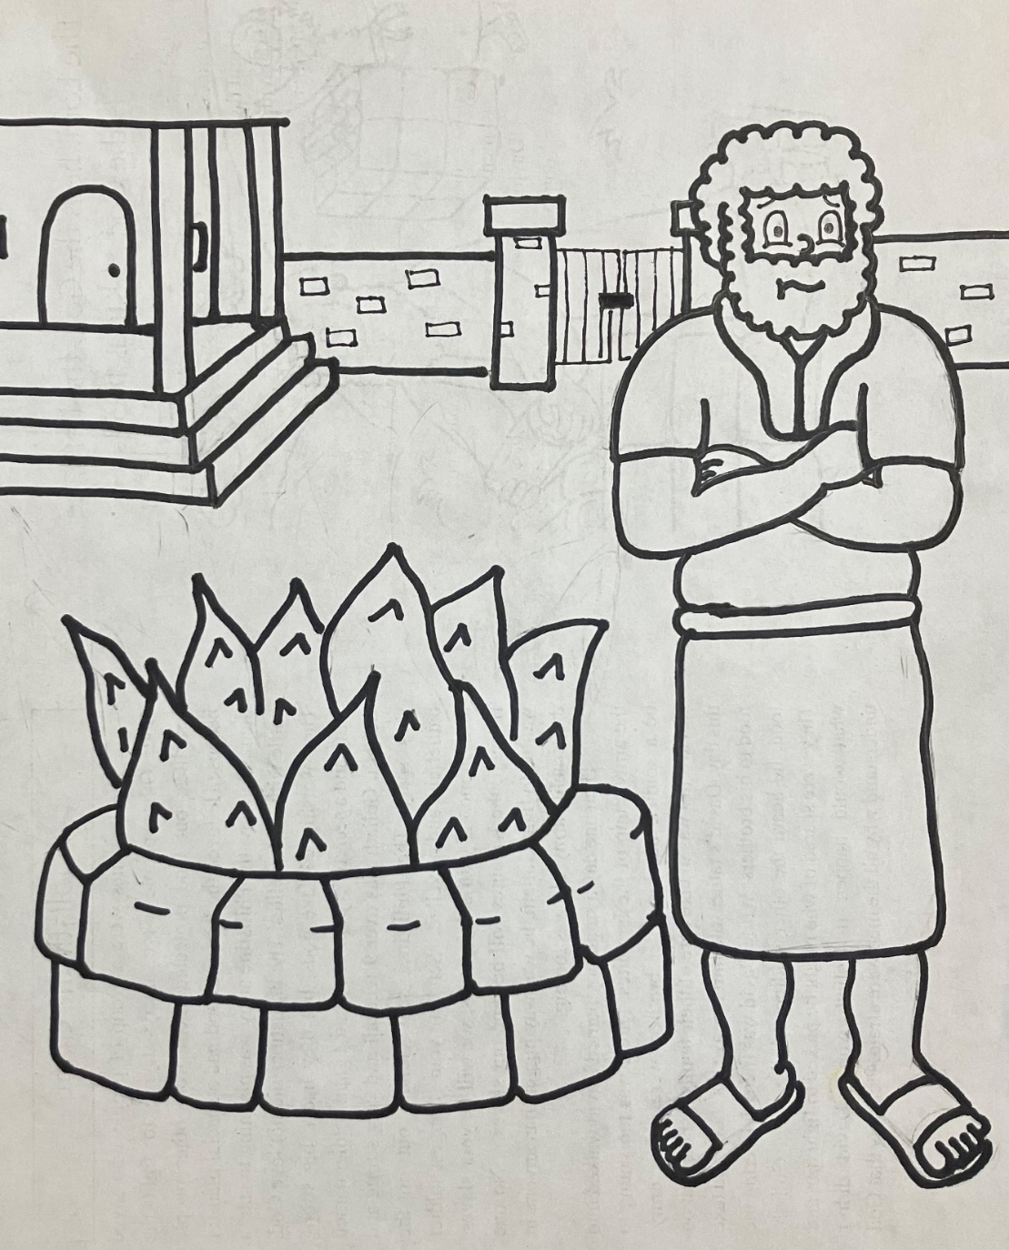
Peter the denied him again: immediately the cock crew. John 18:27

