1

INSTRUCTIONS:

Print hexagons on pages 1 and 2 on regular printer paper. Cut out, cover front and back with contact paper. Cut out.

4

3

12

6

2

INSTRUCTIONS:

Print hexagons on pages 3 and 4 on full-page labels. Cut out, stick to the inside of a file folder. (Optional) Cover folder with contact paper.

3

4

12

6

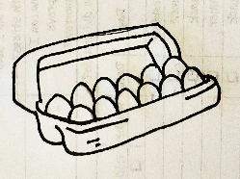

“Eggcellent”

-Dividing

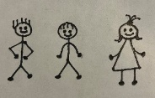





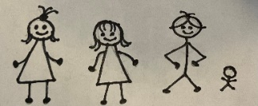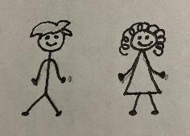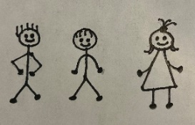





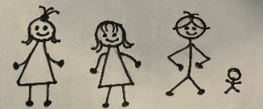



Jacob had 12 sons. 12 is a dozen. A dozen is an easy number to share. Look at each egg carton. How many eggs would each person get if they shared the whole carton.

