Jesus knew that it was almost time for him to be crucified. He tried to explain it to the disciples, but they didn’t quite understand all that was about to happen. One night, after the Passover Meal, Jesus gathered his disciples and went to a place call the Garden of Gethsemane. It was a nice quiet place where Jesus liked to go pray.

The Garden of Gethsemane

As they entered the garden Jesus told most of the disciples to sit and wait as he traveled on a little farther. He asked Peter, James and John to walk with him. He wanted them to stand watch while he prayed. Jesus knew danger would soon be around them all, but he wanted to be able to focus to pray so he asked these three men to watch carefully.

Jesus went on a little farther by himself. Then he fell to his knees and prayed. Jesus was very upset. He knew people were coming who were going to kill him. He knew that it was God’s plan all along for him to come to the world to die for the sins of everyone. He already knew about all the pain he would suffer, and how everyone would turn against him in his last days. He knew that his disciples would scatter, hide, and deny that they even knew him. Jesus knew his heart was about to break and his body would be badly beaten. He knew exactly what was about to happen. But the thing that bothered Jesus the most was the fact that there would be a time when he would be separated from God. God cannot be in the same place as sin so while Jesus was paying for the sins of all people, he had to be separated from God.

This was the part that troubled him the most. Jesus was so burdened that while he prayed he began to sweat drops of blood.

Jesus prayed asking God to take this cup from him. That meant if there was any other way to pay for the sins of the world, he would rather do that. But he ended the prayer by saying, “Not my will but thine.” He was saying, it wasn’t about what was easiest for him. he would do whatever he needed to do.”

After about an hour, Jesus walked back to where Peter, James and John were waiting. All three of the disciples were asleep. Jesus woke them up and asked them why they couldn’t do what he had asked. He asked why they couldn’t stay awake for even one hour to let him pray. Jesus knew how serious things were about to get but the disciples still didn’t understand. He told his disciples to be careful, not to let temptation keep them from doing what they needed to do. He told them the body is weak and sometimes they would struggle to stay focused. Then Jesus went back to pray some more.

Jesus prayed again, asking God the same things he had prayed before. Then he returned to his disciples. Again, he found them asleep. This time he didn’t wake them. He just went back and prayed some more. The third and final time Jesus returned to his disciples they were still sleeping. He let them rest because he knew things were already starting to happen in Jerusalem that would lead to him being captured. His time had come.

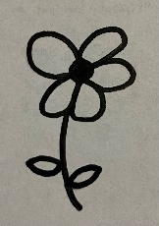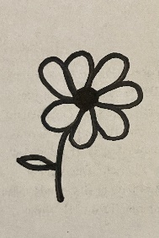

Printing Practice

quiet

Qq

Gg

garden

Dd

disciples

1. Where did Jesus go with his disciples?
2. How many disciples did he ask to walk on with him?
3. What did Jesus ask Peter, James, and John to do while he went to pray?
4. What did Jesus start to sweat because he was praying so hard?
5. What did Jesus pray in the garden?
6. What did Jesus find the disciples doing when he returned from praying?
7. How many times did Jesus go pray alone?
8. What did Jesus say to God that meant he was willing to do whatever he needed to do?

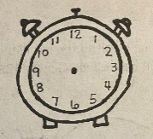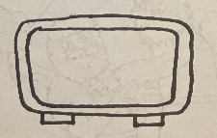

3:00

Jesus went to the garden to pray because he knew it was almost time for him to die on the cross. Look at the pictures below. Match the analogue clocks with the digital clocks that tell the same time.





9:30



8:00



2:30



1:00

Memory Verse

Find it, Read It, Write It, Explain It!

**And he cometh unto the disciples, and findeth them asleep. Matthew 26:40**

Cursive Practice

Q q

quiet

G g

garden

Dd

disciples

U

“Wake Up, Sleepy Head”

Have you ever been so sleepy that you just couldn’t hold your

eyes open? Maybe you’ve been at school or at church and you didn’t mean to fall asleep but the more you tried to fight it, the heavy your eyelids seemed to get. This is what was happening with the disciples. They didn’t mean to disobey Jesus, they were just so tired they couldn’t hold their eyes open any longer. Jesus warned them that the body is weak, and temptation is strong. This means sometimes the wrong things will feel better or easier to do than the right things. We must stay strong and fight the urge to do what our bodies want to do if doing it means sinning

against God. Sometimes doing the right things takes

all the strength we have plus some. In times when

we aren’t strong enough on our own, we should

ask God to help us. He has enough strength

to help us through anything.

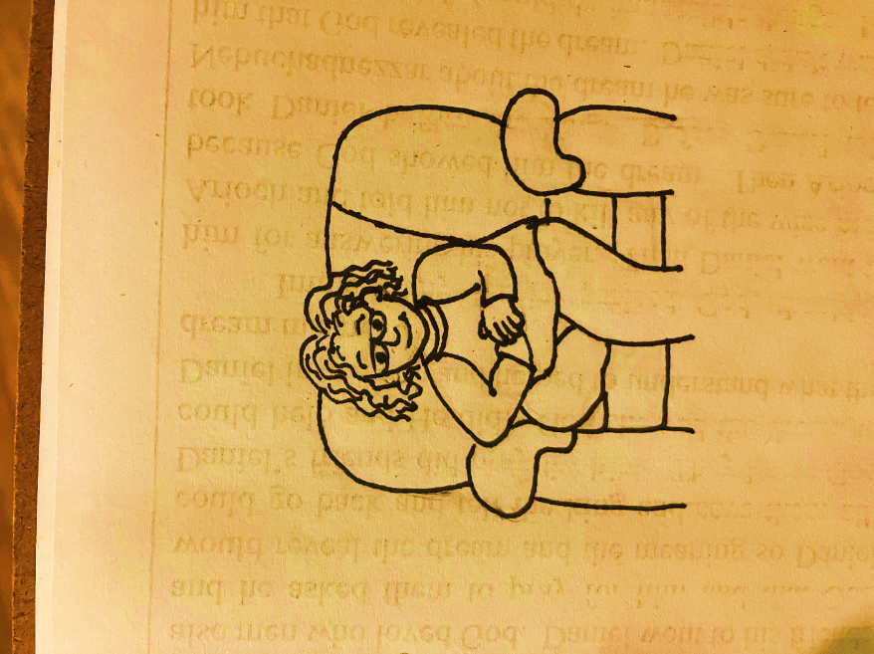

Wordsearch

GARDEN PRAY SLEEP WATCH

JESUS BLOOD WILL

|  |  |  |  |  |  |  |  |  |  |
| --- | --- | --- | --- | --- | --- | --- | --- | --- | --- |
| B | Q | W | E | R | T | W | I | L | L |
| L | Y | P | R | A | Y | U | I | O | P |
| O | S | D | F | G | H | J | K | L | S |
| O | A | Z | X | J | C | V | B | N | L |
| D | G | Y | U | E | I | O | P | M | E |
| T | A | R | E | S | W | Q | A | S | E |
| L | R | K | J | U | H | G | F | D | P |
| M | D | N | B | S | V | C | X | Z | Q |
| P | E | O | I | U | Y | T | R | E | W |
| L | N | K | J | W | A | T | C | H | H |
| B | V | C | X | Z | A | S | D | F | G |

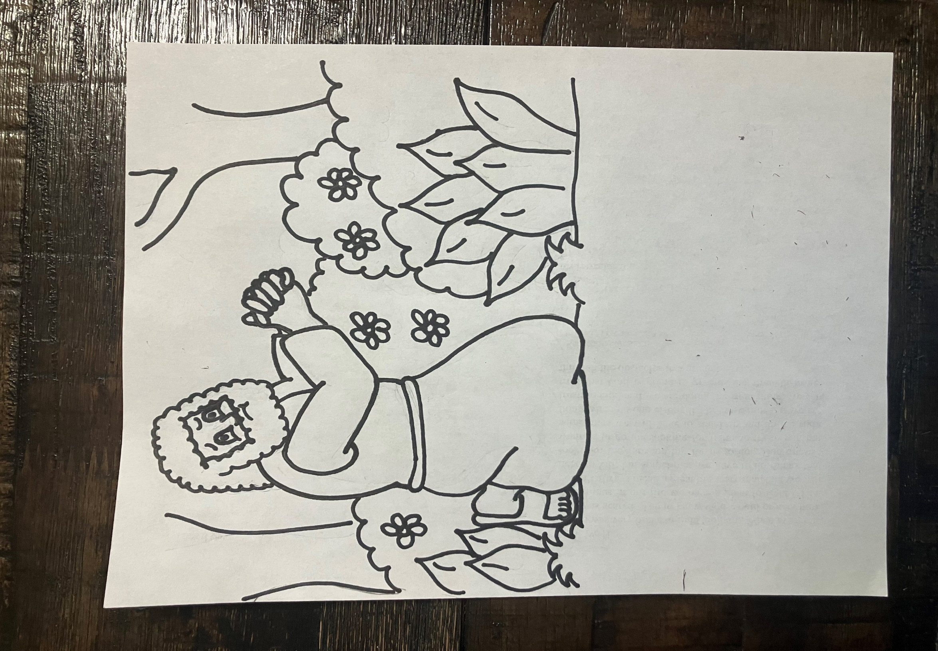

**7**

**7**

**7**

**6**

**And he cometh unto the disciples, and findeth them asleep.**

**Matthew 26:40**

**1**

**1**

**3**

**4**

**2**

**4**

**3**

**2**

**2**

**5**

**5**

**2**

**2**

**5**

**1**

**5**

**5**

**3**

**5**

**5**

1 – tan 2 – green 3 – purple 4 – white

5 – light green 6 – dark blue 7 - brown



Dear God,

Thank you for this

lesson. Thank you so much for

Jesus! Thank you for the example he set for us that

sometimes doing the right thing isn’t easy. Jesus came

to give his life to pay for the sins of anyone that would

call up on his name. Even though that part of his life on earth was difficult, and he didn’t look forward to the pain and suffering, he did it anyway. His love for us kept him focused on the job he had to do. Thank you for your plan. Thank you for Jesus and the strength he had to do what wasn’t easy for his body to do. Please help us to remember to look to you for strength when our bodies don’t feel strong

enough to do the job you have for us. Please help

us never forget that we can call upon you for

help anytime we feel weak.

In Jesus’ Name,

Amen