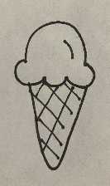

INSTRUCTIONS:

Print the items on pages 1 and 2 on regular printer paper. Cut out, cover front and back with contact paper. Cut out.

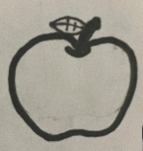









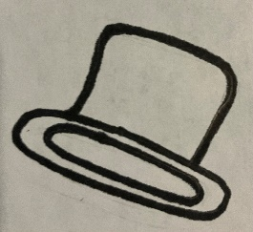

INSTRUCTIONS:

Print the circle sets on pages 3 and 4 on full-page labels. Cut out, stick to the inside of a file folder. (Optional) Cover folder with contact paper.



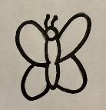





“Big, Bigger, Biggest”

-Comparing

Goliath was much bigger than David. Look at the pictures and put them in order from smallest to biggest.

