The members of the Sanhedrin convinced the Roman government and many Jewish people that Jesus was not the Son of God, and he needed to be crucified. Jesus knew his crucifixion was part of God’s plan for him to save the world from their sins, so he did not fight back. He was arrested, questioned, beaten, spit upon, and then hung on a cross until he was dead. Just after he died, the ground began to shake, graves burst open, dead people lived again, and the veil in the temple ripped from top to bottom. Everyone knew something incredible had just taken place, but the people were confused. Those who believed Jesus was the Son of God were sad and didn’t understand why he had died. Those who did not believe were angry at Jesus, happy that he was dead, and a little unsettled at all that had taken place. No one really knew what was going on at all. Joseph of Arimathea had requested Jesus body so he could give him a proper burial. Joseph had to hurry because it was almost time for the Sabbath to begin and he was not allowed to work on the Sabbath. Preparing the dead would have been considered work and could have gotten him in a lot of trouble. He hurried and wrapped Jesus’ body in linen cloths and placed it in a tomb. Then he rolled a large stone in front of the opening. The members of the Sanhedrin requested that the governor place guards near the tomb to be sure that no one stole Jesus’ body.
Jesus Is Risen
Several women had been with Jesus at the cross. They, like Joseph of Arimathea, also wanted to be sure to give him a proper burial so they watched from far off to see where Joseph had taken his body. They were going to return after the Sabbath to clean his body and pour oils and perfumes on him the way that most bodies were prepared for burial.
As soon as the Sabbath day was over, Mary, Mary Magdelene, Salome who married to a man named Zebedee, and a lady named Joanna gathered spices and oils and headed to the tomb where Jesus had been placed. Just before the arrived at the tomb there was a great earthquake. An angel of God came down from heaven, rolled away the stone, and then sat upon it. The guards trembled in fear and then passed out on the ground. As the ladies walked closer, they could see a man dressed in white sitting on the stone. They did not know he was an angel, but he was so bright they had to look away. They were very frightened. The angel told them not to be afraid. The angel knew why they were there. He asked them why they were looking for someone who was alive in a place that was for a person who was dead. Jesus was no longer there. He had risen. He told them to go and find the disciples and tell them that Jesus had risen from the dead. Then ladies turned and headed back to Galilee to get the disciples. When the Roman guards came to, they rushed to tell the members of the Sanhedrin what had happened. The Sanhedrin didn’t want anyone to know these things so they gave the guards a lot of money and told them to tell anyone who asked that the disciples stole Jesus’s body while they were asleep. The guards agreed to keep their secret even though they knew it was a lie.
Then ladies turned and headed back to Galilee to get the disciples. Along the way, the ladies met Jesus on the road. Jesus was alive and he was right there with them! They were so excited that they fell to his feet to worship him. Jesus told them to go into Galilee and tell the disciples he would soon see them there. The ladies left to find the disciples.
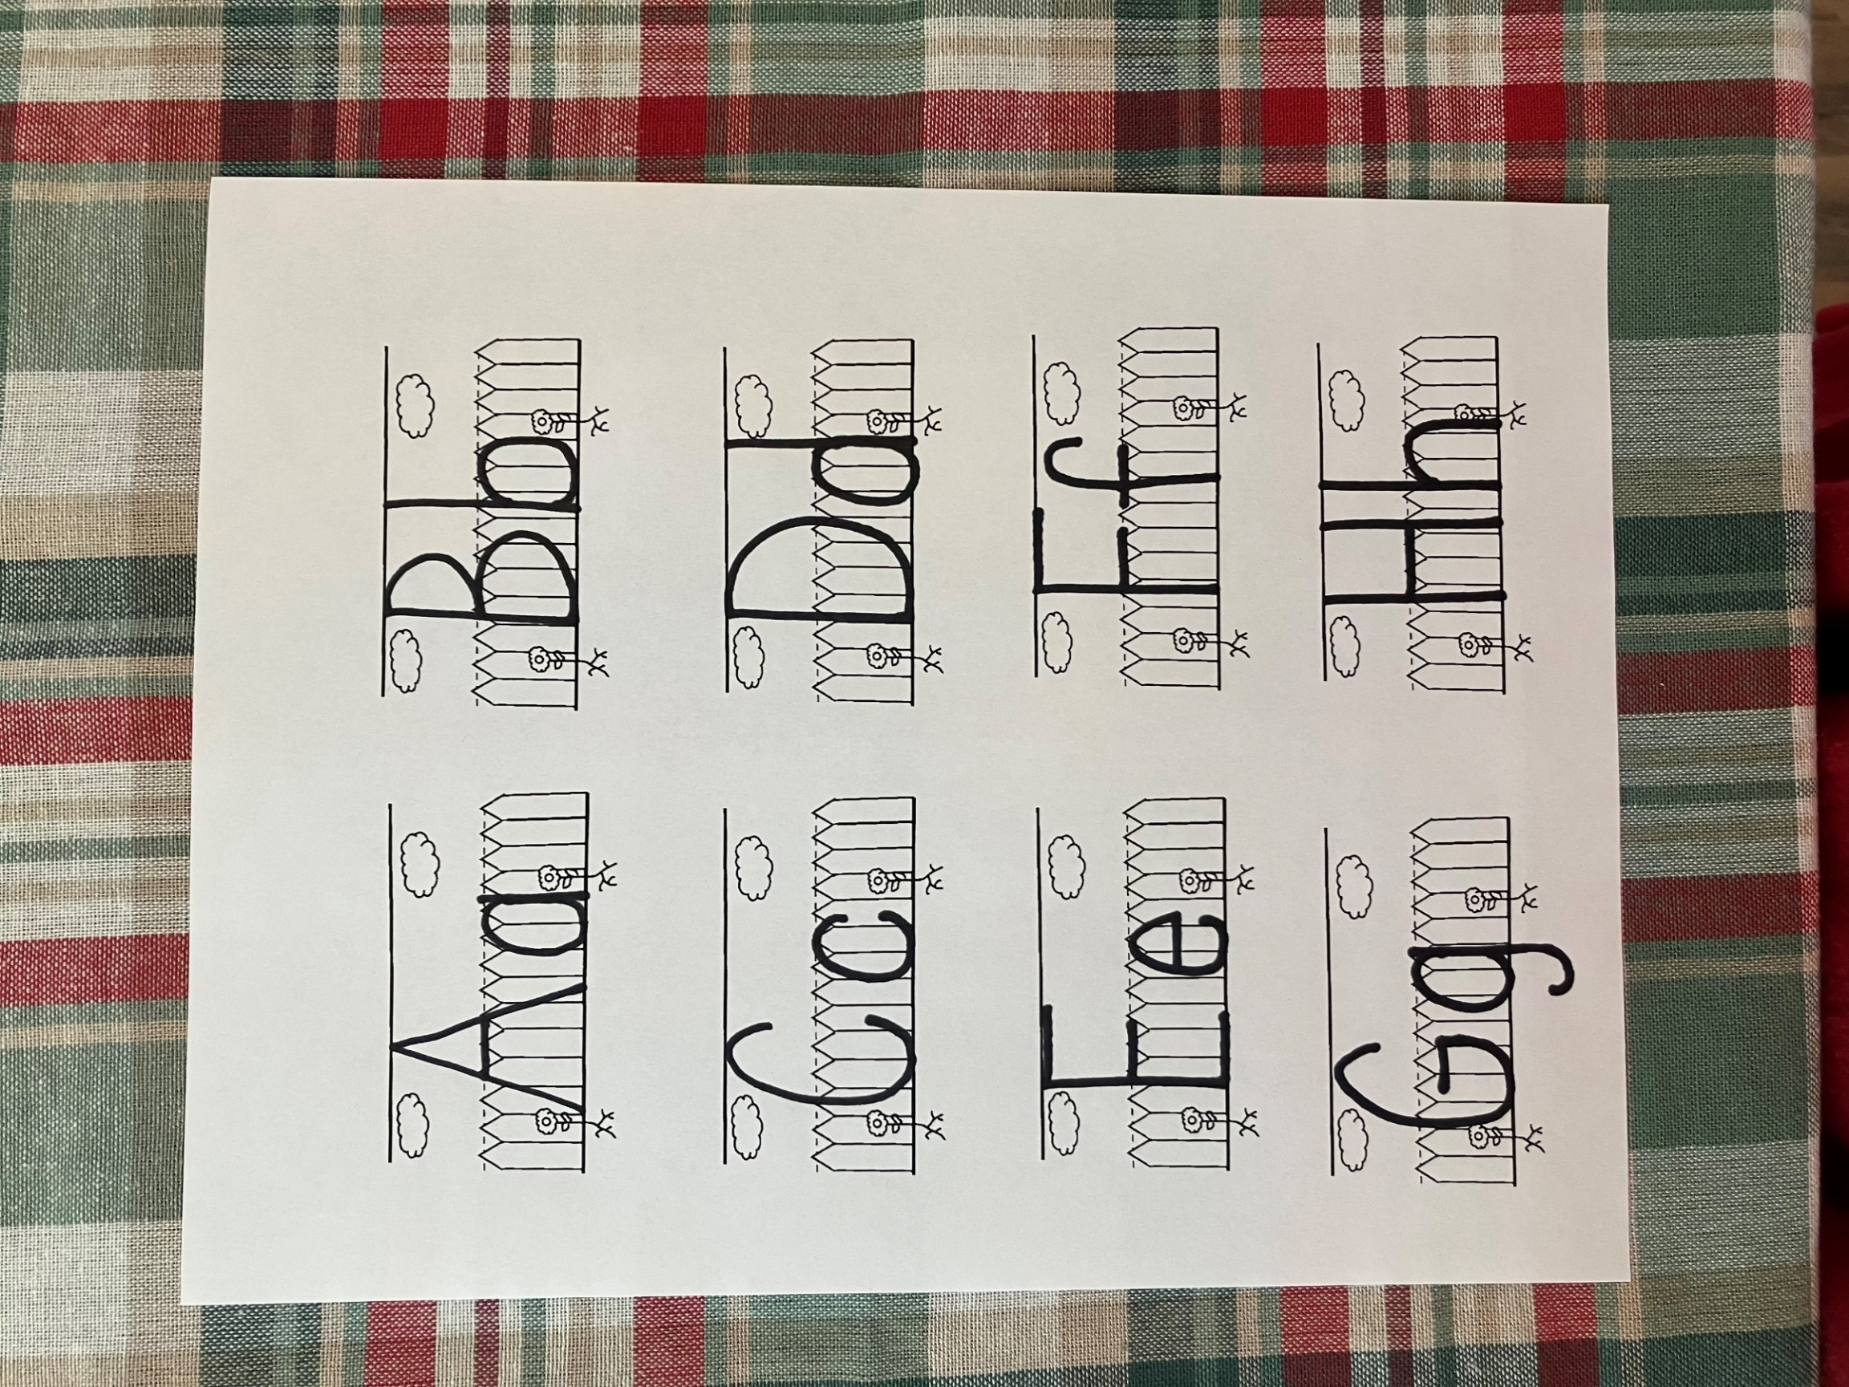
When Mary found the disciples. They were all hiding, scared of what might happen to them. They were afraid of what the Sanhedrin might try to do them. They didn’t know what to do. Mary told them that Jesus was alive and she had been with him and talked to him. The disciples did not believe what she was telling them. Peter and John jumped up and ran as fast as they could to the tomb where Jesus had been buried. John was the first one to arrive at the tomb, but he did not go in. Then Peter arrived and ran right inside. Peter could see the cloths that had been wrapped around Jesus body. They were still in the shape of a man’s body, but Jesus was gone. Peter ran back out of the tomb wondering what was going on. When John saw the cloths, he knew Jesus had risen just as he said he would. Peter and John rushed back to tell the other disciples what they had found.
A

a

angel

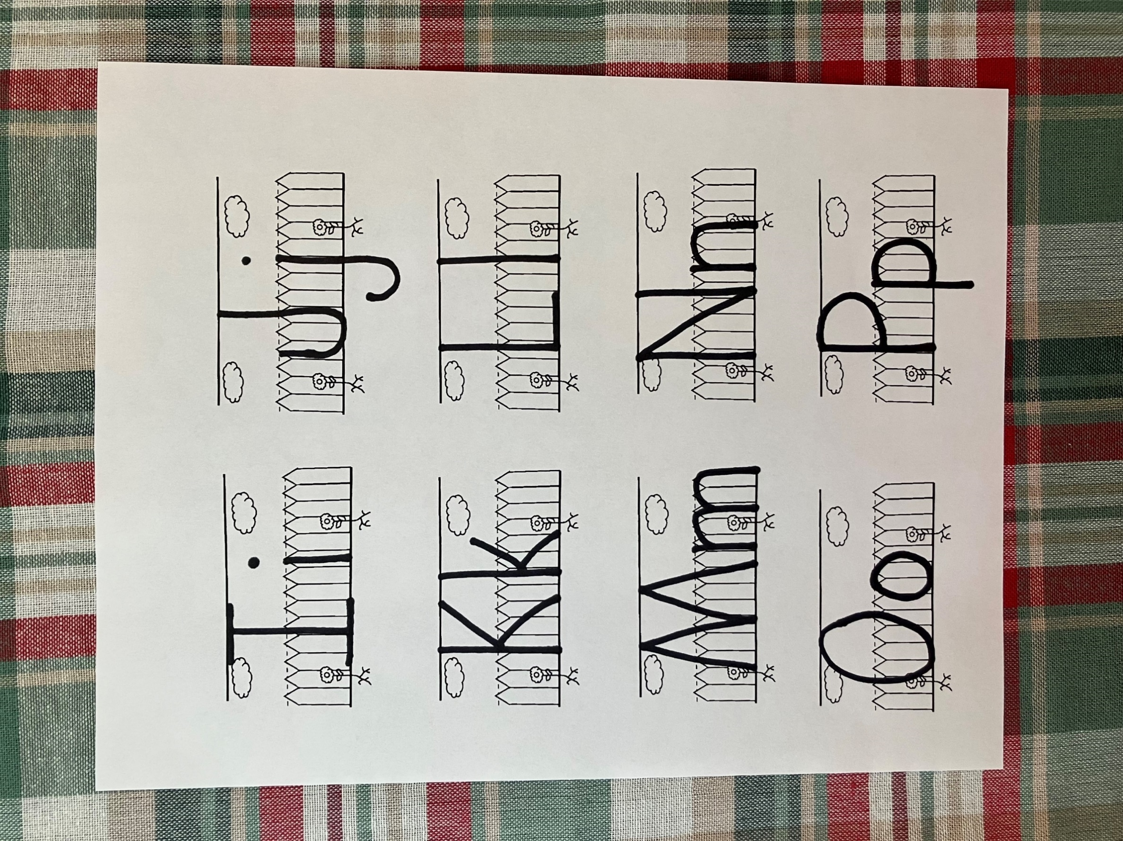

O

o

oils

- Why did Simon have to carry the cross for Jesus?
- How did they hang Jesus on the cross?
- Who was near the cross crying?
- What did the sign on Jesus’ cross say?
- Who yelled at the thief for making fun of Jesus?
- What happened to the sky for 3 hours?
- What did they give Jesus to drink?
- What did Jesus say just before he died?
- What happened after Jesus died?
10. What happened to Jesus’ body after he died?

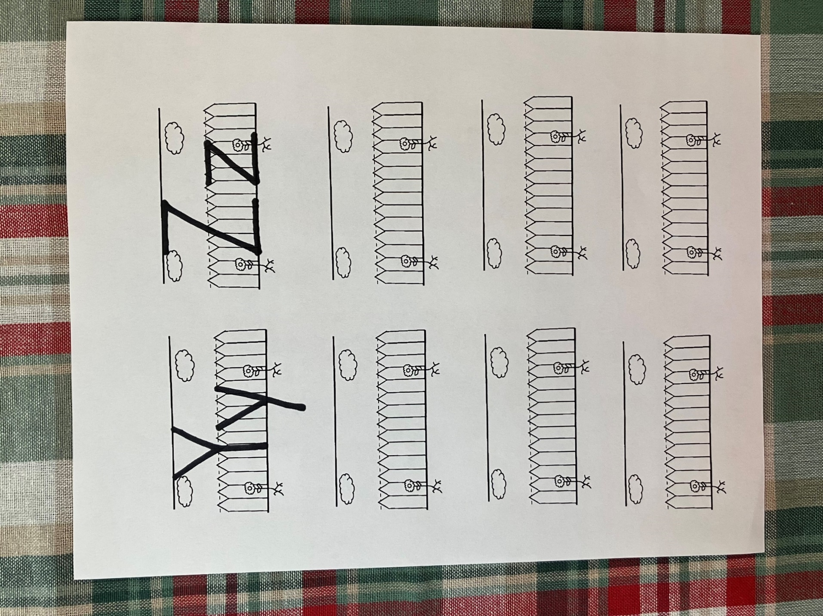
Z

z

Zebedee

When the women arrived at the tomb, the angel asked them why they were looking for someone who was alive in a place that was for people who were dead. Look at the pictures below. Some of the items are living things and some are not living things. Circle the items that are living things.
.
.


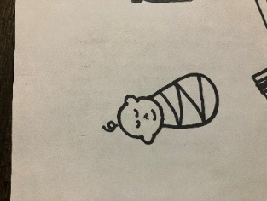








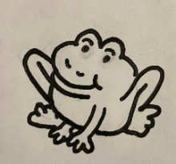
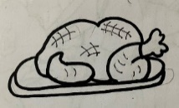
When Peter ran into the tomb and found the cloths that had been wrapped around Jesus, they were still in the shape of a man. Look at the picture below and see if you can match the items with their shapes on the other side.

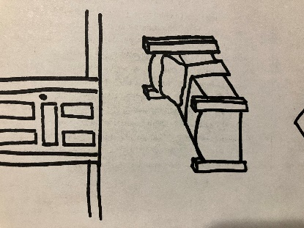
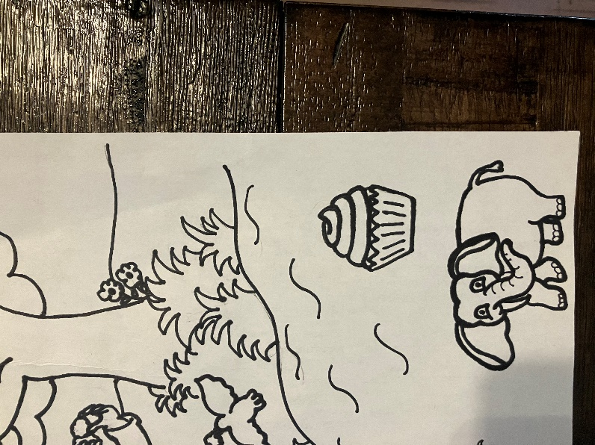


Ee
He is not here: for he has risen. Matthew 28:6

An angel showed up and rolled the stone away. In the space below, draw an angel.

alive
- Living, not dead

- I went to the tomb to put spices on Jesus’ body
- The angel told me to go tell the disciples Jesus had risen.
- I saw Jesus on the road on the way to find the disciples.
- The disciples did not believe that I had seen Jesus.
Who am I?
___ ___ ___ ___

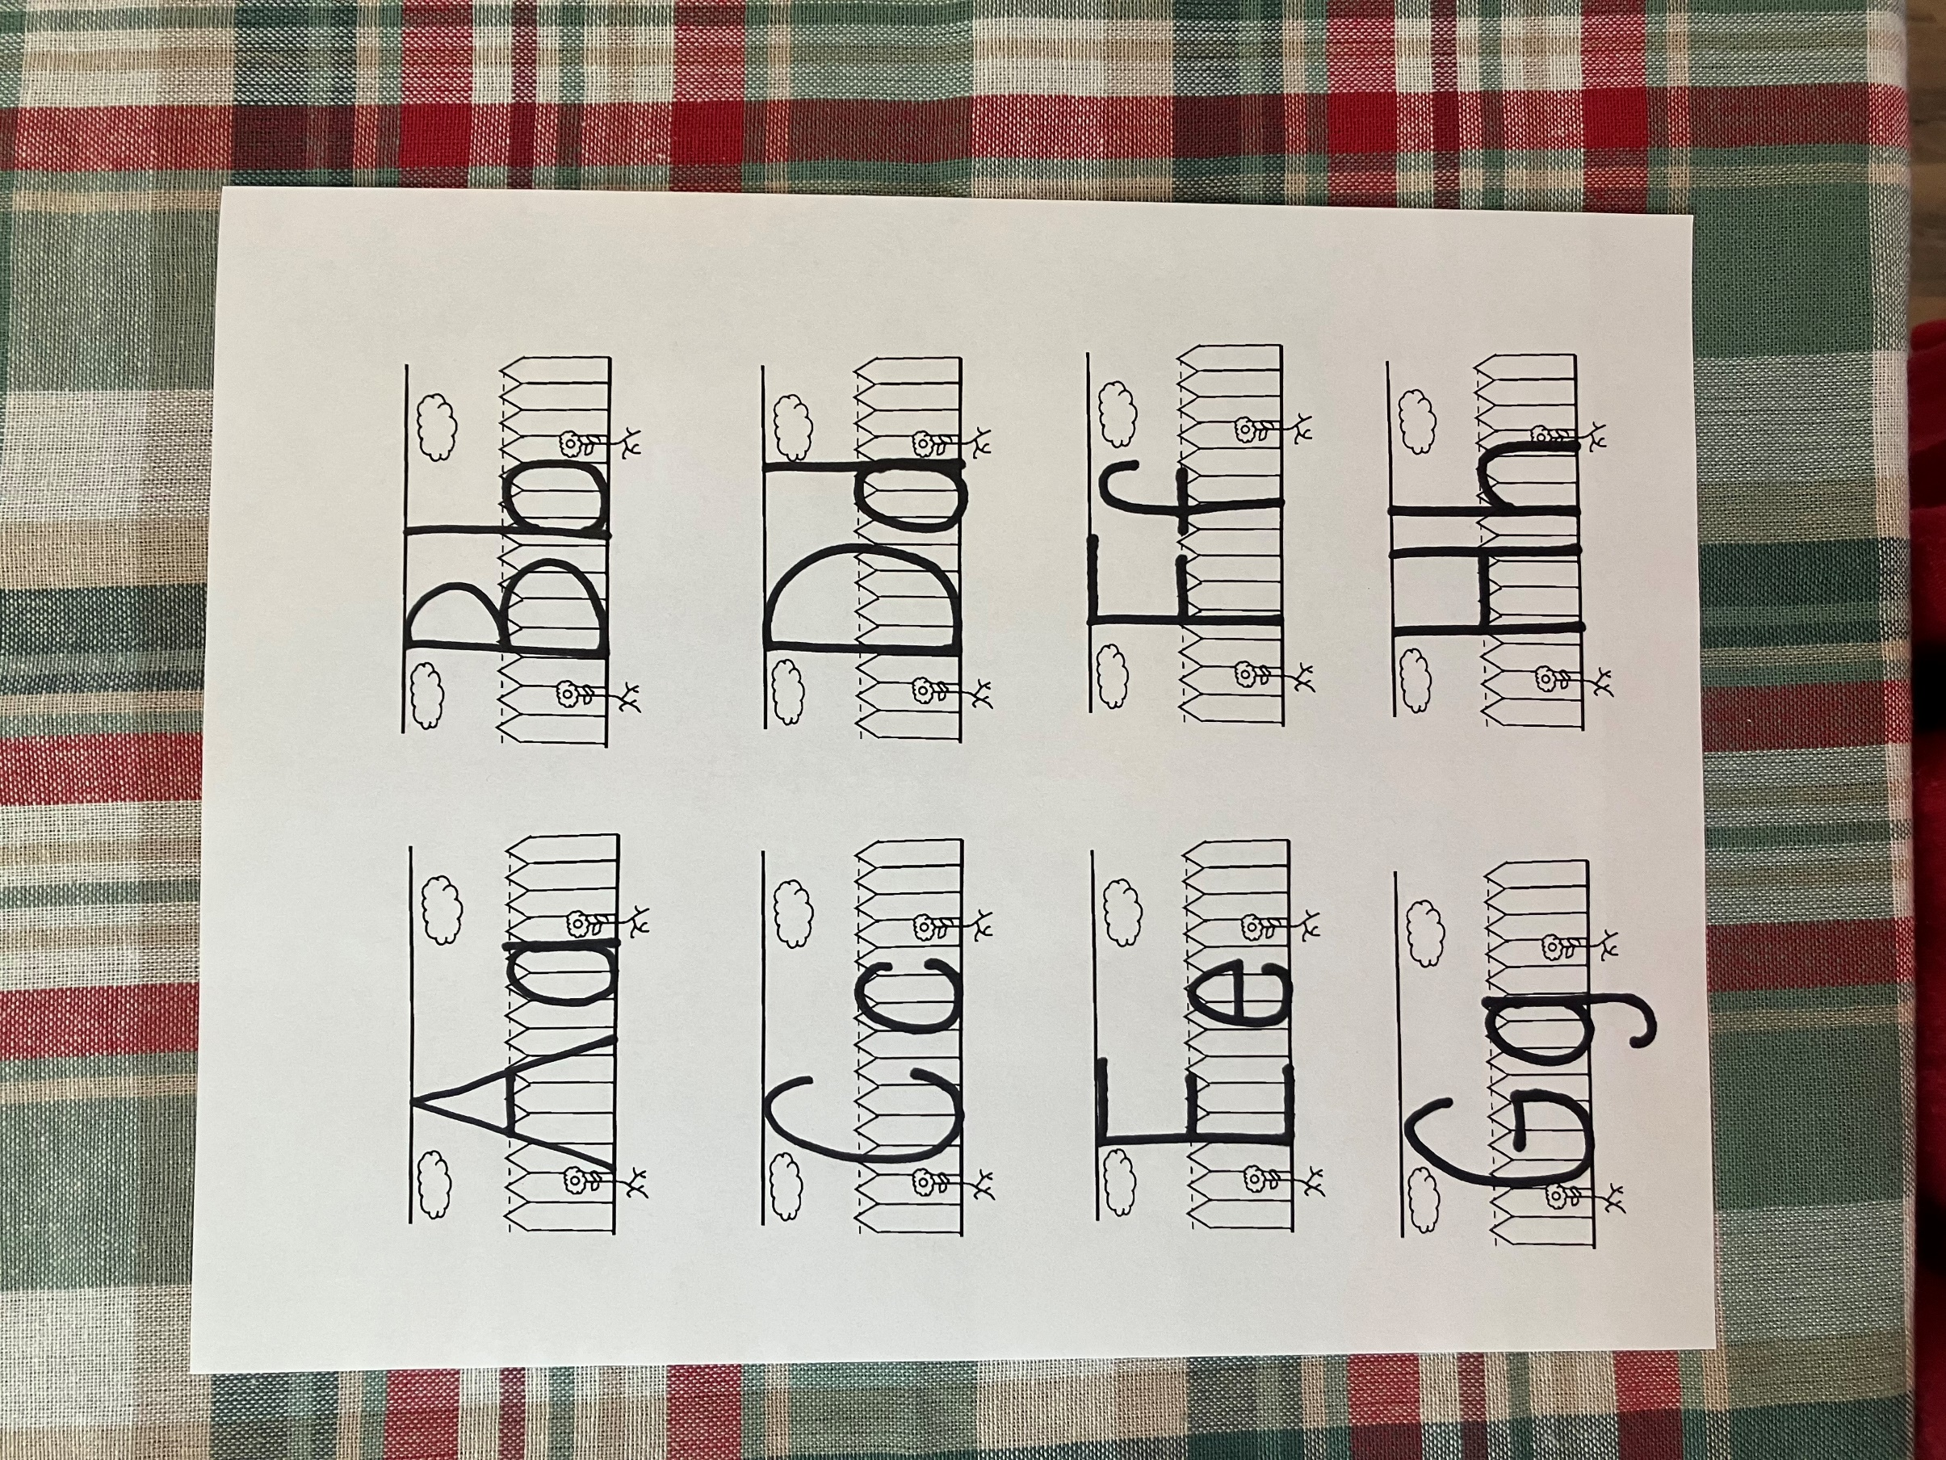

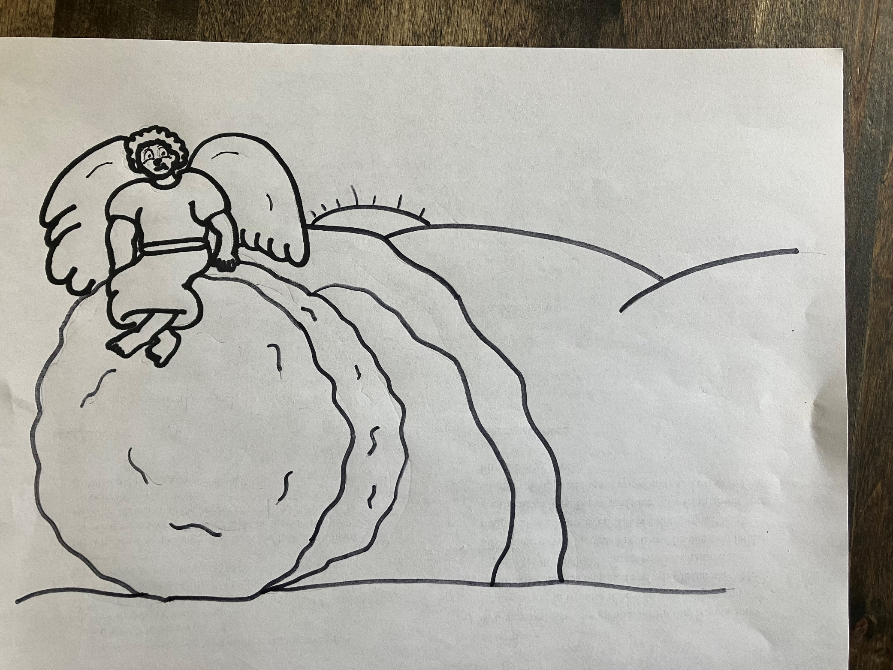
He is not here: for he has risen.
Matthew 28:6

