INSTRUCTIONS:

Print the triangles on pages 1 and 2 on regular printer paper. Cut out, cover front and back with contact paper. Cut out.







INSTRUCTIONS:

Print the triangles on pages 3 and 4 on full-page labels. Cut out, stick to the inside of a file folder. (Optional) Cover folder with contact paper.







“Number 3”

-Counting

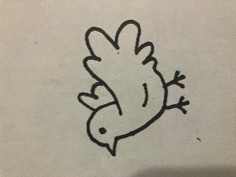



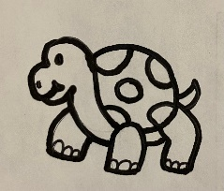















Daniel prayed 3 times every day. Look at each group. Put a thumbs up on the items it there are 3 items in each group. Put a thumbs down if there are not 3 items.

