Jesus and his disciples were in Jerusalem for the Passover celebration. Once a year all Jewish males over the age of 12 would travel to Jerusalem for this celebration so there were lots of people in Jerusalem at this time.
Jesus Washes the Disciples Feet
The disciples asked Jesus where he planned to celebrate the Passover meal. Jesus told two of his disciples, John and Peter, to go into the city. They were to look for a man carrying a pitcher of water and follow him back to his house. Usually, only women would go to get water. It would be easy for them to spot a man doing this job. Jesus told the disciples to follow this man. When he arrived at his home, they were to ask him to show him his guestroom because Jesus needed a place to have the Passover meal with his disciples. Then the man would take them to a room upstairs that was already prepared just the way they would need it.
Peter and John did just as Jesus said. They found the man, followed him, talked to him, and he showed them the upper room. Once the disciples had the place for the Passover meal, they were to prepare the food. For the Passover meal, they ate lamb, flat bread, sauces, and drinks. They ate lamb just as the Israelite children had done many years before. The Israelites were stuck being slaves for the Egyptians. God warned the Pharoah to let the Israelites go but he didn’t listen, so God sent plagues, or bad things, to happen. The last bad thing was that all the firstborns in each family would die. God told the Israelites to kill a lamb and put its blood on the top and around the sides of the doors of their houses. Then they were to eat the lamb. If they did what God instructed them to do, their children would be safe. The death angel would “pass over” their house. The Passover meal was to remember this event, so they chose to eat lamb just as the people had done.
When Jesus sat down to eat with his disciples, he told them this meal would be the last meal he would be able to eat with them. Jesus knew that he had a very important job to do that would take him away from the disciples. He tried to tell them about it many times, but they didn’t understand what he meant.
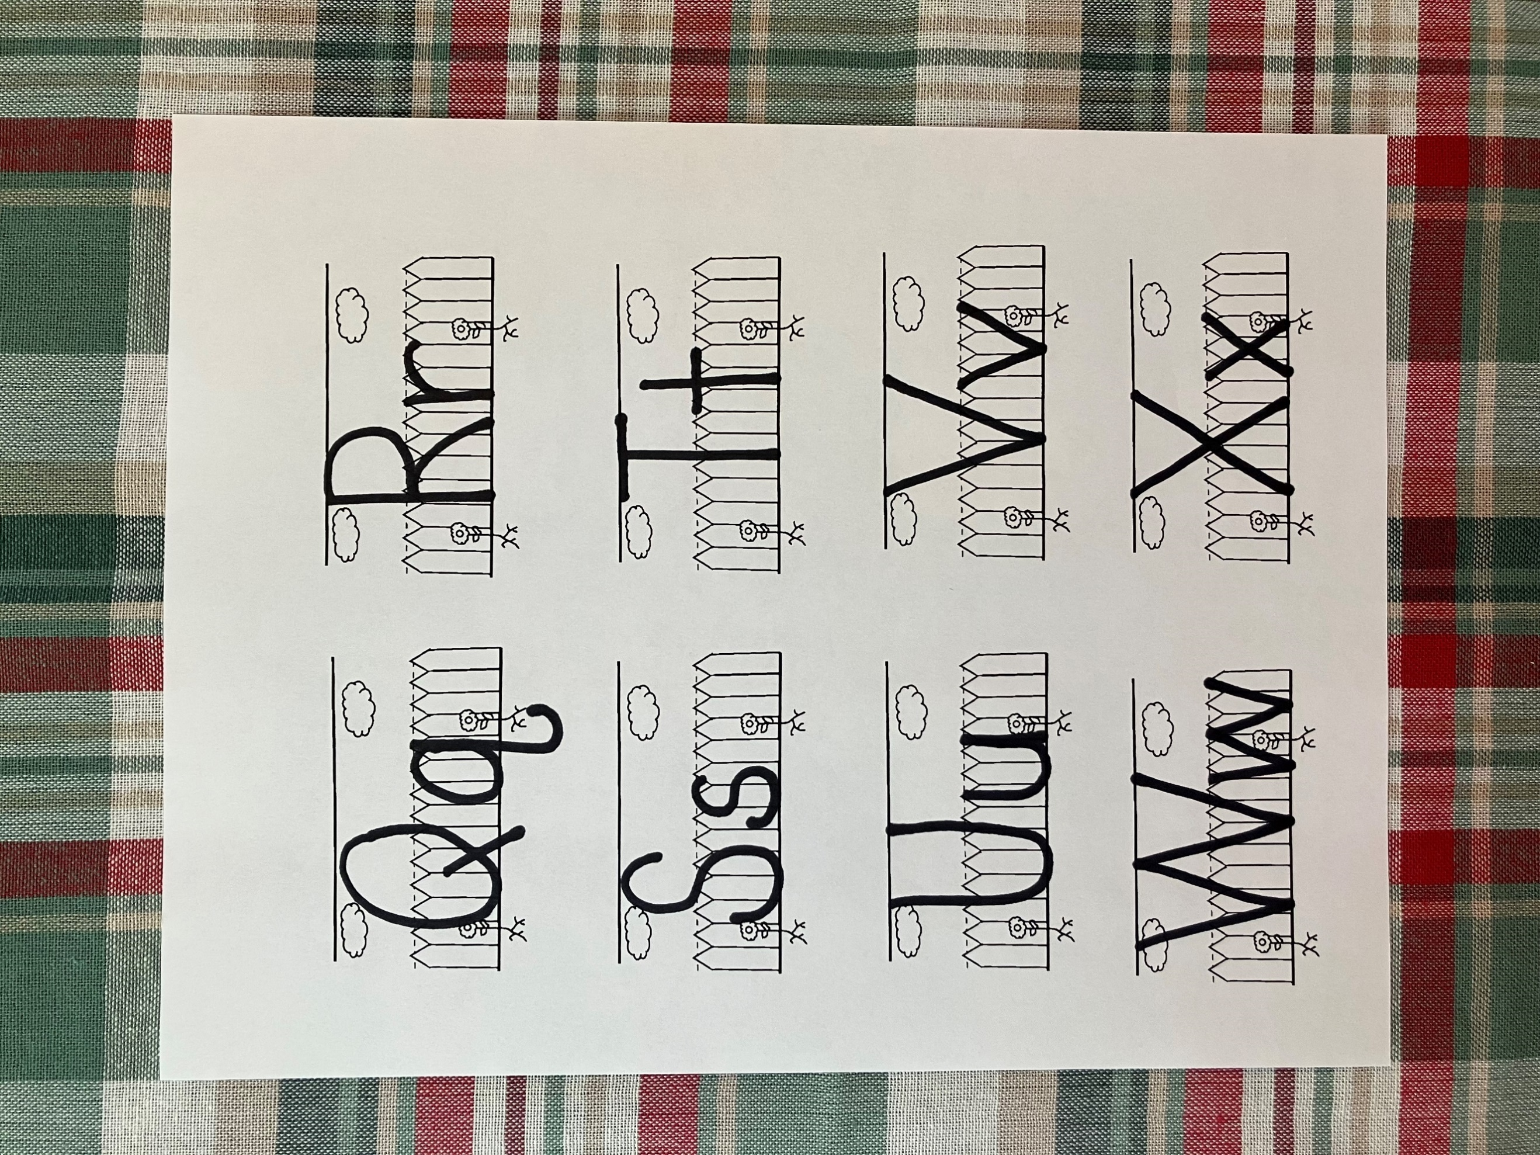
After the meal, Jesus stood up from the table, took off his outer robe and tucked a towel at his waist. Then he filled a large bowl with water. He carried the water to where the disciples were sitting and placed it on the floor. One by one, Jesus started washing the disciples’ feet. This was very strange for the disciples. They walked around all day on dusty roads in their sandals, so their feet were very dirty. Usually, a servant in the house would wash their feet, not Jesus. When Jesus got to Peter, Peter didn’t want him to wash his feet. It made him sad that someone as important as Jesus was going to be doing that dirty job. Jesus told Peter he could never be the disciple God wanted him to be if he didn’t let him wash his feet. This wasn’t just a nice thing Jesus was doing for his disciple. Washing their feet was helping them to understand that following Jesus meant serving others. Peter wanted to be exactly what Jesus him to be, so he told him to wash his hands and his head too. Jesus told Peter that only his feet needed to be washed because he was already clean on the inside but one of the disciples was not clean on the inside. Jesus knew that Peter loved him and wanted to do the right things, but Jesus also knew someone in the group did not.
T

t

towel

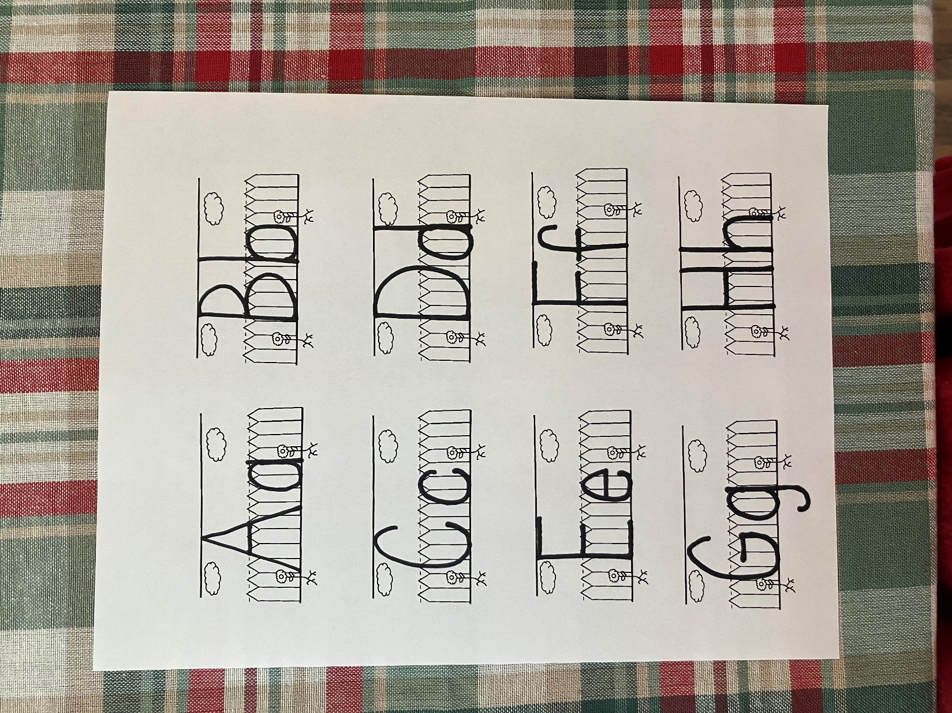
F

f

feet

- What special celebration was happening in Jerusalem?
- How would Peter and John know who to ask about the guest room?
- What were Peter and John supposed to do when they found they man?
- What did the disciples eat for the Passover Meal?
- What did do after the meal?
- Who usually washed people’s feet?
- Which disciple didn’t want Jesus to wash his feet?
- After Jesus explained why he was washing their feet, what else did Peter want him to wash?
- What secret did Jesus know about one of his disciples?

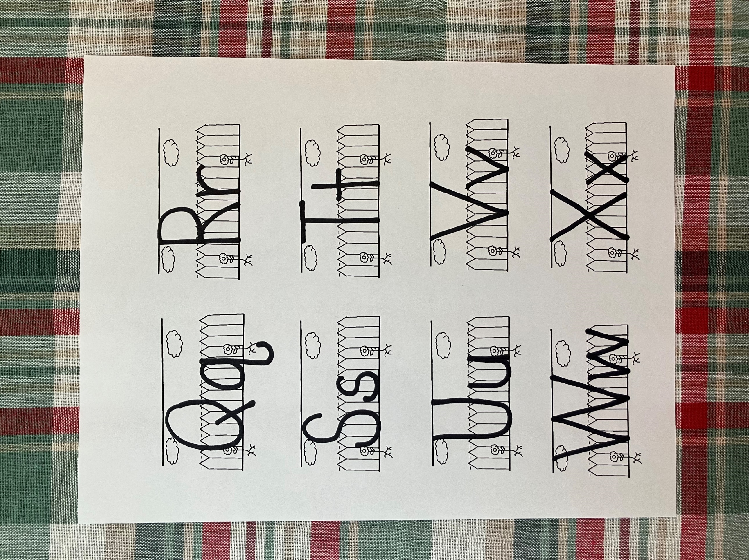
U

u

upper room

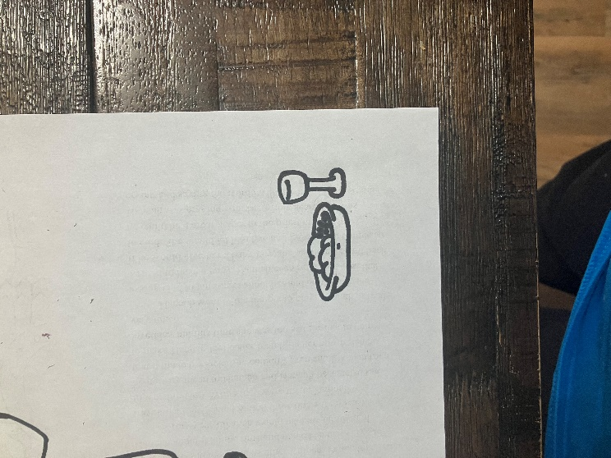
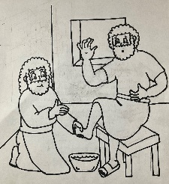
There were a lot of different things that happened in the story. Look at the pictures below and see if you can put them in order of how they happened
.
.

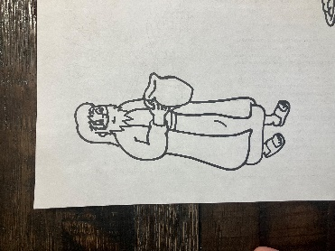

1st
2nd
3rd
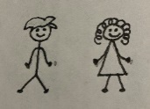
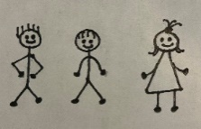
Jesus went around the room washing everyone’s feet. Everyone has two feet. There were 12 disciples so that was a lot of feet to wash. Look at the pictures below. Count the people and see if you can figure out how many feet he would have washed in each group.

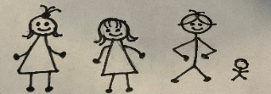


Tt
After that he poureth water into a basin and began to wash the disciples’ feet.
John 13:5

Lamb was the meat that was served for the Passover meal. It was very important because that’s what God told the Israelites to eat in the times of Moses. In the space below, draw a lamb.
upper room
- A guest room that people sometimes had in their houses. Sometimes these rooms would even have special stairs outside
.
.

- I was one of Jesus’s twelve disciples.
- Jesus told me and one other disciple to find the man with a pitcher.
- I helped prepare the Passover meal.
- I didn’t want Jesus to wash my feet.

Who am I?
___ ___ ___ ___ ___

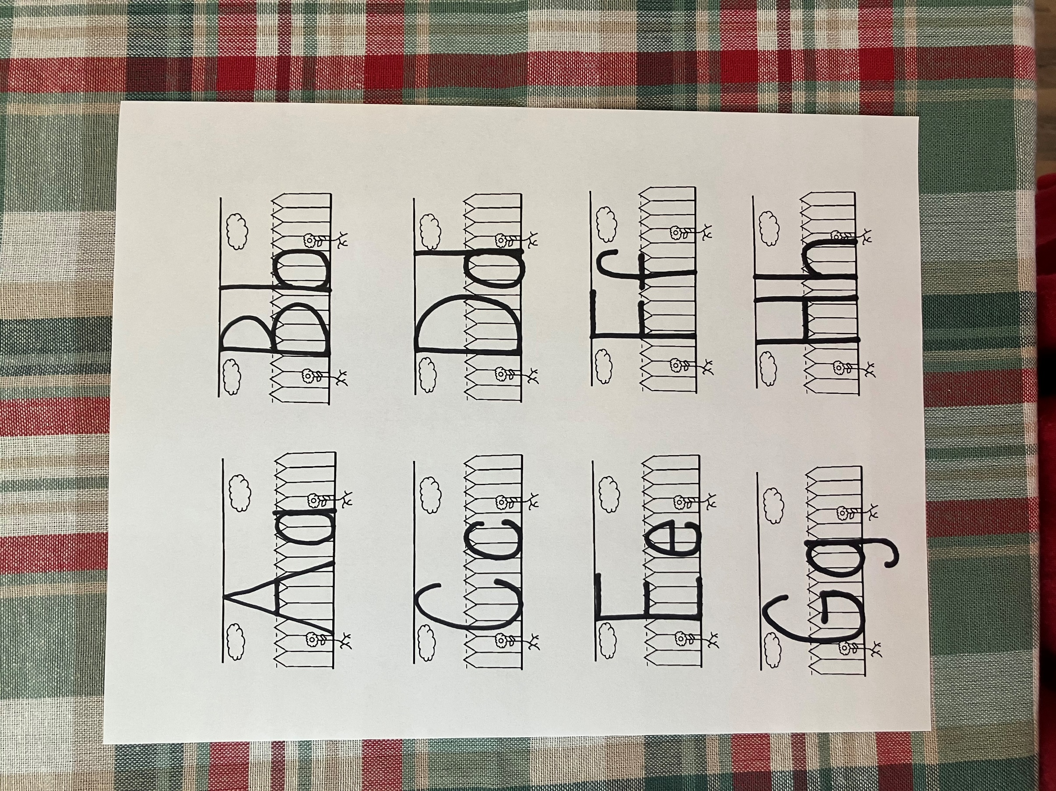

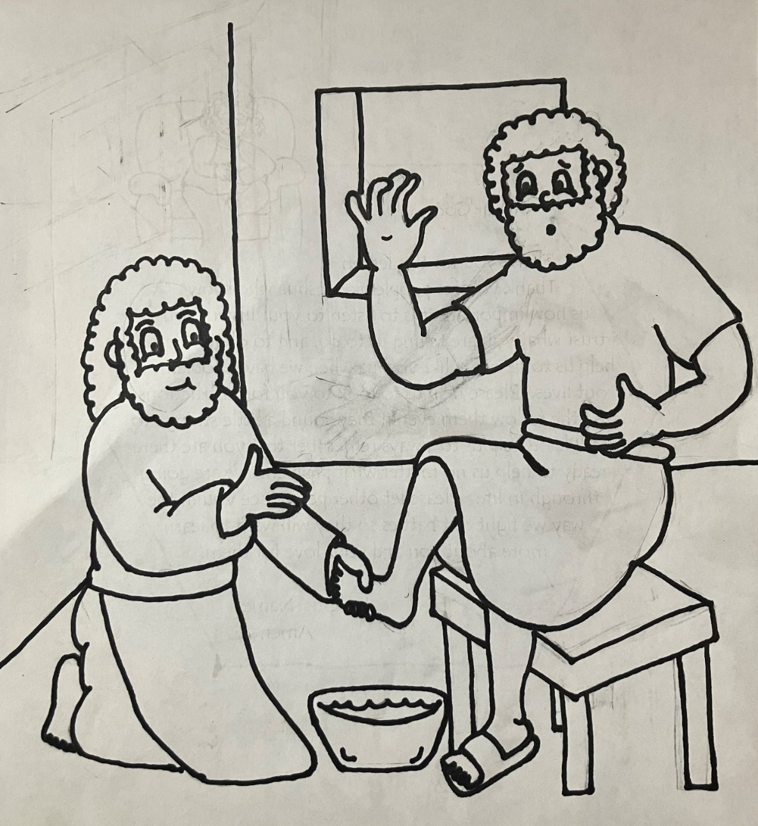
After that he poureth water into a basin and began to wash the disciples’ feet. John 13:5

