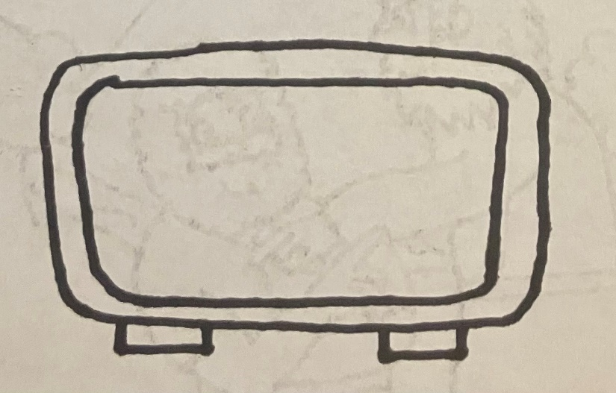

6:00

INSTRUCTIONS:

Print the clocks on pages 1 and 2 on regular printer paper. Cut out, cover front and back with contact paper. Cut out.





8:00

7:00



10:00

9:00



INSTRUCTIONS:

Print the clocks on pages 3 and 4 on full-page labels. Cut out, stick to the inside of a file folder. (Optional) Cover folder with contact paper.

1:00



3:00

2:00



5:00

4:00

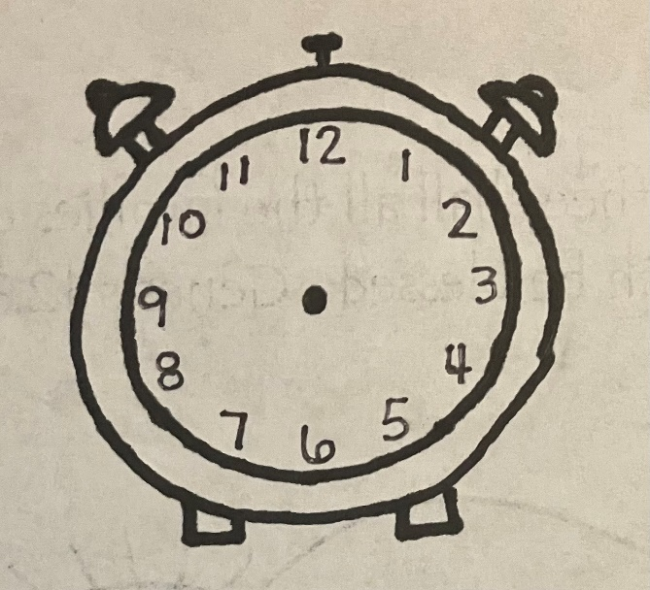

“The Time is Now”

-Time









Hannah had to wait until it was the right time for God to give her a baby. We can know time by looking at two different kinds of clocks. See if you can match the clocks that tell the same time.



