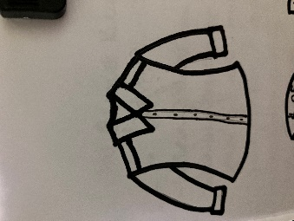

INSTRUCTIONS:

Print items on pages 1 and 2 on regular printer paper. Cut out, cover front and back with contact paper. Cut out.

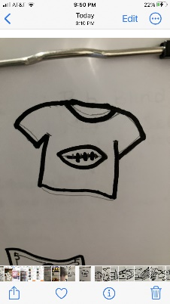

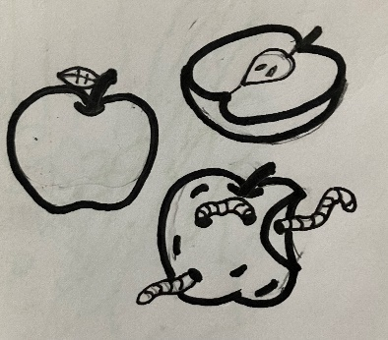



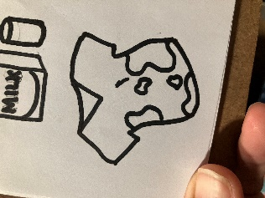



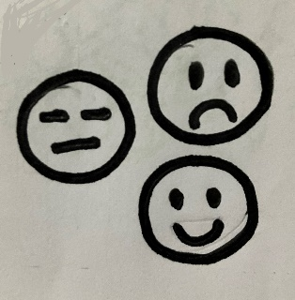

INSTRUCTIONS:

Print the rings on pages 3 and 4 on full-page labels. Cut out, stick to the inside of a file folder. (Optional) Cover folder with contact paper.

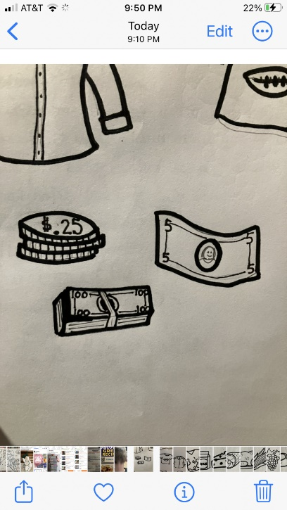







“Good, Better, Best”

-Comparing

God wants us to give Him our best. Look at the items and rank them. If the item is good, match it with a bronze medal. If an item is better, rank it with a silver medal. If an item is best, match it with a gold medal.