“Beginning or End”

-M Sounds

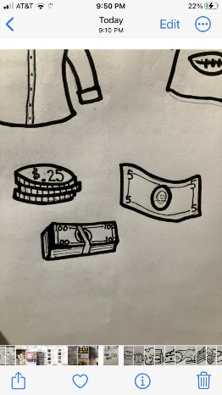

Mary and Mary thought Jesus needed to come BEFORE Lazarus died to be able to heal him, but Jesus came AFTER. Match the before and after picture.

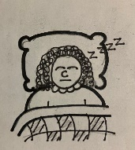

m___

INSTRUCTIONS:

Print pentagons on pages 3 and 4 on regular printer paper. Cut out, cover front and back with contact paper. Cut out.

m___

m___

m___

m___

INSTRUCTIONS:

Print pentagons on pages 1 and 2 on full-page labels. Cut out, stick to the inside of a file folder. (Optional) Cover folder with contact paper.

___m

___m

___m

___m

___m

