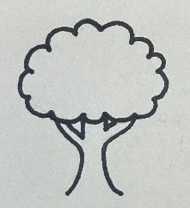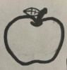

“An Apple a Day”

-Subtracting































Eve took one fruit off the tree. Look at each tree picture. How many fruits would be on the tree if Eve took one apple from it.





















INSTRUCTIONS:

Print the trees on pages 1 and 2 on regular printer paper. Cut out, cover front and back with contact paper. Cut out.

5



6

7



8

9



INSTRUCTIONS:

Print the trees on pages 3 and 4 on full-page labels. Cut out, stick to the inside of a file folder. (Optional) Cover folder with contact paper.

0



4

3

2

1