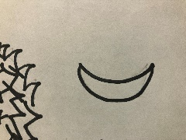

“Am I Seeing a Pattern”

-Patterns

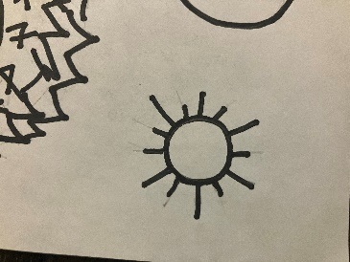





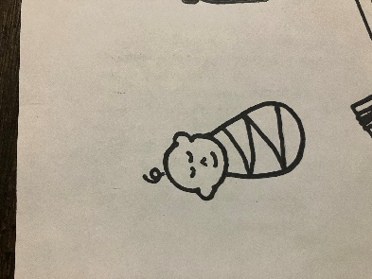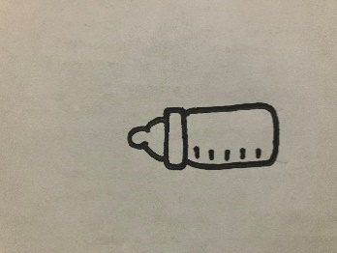









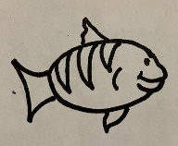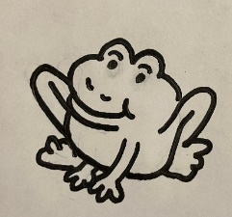





Josiah was a good king after years of bad kings. He broke the patterns of bad kings. Look at each rectangle and see if you can figure out what comes next in each pattern.

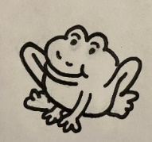



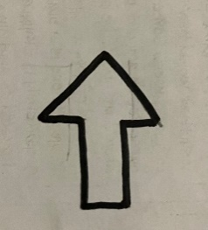



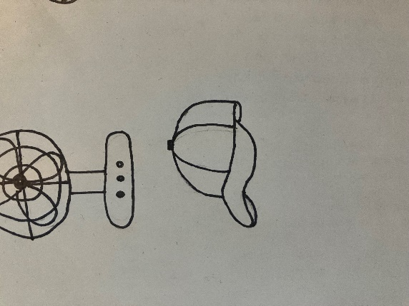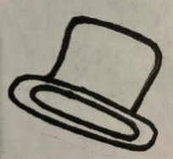





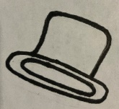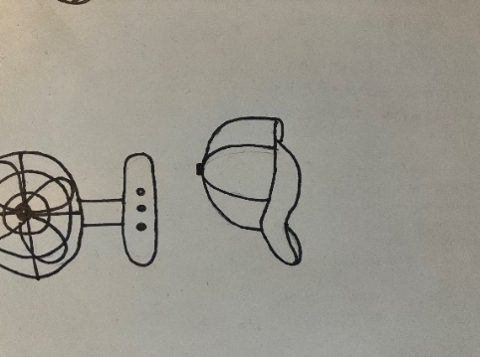

INSTRUCTIONS:

Print rectangles on pages 3 and 4 on regular printer paper. Cut out, cover front and back with contact paper. Cut out.











INSTRUCTIONS:

Print rectangles on pages 1 and 2 on full-page labels. Cut out, stick to the inside of a file folder. (Optional) Cover folder with contact paper.

