One evening after the Passover Meal, Jesus and his disciples went to the Garden of Gethsemane to pray. One of Jesus’ disciples had left the group on a secret mission to betray Jesus. His name was Judas. Judas had agreed to help the members of the Sanhedrin find Jesus in a quiet place so they could arrest him. The Sanhedrin hated Jesus and wanted to see him crucified for telling people he was the Son of God. Although they studies scriptures and should have recognized Jesus as the Messiah, he didn’t fit what they though the Messiah should be. They thought he was just trying to trick the people and pretend to be God. This made them so angry and full of hate that they wanted to see him killed.
Jesus Is Arrested
Jesus knew all that was about to happen to him. He had tried to warn the disciples, but they didn’t understand all that would take place or why it needed to take place. Jesus was very troubled that it was time for all of the bad things to start happening. He had gone to the garden to pray about all that was about to take place. Jesus asked his disciples to stand watch as he prayed because he knew they would all soon be in danger and he wanted to focus on praying. Three times Jesus came back from where he was praying in the garden to find the disciples asleep. They had no idea how serious things were about to get but Jesus knew exactly what was about to happen.
A little while later, Jesus woke the disciples telling them that Judas was coming. Judas knew Jesus often came to the Garden of Gethsemane to pray , pray.so he knew exactly where to lead the high priest, elders, and the guards.
Judas walked up to Jesus and said “Master, Master!” and then gave him a kiss. Jesus knew that kiss was not a friendly greeting like many people did in that time. Jesus knew that kiss was a sign to the other men who were with Judas. Judas was letting them know that Jesus was the man they needed to capture. The soldiers grabbed Jesus to arrest him. The disciples didn’t know what to do. They wanted to help Jesus, but they were scared all at the same time.
Peter grabbed one of the swords Jesus had given them earlier that night, and he cut off the ear of one of the men. The man’s name was Malchus. He was a servant of the high priest. Peter thought he was being brave and helping Jesus, but Jesus didn’t
need them to fight. Jesus told Peter to stop fighting. It was God’s plan for him to be arrested. Jesus touched the man’s ear, and he was healed. Then Jesus was taken away by the guards and priest and the disciples scattered in fear just as Jesus told them they would do.
.

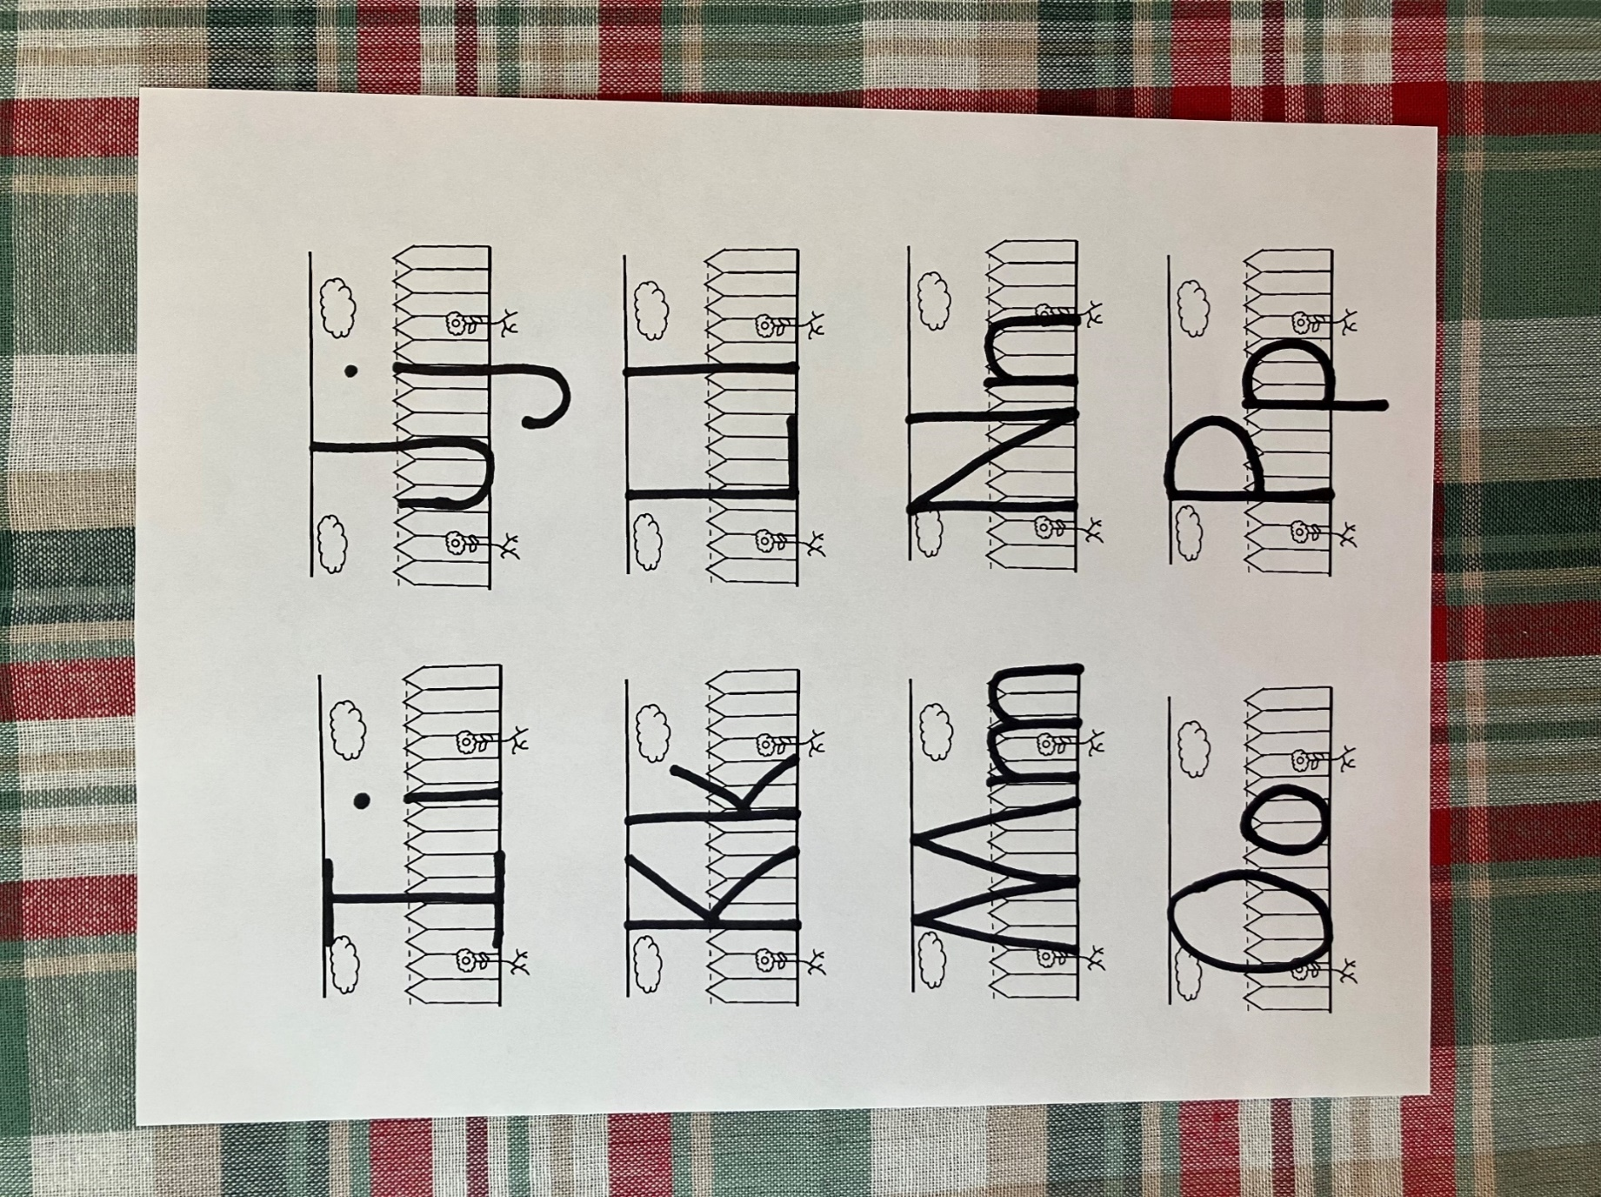
J

j

Judas

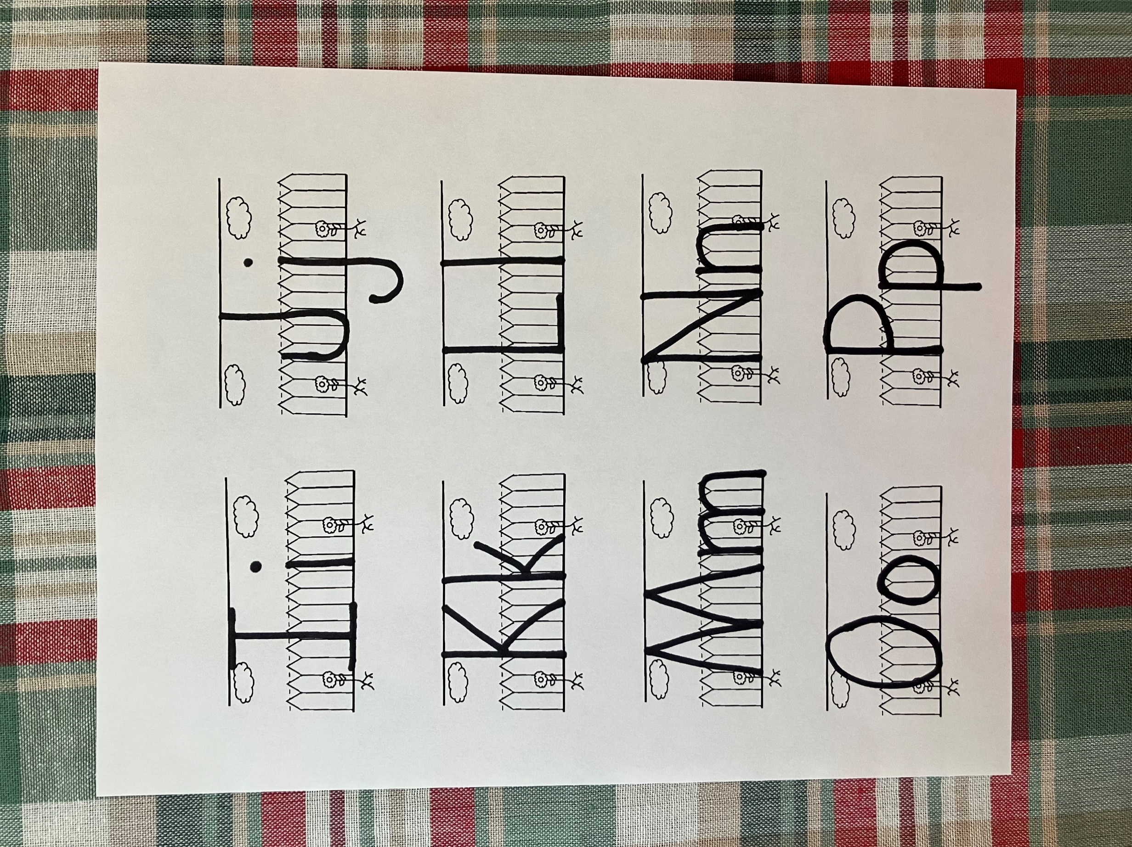
K

k

kiss

- Where were Jesus and his disciples?
- Who lead the guards to find Jesus?
- How did Judas know where to find Jesus?
- What did Judas do to Jesus so they would know who they should arrest?
- What did Peter do to one of the guards?
- What did Jesus do to the man’s ear?
- Why didn’t Jesus want the disciples to fight the guards?
- What did all the disciples do after Jesus was arrested?

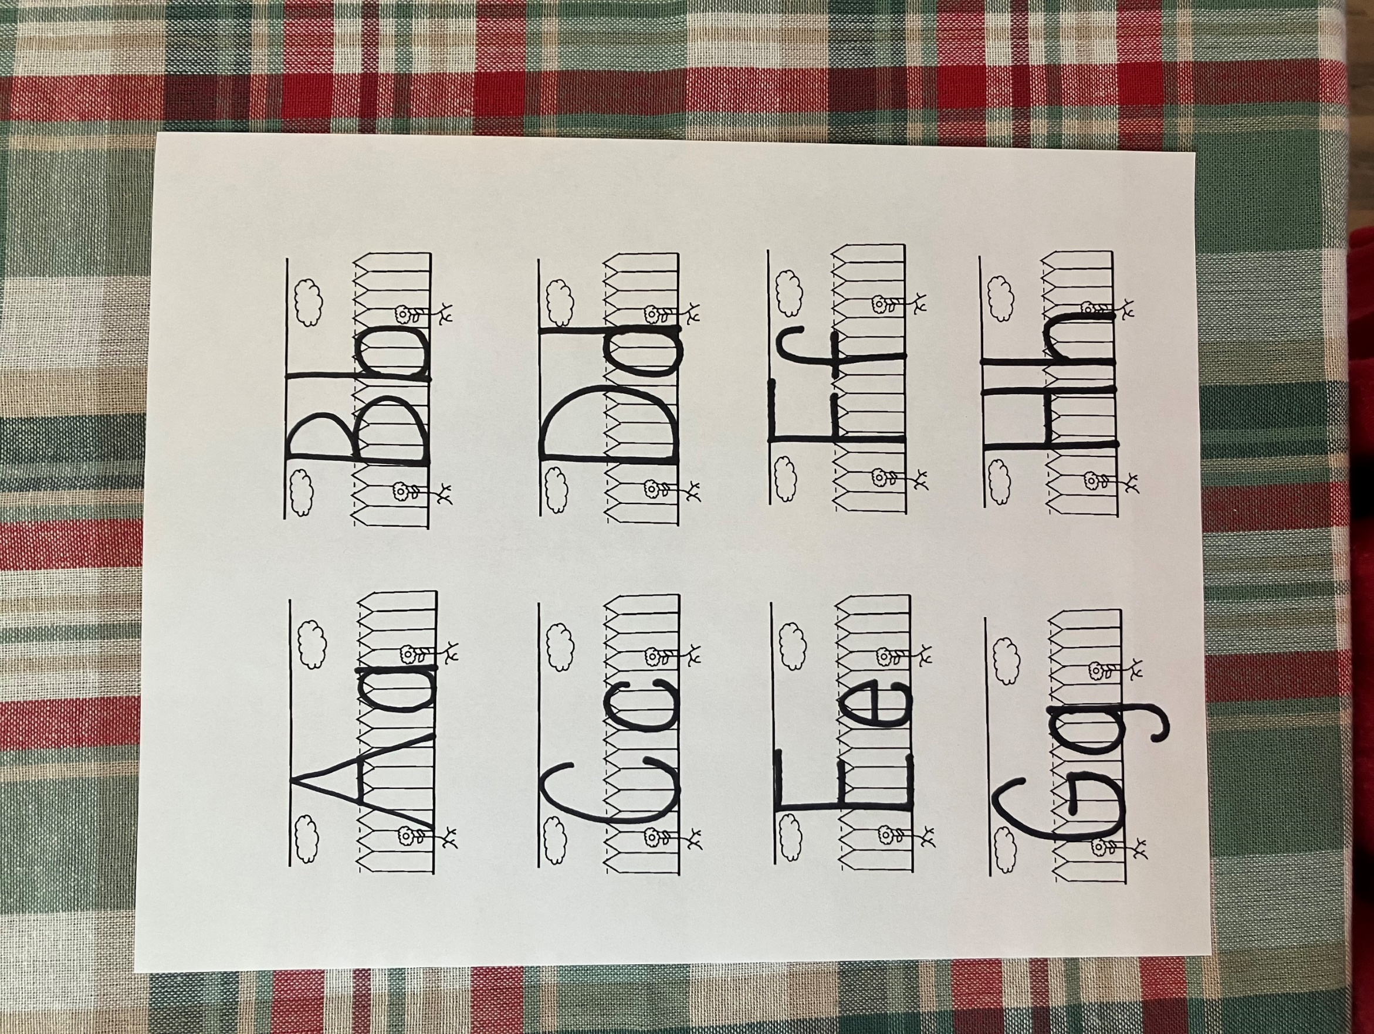
E

e

ar
e

When Jesus was arrested, Peter was filled with fear and cut off the soldier’s ear. Fear and ear rhyme. They have the same ending sound. Look at the pictures below and see if you can match the items that rhyme.
.
.

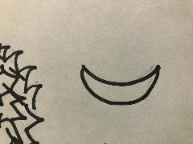
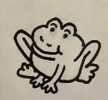
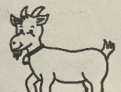
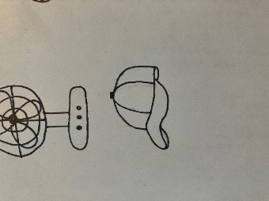
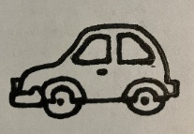

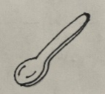

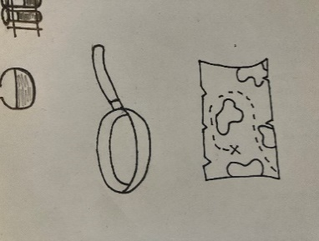
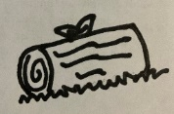
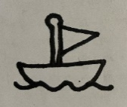
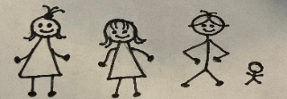
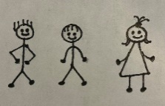
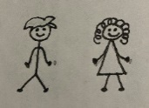
Jesus had 12 disciples. Judas was the first to leave him. When he was arrested the others left too. Look at the pictures below and subtract the disciples. Put an X over the disciples as the leave

12-1 = _____
11-2 = _____
9-4 = _____

5-5 = _____
Kk
And they laid hands on him, and took him. Mark 14:46
Peter cut off someone’s ear, but Jesus touched it and it was healed. In the space below. Draw an animal with funny ears
arrested
- when someone is captured by the police or guards and taken to jail or to be to be punished

- I was one of Jesus’ disciples.
- I was with Jesus in the garden
- I saw Jeus get arrested.
- I heard Jesus say it was part of God’s plan.
- I tried to help Jesus but cutting off the ear of one of the guards.

Who am I?
___ ___ ___ ___ ___ ___

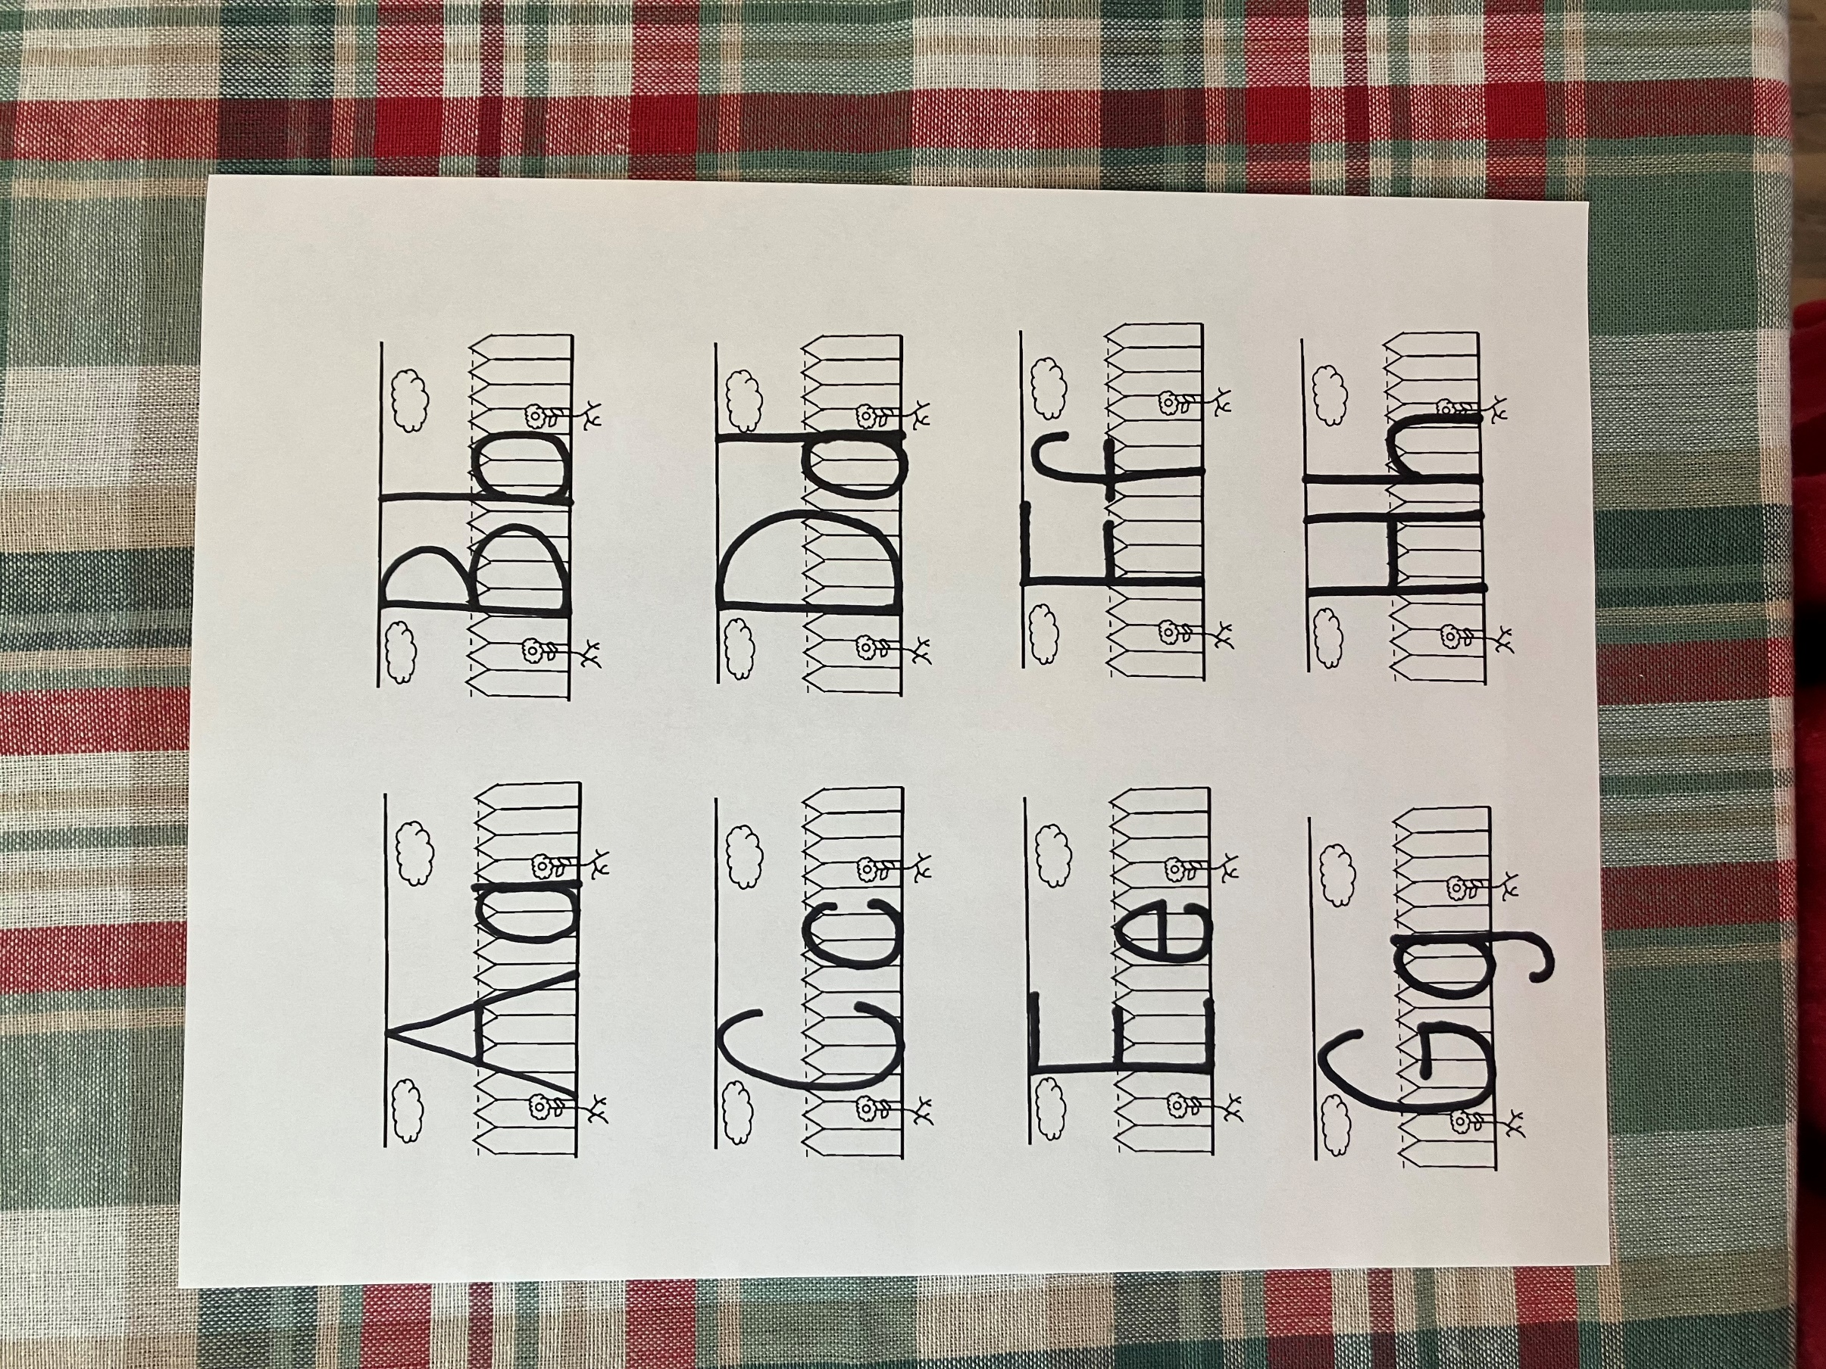

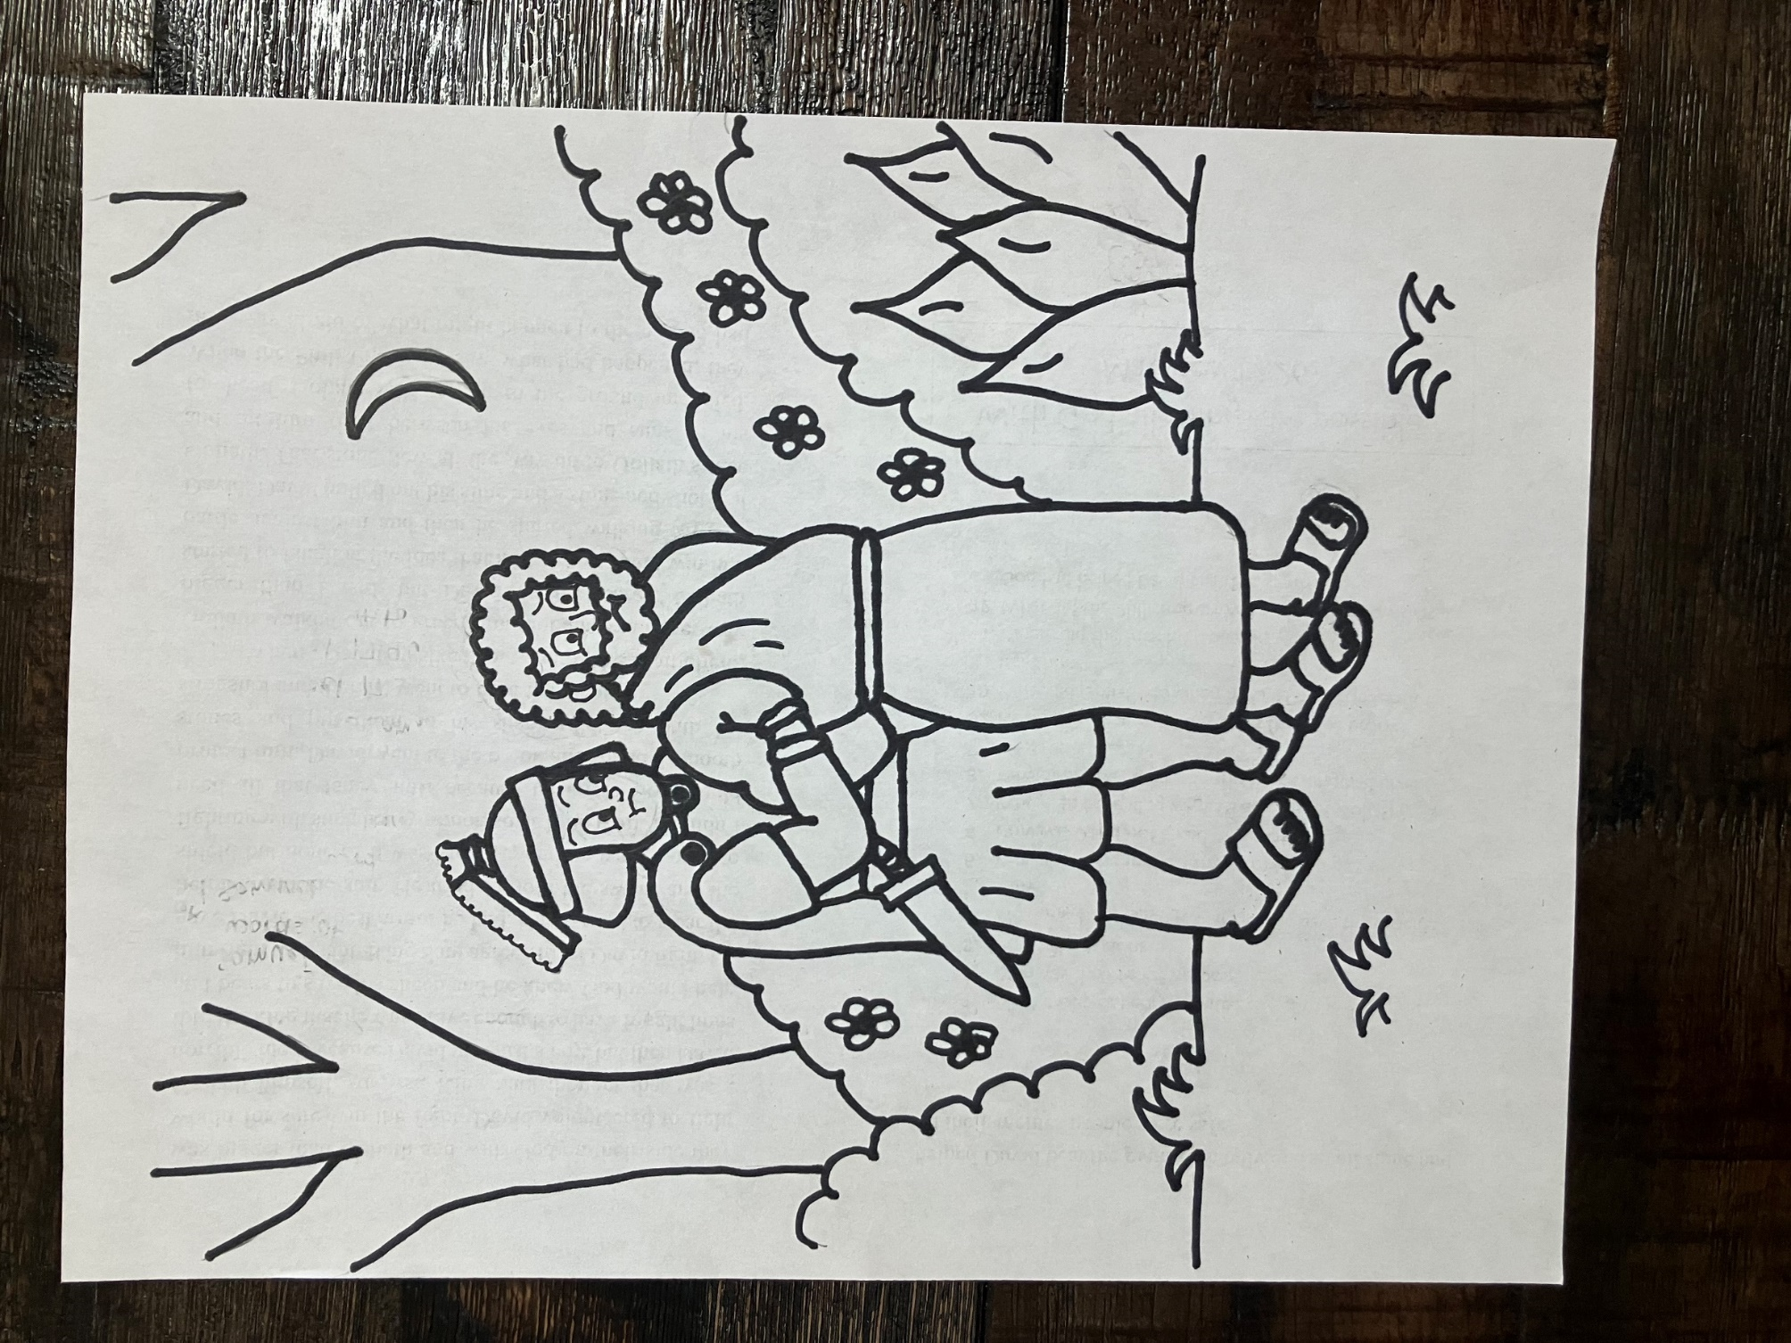
And they laid hands on him, and took him. Mark 14:46

