Not members of the Sanhedrin convinced the Roman government and many Jewish people that Jesus was not the Son of God, and he needed to be crucified. Jesus knew his crucifixion was part of God’s plan for him to save the world from their sins, so he did not fight back. He was arrested, questioned, beaten, spit upon, and then hung on a cross until he was dead. Just after he died, the ground began to shake, graves burst open, dead people lived again, and the veil in the temple ripped from top to bottom. Everyone knew something incredible had just taken place, but the people were confused. Those who believed Jesus was the Son of God were sad and didn’t understand why he had died. Those who did not believe were angry at Jesus, happy that he was dead, and a little unsettled at all that had taken place. No one really knew what was going on at all. Joseph of Arimathea had requested Jesus body so he could give him a proper burial. Joseph had to hurry because it was almost time for the Sabbath to begin and he was not allowed to work on the Sabbath. Preparing the dead would have been considered work and could have gotten him in a lot of trouble. He hurried and wrapped Jesus’ body in linen cloths and placed it in a tomb. Then he rolled a large stone in front of the opening. The members of the Sanhedrin requested that the governor place guards near the tomb to be sure that no one stole Jesus’ body.

Jesus Is Risen

Several women had been with Jesus at the cross. They, like Joseph of Arimathea, also wanted to be sure to give him a proper burial so they watched from far off to see where Joseph had taken his body. They were going to return after the Sabbath to clean his body and pour oils and perfumes on him the way that most bodies were prepared for burial.

As soon as the Sabbath day was over, Mary, Mary Magdelene, Salome who married to a man named Zebedee, and a lady named Joanna gathered spices and oils and headed to the tomb where Jesus had been placed. Just before the arrived at the tomb there was a great earthquake. An angel of God came down from heaven, rolled away the stone, and then sat upon it. The guards trembled in fear and then passed out on the ground. As the ladies walked closer, they could see a man dressed in white sitting on the stone. They did not know he was an angel, but he was so bright they had to look away. They were very frightened. The angel told them not to be afraid. The angel knew why they were there. He asked them why they were looking for someone who was alive in a place that was for a person who was dead. Jesus was no longer there. He had risen. He told them to go and find the disciples and tell them that Jesus had risen from the dead. Then ladies turned and headed back to Galilee to get the disciples. When the Roman guards came to, they rushed to tell the members of the Sanhedrin what had happened. The Sanhedrin didn’t want anyone to know these things so they gave the guards a lot of money and told them to tell anyone who asked that the disciples stole Jesus’s body while they were asleep. The guards agreed to keep their secret even though they knew it was a lie.

Then ladies turned and headed back to Galilee to get the disciples. Along the way, the ladies met Jesus on the road. Jesus was alive and he was right there with them! They were so excited that they fell to his feet to worship him. Jesus told them to go into Galilee and tell the disciples he would soon see them there. The ladies left to find the disciples.

When Mary found the disciples. They were all hiding, scared of what might happen to them. They were afraid of what the Sanhedrin might try to do them. They didn’t know what to do. Mary told them that Jesus was alive and she had been with him and talked to him. The disciples did not believe what she was telling them. Peter and John jumped up and ran as fast as they could to the tomb where Jesus had been buried. John was the first one to arrive at the tomb, but he did not go in. Then Peter arrived and ran right inside. Peter could see the cloths that had been wrapped around Jesus body. They were still in the shape of a man’s body, but Jesus was gone. Peter ran back out of the tomb wondering what was going on. When John saw the cloths, he knew Jesus had risen just as he said he would. Peter and John rushed back to tell the other disciples what they had found.



Printing Practice

angel

Aa

Oo

oils

Zebedee

Zz

1. Where were the ladies going right after the Sabbath ended?
2. What were the ladies’ names?
3. Who rolled the stones away?
4. What happened to the guards?
5. What did the angel tell the women to do?
6. Who did the women run into on the road?
7. What were the disciples doing when Mary found them?
8. Which two disciples ran to the tomb?
9. Which disciples ran into the tomb?
10. What did the disciples find in the tomb?

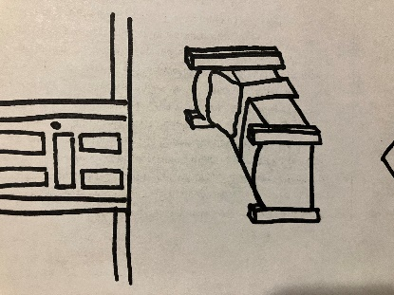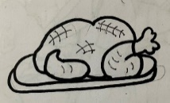



car

When Peter ran into the tomb and found the cloths that had been wrapped around Jesus, they were still in the shape of a man. Look at the picture below and see if you can match the items with their shapes on the other side.



corn

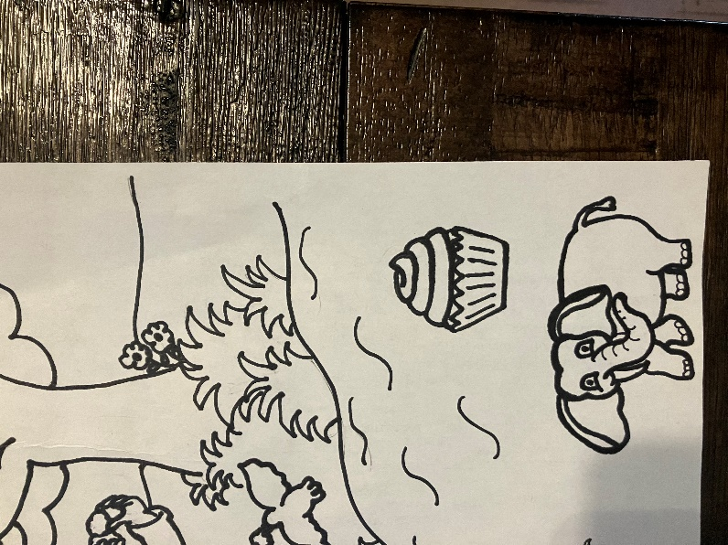



turkey





frog





cupcake





bed

Memory Verse

Find it, Read It, Write It, Explain It!

**He is not here: for he has risen. Matthew 28:6**

Cursive Practice

A a

angel

Oo

oils

Zebedee

Z z

U

“The Early Bird Gets the Worm”

Have you ever heard anyone say that?” People

usually say this when someone misses out on something because

they are late. Birds search for food to eat so the first bird to find a worm

gets the worm. If a bird doesn’t get out there to look for worms, they might miss out on finding one. This is a little like our story because Mary and the other ladies went as soon as they could to prepare Jesus’ body for burial. The laws of the Sabbath wouldn’t allow them to do anything for an entire day but as soon as the Sabbath was over, they were headed to the tomb to do the work. Because these ladies went as soon as they could, they saw the angel, they spoke to the angel, they saw Jesus, and they spoke to him. The disciples didn’t get up early to do this and they missed out on seeing things first. The women weren’t waiting to see what would happen next. They didn’t let anything keep them from doing what they thought needed to be done. They didn’t waste any time. They kept worshipping and honoring Jesus even in death. In our story today, the early birds didn’t

get the worm, the early birds got to see Jesus right after

he rose from the dead. I’d take that

over worms any day!

Crossword Puzzle

DOWN

1. Who rolled the stone away?
2. Who told the disciples that she had seen Jesus?
3. Which disciples went into the tomb?
4. What was the angel sitting on?

ACROSS

1. Where was Jesus buried?
2. Who passed out near the tomb?
3. Which disciples was the first to arrive at the tomb?
4. The angel said, “He is not here, he has _________”

|  |  |  |  |  |  |  |  |  |
| --- | --- | --- | --- | --- | --- | --- | --- | --- |
|  |  |  |  | 3 |  |  |  |  |
|  |  |  |  |  |  |  |  |  |
|  | 1 |  |  |  |  |  |  |  |
|  |  |  | 5 |  |  |  |  |  |
|  |  |  |  |  |  | 4 |  |  |
| 6 |  |  |  |  |  |  |  |  |
|  |  |  | 2 |  |  |  |  |  |
|  |  |  |  | 7 |  |  |  |  |
|  |  |  |  |  |  |  |  |  |
|  |  | 8 |  |  |  |  |  |  |
|  |  |  |  |  |  |  |  |  |

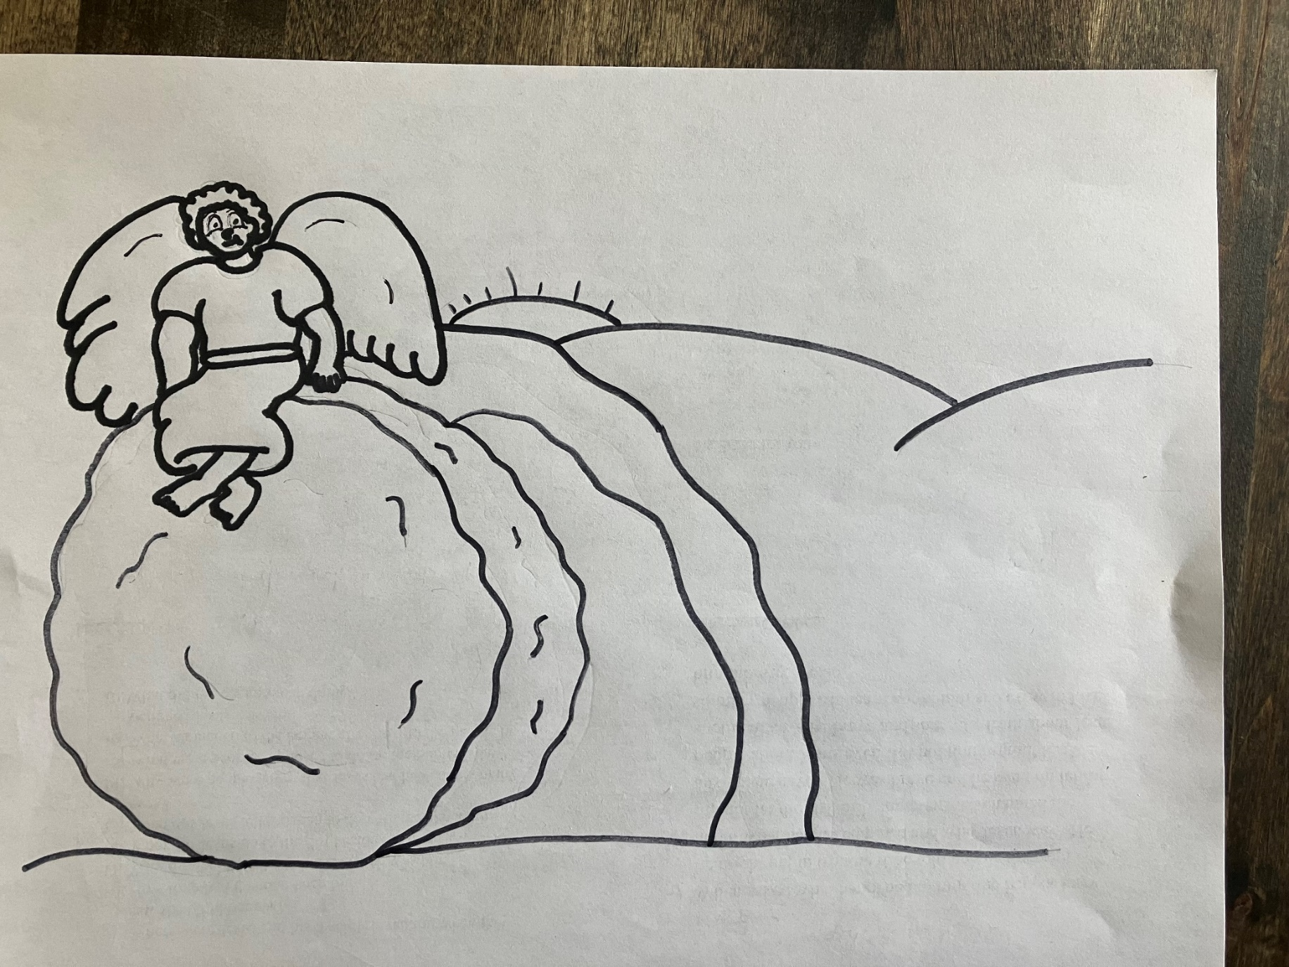

**He is not here: for he had risen.**

**Matthew 28:6**



**3**



**4**

**4**

**2**

**1**

**2**

**2**

**5**

1 – green 2 – gray 3 – light blue

4 – yellow 5 – black

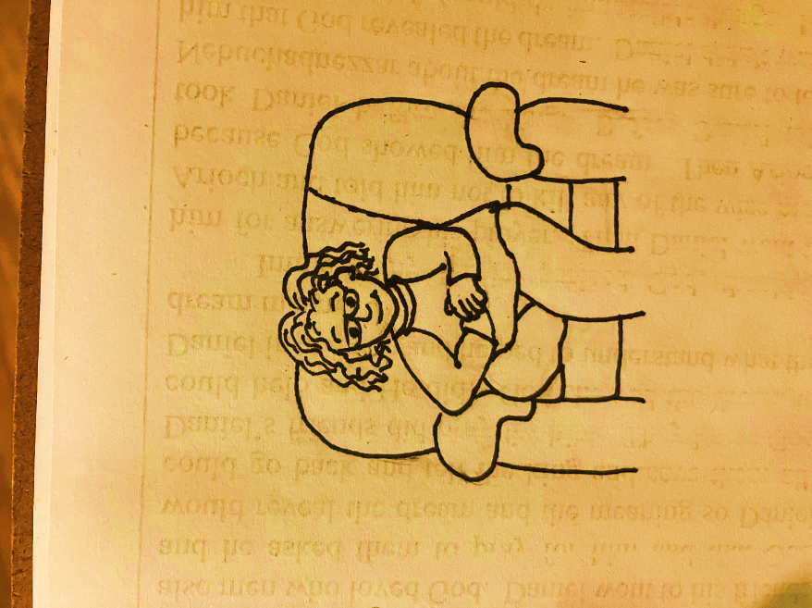

Dear God,

Thank you for this lesson.

Thank you for Jesus. Thank you for sending

Jesus to die on the cross to pay for my sins.

Thank you for loving me enough to have that plan.

Thank you for letting him rise again three days later

just as he said he would. Please help me to never forget

what Jesus went through so that I can be with you in heaven for all eternity. Please help me share the news of his death, burial, and resurrection everywhere I go because the world needs to know. Help me to do my part to help others learn about you and your love for them. Please be with anyone who doesn’t realize they are a sinner who needed Jesus to die to pay for their sins. Help them to realize that their sins

are something they can’t pay for on their own. Please

help me to remember that it’s my job to help them understand that Jesus died for them just as

much as he died for me. Help me to want

to share the love of Jesus everywhere I go.

In Jesus’ Name,

Amen