Jesus came to earth to love people and to teach them about God’s love. He performed miracles and did many wonderful things, and many people followed and believed he was the Son of God. Jesus never sinned, everything he did was pleasing to God, yet some people hated him. The chief priest and the elders hated him so much, they wanted Jesus to be killed. They did not believe he was the Son of God, and it made them very jealous that other people followed and worshipped him.

Peter Denies Jesus

With the help of Judas, one of Jesus’s disciples, they came up with a plan and arrested Jesus while he was in the Garden of Gethsemane praying with the other disciples. The soldiers carried Jesus away and the disciples scattered in fear. Jesus wasn’t afraid, He knew this was part of God’s plan. He knew bad things were about to happen. He had tried to warn the disciples about it many times, but they didn’t understand what he was telling them.

After Jesus was arrested, the soldiers and high priest led Jesus to the house of Annas. Annas was like a judge. He could give them permission to punish Jesus if he thought Jesus needed to be punished. Peter and John secretly followed them because they wanted to know what was happening to Jesus. When they came to the home of Annas, John entered the gate because he knew Annas. Peter waited just outside. When John realized Peter hadn’t followed him in, he went back to the girl who was guarding the gate and spoke to her. Then he went to Peter and told him it was ok for him to enter. As Peter was going in, the girl at the door recognized him and asked him if he was one of the disciples. Peter was afraid so he acted like he didn’t know what she was talking about. and just kept walking. Peter didn’t go too far from the door. He stopped by the fire to warm himself and tried to blend in with the servants who were also standing there. John walked farther so he could see and hear what was happening to Jesus.

Annas asked Jesus lots of questions. He asked him about his disciples and about what he was teaching. Jesus answered Annas by telling him that he wasn’t teaching anything in secret, it was for all people. Many people could tell him what he had been teaching. Annas and the soldiers didn’t like the way Jesus answered that question. One soldier smacked Jesus because they thought he was being rude to Annas. Jesus responded, “I’ve told the truth, why did you hit me?” Annas didn’t want to deal with Jesus anymore, so he sent him to Caiaphas. Caiaphas was the highest of the high priest. He already hated Jesus. In fact, he was the first person to have the idea to kill Jesus.

Caiaphas was married to Annas’s daughter, and he lived very close to Annas’s house. Peter was still standing by the fire with servants, but from the fire, he could see both houses. While he was standing there one of the servants said, “This man was with Jesus of Nazareth.” Peter was scared, he started to panic and said, “I swear I don’t know him.” This was the second time Peter acted like he didn’t even know Jesus. By this time some of the guards were also standing around the fire. One of them was Malchus. Malchus had been in the garden when Jesus was arrested. Peter had tried to fight him and cut off his ear with a sword. Jesus healed Malchus’ ear by just touching it. Malchus knew for sure that Peter was the man who had cut off his ear. He said to Peter, “Didn’t I see you with Jesus tonight in the garden?” For the third time Peter acted like he didn’t know Jesus. Just then the rooster crowed. Jeus looked at Peter from where he was standing. Peter knew exactly what he just had done. Just as Jesus said he would do; Peter had denied Jesus three times. Peter then ran away weeping. He was sad and embarrassed at what he had done.

Meanwhile, Caiaphas was questioning Jesus. The members of the Sanhedrin brought in other people to tell Caiaphas all the things Jesus had done wrong. People told lies about Jesus and twisting his words trying to get him into trouble. Caiaphas knew the people were lying and he needed proof before he could punish Jesus. Caiaphas turned to Jesus and said, “Are you the Son of God?” Jesus didn’t answer by saying “Yes.” Instead, he told Caiaphas that he would know the truth when he died and saw him sitting right beside God. This made Caiaphas so mad that he ripped his clothes. He accused Jesus of blasphemy which means pretending to be God. That is a very bad thing, and the law said people who pretended to be God should be put to death. They didn’t know Jesus wasn’t pretending to be God. He really was the son of God. Caiaphas and the priest wanted Jesus to die but he didn’t have enough power to make that decision. Jesus was then sent to stand before the Roman governor.

Printing Practice

Caiaphass

Cc

Peter

Pp

Rr

rooster

1. Who was the first person the guards took Jesus to see.
2. Which two disciples followed Jesus?
3. Which disciple waited by the gate and which disciple went into the house?
4. Where did Peter stand when he entered the gate?
5. Who was the first person to recognize Peter?
6. Who was the third person to recognize Peter?
7. What happened after Peter denied Jesus the third time?
8. What happened to Jesus when the guards didn’t like his answers to Annas?
9. Who did Annas send Jesus to speak to?
10. When Jesus told Caiaphas that he would one day see him sitting beside God, what did Caiaphas do?
11. Who did Caiaphas send Jesus to talk to?

1st

Jesus was sent to Caiaphas

Caiaphas ripped his clothes

A lot of things happened in this lesson. See if you can put them in the right order.

2nd

3rd

Jesus was sent to the governor

4th

Annas Questioned Jesus

5th

The guard smacked Jesus

1st

The girl recognized Peter

2nd

John went back for Peter

The rooster crowed

3rd

5th

4th

Peter waited by the fire

Malchus recognized Jesus

Memory Verse

Find it, Read It, Write It, Explain It!

**Peter then denied again: and immediately the cock crew. John 18:27**

Cursive Practice

Caiaphas

C c

P p

Peter

R r

rooster

U

“Strike Three, You’re Out!

In baseball, you get three attempts and then your turn is

over. In life, sometimes people give you a few chances and then

they decide to move on to someone else. Peter denied Jesus 3 times and then he ran off weeping. When Jesus told him he would deny him, Peter didn’t believe he would ever do such a thing one time, much less three times. So when the rooster crowed and Peter realized he had done exactly what Jesus said he would do, Peter was broken. How could he have done this horrible thing three times? But the good news is, he wasn’t out. Jesus still loved Peter. Peter was sad. Jesus was sad, but the love

between them never changed. We should always do

our best to honor God in everything we do but He

doesn’t have a three strike you’re out rule. He will always love us back.

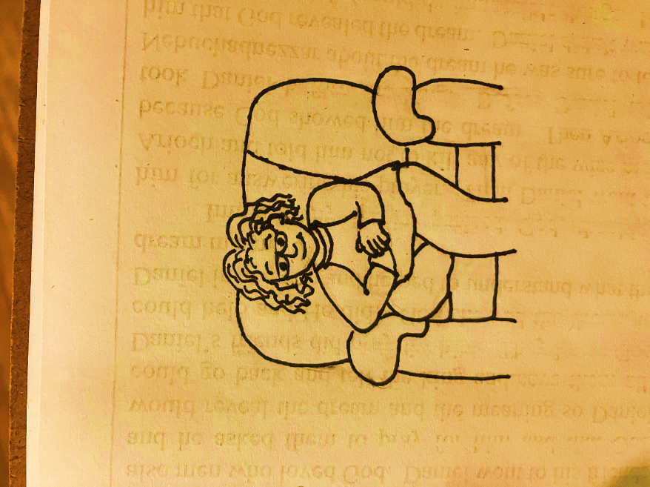

Wordsearch

THREE SMACK WEEP

FIRE ROOSTER JOHN PETER

|  |  |  |  |  |  |  |  |  |  |
| --- | --- | --- | --- | --- | --- | --- | --- | --- | --- |
| Q | W | E | R | T | Y | I | W | P | L |
| H | J | K | L | M | N | B | E | V | K |
| G | T | H | R | E | E | X | E | C | S |
| P | Q | W | E | R | T | Y | P | U | M |
| E | G | H | J | K | L | P | O | I | A |
| T | F | D | J | O | H | N | S | A | C |
| E | F | M | N | B | V | C | X | Z | K |
| R | I | Q | W | E | R | T | Y | U | J |
| F | R | O | O | S | T | E | R | P | H |
| D | E | D | F | G | H | J | K | L | G |
| S | A | M | N | B | V | C | X | Z | F |

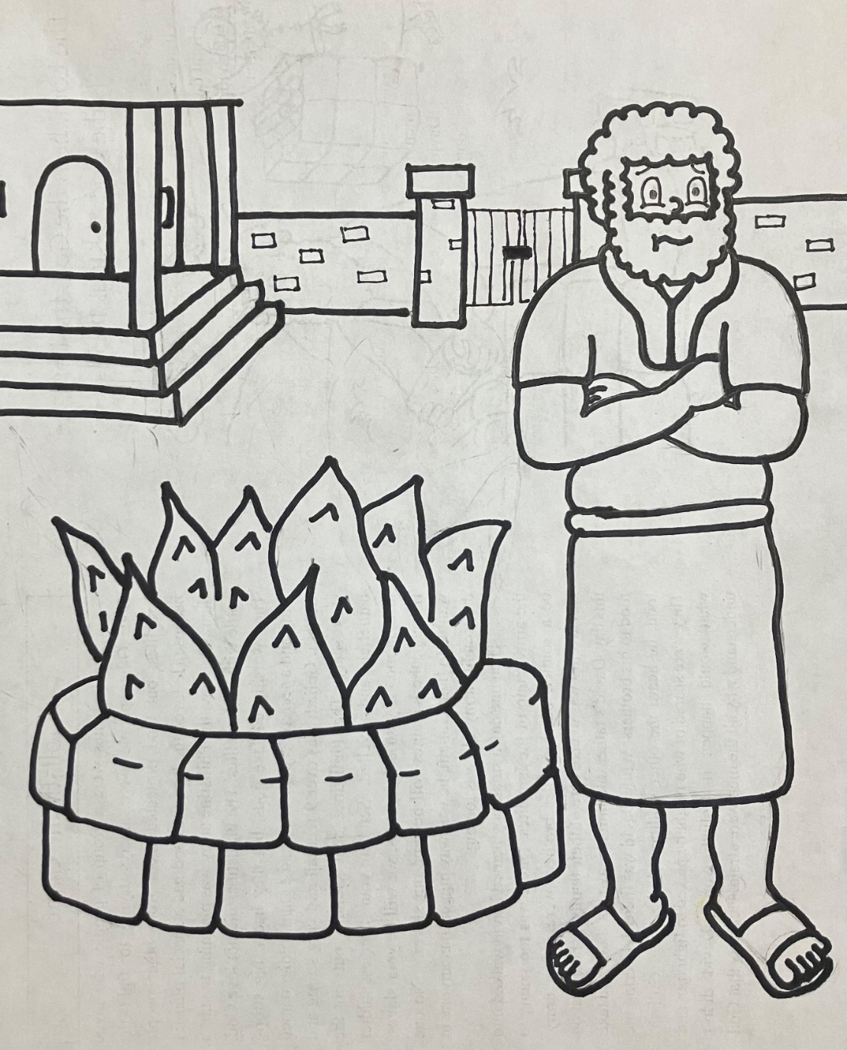

**1**

**7**

**3**

**3**

**Peter then denied again: and immediately the cock crew. John 18:27**

**7**

**6**

**1**

**1**

**1**

**1**

**4**

**4**

**6**

**6**

**2**

**2**

**4**



**5**

**5**

**5**

**5**

**5**

**4**

**5**

**5**

**5**

**1**

**1**

**1**

**1**

**1**

**1**

**1**

**1**

**1**

**1**

**1**

**1**

**6**

**6**

**2**

**7**

**7**

1 – gray 2 – green 3 – dark blue 4 – red

5 – yellow 6 – tan 7 - brown



Dear God,

Thank you for this lesson.

Thank you for the example of Peter. Peter wasn’t

perfect. He wanted to believe he was strong enough to

stand up for Jesus even in the scariest of situations. But

when things got scary, he reacted before he could even think about it. What Peter did wasn’t right, but it proved he was human just like us. Sometimes we do the wrong things even when we plan and try to focus on doing the right thing. Thank you for loving Peter anyway. Thank you for loving us anyway. Please help us to try to live a life pleasing to you and tell people about you everywhere we go, but please help us to understand that you love us even when we mess up. Please help us to

dust ourselves off after we have a moment to weep and

then get up ready to go out and keep living for you.

Please help us to grow stronger every day.

In Jesus’ Name,

Amen