INSTRUCTIONS:

Print hexagons on pages 1 and 2 on regular printer paper. Cut out, cover front and back with contact paper. Cut out.

1

3

2

5

4

INSTRUCTIONS:

Print hexagons on pages 3 and 4 on full-page labels. Cut out, stick to the inside of a file folder. (Optional) Cover folder with contact paper.

6

0

7

3

4

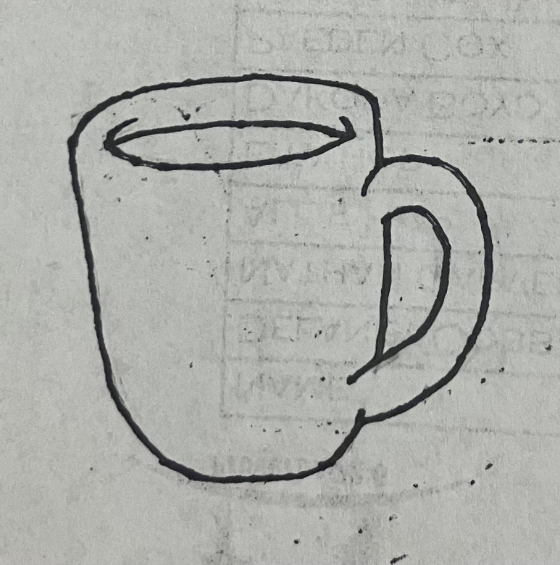

“Dunking Donuts”

-Counting

6 + __

7



5 + __

7

4 + __

7



3 + __

7

2 + __

7



Naaman was to dunk in the Jordan River 7 times. We are going to dunk donuts 7 times. Look at the addition problem on each cup and then match it to the donut with the number of times we still need to dunk.

1 + __

7

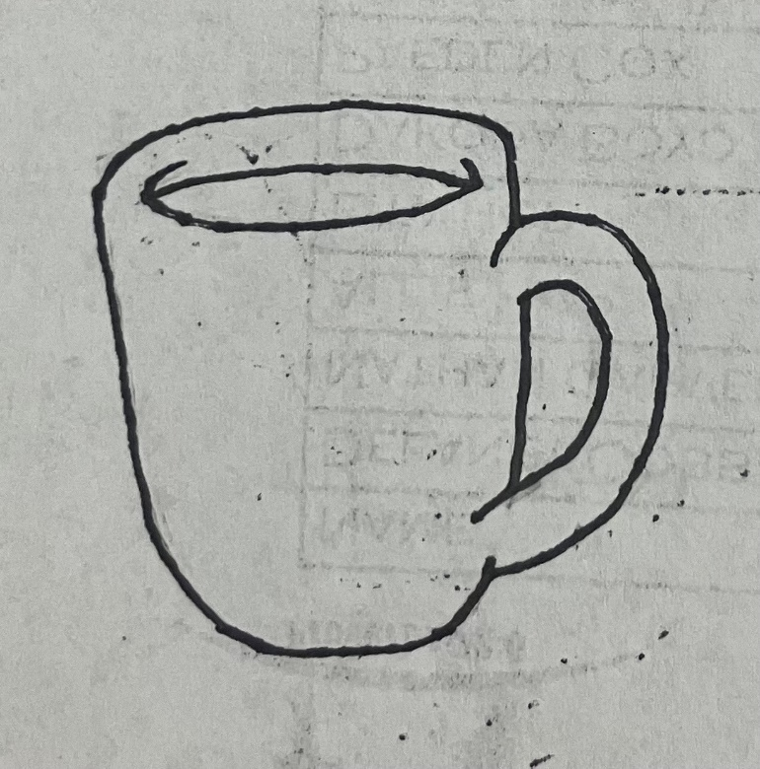

3 + __

7

4 + __

7

7 + __

7

0 + __

7

