A

INSTRUCTIONS:

Print diamonds on pages 1 and 2 on regular printer paper. Cut out, cover front and back with contact paper. Cut out.

B

A

C

B

C

INSTRUCTIONS:

Print diamond on pages 3 and 4 on full-page labels. Cut out, stick to the inside of a file folder. (Optional) Cover folder with contact paper.

D

D

B

C

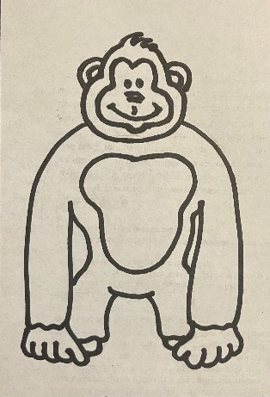

“A-D Animals”

-Letter Sounds

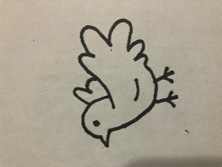

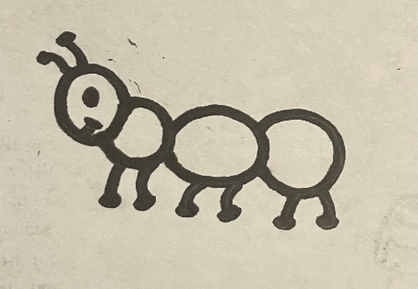

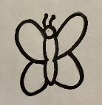

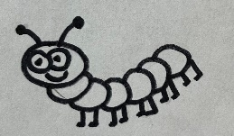

Daniel was thrown in with the lions. Lions are animals. Look at the animals and see if you can figure out what letter begins each animal name. Match that letter to the animal.

