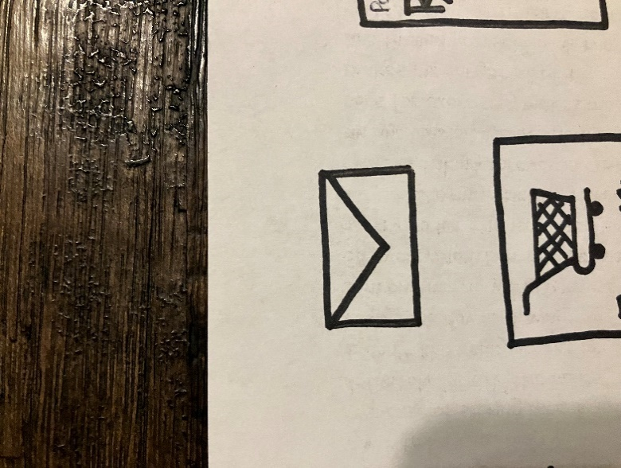

You’ve

Got Mail

-Reading

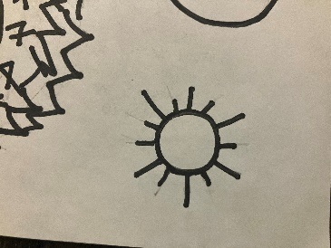





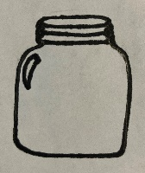



Naaman took a letter to the king in Israel. The king read the letter and then got upset. Look at the envelopes and see if you can read what is written.



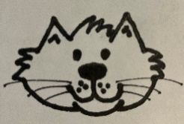



INSTRUCTIONS:

Print hexagons on pages 1 and 2 on regular printer paper. Cut out, cover front and back with contact paper. Cut out.

**sun**



**bed**

**bat**





**jar**

**cow**



INSTRUCTIONS:

Print hexagons on pages 1 and 2 on regular printer paper. Cut out, cover front and back with contact paper. Cut out.

**dog**



**cat**

**hat**





**car**

**log**