INSTRUCTIONS:

Print the apples on pages 1 and 2 on regular printer paper. Cut out, cover front and back with contact paper. Cut out.

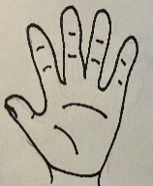

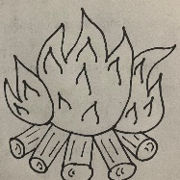

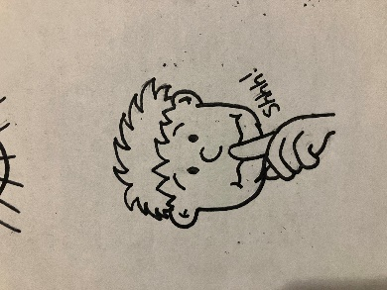

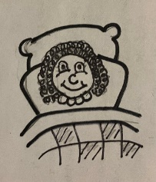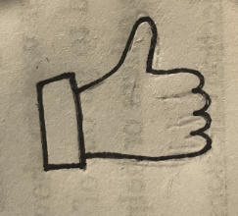

INSTRUCTIONS:

Print the apples on pages 3 and 4 on full-page labels. Cut out, stick to the inside of a file folder. (Optional) Cover folder with contact paper.

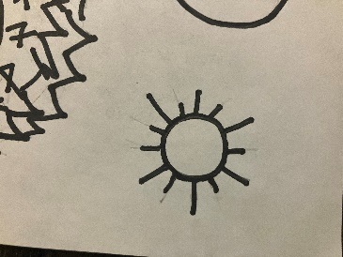

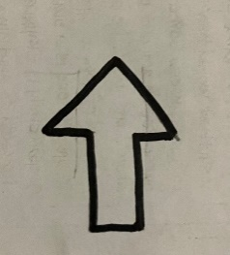

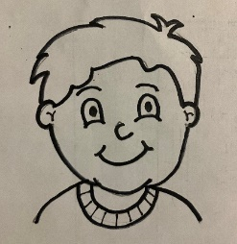

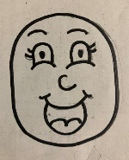

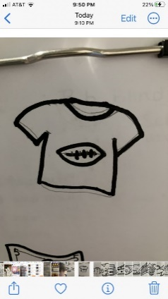

“How About Them Apples”

-Opposites



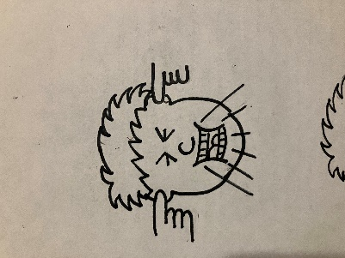

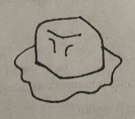

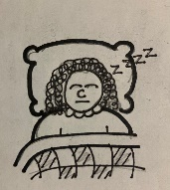

Eve did not obey God. She disobeyed. Obey and disobey are Opposites. Opposites are all the way different from each other. Match the pictures to their opposites.



