Not long after God created man, man sinned. Man disobeyed God. Anything that we do that is unpleasing to God is sin. God cannot be in a place where there is sin. So, sin separated God and man. God sent rules for His people to obey and when those rules were broken, people would go to the priest and offer sacrifices so God would forgive them for their sins. But God had another plan. God decided to send Jesus to live on earth as a perfect man who never sinned and then Jesus would die on the cross to pay for the sins of all men. Those who believed in Jesus would be saved and have a relationship with God without animal sacrifices or priest. Those who did not would be separated from God forever.

Jesus Is Crucified

God told the prophets of the Old Testament that the Messiah would be coming to save the world from their sins. Many people had heard of the Messiah. Many people believed Jesus was the Messiah, but some did not. The chief priest and elders, also known as the Sanhedrin, did not believe Jesus was the Messiah. They had studied the scriptures and understood all the laws of the bible, but they did not think Jesus was good enough to be the Messiah. They were more interested in following rules than seeing what was right in front of them. They hated Jesus. They thought he was faking being the Messiah to trick people into worshipping him. When they saw how much other people loved Jesus, it made them angry. They decided to have Jesus killed. They came up with secret plans to have Jesus arrested. They made up stories for the judges and governors. They convinced crowds of people that Jesus needed to die, and Jesus never tried to stop them. Jesus knew all the horrible things that were happening to him were part of God’s plan. Jesus was born to die on the cross. God gave him to the world to save the world. It was all part of His plan, but Jesus still suffered as he gave his life for us.

The Roman soldiers led Jesus to the Golgotha to kill him. Jesus was given a large wooden cross to carry to the place where he would die. Jesus was so weak from the being beaten by the soldiers that he wasn’t strong enough to carry his own cross. They had beat him, whipped him, spit upon him, and crammed a crown of thorns onto his head until blood was running down his broken body. So, the guards grabbed a man from the crowd named Simon and told him carry the cross for Jesus.

Once they were to Golgotha, they stripped Jesus of his clothes. They took Jesus, laid him on the cross and stretched out his arms. Then they drove nails into each of his hands into the cross. They crossed his feet at the ankles and drove a third spike into his feet. Jesus was now stuck to the cross. They lifted the cross and dropped it into a hole. Jesus hung on the cross for all the people to see. This was not the way to treat the Son of God who had come to save all people. This was the way to treat criminals and thieves.

Criminals were often hung there beside the road so other people would see. The soldiers would put signs over their heads telling people what crime they had committed so people would know not to commit crimes. Jesus had committed no crime, so on his sign, they wrote the words. “King of the Jews.” When people walked by and saw him, they laughed at him. They said mean things like, “Save yourself,” “He can save others, but he can’t save himself.”, “Show us that you are the Christ and come down from the that cross.” Even the thief hanging on the cross beside him started to mock him. The thief on the other side, did not. He yelled at the first thief to stop. He knew that Jesus was the Son of God. He knew he had done nothing wrong, and he asked Jesus to think of him when he was with God. Jesus answered him saying that day, they would be together in heaven because he believed.

Jesus stayed on the cross for many hours while his mother, John, and many other women stood close by and cried. Jesus looked down from the cross to John and asked him to take care of his mother after he was gone. John agreed.

The world became dark for three hours, and then Jesus cried out with a loud voice, “Father why have thou forsaken me?” God cannot be where there is sin. Jesus knew God could not be with him while he took on the sins of the world. This was the part that hurt him the most; not the beatings, the crown of thorns, or the nails, but knowing he would be separated from God. When Jesus knew the job was complete, he had paid for all the sins of all mankind, he said, “I thirst”. Someone took a sponge dipped it in vinegar and put the sponge on a stick that they then lifted it up to Jesus. After he received the vinegar, he cried out, “It is finished.” and died.

At the very moment Jesus died, the ground started to shake, and the graves burst open. People who had died before came back to life. The veil in the temple that separated the priest from the people, ripped from top to bottom. The job Jesus had come to earth to do was now finished. Even one the soldiers knew these things meant that Jesus must have been the Son of God.

After Jesus died, a man named Joseph of Arimathea went to the governor, Pilate, to ask for Jesus’ body. Joseph believed that Jesus was the Son of God, and He wanted to be sure that Jesus was buried properly. He took the body from the cross, wrapped it in linen cloths and placed it in a tomb. Then he rolled a large stone to cover the opening.

The members of the Sanhedrin thought they had won. They watched Jesus die, but they also remembered him telling people he would rise again on the third day. They thought the disciples might try to steal Jesus’ body and tell people he had risen. So, they went to Pilate and asked him to send guards to stand by the tomb for three days. Pilate agreed and soldiers were sent to guard the body of Jesus that had been laid in Joseph’s tomb.

Printing Practice

king

Kk

Vv

vinegar

Tt

thieves

1. Why did Simon have to carry the cross for Jesus?
2. How did they hang Jesus on the cross?
3. Who was near the cross crying?
4. What did the sign on Jesus’ cross say?
5. Who yelled at the thief for making fun of Jesus?
6. What happened to the sky for 3 hours?
7. What did they give Jesus to drink?
8. What did Jesus say just before he died?
9. What happened after Jesus died?

10. What happened to Jesus’ body after he died?

They placed Jesus on the cross at

About 9 o’clock in the morning

The day Jesus was crucified, a lot of different things happened in not a lot of time. Three events are listed below. Finish the clocks so they both say the time of each event.

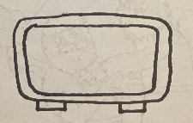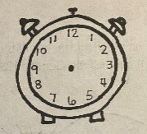

:00

Darkness covered the land at about

12 o’clock in the afternoon





:00

Jesus died at about

3 o’clock in the afternoon





:00

The Sabbath ended at about

6 o’clock in the evening



:00

Memory Verse

Find it, Read It, Write It, Explain It!

**He said, it is finished: and he bowed his head and gave up the ghost. John 19:30**

Cursive Practice

K k

king

Vv

vinegar

T t

thieves

U

“Paid in Full”

Have you ever heard someone say this?

Sometimes things are too expensive to buy all at once so

people are allowed to pay a little at a time. When all of their little payments equal the whole amount, they don’t have to pay anymore because it has been “paid in full.” When we sin, or do things that are against God’s rules, we have to pay for those sins. People used to make sacrifices at the temple to pay for their sins. When Jesus died on the cross, people could stop making sacrifices because Jesus paid for all of our sins. He knew it would be impossible for us to pay for all the times we mess up and do things that aren’t pleasing to God. So, Jesus came and died to pay that for us. When we realize that we sin, we need to pray and tell God that we know we are a sinner. When we understand and believe in our hearts that Jesus paid for our sins, we can accept that gift, that payment

he made for us. Our sins will be forgiven. That payment

is then “paid in full.” Then we are ready to start

living our lives in the family of God.

Crossword Puzzle

CROSS JESUS THIEVES

NAILS DARK

VINEGAR MOCK FINISHED

DIED KING

|  |  |  |  |  |  |  |  |  |  |
| --- | --- | --- | --- | --- | --- | --- | --- | --- | --- |
| F | I | N | I | S | H | E | D | Q | W |
| L | P | A | O | I | U | Y | T | R | E |
| A | S | I | D | M | F | J | G | H | T |
| C | N | L | M | O | L | O | K | J | H |
| R | B | S | V | C | C | H | X | Z | I |
| O | Y | T | R | K | E | N | W | Q | E |
| S | U | D | I | E | D | I | O | P | V |
| S | K | J | H | G | F | D | S | A | E |
| L | I | N | B | D | A | R | K | V | S |
| U | N | R | T | E | W | Q | Z | X | C |
| I | G | V | I | N | E | G | A | R | G |

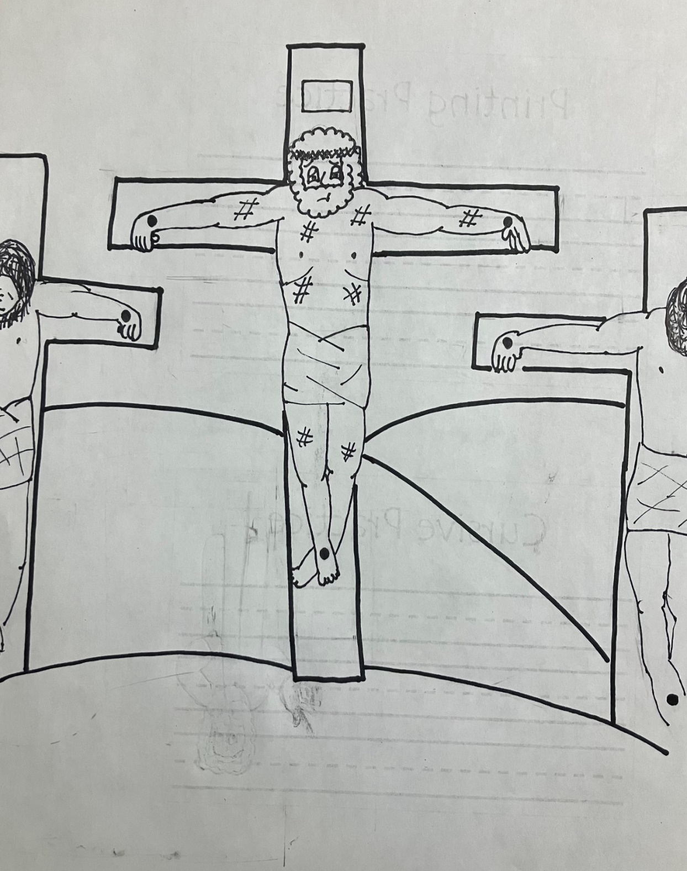

**2**

**He said, It is finished: and he bowed his head and gave up the ghost.**

**John 19:30**

**3**

**3**

**2**

**2**

**2**

**2**

**1**



**1**

**5**

**1**

**5**

**1**

**5**

**1**

**1**

**4**

**4**

**1**

**4**

**2**

**2**

1 – tan 2 – brown 3 – light blue

4 – green 5 – light green

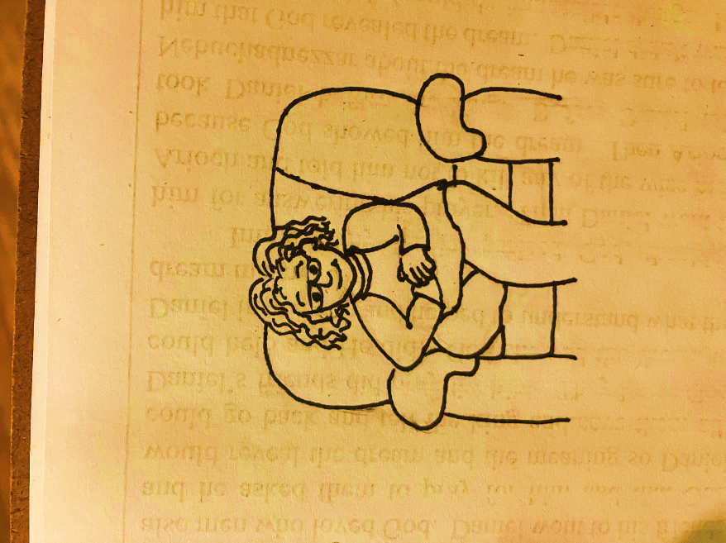

Dear God,

Thank you for this lesson. This was very

sad lesson but it’s also a very important lesson.

Everything that happened to Jesus was part of

your plan. Jesus could have saved himself. He

could have performed miracles to make everything

easier on himself but he didn’t. He went through all of

the terrible things because of how much he loves us. Please help us to understand that Jesus did what he did so he could pay for our sins. Please help us to understand without his payment for our sins, we could never pay for them on our own. Jesus paid the price so that we can be with you in heaven one day. Thank you so much for making a way for us. Please help us to understand that we are sinners who needed someone to come pay for our sins. Please help

us to accept what Jesus has done for us and then

go out and tell the world so more people

will come to know him.

In Jesus’ Name,

Amen