Jesus and his disciples had just finished the Passover meal when Jesus stood up from the table and began washing the feet of the disciples. The disciples didn’t understand what Jesus was doing because washing feet was usually a job completed by the servants in the house, not someone who they referred to as “Master.” Jesus explained to the disciples that allowing him to wash their feet was another way he was able to teach them. His disciples wanted to know everything he had to teach them.

The Lord’s Supper

When Jesus finished washing the disciples’ feet, he stood up, put his outer clothing back on and then returned to his spot around the table. Jesus then announced that one of them would soon betray him. Jesus knew that one of the disciples would do something that would cause him a lot of pain and sadness. The disciples were shocked. They couldn’t believe anyone in their group would do such a thing. They started to question Jesus, “Is it me? Will I be the one?” Peter leaned over the John who was sitting beside Jesus and told John to ask Jesus who it will be. John leaned over near Jesus’ chest and asked him who of them would do such a horrible thing. Jesus answered John telling him it would be the one he gave bread to. Jesus then stood up, took a piece of bread, dipped it in the sauce and walked over to Judas. Jesus knew it was Judas who would help the high priest and elders arrest him. He handed Judas the bread and said, “that thou doest, do quickly.”

Then Judas stood up from the and left the upper room. The disciples didn’t know why Judas left. He was the disciple who took care of the money. They thought he might have left to buy items for the meal they were eating or even to go help the poor. No one else knew that it would be Judas to betray Jesus. They were still talking and questioning who it might be. Then they started to wonder which one of them was the greatest.

Jesus sat back down and explained to the disciples that “greatest” the way the world thinks and “greatest” the way that God thinks are two different things. In the world, people think someone is great because of how much power, money or fame they have. In heaven, greatness has nothing to do with those things. Instead, it would be how you would describe someone who serves others. The one who treats others with love and kindness and help others would be the person who is called “great.” He told them just as he had washed their feet, they were to wash each other’s feet. He didn’t let the fact that they called him “Master” keep him from serving them even to do the dirty jobs. Being willing to show kindness and serve others is one way to share God’s love with people.

Jesus then took the bread from the table and gave thanks for it. Then he broke it into pieces and shared it with the disciples. But before they ate the bread, he said something very important to them. “This bread is like my body, take it, eat, and when you do, remember that I am about to give my body because of my love for you.” Jesus knew he would soon be killed. It was part of God’s plan for him to die to pay for the sins of all the people who would believe in him. The disciples didn’t completely understand what Jesus was saying but they loved him and believed he was the Son of God, so they listened and did exactly what he told them to do.

Then Jesus just took the drink and blessed it. He shared the drink with the disciples just as he had shared the bread. He told the disciples the drink was like his blood that he was about to shed in death. His blood would pay for all the sins of all those who believe in him. They would no longer have to make animal sacrifices for their sins. Jesus was the going to be the sacrifice for all people. Jesus told them to think about his sacrifice and his blood every time they drank it. After that, Jesus and the disciples sang a song and left the upper room. They followed Jesus to the Garden of Gethsemane. The garden was a special place where Jesus went to pray.

On their way to the garden, Jesus explained several things to the disciples. He told them that all of them would soon leave him. This upset the disciples. They didn’t want to leave him; He told them the bible said when the shepherd was attacked the sheep would scatter. He was the shepherd, and they were the sheep. This was just another thing that had to happen for God’s perfect plan.

Peter was outraged. He said, “They may leave you, but I never will.”

Jesus turned to Perter and said, “You will deny that know me three times before the rooster crows tomorrow.”

Peter did not want to believe this was true. He said, “I will die with you. I will not deny you.”

Then Jesus started to explain to the disciples the things they needed to do differently when he was no longer with them. While Jesus was with them, they didn’t need money or weapons but when he was gone from them, they should always have both of those things. Jesus gave the disciples two swords. They would need to be prepared to protect themselves. There would be people who hated them just because they were his followers. Jesus and his disciples continued to the garden. He spoke of many things while they walked.

Printing Practice

bread

Bb

Ss

serve

Judas

Jj

1. Who was the disciple who was going to betray Jesus?
2. How is “greatness” different in the world than in heaven?
3. When Jesus shared the bread, what did he compare it to?
4. When Jesus shared the drink, what did he compare it to?
5. Where did Jesus and the disciples go after they sang a song?
6. When Jesus told the disciples they would leave him, what did he tell them about the bible when they started to get upset?
7. Which disciple said that he would never leave Jesus?
8. How many times did Jesus say Peter would deny him before the rooster crowed?
9. Why did Jesus give the disciple swords?

Jesus broke the bread and shared it with the all the disciples. Look at the pictures below. How would you divide the food to share it with each group of people? Draw a line on the food to show each part.

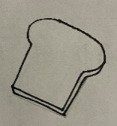

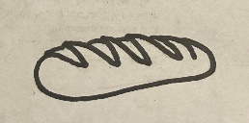



Memory Verse

Find it, Read It, Write It, Explain It!

**Take, eat; this is my body. Mark 14:22**

Cursive Practice

B b

bread

S s

serve

udas

j

U



“There is Enough to Go Around”

Maybe you’ve heard someone say this when people have

been fighting for their share. Sometimes people get impatient while they wait for things and need someone to remind them there is plenty for everyone. In our lesson, Jesus broke the bread and shared with his disciples as he explained that he would soon give his body to save all people from their sins. Sharing the bread and the drink are things Jesus wants us to do as we remember what He did for us because he loves. Jesus gave his life over 2000 years ago

but the blood he shed was enough for

everyone how would ever call upon his

name to be saved. There is no chance of

running out of blood. There will

always be enough to go

around.

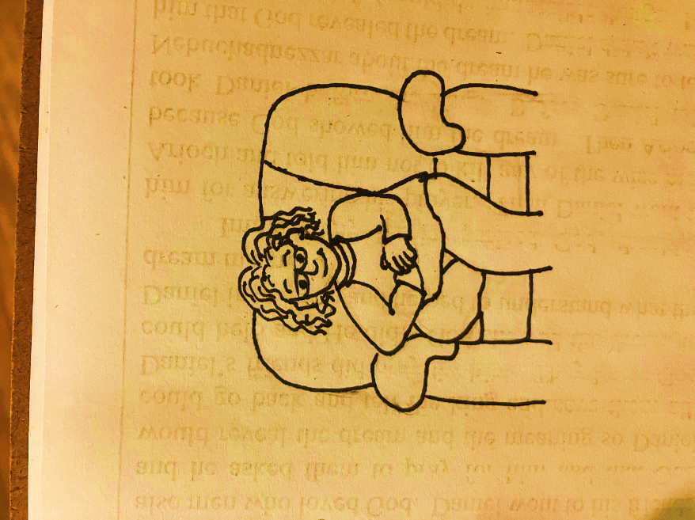

Crossword Puzzle

DOWN

1. Who was the disciple sitting next to Jesus at the table?
2. What did Jesus say to remember when they drank from the cup?
3. What did the disciples do with the bread he shared with them?
4. What did Jesus do with the bread and the drink?

ACROSS

1. Who told the disciples to remember him when they ate the bread?
2. What did Jesus break and share with the disciples?
3. What did Jesus tell the disciples should remind them of his blood?
4. What was the bread supposed to remind the disciples of?

|  |  |  |  |  |  |  |  |  |  |  |
| --- | --- | --- | --- | --- | --- | --- | --- | --- | --- | --- |
|  |  |  | 1 |  |  |  | 4 |  |  |  |
|  |  |  |  |  |  |  |  |  |  |  |
|  |  |  |  |  |  |  |  |  |  |  |
|  |  |  |  |  |  |  |  |  |  |  |
|  |  |  |  |  | 5 |  |  |  |  |  |
|  |  |  | 2 |  | 3 |  |  |  |  |  |
|  |  |  |  |  |  |  |  |  |  |  |
|  |  |  |  |  |  |  |  |  |  |  |
|  |  |  |  |  |  |  |  |  |  |  |
|  |  |  |  |  |  |  |  |  |  |  |
| 6 |  |  |  |  |  |  |  |  |  |  |

**7**

**5**

**5**

**5**

**5**

**5**

Take, eat: this is my body. Mark 14:22

**6**

**5**

**6**

**7**

**4**

**4**

**3**

**3**

**4**

**4**

**3**

**1**

**5**

**1**

**2**

1 – red 2 – green 3 – purple 4 – gray 5 – light brown 6 – dark blue 7 - brown



Dear God,

Thank you for this

lesson. Thank you so much for

Jesus! Thank you for the sacrifice he made on

the cross to pay for our sins. Please help us to never forget what he did for us. Help us to always appreciate how much you love us. Please help us to remember that you made a way by sending Jesus to earth to die for our sins so we could one day be with you in heaven. Thank you so much for that indescribable act of love. Please help us to realize just how lost we would be without Jesus. Help us to go through life looking for opportunities to help lead others to know you

and their need for a Savior. Please help us to

share your love with others.

In Jesus’ Name,

Amen