One day Jesus and his disciples were on their way to Jerusalem. Lots of people were going to Jerusalem because it was time for the Passover Feast. This was a special meal to remember how God had protected the Israelite children. People came from all around for this special celebration. Jerusalem was full of people.
Jesus Arrives in Jerusalem
When Jesus and his disciples were getting close to Jerusalem, Jesus told two of his disciples to run ahead of them into the city. There they would find a young donkey tied to a tree. Jesus told them to get the donkey and bring it back to him. He said, “If anyone asks you why you are taking the donkey, tell them Jesus needs it and then it will be returned.”
His disciples ran ahead, and just inside the city, just as Jesus had said, there was a young donkey tied to a tree. They untied it and someone stopped them to see what they were doing. The disciples answered that Jesus needed the donkey and it would be returned. The people in Jerusalem had heard of Jesus and they were willing to let him borrow the donkey. So, the disciples led the donkey back to where Jesus and the other disciples were walking.
The disciples put clothes on the donkey’s back and then Jesus climbed up on top of it and rode it into the town of Jerusalem. When other people saw Jesus coming, they started laying clothes and branches for the palm trees on the ground in front of where the donkey was walking. They were making a special path for Jesus. The people knew that Jesus was special. They had heard about his teachings and the miracles he had done. They knew he must be the Son of God. They started saying “Hosanna, Blessed is he that cometh in the name of the Lord.”
Many people cheered and worshiped Jesus as he was entered Jerusalem, but not everyone was excited to see Jesus coming to town. There were also people who didn’t believe that Jesus was the Son of God. It made these people very angry to hear other people praising Jesus. These people were the Pharisees. They were the high priest and elders. They worked in the church. They studied the scriptures and told everyone how to follow the rules and live the way God wanted them to live. They were supposed to be the good guys, but they were very jealous of Jesus. They were jealous that people loved Jesus. They didn’t think Jesus was the one the scripture was saying would come to rescue the people. They thought he was lying and just trying to trick people, and this made them very angry. So, that day, they decided they would have Jesus killed. He was messing up their plans and they were going to come up with a sneaky plan to arrest him and have him crucified. The Pharisees decided to wait until after the Passover celebration. They thought there were too many people visiting Jerusalem who might try to help Jesus. They weren’t exactly sure what they were going to do but they were afraid if they didn’t do something soon, people would listen to Jesus more then they listened to them. Their minds were made up that it was time for them to put an end to Jesus’s ministry.
Jesus knew bad things were about to start happening to him. He had warned the disciples many times that his time on earth was about to be over, but they didn’t understand what he meant. All the disciples could see was how much people loved Jesus. They didn’t understand what was about to happen, but even when Jesus was riding on the donkey’s back listening to the people shout “Hosanna,” he knew exactly what the Pharisees were planning to do.

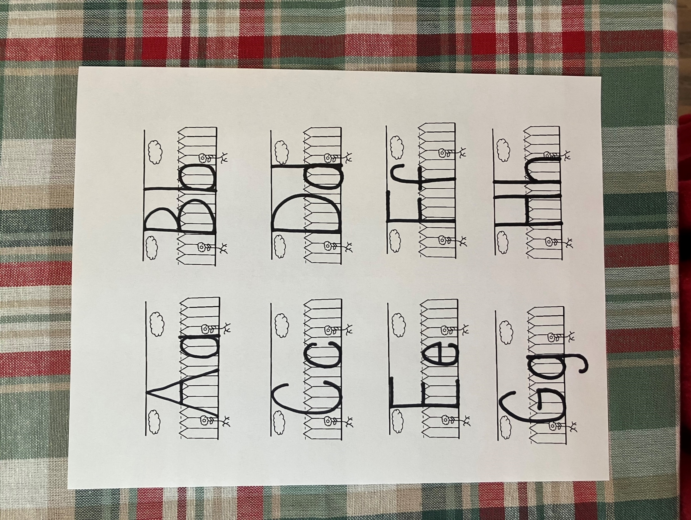
D

d

donkey

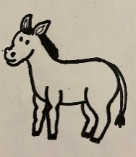

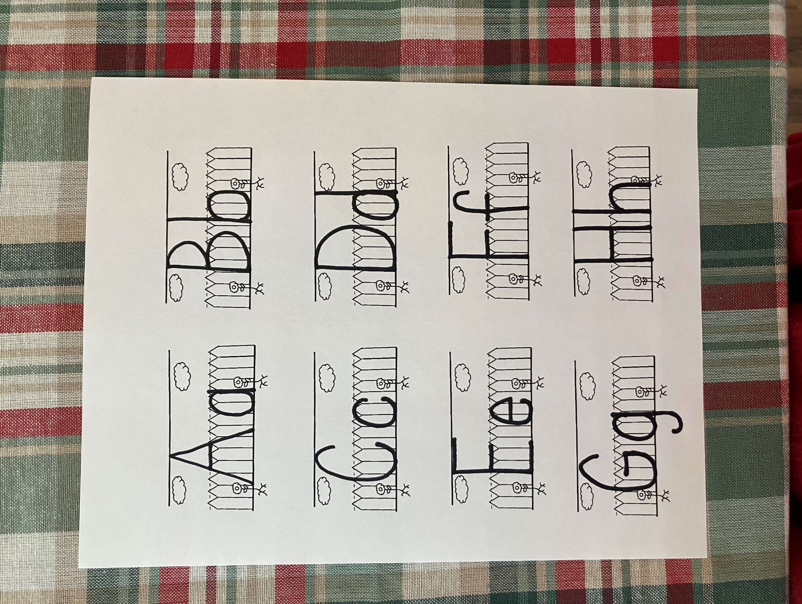
H

h
Hosanna

- Why were Jesus and his disciples in Jerusalem?
- What did Jesus tell two of his disciples to run ahead of them to get?
- What did Jesus do with the donkey?
- What were the people shouting when Jesus entered the city?
- What did the people put on the ground in front of the donkey?
- Why didn’t the priest and elders like Jesus?
- What were they planning to do?
- Why did they want to wait until after the Passover to try to capture Jesus?
- Who else knew what they Pharisees were planning to do?
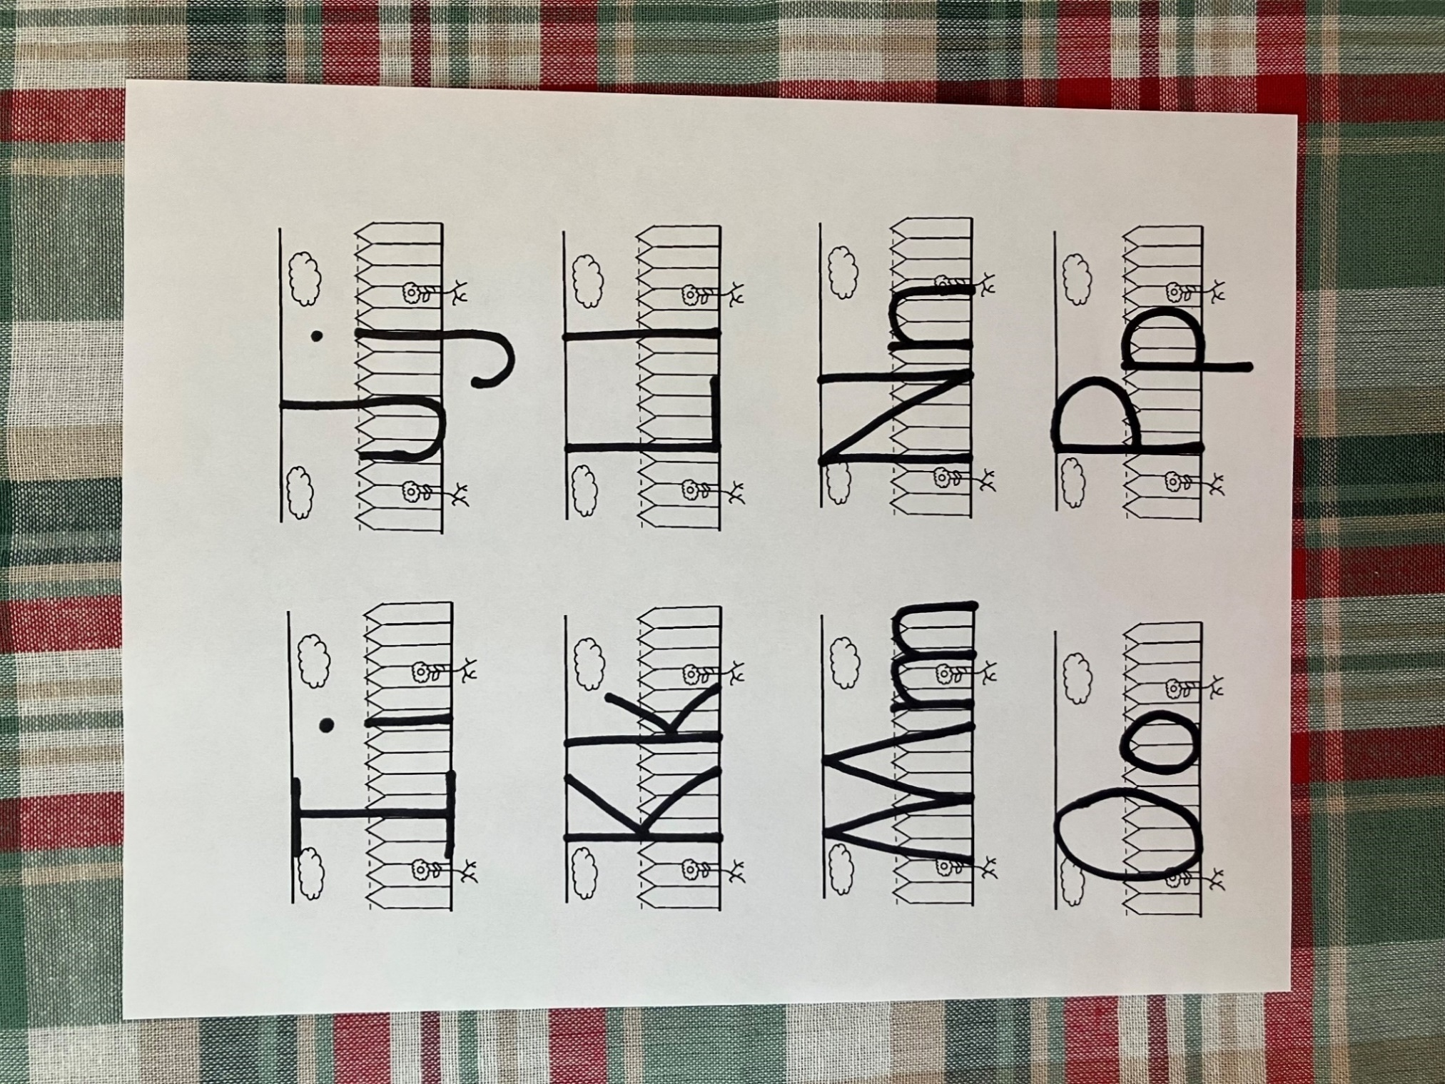
J

j

Jerusalem

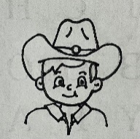
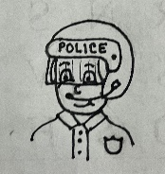
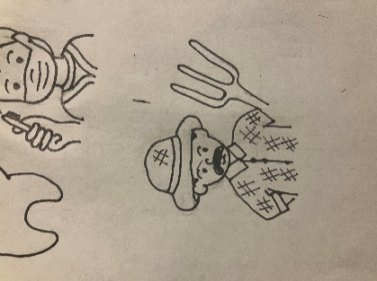
Jesus rode into Jerusalem riding a donkey. This was very important because it was another clue to the people that he was the Messiah. People ride many different things for many different reasons. Look at the pictures below. See if you can match the person to the thing they should be riding.
.
.
right.
.
.

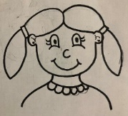

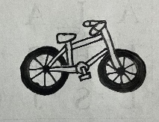
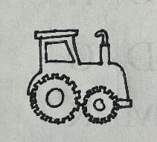
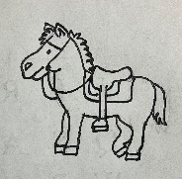
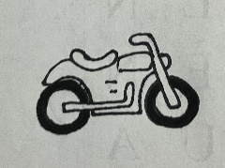

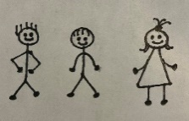
Jesus had twelve disciples. Twelve is a good number for making teams because you can make 2, 3, 4, or 6 teams and all the teams will be even. Sometimes Jesus asked his disciples to do stuff in teams or groups. Look at the pictures below see if you can figure out how many people will be on each team.

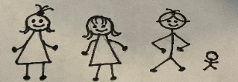
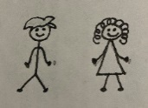


Hh
Hosanna, Blessed is he that cometh in the name of the Lord. Mark 11:9

Jesus rode into town on a donkey. In the space below, draw a donkey
Passover Feast
- A special celebration to remember what God did for the Israelites.
.
.

- I was in Jerusalem for the Passover.
- I was riding on a donkey.
- People were yelling “hosanna” to me.
- Other people were trying to figure out a way to kill me.

Who am I?
____ ____ ____ ____ ____

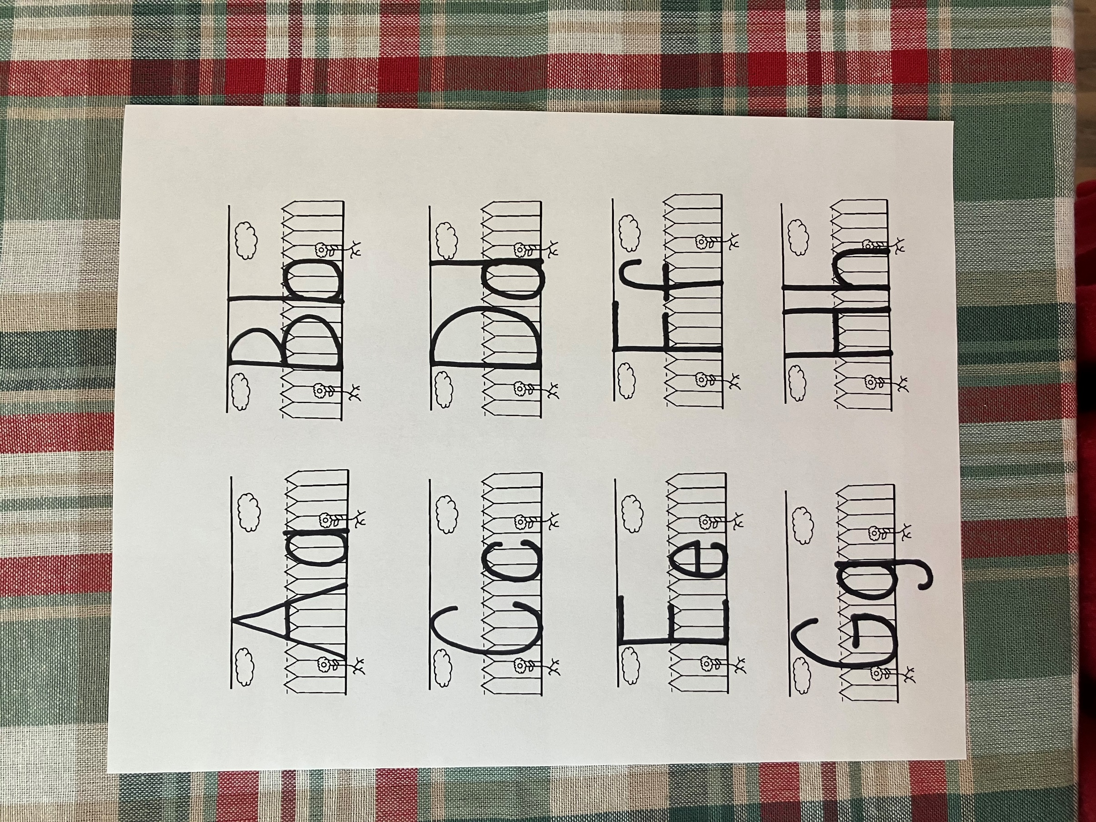

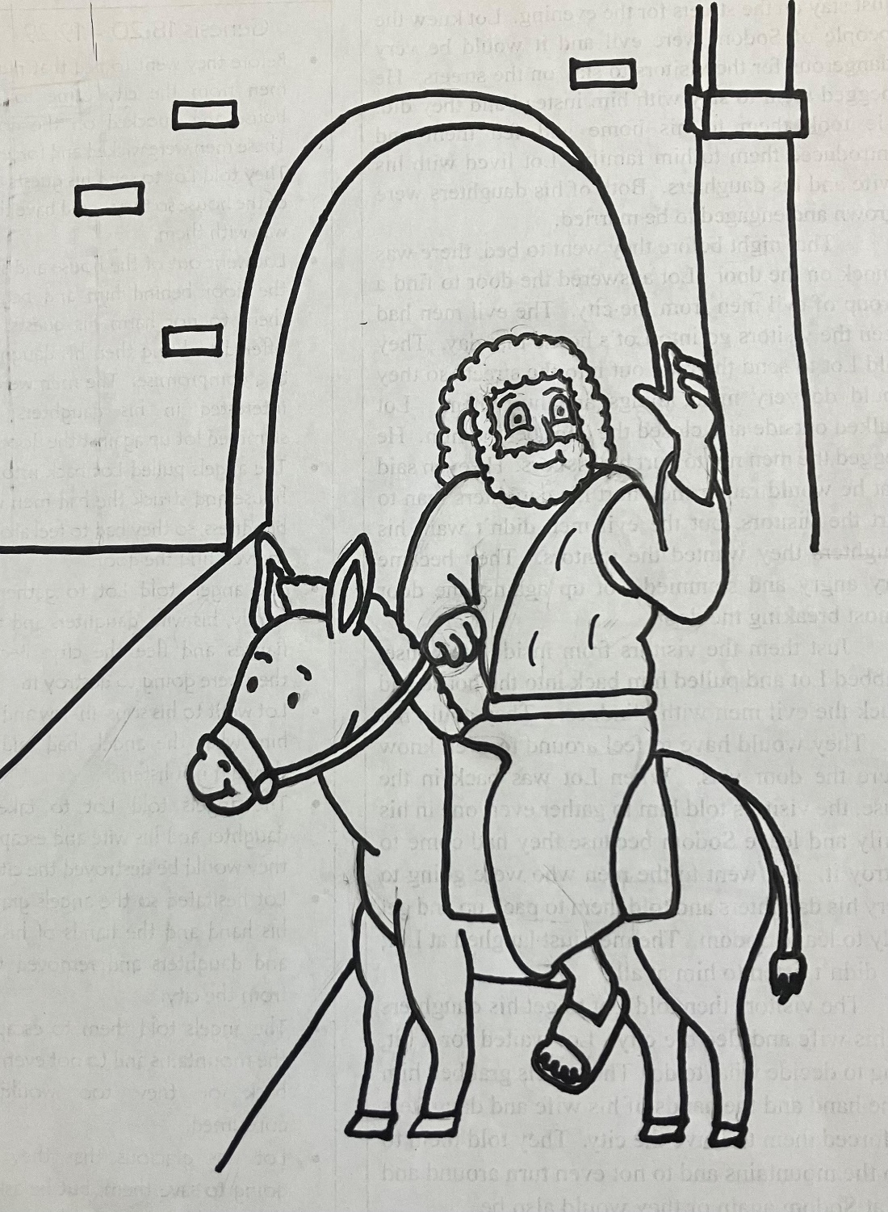
Hosanna, Blessed is he that cometh in the name of the Lord. Mark 11:9

