



“Framework”

-adding and subtracting

+









+

+



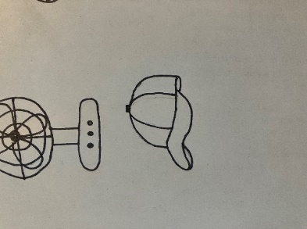

+

+



Lazarus had been dead for four days before Jesus called him out of the tomb. Look at the pictures below. Add or subtract depending on the sign. If the answer is four give it a checkmark. If it doesn’t equal four give it an x.



-





-



-









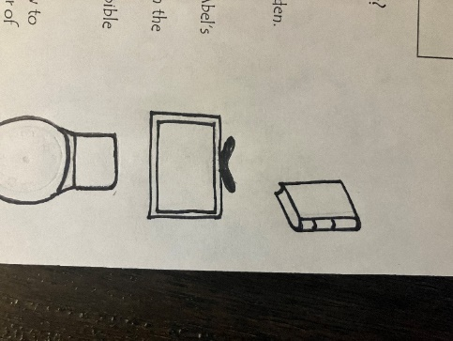

-

-



**X**

INSTRUCTIONS:

Print pentagons on pages 3 and 4 on regular printer paper. Cut out, cover front and back with contact paper. Cut out.

**X**

**X**

**X**

**X**

**P**

INSTRUCTIONS:

Print pentagons on pages 1 and 2 on full-page labels. Cut out, stick to the inside of a file folder. (Optional) Cover folder with contact paper.

**P**

**P**

**P**

**P**

