INSTRUCTIONS:

Print crayons on pages 1 and 2 on regular printer paper. Cut out, cover front and back with contact paper. Cut out.

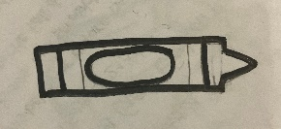









INSTRUCTIONS:

Print items on pages 3 and 4 on full-page labels. Cut out, stick to the inside of a file folder. (Optional) Cover folder with contact paper.











“Game of Many Colors”

-Colors

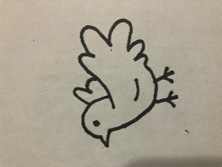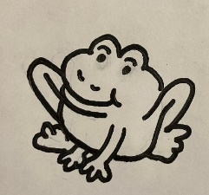

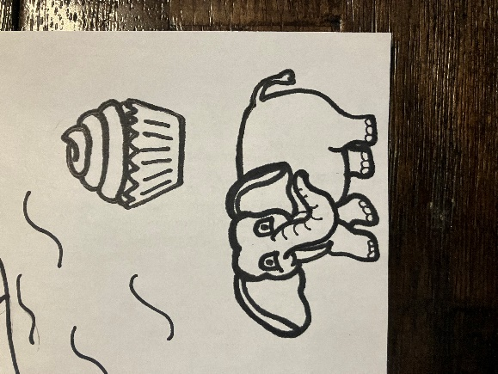

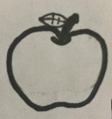

Joseph’s father gave him a coat of many colors. There are colors all around us. Look at the items and match them with the crayon of their color.

