The day after Jesus had been arrested by the Sanhedrin he was taken to Pilate, the governor of Jerusalem for sentencing. Pilate did not think Jesus should be killed for his crimes. He could tell the priest, and elders were just jealous of Jesus’ following. Pilate sent Jesus to another governor for sentencing because the Sanhedrin said he had been causing trouble in Galilee. Pilate was not the governor in Galilee. He would let that governor decide what to do. The governor in Galilee thought Jesus was innocent. He didn’t want to decide either. He sent Jesus back to Pilate.
Pilate Washes His Hands
When Jesus, the guards, and the Sanhedrin arrived back at Pilate’s house, Pilate told them that he couldn’t find anything that Jesus had done wrong. The members of the Sanhedrin became so angry that they threatened to go all the way to Caesar if Pilate didn’t put Jesus to death. Pilate didn’t want them to go to Caesar because then it would look like he wasn’t doing his job. Pilate offered to have Jesus beaten. He thought that might be enough to make them happy and then he wouldn’t have to kill Jesus. He took Jesus into a hallway. The guards stripped him of his clothes and put a fancy robe on him, the kind a king would wear. Then they put a crown on his head that was made of thorns. They pushed it down into his skin and Jesus began to bleed. They gave him a reed to hold and then they started to bow down to him. They were mocking him. They were not worshipping Jesus. At all. Then they took the reed and hit him over the head with hit. They started to spit on him and whip him. They beat him very against After seeing Jesus beat and broken, the members of the Sanhedrin did not change their minds. They still wanted to see him killed. Pilate’s plan had not worked. Pilate had one last idea. It was tradition that one prison would be released during the Passover. Pilate announced to the people that they could decide who would be released. He stood Jesus in front of them along with another prisoner named Barabbas, Barabbas
was guilty of stealing and murdering people. Pilate thought for sure the people would choose Jesus. Pilate was wrong. The people shouted to let Barabas go and crucify Jesus. Pilate had no choice but to do as the people said and let Barabas go.
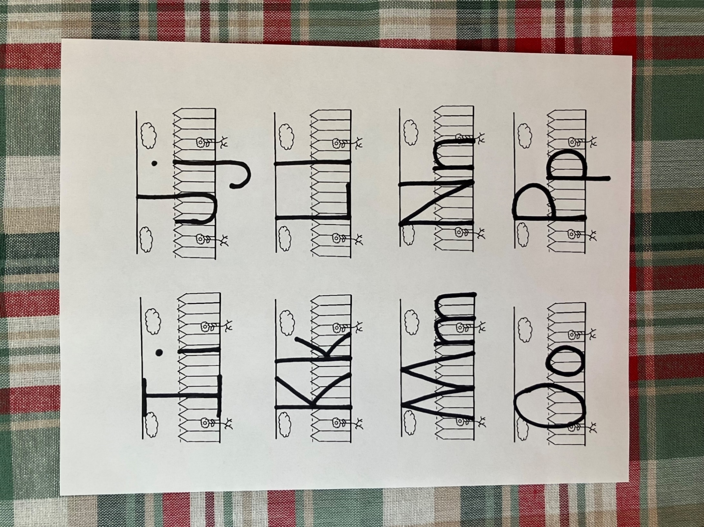
Just then, Pilates wife came up to him and begged him not to kill Jesus. She had been having horrible dreams about what would happen if he killed Jesus. Pilate knew it was wrong. His wife knew it was wrong, but he didn’t know what else to do. Pilate stood in front of the crowd and washed his hands. He said, “I find no fault in this man. His blood will be on your hands, my hands are clean of this.” Then he gave Jesus over to the crowd for him to be crucified. The guards placed a cross on his back for him to carry to the place he would die. Jesus was so weak from the beatings he could not even carry his cross. They grabbed a man from the crowd named Simon and made him carry it for him. Then they led Jesus to a place called Golgotha to be crucified.
P

p

Pilate

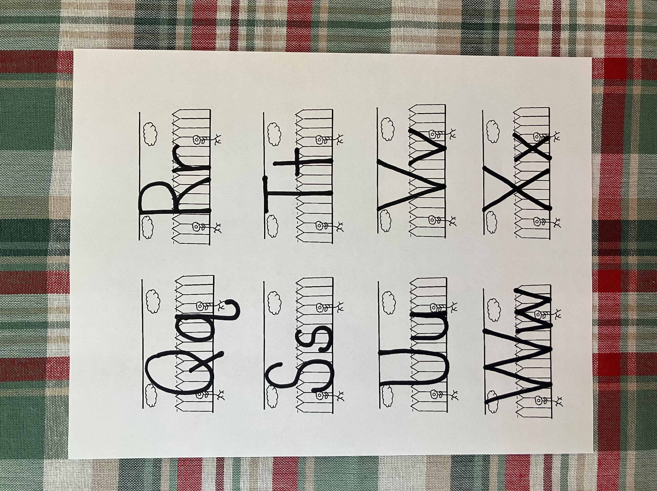
R

r

robe

- Who did the Sanhedrin say they would go talk to if Pilate didn’t kill Jesus?
- What did Pilate have the guards do to Jesus thinking it would make the Sanhedrin happy?
- What did the guards put on Jesus to wear?
- What did the guards do to Jesus?
- After the Sanhedrin saw Jesus had been beaten did it change their minds about wanting to kill him?
- Pilate offered to release one prisoner, who did the crowd choose to release?
- Who had been having bad dreams about Jesus?
- What did Pilate do sin front of the crowd before he handed Jesus over to them to be crucified.

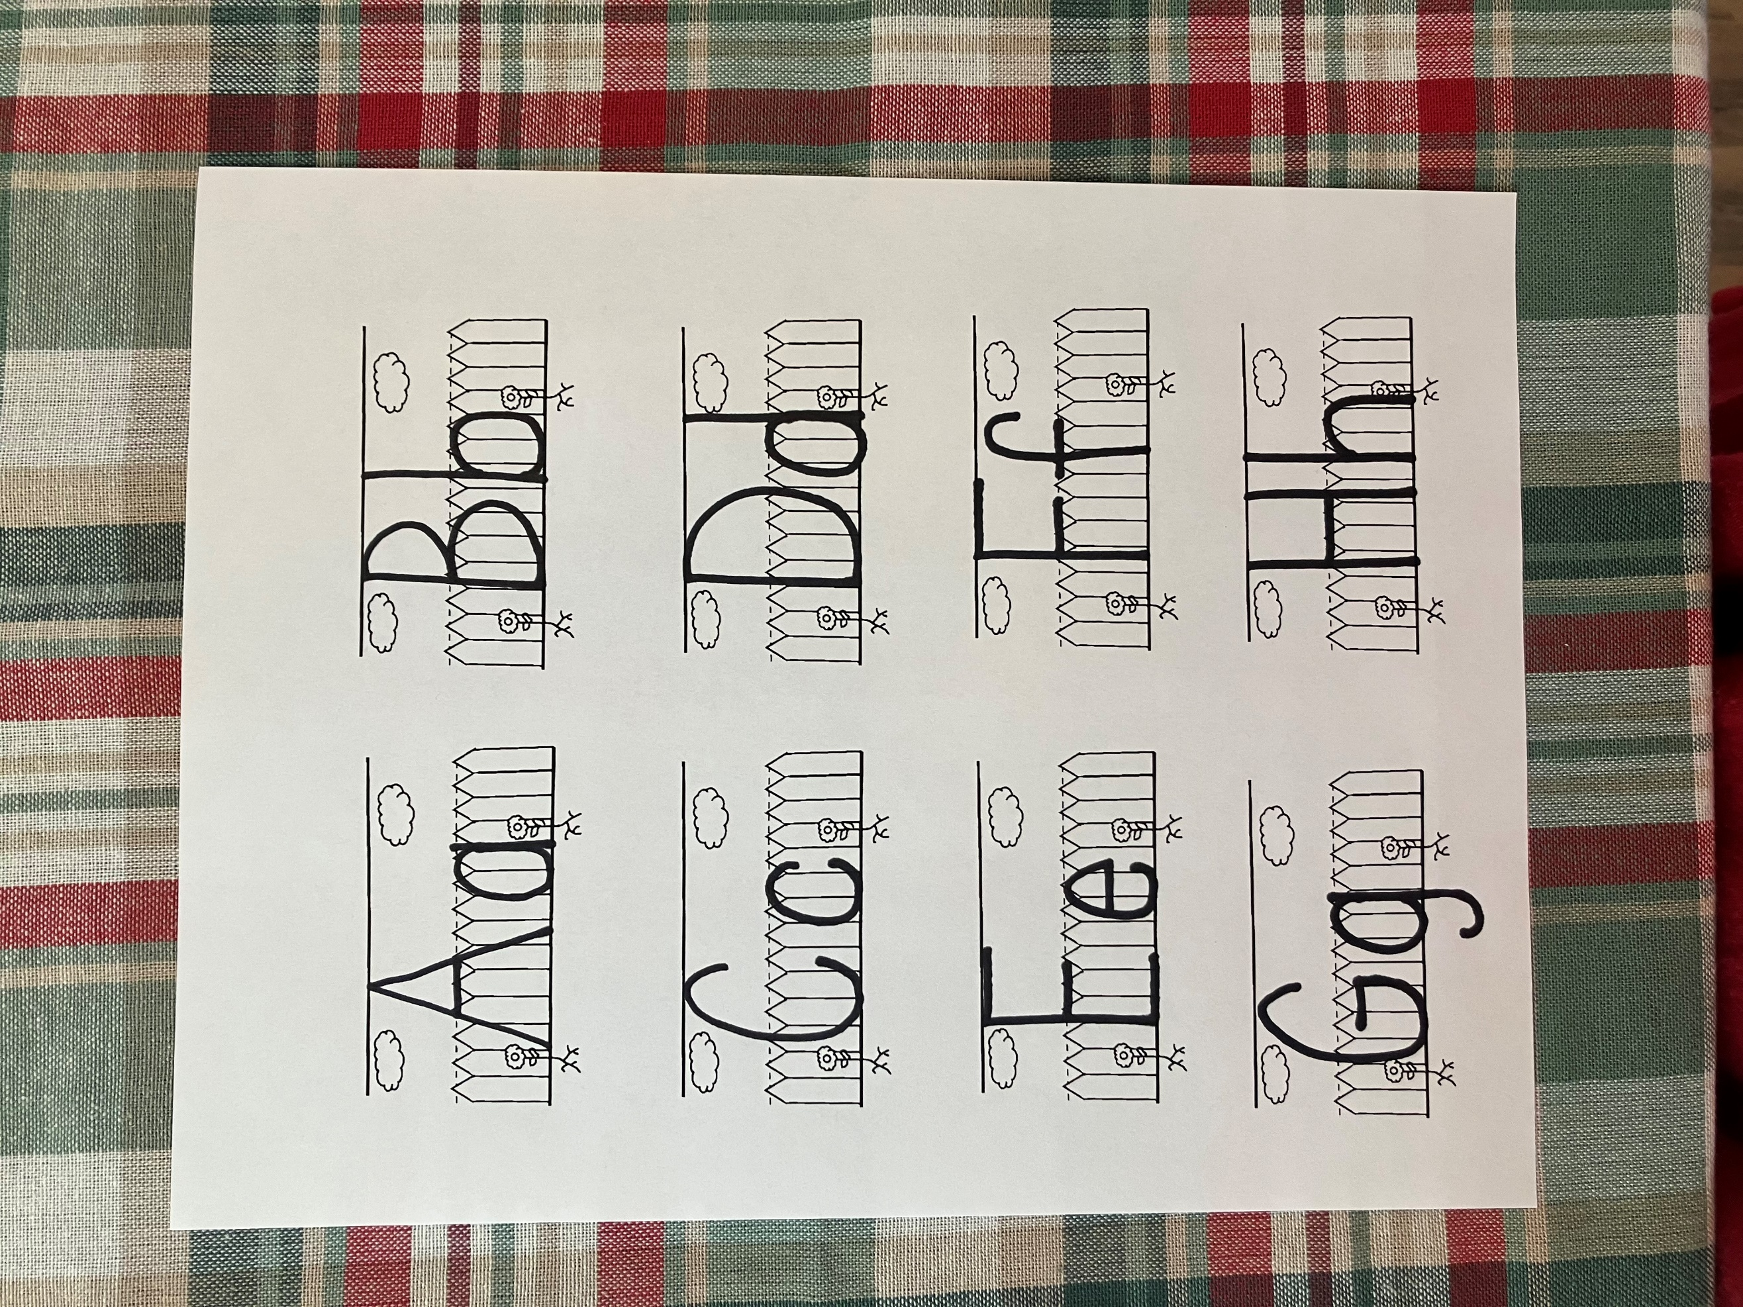
C

c

crown

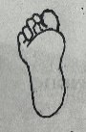
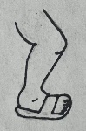

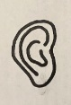

Before the guards beat Jesus, they placed a crown of thorns on his head and a robe on his shoulders. Look at the pictures below. Match the clothing to the part of the body you would wear it.
.
.




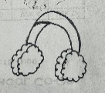
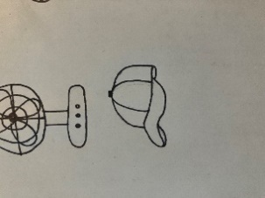
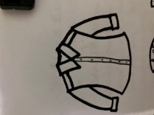
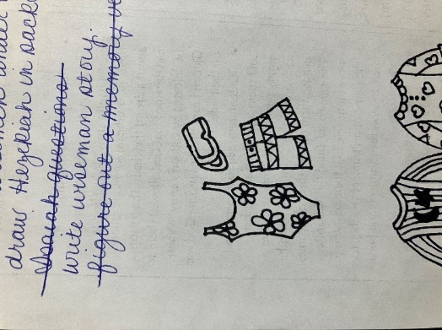

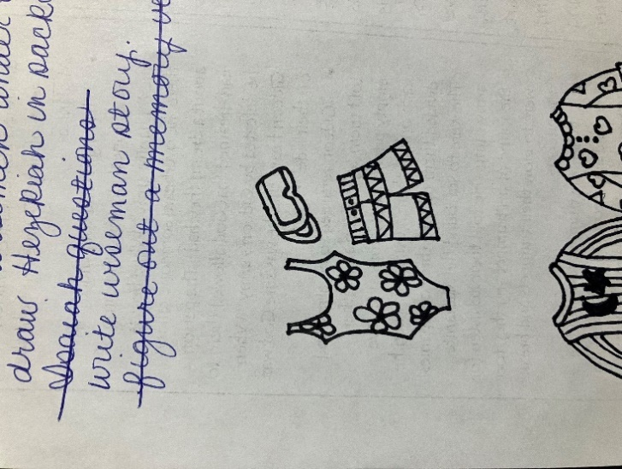
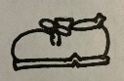

Pilate told the crowd he would release one of the prisoners. He let them decide whether he should let Jesus or Barabbas go. Count the items in each group. How many would you have if you let one go? Write that number in the box.








Cc
Then delivered he him therefore unto them to be crucified.
John 19:16

Rr
Pilate thought if he washed in hands in front of the crowd, they would understand that he didn’t think Jesus was guilty. He didn’t want the guilty of Jesus death on his hands. In the space below, trace your hand.

innocent
- Not guilty, did nothing wrong

- The members of the Sanhedrin brought Jesus to me.
- I sent Jesus to Herod.
- Herod sent Jesus back to me.
- I didn’t think Jesus was guilty.
- I tried to get the crowd to pick Barabas instead of Jesus
- I washed my hands of the guilt.
Who am I?
___ ___ ___ ___ ___ ___

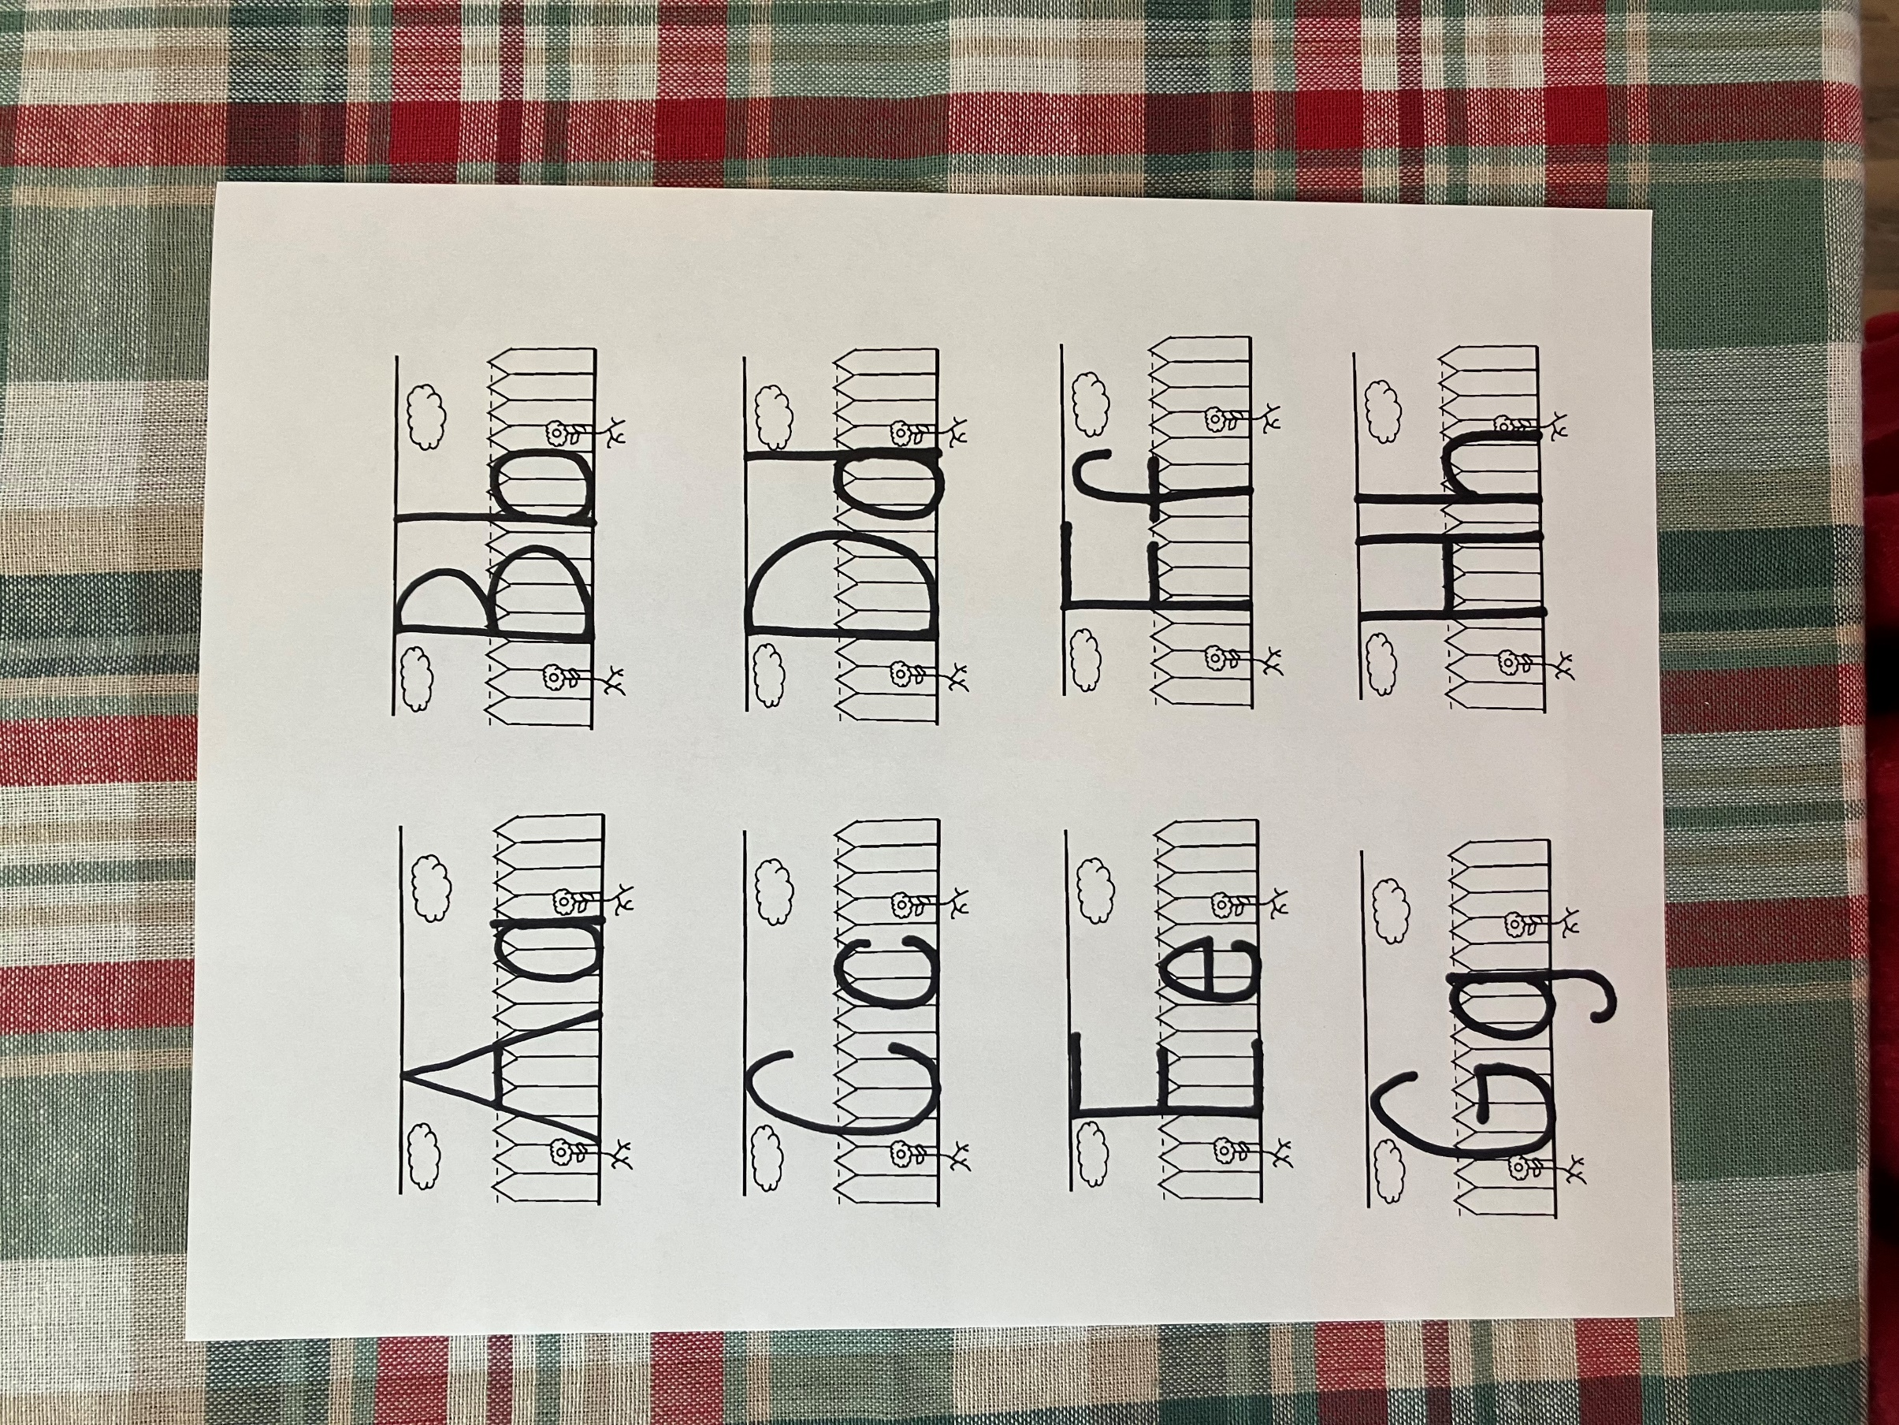

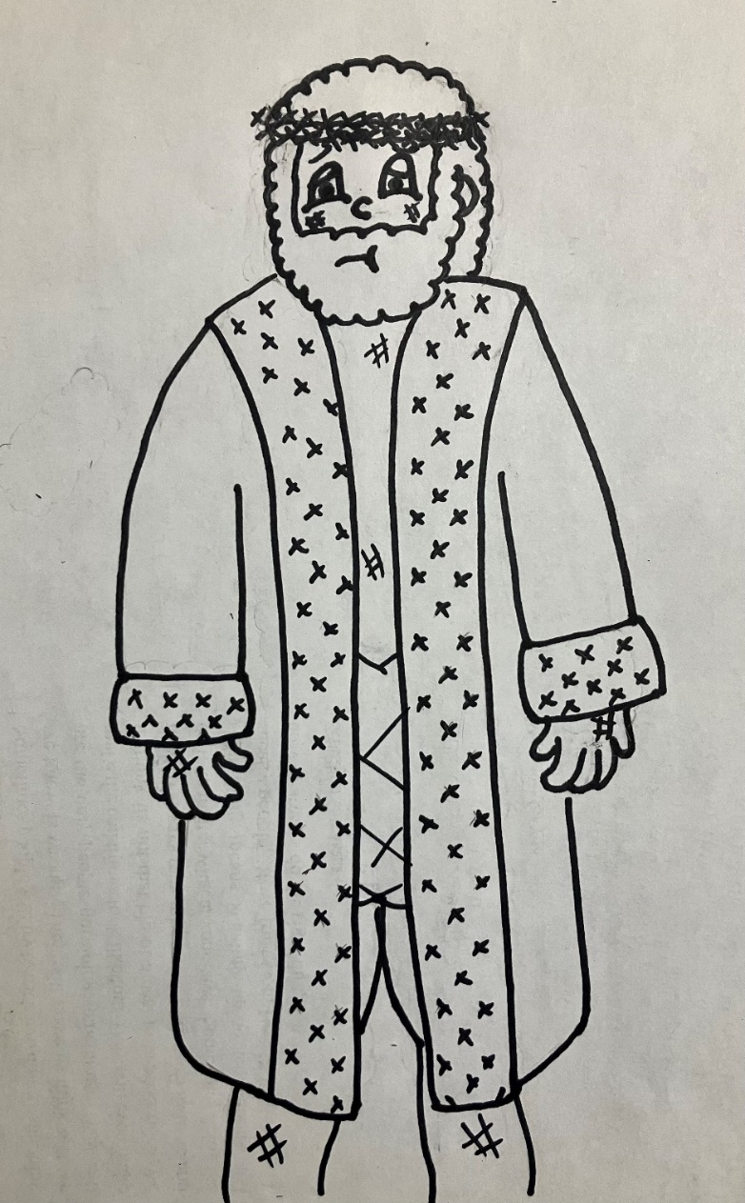
Then delivered he him, therefore unto them to be crucified. John 19:16

