Jesus knew that it was almost time for him to be crucified. He tried to explain it to the disciples, but they didn’t quite understand all that was about to happen. One night, after the Passover Meal, Jesus gathered his disciples and went to a place call the Garden of Gethsemane. Jesus often went to this garden to pray.

The Garden of Gethsemane

As they entered the garden Jesus told most of the disciples to sit and wait and he traveled on a little farther. He asked Peter, James and John to walk with him. He wanted them to stand watch while he prayed. Jesus knew danger would soon be around them all, but he wanted to be able to focus to pray so he asked these three me to carefully watch.

Jesus went on a little farther by himself. Then he fell to his knees and prayed. Jesus was very upset. He knew people were coming that were going to kill him. He knew that it was God’s plan all along for him to come to the world to die for the sins of everyone. He already knew about all the pain he would suffer and how everyone would turn against him in his last days. He knew that his disciples would scatter, hide, and deny that they even knew him. Jesus knew his heart was about to break and his body would be badly beaten. He knew exactly what was about to happen. But the thing that bothered Jesus the most was the fact that there would be a time when God would be separated from him. God cannot be in the same place as sin so while Jesus was paying for the sins of all people he had to be separated from God.

was the part that troubled him the most. Jesus was so burdened in his praying that he sweat drops of blood.

Jesus prayed asking God to take this cup from him which meant if there was any other way to pay for the sins of the world, he would rather do that. But he ended the prayer by saying, “Not my will but thine.” This was saying, its not about what is easiest for me. Whatever I need to do, I will do it.”

After about an hour, Jesus walked back to where Peter, James and John were waiting. All three of the disciples were asleep. Jesus woke them up and asked them why they couldn’t do what he had asked. He asked why they couldn’t stay awake for even one hour to let him pray. Jesus knew how serious things were about to get but the disciples still didn’t understand. He told his disciples to be careful. To not let temptation make them not do what they needed to do. The body is weak and sometimes it is a struggle to stay focused. Then Jesus went back to pray some more.

1. Where did Jesus go with his disciples?
2. How many disciples did he ask to walk on with him?
3. What did Jesus ask Peter, James, and John to do why he went to pray?
4. What did Jesus start to sweat because he was praying so hard?
5. What did Jesus pray in the garden?
6. What did Jesus find the disciples doing when he returned from praying?
7. How many times did Jesus go pray alone?
8. What did Jesus say to God that meant he was willing to do whatever he needed to do?

**Look it Up! (Answers are KJV specific) _**

**In My World**

**My Prayer for You**

**Reflection Questions**

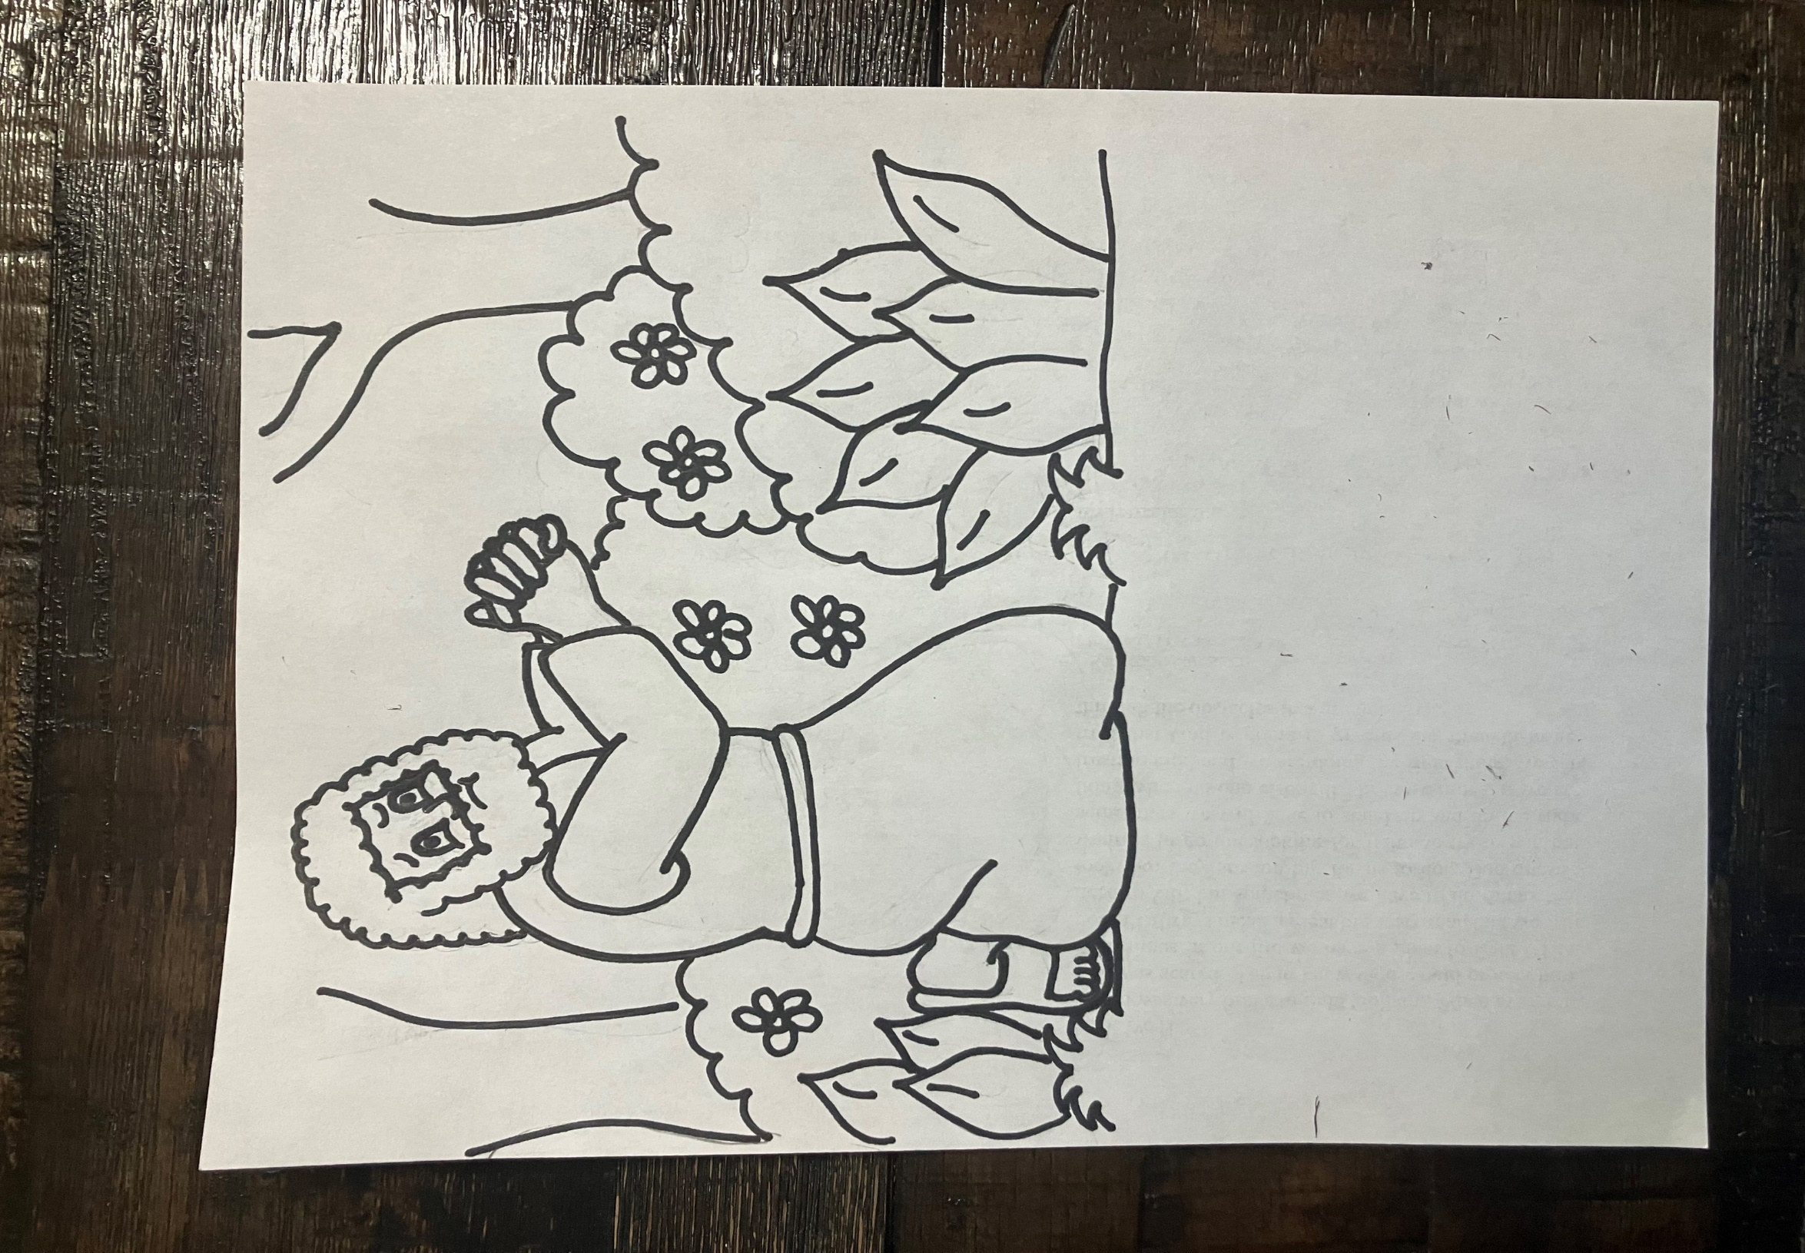

And he cometh unto the disciples, and findeth them asleep. Matthew 26:40