“Animals Everywhere”

-Counting By 10



















INSTRUCTIONS:

Print hexagons on pages 3 and 4 on full-page labels. Cut out, stick to the inside of a file folder. (Optional) Cover folder with contact paper. Print hexagons on pages 1 and 2 on regular printer paper. Cut out, cover front and back with contact paper. Cut out.

10

30

20

50

40

The disciples thought what Mary was doing was a bad idea. Jesus knew she was doing a good thing. Good and bad are opposites. See if you can match up all the opposites.



























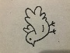

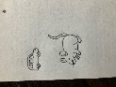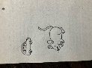











60

80

70

100

90

