Daniel Stories with Jolly

Written and illustrated

by Jill Crowder

“Daniel Stories with Jolly” is part of the “Jesus Stories with Jolly” series.

Copyright © 2024 by Crowded Acres Publication.

ISBN 9798324648923

Follow us on Facebook under “Jesus Stories with Jolly”

Table of Contents

Daniel and the King’s Table – Daniel 1…………………………...4

Daniel and the King’s Dream – Daniel 2….………………………10

Daniel’s Friends and the Fiery Furnace – Daniel 3………………..16

Daniel and the King’s Dream…Again – Daniel 4………………..22

Daniel and the Writing on the Walls – Daniel 5…………..…….…28

Daniel and the Lions’ Den – Daniel 6……………….……………34

There was once a young man named Daniel. Daniel was an Israelite who lived in Jerusalem. One day, Jerusalem was attacked by the armies of Babylon. The Israelite people believed in God and lived by His rules, but the Babylonians did not. The Babylonians won the fight and took lots of the Israelite children and brought them back to their land. The Babylonian king, Nebuchadnezzar, wanted all the smart, talented, hardworking, goodlooking young people to come live in his palace so he could force them to one day be leaders in his kingdom. He only wanted the best and smartest so he could teach them things he wanted them to know and them be on his side and make his kingdom stronger. Daniel and his friends; Hananiah, Mishael, and Azariah were in the group of people captured and taken to the king’s palace.

Daniel and the King’s Table

When they arrived in Babylon, the king had their names changed. He thought their names sounded too much like Israelite names, so he changed them to names that sounded more like the names of the people in Babylon. He called Daniel “Belteshazzar.” He called Hananiah “Shadrach.” He called Mishael “Meshach”, and he called Azariah “Abednego.” He wanted them to fit in with the people in his kingdom.

King Nebuchadnezzar had a plan for Daniel and his friends along with all the other Israelite children. For 3 years they were going to be trained and taught all the Babylonian ways. He was going to let them live in the palace and even eat the same food he was eating. They would get the best meat and wine just like the king. After 3 years, they would be workers for him, so he wanted them to be as smart and healthy as possible. But Daniel didn’t want to eat the king’s food. The food the king was serving them was against the rules for him to eat when he lived in Jerusalem. He knew that even though he wasn’t in Jerusalem, it would be wrong for him to eat the food anyway. God had given the Israelites rules about what kind of food to eat and how to cook it. Daniel knew that the king’s food was against those rules. Daniel went to one of the king’s helpers and asked if he could have different food, but the king’s helper would not let him eat different food. The helper was afraid the king would punish him if Daniel ate different food and then turned out not to be as healthy as the other people. So, Daniel talked to someone else. Daniel went to Melzar who was the person who was supposed to take care of him and his friends, and he asked him to do an experiment.

Daniel said, “Why don’t you feed my friends and me vegetables and water for 10 days and feed everyone else the king’s food. Then after 10 days, compare us to the others to see who looks the healthiest.”

Melzar agreed to the challenge and did just as Daniel asked him to do. After 10 days, Melzar compared the two groups of Israelites children. Daniel and his friends looked much healthier than the people who were eating the king’s meat and drinking his wine. Melzar changed the rule. Daniel didn’t have to eat the food that wasn’t’ pleasing to God. In fact, the rule changed so everyone had to eat the same foods Daniel was eating.

Daniel was loyal to God. He wasn’t tempted to do the wrong thing because he wanted to please God in everything he did. He was brave to ask the king’s helpers to change his diet and he handled the situation in a peaceful way. Daniel did what was right even though it wasn’t easy, and God took care of the rest.

1. Why did Daniel have to leave his home?
2. Why did the king want people like Daniel?
3. What was the King’s name?
4. What did the king change about Daniel, Hananiah, Mishael, and Azariah?
5. Why didn’t Daniel want to eat the king’s food?
6. Why didn’t the king’s helper let Daniel have different food?
7. What kind of experiment did Daniel ask Melzar to do?
8. Which group was the healthiest after the 10 days?
9. What change did Melzar make after the contest?

**Look it Up! (KSV)**

**Down**

1. Daniel 1:11 Then Daniel said to Melzar, whom the prince of the __________ had set over Daniel, Hananiah, Mishael, and Azariah.
2. Daniel 1:4 Children in whom was no __________
3. Daniel 1:12 …and let them give us ________ to eat.
4. Daniel 1:16 …and the _______ that they should drink.

**Across**

1. Daniel 1:7 …for he gave unto Daniel the name of _________
2. Daniel 1:5 And the king appointed them a daily ______ of the king’s meat,

5 Daniel 1:1 In the third year of the reign of Jehoakim

king of Judea came Nubuchadnezzar king of Babylon

unto Jerusalem, and _____________ it.

6 Daniel 1:15 And at the end of ten days their

countenance appeared _________ and fatter in flesh than all

the children which did eat the portion of the king’s meat

|  |  |  |  |  |  |  |  |  |  |  |  |  |  |  |  |  |  |  |  |  |
| --- | --- | --- | --- | --- | --- | --- | --- | --- | --- | --- | --- | --- | --- | --- | --- | --- | --- | --- | --- | --- |
|  |  |  |  |  |  |  |  |  |  |  |  |  |  |  |  |  |  |  |  | 4 |
|  |  |  |  |  |  |  |  |  |  |  |  |  |  |  |  |  |  |  |  |  |
|  |  |  |  |  |  |  |  |  |  |  |  |  |  |  |  |  |  |  |  |  |
|  |  |  |  |  |  |  |  |  |  |  | 3 |  |  |  |  |  |  |  |  |  |
|  |  |  |  |  |  |  |  |  |  |  |  |  |  |  |  |  |  |  |  |  |
|  |  |  |  |  |  |  | 2 |  |  |  |  |  |  |  |  |  |  |  |  |  |
|  |  |  |  |  |  | 5 |  |  |  |  |  |  |  |  |  |  |  |  |  |  |
|  |  | 1 |  |  |  |  |  |  |  |  |  |  |  |  |  |  |  |  |  |  |
| 6 |  |  |  |  |  |  |  |  |  |  |  |  |  |  |  |  |  |  |  |  |
|  |  |  |  |  |  |  |  |  |  |  |  |  |  |  |  |  |  |  |  |  |
|  |  |  |  | 7 |  |  |  |  |  |  |  |  |  |  |  |  |  |  |  |  |
|  |  |  |  |  |  |  |  |  |  |  |  |  |  |  |  |  |  |  |  |  |
|  |  |  |  |  |  |  |  |  |  |  |  |  |  |  |  |  |  |  |  |  |
|  |  |  |  |  |  |  |  |  |  |  |  |  |  |  |  |  |  |  |  |  |
|  |  |  |  |  |  |  |  |  |  |  |  |  |  |  |  |  |  |  |  |  |

**My Prayer for You**

My prayer for you is that you always try to do what is right in the eyes of God even if it means going against what everyone else is doing. I hope when you take a stand doing the right thing, people see that what you are doing is the right thing and they follow in your footsteps. I hope you never forget that it’s more important to please God than man.

**Reflection Questions**

1. Have you ever been in a situation where you knew something was wrong but it seemed like everyone else was doing it?
2. Have you ever taken a stand for what you knew was right and something big and wonderful happened?

**In My World**

Something very bad happened to Daniel and he was taken from his family and his home. He was alone with his friends in Babylon and the king tried to get him to do something that was against God’s rules. Daniel’s parents would have never known if he just ate the food, but Daniel knew God would know and Daniel wanted to always try to do what God wanted him to do. Daniel made a bold choice to do the right thing. Sometimes in our life, we will have the choice to do the right thing or something else. Even if you think no one will know if you do the wrong thing, God will know. Try to always do the things that God wants you to do.

Let our countenance be looked upon before thee, Daniel 1:13

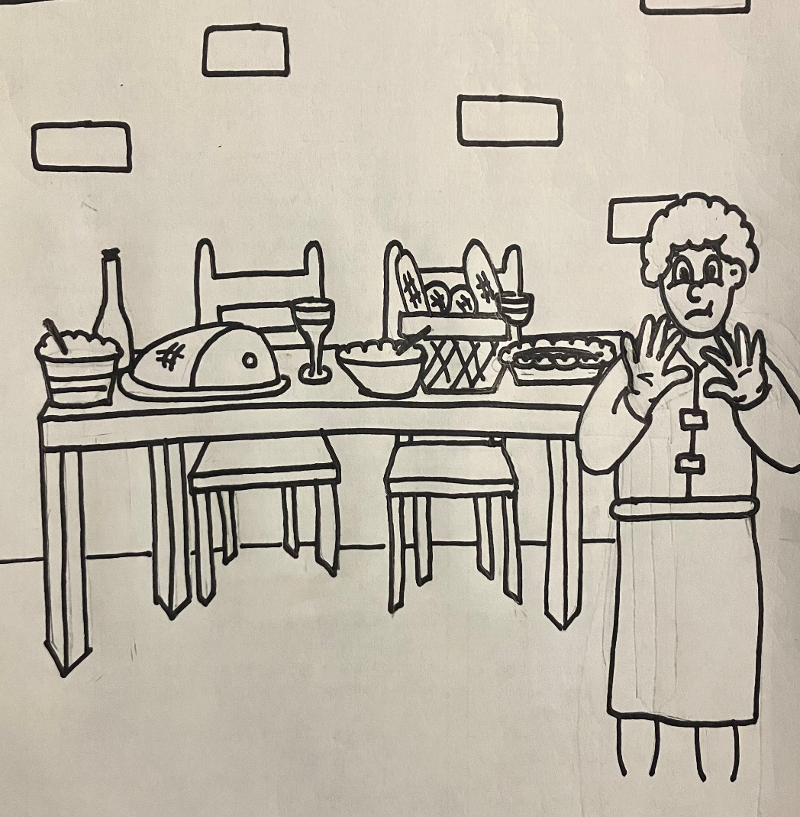

There once was a very bad King named Nebuchadnezzar. Nebuchadnezzar was king over Babylon, and he didn’t love God. He worshipped fake gods. He was a very mean and powerful man. One day King Nebuchadnezzar called for all of his wise men. He had a problem, and he needed their help. Nebuchadnezzar was dreaming the same dream every time he went to sleep, and it was a very strange dream. He wanted the men on his counsel to tell them what his dream meant. The wise men were ready to help him, but Nebuchadnezzar refused to tell him his dream. The wise men couldn’t tell him what the dream meant if he didn’t tell them about it. But the King still refused. He said, “the thing is gone from me”. He acted like he forgot the dream, maybe he did forget the dream, maybe he was trying to test his wise me. He told them if they were as wise as they said they were, they should be able to tell him the dream and the interpretation without him telling them the dream. They couldn’t do that, no one could do that. Only God could know someone’s dreams. This made the king very angry, and he ordered for the wise men to be killed. All the wise men were to be killed even if they weren’t there that day. So he had his guards go out and gather up all the wise men.

Daniel and the King’s Dream

One of his wise men was named Daniel. Daniel loved God even though the king and most of the other people in Babylon didn’t love God. Daniel wasn’t there when the king asked the wise men to tell him about the dream so when Arioch, the king’s guard, came to him he wanted a chance to help the king. Arioch took Daniel to Nebuchadnezzar and then Daniel asked Nebuchadnezzar if he could have extra time to figure out the dream and the meaning. Nebuchadnezzar agreed to give Daniel the extra time.

When Daniel left the king, he went straight to his friends Shadrach, Meshach, and Abednego. They were also wise men. They were also going to be killed if someone didn’t help the king. They were also men who loved God. Daniel went to his friends, and he asked them to pray for him, that God would reveal the dream and the meaning so Daniel could go back and tell the king and save them all. Daniel’s friends did pray for him. They knew God could help and He did! God showed the dream to Daniel in a vision and helped him to understand what the dream meant.

Immediately Daniel praised God, thanking him for answering his prayer. Then Daniel went to Arioch and told him not to kill any of the wise men because God showed him the dream. Arioch took Daniel before the king. Before Daniel told Nebuchadnezzar about the dream, he was sure to tell him that God revealed the dream. Daniel didn’t want the king to think he could do impossible things. He wanted to be sure the king understood that it was only because of God that he was able to help at all.

Then Daniel told him about the dream. Daniel said, “You saw an image of a man with a head made of gold, shoulders and chest made of silver, his belly and the top of his legs were made of brass, the bottom of his legs were made of iron, and his feet were mixed with iron and clay. Then in your dream, you saw a rock being cut out of a mountain, but no one was cutting it. Suddenly the rock flew and hit the man in the feet and the feet started to crumble. Then the legs started to crumble. The belly, chest, shoulders, and head all started to crumble until the whole man was on the ground. Then the wind carried away all the pieces until there was nothing left but the rock. The rock started to grow and grow and grow until it was a mountain that covered the whole earth.” King Nebuchadnezzar could not believe it! That was exactly his dream. Then Daniel explained the dream. He told the king that he was like the head of gold. Gold is a very strong metal, just like Nebuchadnezzar was a very powerful king. The silver was going to be like the next king that ruled Babylon after Nebuchadnezzar. Silver is also strong but not quite as strong as gold. The brass belly was the next king. Brass is not even as strong as silver. Then the iron legs were like the king after that. With ever king the metal was getting weaker and weaker, not near as strong as gold which meant the kings were going to be less and less powerful. Then one day there would be lots of rulers. Some would have a little bit of power, and some would not have much power at all. That would be like the feet that were a mix of iron and clay. Then rock would strike in the feet and cause everything to crumble right before the rock grew to be the biggest most powerful thing on earth. That rock would be Jesus. One day God is going to send Jesus to come and take over everything as king. Everyone, even the important people will know that Jesus is the most important and they will have no power because everyone will see that Jesus has all the power.

The king was amazed at what Daniel told him. He knew God was telling them exactly what He was going to do with the world and the future. Nebuchadnezzar fell and put his face on the ground and said, “Your God is the one true God.” Nebuchadnezzar believed in Daniel’s God that day. Then King Nebuchadnezzar gave Daniel lots of gifts and decided that Daniel should be a ruler over the other wise men and all the people in Babylon.

1. What was the king’s name?
2. What problem was the king having?
3. What did the king expect the wise men to do for him?
4. Why couldn’t the wise men tell him what his dream meant?
5. What was going to happen to Daniel and his friends because the king was angry at all the wise men?
6. What brave thing did Daniel do?
7. How did Daniel ask his friends to help?
8. What did Daniel do after God revealed the dream?
9. What was the king’s dream about?
10. What did the king do to Daniel after Daniel told him about the dream?

**Look it Up! (KSV)**

In Nebuchadnezzar’s dream, what material made up each of the parts below. Use the key above to find your answers.

Head g o l d

Breast and Arms s i l v e r

Belly and Thighs b r a s s

Legs i r o n

Feet i r o n

and

c l a y

Look up Daniel 2:32-33 to see if your answers are correct.

|  |  |  |  |  |  |  |  |  |  |  |  |  |
| --- | --- | --- | --- | --- | --- | --- | --- | --- | --- | --- | --- | --- |
| A | B | C | D | E | F | G | H | I | J | K | L | M |
| a | b | c | d | e | f | g | h | i | j | k | l | m |
|  |  |  |  |  |  |  |  |  |  |  |  |  |
| N | O | P | Q | R | S | T | U | V | W | X | Y | Z |
| n | o | p | q | r | s | t | u | v | w | x | y | z |

**Reflection Questions**

1. Have you ever had a task before you that seemed impossible? How did you handle things? Did you take it to God?
2. All the wise men were going to die if Daniel wasn’t able to interpret the king’s dreams. Have you ever had a large group of people depending on you to know how to do something? How did that pressure make you feel?

**In My World**

What the king was asking the wise men to do was impossible. Sometimes in life things seem impossible. In those moments when something is impossible for us, it is not impossible for God. With God all things are possible. When we are faced with something we can’t fix, we need to always remember that God can do things we can’t do. We need to be like Daniel and pray to God for help. Then we must trust that He will take care of the situation the right way.

**My Prayer for You**

My prayer for you is that you never forget that God specializes in the impossible. Don’t go looking for impossible situations but when life puts you in a place where there seems like there is no way out, I pray that you always remember God can make a way. Trust him to lead you to the right answers even when things seem hopeless. Seek him and then trust him.

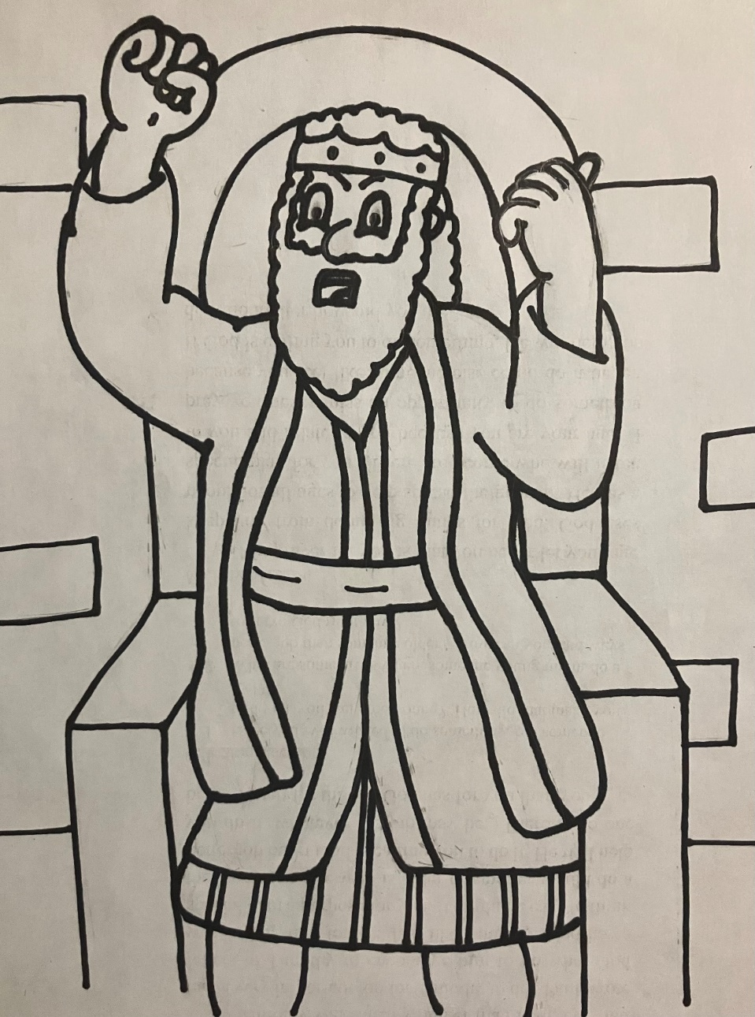

For with God nothing shall be impossible. Luke 1:37

Once there was a very bad king in the land of Babylon named Nebuchadnezzar. King Nebuchadnezzar was a very powerful king who did not love God. He worshiped fake gods. King Nebuchadnezzar had a horrible temper, if he got mad about something, he would kill the person who had made him angry. So almost everyone did exactly what he told them to do.

Daniel’s Friends and the Fiery Furnace

One day, King Nebuchadnezzar had a very bad idea. He decided to build a great big, huge golden statue. He had it built to be 90ft tall and 9ft wide. When the statue was finished, he made all the important people come to a special ceremony to see his new statue. While the people gathered together, King Nebuchadnezzar had someone explain the rule with this statue. Any time the music played, all the people were supposed to stop what they were doing and bow down and worship the statue. If anyone didn’t follow this rule, they would be thrown into a fiery furnace and die. This was a very bad plan because we are only supposed to worship God and bowing down to the statue would be breaking God’s rules. All the people who loved God were going to have to decide to break God’s rule or be thrown into the fire.

When the music began to plan, everyone bowed down just as the king told them to do, everyone except Shadrach, Meshach, and Abednego. They refused to do anything that was against God’s rules. When the other people saw that they were breaking the king’s rule, they hurried to tell King Nebuchadnezzar all about it. King Nebuchadnezzar was mad. He called for Shadrach, Meshach, and Abednego to be brought to him at once. King Nebuchadnezzar reminded the three men just what was going to happen to them if they didn’t bow down when they heard the music. The king asked, “Who can save you from the fire and from me?”

Shadrach, Meshach, and Abednego answered the king and said, “Our God whom we serve is able to save us from the burning fiery furnace and will save us from you.”

This made King Nebuchadnezzar even more angry than before, so he called for his men to heat up the furnace 7 time hotter than usual. Then he had his men tie up Shadrach, Meshach, and Abednego and throw them into the fire. The fire was so hot that when his men got close enough to put Shadrach, Meshach, and Abednego inside the furnace, the heat killed them. It was super, super hot. King Nebuchadnezzar sat and watched Shadrach, Meshach, and Abednego as they were in the fire. He wanted to be sure they were punished. While he was watching, he could see the three men walking around in the fire. They weren’t screaming or falling. They didn’t act like the fire was hurting them at all and then King Nebuchadnezzar noticed something else. There weren’t three men in the fire, there were four! There was an extra person in the fire and the extra person looked like an angel or maybe even Jesus. King Nebuchadnezzar knew that God had put someone else in the fire with Shadrach, Meshach, and Abednego so he had the men pulled out of the fire.

When Shadrach, Meshach, and Abednego came out they weren’t hurt at all. Their clothes were not burned. Their hair wasn’t even burned, not even a little bit. They didn’t even smell like smoke. The only thing that burned up in the fire was the rope that had been tied around them. King Nebuchadnezzar knew that God had saved them from the fire and from him just as they told him God could do. Then the king told everyone they could not talk bad about their God, and Shadrach, Meshach, and Abednego were free to worship only their God.

1. Where was Nebuchadnezzar the king?
2. What would happen to people if they didn’t obey the king?
3. What did King Nebuchadnezzar have built?
4. What were the people supposed to do when they heard the music?
5. Who did not bow down to the statue?
6. How did Shadrach, Meshach and Abednego respond with the king asked who would save them from the fiery furnace?
7. What did the king have done to the men when they refused to bow?
8. How much hotter did Nebuchadnezzar have his guards make the fire.
9. What happened to the guards who threw the men into the fire?
10. How many people did the king see when he looked into the fire.
11. Describe the men after they were pulled from the fire

**Look it Up!**

Daniel 3:1 Nebuchadnezzar the king made an image

of gold, whose height was threescore STIBUC, ___________

Daniel 3:5 That at what time ye hear the sound of

the TRONEC, __________ flute, harp, sackbut, psaltery, dulcimer, and all kinds of music

Daniel 3:12 There are certain Jews whom thou has set over the affairs of the provinces of LABBYNO.__________

Daniel 3:13 Then Nebuchadnezzar in his rage and UFRY__________ commanded to bring Shadrach, Meshach, and Abednego.

Daniel 3:17 If it be so, our God whom we serve is able to deliver us from the burning fiery furnace, and he will deliver us out of thine DANH ________, O King.

Daniel 3:19 …and commanded that they should heat the furnace one VEENS _________ times more that it was wont to be heated.

Daniel 3:25 …and the form of the THRUFO __________ is like the Son of God.

Daniel 3:29 Therefore I make a CREEDE ________, That every people, nation, and language, whish speak any thing amiss against the God of Shadrach, Meshach, and Abednego, shall be cut into pieces, and their houses shall be made a dunghill: because there is no other God that can deliver after this sort.

**My Prayer for You**

My prayer for you is that you never bow down to anything that tries to force its way in between you and God. Never allow anything or anyone to make you think their power is worth defying God. Try to make every decision in your life in such a way that when you stand before God you won’t be ashamed of how you responded. Honoring God with your life is always the right decision.

**Reflection Questions**

1. Have you ever had to trust God even if it meant things might not turn out the way you wanted them to?
2. If you were Shadrach, Meshach, or Abednego, what would you have done in this situation? Would your response have given God an opportunity to show His power?

**In My World**

Nebuchadnezzar forced Shadrach, Meshach, and Abednego to make a very difficult choice, either do something against God or die. They replied by saying that God could save them. Shadrach, Meshach, and Abednego didn’t know if God was going to save them, but they knew He could. They knew there was a chance they would die in the fire, but they knew not bowing to the statue was still the right thing to do. They trusted God with how He would handle the situation even if it meant something bad was going to happen to them. Sometimes in life there is a risk to do the right thing. It may not be being cast into a fiery furnace. It may be missing out on something that looks like fun or causing an embarrassing moment. When we are faced with a risk, we need to still do the right thing and trust God with how things turn out.

.

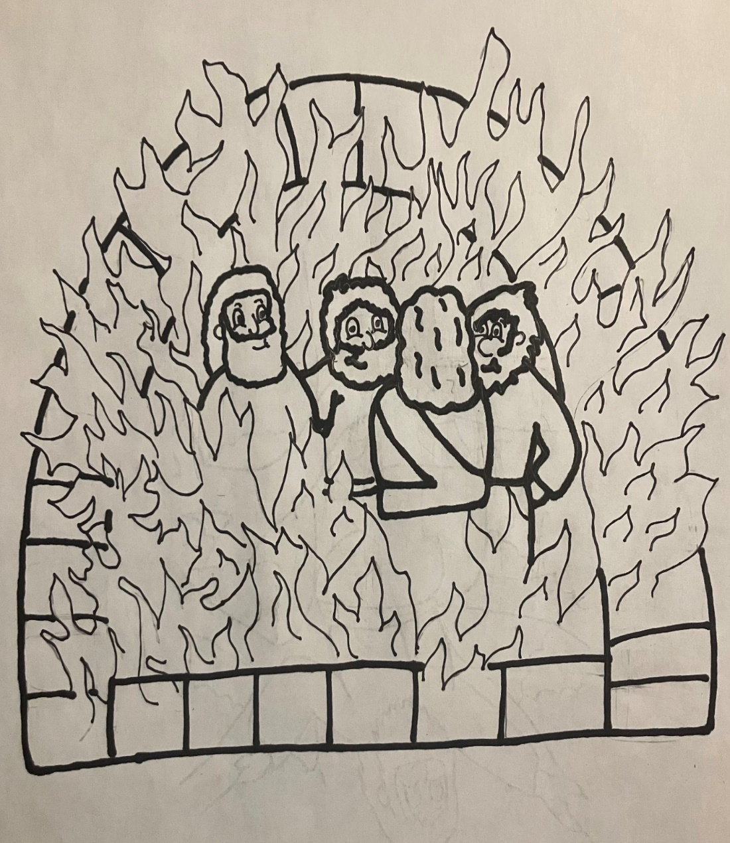

Our God whom we serve is able to deliver us from the burning fiery furnace. Daniel 3:17

There was a great king named Nebuchadnezzar. He was great in the way that means everyone knew him and listened to him but sometimes he was a very mean king. King Nebuchadnezzar knew about God and had seen what wonderful things God could do but he still chose to worship fake gods and not act in a way that pleased the one true God.

Daniel and the King’s Dreams, Again

One day King Nebuchadnezzar started having bad dreams. This had happened to him before, so he knew God was trying to tell him something through his dreams, but he didn’t understand what it was. He called for all the wise me in Babylon to come and help him understand his dream. None of the wise men could help him. So, he called a man named Daniel. Daniel loved God and always tried to live his life the way God wanted him to live. King Nebuchadnezzar knew Daniel could help him.

The king told Daniel about his dream. He said, “In my dream there was a great big tree. This tree had lots of leaves and fruits. It even had meat enough for everyone to eat. All the animals in the fields could have shade under this huge tree and all the bird could live in the branches. Then there was someone watching from heaven, and they said to cut down the tree, cut off all the branches, shake off all the leaves, but to leave the stump. All the animals and birds had to scatter. Then the heart of the stump changed to the heart of a beast, and it was to stay out in the fields for 7 years. Then everyone will know that God is greater and more powerful than the tree.”

Daniel understood the dream and he knew exactly what it meant but he didn’t want to tell the king. The dream made him very sad, and he waited an hour before he told the king about it. Daniel even told the king he wished the dream was about the king’s enemy. The king told Daniel not to worry about the bad news but to tell him anyway. Daniel explained the dream. He told Nebuchadnezzar that the dream was about him. He was the tree. Nebuchadnezzar had great power and lots of people in his kingdom that he took good care of, kind of like the tree took care of all the animals and birds with all the leaves and fruits on it. Then he said the watcher from heaven was like God saying that Nebuchadnezzar was going to lose his kingdom. Nebuchadnezzar was going to go crazy, and his mind was going to think he was an animal instead of a man. When that happened, the people would make him leave the kingdom to go live in the fields with the animals and he would eat grass just like the animals do. He would have to stay outside for 7 years and then one day his mind would turn back into the mind of a king, but he would be a better king. He would be a better man, because then he would understand that God is more powerful that he is and he would praise God and honor God with the way he lived his life.

This was very bad news for King Nebuchadnezzar and Daniel begged him to change his ways and love God more so this horrible thing wouldn’t happen to him. Nebuchadnezzar didn’t listen to Daniel and one year later these bad things started to happen. While Nebuchadnezzar was admiring his wonderful kingdom one day, he heard a voice from heaven say “This is not your kingdom anymore you are going to be kicked out to live in the fields like an animal for 7 years. Then you will know that God is the highest ruler of men.” Then Nebuchadnezzar lost his mind. He went crazy. He thought he was an animal, and it only took one hour for the people to kick him out of his kingdom to live outside in the field. Nebuchadnezzar lived like an animal for 7 years. He ate the grass; the dew made his hair grow to look like feathers on his body and his fingernails and toenails grew to be strong like bird claws. After the 7 years were up, Nebuchadnezzar looked up to the sky and he wasn’t crazy anymore. He didn’t think he was an animal anymore; he knew he was a king. He also knew that God was the one true God and He was more powerful than Nebuchadnezzar could even think about being. Then Nebuchadnezzar praised God for being such a great and powerful God. Nebuchadnezzar went back to being the king but this time he kept praising God and honoring God with the way he was living.

1. Where did Daniel live?
2. What was the king’s name?
3. Why did the king ask the wise men to help him?
4. Who was the only person who could help him?
5. What was the king’s dream about?
6. Why didn’t Daniel want to tell the king about

the dream?

1. What did the king’s dream mean?
2. What happened a year after the king had the

dream?

1. How long was the king a beast?

10.What happened when the king looked up to

heaven?

**Look it Up! (KJV)**

Daniel 4:5 I saw a dream which made me afraid, and the thoughts upon my bed and the visions of my head ___________ me.

Daniel 4:7 The came in the magicians, the astrologers, the _____________, and the soothsayers…

Daniel 4:11 The tree grew, and was strong, and the height thereof reached unto ____________

Daniel 4:13 I saw in the vision of my head upon my bed, and, behold, a _____________ and an holy one came down from heaven.

Daniel 4:19 Then Daniel, whose name was Belteshazzar, was _______________ for one hour,

Daniel 4: 31 …The kingdom is ____________ from thee

Daniel 4:33 …and he was driven from men, and did eat grass as ______

Daniel 4:37 Now I Nebuchadnezzar praise and ________ and honour the King of heaven

|  |  |  |  |  |  |  |  |  |  |  |  |  |  |  |
| --- | --- | --- | --- | --- | --- | --- | --- | --- | --- | --- | --- | --- | --- | --- |
| M | N | B | V | C | X | Z | L | K | J | H | C | G | F | D |
| Y | U | W | A | T | C | H | E | R | I | O | H | P | A | S |
| T | R | E | W | Q | Z | X | C | V | B | N | A | M | Q | W |
| I | O | P | Z | X | C | V | B | N | M | L | L | K | D | P |
| U | Q | A | S | T | O | N | I | S | H | E | D | J | E | O |
| Y | A | D | F | R | G | H | J | K | J | H | E | H | P | I |
| T | Q | W | E | O | X | E | N | T | K | G | A | G | A | U |
| R | Z | X | C | U | V | B | N | M | L | F | N | F | R | Y |
| R | H | J | K | B | O | P | Q | A | S | D | S | D | T | T |
| E | G | F | D | L | S | A | Z | X | C | V | B | S | E | R |
| H | E | A | V | E | N | H | J | K | L | M | N | A | D | E |
| W | Q | A | S | D | F | G | E | X | T | O | L | Q | W | W |

**My Prayer for You**

My prayer for you is that you will never forget God is the source of your strength and your goodness. Never boast or be proud of your own accomplishments. Be humble and know that all you are is by the goodness of God and that is more than anything you could ever be on your own. God has a specific plan and a purpose for you, and He is going to give you everything you need to fulfill that special plan. I pray you follow where He is leading, do everything to the best of your ability, but remember to praise Him for that ability.

**Reflection Questions**

1. How often do you use the phrases “I can”, “I did”, or “I will” without thinking about what God has allowed or will allow you to do?
2. Have you ever had a moment when you were overconfident in your own abilities and things didn’t work out the way you planned?

**In My World**

Nebuchadnezzar was a very powerful king, but he thought his power came from himself. He didn’t understand that God was more powerful that he was or that God gave him his power. Seven years as a beast opened his eyes to God’s great power. Sometimes it’s easy to think that we are good at things because of our own strength. Sometimes its easy to say “look what I did” but we must be sure to give God the praise He deserves for allowing us to have the power or the talents He has given us. We must never forget that God has power over everything and anything that we are is because of Him.

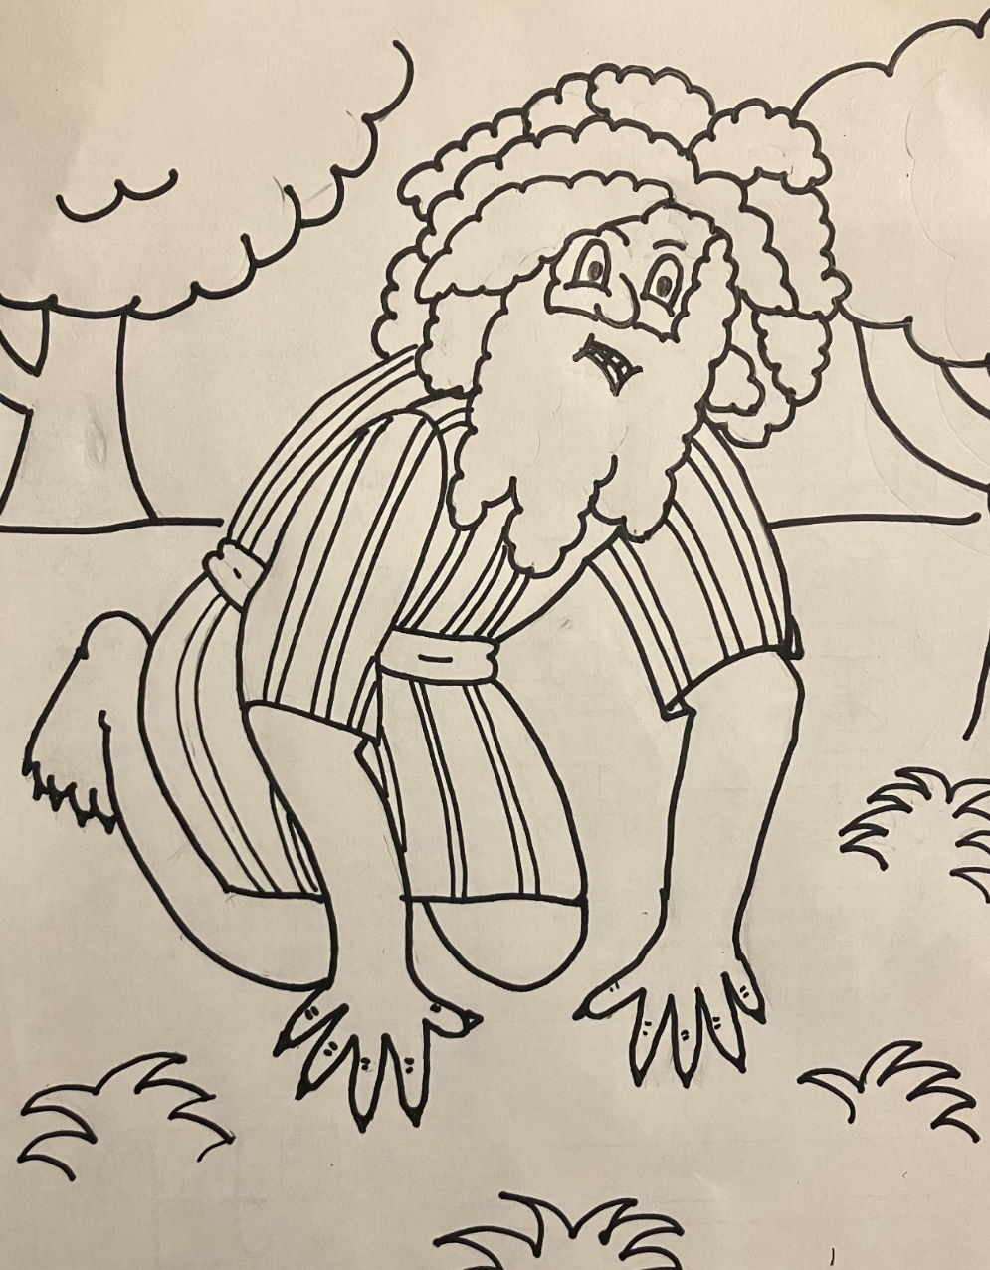

Now I Nebuchadnezzar praise and extol and honour the King of heaven. Daniel 4:37

There once was a man named Belshazzar. Belshazzar’s father was the king in Babylon, but he was gone all the time, so Belshazzar had to do the job of the king while his dad was away. He was not a good king, but neither was his dad or even his grandfather. In fact, Babylon had very bad kings for many, many years. They didn’t try to live their lives or rule their kingdom the way God wanted them to. Instead, they worshipped fake gods and treated people badly.

Daniel and the Writing on the Walls

After Belshazzar had been working as the king for a few years, he had a big problem. Other people were trying to attack and take over his kingdom. Some of the people were called Medes and some were called Persians. He knew they were planning to attack; they had even started to surround his kingdom. Instead of asking God to protect them or help them fight the other people, King Belshazzar decided to have a party. He had a feast and invited lots of people to come. During this party, Belshazzar told his men to go get special cups and bring them to him. Many years before Belshazzar was born, his grandfather attacked at place called Judah, just like the Medes and the Persians were trying to attack his kingdom. When his grandfather attacked Judah, he knew those cups were very import to the people who lived there so he stole them from the temple and brought them back to his kingdom in Babylon. He also captured lots of the children in Judah and brought them back with him too. Belshazzar’s grandfather never used those cups. Even as mean as he was, he knew the cups were special to the people in Judah and to God, and that he didn’t need to mess with them. Belshazzar didn’t care. He called for the cups and when they were brough to him, he poured wine in them and started praising fake gods. He even let other people drink from the special cups. Suddenly, King Belshazzar looked up and saw a very scary thing. He saw fingers writing on the wall. It was just fingers. There was no hand. There was no person, just fingers. This scared him so much it made his legs shake until his knees were knocking together. King Belshazzar called for his wise men to come help him understand what was going on. The fingers had written a secret message on the wall, and he didn’t know what it meant. His wise men didn’t even know what it meant. No one could read or understand the writing on the wall.

Just then the queen came into the room. She told Belshazzar to call a man named Daniel. Daniel loved God and always tried to do what God wanted him to do. Daniel had helped his grandfather understand confusing things because God helped Daniel understand confusing things. So, Belshazzar called for Daniel. When Daniel showed up, King Belshazzar told him that he would give him fancy purple clothes, a gold necklace, and make him his most important helper if he would explain the secret message on the wall. Daniel didn’t want the gifts. He said, “keep your gifts or give them to someone else but I will tell you about the message.”

Before Daniel started telling King Belshazzar the secret message, he explained to the king that he had not been leading his kingdom the way God wanted him to. He said “You are acting like your grandfather and doing very bad things that God doesn’t like. God punished your grandfather for those bad things, and even though you saw God punish him, you still did the same bad things.

Then, Daniel read the secret message to the king and told him what it meant. The secret message told the king his time was up, and he would not be the king anymore. The Medes and the Persians were going to attack and take over his kingdom. Even though this message upset King Belshazzar, he still gave Daniel the gifts he had promised.

Let thy gifts be to thyself and give thy rewards to another. Daniel 5:17

That night Babylon was attacked, and Belshazzar was killed. The message on the wall was right. His time as king was up. God took care of Daniel, and he became one of the most important helpers to the new king named Darius.

1. What was king’s name?
2. Who was planning to attack Babylon?
3. What did the king call for during the feast?
4. What did the king see happening to the wall?
5. Who told the king to ask Daniel to interpret the message?
6. What did Daniel tell the king before he interpreted the message?
7. What was the message?
8. What happened to the king that night?

**Look it Up! (KJV)**

Who took over the kingdom? __ __ __ __ __ __

Daniel 5:1 Belshazzar the king made a great feast to a __ __ __ __ __ __ __ __ of his lords…

Daniel 5:5 In the same hour came forth fingers of a man’s hand and wrote over against the candlestick upon the __ __ __ __ __ __ __ of the wall of the king’s palace.

Daniel 5:7 …Whosever shall read this writing, and show me the interpretation thereof, shall be clothed with __ __ __ __ __ __ __...

Daniel 5:25 And this is the writing that was written, MENE, MENE, TEKEL,

__ __ __ __ __ __ __ __

Daniel 5:22 And thou his son, O Belshazzar, has not

__ __ __ __ __ __ __ thine heart…

Daniel 5:2 Belshazzar, whiles he tasted the wine, commanded to bring the golden and silver __ __ __ __ __ __ __ which his father Nebuchadnezzar had taken…

**My Prayer for You**

My prayer for you is that you always strive to live a life that please God even though perfect living is impossible. I hope God puts people in your path like Daniel who will have difficult conversations with you in a wise and loving way to help you get back on track when you stray. I also pray that you can be the Daniel to someone else who may need a loving friend to help them see the errors of their ways so they can also live a life pleasing to God.

**Reflection Questions**

1. Have you ever had to have a difficult conversation with a friend or family member? Did you find that God helped you to find the right words to say and the courage to say them?
2. Have you ever had a friend or family member talk to you about something you needed to change about yourself? How did the person’s tone and attitude affect how you received the message?

**In My World**

Before Daniel explained the message on the wall, he told King Belshazzar that he hadn’t been leading his kingdom God’s way. Daniel had a difficult conversation with the king even though it might have gotten him into a lot of trouble. Sometimes we will need to have difficult conversations with people to help them understand God’s love and how God wants us to live our lives. In those times we must be brave like Daniel and tell people the truth even if they may not like what we have to say.

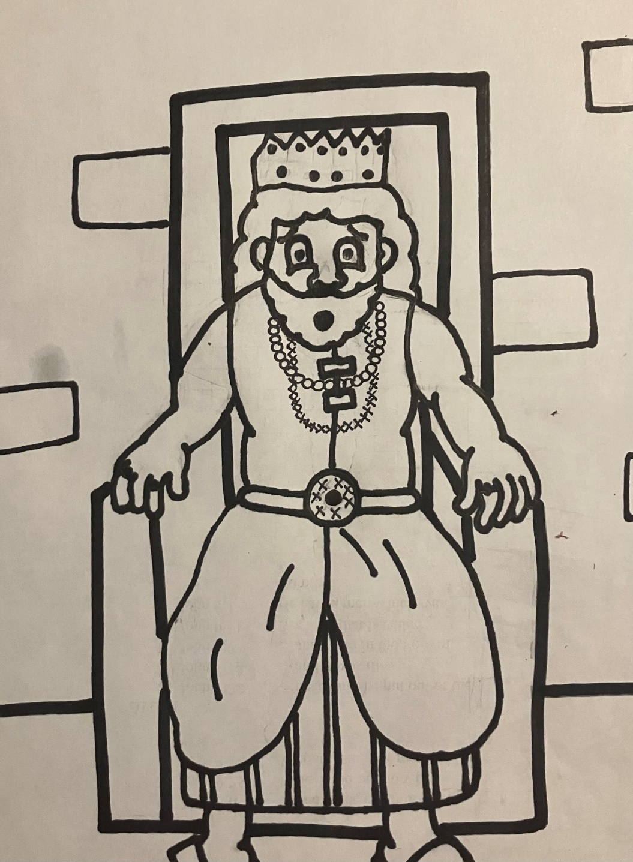

Let thy gifts be to thyself and give thy rewards to another. Daniel 5:17

Daniel was a man who loved God. He always tried to make choices that pleased God. Daniel lived in a place called Babylon and the Kings of Babylon didn’t love God. They didn’t care about doing the right thing, but they liked Daniel. Because Daniel was always trying to please God, he was always doing his very best. Daniel was a great help to the kings of Babylon, and they always gave him very important jobs. Even when Babylon would get a new king, the new king would see that Daniel was a good man and give him the most important jobs.

Daniel and the Lions’ Den

Once there was a king named Darius. Darius liked Daniel and made him one of his three most important helpers. The other men were jealous of Daniel. They didn’t understand what was so special about him. They got together and came up with a plan to get Daniel in trouble. If Daniel got in trouble the king would have to remove him from his job. They watched Daniel very carefully hoping to catch him breaking the law, but he never did. So, they came up with a secret plan. They knew how important it was to Daniel to please God so they decided to trick the king into making a law that would be against God. They told the king he should make a rule that everyone had to pray to only him for 30 days. If someone broke that rule, they would be thrown into the lions’ den. The king didn’t think about Daniel and how much Daniel loved God. He liked this new rule because it made him feel more important, so he agreed and signed all the papers for the new law.

Daniel heard about the new law, but it wasn’t going to make him do anything against God and praying to anyone other than God is wrong. So, three times every day, just as he had always done, Daniel went into his house to pray and give thanks to God. The bad men were always watching Daniel, and they saw him through the open windows of his house. They saw him praying to God and they knew their plan had worked. They went straight to the king and told him what Daniel had done. This made the king very upset. He loved Daniel. Daniel was important to him. He didn’t want to throw Daniel in the lions’ den but there was nothing he could do. It was too late for him to change the rule and Daniel had to be punished. He was going to have to be thrown in with the lions. Just before they threw Daniel into the lions’ den, the king told Daniel, “Thy God, whom thou servest continually, he will deliver thee.” That meant the king believed Daniel’s God would save him from the lions. Then the king went back to his palace. He was so worried about Daniel that he fasted all night. He didn’t eat. He didn’t listen to music. He didn’t even sleep.

The next morning the king ran to the lions’ den to check on Daniel. Daniel was ok! Daniel told King Darius that God had sent an angel to close the mouths of the lions. King Darius had Daniel pulled out of the den and he told everyone that Daniel’s God was the one true God. Then King Darius had all the bad men and their families thrown into the lions’ den for the bad things they had done. The lions had a big supper that night.

1. Where did Daniel live?
2. What was the king’s name?
3. Why did some people not like Daniel?
4. What new rule did the bad men trick the king into making?
5. What did Daniel do when he heard about the new rule?
6. How did the bad men catch Daniel breaking the new rule?
7. How did the king feel after Daniel was caught?
8. What happened to Daniel because he broke the rule?
9. What happened that night in the lions’ den?
10. What did the king do the next morning?

Thy God whom thou servest continually, he will deliver thee. Daniel 6:16

**Look it Up!**

**Down**

1. Daniel 6:4 …neither was there any __________ or fault found in him.
2. Daniel 6:9 King Darius signed the writing and the ________
3. Daniel 6:11 Then these men assembled and found him __________
4. Daniel 6:7 He shall be cast into the den of _______

**Across**

2. Daniel 6:9 Wherefore king ________ signed the writing and the decree

1. Daniel 6:10 …he kneeled upon his knees ________ times a day.
2. Daniel 6:16 Thy God whom thou servest continually, he will ____________ thee.
3. Daniel 6:22 My God hath sent His _________ and hath shut the lion’s mouth.

|  |  |  |  |  |  |  |  |  |  |  |  |  |  |  |  |  |
| --- | --- | --- | --- | --- | --- | --- | --- | --- | --- | --- | --- | --- | --- | --- | --- | --- |
|  |  |  |  |  |  |  |  |  |  |  |  |  |  |  |  |  |
|  |  |  |  | 1 |  |  |  |  |  |  |  |  |  |  |  |  |
|  |  |  |  |  |  | 2 |  |  |  |  |  |  |  |  |  |  |
|  |  |  |  |  |  |  |  |  |  |  |  |  |  |  |  |  |
|  | 5 |  |  |  |  |  |  |  |  |  |  |  |  |  |  |  |
|  |  |  |  |  |  |  |  |  |  |  |  |  |  |  |  |  |
|  |  |  |  |  |  |  |  |  |  |  | 3 |  |  |  |  |  |
|  |  |  |  |  |  |  |  |  |  |  |  |  |  |  |  |  |
|  |  |  |  | 6 |  |  |  |  |  |  |  |  |  |  | 4 |  |
|  |  |  |  |  |  |  |  |  |  | 7 |  |  |  |  |  |  |
|  |  |  |  |  |  |  |  |  |  |  |  |  |  |  |  |  |
|  |  |  |  |  |  |  |  |  |  |  |  |  |  |  |  |  |
|  |  |  |  |  |  |  |  |  |  |  |  |  |  |  |  |  |
|  |  |  |  |  |  |  |  |  |  |  |  |  |  |  |  |  |
|  |  |  |  |  |  |  |  |  |  |  |  |  |  |  |  |  |

**Reflection Questions**

1. Have you ever been in a situation where someone tried to get you to do something that was against God’s rules?
2. Praying to God even though it might mean being thrown in the lions’ den was a very brave thing to do. What do you think helped Daniel to be brave?

**My Prayer for You**

My prayer for you is that you will never forget that God has unlimited strength and courage to give you when you ask for it and trust Him with the situation. Being brave doesn’t mean jumping in lions’ dens. Being brave is doing the right thing and following God’s plan even when it’s scary. My prayer is that you trust God’s plan even in the scariest situations.

**In My World**

Sometimes in life, making the choice to do the right thing might be a hard decision. Sometimes other people won’t like us because we are doing the right thing. Sometimes people might even try to punish us because we are choosing to do things God’s way instead of their way. In those times, we need to be brave like Daniel and know that God’s way is always the right way, and He is always with us helping us to stay strong even when it might be a little scary.

Thy God whom thou servest continually, he will deliver thee. Daniel 6:16b

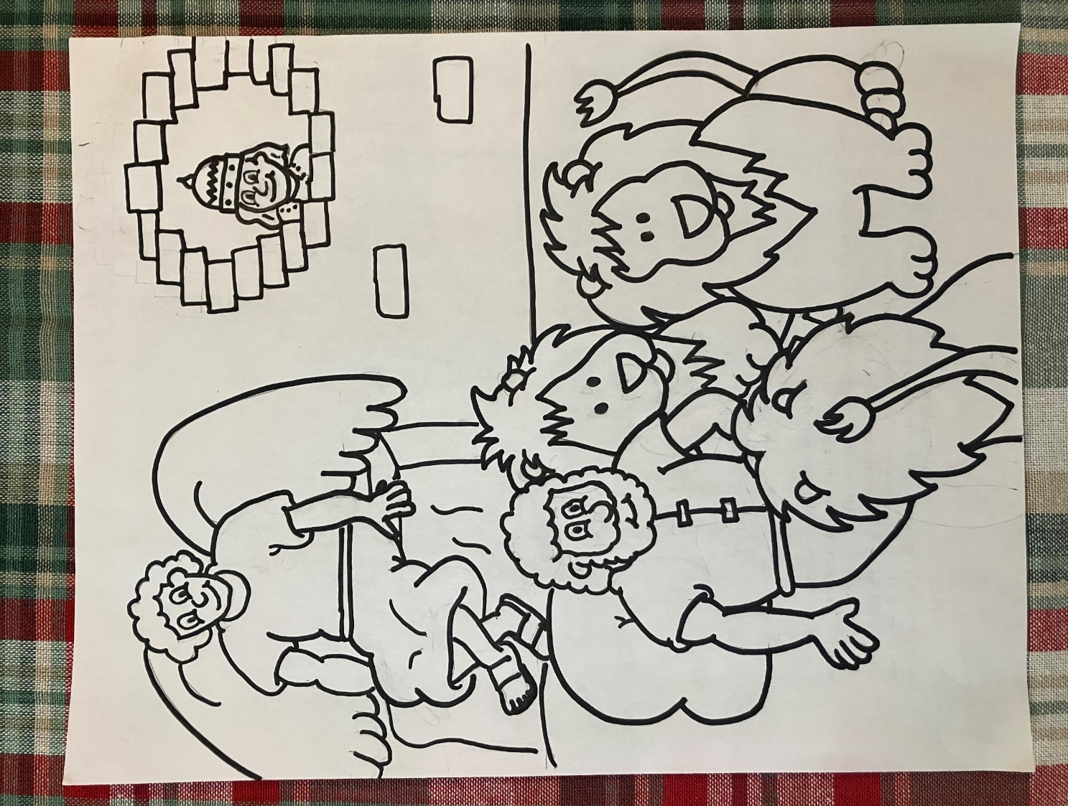

Look for us on YouTube under “Jesus Stories with Jolly” to find interactive videos of each lesson.

OR

Follow us on Facebook at “Jesus Stories with Jolly” for updates for future books, lessons, and additional materials.

OR

Printable materials for this and other “Jesus Stories with Jolly” lessons can be downloaded from TeachersPayTeachers.com under the store name “Crowded Acres Publications”.