Jesus knew that it was almost time for him to be crucified. He tried to explain it to the disciples, but they didn’t quite understand all that was about to happen. One night, after the Passover Meal, Jesus gathered his disciples and went to a place call the Garden of Gethsemane. It was a nice quiet place where Jesus liked to go pray.
The Garden of Gethsemane
As they entered the garden Jesus told most of the disciples to sit and wait as he traveled on a little farther. He asked Peter, James and John to walk with him. He wanted them to stand watch while he prayed. Jesus knew danger would soon be around them all, but he wanted to be able to focus to pray so he asked these three men to watch carefully.
Jesus went on a little farther by himself. Then he fell to his knees and prayed. Jesus was very upset. He knew people were coming who were going to kill him. He knew that it was God’s plan all along for him to come to the world to die for the sins of everyone. He already knew about all the pain he would suffer, and how everyone would turn against him in his last days. He knew that his disciples would scatter, hide, and deny that they even knew him. Jesus knew his heart was about to break and his body would be badly beaten. He knew exactly what was about to happen. But the thing that bothered Jesus the most was the fact that there would be a time when he would be separated from God. God cannot be in the same place as sin so while Jesus was paying for the sins of all people, he had to be separated from God.
This was the part that troubled him the most. Jesus was so burdened that while he prayed he began to sweat drops of blood.
Jesus prayed asking God to take this cup from him. That meant if there was any other way to pay for the sins of the world, he would rather do that. But he ended the prayer by saying, “Not my will but thine.” He was saying, it wasn’t about what was easiest for him. he would do whatever he needed to do.”
After about an hour, Jesus walked back to where Peter, James and John were waiting. All three of the disciples were asleep. Jesus woke them up and asked them why they couldn’t do what he had asked. He asked why they couldn’t stay awake for even one hour to let him pray. Jesus knew how serious things were about to get but the disciples still didn’t understand. He told his disciples to be careful, not to let temptation keep them from doing what they needed to do. He told them the body is weak and sometimes they would struggle to stay focused. Then Jesus went back to pray some more.
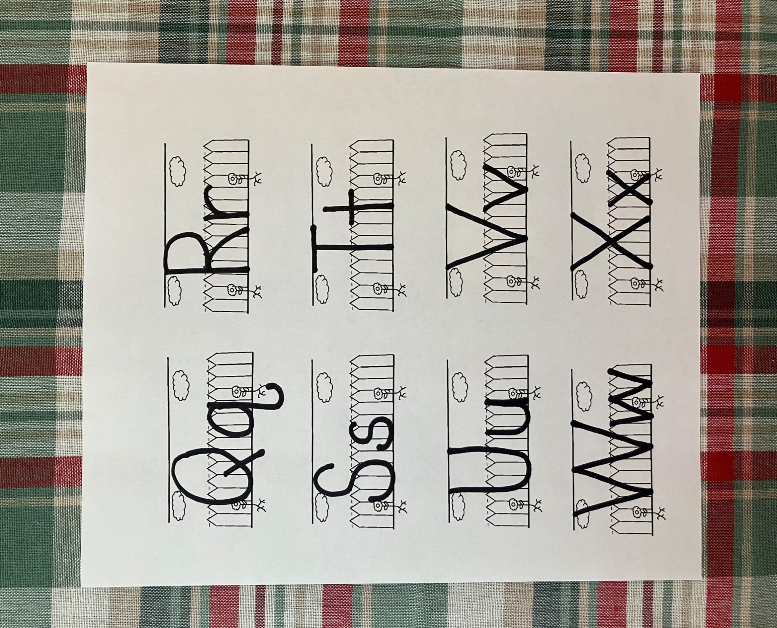
Jesus prayed again, asking God the same things he had prayed before. Then he returned to his disciples. Again, he found them asleep. This time he didn’t wake them. He just went back and prayed some more. The third and final time Jesus returned to his disciples they were still sleeping. He let them rest because he knew things were already starting to happen in Jerusalem that would lead to him being captured. His time had come.
Q

q

quiet

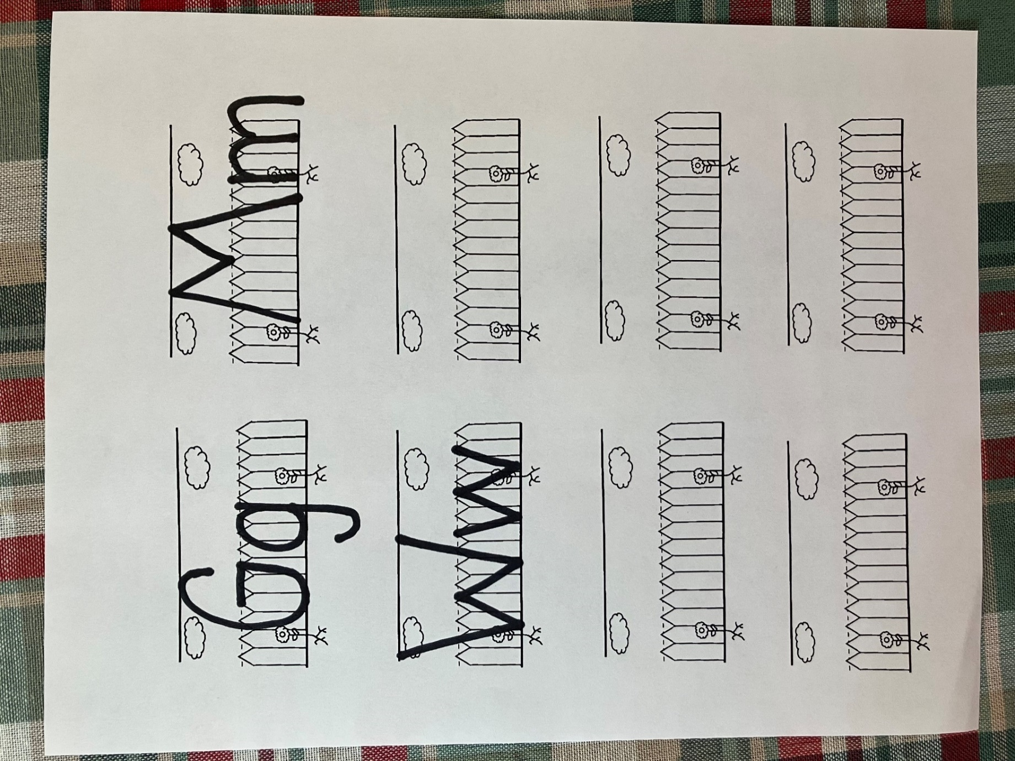
G

g

garden

- Where did Jesus go with his disciples?
- How many disciples did he ask to walk on with him?
- What did Jesus ask Peter, James, and John to do while he went to pray?
- What did Jesus start to sweat because he was praying so hard?
- What did Jesus pray in the garden?
- What did Jesus find the disciples doing when he returned from praying?
- How many times did Jesus go pray alone?
- What did Jesus say to God that meant he was willing to do whatever he needed to do?

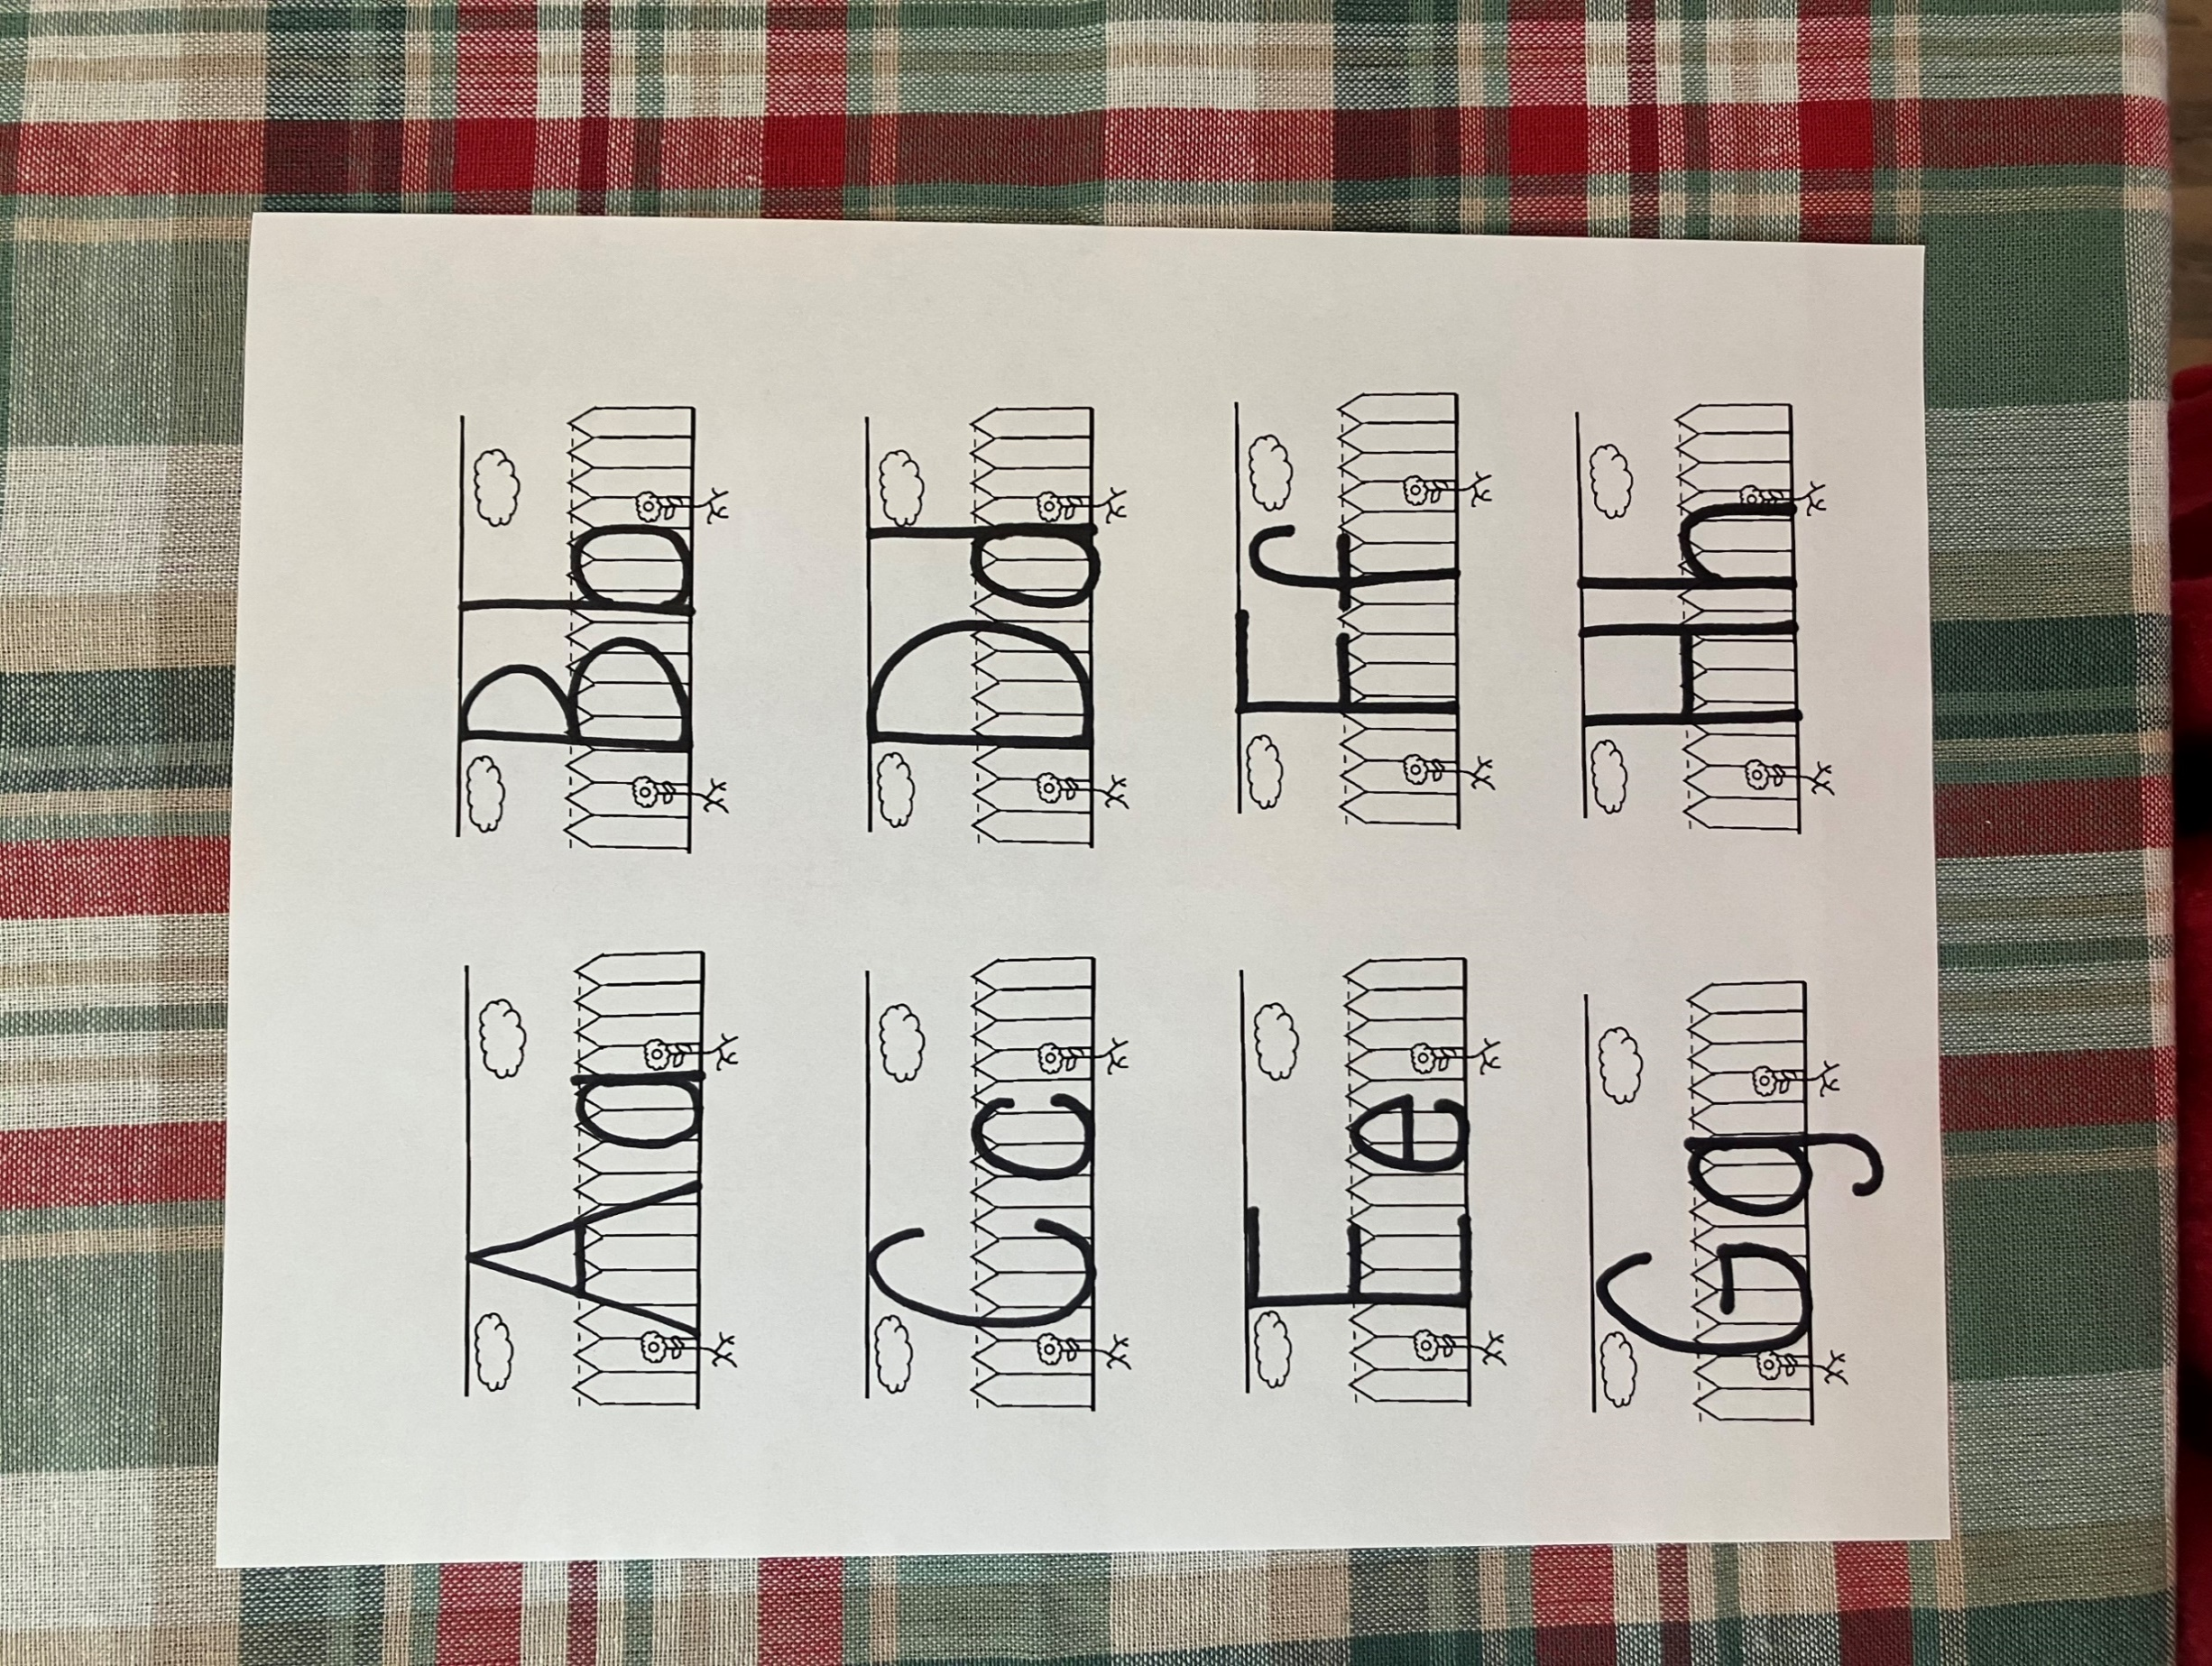
D

d

disciples

Jesus asked Peter, James, and John to stand watch as he went to pray. When he came back, he found them asleep. They were supposed to be awake. Awake and asleep are opposites. Look at the picture below and match the opposites.
.
.

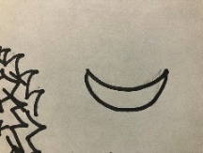
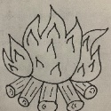
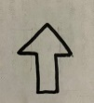
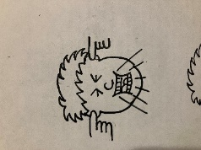


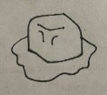

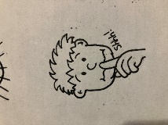
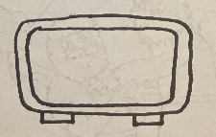
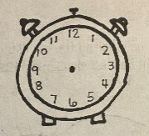
7:00
Jesus went to the garden to pray because he knew it was almost time for him to die on the cross. Look at the pictures below. Match the analogue clocks with the digital clocks that tell the same time.

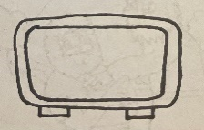
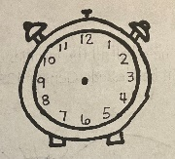
3:00

8:00

1:00

Dd
And he cometh unto the disciples,
and findeth them asleep.
Matthew 26:40

Jesus went to the garden to pray. Some gardens have beautiful flowers. In the space below, draw flowers.
sin
- anything we do that isn’t pleasing to God

- I was in the Garden of Gethsemane.
- I asked Peter, James, and John to stand watch for me.
- I prayed so hard I started to sweat blood
- I found the disciples asleep 3 different times.

Who am I?
___ ___ ___ ___ ___

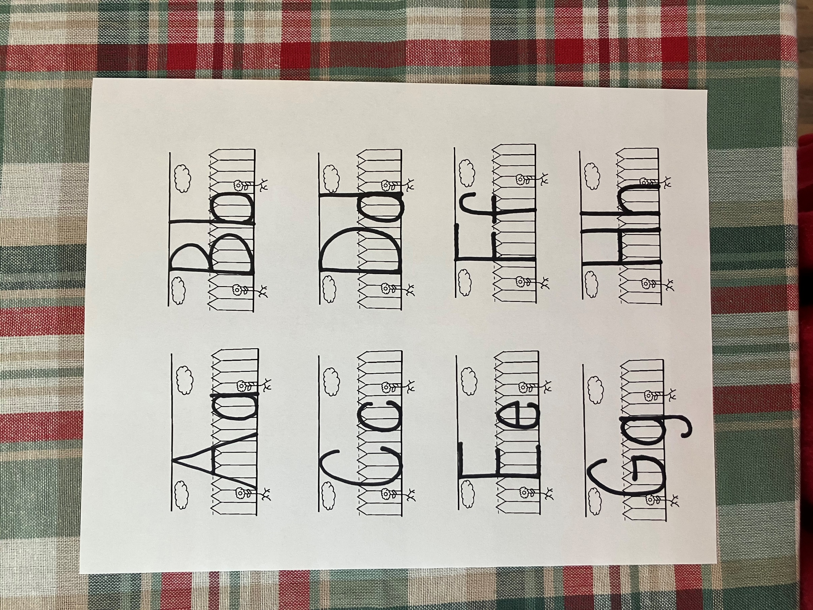

And he cometh unto the disciples, and findeth them asleep. Matthew 26:40

