Jesus and his disciples, along with many other people, were in Jerusalem for the Passover Feast. This was a special feast that took place once a year to remember the wonderful things God had done for the Israelites. Bethany was a town near Jerusalem. Jesus and his disciples had been there many times and had made friends with several people in Bethany. They were there at the home of a man named Simon having their evening meal.

Mary’s Special Gift

As they were eating a woman walked into the room. Her name was Mary. Jesus and his disciples knew Mary. They often stayed with Mary, her brother Lazarus, and sister Martha when they came to town. When Mary walked into the room, she was carrying a small alabaster box. This box was made of stone and was filled with very expensive perfumes, so expensive that someone would have to work a whole year to have enough money to buy it. Mary carried her box over to Jesus and then broke it and poured the perfume over Jesus’s head.

The disciples thought that this was a very strange thing for her to do. They thought she was wasting the expensive perfume. They didn’t understand why Jesus was letting her be wasteful. They started to grumble and complain. One of the disciples even said it would have been better for her to let them sell the perfume so they could give the money to the poor. They could have helped a lot of poor people with that money, but instead she was just pouring it all out.

Jesus told the disciples not to talk bad about Mary. Jesus knew that Mary was giving the very best thing she had to worship Jesus. Jesus told the disciples they would always be able to take care of the poor, but Jesus would not always be there with them. This woman wanted to worship him with gifts while he was there. What she was doing was very important. Jesus was about to die. He had been telling people this for a while, but the disciples didn’t understand what he was saying. Mary was helping to prepare his body for when he would give his life and die for all people. Jesus told his disciples that Mary would always be remembered for her kindness that night.

The disciple didn’t understand all of what Jesus was talking about, but they obeyed him and stopped grumbling about the woman. One disciple, named Judas Iscariot, stayed upset about the perfume. Judas was the disciple who took care of their money. Money was very important to him so thinking someone was wasting money made him angry. Jesus saying it was ok also made him angry. Judas was confused. How could Jesus become a powerful ruler if he was going to be ok with wasting money like this? Judas then realized Jesus was going to be powerful in heaven, but he wouldn’t be rich and powerful on earth. Judas thought being on Jesus’s side was going to make him rich or powerful so when he started to understand what Jesus was saying, he changed his mind about wanting to help Jesus at all. In fact, he decided to turn against Jesus.

Judas decided to have a secret meeting with the members of the Sanhedrin. This was a group of chief priest and scribes who wanted to kill Jesus because they were jealous of how much other people loved him. They were already planning to arrest Jesus, but they were going to wait until after the Passover Feast. They thought there were too many people visiting Jerusalem for the feast who might try to help Jesus. Judas went to them and asked what they would give him if he told them where they could find Jesus. He told them he would wait until he knew Jesus wasn’t in a crowd of people and then take them to him so they could arrest him. They told Judas they would give him 30 pieces of silver if he helped them. Judas agreed and then they started to talk about their evil plan.

1. Why were Jesus and his disciples in Jerusalem?
2. What was the lady’s name who came to visit Jesus?
3. What did Mary bring to Jesus?
4. What did Mary do with the perfume?
5. Why did the disciples get upset with what Mary was doing?
6. What did Jesus tell the disciples to do?
7. Who stayed upset about the perfume?
8. Who did Judas go talk to after the meal?
9. What did Judas tell the members of the Sanhedrin he would do?
10. How much money was Judas going to get for taking them to Jesus?

Printing Practice

woman

Ww

Mary

Mm

Iscariot

Ii



Judas agreed to betray Jesus if the high priest would give him 30 pieces of silver. Count by tens to see how many items are in each group. Circle the groups that have 30 items.







Memory Verse

Find it, Read It, Write It, Explain It!

**And there came unto him a woman having an alabaster box. Matthew 26:7**

Cursive Practice

Ww

woman

Mm

Mary

Iscariot

Ii

“Don’t waste that!”

How many times have you heard someone say

that to you when you were making a snack or doing a craft? This is exactly what the disciples were saying to Mary as she poured the perfume on Jesus. They didn’t understand that her gift wasn’t about the money. Her gift was about loving Jesus. She wanted to worship him big,

and he felt the big love behind her

gift. When we worship God, we need

to worship him with our whole

hearts just as Mary did.

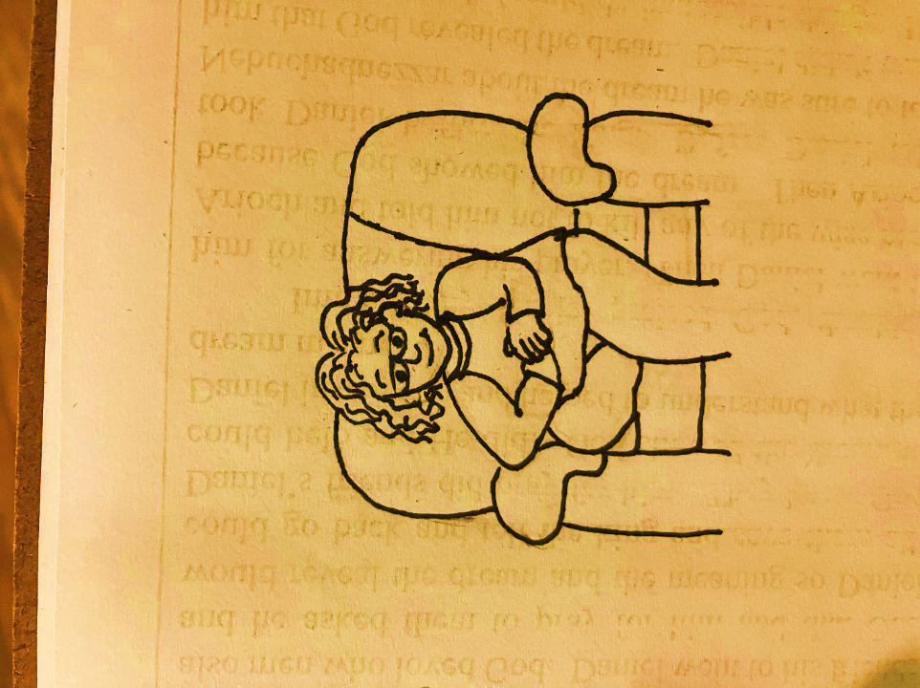

Wordsearch

MARY HEAD JESUS

JUDAS MONEY SILVER

|  |  |  |  |  |  |  |  |
| --- | --- | --- | --- | --- | --- | --- | --- |
| M | O | N | E | Y | Q | W | H |
| E | R | T | Y | U | I | O | E |
| J | S | I | L | V | E | R | A |
| U | G | H | J | K | L | P | D |
| D | F | D | M | A | R | Y | S |
| A | Z | J | E | S | U | S | A |
| S | X | C | V | B | N | M | G |

**4**

And there came unto him a woman having an alabaster box.

Matthew 26:7

**2**

**1**

**5**

**3**

**4**

**3**

**3**

**4**

**4**

1 – blue 2 – yellow 3 – orange

4 – gray 5 - brown

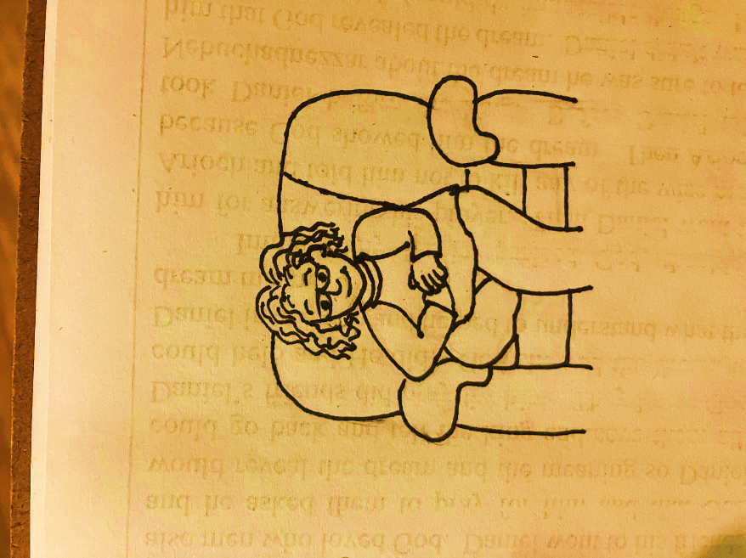

Dear God,

Thank you for this lesson.

Thank you for people like Mary who show

us how to love you big and bold even when

it doesn’t make sense to others. Please help us to love you with our whole heart just as Mary did. Please help us to always worship you and never worry about what others think.

In Jesus’ Name,

Amen